The potential of species distribution modelling for reintroduction projects: the case study of the Chequered Skipper in England

Dirk Maes1 · Sam Ellis2 · Philippe Goffart3 · Katie L. Cruickshanks2 · Chris A. M. van Swaay4 · Ruddy Cors3 · Marc Herremans5 · Kristijn R. R. Swinnen5 · Carine Wils1 · Sofie Verhulst6 · Luc De Bruyn1,6 ·
Erik Matthysen6 · Susannah O’Riordan2 · Daniel J. Hoare2 · Nigel A. D. Bourn2

Abstract
The Chequered Skipper Carterocephalus palaemon inhabits a variety of habitats in NW Europe: heathlands, wet grasslands and chalk grasslands, usually at woodland edges and wide rides and glades in different types of woodlands. It mainly uses broadleaved grasses such as Molinia, Calamagrostis and Brachypodium as host plants. The species became extinct in Eng- land in 1976 and an earlier reintroduction attempt in 1995–1999 was unsuccessful. Using species distribution models, we located potential source regions in NW Europe for its reintroduction to England. To do so, we gathered distribution data of the butterfly and environmental variables (Corine Land Cover and climate data) from four regions in Belgium (Belgian Campine, Fagne–Famenne–Calestienne, Ardenne–Thiérache and Gaume–Lorraine), two in the Netherlands (Achterhoek and Dutch Campine) and one in the United Kingdom (Argyll, Scotland). We calibrated the models in these regions and pro- jected them to the Rockingham Forest landscape, the reintroduction site in England. The Fagne–Famenne–Calestienne and the Gaume–Lorraine model resulted in the highest average probability when projected to the Rockingham Forest landscape. Based on additional expert knowledge on potential host plant abundance and the presence of large source populations, the Fagne–Famenne–Calestienne was selected as the source region for the reintroduction of the Chequered Skipper to England. To assess the possible impact of climate change, we also built a model with present-day climate data in NW Europe and modelled the probability of occurrence in the Rockingham Forest landscape in the year 2070. The species was predicted to increase in the Rockingham Forest landscape under future climate conditions.

Keywords Conservation · Carterocephalus palaemon · Butterflies · Belgium · The Netherlands · UK

Introduction

Species are going extinct at a much faster pace than ever before, both at the global and at the regional scale (Thomas et al. 2004b). Several, often interacting drivers are at the ori- gin of these declines such as habitat loss and fragmentation (Krauss et al. 2010), habitat quality loss through a degrad- ing environmental quality (e.g. increased nitrogen deposi- tion—Mortelliti et al. 2010; WallisDeVries and van Swaay 2017), a lack of appropriate management (New et al. 1995)

and/or climate change causing species range shifts that can lead to local extinctions (Travis 2003; Thomas et al. 2004a). Anthropogenic pressures such as intensive agriculture and forestry and industrial pollution, together with urban expan- sion have brought many species to the brink of extinction, especially in highly industrialised regions (Maes and Van Dyck 2001; Konvička et al. 2006; van Strien et al. 2019). Sedentary species in particular are suffering from a decline in habitat quality (Thomas et al. 2001) and increased frag- mentation of metapopulations, which prevent recolonisa-

tions (Hanski 1999). When distances between populations

.

* Dirk Maes dirk.maes@inbo.be
Extended author information available on the last page of the article
or to potentially suitable locations become greater than the dispersal capacity of the species, genetic exchange and nat- ural colonisation is less likely or even impossible (Fahrig and Merriam 1994). In such cases, reintroducing individu- als from a suffi y large source population is often the only solution for its conservation (e.g. Seddon et al. 2007;

Chauvenet et al. 2013). Due to habitat fragmentation and changing climatic conditions, species are not always able to track their optimal climatic niche and, therefore, transloca- tion of individuals to climatically suitable areas (“assisted migration/colonisation”) can be applied as a species con- servation measure (e.g. McLachlan et al. 2007; Willis et al. 2009; Thomas 2011).
Although species distribution models are increasingly used in conservation biology (Hodgson et al. 2009; Guisan et al. 2013; Wood et al. 2018), their applicability is still strongly underestimated (Tulloch et al. 2016). With more and more environmental data available (e.g. land use, cli- mate, soil) at increasingly higher resolutions (e.g. through remote sensing), species distribution modelling is now able to predict potential species occurrences at increasingly finer scales (Ciuti et al. 2018). One of the more recent applica- tions of species distribution modelling is to predict poten- tially suitable localities for the reintroduction or transloca- tion of species in or to a focal region (e.g. Martinez-Meyer et al. 2006; Anderson et al. 2009; Kalle et al. 2017; Brooker et al. 2018). By using relevant, often broad-scaled variables (land use and climate) in sites where the species is still pre- sent, species distribution modelling can explain why they went extinct in certain regions and/or which areas have the highest probability of occurrence in sites that are beyond their dispersal capacities (Hijmans and Graham 2006). One of the limiting factors in species distribution model- ling, however, is that important small-scale variables (e.g. microclimate, host plant abundance and condition, level of the ground water table) are usually not available on larger scales (e.g. countries, continents) and cannot be included in such models (IUCN/SSC 2013). Therefore, local expert knowledge about the focal species and its local habitat use are an important additional source of information to decide where to get source individuals from and where to select the reintroduction sites (White et al. 2015).
Butterfl conservation has a long history in the United Kingdom (Heath et al. 1984). With only four out of the 62 resident and regularly breeding butterfly species being clas- sified as Regionally Extinct (i.e. Black-veined White Apo- ria crataegi, Large Copper Lycaena dispar, Mazarine Blue Cyaniris semiargus and Large Tortoiseshell Nymphalis poly- chloros), the UK has one of the lowest proportions of extinct butterflies among European countries (Fox et al. 2011; Maes et al. 2019). Part of the success of butterfly conservation in the UK can be attributed to reintroduction projects, although not all of them were equally successful (Oates and War- ren 1990; Schultz et al. 2008). One of the best known and most successful reintroductions in the United Kingdom is that of the Large Blue Phengaris arion (Linnaeus 1758), a myrmecophilous butterfl that went extinct in 1979, but is now present in several populations in southern England (Thomas et al. 2009). A few years earlier (1976), another
butterfly also became extinct in England: the Chequered Skipper Carterocephalus palaemon (Pallas 1771) and the re-introduction of the Chequered Skipper to England was a long held conservation priority for Butterfly Conservation. Studies suggest that single and/or small populations of spe- cialist, rare or endangered butterflies rarely survive longer than a few decades and that metapopulations are needed for the sustainable conservation of such species (e.g. Hanski et al. 1994; Thomas and Hanski 1997; Harrison et al. 1988; León-Cortés et al. 2003). The successful application of this metapopulation theory to landscape-scale approaches for the conservation of butterflies and moths (e.g. Small Pearl- bordered Fritillary Boloria selene ([Denis & Schiffermül- ler], 1775), Duke of Burgundy Hamearis lucina (Linnaeus, 1758)—Ellis et al. 2011) suggested that reintroductions to multiple sites were more likely to succeed than single-site reintroductions. Therefore, Butterfly Conservation aims at reintroducing the Chequered Skipper to several sites within a landscape comprising networks of well-connected wood- lands supporting patches of high quality habitat, with the objective of establishing a functional metapopulation. From a genetic point of view, there is no indication that Scottish or Belgian populations of the Chequered Skipper differed from the extinct populations in England. Instead, populations in NW Europe (Belgium, England and Scotland) and southern Scandinavia (Norway) all come from the same post-glacial colonisation route and can, therefore, be regarded as belong- ing to a similar gene-pool (Joyce and Pullin 2004).
Here, we first apply species distribution modelling using land cover variables in seven regions in Belgium, the Nether- lands and Scotland to locate the region that is most suitable as a source for the reintroduction of the Chequered Skipper to the Rockingham Forest landscape in England. Secondly, we use additional ecological knowledge of local experts on host plant use, microclimate and habitat management to determine and confi m the most suitable source region for the reintroduction of the Chequered Skipper to England. Finally, to assess how climate change will aff the suit- ability for the butterfly in the Rockingham Forest landscape, we also calibrated a climate change model for the whole of NW Europe and projected it to the Rockingham Forest landscape to see how the modelled occurrence probability would change in the future.

Methods

Study species

The Chequered Skipper Carterocephalus palaemon (Pal- las 1771) is a small brown and yellow butterfl that fl from early May to late June in a variety of biotopes: wood- land rides and glades, damp grasslands or heathlands, fens

and calcareous grasslands at woodland edges (Bink 1992; Ravenscroft 1994b). Its distribution area ranges from Scot- land in the west to Japan in the east and from northern Spain in the south to northern Norway in the north (Bink 1992). The species also occurs in Canada and the United States, where it is known as the Arctic Skipper (Bird et al. 1995). The Chequered Skipper uses a variety of host plants, mostly occurring on certain soil types in each of the regions: Purple Moor-grass Molinia caerulea and Calamagrostis canescens are the main host plants on sandy and/or acid soils [with the highest abundances in the Campine, Ardenne–Thiérache, Gaume-Lorraine (Belgium), Achterhoek, Campine (Neth- erlands) and Argyll (Scotland), see below] and False Brome Brachypodium sylvaticum and/or Tor-grass B. pinnatum on loamy and calcareous soils (with the highest abundances in the Fagne–Famenne–Calestienne region—Lambinon et al. 1998; FLORON 2011; Preston et al. 2002; Ravenscroft and Warren 1992; Van Landuyt et al. 2006). In the former Eng- lish populations, the two Brachypodium spp. were believed to be the main host plants (Emmet and Heath 1989). Other broad-leaved grasses such as Wood Small-reed Calamagros- tis epigejos, Purple Small-reed C. canescens, Reed Canary Grass Phalaris arundinacea, Meadow Foxtail Alopecurus pratensis, Giant Fescue Festuca gigantica, Meadow fescue
F. pratensis and Yorkshire Fog Grass Holcus lanatus have been reported as host plants as well (Bink 1992; Moore 2004).
The Chequered Skipper is classifi as Endangered in the United Kingdom (Fox et al. 2011), Near Threatened in Flanders (northern Belgium; Maes et al. 2012), Least Con- cern in Wallonia (southern Belgium; Fichefet et al. 2008) and Least Concern in the Netherlands (van Swaay 2019). On a European scale, however, the species is of Least Concern (van Swaay et al. 2010).
The Chequered Skipper was first recorded in England in 1798 and was quite common in woodlands of the East Mid- lands (mainly Bedfordshire, Cambridgeshire, Huntingdon- shire, Lincolnshire and Northamptonshire) until the 1960s. Old records are also known from other parts of England, such as Dartmoor and possibly the Lake District (Fig. 1— Collier 1986; Farrell 1973). Its decline was gradual and hardly noticed but its extinction was sudden. There were about 80 known sites at the beginning of the 1900s, 20 in the 1960s, but only six in 1971 before extinction in 1976 (Raven- scroft 1995). It seems probable that a combination of factors was responsible for its strong decline. Abandoning coppic- ing practices and associated ride maintenance would have increased shade levels in open space habitat and excluded the species from woodlands (Collier 1986; Warren 1990). Furthermore, the delayed effects of myxomatosis, reducing Rabbit Oryctolagus cuniculus numbers and grazing pres- sure would have resulted in coarse grassland scrubbing over (cf. Thomas and Jones 1993), despite initially improving the
habitat for C. palaemon (Ravenscroft 1995). Other factors,
e.g. the destruction of marginal habitats around woodland, such as hedgerows, may have contributed to the increased isolation of habitats (Ravenscroft 1995). A previous attempt to reintroduce the species in the Bardney Limewoods land- scape in Lincolnshire in 1995–1999 using individuals from northern France (Forêt de Spincourt, Villecloye, Bois de Rafour, Forêt d’Argonne) and southern Belgium (Chante- melle) failed to establish a viable population due to the lack of sufficient high quality habitat within the whole woodland complex (Warren 1995; Moore 2004).

The reintroduction site: the Rockingham Forest landscape

The Rockingham Forest landscape (Northamptonshire and Cambridgeshire) was the last stronghold of the Chequered Skipper in England (Fig. 1; Asher et al. 2001), which was one of the reasons to select it as the reintroduction site. The Rockingham Forest landscape is large (> 500 km2) and the amount of suitable habitat for the species (78 km2) was strongly increased by species-specifi management meas- ures (in collaboration with the woodland owners). Key prac- tices such as widening the woodland rides to 20–30 m and rotational ride mowing to both provide sufficient nectaring plants during the flight season of the adult butterflies, as well as prevent the grassy margin breeding habitat from becom- ing scrubbed over. The Rockingham Forest landscape was also selected because it holds at least 30 potentially suitable woodlands within the dispersal capacity of the Chequered Skipper (Ravenscroft 1994a), although their ability to sup- port the species is strongly dependent on appropriate habitat restoration.

Species distribution modelling

To model the Chequered Skipper’s distribution, we fi t compiled all available distribution data in NW Europe. We restricted our analysis to Belgium, the Netherlands and Scot- land because distribution data were readily available here. Other possible source locations might be present in the north of France, but extensive distribution data were not avail- able from this region. In NW Europe, the Chequered Skip- per occurs in four ecological regions in Belgium (Belgian Campine, Ardenne–Thiérache, Fagne–Famenne–Calestienne and Gaume–Lorraine), two in the Netherlands (Achterhoek, Dutch Campine) and one in the United Kingdom (Argyll, Scotland—Fig. 1). To compile the calibration data sets for the different ecological regions, we attributed every obser- vation of the Chequered Skipper to a 1 × 1 km2 grid cell of the European Universal Transverse Mercator (UTM) projec- tion (Table 1). Observations were obtained from www.waar nemingen.be and the butterfl database of l’Observatoire

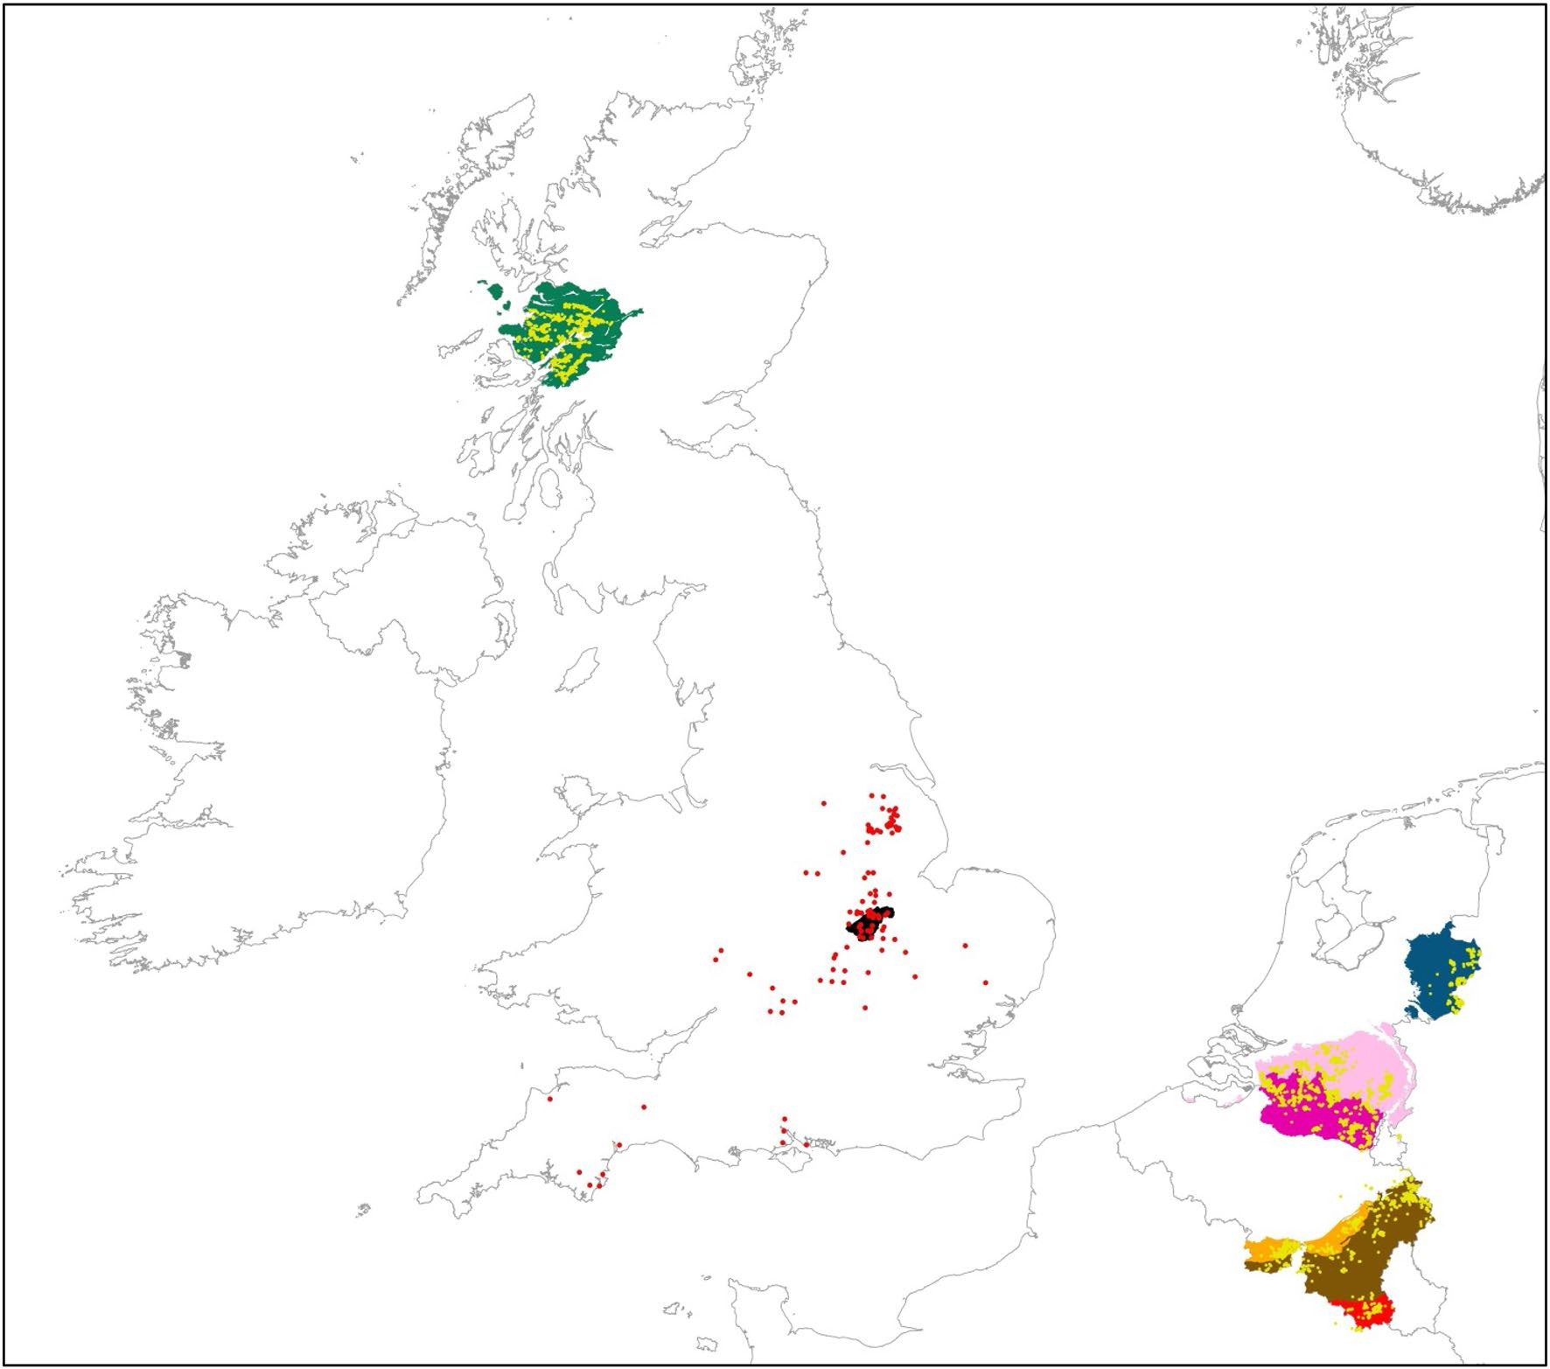

Fig. 1 Ecological regions in the Netherlands (blue: Achterhoek, pink: Dutch Campine), Belgium (purple: Belgian Campine, orange: Fagne– Famenne–Calestienne, brown: Ardenne–Thiérache, red: Gaume–Lor- raine) and the United Kingdom (dark green: Argyll, black: Rocking-
ham Forest landscape). The actual observations of Carterocephalus palaemon in the different regions are shown in yellow; the historical records in England are shown in red. (Color figure online)

de la Faune, de la Flore et des Habitats (OFFH) (Belgium), www.waarnemingen.nl and the National Database Flora and Fauna (the Netherlands) and Butterfl Conservation UK (Scotland). Subsequently, for each region, we added a simi- lar number of absences using the best-surveyed grid cells in each ecological region (i.e. grid cells with a minimum num- ber of observed butterfly species, depending on the ecologi- cal region, without observations of the Chequered Skipper during the fl period). As environmental variables, we used data from the Corine Land Cover 2012 Version 18.5.1 (http://land.copernicus.eu/pan-european/corine-land-cover
/clc-2012). We reduced the Corine Land Cover variables to eleven land cover types (Tables 1, 2). For normality, these variables were square root-transformed prior to analysis.
For modelling, we used quadratic Generalised Linear Models (GLM—McCullagh and Nelder 1989) with one interaction level. We used the Akaike Information Criterion
(AIC) for variable selection in the Biomod2 package (Thu- iller et al. 2009, 2012). For each ecological region in which the Chequered Skipper occurs in NW Europe, we applied a separate species distribution model. Per region, we did 20 model runs with a random split in 70% calibration and 30% evaluation. Models were evaluated using the Area under the Curve (AUC) of the Receiver Operating Characteris- tic (ROC) and models with an AUC ≥ 0.7 were considered acceptable (Huang and Ling 2005; Swets 1988). The average variable importance was obtained by averaging the variable importance of the 20 randomised models in each region. To obtain a fi probability per grid cell in each ecologi- cal region, we applied ensemble forecasting (Araújo and New 2007) for which only models with an AUC ≥ 0.7 were used in all regions, except in Fagne–Famenne–Calestienne where, due to poorer performance of the models, we used AUC ≥ 0.6. To test the performance of each model projected

Table 1 Land cover variables
used and average area (in ha) per grid cell in the different regions
Country Belgium Netherlands United King- dom

Only grid cells > 50% land are used. Belgium: CB Campine, FFC Fagne–Famenne–Calestienne, AT Ardenne–Thiérache, GL Gaume–Lorraine; the Netherlands: AH Achterhoek, CN Campine; United King- dom: Ar Argyll, RFL Rockingham Forest landscape
Ecological region | CB | FFC | AT | GL | AH | CN | Ar | RFL
Grid cells with C. palaemon | 431 | 159 | 259 | 64 | 134 | 395 | 165 | –
Agriculture | 26.67 | 29.78 | 14.03 | 22.62 | 25.18 | 52.99 | – | 61.37
Coniferous woodland | 9.22 | 1.04 | 15.98 | 2.55 | 5.27 | 12.24 | 14.33 | 0.73
Deciduous woodland | 2.63 | 21.19 | 11.55 | 24.37 | 0.6 | 1.2 | 8.75 | 6.63
Grassland | 6.31 | 0.23 | 4.1 | – | 7.46 | 0.42 | 14.73 | –
Heathland | 1.56 | – | 1.29 | 0.52 | 1.44 | 2.02 | 30.32 | –
Marshes | 0.41 | 0.02 | 7.35 | 9.88 | 2.58 | 9.66 | – | –
Mixed woodland | 5.48 | 16.31 | 27.08 | 10.95 | 4.1 | 3.68 | 1.58 | 2.95
Pasture | 12.85 | 16.57 | 18.24 | 25.53 | 37.38 | 5.67 | 8.54 | 14.49
Agricultural grassland | 9.69 | 5.91 | 4.51 | 5.93 | 16.23 | 3.6 | 0.36 | –
Shrub | 1.04 | – | 1.84 | 0.37 | 1.79 | 6.23 | 2.80 | 0.62
Water | 1.16 | 0.44 | 0.11 | – | 0.1 | 0.43 | 3.79 | 0.41

Table 2 Average temperature
(in °C) and mean precipitation (in mm) in the warmest quarter in 2000 and in 2070 for grid cells in which the Chequered Skipper is present since the year 2010 in the different regions and in the Rockingham Forest landscape. Source For the CCSM3 climate model: Hijmans et al. 2005
 | 2000 | 2070 | Diff | 2000 | 2070 | Diff
Campine (B) | 16.61 | 18.27 | + 1.66 (10%) | 210.82 | 207.18 | − 3.64 (2%)
Fagne–Famenne–Calestienne (B) | 16.52 | 18.05 | + 1.53 (9%) | 241.45 | 274.75 | + 33.3 (14%)
Ardenne–Thiérache (B) | 14.77 | 16.32 | + 1.55 (10%) | 269.80 | 309.26 | + 39.46 (15%)
Gaume–Lorraine (B) | 16.24 | 17.78 | + 1.54 (9%) | 238.43 | 268.98 | + 30.55 (13%)
Achterhoek (NL) | 16.26 | 17.93 | + 1.67 (10%) | 221.79 | 214.93 | − 6.86 (3%)
Campine (NL) | 16.50 | 18.19 | + 1.69 (10%) | 211.90 | 202.12 | − 9.78 (5%)
Argyll (UK) | 14.05 | 16.16 | + 2.11 (15%) | 333.31 | 364.75 | + 31.44 (9%)
Rockingham Forest landscape (UK) | 16.03 | 17.89 | + 1.86 (12%) | 159.78 | 164.52 | + 4.74 (3%)

Temperature Precipitation

to its own (calibration) region but also in the six other regions, we used the pROC package (Robin et al. 2011). The latter test was done using grid cells in each of the eco- logical regions in which at least 10 species were observed. To test for differences between each of the projected prob- abilities among the seven source regions to the introduc- tion site (the Rockingham Forest landscape), we applied a TukeyHSD post hoc comparison test using the multcomp package (Hothorn et al. 2008) in R (R Core Team 2018).
In addition to the habitat suitability, we also projected the future climatic suitability of the reintroduction site. Since the seven ecological regions are relatively small (ranging from 935 km2 in the Gaume–Lorraine region in Belgium to about 6000 km2 in the Argyll region in Scot- land) leading to very restricted ranges of the climate vari- ables, it is not appropriate to include climate variables in each region separately and projecting the outcome of the models to the other regions (Barbet-Massin et al. 2010; Synes and Osborne 2011; Titeux et al. 2017). Therefore,
we built a climate model with the data from all seven eco- logical regions together (Belgium, the Netherlands and the United Kingdom) and projected it to the Rockingham For- est landscape for the present (i.e. the year 2000) and future climate (i.e. the year 2070). This resulted in a wider varia- tion in the calibration set. Apart from land cover variables, we added two climate variables from the WordClim data- base (Hijmans et al. 2005) to the climate change model: the temperature (Bioclim variable 10) and precipitation of the warmest quarter (Bioclim variable 18—Table 2). We used these variables because they potentially have the highest impact on host plant quality with higher tempera- tures and lower precipitation leading to drought and thus a lower host plant quality (Ravenscroft 1994a). As a pos- sible future climate scenario, we used the CCSM3 scenario (Hijmans et al. 2005). To test for diff ences between pre- sent and future projected probabilities in the Rockingham Forest landscape in the climate change model, we used an analysis of variance model (Chambers et al. 1992).

Results

With an average AUC ranging from 0.790 to 0.845, most of the calibrated models performed well when projected to their own region. Only the Fagne–Famenne–Calestienne model performed relatively poorly (average AUC = 0.655; Table 3). When projected to other regions, however, the average AUC was usually lower (Table 3). The most important land cover variables that explained the distri- bution of the Chequered Skipper were the three diff ent woodland types (coniferous, deciduous and mixed wood- land) and heathland, which coincides with its biotope pref- erences (Table 4).
The models calibrated in the Fagne–Famenne– Calestienne and the Gaume–Lorraine region in Bel- gium resulted in the highest average probability in the
Rockingham Forest landscape, but as mentioned earlier, the Fagne–Famenne–Calestienne model performed rather poorly. A post hoc comparison did not show signifi
diff ences between these two models, but both were sig- nificantly better than all the other models (Fig. 2). The projections of the seven diff ent models to the full area of Belgium, the Netherlands and the UK are given in Sup- plementary Material S1.
Climate change was predicted to have a negative eff
on the distribution of the Chequered Skipper in all the seven present-day regions in NW Europe ranging from predicted declines of 38% in the Dutch Campine region (Netherlands) to 68% in the Gaume–Lorraine region in the south of Belgium (Table 5). When projected to the Rockingham Forest landscape, however, probabilities were predicted to increase signifi y (+ 155%) by 2070 com- pared to the year 2000 (Fig. 3).

Table 3 AUC per model projected to its own region (in bold) and to the other regions
Model built in  AT | AT  0.790 | CB  0.646 | FFC  0.598 | GL  0.718 | AH  0.650 | CNL  0.691 | Ar  0.734
CB | 0.719 | 0.845 | 0.604 | 0.743 | 0.727 | 0.794 | 0.535
FFC | 0.682 | 0.576 | 0.655 | 0.735 | 0.677 | 0.599 | 0.554
GL | 0.679 | 0.734 | 0.574 | 0.792 | 0.615 | 0.677 | 0.608
AH | 0.535 | 0.692 | 0.606 | 0.683 | 0.836 | 0.776 | 0.520
CNL | 0.655 | 0.722 | 0.555 | 0.699 | 0.742 | 0.838 | 0.585
Ar | 0.498 | 0.704 | 0.610 | 0.711 | 0.656 | 0.662 | 0.776

Values in bold indicate the highest AUC value per model
Belgium: C Campine, FFC Fagne–Famenne–Calestienne, AT Ardenne–Thiérache, GL Gaume–Lorraine; the Netherlands: AH Achterhoek, C Campine; United Kingdom: Ar Argyll

Table 4 Average variable
importance in the calibration
Country Belgium Netherlands United Kingdom #+

models in the different  ecological regions | Variable | CB | FFC | AT | GL | AH | CNL | Ar
 | Deciduous woodland | 0.151 | 0.304 | 0.117 | 0.085 | 0.192 | 0.199 | 0.562 | 6
 | Coniferous woodland | 0.548 | 0.091 | 0.003 | 0.119 | 0.452 | 0.683 | 0.296 | 5
 | Mixed woodland | 0.329 | 0.120 | 0.003 | 0.139 | 0.507 | 0.244 | 0.094 | 5
 | Heathland | 0.178 | 0.069 | 0.587 | 0.099 | 0.336 | 0.473 | 0.049 | 4
 | Shrub | 0.032 | 0.064 | 0.158 | 0.166 | 0.006 | 0.024 | 0.097 | 2
 | Marshes | 0.093 | 0.022 | 0.012 | 0.117 | 0.003 | 0.037 | – | 1
 | Agricultural grassland | 0.017 | 0.005 | – | 0.118 | 0.464 | 0.145 | 0.002 | 1
 | Agriculture | 0.077 | 0.069 | 0.088 | 0.056 | 0.160 | 0.305 | – | –
 | Grassland | 0.002 | 0.210 | – | – | – | 0.077 | 0.309 | –
 | Pasture | 0.003 | 0.157 | 0.021 | 0.218 | 0.361 | 0.069 | 0.041 | –
 | Water | 0.051 | 0.011 | 0.011 | – | 0.003 | 0.044 | – | –
Values in bold indicate variable importances higher than 0.100
Variable importance > 0.100 that are positively correlated with the presence of the Chequered Skipper are given in bold. Belgium: C Campine, FFC Fagne–Famenne–Calestienne, AT Ardenne–Thiérache, GL Gaume–Lorraine; the Netherlands: AH Achterhoek, C Campine; United Kingdom: Ar Argyll. #+ number of times the variable had an importance above 0.1 and was positively correlated with the presence of the Chequered Skipper

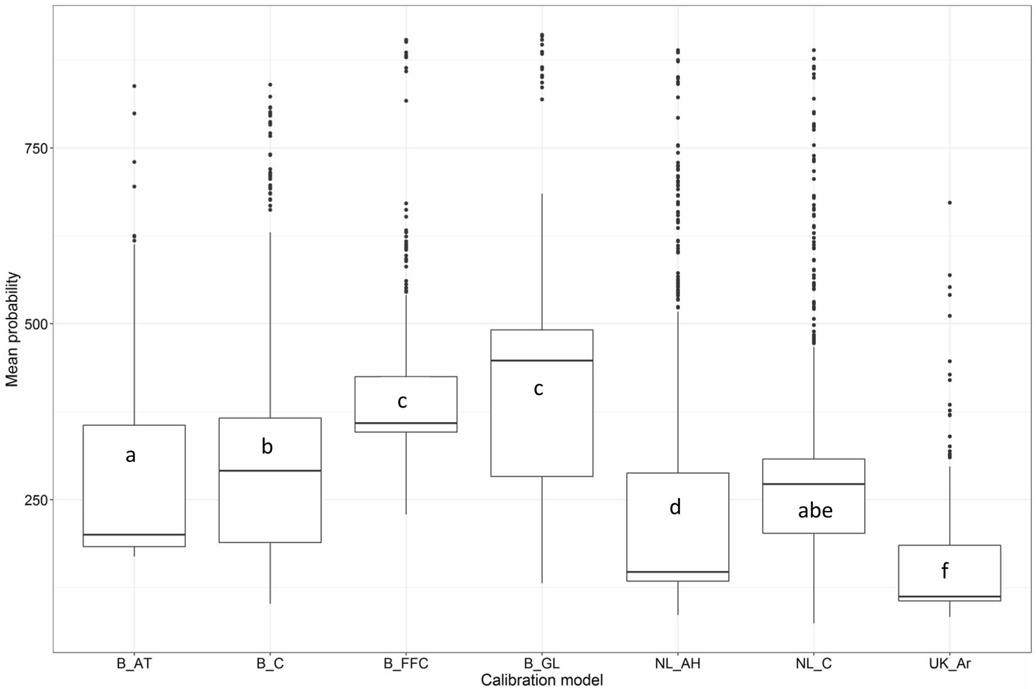

Fig. 2 Median predicted probability (horizontal black bar, multi- plied by 1000 for readability) with the standard deviation (white box) (y-axis) in the Rockingham Forest landscape depending on the origin of the calibration data set (x-axis). B_AT Ardenne–Thiérache (Bel- gium); B_C Campine (Belgium); B_FFC Fagne–Famenne–Calesti-
enne (Belgium); B_GL Gaume–Lorraine (Belgium); NL_AH Achter- hoek (Netherlands); NL_C Campine (Netherlands); Ar Argyll (United Kingdom). Different letters indicate significant differences between the probabilities from the different models when projected to the Rockingham Forest landscape

Table 5 Average predicted probability (multiplied by 1000 for read- ability) in the years 2000 and 2070 in the grid cells in which the Chequered Skipper is actually present and in the Rockingham Forest landscape

Region 2000 2070 Diff (in %)

Campine (B) 665 ± 8 382 ± 8 − 43+++
Fagne–Famenne–Calestienne (B) 443 ± 14 152 ± 5 − 66+++
Ardenne–Thiérache (B) 479 ± 11 217 ± 6 − 55+++
Gaume–Lorraine (B) 574 ± 23 182 ± 7 − 68+++
Achterhoek (NL) 496 ± 15 294 ± 11 − 41+++
Campine (NL) 625 ± 9 389 ± 8 − 38+++
Argyll (UK) 352 ± 13 163 ± 4 − 54+++
Rockingham Forest landscape (UK) 304 ± 3 776 ± 6 + 155++

Diff difference in percentage compared to the year 2000 together with the significance of an ANOVA-test (+++p < 0.001, ++p < 0.01)

Discussion

The use of species distribution modelling in addition to detailed local ecological knowledge about the Cheq- uered Skipper and its habitat, allowed us to select the

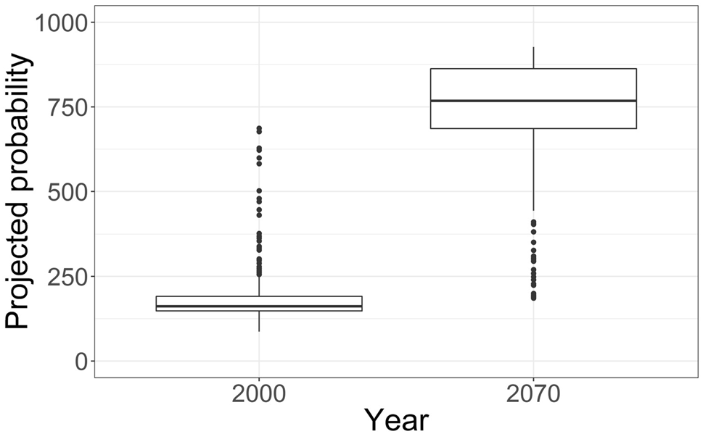

Fig. 3 Median projected probability (horizontal black bar, multiplied by 1000 for readability) with the standard deviation (white box) in the Rockingham Forest landscape under present (2000) and future cli- mate conditions (2070). Results of the statistical analyses are given in Table 5

most suitable potential source region for the reintro- duction of the Chequered Skipper to the Rockingham Forest landscape in England. The models calibrated in the Fagne–Famenne–Calestienne region and in the

Gaume–Lorraine region both resulted in the highest aver- age occurrence probability in the reintroduction site, but the former was selected based on additional expert knowledge about the host plant and habitat similarity between the source region and the reintroduction site. Climate change models for 2070 predicted a decrease of the species in NW Europe, but a strong increase in the Rockingham Forest landscape.

Why a reintroduction in the Rockingham Forest landscape?

The Chequered Skipper is considered a High Priority species for Butterfl Conservation in the UK, particularly within Scotland, where its last remaining populations reside (40 grid squares of 10 × 10 km2 during the period 2010–2014). It is also included on the Scottish Biodiversity List (spe- cies considered of principal importance for biodiversity conservation). Since 1976, its distribution in Scotland has declined by 44% and it is, therefore, considered as threatened in the UK (Fox et al. 2011). Re-establishing a metapopula- tion in England would represent a significant step forward in increasing the resilience and strengthening the status of the Chequered Skipper in the UK. For this purpose, the Rock- ingham Forest landscape provides a suitable landscape to establish a local metapopulation of the species either by natural colonisation or by targeted additional reintroductions (cf. Thomas et al. 2009).
Previous management measures for the reintroduction of the Chequered Skipper to the Rockingham Forest land- scape will benefit a wide variety of other priority butterflies such as the Dingy Skipper Erynnis tages (Linnaeus, 1758), the Grizzled Skipper Pyrgus malvae (Linnaeus, 1758), the Wood White Leptidea sinapis (Linnaeus, 1758), the White Admiral Limenitis camilla (Linnaeus, 1764) and the White- letter Hairstreak Satyrium w-album (Knoch, 1782). Apart from butterfl other species groups such as moths (e.g. Concolorous Chortodes extrema (Hübner, 1809) and Liq- uorice Piercer Grapholita pallifrontana (Lienig & Zeller, 1846)), plants (e.g. Basil Thyme Clinopodium acinos (L.) Kuntze), bats (e.g. Brown Long-eared bat Plecotus auri- tus (Linnaeus, 1758)) and reptiles (e.g. Adder Vipera berus (Linnaeus, 1758)) that are also associated with high quality woodlands will also benefit from the woodland management instigated for this reintroduction (https://naturebftb.co.uk/ the-projects/roots-of-rockingham/). The Chequered Skip- per may represent a fl species for additional habitat improvements to the woodlands in the Rockingham Forest landscape initially and to other potential suitable areas in the future. The species distribution models from the differ- ent possible source regions in NW Europe could also be used to estimate the potential suitability of other historic strongholds such as Willingham Woods, Market Rasen or
Bardney Limewoods (the site where the previous reintroduc- tion attempt was carried out—Supplementary Material S1).

Suitability of the source regions and additional ecological resources

The Fagne–Famenne–Calestienne and the Gaume–Lorraine models resulted in the highest predicted probabilities in the Rockingham Forest landscape and, therefore, appeared to be the most suitable source regions for the reintroduction of the Chequered Skipper in England. An additional consideration for the choice of the source region was host plant distribu- tion. This is an important factor, but was not included in the models, because suitable host plants are present almost everywhere, albeit in very diff ent abundances. The lack of detailed data on their local abundance and quality made it impossible to consider this variable in the models. In the Netherlands and in most regions in Belgium, includ- ing Gaume–Lorraine, Molinia caerulea and Calamagrostis canescens are the primary host plants (Ravenscroft 1994a). Meanwhile, in the Fagne–Famenne–Calestienne region Brachypodium spp. are widespread host plants, notably in an extensive network of forest rides and glades which were widened in the framework of a EU Life+ project (“Butterfly Life project”, LIFE07NAT/B/000039—http://www.life-papil lons.eu). The Chequered Skipper is probably flexible enough to use the locally available broad-leaved grasses since it is known to accept a wide range of grasses when bred in cap- tivity (Bink 1992; Ravenscroft 1994c). Nevertheless, we conclude from the combination of the species distribution modelling, the similarity in host plant abundance and the availability of large populations of the Chequered Skipper that the Fagne–Famenne–Calestienne region is the most suitable source region. Whether individuals from within the UK, i.e. Argyll (where its main host plant is Molinia caerulea—Ravenscroft 1994a) could strengthen the rein- troduced population in the Rockingham Forest landscape (where Brachypodium spp. are the main host plants) at a later date remains to be studied, although on the basis of the results presented in this paper it is not recommended. This could be experimentally tested by off ing Brachypodium spp. to females from a Molinia population and vice versa and test for acceptance of the host plant (Moore 2004) and for caterpillar survival rate on the host plant. Other important factors for which high resolution data were lacking are, for example, microclimate and water regime of the soil, two major environmental conditions that determine the quality of the host plant (Ravenscroft 1994a, b).
Genetic diversity and potential impact risk on source pop- ulations are two crucial issues in re-introduction projects. According to the data available (from the Lycaena Working Group) and thanks to the Butterfly Life+ project restorations, the forest populations of Fagne–Famenne–Calestienne are

now better connected than the ones from the Gaume–Lor- raine region. Genetic diversity could, therefore, be larger and the impact risk on source populations lower by sam- pling individuals from the Fagne–Famenne–Calestienne region (cf. Weeks et al. 2011). This assumption, however, remains to be tested as a possible follow-up project of the reintroduction. To increase genetic diversity in the intro- duced population in England, we suggest not to restrict the collection of individuals to a single source site, but to collect them from a number of preferably large populations. After the initial reintroduction, restocking is often needed after the first year of establishment to keep the number of individuals in the introduced population sufficiently high (Fischer and Lindenmayer 2000). This also enables individuals to spread to potentially suitable habitats in the vicinity to create a sus- tainable metapopulation (Hanski et al. 1994; León-Cortés et al. 2003).

Model performance

Apart from the Fagne–Famenne–Calestienne model, all species distribution models performed relatively well when projected to their own region (Table 3). The Fagne–Famenne–Calestienne is an ecological region with a mixture of soil types (limestone, peat, clay and schist), which makes it diffi for a statistical model to calibrate correctly. Building separate models for the Fagne, the Famenne (clay and schist) and the Calestienne (limestone) regions, however, would lead to a too low number of pres- ences to run the models appropriately. Adjacent regions in the north of France could probably also be suitable as source regions (they were used in the 1990s reintroduction), but we did not have access to detailed distribution data of the Cheq- uered Skipper to test how northern France would perform as a potential source region.
As variables in the species distribution models, we used CORINE land cover data instead of national land cover maps of the three countries. CORINE has the advantage that it covers the whole of Europe using the same biotope types, although countries sometimes have different interpretations of these biotopes (Garcia-Alvarez and Olmedo 2017). When using national land cover maps, if at all available, it would have been diffi to transform the diff ent national land cover categories into uniform biotopes for the four coun- tries. The fact that different woodland types and heathlands were selected as the most important variables in most of the models (Table 4) corresponds well with the species’ ecology. These broad biotopes give an indication of the suitability of a region on a landscape-scale, but additional detailed infor- mation on species-specifi ecological resources is needed to determine whether the woodlands in the high probability grid cells indeed contain suitable habitats for the Chequered Skipper (e.g. wide rides, suffi host and nectar plants,
high water table for optimal host plant quality, etc.—cf. Van- reusel and Van Dyck 2007).
As shown in Table 3, model performance was always highest when projected to the region in which the model was calibrated. When transferred to other regions, model performance decreased considerably. Transferability of spe- cies distribution models to other regions is usually better when the source and the receiver regions are more similar in the variables used for calibration (Randin et al. 2006; Vanreusel et al. 2007). Although there are differences among the ecological regions to calibrate the models on the one hand and the Rockingham Forest landscape on the other, they were suffi y comparable to assume that models were transferable among regions (Tables 1, 2).

Climate change

Given the fact that climate will become warmer and drier in the future, the climate change model predicts a relatively strong decline in species occurrence probability in NW European regions under future climate conditions (Table 5), which agrees with the predictions by Settele et al. (2008). Translocation of species to climatically suitable areas is, therefore, a conservation measure that has been increasingly advocated (cf. Thomas 2011). The Chequered Skipper is a species of humid and relatively cool climates (Ravenscroft 1994b) for which future climates in lowland regions are pre- dicted to become less suitable in the future. The Ardenne- Thiérache and the Argyll regions are at present cooler than the Rockingham Forest landscape. Nonetheless, the com- bination of a predicted moderate temperature rise and the strong predicted increase in precipitation in both regions (in comparison with a modest predicted increase in the Rock- ingham Forest landscape—Table 5), might cause a potential strong decline in biotope suitability for the Chequered Skip- per in NW Europe in the future.

Epilogue: the actual reintroduction

On 22–23 May 2018, 42 individuals of the Chequered Skip- pers (32 females and 10 males) were caught in five different populations in the Fagne–Famenne–Calestienne region in Belgium (Matagne-la-Grande, Doische, Hazalles, Petit-Han and Fronville). Butterfly Conservation and partners released them in the Rockingham Forest landscape on 24 May 2018 as part of the Back from the Brink project.

Future prospects of the Chequered Skipper in England

By reintroducing the Chequered Skipper to the Rockingham Forest landscape, we hope to establish a viable metapopula- tion in its former national stronghold in England. Different

reasons strengthen our assumption that this reintroduction can be successful:

- The reintroduction of a genetically diverse initial popula- tion, coming from five different locations in the Fagne– Famenne–Calestienne region in Belgium, should prevent problems of inbreeding;
- The conservation management to maintain and/or increase the suitability of the Rockingham Forest land- scape and the number of potentially suitable habitat patches present for the Chequered Skipper is assured by several local partners, such as the Forestry Commission, the Wildlife Trust for Bedfordshire, Cambridgeshire & Northamptonshire and private landowners under the guidance of Butterfly Conservation UK;
- Climate change is predicted to have a positive effect on the presence of the Chequered Skipper in the Rocking- ham Forest landscape. Since micro-climate and local water level conditions could not be used in the land- scape-scale model, this result should be interpreted with care.

Conclusion

Based on species distribution modelling, the Fagne–Famenne–Calestienne and the Gaume–Lorraine appeared to be the best source regions for the reintroduc- tion of the Chequered Skipper to England. Additional local expert knowledge about host plant use in the possible source regions and the abundance of host plants in the reintroduc- tion site and the presence of large and well-connected forest populations of the target species, the Fagne–Famenne–Cal- estienne was recommend as the source region for the reintro- duction to England. Reintroduction of the species in England will likely contribute to the overall persistence of the Cheq- uered Skipper under future climate change.

Acknowledgements Jeroen De Reu, Jo Loos, Toon Van Daele and Hans Van Calster are kindly thanked for their help with data handling and for statistical advice. Data from Wallonia were kindly made avail- able by the Groupe de Travail Lycaena and by Gilles Maldague (Dépar- tement de l’Etude du Milieu Naturel et Agricole—DEMNA). We thank Pieter Vantieghem and Thomas Merckx (Vlinderwerkgroep Natuur- punt), Camille Turlure and Aurélien Kaiser (Université catholique de Louvain), Camille Van Eupen (Katholieke Universiteit Leuven), Jamie Wildman (Butterfl Conservation UK) and Jenny Jaff (Zoological Society London) for their help during the fi work. We also thank Jorge Léon-Cortés and an anonymous reviewer for their critical com- ments on the manuscript.

Compliance with ethical standards

Conflict of interest The authors declare that they have no conflict of interest.
Ethical approval All procedures performed involving animals were in accordance with the ethical standards of the Disease Risk Management and Post-Release Health Surveillance.

References

Anderson BJ et al (2009) Using distribution models to test alternative hypotheses about a species’ environmental limits and recovery prospects. Biol Conserv 142:488–499. https://doi.org/10.1016/j. biocon.2008.10.036
Araújo MB, New M (2007) Ensemble forecasting of species distri- butions. Trends Ecol Evol 22:42–47. https://doi.org/10.1016/j. tree.2006.09.010
Asher J, Warren MS, Fox R, Harding P, Jeffcoate G, Jeffcoate S (2001) The millennium atlas of butterflies in Britain and Ireland. Oxford University Press, Oxford
Barbet-Massin M, Thuiller W, Jiguet F (2010) How much do we over- estimate local extinction rates when restricting the range of occur- rence data in climate suitability models? Ecography 33:878–886. https://doi.org/10.1111/j.1600-0587.2010.06181.x
Bink FA (1992) Ecologische atlas van de dagvlinders van Noordwest- Europa. Schuyt & Co Uitgevers en Importeurs bv, Haarlem
Bird CD, Hilchie GJ, Kondla NG, Pike EM, Sperling FAH (1995) Alberta butterflies. The Provincial Museum of Alberta, Edmonton Brooker RW et al (2018) Tiny niches and translocations: The chal- lenge of identifying suitable recipient sites for small and
immobile species. J Appl Ecol 55:621–630. https://doi. org/10.1111/1365-2664.13008
Chambers JM, Freeny A, Heiberger RM (1992) Analysis of variance; designed experiments. In: Chambers JM, Hastie TJ (eds) Statisti- cal models. S. Wadsworth & Brooks/Cole, Pacific Grove
Chauvenet ALM, Ewen JG, Armstrong DP, Blackburn TM, Pet- torelli N (2013) Maximizing the success of assisted coloni- zations. Anim Conserv 16:161–169. https://doi.org/10.111 1/j.1469-1795.2012.00589.x
Ciuti S, Tripke H, Antkowiak P, Silveyra Gonzalez R, Dormann CF, Heurich M (2018) An effi method to exploit LiDAR data in animal ecology. Methods Ecol Evol 9:893–904. https://doi. org/10.1111/2041-210X.12921
Collier R (1986) The conservation of the Chequered skipper in Britain. Nature Conservancy Council, Northminster House, Peterborough Ellis S, Wainwright D, Berney F, Bulman CR, Bourn NAD (2011) Landscape-scale conservation in practice: lessons from northern England, UK. J Insect Conserv 15:69–81. https://doi.org/10.1007/
s10841-010-9324-0
Emmet AM, Heath J (1989) The moths and butterflies of Great-Brit- tain and Ireland. Hesperiidae–Nymphalidae, vol 7. Harley Books, Colchester
Fahrig L, Merriam G (1994) Conservation of fragmented pop- ulations. Conserv Biol 8:50–59. https://doi.org/10.104 6/j.1523-1739.1994.08010050.x
Farrell L (1973) A preliminary report on the status of the chequered skipper (Carterocephalus palaemon (Pall.)). Joint Committee for the Conservation of British Insects
Fichefet V, Barbier Y, Baugnée JY, Dufrêne M, Goff t P, Maes D, Van Dyck H (2008) Papillons de jour de Wallonie (1985–2007). Faune-Flore-Habitats, vol n° 4. Groupe de Travail Lépidoptères Lycaena, Département de l’Etude du Milieu Naturel et Agricole (SPW/DGARNE), Gembloux
Fischer J, Lindenmayer DB (2000) An assessment of the published results of animal relocations. Biol Conserv 96:1–11. https://doi. org/10.1016/s0006-3207(00)00048-3

FLORON (2011) Nieuwe atlas van de Nederlandse fl a. Stichting Floron, Nijmegen
Fox R, Warren MS, Brereton TM, Roy DB, Robinson A (2011) A new red list of British butterfl Insect Conserv Diver 4:159– 172. https://doi.org/10.1111/j.1752-4598.2010.00117.x
Garcia-Alvarez D, Olmedo MTC (2017) Changes in the methodol- ogy used in the production of the Spanish CORINE: uncertainty analysis of the new maps. Int J Appl Earth Observ 63:55–67. https://doi.org/10.1016/j.jag.2017.07.001
Guisan A et al (2013) Predicting species distributions for conserva- tion decisions. Ecol Lett 16:1424–1435. https://doi.org/10.1111/ Ele.12189
Hanski I (1999) Habitat connectivity, habitat continuity, and meta- populations in dynamic landscapes. Oikos 87:209–219. https:// doi.org/10.2307/3546736
Hanski I, Kuussaari M, Nieminen M (1994) Metapopulation struc- ture and migration in the butterfl Melitaea cinxia. Ecology 75:747–762. https://doi.org/10.2307/1941732
Harrison S, Murphy DD, Ehrlich PR (1988) Distribution of the Bay Checkerspot butterfly, Euphydryas editha bayensis—evidence for a metapopulation model. Am Nat 132:360–382. https://doi. org/10.1086/284858
Heath J, Pollard E, Thomas JA (1984) Atlas of Butterflies in Britain and Ireland. Viking, Harmondsworth
Hijmans RJ, Graham CH (2006) The ability of climate envelope models to predict the eff of climate change on species distri- butions. Glob Chang Biol 12:2272–2281. https://doi.org/10.11 11/j.1365-2486.2006.01256.x
Hijmans RJ, Cameron SE, Parra JL, Jones PG, Jarvis A (2005) Very high resolution interpolated climate surfaces for global land areas. Int J Climatol 25:1965–1978. https://doi.org/10.1002/ Joc.1276
Hodgson JA, Moilanen A, Bourn NAD, Bulman CR, Thomas CD (2009) Managing successional species: modelling the depend- ence of heath fritillary populations on the spatial distribution of woodland management. Biol Conserv 142:2743–2751. https://doi. org/10.1016/j.biocon.2009.07.005
Hothorn T, Bretz F, Westfall P (2008) Simultaneous inference in general parametric models. Biom J 50:346–363. https://doi. org/10.1002/bimj.200810425
Huang J, Ling CX (2005) Using AUC and accuracy in evaluating learn- ing algorithms. IEEE Trans Knowl Data Eng 17:299–310. https:// doi.org/10.1109/TKDE.2005.50
IUCN/SSC (2013) Guidelines for reintroductions and other conserva- tion translocations. Version 1.0. IUCN Species Survival Com- mission, Gland
Joyce DA, Pullin AS (2004) Using genetics to inform re-introduction strategies for the Chequered Skipper butterfly (Carterocephalus palaemon, Pallas) in England. J Insect Conserv 8:69–74. https:// doi.org/10.1023/b:jico.0000027510.59074.16
Kalle R, Combrink L, Ramesh T, Downs CT (2017) Re-establishing the pecking order: Niche models reliably predict suitable habitats for the reintroduction of red-billed oxpeckers. Ecol Evol 7:1974– 1983. https://doi.org/10.1002/ece3.2787
Konvička M, Fric Z, Beneš J (2006) Butterfl extinctions in Euro- pean states: do socioeconomic conditions matter more than physical geography? Global Ecol Biogeogr 15:82–92. https://doi. org/10.1111/j.1466-822x.2006.00188.x
Krauss J et al (2010) Habitat fragmentation causes immediate and time-delayed biodiversity loss at different trophic levels. Ecol Lett 13:597–605. https://doi.org/10.1111/j.1461-0248.2010.01457.x
Lambinon J, De Langhe JE, Delvosalle L, Duvigneaud J (1998) Flora van België, het Groothertogdom Luxemburg, Noord-Frankrijk en de aangrenzende gebieden (Pteridofyten en Spermatofyten). Nationale Plantentuin van Belgi, Meise
León-Cortés JL, Lennon JJ, Thomas CD (2003) Ecological dynam- ics of extinct species in empty habitat networks. 1. The role of habitat pattern and quantity, stochasticity and dispersal. Oikos 102:449–464. https://doi.org/10.1034/j.1600-0706.2003.12129.x
Maes D, Van Dyck H (2001) Butterfly diversity loss in Flanders (North Belgium): Europe’s worst case scenario? Biol Conserv 99:263– 276. https://doi.org/10.1016/S0006-3207(00)00182-8
Maes D, Vanreusel W, Jacobs I, Berwaerts K, Van Dyck H (2012) Applying IUCN red list criteria at a small regional level: a test case with butterflies in Flanders (north Belgium). Biol Conserv 145:258–266. https://doi.org/10.1016/j.biocon.2011.11.021
Maes D et al (2019) Integrating national red lists for prioritising con- servation actions for European butterflies. J Insect Conserv 23:2– 3. https://doi.org/10.1007/s10841-019-00127-z
Martinez-Meyer E, Peterson AT, Servin JI, Kiff LF (2006) Ecological niche modelling and prioritizing areas for species reintroductions. Oryx 40:411–418. https://doi.org/10.1017/s0030605306001360
McCullagh P, Nelder JA (1989) Generalized linear models, 2nd edn.
Chapman & Hall, London
McLachlan JS, Hellmann JJ, Schwartz MW (2007) A framework for debate of assisted migration in an era of climate change. Conserv Biol 21:297–302. https://doi.org/10.1111/j.1523-1739.2007.00676
.x
Moore JL (2004) The ecology and re-introduction of the Chequered Skipper butterfl Carterocephalus palaemon in England. The University of Birmingham, School of Biosciences, Birmingham Mortelliti A, Amori G, Boitani L (2010) The role of habitat quality in fragmented landscapes: a conceptual overview and prospectus for future research. Oecologia 163:535–547. https://doi.org/10.1007/
s00442-010-1623-3
New TR, Pyle RM, Thomas JA, Thomas CD, Hammond PC (1995) Butterfly conservation management. Annu Rev Entomol 40:57– 83. https://doi.org/10.1146/annurev.en.40.010195.000421
Oates MR, Warren MS (1990) A review of butterfly introductions in Britain and Ireland. Joint Committee for the Conservation of Brit- ish Insects/World Wildlife Fund, Godalming
Preston CD, Pearman DA, Dines TD (2002) New atlas of the British and Irish Flora: An atlas of the vascular plants of Britain, Ireland, The Isle of Man and the Channel Islands. Oxford University Press, Oxford
R Core Team (2018) R: a language and environment for statistical computing. 3.5.1 edition. R Foundation for Statistical Comput- ing, Vienna
Randin CF, Dirnbock T, Dullinger S, Zimmermann NE, Zappa M, Guisan A (2006) Are niche-based species distribution models transferable in space? J Biogeogr 33:1689–1703. https://doi.org/ 10.1111/j.1365-2699.2006.01466.x
Ravenscroft NOM (1994a) The ecology and conservation of the Cheq- uered skipper butterfly Pallas in Scotland. II: foodplant qual- ity and population range. J Appl Ecol 31:623–630. https://doi. org/10.2307/2404153
Ravenscroft NOM (1994b) The ecology of the Chequered skipper butterfl Carterocephalus palaemon in Scotland. I: Microhabi- tat selection. J Appl Ecol 31:613–622. https://doi.org/10.1023/ B:JICO.0000027510.59074.16
Ravenscroft NOM (1994c) The feeding behaviour of Carterocephalus palaemon (Lepidoptera: Hesperiidae) caterpillars: does it avoid host defences or maximize nutrient intake? Ecol Entomol 19:26– 30. https://doi.org/10.1111/j.1365-2311.1994.tb00386.x
Ravenscroft NOM (1995) The conservation of Carterocephalus palae- mon in Scotland. In: Pullin AS (ed) Ecology and conservation of butterflies. Chapman & Hall, London, pp 165–179
Ravenscroft NOM, Warren MS (1992) Habitat selection by larvae of the Chequered skipper Carterocephalus palaemon in northern Europe. Entomol Gaz 43:237–242

Robin X, Turck N, Hainard A, Tiberti N, Lisacek F, Sanchez J-C, Mül- ler M (2011) pROC: an open-source package for R and S+ to analyze and compare ROC curves. BMC Bioinform 12:77. https
://doi.org/10.1186/1471-2105-12-77
Schultz CB, Russell C, Wynn L (2008) Restoration, reintroduction, and captive propagation for at-risk butterflies: a review of British and american conservation efforts. Isr J Ecol Evol 54:41–61. https:// doi.org/10.1560/IJEE.54.1.41
Seddon PJ, Armstrong DP, Maloney RF (2007) Developing the science of reintroduction biology. Conserv Biol 21:303–312. https://doi. org/10.1111/j.1523-1739.2006.00627.x
Settele J et al (2008) Climatic risk atlas of European butterflies. BioR- isk 1:1–710. https://doi.org/10.3897/biorisk.1
Swets JA (1988) Measuring the accuracy of diagnostic systems. Sci- ence 204:1285–1293. https://doi.org/10.1126/science.3287615
Synes NW, Osborne PE (2011) Choice of predictor variables as a source of uncertainty in continental-scale species distribution modelling under climate change. Glob Ecol Biogeogr 20:904–914. https://doi.org/10.1111/j.1466-8238.2010.00635.x
Thomas CD (2011) Translocation of species, climate change, and the end of trying to recreate past ecological communities. Trends Ecol Evol 26:216–221. https://doi.org/10.1016/j.tree.2011.02.006
Thomas CD, Hanski I (1997) Butterfl metapopulations. In: Hanski I, Gilpin M (eds) Metapopulation biology: ecology, genetics and evolution. Academic Press, New York, pp 359–386
Thomas CD, Jones TM (1993) Partial recovery of a skipper butterfly (Hesperia comma) from population refuges: lessons for conserva- tion in fragmented landscape. J Anim Ecol 62:472–482. https:// doi.org/10.2307/5196
Thomas JA et al (2001) The quality and isolation of habitat patches both determine where butterflies persist in fragmented landscapes. Proc R Soc Lond B 268:1791–1796. https://doi.org/10.1098/ rspb.2001.1693
Thomas CD et al (2004a) Extinction risk from climate change. Nature 427:145–148. https://doi.org/10.1038/nature02121
Thomas JA, Telfer MG, Roy DB, Preston CD, Fox R, Clarke RT, Law- ton JH (2004b) Comparative losses in British butterfl birds, and plants and the global extinction crisis. Science 303:1879– 1881. https://doi.org/10.1126/science.1095046
Thomas JA, Simcox DJ, Clarke RT (2009) Successful conservation of a threatened Maculinea butterfly. Science 325:80–83. https://doi. org/10.1126/science.1175726
Thuiller W, Lafourcade B, Engler R, Araujo MB (2009) BIOMOD—a platform for ensemble forecasting of species distributions. Ecogra- phy 32:369–373. https://doi.org/10.1111/j.1600-0587.2008.05742
.x
Thuiller W, Georges D, Engler R (2012) biomod2: ensemble platform for species distribution modeling. R package version 1.3.7/r529
Titeux N et al (2017) The need for large-scale distribution data to esti- mate regional changes in species richness under future climate change. Divers Distrib 23:1393–1407. https://doi.org/10.1111/ ddi.12634
Travis JMJ (2003) Climate change and habitat destruction: a deadly anthropogenic cocktail. Proc R Soc Lond B 270:467–473. https
://doi.org/10.1098/rspb.2002.2246
Tulloch AIT et al (2016) Conservation planners tend to ignore improved accuracy of modelled species distributions to focus on multiple threats and ecological processes. Biol Conserv 199:157– 171. https://doi.org/10.1016/j.biocon.2016.04.023
Van Landuyt W, Hoste I, Vanhecke L, Van den Bremt P, Vercruysse W, De Beer D (2006) Atlas van de Flora van Vlaanderen en het Brus- sels Gewest. Instituut voor Natuur-en Bosonderzoek, Nationale Plantentuin van België & Flo.Wer., Brussel
van Strien AJ, van Swaay CAM, van Strien-van Liempt WTFH, Poot MJM, WallisDeVries MF (2019) Over a century of data reveal more than 80% decline in butterflies in the Netherlands. Biol Con- serv 234:116–122. https://doi.org/10.1016/j.biocon.2019.03.023
van Swaay CAM (2019) Basisrapport Rode Lijst Dagvlinders 2019 volgens Nederlandse en IUCN-criteria. De Vlinderstichting,
Wageningen
van Swaay CAM et al (2010) European red list of butterflies. Publica- tions Office of the European Union, Luxembourg
Vanreusel W, Van Dyck H (2007) When functional habitat does not match vegetation types: a resource-based approach to map butter- fly habitat. Biol Conserv 135:202–211. https://doi.org/10.1016/j. biocon.2006.10.035
Vanreusel W, Maes D, Van Dyck H (2007) Transferability of species distribution models: a functional habitat approach for two region- ally threatened butterflies. Conserv Biol 21:201–212. https://doi. org/10.1111/j.1523-1739.2006.00577.x
WallisDeVries MF, van Swaay CAM (2017) A nitrogen index to track changes in butterfly species assemblages under nitrogen deposi- tion. Biol Conserv 212:448–453. https://doi.org/10.1016/j.bioco n.2016.11.029
Warren MS (1990) The Chequered Skipper Carterocephalus palaemon in Northern Europe. The British Butterfly Conservation Society Ltd., Chequered Skipper Working Party, Dorchester, Dorset
Warren MS (1995) The Chequered Skipper returns to England. But- terfly Conserv News 60:4–5
Weeks AR et al (2011) Assessing the benefits and risks of transloca- tions in changing environments: a genetic perspective. Evol Appl 4:709–725. https://doi.org/10.1111/j.1752-4571.2011.00192.x
White TH, Barros YD, Develey PF, Llerandi-Roman IC, Monsegur- Rivera OA, Trujillo-Pinto AM (2015) Improving reintroduc- tion planning and implementation through quantitative SWOT analysis. J Nat Conserv 28:149–159. https://doi.org/10.1016/j. jac.2015.10.002
Willis SG, Hill JK, Thomas CD, Roy DB, Fox R, Blakeley DS, Hunt- ley B (2009) Assisted colonization in a changing climate: a test- study using two UK butterflies. Conserv Lett 2:45–51. https://doi. org/10.1111/j.1755-263X.2008.00043.x
Wood KA, Stillman RA, Hilton GM (2018) Conservation in a changing world needs predictive models. Anim Conserv 21:87–88. https:// doi.org/10.1111/acv.12371

Publisher’s Note Springer Nature remains neutral with regard to jurisdictional claims in published maps and institutional affiliations.

Affiliations

Dirk Maes1 · Sam Ellis2 · Philippe Goffart3 · Katie L. Cruickshanks2 · Chris A. M. van Swaay4 · Ruddy Cors3 · Marc Herremans5 · Kristijn R. R. Swinnen5 · Carine Wils1 · Sofie Verhulst6 · Luc De Bruyn1,6 ·
Erik Matthysen6 · Susannah O’Riordan2 · Daniel J. Hoare2 · Nigel A. D. Bourn2

Sam Ellis
sellis@butterfly-conservation.org
Philippe Goffart philippe.goffart@spw.wallonie.be
Katie L. Cruickshanks kcruickshanks@butterfly-conservation.org
Chris A. M. van Swaay chris.vanswaay@vlinderstichting.nl
Ruddy Cors ruddy.cors@spw.wallonie.be
Marc Herremans marc.herremans@natuurpunt.be
Kristijn R. R. Swinnen kristijn.swinnen@natuurpunt.be
Carine Wils carine.wils@inbo.be
Sofie Verhulst verhulst.sofie@hotmail.com
Luc De Bruyn luc.debruyn@uantwerpen.be
Erik Matthysen erik.matthysen@uantwerpen.be
Susannah O’Riordan soriordan@butterfly-conservation.org
Daniel J. Hoare
dhoare@butterfly-conservation.org
Nigel A. D. Bourn nbourn@butterfly-conservation.org

1 Research Institute for Nature and Forest (INBO), Herman Teirlinckgebouw, Havenlaan 88, Bus 73, 1000 Brussels, Belgium
2 Butterfly Conservation, Manor Yard, East Lulworth, Wareham, Dorset BH20 5QP, UK
3 Département de l’Étude du Milieu naturel et agricole (DEMna), Service Public de Wallonie (SPW/DGO3), Direction de la Nature et de l’Eau, avenue Maréchal Juin 23, 5030 Gembloux, Belgium
4 Dutch Butterfly Conservation, Postbus 506, 6700 AM Wageningen, The Netherlands
5 Natuurpunt Studie, Coxiestraat 11, 2800 Mechelen, Belgium
6 Department of Biology, Evolutionary Ecology Group, University of Antwerp, Campus Drie Eiken, Universiteitsplein 1, 2610 Antwerp, Belgium

