The impact of intermediate-head navigation locks on downstream fish passage

Jenna Vergeynst1 Ine Pauwels2 Raf Baeyens2 Johan Coeck2 Ingmar Nopens1 Tom De Mulder3 Ans Mouton2

1 BIOMATH - Model-based analysis and optimisation of bioprocesses, Department of Data Analysis and Mathematical Modelling, Ghent University, Ghent, Belgium
Abstract
Navigation in inland waterways is increasingly important worldwide and so is inherently the construction and use of navigation locks. However, the impact of navigation locks on downstream migrating fish is rarely documented. In Belgium, the Albert Canal connecting the Meuse River to the Scheldt Estuary may offer migration opportunities for European eel (Anguilla anguilla) and Atlantic salmon (Salmo salar), two critically endangered species. During their downstream migration phase (respectively silver eels and salmon smolts), both species have to pass five intermediate-head navigation locks before reaching the estuary. Previous research showed that silver eel escapement is largely unsuccessful and that eels are delayed extensively at the navigation lock complexes. To get a better understanding of the mechanisms behind these failures and delays, we tagged and released 62 silver eels and 44 salmon smolts in the vicinity of one navigation lock complex of the canal. This paper reports the mechanisms behind the previously perceived delay, the route choices to pass the complex, and the risks involved. Of the 65% tagged eels and 73% tagged smolts that succeeded to pass the complex, respectively, 20% and 41% needed more than one trial to pass the complex. Moreover, 52% of all trials were via intakes of the lock filling system, at least four smolts (17%) died after intake passing, and about 30% of both intake-passing smolts and eels stopped migrating after passage. Therefore, intermediate-head navigation locks are a potential threat to downstream migrating fish, which requires more research to fully investigate its impact.

KEYWORDS
Atlantic salmon, downstream fish migration, European eel, fish-friendliness, navigation locks
2 INBO - Research Institute for Nature and
Forest, Brussels, Belgium
3 Department of Civil Engineering, Ghent University, Ghent, Belgium

Correspondence
Jenna Vergeynst, BIOMATH - Model-based analysis and optimisation of bioprocesses, Department of Data Analysis and Mathematical Modelling, Ghent University, Coupure Links 653, Gent 9000, Belgium.
Email: Jenna.Vergeynst@UGent.be

Funding information
Bijzonder Onderzoeksfonds; INBO, LifeWatch Belgium, and the European Union's Horizon 2020 research and innovation programme, Grant/Award Number: 727830 ; Research Institute for Nature and Forest (INBO)

INTRODUCTION

Locks are important structures to protect ports against the tides, to provide flood control and to allow navigation in inland waterways. In the context of adapting to sustainability goals, water navigation is increasingly important (Rohács & Simongáti, 2007). Only in Belgium, encompassing 30.500 km2 , about 190 locks can be counted on canals and canalised rivers (VNF, 2008). However, the impact of navigation locks on downstream migrating fish is rarely documented and is very case dependent.
Simultaneous passage of fish and ships through navigation locks only occurs by coincidence and is not effective (Larinier & Marmulla, 2003; Travade, 2002). Both studies state that fish migration through
navigation locks requires attraction flow towards the open lock gates, and an exit flow stimulating the fish to leave the lock. However, this change of operation mode is not compatible with the passage of ships. In other studies, navigation locks showed potential as low-cost alternatives to fish passes at dams and hydropower stations for differ- ent fish species (Garrone-neto, Haddad, & Gadig, 2014; Lin, Brosse, Gao, Liu, & Liu, 2013; Moser, Darazsdi, & Hall, 2000). Silva, Lowry, Macaya-Solis, Byatt, and Lucas (2017) showed that the management of navigation locks at tidal barrages can be adapted to serve as verti- cal slot fish passes for upstream migration of river lamprey. However, the lack of attraction to the lock might impair its efficiency. Silva et al. (2017) also suggest that downstream migration at these locks might be possible, given the observation of adult eels and cyprinid fish mov-

ing downstream through the locks, but they state that knowledge on its effectiveness is lacking.
Previous research by Baeyens (2016, unpublished) and Malbrouck, Micha, and Philippart (2007) proved that the Albert Canal is one of the escapement routes for silver eels and salmon smolts coming from the Meuse River. In the telemetry study by Baeyens (2016, unpublished) where 15 tagged silver eels were released upstream of Liège, five continued in the Meuse River, 7 deflected to the Albert Canal, and the remaining three were lost. Verhelst et al. (2018) also showed that silver eels use the Albert Canal as migration route but 66% did not succeed to exit the canal. The eels that successfully migrated through the canal, did so at a very slow pace, and experienced major delays at the navigation lock complexes. Also, salmon smolts can deviate to the Albert Canal when migrating downstream through the Meuse River. A study by Malbrouck et al. (2007) showed that during low flow periods in the Meuse (<150–200 m3 /s), 56% (nine in a study with 16 smolts) deviated to the Albert Canal.
In this paper, we investigate the impact of one intermediate-head navigation lock complex of the Albert Canal. Specifically, we analysed the mechanisms behind the observed successes, failures, and delays of fish that pass the navigation locks, by evaluating their route choices, the risks involved when passing and how this affects the migration further downstream. We analysed the tracks of downstream migrating European eel (Anguilla anguilla) and Atlantic salmon (Salmo salar), both listed as critically endangered in the IUCN Red List of the Flemish region of Belgium (Verreycken et al., 2014), at the navigation lock complex.

MATERIALS AND METHODS

  - Study area
The Albert Canal in Belgium is a man-made shipping canal connecting the Meuse River in Liège to the Scheldt Estuary in Antwerp. The 56-m difference in altitude between both locations is bridged by five intermediate-head navigation lock complexes (head difference 10–15 m; PIANC (1986)) and one low-head complex (head difference
<10 m; Figure 1a). Three of these (Hasselt, Kwaadmechelen, and Olen) contain Archimedes screws to generate hydropower electricity and pump water back upstream in dry periods. Additional maritime locks in the docks of the Port of Antwerp separate the canal from the Scheldt Estuary. Details on the flow regime in the canal can be found in the study of Verhelst et al. (2018).
At the navigation lock complex of Kwaadmechelen (Figure 1b), the northern lock (NL) and middle lock (ML) use 22.500m3 water per lockage, and the newer pushed convoy lock (PCL) uses 50.000 m3 per lockage. Each lock operates 11 times per day on average, with fewer lockages at night (low ship traffic) and none on Sundays. Filling of the locks occurs with cylindrical valves (Figure 2a). By raising the valve, a circular space appears, which allows water to start flowing in. The water enters via the trash rack, through the water intake and the circular space, through a vertical culvert and then it continues to longitudinal culverts with ports divided over the length of the lock chamber.

Hydraulic conditions
Information about the hydraulic conditions in the zone of interest was provided by the River Information Services Hasselt. For each lock, the lockmaster keeps record of the lockages, including the number of ships, direction, and timing. Three different operational conditions create opportunities for fish to pass the lock complex:
- Open lock gates at the upstream side: In this situation, no particular flow is present, but the fish can swim through the open lock gates and get downstream by the next lockage.
- Upstream lockage: During filling of a lock, flow is created at both sides of that lock (Figure 1b) over the course of 11 (PCL) or 14 minutes (ML/NL). The filling occurs via lateral intake structures, and the lock gates are closed during that time.
- Operation of the hydropower station: During turbine opera- tion, flow is created towards the bypass channel leading to the Archimedes screws.
The PCL is filled at an average discharge of 34 m3 /s, with a maximum of 60 m3 /s, resulting in an average water velocity through the intakes (each 9.6 × 4.0 m) of 0.9 m/s and maximum 1.5 m/s (Figure A1; Vergeynst et al., 2018). The ML and NL are both filled at an average discharge of 13 m3 /s, with a maximum of 20 m3 /s, resulting in an average water velocity through the intakes (each 3.6×3.1 m) of 1.2 m/s and maximum 2 m/s. Data on the operation mode of the hydropower station were given by the Hydrology Information Centre and varied between 0 and 15 m3 /s, creating a maximum water velocity of 0.3 m/s through the bypass intake.
Observation of lock fillings in the field (Figure 2c) raised the assumption that passing through an intake might be harmful, consid- ering the head difference (10 m) and the small space through which the flow is pressed when passing the cylindrical valve. The latter is of concern especially at the beginning of the lock filling, when the valve just starts to lift and the water enters at a velocity of up to 2 (ML/NL) or 6 (PCL) m/s through a slit of about 25–50 cm (Figure A2, estimates based on measurements of the cylinder lift velocity). Additional struc- tures in the filling system might contribute to the risk for collisions, such as the fixed vanes at the base of the cylindrical valve (Figure 2a, b).

Fish tracking
In 2015 and 2016, we captured 62 female silver eels upstream of the navigation lock complex of Genk (36km upstream of Kwaadmechelen), using double fyke nets. After anaesthetising with 0.3 ml/L clove oil, we tagged the eels by an incision in the abdominal cavity, as recom- mended by Thorstad, Økland, Westerberg, Aarestrup, and Metcalfe (2013). We closed the incision with resorbable polyfilament and deter- mined the Durif maturation stage (Durif, Dufour, & Elie, 2005). After 1 hour recovery, we released the eels between November 25th and December 17th 2015 and between November 23rd and 25th 2016, at receiver HH5 13km upstream of Kwaadmechelen (Figure 1a). The tags were V9 and V13 69-kHz acoustic transmitters (VEMCO, Halifax, NS) with a unique coded ID for each individual (see Table A1 for the specifications of the used transmitters).

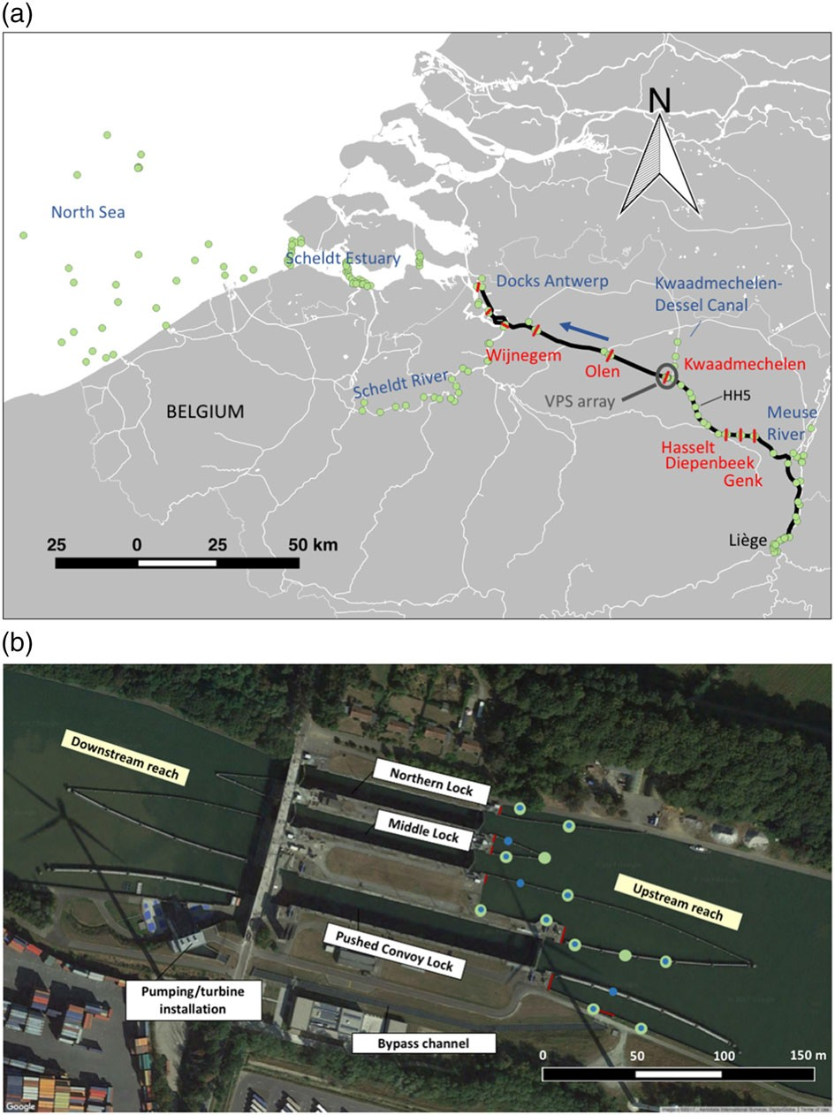

FIGURE 1 (a) The Albert Canal (black line) between Liège and Antwerp, with six navigation lock complexes on the canal (in red). Green dots are acoustic receivers allowing presence/absence (whole area) and 2D fish telemetry with the Vemco Positioning System (VPS; 200 × 150-m area directly upstream of the Kwaadmechelen lock complex). (b) Aerial view of the navigation lock complex in Kwaadmechelen. The red lines are the locations of the water intakes to the locks and the inlet to the bypass channel, leading to the hydropower installation. The large green dots are the receivers of the VPS array; the small blue dots are the fixed transmitters (often collocated with receivers). Background from Google Maps Satellite [Colour figure can be viewed at wileyonlinelibrary.com]

Salmon smolts originated from the hatchery of Érezée (Belgium), as they are too scarce to be captured in the Albert Canal. After tagging (with the smaller V7 transmitters) and recovery of 44 smolts, we released them 1km upstream of the navigation lock complex in Kwaadmechelen on April 6th and 11th 2016. We opted for this much smaller distance to the complex (compared to 13 km for eels) because hatched salmon smolts have a higher risk to get predated (Einum & Fleming, 2001).
Directly upstream of the locks, the fish are subject to flows created by levelling the locks and by operation of the hydropower station. Therefore, this area (200 × 150 m) was covered with acoustic receivers (VR2W, VEMCO), attached at the ship guiding structures and the canal walls at 2-m depth (Figure 1b). The layout of the receiver array
allowed multiple receivers to simultaneously hear a transmitter, so that 2D fish positioning would be possible every 25 s on average in ideal circumstances. In practice, the median time between calculated positions for all tagged fish was 34 s.
Additional receivers were placed in each lock chamber, in the bypass channel leading to the hydropower station, and down- stream of the complex. These receivers detect the fish presence within receiver range (up to 2 km in this canal), but exact posi- tions cannot be calculated (i.e., only presence/absence). As part of the Belgian Fish Tracking Network (http://www.lifewatch.be/ en/fish-acoustic-receiver-network), presence/absence receivers are installed also in the rest of the Albert Canal upstream and downstream of each navigation lock complex, in the side canal between Kwaad-

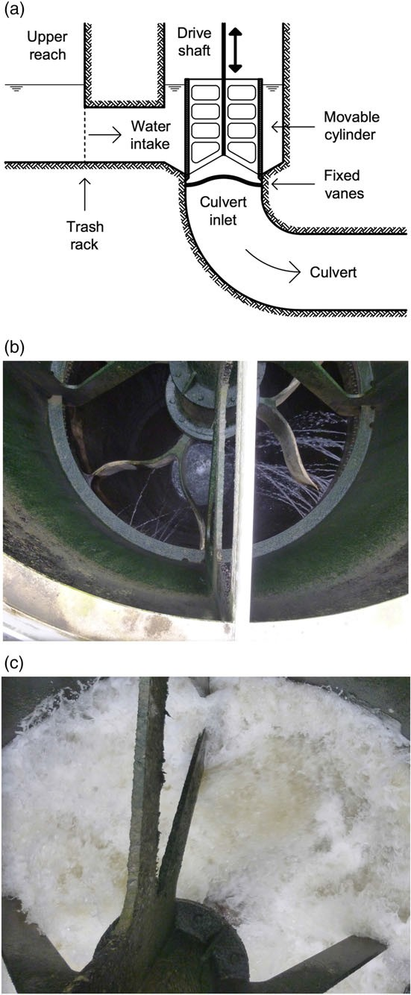

FIGURE 2 (a) Sectional view on the cylindrical valve. When the valve is lifted, water will enter from the left and get down vertically through the culvert. (b) Top view of the cylindrical valve of the middle lock. (c) Top view of the cylindrical valve during filling of the middle lock [Colour figure can be viewed at wileyonlinelibrary.com]

mechelen and Dessel, in the Meuse River, the Scheldt River, the Docks of Antwerp, the Scheldt Estuary, and the Belgian part of the North Sea (Figure 1a).

VPS data analysis
Positions were calculated by VEMCO (Smith, 2013), using the Vemco Positioning System (VPS). In this hyperbolic positioning technique, dif- ferences in signal detection time are converted into range differences, by use of signal travel speed. When a signal is heard by at least three receivers, a position can be calculated. The average position yield

(proportion of calculated to expected number of positions) was 83% during this study.
To account for the error on VPS positions, we assigned a colour code to each position prior to analysis (Figure A3). This colour code is determined as follows: In the VPS array, 13 fixed transmitters with known location are positioned every 10 minutes during the study, serving as a reference for system performance. Therefore, each fish position is calculated by a group of receivers, which also calculated a certain amount of fixed positions. The colour code then corresponds to the percentage of fixed positions with an error smaller than 5 m, which is sufficient accuracy to solve the research questions in this paper.

Methods for analysis
We performed all analyses separately on the silver eel and salmon smolt data and compared the results between species, to determine whether results were species dependent or intrinsic to the barrier. For testing differences between groups, we used the nonparametric Mann–Whitney test, given the small numbers of individuals per group.

Route choice
The route choice was determined by comparing fish positions with the condition of the locks (filling or open gates) or hydropower turbines (whether or not in operation) and detections inside the lock chamber or bypass channel. A distinction was made between unsuccessful and successful trials. In the case of an unsuccessful trial, the fish either passed through the open gates, stayed inside the lock chamber when it was lowered and left the lock again through the upstream gates after one of the next upstream lockages, or passed through an intake and subsequently swam upstream through the open lock gates after the current orone of the next upstream lockages. In the case of a successful trial, the fish passed through the gates, intakes, or bypass channel and was detected downstream after one of the next downstream lockages or after passage through one of the turbines. Fish that resided inside the lock chamber until the end of the transmitter battery life time (i.e., more than 1 month), were considered dead and counted as unsuccessful trials.

Lock residence time
Whether a passage trial was unsuccessful or successful, it was possible that some upstream and downstream lockages occurred before the fish found its way out. The delay caused in this way was calculated in terms of lock residence time. Lock residences that last until the end of a fish' tag battery life, most probably indicate a fish mortality, because a lock chamber does not provide adequate or safe habitat for fish. Therefore, these residence times were omitted from analysis. We also calculated the difference in lock residence time between fish that passed via an intake and those that passed via a gate.

Windows of opportunity
To better understand the route choices that the fish made to pass the complex, we investigated the windows of opportunity. These are defined as the time windows when flow is present in the area during a fish's presence in the VPS array. These include both lock filling

and hydropower operation, but the latter was outside the paper's scope. We defined one VPS residence as a series of successive positions (a track) in the VPS array, with maximal 1 hour between two successive positions. For each residence, we calculated the percentage of time when flow (by lock filling) was present in the study area. The percentage filling time for one fish is the sum of filling times during its different residences divided by the sum of residence durations (total residence time).

Impact on further downstream migration
To assess the impact of the route choice (passed via intakes, gates, or turbines) on the fish' capacity to migrate further in the
canal, we determined the location of last detection in the canal for each fish. Additionally, we compared the overall impact (i.e., upstream + downstream losses) of the Kwaadmechelen lock complex with the subsequent lock complexes in Olen and Wijnegem.

RESULTS

The percentages of passing versus not-passing individuals were similar for eels and smolts (Figure 3). Both species had passages via intakes and gates (only eels also via turbines) and individuals that never passed the complex despite trying.

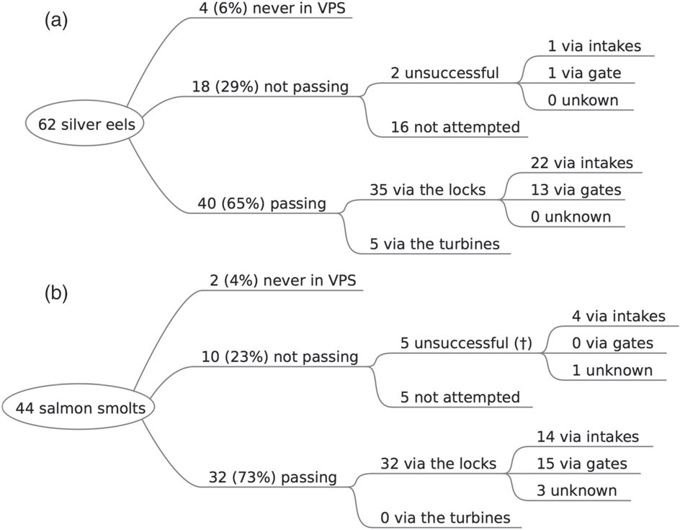

FIGURE 3 Overview of passage results for released eels (a) and smolts (b). † indicates that these fish probably died after the trial

TABLE 1 Unsuccessful and successful final trials of eels and salmon smolts (with percentages of the total in the column between brackets)

 | Eel |  |  | Smolt
 | Unsuccessful | Successful |  | Unsuccessful | Successful | Total
PCL intakes | 0 (0.0) | 12 (30.0) |  | 2 (40.0) | 9 (28.1) | 23 (29.1)
PCL gates | 1 (50.0) | 7 (17.5) |  | 0 (0.0) | 6 (18.8) | 14 (17.7)
PCL unknown | 0 (0.0) | 0 (0.0) |  | 1 (20.0) | 1 (3.1) | 2 (2.5)
ML intakes | 1 (50) | 5 (12.5) |  | 1 (20.0) | 3 (9.4) | 10 (12.7)
ML gates | 0 (0.0) | 3 (7.5) |  | 0 (0.0) | 7 (21.9) | 10 (12.7)
NL intakes | 0 (0.0) | 5 (12.5) |  | 1 (20.0) | 2 (6.3) | 8 (10.1)
NL gates | 0 (0.0) | 3 (7.5) |  | 0 (0.0) | 2 (6.3) | 5 (6.3)
Turbines | 0 (0.0) | 5 (12.5) |  | 0 (0.0) | 0 (0.0) | 5 (6.3)
Unknown | / (/) | 0 (0.0) |  | / (/) | 2 (6.3) | 2 (2.5)
Total intakes | 1 (50.0) | 22 (55.0) |  | 4 (80.0) | 14 (43.8) | 41 (51.9)
Total gates | 1 (50.0) | 13 (32.5) |  | 0 (0.0) | 15 (46.9) | 29 (36.7)
Other | 0 (0.0) | 5 (12.5) |  | 1 (20.0) | 3 (9.4) | 9 (11.4)
Total | 2 | 40 |  | 5 | 32 | 79
Abbreviations: ML, middle lock; NL, northern lock; PCL, pushed convoy lock. PCL unknown means that the choice between intakes and gates could not be determined due to missing data. Unknown is for fish that got downstream without being detected in the locks or bypass channel to the turbines.

Route choice
Overall, of the successful and unsuccessful eel and smolt trials, 52% were via intakes, 37% via gates, and the remaining 11% via another route (turbines or unknown; Table 1). For eels and smolts, respectively, 55% and 44% of the successful trials were through an intake. The five smolts that did unsuccessful trials (four via intakes, one via PCL intake or gate) ended inside the lock chamber and were assumed dead. The unsuccessful eels (one intake trial, one gate trial) ended somewhere upstream of the complex.
Note that Table 1 only counts the final attempts of fish to pass the complex. Eight eels and 13 smolts did one to three unsuccessful trials prior to their final successful trial. This resulted in 25 (63%) of the passing eels and 20 (63%) of the passing smolts that went at least once through an intake.
For both eels and smolts, the number of passages through the PCL intakes was 2–3 times higher than through the ML or NL intakes. This preference can be attributed to the filling discharge (Figure A1), which is at its maximum 3 times higher for the PCL (60 m3 /s) as for the ML and NL (20 m3 /s). For the gates, a similar pronounced and consistent difference cannot be found, confirming the coincidental nature of passing through the gates (because no flow is present when the gates are open).

Lock residence time
No significant differences in lock residence time were found between intake and gate passers for both eels and smolts (Figure 4). However, for both species, intake passers have more lock residences of (extreme) long duration. For instance, two eels passed via a PCL intake and stayed inside the lock for 1 and more than 8 days. Both eels, and also the ML intake passer with a 7 hour lock residence, stopped migrating upon arrival downstream of the complex. Also intake-passing smolts had more residences of long duration, and two of these outliers stopped migrating immediately after passage. The lock residence times of the five assumed dead smolts were not included in this figure. The observations that some fish die and some need more than a day to leave the lock after intake-passing suggest that passage through an intake can be problematic for fish.
Overall, lock residence times were longer for smolts than for eels, with 66% and 75% chance for respectively intake and gate passers that a smolt had a longer lock residence time than an eel (p = 0.04; p = 0.008).

Windows of opportunity
Although individuals having long residence times were observed more frequently in not-passing versus passing fish, there was no significant

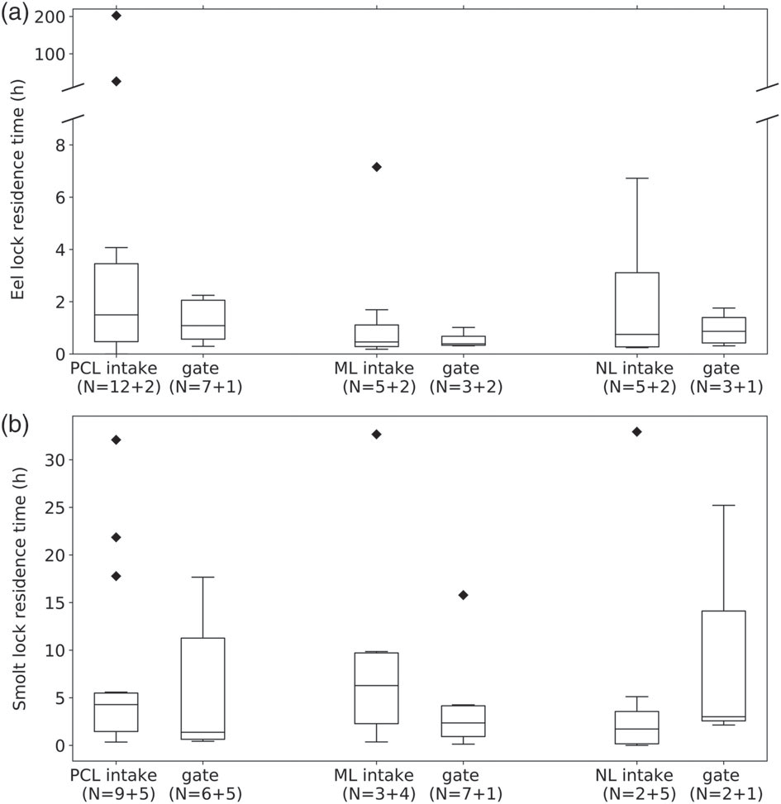

FIGURE 4 Residence time of eels (a) and smolts (b) in the pushed convoy lock (PCL), middle lock (ML) and northern lock (NL). For the eels, two extreme outliers for the PCL intakes of 1 day and 8 days 10.5 hr were observed. N = successful trials + unsuccessful trials. The trials resulting in a lock residence until end of battery life were omitted

difference in total residence time between passing and not-passing groups in both eels and smolts (Figure 5).
The prevalence of filling of the locks is used as a measure for passage opportunities because that event creates flow in the study area. There was respectively 67% (p = 0.03) and 70% (p = 0.03) chance (Figure 6) that an intake-passing eel or smolt had a larger window of opportunity in terms of lock fillings than one that never passed an intake.

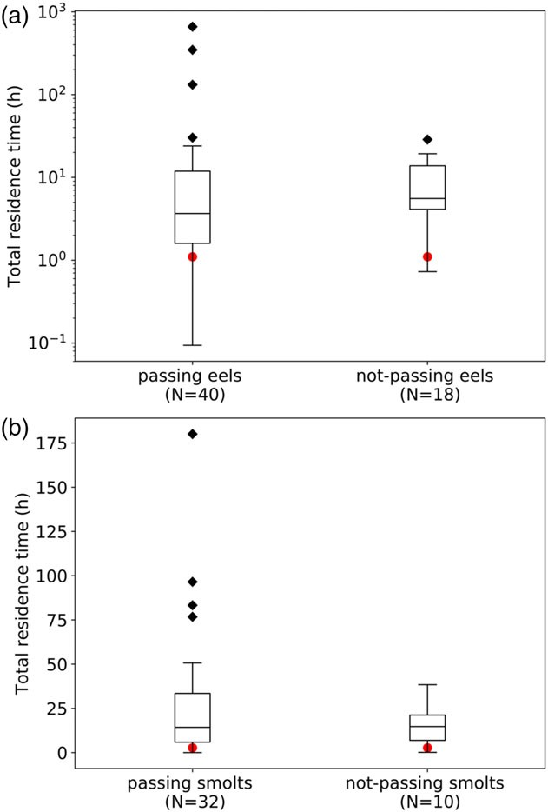

FIGURE 5 Total residence time (i.e., sum of all residence durations) for eels (a) and smolts (b), for those who finally passed the complex, versus those that did not. The red dots indicate the time that it would take to pass the 200-m length of the Vemco Positioning System array in absence of the lock complex [Colour figure can be viewed at wileyonlinelibrary.com]

Impact on further downstream migration
Whether eels and smolts had passed the complex via an intake, via gates or via the turbines, all groups reached downstream situ- ated receivers in varying numbers (Table 2). However, an important share of intake-passing eels (36%), intake-passing smolts (30%) and gate-passing smolts (44%) stopped migration directly downstream of the complex.

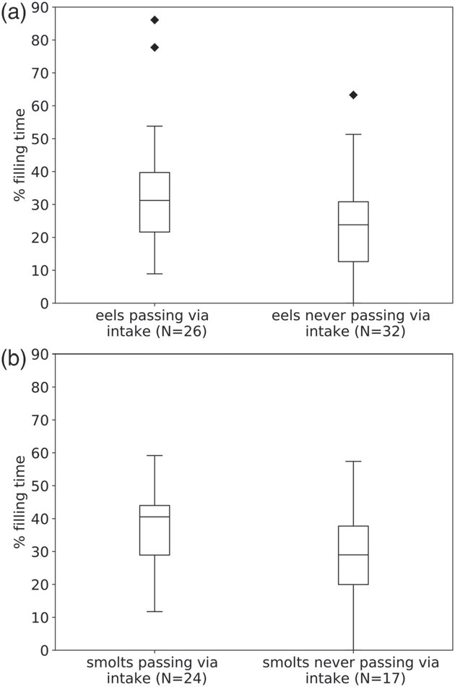

FIGURE 6 Percentage of time that one of the locks was filling during an eel (a) or smolt's (b) total residence time in the Vemco Positioning System array, for those who passed at least once through an intake, versus those that never passed through an intake (passed via a gate or did not pass at all)

TABLE 2 Location of last detection for smolts and eels that passed at least once through an intake, via gates, turbines, or an unknown route (DS = downstream, US = upstream): number of individuals (and percentage of total in the columns)
Eel  Intake Gate Turbines | Smolts
 | Intake | Gate | Unknown

DS Kwaadmechelen | 9 (36.0) | 2 (20.0) | 0 (0.0) | 6 (30.0) | 4 (44.4) | 1 (33.3)
US Olen | 2 (8.0) | 0 (0.0) | 0 (0.0) | 1 (5.0) | 1 (8.3) | 0 (0.0)
DS Olen | 4 (16.0) | 0 (0.0) | 1 (20.0) | 2 (10.0) | 1 (8.3) | 0 (0.0)
US Wijnegem | 1 (4.0) | 2 (20.0) | 1 (20.0) | 2 (10.0) | 0 (0.0) | 0 (0.0)
DS Wijnegem | 1 (4.0) | 1 (10.0) | 0 (0.0) | 1 (5.0) | 0 (0.0) | 1 (33.3)
Antwerp docks | 1 (4.0) | 1 (10.0) | 0 (0.0) | 6 (30.0) | 2 (16.7) | 0 (0.0)
Escape from docks | 7 (28.0) | 4 (40.0) | 3 (60.0) | 2 (10.0) | 1 (8.3) | 1 (33.3)
Fish that were detected in the Scheldt Estuary or the North Sea are grouped in "Escape from docks" because there is no barrier between both

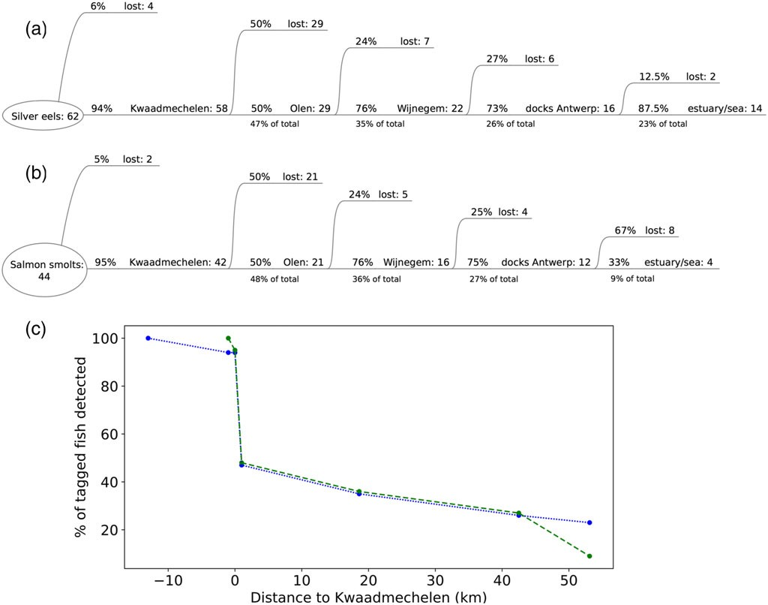

FIGURE 7 Flow-through schemes of (a) tagged silver eels and (b) salmon smolts. At each barrier, percentages indicate the number of fish that are lost (i.e., end upstream or downstream of that barrier) versus the number that continue in proportion to the total number arriving at that barrier. (c) shows the percentages of fish that pass the barrier in proportion to the total number of tagged fish, in function of distance to Kwaadmechelen, for eels (dotted blue line) and smolts (dashed green line) [Colour figure can be viewed at wileyonlinelibrary.com]

The above observations suggest that a navigation lock complex is not only a barrier for migration in the sense that it is difficult to pass but also in the sense that it hampers continuation of the journey after passage, potentially due to injury and disorientation. As such, we can consider the total loss at each complex as the sum of fish that are stuck both upstream and downstream, in proportion to the total arriving. For both eels and salmons, this loss was about 50% at the complex in Kwaadmechelen and about 25% at the following two complexes (Figure 7). The last barrier to overcome was then finding one of the maritime locks in the docks of Antwerp to escape towards the estuary, which failed for 12.5% of the eels and 67% of the smolts. This resulted in a final escape to the sea of respectively 23% and 9% of all tagged silver eels and salmon smolts.

DISCUSSION

For the analysis of route choices and further migration, we assumed that movement of transmitters represented the active movement of fish. According to Havn et al. (2017), dead fish can drift long distances in rivers and can be difficult to distinguish from living fish. However, in the VPS array, tracks of a drifting dead fish would be unidirectional, as opposed to the complex movement tracks that we observed. Another issue might be the question whether the tracks result from a tagged fish or from a potential predatory fish that has eaten it. The tagged silver eels were too large for most predatory fish in the Albert Canal. Salmon smolts might be predated, but tags
would probably be excreted after some time, resulting in constant positions. The latter can nevertheless only be verified in the VPS array. In the presence/absence telemetry areas, such as downstream of the complex, predation cannot be excluded without the use of predation tags. For smolts that migrated further downstream and until the Scheldt river, predation can be excluded because the predatory fish do not show this kind of migration behaviour.

Route choice
As stated by Travade (2002) and Larinier and Marmulla (2003), passing the locks by swimming through open lock gates only occurs coinci- dentally, given the absence of attraction flow. However, we saw that another operational condition creates opportunities for a fish to pass the complex: the filling of a lock during an upstream lockage. In this case, fish swim through the thrash racks of the water intake, via the small opening created by lifting the cylindrical valves and through the culverts to arrive inside the lock chamber. The passage in high-velocity flow via the circular slit, created by lifting the cylindrical valve, and via other structures such as blades, is potentially harmful for fish, given the possibility of collisions. The third condition that creates passage opportunities is the operation of the hydropower station. However, only five eels and none of the smolts passed the turbines in this study. In a parallel study, the fish-friendliness of the turbines, as well as the general impact on the fish populations, is further being investigated (unpublished data of INBO).

Even if a fish succeeds to get inside the lock, via gates or intakes, passage of the lock complex is not guaranteed. Because there is no flow inside the lock chamber indicating the downstream direction after lock filling, it is possible that they leave the lock in upstream direction upon opening of the upstream gates. These unsuccessful trials add up to the delay at the complex. As such, 20% of the eels and 41% of the smolts needed more than one trial to pass the complex, resulting in a maximum of two trials for eels and up to four trials for smolts. Moreover, 63% of the passing eels and smolts passed at least once through an intake, hence the importance of this route. The observation that four intake-passing smolts (and potentially a 5th) died inside the lock chamber, reinforces the assumption that this route might be not fish-friendly. Note that the assumption of dead fish was based on the ongoing detections inside the lock chamber, until the end of battery life time. We could not directly observe that the fish was dead and tag expulsion cannot be excluded with certainty. However, we consider it unlikely that five fish would lose their tag exactly in the lock chamber (and not in other locations outside the lock), unless being deadly wounded.

Windows of opportunity
The route choices discussed above can be regarded in the light of the conditions a fish encounters just before entering the lock complex. The first prerequisite for passing the complex is arriving in its vicinity, which succeeded for 96% of the smolts and 94% of the eels. Failure to arrive here might be due to predation or bifurcation to the Kwaadmechelen-Dessel Canal 2km upstream of the complex (Figure 1a). Immediate passage of the complex was rare, and as already mentioned in Verhelst et al. (2018), most fish were delayed in front of the complex. Although no significant difference in total residence time could be found between passing and not-passing fish, some passing eels and smolts spent up to respectively 660 and 180 hours in the VPS array during several residences. The majority of the fish resided many times longer in the VPS array than it would take to pass the 200-m canal section in absence of a lock complex, which is about 1 and 3 hours for eels and smolts respectively. To estimate the latter, we used an average migration speed of 0.05 m/s for eels (Bultel et al., 2014) and 0.02 m/s for smolts (Nyqvist et al., 2017).
Both intake-passing eels and smolts had a larger window of oppor- tunity in terms of lock fillings than eels and smolts that never passed via an intake. The preference of eels and smolts to migrate at night (Vollestad et al., 1986; McCormick, Hansen, Quinn, & Saunders, 1998), when ship traffic is lower and hence the window of opportunity smaller, is thus not helpful for their success to pass the navigation locks.

Lock residence time
Although emptying of the lock creates a flow that can be a cue for fish, some fish endure several lockages before getting out. This contribution to the delay is calculated as lock residence time. In general, smolts had longer lock residence times than eels, and more higher than average values up to 1 day. This can be due to a higher capacity of eels to
orient inside the lock chamber or a higher urge to migrate. Additionally, no eels were found dead in the lock after passage through an intake (although the lock residence time of about 8 days might indicate a mortality). Possibly, the more robust eels are less prone to succumbing immediately if they would be injured by passage through an intake. For both species, the highest lock residence times were found for intake-passing individuals, indicating the possible impact that this route might have.

Impact on further downstream migration
Even if a fish succeeds to get downstream of the complex after passing through an intake, injuries or disorientation can still lead to an inhibition of further migration. As such, we observed that respectively 36% and 30% of intake-passing eels and smolts stopped migrating after passing the complex. On the other hand, 32% and 10% finally escaped to the Scheldt Estuary or North Sea. Apparently, passing through an intake can be harmful, but some fish survive it and remain in a good enough condition to be able to migrate further and eventually escape to the sea. This can be explained by the filling mechanism. When the cylindrical valve is just lifted, water flows at high velocities through a small slit (Figure A2) and past other structures, a dangerous moment for fish to get in. After some minutes, the slit opening increases and water velocity decreases, weakening the danger for a fish to collide and get injured.
However, also gate-passing eels and smolts do not necessarily continue their migration after arriving at the downstream side. We observed that respectively 20% and 44% of gate-passing eels and smolts stopped migrating downstream of the complex. This indicates that other mechanisms are at play than merely the impact of route choice when entering the lock. First, a property inherent to this canal is the lack of a clear and consistent flow because filling and emptying of the locks create translatory waves in each canal section. Second, a migration stop can be induced by physiological stress not only as a delayed effect of the tagging procedure (Winter, Jansen, & Bruijs, 2006) but also as a result of the (often several and potentially harmful) trials to pass the complex. For instance, we observed fish that needed up to four trials to pass. Additionally, smolts might have moved out of their physiological smolt window (i.e., desmolt) due to a too long delay in freshwater (Lundqvist & Fridberg, 1982). Finally, the route choice when leaving the lock can also play a role. Fish can leave the lock either during emptying of the lock or after, when the downstream gates are opened. Upon lifting the downstream cylindrical valves (in case of the PCL) or opening the butterfly valves (ML and NL), water flows back through the ports in the longitudinal culverts at both sides of the lock chamber. Similarly as for filling of the locks in the beginning, opening spaces of the valves are small and water velocities high, leading to dangerous situations for fish.
For fish that continued to migrate after passage, the journey to the sea still included three barriers to overcome: one intermediate-head and one low-head navigation lock complex in the canal, and one (out of six) low-head maritime lock to exit the docks of Antwerp. Considering total losses at each barrier as the sum of downstream and upstream losses, the loss at the barrier of Kwaadmechelen was twice

the loss at the next two complexes in Olen and Wijnegem, despite no significant differences between the complexes nor their operation. This difference might be due to tagging effects still playing at the first complex, or to learning behaviour at the next complexes. Results were very similar for both eels and smolts, suggesting that the impact of these navigation locks is not species-specific. Only in overcoming the last barrier to escape to the sea, eels were largely more successful. This can be explained by the possible disorientation upon arriving in the network of docks, where the maritime locks are dispersed over different cloves and difficult to find. Smolts, migrating mostly at the surface (Moore, Ives, Mead, & Talks, 1998; McCormick et al., 1998), might be more prone to predation during their search for the exit. Also, due to the migration delay, they might have missed the ecological smolt window, that is, the period with beneficial conditions related to temperature, food, and predators (McCormick et al., 1998).

CONCLUSION AND PERSPECTIVES

Intermediate-head navigation lock complexes in canals are important barriers for downstream fish migration due to several reasons. First, our results strongly indicate that migrating fish are subject to the windows of opportunity they encounter at the complex. If a fish arrives in a low ship-traffic period (e.g., at night or on Sundays), it might not find any opportunity to pass, except from the turbines if these are in operation. Second, part of the passage opportunities (i.e., passing via gates) lack any cue for fish and are only found by coincidence. The third challenge for fish is the mechanism of lock filling. Flow going in the lock during filling (a cue in the right direction) is followed by the opening of the upstream lock gates (towards the wrong direction). This leads to unsuccessful trials where a fish ends upstream again. The occurrence of unsuccessful trials, as well as the need for favourable conditions, contributes to the delay. Fish that reside long enough in front of the complex will probably finally pass but experience migration delays and energy loss.
Lastly, intermediate-head navigation locks may form a threat to the fish' physical integrity, given the potential risk when passing via both the intakes (during lock filling) or outlets (during lock emptying). Because half of all trials (successful and unsuccessful) were through the intakes, the importance of this route should not be underestimated. More research is needed to fully investigate its impact.

ACKNOWLEDGEMENT

This work was a collaboration between Ghent University and the Research Institute for Nature and Forest (INBO). The first author is a PhD fellow funded by the Special Research Fund (BOF) of Ghent Uni- versity. Receivers and transmitters were funded by INBO, LifeWatch, and the European Union's Horizon 2020 research and innovation pro- gramme under grant agreement No 727830. N. De Maerteleire, E. Gelaude, S. Pieters, and K. Robberechts assisted with the data collec- tion. L. Engelen and S. Hendrieckx provided the sketch of the cylindrical valves. Data and information on lock operation were provided by nv de Vlaamse Waterweg and River and Information Systems Has-
selt. Hydropower operation data were provided by the Hydrological Information Centre.

REFERENCES
Baeyens, R. (2016). Spawning migration onset of silver-stage eel (Anguilla anguilla) in the Albert Canal (Belgium). Thesis presented to achieve the degree of Master of Science Environmental sciences. Unpublished.
Bultel, E., Lasne, E., Acou, A., Guillaudeau, J., Bertier, C., & Feunteun, E. (2014). Migration behaviour of silver eels (Anguilla anguilla) in a large estuary of Western Europe inferred from acoustic telemetry. Estuarine, Coastal and Shelf Science, 137, 23–31. https://doi.org/10.1016/j.ecss. 2013.11.023
Durif, C., Dufour, S., & Elie, P. (2005). The silvering pro- cess of Anguilla anguilla: A new classification from the yellow resident to the silver migrating stage. Journal of Fish Biol- ogy, 66, 1025–1043. https://doi:10.1111/j.1095- 8649.2005.00662.x.
\ignorespacesarXiv:EECS- 2011- 82. arXiv:EECS-2011-82.
Einum, S., & Fleming, I. A. (2001). Implications of Stocking: Ecological interactions between wild and released salmonids. Nordic Journal of Freshwater Research, 75, 56–70.
Garrone-neto, D., Haddad, V. Jr, & Gadig, O. B. F. (2014). Record of ascending passage of potamotrygonid stingrays through navigation locks : Implications for the management of non-native species in the Upper Paraná River basin , Southeastern Brazil. Management of Biological Invasions, 5, 113–119. https://doi.org/10.3391/mbi.2014.5.2.04
Havn, T. B., Økland, F., Teichert, M. A. K., Heermann, L., Borcherding, J., Sæther, S. A., ..., & Thorstad, E. B. (2017). Movements of dead fish in rivers. Animal Biotelemetry, 5, 1–9. https://doi.org/10.1186/ s40317- 017- 0122- 2.
Larinier, M., & Marmulla, G. (2003). Fish passes: Types, principles and geo- graphical distribution - an overview. In Second International Symposium on the Management of Large Rivers for Fisheries, Phnom Penh, Kingdom of Cambodia, pp. 183–205.
Lin, P. C., Brosse, S., Gao, X., Liu, C. C., & Liu, H. Z. (2013). Species com- position and temporal pattern of fish passing through the navigation locks in the middle reach of Yangtze River: Implications for fish conser- vation. Journal of Applied Ichthyology, 29, 1441–1444. https://doi.org/ 10.1111/jai.12362
Lundqvist, H., & Fridberg, G. (1982). Sexual maturation versus imma- turity: Different tactics with adaptive values in Baltic salmon (Salmo salar L.) male smolts. Canadian Journalof Zoology, 60, 1822–1827. http://www.nrcresearchpress.com/doi/abs/10.1139/z82-
236?journalCode=cjz{#}.VNHwAWjGpPo.
Malbrouck, C., Micha, J.-C., & Philippart, J.-c. (2007). La réintroduction du saumon atlantique dans le bassin de la Meuse: Synthèse et résultats: projet Meuse Saumon 2000. Jambes, Région Wallonne.
McCormick, S. D., Hansen, L. P., Quinn, T. P., & Saunders, R. L. (1998). Movement, migration, and smolting of Atlantic salmon (Salmo salar). Canadian Journal of Fisheries and Aquatic Sciences, 55, 77–92. https:// doi.org/10.1139/cjfas- 55- S1- 77
Moore, A., Ives, S., Mead, T. A., & Talks, L. (1998). The migratory behaviour of wild Atlantic salmon (Salmo salar L.) smolts in the River Test and Southampton Water, southern England. Hydrobiologia, 371/372, 295–304. http://doi.org/10.1023/A:1017087524694
Moser, M. L., Darazsdi, a. M., & Hall, J. R. (2000). Improving passage effi- ciency of adult American shad at low-elevation dams with navigation locks. North American Journal of Fisheries Management, 20, 376–385. https://doi.org/10.1577/1548-8675(2000)020<0376:IPEOAA>2.3.CO;2
Nyqvist, D., McCormick, S. D., Greenberg, L., Ardren, W. R., Bergman, E., Calles, O., & Castro-Santos, T. (2017). Downstream migration and multiple dam passage by Atlantic salmon smolts. North Ameri-

can Journal of Fisheries Management, 37(4), 816–828. https://www. tandfonline.com/doi/full/10.1080/02755947.2017.1327900. https:// doi.org/10.5331080/02755947.2017.1327900
Permanent International Association of Navigation Congresses. Interna- tional Commission for the Study of Locks (PIANC) (1986). Final report of the international commission for the study of locks. Brussels.
Rohács, J., & Simongáti, G. (2007). The role of inland waterway navigation in a systainable transport system. Transport, 22, 148–153. https://doi. org/10.1080/53816484142.2007.9638117
Silva, S., Lowry, M., Macaya-Solis, C., Byatt, B., & Lucas, M. C. (2017). Can navigation locks be used to help migratory fishes with poor swimming performance pass tidal barrages? A test with lampreys. Eco- logical Engineering, 102, 291–302. https://doi.org/10.1016/j.ecoleng. 2017.02.027.
Smith, F. (2013). Understanding HPE in the VEMCO Positioning Sys- tem (VPS). Vemco Tutorials. http://vemco.com/wp- content/uploads/ 2013/09/understanding- hpe- vps.pdf
Thorstad, E. B., Økland, F., Westerberg, H., Aarestrup, K., & Metcalfe,
J. D. (2013). Evaluation of surgical implantation of electronic tags in European eel and effects of different suture materials. Marine and Freshwater Research, 64, 324–331.
Travade, F. (2002). Franchissement des barrages de navigations par les poissons. (Technical Report) HP-76/02/028/A: Département laboratoire national d'hydraulique et environnement, Chatou Cedex, France.
Voies navigables de France (VNF) (2008). Carte: Les voies navigables du bassin du Nord-Pas-de-Calais.
Vergeynst, J., Baeyens, R., Coeck, J., Pauwels, I., Nopens, I., Mouton, A.,
& De Mulder, T. (2018). Fish behaviour in the vicinity of a navigation lock complex: The challenges. In International Symposium on Hydraulic Structures, Aachen, pp. 8. https://digitalcommons.usu.edu/ishs/2018/ session4- 2018/8
Verhelst, P., Baeyens, R., Reubens, J., Benitez, J.-P., Coeck, J., Goethals, P., ...,
& Mouton, A. (2018). European silver eel (Anguilla anguilla L.) migration behaviour in a highly regulated shipping canal. Fisheries Research, 206, 176–184.
Verreycken, H., Belpaire, C., Van Thuyne, G., Breine, J., Buysse, D., Coeck, J., ..., & Maes, D. (2014). IUCN Red List of freshwater fishes and lampreys in Flanders (north Belgium). Fisheries Management and Ecology, 21, 122–132. https://doi.org/10.1111/fme.12052
Vollestad, L. A., Jonsson, B., Hvidsten, N. A., Naesje, T. F., Haraldstad, O., & Ruud-Hansen, J. (1986). Environmental factors regulating the seaward migration of European silver eels. Canadian Journal of Fisheries and Aquatic Sciences, 43, 1909–1916.
Winter, H. V., Jansen, H. M., & Bruijs, M. C. M. (2006). Assessing the impact of hydropower and fisheries on downstream migrating silver eel, Anguilla anguilla, by telemetry in the River Meuse. Ecology of Freshwater Fish, 15, 221–228. http://doi.wiley.com/10.1111/j.1600- 0633.2006. 00154.x.

APPENDIX A

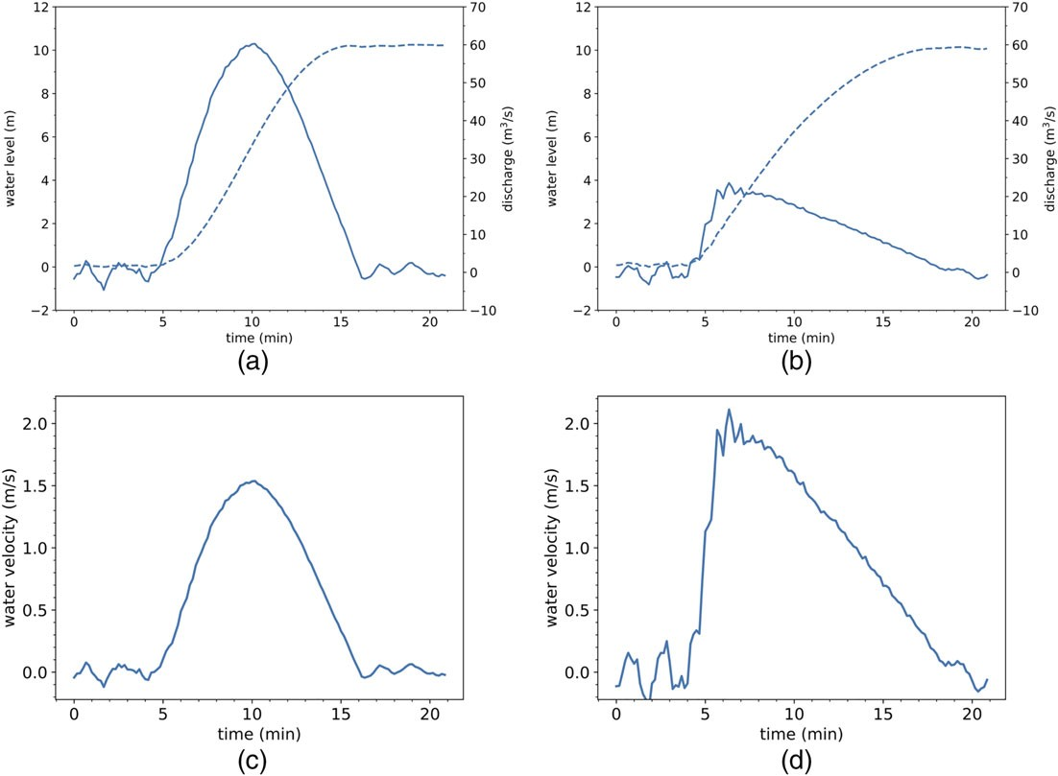

FIGURE A1 Time profiles of the water level in the lock chamber and discharge and velocity through one water intake of the (a, c) pushed convoy lock and of the (b, d) middle and northern locks. The dotted line is the water level in the respective locks; the full lines are running means of discharge/water velocity over 1 min (Vergeynst et al., 2018)

Dimensions (mm)
13 × 36
13 × 48
13 × 36
13 × 36
Weight in water (g)
6
6.5
6
6
9 × 21
3.3
7 × 18
7 × 18
0.7
0.7
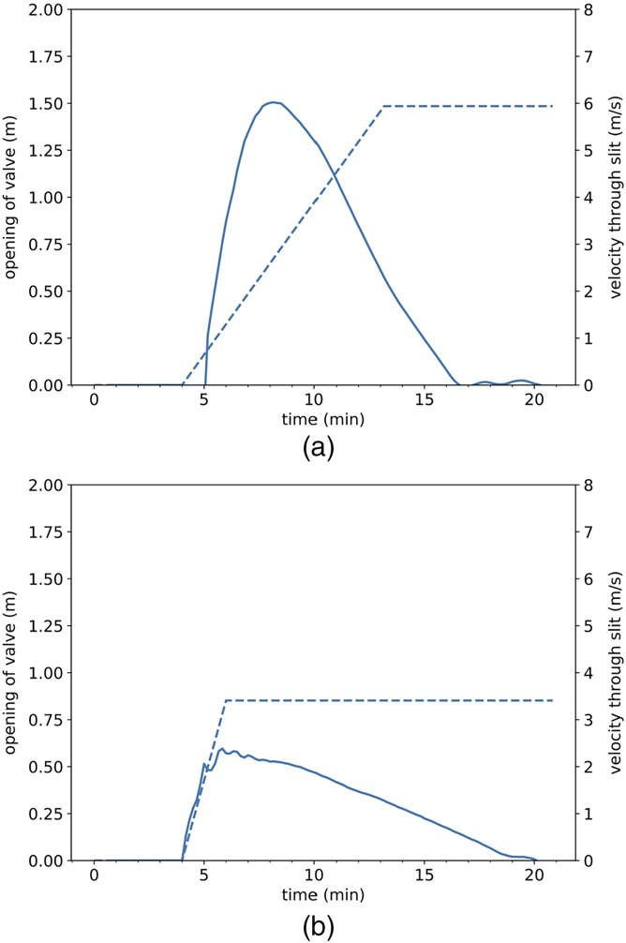

FIGURE A2 Time profiles of the opening height when the cylindrical valve is lifted (dotted line) and the velocity of the water that goes through the created circular slit (full line, running mean over 1 min) for the (a) pushed convoy lock versus the (b) middle/northern lock
TABLE A1 Overview of acoustic transmitters types, number of individuals tagged (Nb), programmed transmission delay, and other properties
Release period
Nov-Dec 2015
Nov-Dec 2015
Nov 2016
Nov 2016
IDs
38725-38740
100-109
38741-38754
47307-47317
Nb
16
10
14
11
Type
V13-1L V13P-1L V13-1L V13-1L
Programmed delay
17-33 s
17-33 s
17-33 s
17-33 s
60-120 s
20-40 s
17-35 s
300-360 s
20-40 s
40-80 s
15-30 s
Battery life
507d
301d
507d
85d 130d
430d
85d 130d
153d
197d
64d
47318-47328
11
V9-2L
34429-34453
34517-34535
25
19
V7-4L
V7-2L

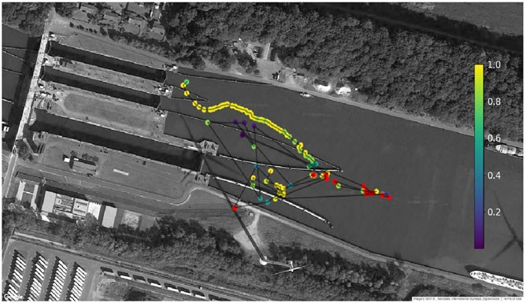

FIGURE A3 Example of a fish track with colour code: shades ranging from yellow (calculated with a receiver group that positioned 100% of the fixed tags within 5-m accuracy) to blue (calculated with a receiver group that positioned 0% of the fixed tags within 5-m accuracy). Red dots are positions for which the receiver groups calculated less than 10 fixed positions and therefore could not be classified
Silver eels
Nov 2016
Salmon smolts April 2016
April 2016

