Downstream migration of European eel (Anguilla anguilla L.) in an anthropogenically regulated freshwater system: Implications for management
Pieterjan Verhelsta,b,c,d,⁎, David Buysseb, Jan Reubensc, Ine Pauwelsb, Bart Aeltermanb,
Stijn Van Hoeyb, Peter Goethalsd, Johan Coeckb, Tom Moensa, Ans Moutonb,d
a Marine Biology Research Group, Ghent University, Krijgslaan 281, 9000 Ghent, Belgium
b Research Institute for Nature and Forest (INBO), Kliniekstraat 25, 1070 Brussels, Belgium
c Flanders Marine Institute, Wandelaarkaai 7, 8400 Ostend, Belgium
d Laboratory of Environmental Toxicology and Aquatic Ecology, Ghent University, Coupure Links 653, 9000 Ghent, Belgium

A R T I C L E I N F O

Handled by George A. Rose
Keywords: European eel Migration Freshwater Estuary Telemetry
Migration barriers
A B S T R A C T

Connectivity between freshwater habitats and marine areas is heavily obstructed by anthropogenic structures (e.g. weirs, pumping stations, sluices…), leading to a high pressure on diadromous ﬁsh populations. A better understanding of ﬁsh migration behaviour in relation to these barriers is needed to take proper mitigation actions. We investigated the impact of migration barriers on downstream migrating European eel (Anguilla anguilla L.) by tracking 50 acoustically tagged eels between July 2012 and March 2015 in a Belgian polder area. The study area was selected due to the presence of a wide range of migration barriers, such as two pumping stations, a weir and tidal sluices. These structures regulate the water level, resulting in discontinuous ﬂow conditions. The results showed that migration was primarily nocturnal and discharge appeared to be the main trigger for migration in the polder. We also observed substantial delays and exploratory behaviour near barriers. Delays can have a serious impact on eels since their energy resources are limited for a successful trans-Atlantic migration. In addition, delays and exploratory behaviour can also increase predation and disease risk. The obtained knowledge can contribute to eﬃcient management such as improved ﬁsh passage and guidance so- lutions.

- Introduction

Worldwide, water levels of freshwater systems are controlled by structures such as pumping stations, weirs, dams and sluices. These structures hamper the movement of aquatic organisms, especially dia- dromous ﬁsh (Baumgartner et al., 2009; Lassalle et al., 2009; Thompson et al., 2011). Polders are one particular ecosystem type where the role of barriers is crucial. A polder is an anthropogenic system where water is maintained at a lower level than outside the polder by pumping stations and weirs, which are two types of barriers that can negatively inﬂuence migration of both diadromous and potamodromous ﬁsh spe- cies (Buysse et al., 2014; Falke and Gido 2006). Due to climate change, the associated rising sea level and a growing human population, pres- sure on dewatering systems is likely to intensify in the future, resulting in the development of more polders with their accompanying migration barriers (Beatty et al., 2014; Hannah et al., 2007; Hermoso and Clavero 2011; Maceda-Veiga 2013). In recent years, the importance of aquatic

habitat connectivity has been recognized and is being addressed in management practices, resulting in developments to improve ﬁsh mi- gration. As such, ﬁsh-friendly pump adaptations and ﬁshways have been developed to reduce mortality (Buysse et al., 2015; Clay 1994). However, the eﬃcacy of many presumably ﬁsh-friendly adaptations remains to be established (Boggs et al., 2004; Gowans et al., 1999; Keefer et al., 2004; Marmulla 2001; Roscoe and Hinch 2010). Next to mortality eﬀects, pumping stations may also aﬀect migration beha- viour, resulting in delays or even migration stops. Consequently, delays or migration stops may result in a higher predation risk or reduced ﬁtness and therefore contribute to the decline of a species (Marmulla 2001).
In this study, we selected the European eel (Anguilla anguilla L.) as a model species for downstream migrating ﬁsh encountering migration barriers. The European eel is a facultatively catadromous ﬁsh species, which grows in coastal and freshwater habitats (i.e. the yellow eel stage) of Europe and North-Africa. After two to 20 or more years, they

⁎ Corresponding author at: Ghent University − Biology Department Marine Biology Research Group Krijgslaan 281/S8 9000 Gent − Belgium.
E-mail address: Pieterjan.Verhelst@UGent.be (P. Verhelst).

migrate over ca 6000 km as silver eels to the spawning grounds in the Sargasso Sea, depending entirely on the fat reserves they have accu- mulated during the yellow eel stage (Chow et al., 2010; Tesch 2003). During the last decades, recruitment of the European eel has declined between 90% and 99% (Dekker and Casselman 2014), making it a critically endangered species according to the IUCN Red List (Jacoby and Gollock, 2014). Various causes likely contribute to this decline, such as migration barriers, habitat deterioration, pollution, human-in- troduced parasites, ﬁsheries and changes in ocean climate (Buysse et al., 2014; Feunteun 2002; Køie 1991; Miller and Tsukamoto 2016; Moriarty and Dekker 1997). To aid conservation and recovery of Eur- opean eel stocks, the European Union adopted a Council Regulation (European Eel Regulation; EC no. 1100/2007) which imposes a man- agement system that ensures 40% escapement of the spawning stock biomass, deﬁned as the best estimate of the theoretical escapement rate if the stock were completely free of anthropogenic inﬂuences. Adequate mitigation measures to improve the escapement rate therefore require proper insight in eel migration behaviour and how this is aﬀected by current management practices.
We used acoustic telemetry to reveal migration routes and link the detection data with biotic and abiotic data, thus providing knowledge about what variables trigger migration and whether eels encounter delays near barriers. This information can be implemented in man- agement measures to improve silver eel escapement rates.
Downstream migrating European eels were tracked from a polder area in Flanders (Belgium) into the Schelde Estuary (SE, The Netherlands). We selected the study area due to the presence of a wide range of migration barriers, such as two pumping stations (an Archimedes screw pumping station (APS) and a propeller pumping station), a weir and tidal sluices. Previous research showed silver eel mortality rates up to 19% at that particular APS (Buysse et al., 2015). We assessed ﬁve research questions related to downstream eel migra- tion behaviour: (1) do eels take diﬀerent migration routes; (2) does eel behaviour change signiﬁcantly in the vicinity of barriers; (3) does mi- gration follow a circadian pattern; (4) does migration start at a speciﬁc point in time; and (5) do environmental variables inﬂuence migration? The results of this study will support river and/or polder managers to facilitate downstream eel migration and hence contribute to the con- servation of the eel stock.

- Methods

  - Study area

The study area is comprised of three subareas, which are all part of the Schelde river basin: a polder (Flanders, Belgium), the Braakman pond (The Netherlands) and the SE (The Netherlands) (Fig. 1). The polder covers an area of about 200 km2 and is drained via the Leopold Canal (LC). The LC is an unnavigable waterway of approximately 46 km long, 10–20 metres wide and one to four metres deep. It extends from Heist at the Belgian coast to Boekhoute. Generally, it is a stagnant water system, but during dewatering, it can have a slow ﬂowing current (on average 1.21 m3·s−1 during this study period). Within the polder area, the LC connects diﬀerent habitats such as ponds and small and large polder ditches with variable width and depth (Table 1). The Braakman is a brackish pond in The Netherlands, connected to the polder area in Belgium, with a mean chloride concentration of 3265 mg·L−1 (range 580–8200 mg·L−1), a surface of approximately 2.05 km2 and a depth up to 14 m. It is located at approximately one third of the SE (starting from the estuarine mouth) and functions as a transition area between the freshwater polder and the polyhaline zone of the SE. The latter is the lowest part of the Schelde river and leads to the North Sea. The funnel shaped estuary is approximately 55 km long with a variable width be- tween two and eight km. It is characterized by intensive tidal action and strong currents and contains many sand banks, mudﬂats and salt mar- shes, resulting in a high turbidity.
To dewater the system during high precipitation, water is pumped from the LC (1.40 m above sea level (a.s.l.)) into the Braakman pond (1.97 m a.s.l. in summer, 1.42 m a.s.l. in winter) via an APS in the Isabella Canal (Boekhoute), and ﬂows gravitationally into the SE via a tidal sluice (Fig. 1). In case gravitational ﬂow is insuﬃcient to dewater the system, propeller pumps in the tidal sluice are used. In cases of exceptionally high precipitation, the polder system can also be dewa- tered towards Zeebrugge by lowering a weir in the LC (Sint-Laureins) (Fig. 1).
The APS has de Wit modiﬁcations to reduce ﬁsh mortality during passage, and along the APS a de Wit ﬁshway is present (Buysse et al., 2015) (Fig. S1). The propeller pumps in the tidal sluice at the border between the Braakman pond and the SE do not have ﬁsh-friendly adaptations. In the western direction, connectivity from the polder area to marine areas is blocked by a low-head weir in Sint-Laureins and a tidal sluice in Heist at the freshwater − sea border.

  - Tagging procedure

During the summer and autumn of 2012, 566 eels were caught in the polder and at the APS. From July to August 2012, 526 eels were caught with double fyke nets, which were placed in the LC, ponds and large polder ditches. At each location, four double fyke nets were placed and emptied during four consecutive days. Between the 5th and 16th of October 2012, another 40 eels were caught with two fyke nets attached to the outlet of two pumps of the APS during a survey to study eel mortality after passage (Buysse et al., 2015). Total length (TL, to the nearest mm) and body weight (W, to the nearest g) were measured and 50 eels (26 eels in the polder and 24 at the APS) were selected as large enough to tag with a mean length of 684 mm ± 75.76 mm (range 556 mm − 874 mm) and mean weight of 683 g ± 260.23 g (range 381 g − 1615 g). In this study, only females were tagged, since males are smaller than the minimum size handled in this study (< 450 mm (Durif et al., 2005)). Also note that the eels caught at the APS were checked for deformities and lesions prior to tagging.
In 2012, 46 eels were tagged with V13-1L coded acoustic trans- mitters (13 × 36 mm, weight in air 11 g, random delay between 80 s and 160 s, life time 1116 days, frequency 69 Hz) and four with V7-4L coded acoustic transmitters (7 × 22.5 mm, weight in air 1.8 g, random delay between 45 s and 95 s, life time 157 days, frequency 69 Hz) from VEMCO Ltd (Canada, http://www.vemco.com). After anaesthetising the eels with 0.3 ml·L−1 clove oil, tags were implanted according to Baras and Jeandrain (Baras and Jeandrain, 1998). After recovery in a quarantine reservoir, eels were released at their catch location.

  - Acoustic network

An acoustic network of 56 automatic listening stations (ALSs) (VR2W, VEMCO Ltd), which register the tag numbers with date and time (i.e. the time stamp) of the detection, was deployed in the harbour of Zeebrugge (n = 1), the polder area (n = 27), the Braakman pond (n = 6) and the SE (n = 22) (Fig. 1). The two ALSs in the Isabella Canal were considered part of the Braakman pond and detection data were handled accordingly. ALSs were moored at strategic locations to max- imise the probability of detection: up- and downstream of each mi- gration barrier, an ALS was deployed. Furthermore, ALSs were placed at each entry of a pond or polder waterway into the LC, while a uniformly distributed pattern in the Braakman pond was achieved. At the mouth of the Braakman into the SE, a double semi-circular array of ALSs was deployed in the SE, combined with one array stretching from the left to the right bank of the estuary. In the polder area and the Braakman pond, the stations were moored at the bank with weights and a small buoy. In this way, the hydrophone had an upward direction in the water column. In the SE, ALSs were moored at marine buoys, attached to a three-metre long chain with a weight at the end for stability. This re- sulted in downward directed hydrophones.

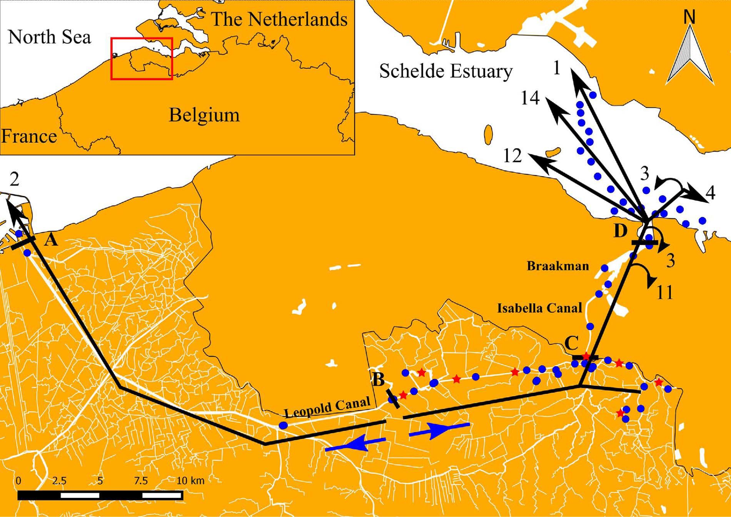

Fig. 1. Study area with the Leopold Canal and its network of connected waterways (Belgium), the Isabella Canal, the Braakman pond (The Netherlands) and the Schelde Estuary (The Netherlands). ALSs are indicated as blue dots and catch-release locations as red asterisks. The four migration barriers within the study area are indicated with a black bar and bold letter:
(A) the tidal sluice in Zeebrugge, (B) the low-head weir in Sint-Laureins, (C) the Archimedes Pumping station in Boekhoute, and (D) the tidal sluice with propeller pumps between the Braakman pond and the Schelde Estuary. The main current direction at each side of the weir is indicated with a blue arrow, while the migration routes of the 50 tagged eels are presented by black arrows. The numbers reﬂect the number of eels taking this speciﬁc migration route in the present study. (For interpretation of the references to colour in this ﬁgure legend, the reader is referred to the web version of this article.)

Table 1
Depth and width of the diﬀerent habitat types in the study area.
sharp border between resident and downstream migration behaviour, a trajectory analysis was applied to each individual eel (Verhelst et al., 2017). We used the method of Lavielle from the adehabitatLT package

in R to divide an animal’s trajectory in a resident and a migratory phase
Type  Canal | Depth (m)  1–4 | Width (m)  10–20
Polder pond | 0.5–10 | 15–150
Large polder waterway | 0.5–2 | 5–10
Small polder waterway | 0.2–1 | 0.5–5
Braakman pond | 1–14 | 200–750
Schelde Estuary | 1–38 | 2000–8000

(Calenge, 2006) (Fig. S2). This method does not require discretization in time and is based on residence time (Lavielle, 1999, 2005).

  - Data processing

Eels were tracked between 18th July 2012 and 25th March 2015 resulting in a dataset with 127475 detections. To reduce the dataset, the detections were accumulated for each eel at each ALS, resulting in detection intervals with arrival and departure times (Vemco Users Environment software program, VEMCO Ltd, Canada). A one-hour ab- sence threshold was applied: when an eel was detected within an hour at the same ALS as the previous detection, it was considered within the same detection interval. If not, the detection was assigned to a new interval. Further, between an arrival and departure within the same detection interval, the number of detections and the residence time were calculated (Verhelst et al., 2017).
Of the 50 tagged eels, 18 showed resident behaviour followed by downstream migration. As this study focused on downstream migration behaviour only, the data records with resident behaviour prior to downstream migration were removed from the dataset. To determine a
  - Data analysis

In this study, diﬀerent research questions were tackled with dif- ferent data analyses. To determine the diﬀerent migration routes and the impact of the migration barriers on eel behaviour, exploratory be- haviour (i.e. non-directional movement) was included along with mi- gration behaviour. To analyse the circadian pattern, when eels start to migrate, and what environmental variables inﬂuence migration, only downstream migration records were taken into account (hereafter called ‘migration records’). After chronologically ordering the data, a record was considered a migration record if the previous and next de- tection were at an ALS up- and downstream, respectively, or if the previous two detections were at two subsequent upstream located ALSs. For each analysis, assumptions were checked and data exploration was conducted following the protocol of Zuur et al. (2010).

    - Migration routes and impact of barriers on downstream migration behaviour
Recently, network-based tools have proven to be helpful in visua- lising the extensive datasets obtained by acoustic telemetry (Jacoby and Freeman 2016). To reveal migration routes of individual eels, a

unipartite network (i.e. ‘one-mode’ networks, see Jacoby and Freeman 2016 for more details) was created for each eel, consisting of nodes and edges. Nodes represented the ALSs with the total residence time of an eel at that ALS and edges the movements between them. The eﬀect of barriers on migration behaviour was analysed in two ways (i.e. delays and exploratory behaviour) and only for the main migration route. For each node, the distance till the ﬁrst downstream located migration barrier was calculated via QGIS (as there was no physical migration barrier downstream the SE ALSs, these records were excluded from the analysis of delays and of exploratory behaviour). For both delay and exploratory behaviour analysis, a Generalised Linear Mixed Model (GLMM) was applied with transmitter ID as random eﬀect (i.e. as a proxy for individual variation). For analysing the delays, the total re- sidence time per eel at each ALS was used as the ﬁxed eﬀect, while the total number of arrivals per eel at each ALS was applied as a ﬁxed eﬀect for the exploratory behaviour analysis. The distances between the nodes and the barriers were considered the ﬁxed eﬀect in both models. The residence time data were continuous, consequently, a Gaussian GLMM with identity link was applied (Zuur et al., 2009). For ex- ploratory behaviour analysis, we chose to perform a negative Binomial GLMM with log link, since this model is more robust against over- dispersion compared to a Poisson GLMM (Zuur et al., 2009). We used the ‘lme4′ and ‘lmerTest’ package (Bates et al., 2014) in R (Team 2015) to create the GLMMs and the ‘blmeco’ package to check the models for overdispersion: if the scale parameter was between 0.75 and 1.4, overdispersion was considered absent. The packages ‘igraph’, ‘lu- bridate’, ‘matrix’ and ‘plyr’ were used to represent the data as unipartite networks.

    - Circadian pattern
The number of migration records was summed per circadian phase. Consequently, four diﬀerent circadian phases were determined and linked to each record in the dataset: dawn (start of civil twilight (i.e. when the geometric centre of the sun is six degrees below the horizon in the morning) to sunrise), day (sunrise to sunset), dusk (sunset to end of civil twilight (i.e. when the geometric centre of the sun is six degrees below the horizon in the evening) and night (end of civil twilight to start of civil twilight). Timestamps of sunset, sunrise and twilight were obtained from the Astronomical Applications Department of the U.S. Naval Observatory (http://aa.usno.navy.mil/index.php; coordinates: 51°16′N 3°43′E).

    - Onset of migration
The onset of migration was simply determined as the month of the
ﬁrst migration record for each eel.

    - Environmental triggers of migration
      - Environmental data. To examine environmental triggers of downstream migratory behaviour, environmental variables were linked to the departure times per subarea (polder, Braakman pond and SE) in the dataset (Table S1). Environmental variables were selected based on data availability and on previous research (e.g. McCleave and Arnold 1999; Tesch 2003; Bultel et al., 2014; Buysse et al., 2015). The 11 continuous variables were precipitation mm, the APS and propeller pumps discharge (m3·s−1), water temperature (°C) from the polder system and the SE, chloride concentration of the Braakman pond and the SE (mg·L−1), current velocity (cm·s−1) and direction (degrees) in the SE, day length (min) and air pressure (hPa). One variable was categorical: the gravitational ﬂow at the tidal barrier between the Braakman pond and the SE (0: no gravitational ﬂow; 1: gravitational ﬂow).
Pumping discharge, precipitation, water temperature and air pres- sure data were measured daily and obtained from the Flemish Environment Agency (www.waterinfo.be). Pumping discharge data were obtained daily by recordings from a metre at the APS, while water temperature and air pressure were measured near the APS (coordinates:
51°16′15.8“N 3°42′43.6“E). Precipitation data was the average value over a large part of the study area (Fig. S3). There were two gaps of a couple of months in the water temperature data. To ﬁll these gaps, data from a nearby canal were used (Ede canal; coordinates: 51°12′15.4“N 3°26′22.3“E). Both canals have a similar morphology and discharge regime, and showed a high correlation (0.98) in temperature regime. However, water temperature data for both canals diﬀered signiﬁcantly (two-sample t-test, t = 2.98, p< 0.05). Therefore, we applied a linear regression to obtain the relationship between the two datasets and ﬁll in the gaps of the water temperature data of the studied polder area with the modiﬁed values of the nearby canal:
Water temperature LC = 1.161941 * water temperature Ede canal −
0.780858
Water level, pumping discharge, water temperature and con- ductivity data for the Braakman pond were obtained from the ‘Scheldestromen Water Board’. Water levels up- and downstream of the tidal barrier were measured every 15 min; based on those data, it could be qualitatively determined when gravitational ﬂow took place at the Braakman outﬂow (Fig. 1). As such, the variable gravitational ﬂow was binomial: gravitational ﬂow or no gravitational ﬂow. However, during periods of high precipitation and no gravitational ﬂow, pumps in the tidal barrier were activated to dewater the system (i.e. Braakman dis- charge; measured every 15 min). Conductivity data were measured once per month. These data were interpolated to link conductivity to the departure times of the eels. Water temperature of the Braakman was also logged once per month by the Scheldestromen Water Board. As the water from the upstream located polder ﬂows into the Braakman, water temperature of the Braakman was highly similar to the water tem- perature of the LC: both datasets showed a high correlation (cor = 0.99) and a t-test indicated no signiﬁcant diﬀerence (two- sample t-test, t = 0.22, p = 0.83).
As such, the water temperature data of the polder was used for the analysis of downstream eel behaviour in the Braakman, because it has a higher resolution. The same air pressure and precipitation data of the polder area were used for the Braakman pond as the Braakman is lo- cated next to, and connected to the polder area.
Conductivity and water temperature of the SE were obtained from Rijkswaterstaat. These data were measured every 10 min near the Braakman outlet (coordinates: 51°20′38.8“N 3°49′07.1“E). Rijkswaterstaat also provided modelled data, with a 10-min accuracy, of ﬂow velocity in the proximity of the ALS array (coordinates: 51°23′53.7“N 3°43′15.7“E). The same air pressure and precipitation data for the polder area were used for the SE.
The variable ‘day length’ was obtained from the Astronomical Applications Department of the U.S. Naval Observatory (http://aa. usno.navy.mil/index.php; coordinates: 51°16′N 3°43′E). In addition to the ﬁve environmental variables, one categorical explanatory variable was included, namely catch-release location habitat type (canal, polder ditch and pond).

      - Model development. For each subarea (polder, Braakman pond and SE), a model was developed with a diﬀerent number of eels due to tagging locations and losses: the polder model (n = 25), the Braakman model (n = 48) and the SE model (n = 34) (Fig. S4).
For each model, the data was checked for outliers and homogeneity of variances. Thereafter, a collinearity analysis was conducted on the continuous variables (Zuur et al., 2010). For both the polder and Braakman pond model, a strong correlation (> 0.70) was found be- tween water temperature and day length; hence, the latter was removed from further analysis (Table S2 and S3) (Dormann et al., 2013). We chose to remove day length since previous research found that water temperature may play a role (Vøllestad et al., 1986). For the SE model, current direction and current strength were strongly correlated (Table S4). We chose to remove current strength, since we wanted to test for

selective tidal stream transport, which is merely based on current di- rection (McCleave and Arnold 1999). As such, for each subarea, dif- ferent variables were selected for implementation in the GLMM (Table S1).
To determine what variables signiﬁcantly contributed to silver eel migration, Random Forests (Hadderingh et al., 1999) and a Generalised Linear Mixed Model (GLMM) were applied. Both techniques use a dif- ferent approach (classiﬁcation versus regression, respectively), and re- sults between the diﬀerent models were compared. For each model, the response variable ‘migration’ was binomial: a record was considered migratory or not. To give an equal weight to migration and non-mi- gration behaviour, bootstrapping was applied for the Braakman model to obtain the same number of records with and without migration (Mouton et al., 2010).
Random Forests (Hadderingh et al., 1999) is a widely applied ma- chine learning technique (Breiman 2001; Mouton et al., 2011a). Several studies have shown that RF often outperforms other state-of-the-art modelling techniques such as decision trees or support vector machines (Cutler et al., 2007; Fukuda et al., 2013). An important feature of RF is the availability of some measures to assess the importance of each variable and to detect outliers. In this study, the mean decrease in ac- curacy was calculated as an importance measure: after running the model, each variable obtains a value which represents the drop in model accuracy when that particular variable is excluded from the model (i.e. the proportion of observations that will be wrongly classi- ﬁed if the variable is excluded). A more detailed description of the concept of RF can be found in Appendix A. We used the ‘randomForest’ package (Liaw and Wiener 2002) of the R environment (Team 2015), in which the default settings were applied.
GLMM, an extension of linear regression models, is a valuable technique to analyse relationships between explanatory variables and a response variable (Mouton et al., 2011a; Verhelst et al., 2016; Zuur et al., 2009). In this study, a binomial GLMM with a logit link was applied to assess the eﬀects of the explanatory variables on silver eel migration. In addition, the signiﬁcance of three random eﬀects in the models was tested: year, month and tag ID, the latter as a proxy for individual variation. For each full model (i.e. the model with all ex- planatory variables), all possible combinations with the random eﬀects were applied, including the single random eﬀects. The model with the lowest Akaike Information Criterion (AIC) was selected to apply a stepwise backward model selection, again based on AIC: the polder model with the random eﬀects ‘month’ and ‘tag ID’ had the lowest AIC (410.92), while the Braakman model with only ‘month’ as a random eﬀect had the lowest AIC (659.03). For the SE, the model with ‘tag ID’ had the lowest AIC (378.61).
The kappa statistic (κ) was calculated to evaluate the RF and ﬁnal GLMM models; the kappa index ranges between −1 and 1 (Cohen 1960; Goethals et al., 2007; Mouton et al., 2010). We used the ‘lme4′ package (Bates et al., 2014) of the R environment (Team 2015) to create the GLMMs and the ‘blmeco’ package to check the models for overdispersion: if the scale parameter is between 0.75 and 1.4, over- dispersion is considered absent.

- Results

  - Migration routes

Two migration routes were found: 48 eels (96%) migrated north via the APS in Boekhoute, while two (4%) migrated westward and reached the North Sea in Zeebrugge (Figs. 1 and 2, Appendix B). The 48 eels arrived in the Braakman between summer (20th July) and winter (12th January). Of these, 37 (77%) reached the SE via the tidal sluice, while 11 eels (23%) were not detected outside the Braakman pond. Their detection signal was lost on average after 105 days (range 0–579 days). Ten of these eels had been tagged in the polder area, while one was tagged when intercepted in the APS, but swam upstream via the
gravitational sluice after tagging and then migrated downstream through the APS into the Braakman. Notably, 11 (44%) of the 25 eels migrating through the APS (24 tagged in the polder and one tagged eel at the APS which swam upstream upon tagging) remained in the Braakman (Fig. S3).
The eels detected in the SE departed from the Braakman between autumn (October 15th) and winter (January 20th), yielding a mean residence time of 26 days (0–102 days). None of them migrated from the Braakman into the SE when the propeller pumps were active. In the SE, three of the 37 eels (8%) were detected only at the ﬁrst ALS downstream of the tidal sluice in the Braakman, 27 (73%) migrated westward towards the North Sea, while seven eels (19%) swam east- ward. The 27 westward migrating eels were detected on the array stretching from the left to the right bank of the estuary and revealed three diﬀerent route choices in the SE (Fig. 1): 12 migrated along the left (southern) bank, 14 through the middle of the estuary and one swam across the estuary and then followed the right (northern) bank. Of the seven eastward migrating eels, three changed their swimming direction and were last detected near the mouth of the Braakman, in- dicating a westward migration direction. Together with the two eels detected in Zeebrugge, a total of 29 (58%) downstream migrating eels swam to the North Sea during this study.

  - Impact of barriers on downstream migration behaviour

Based on the individual unipartite network visualisations and statistical analyses, a signiﬁcant higher residence time (Gaussian GLMM, estimated coeﬃcient = −0.8246 ± 0.1169, t value = −7.055, p = 1.09e-22) and number of arrivals (negative bi- nomial GLMM, estimated coeﬃcient = −0.70723 ± 0.06327, z value = −11.18, p < 2e-16) was observed near the migration barriers (APS and tidal sluice) (Figs. 2 and 3, Appendix B).
For the 25 eels migrating over the APS, the mean residence time at the ALS upstream of the APS was almost fourfold (12.48 days ± 22.984 days (range 0.01–91.74 days)) the mean residence time at the other ALSs located in the polder (3.13 days ± 7.982 days (range 0.01–61.6 days)). The same trend was found for the 48 eels reaching the Braakman. The mean residence time at the ALS upstream of the tidal sluice was over eight times as high (84.47 days ± 130.058 days (range 0.01–667.07 days)) compared to the other ALSs located in the Braakman (10.44 days ± 63.594 days (range 0.01–875.26 days)). Once in the SE, the mean residence time of the 37 eels (8.05 days ± 84.756 days (range 0.01–1141.22 days)) was intermediate to the mean residence times found at the ALSs in the polder and the Braakman. Notably, the maximum residence time of 1141.22 days observed in the SE was attributed to an eel detected at the ALS downstream of the tidal sluice, which eventually migrated westwards. The second highest re- sidence time in the SE was 89.57 days.
The average number of arrivals for the 25 eels in the polder was approximately the same at the ALS upstream of the APS and the other ALSs (5 ± 6.5 arrivals (range 1–22 arrivals) and 4 ± 7.6 arrivals (range 1–59 arrivals), respectively). For the 48 eels in the Braakman, the number of arrivals was more than sixfold higher at the ALS up- stream of the APS (32 ± 34.7 arrivals (range 1–158 arrivals)) com- pared to the other ALSs in the Braakman (5 ± 10.3 arrivals (range 1–118 arrivals)). The number of arrivals for the 37 eels in the SE was relatively low compared to the polder and Braakman (3 ± 7.8 arrivals (range 1–95 arrivals)).

  - Circadian pattern

Overall, the majority of the migration records were obtained at night (n = 413), followed by day (n = 71), dawn (n = 10) and dusk (n = 1). This trend was found in each of the three subareas (polder, Braakman and SE) (Fig. 4), albeit that the proportions of observed migrations diﬀered somewhat between subareas: almost fourfold the

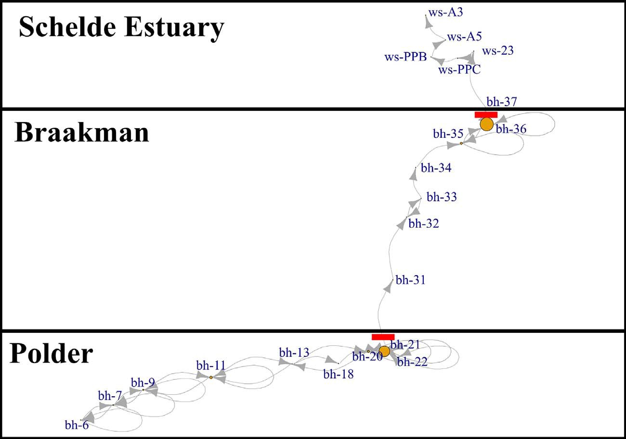Fig. 2. Unipartite network visualization of the trajectory of eel 29226. Each node represents an ALS (indicated by a yellow sphere with a location name) and the edges connecting the nodes are the movement patterns. The size of the node represents the total residence time for an eel at that ALS. The migration barriers are indicated with a red bar: in the polder the APS at Boekhoute and in the Braakman the tidal sluice with propeller pumps. Note that the thickness of the arrows does not indicate the number of movements between diﬀerent nodes. (For interpretation of the references to colour in this ﬁgure legend, the reader is referred to the web version of this article.)

number of migration records in the polder were observed at night (n = 82) compared to daytime (n = 22), while in the Braakman, the number of migration records at night was over ﬁfteen times higher (n = 228) compared to daytime (n = 15). In the SE, the diﬀerence in number of migration records between night and day was threefold (n = 124 and n = 33, respectively). Only four, two and four records were found during dawn in the polder, Braakman and SE, respectively, and only a single record was obtained during dusk, in the SE.

  - Onset of migration

The onset of migration of the tagged eels occurred between July 2012 and January 2015 (Fig. 5). Of the 50 tagged eels, 39 emigrated in 2012, seven in 2013, three in 2014 and one in 2015. The majority of the eels migrated in October (n = 36), while an equal number of emi- grating eels was found in July (n = 4), August (n = 4) and September (n = 4). Single eels started emigrating in December and January.

  - Environmental triggers of migration

In the polder, a signiﬁcant positive relationship was found between discharge and downstream eel migration (GLMM, κ = 0.55, esti- mated coeﬃcient = 0.1891 ± 0.0917, z value = 2.062, p = 0.0392; Table 2). This result was conﬁrmed by the RF (κ = 0.16), which also
selected discharge as the most important variable aﬀecting downstream eel migration (Table 3).
Weak positive relationships were found between downstream eel migration in the Braakman and the variables chloride (GLMM, κ = 0.14, estimated coeﬃcient = 0.00024 ± 0.00011, z value
= 2.103, p = 0.0354) and discharge (GLMM, κ = 0.14, estimated coeﬃcient = 0.00019 ± 0.00011, z value = 1.902, p = 0.0572). In addition, RF (κ = 0.11) selected discharge as the most important variable.
Finally, no signiﬁcant eﬀect of any of the measured variables was found in relation to downstream eel migration in the SE. A slightly non- signiﬁcant positive relationship with water temperature (GLMM, κ = 0.57, estimated coeﬃcient = 0.3015 ± 0.1574, z value = 1.916, p = 0.0554) was conﬁrmed by the RF (κ = 0.37), which selected water temperature as the most important variable.

- Discussion

  - Migration routes and impact of barriers on downstream migration behaviour

The main eel migration route in the polder was via the APS, as only two eels passed the low-head weir and migrated via the tidal sluice in Zeebrugge into the Belgian Part of the North Sea. The 48 downstream

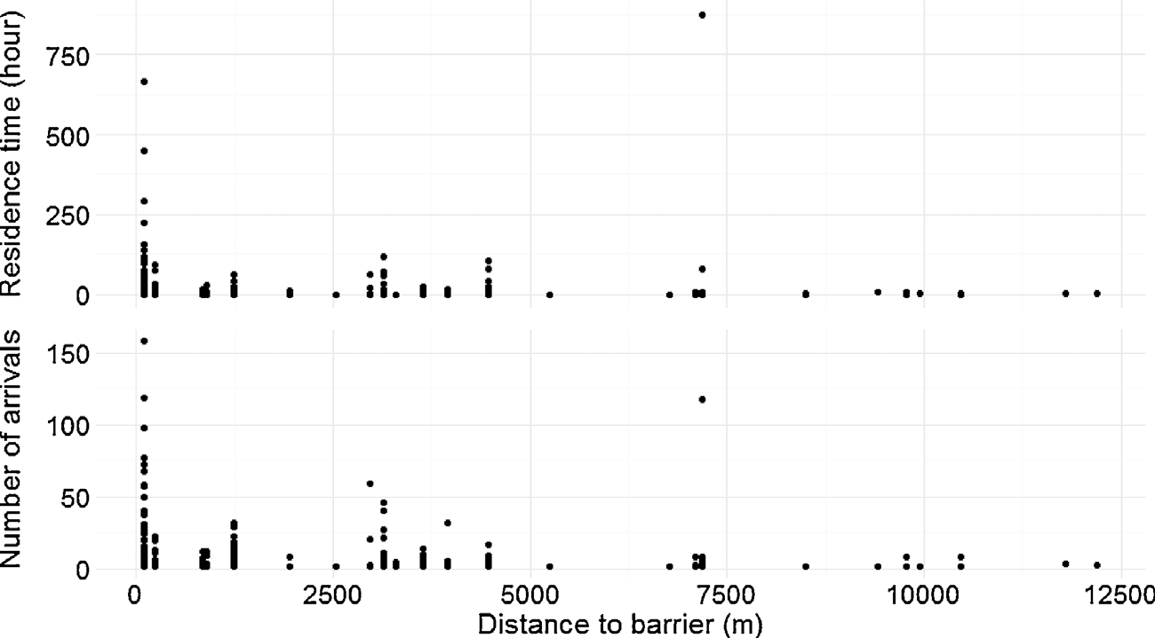Fig. 3. Residence time (upper) and number of arrivals (lower) as a function of upstream distance to a barrier. Both residence time and number of arrivals increased as the upstream distance to migration barriers decreased.

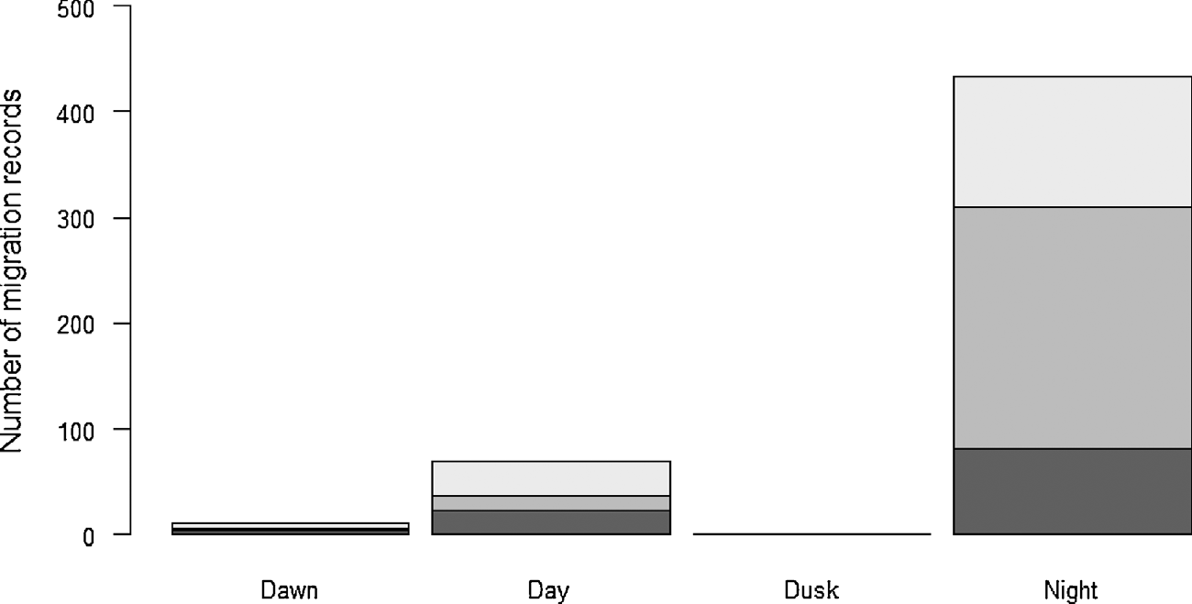Fig. 4. Number of migration records during the four circadian phases (dawn, day, dusk, night). Dark grey represents the number of records in the polder, medium-dark grey the Braakman and light grey the Schelde Estuary.

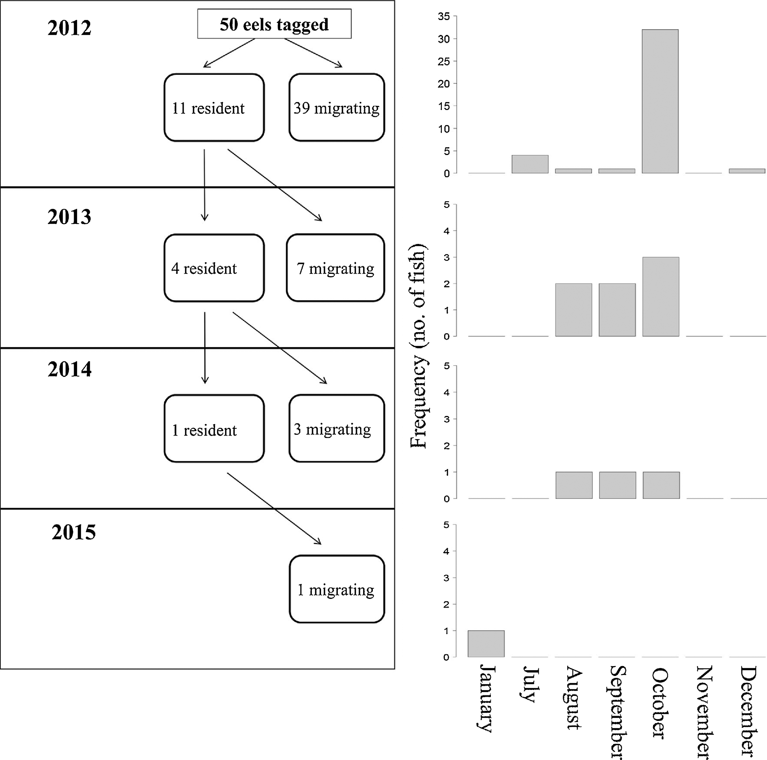

Fig. 5. Schematic overview with the number of eels tagged in 2012 and the number of resident (i.e. eels residing in the polder area) and emigrated eels in the subsequent years. The boxplots indicate the number of eels emigrated per month over each year.

Table 2
The output of the GLMMs for each of the three subareas (polder, Braakman, Schelde Estuary) after stepwise backward selection. For each model, the number of migratory (N1) and non-migratory (N2) records taken into account is given, as is the AIC, κ and the selected random eﬀect with the variance and standard deviation. For the intercept and the selected variables, the estimate, standard error (SE), Z value and P value are given.

Binomial GLMM (polder)

N1 = 108; N2 = 327
addition, although the Braakman was primarily dewatered grav- itationally during the study period, creating a temporary migration barrier, the mean residence time for migrating eels in the Braakman was 26 days. During this residence time, exploratory behaviour was observed with signiﬁcantly longer delays at the ALS near the tidal sluice. The discontinuous water ﬂow resulting from the APS and tidal sluice may not be suﬃcient or last long enough for eels to eﬀectively ﬁnd their way to the estuary. This may disorient the eels, resulting in

increased exploratory behaviour, which could lead to temporary mi-

AIC: 407; κ: 0.55

Random e ﬀect: month (var = 0.98; SD = 0.99); transmitter (var = 2.71; SD = 1.65)
Estimate SE Z value P value Intercept −0.6554 0.6224 −1.053 0.2923
Discharge 0.1891 0.0917 2.062 0.0392
Binomial GLMM (Braakman)
N = 245; N = 232
gration stops (Marmulla 2001). Another plausible reason is that the APS and propeller pumps in the tidal barrier caused a lot of disturbance (i.e. noise, turbulence…), resulting in a certain reluctance of the eels to migrate further downstream (Sand et al., 2000).
In this study, 11 of the 25 (44%) eels migrating through the APS remained in the Braakman. A plausible explanation for this behaviour would be mortality after passage of the APS. However, the 44% ob- served in our study was much higher than the aforementioned 19% mortality reported by Buysse et al. (2015) at the same APS. Possible explanations for this higher percentage could be delayed mortality or a

1 2
migration stop because of a reduced ﬁtness after injury (Ferguson et al.,

AIC: 655; κ: 0.14
Random eﬀect: month (var = 0.06; SD = 0.25)
2006). Migration stops due to insuﬃcient fat content (Svedäng and Wickström 1997) are unlikely as the polder area is located close to the sea. Delays attributed to acclimatization are also implausible since eels

Braakman chloride 0.00024 0.00011 2.103 0.0354
 | Estimate | SE | Z value | P value | can move frequently between fresh and salt water (Daverat et al., 2006)
 |  |  |  |  | and progression rates are often faster close to estuaries (Aarestrup et al.,
Intercept | −0.82530 | 0.37830 | −2.182 | 0.0291 | 2010; Bultel et al., 2014). As such, the impact of pumping stations on
Braakman discharge | 0.00019 | 0.00010 | 1.902 | 0.0572 | ﬁsh migration could be underestimated in studies based on netting

methods. Furthermore, piscivorous birds such as grey herons (Ardea
cinerea L.) and cormorants (Phalacrocorax carbo L.) are abundant in the
Binomial GLMM (Schelde Estuary)
study area, so tag loss due to predation cannot be excluded. Adding to

N1 = 162; N2 = 178

AIC: 372; κ: 0.57

Random eﬀect: transmitter (var = 5.091; SD = 2.256)
this, a commercial ﬁsherman was active at the mouth of the Braakman, except between September and November when it is legally prohibited to catch eels in The Netherlands. Although the ﬁsherman was able to identify and put back tagged eels, some eels may have gone uni-

dentiﬁed.

Estimate SE Z value P value

Intercept −1.8973 1.7344 −1.094 0.2740
Water temperature 0.3015 0.1574 1.916 0.0554
Once in the SE, the eels did not encounter physical migration barriers on their way to the sea. Nonetheless, diﬀerent migration behaviours were observed (Fig. 1). The westward migrating eels (n = 27) selected three

diﬀerent migration routes (centre, left and right estuary bank), while a non-
negligible proportion of eels (n = 7) even swam eastward. All these dif-

migrating eels taking the main migration route likely went through the APS and did not use the ﬁshway, since Buysse et al. (2015) caught no tagged eels in the ﬁshway from April 23rd 2012 to March 22nd 2013 (when 39 of the 50 tagged eels migrated) and concluded that the ﬁshway did not mitigate downstream eel migration. Further, none of the tagged eels migrated from the Braakman into the SE when the propeller pumps were active (dewatering via the propeller pumps was exceptional and occurred for 49 days during the study period). Eels showed increased exploratory behaviour and delays at the APS and tidal sluice, much like they do when encountering hydropower stations (Jansen et al., 2007; Piper et al., 2013, 2015b; Travade et al., 2010). In
ferent types of behaviour may be the result of the dynamic processes in the SE: tidal movements, ﬂuctuations in salinity, turbidity, oxygen and chemical composition of the water. The three migration routes of the westward mi- grating eels were probably attributed to diﬀerent currents related to bathymetric channels and sand banks. Three eels were only detected at the ALS downstream of the tidal sluice. Since they emigrated during gravita- tional ﬂow, injury is unlikely. They may have been predated by cormorants or have emigrated without being detected. Range tests in the Belgian part of the North Sea illustrated a mean detection range of 200 m, but this can be substantially reduced under conditions of strong currents or winds (Reubens et al. unpubl. data).

Table 3
Order of importance of environmental variables in driving eel migration as obtained by the RFs and backward selection process for the GLMMs for the three diﬀerent subareas (polder, Braakman pond and Schelde Estuary).

Order of importance | GLMM polder | GLMM Braakman pond | GLMM Schelde Estuary | RF polder (mean decrease in accuracy) | RF Braakman pond (mean decrease in accuracy) | RF Schelde Estuary (mean decrease in accuracy)
1 | Discharge | Braakman chloride | WS water | Discharge (104.00) | Braakman discharge (32.22) | WS water temperature
 |  |  | temperature |  |  | (92.26)
2 | Precipitation | Braakman discharge | Precipitation | Precipitation (64.10) | Precipitation (25.72) | Precipitation (69.49)
3 | Water | Air pressure | WS chloride | Water temperature | Braakman chloride (17.91) | Air pressure (60.09)
4 | temperature Air pressure | Gravitational ﬂow | Air pressure | (55.21)  Air pressure (50.59) | Water temperature (12.47) | WS chloride (57.17)
5 |  | Precipitation | Current direction |  | Air pressure (8.81) | Day length (42.34)
6 |  | Water temperature | Day length |  | Gravitational ﬂow (1.65) | Current direction (10.27)

For the seven eastward migrating eels, disorientation as a cause of tidal currents may have occurred, although some eels migrated east- ward when tidal direction was westward. It is possible that the eels were not ﬁt anymore for migration due to the delays or were still re- covering from injuries inﬂicted on them at the APS. Eels can postpone their migration in estuaries, probably due to insuﬃcient fat reserves (Aarestrup et al., 2008; Parker and McCleave 1997). As such, eels might have swam eastward up the estuary to proceed feeding until they were ﬁt enough again for migration. However, eels migrating westward could equally turn into a semi-yellow stage (Svedäng and Wickström 1997). This would imply that the silvering process is still reversible in late freshwater − early estuarine conditions (Svedäng and Wickström 1997). Despite the good coverage by the ALS arrays in the estuary, we cannot exclude that the eastward migrating eels later migrated to the North Sea without being detected on the array stretching from the left to the right bank due to the dynamic currents in the SE (Reubens et al. unpubl. data). Speciﬁcally, three of the seven eastward migrating eels changed their migration direction westwardly, but they were not de- tected on the ALS array stretching from the left to right SE bank.

  - Circadian pattern

Eels primarily migrated at night, which is in accordance with pre- vious studies (Aarestrup et al., 2008, 2010; Brown et al., 2009; Travade et al., 2010; Vøllestad et al., 1986) and with the general assumption of predator avoidance (Westerberg et al., 2007). Notably, nocturnal downstream migration was more pronounced in the Braakman than in the polder. A plausible explanation might be that the large numbers of cormorants (tens to hundreds) in the Braakman result in a higher pre- dator avoidance eﬀect in the eels and therefore a more pronounced nocturnal activity. Consequently, although gravitational ﬂow can occur twice every 24 h since it is dependent on low tide, the majority of the eels may only be able to pass the tidal barrier at night.
Especially in the SE, however, diurnal downstream migration also occurred, more frequently so than in the polder and Braakman. This is likely a consequence of the high turbidity of the SE (Bultel et al., 2014). Indeed, daytime activity of resident eels has been reported during periods of increased turbidity and/or during overcast weather (Baras et al., 1998; LaBar et al., 1987; McGovern and McCarthy 1992).

  - Onset of migration

Due to the large distribution range of the European eel, the onset of downstream migration varies between catchments depending on the travel distance to the spawning grounds (Tesch 2003). Considerable variation also exists within catchments: eels living in upstream loca- tions migrate earlier (Tesch 2003). Nonetheless, downstream migration generally takes place in autumn (September to December) (Righton et al., 2016; Tesch 2003; Vøllestad et al., 1986). Despite the relatively small catchment area (200 km2) studied here, substantial variation in onset of migration was observed (covering a period of six months (July
— January), but with a clear peak in October. However, the 24 eels caught at the APS in October were considered intercepted downstream migrating eels, so the onset of their migration may have occurred before October. This is in line with a ’parallel’ study by Buysse et al. (2015) at the APS of the LC, where the highest eel numbers were caught in July, October and December 2012, with a main peak in October. The broad period of six months indicates that mitigation actions for downstream migrating eels may need to cover a broader time window than the commonly referred autumn months.

  - Environmental trigger of migration

Discharge appeared to be the primary trigger of migration in the polder, corroborating observations at the APS of the LC, where eels passed mostly during high discharge events (Buysse et al., 2015), as
well as earlier studies (Travade et al., 2010; Vøllestad et al., 1986). It is generally assumed that eels migrating downstream take the en- ergetically most favourable route to their spawning grounds (van Ginneken and van den Thillart, 2000) as they do not feed during mi- gration (Chow et al., 2010; Tesch 2003) and rely on their fat reserves for both migration and spawning. As such, swimming along with the current gives the eel an energetic advantage.
In the Braakman, a weak, but signiﬁcantly positive relationship of migration behaviour with chloride concentration was found. It is pos- sible that eels used saltwater intrusions during gravitational ﬂow to ﬁnd their way to the estuary. In contrast to the polder, no signiﬁcant re- lationship with discharge or gravitational ﬂow was found. The dis- charge and gravitational ﬂow probably were not substantial or did not last long enough for eels to show a signiﬁcant response. This was conﬁrmed by the long residence time of eels in the Braakman (cfr. 4.1).
It is still unclear which estuarine cues guide eels to the sea; probably a hierarchical interaction of diﬀerent directional cues is used (Barbin et al., 1998). In this study, a positive relationship between water tem- perature and migration was revealed by the statistical models. In au- tumn and winter, the North Sea water is warmer than that of the SE; no water column stratiﬁcation is present in the SE. It is therefore plausible that, once in estuarine conditions, eels positively react to higher water temperatures for guidance to the sea. Furthermore, it has been shown that eels use selective tidal stream transport to migrate in an en- ergetically favorable way (Béguer-Pon et al., 2014; McCleave and Arnold 1999; Parker and McCleave 1997), but no such relation was found in our study. However, we cannot exclude the use of selective tidal stream transport, because the estuarine behaviour comprises only the initial encounter of the eels with the tidal environment, and they may require some time to ‘adapt’ to the tidal rhythm (Barbin et al., 1998).

  - Management recommendations

Understanding and mapping eel migration routes from inland wa- ters to the sea is extremely important in view of the critically en- dangered status of the European eel, the population of which is still declining (Dekker 2016). The goals of the European Eel Regulation, i.e. that 40% of the emigrating eels should reach the sea, are still not met (Dekker 2016). This study analysed downstream eel migration beha- viour from a freshwater polder into an estuary. We found that 64% of the tagged emigrating eels reached estuarine and marine areas during the study period, conﬁrming the negative impact of migration barriers on eels. The barriers not only aﬀect eels directly via mortality and in- juries (Buysse et al., 2015), they also cause signiﬁcant delays and ex- ploratory behaviour, likely due to discontinuous ﬂow conditions. These negative impacts of barriers on downstream eel migration may sub- stantially impact the eels’ chances to contribute to the spawning po- pulation (Brown et al., 2009; Jansen et al., 2007; Piper et al., 2013, 2015a, 2015b; Travade et al., 2010).
Polder areas and pumping stations exist all over the world, and many are under construction to deal with climate change impacts and sea level rises, creating migration barriers to diadromous ﬁsh species like the eel. As diadromous species show seasonal spawning migration under speciﬁc conditions, a possible cost-eﬀective management mea- sure could be ‘temporal barrier management’ (Piper et al., 2013). Bar- riers could temporarily be removed when migration conditions are met, during so-called environmental windows, a concept commonly applied with dredging operations (Suedel et al., 2008) and recently also to improve glass eel colonization of freshwater systems (Mouton et al., 2011b). In addition, if eﬀective ﬁsh-friendly adaptations to pumping stations are not present, gravitational ﬂow should be stimulated during the environmental windows.
Since eels in freshwater systems mainly migrate at night and during periods of high discharge, a stimulation of gravitational ﬂow under such conditions could probably increase the number of eels reaching

the sea and contributing to the spawning population. Notably, the duration of this mitigation action needs to be suﬃcient so that a con- tinuous ﬂow over a longer time period is generated. However, the duration may be dependent on the study area and requires further re- search.
Indeed, since the end of 2015, Flemish water managers (Flemish Environment Agency and Waterwegen en Zeekanaal NV) have been taking actions to stimulate gravitational ﬂow: the weir in Sint-Laureins has been lowered, such that the polder can be dewatered through gravitational ﬂow towards Zeebrugge. However, during periods of high precipitation (especially autumn and winter), dewatering towards Zeebrugge is insuﬃcient, leading to activation of the APS in Boekhoute. To stimulate gravitational ﬂow, a possible mitigation action would be to reduce the water level of the Braakman below the level of the polder in autumn.

Acknowledgements

P. Verhelst holds a doctoral grant from the Flemish Agency for Innovation & Entrepreneurship (VLAIO). R. Baeyens, N. De Maerteleire,
E. Gelaude, Y. Jacobs, S. Pieters and K. Robberechts assisted with the data collection. The authors want to thank S. Gobeyn (UGent) and T. Van Daele (INBO) for advice considering the GLMM development. This manuscript has beneﬁtted from a statistical consult with the Ghent University FIRE service (Fostering Innovative Research based on Evidence). This research was ﬁnanced by the Agency Nature and Forest (ANB) and the Fisheries Fund of the Flemish Governement. Furthermore, this work was supported by data and infrastructure pro- vided by the INBO and VLIZ (RV Simon Stevin and RHIB Zeekat) as part of the Flemish contribution of the LifeWatch ESFRI observatory. We would also like to thank the Royal Belgian Institute of Natural Sciences, Operational Direction Natural Environment (RHIB Tuimelaar) for in- frastructure provision and Rijkswaterstaat for their cooperation and the permission to use their marine buoys. Furthermore, we thank M. Lauwers (Flemish Environment Agency), Marius van Wingerden (Scheldestromen Water Board) and Jan-Rolf Hendriks (Rijkswaterstaat) for providing environmental data.

References

Aarestrup, K., Thorstad, E., Koed, A., Jepsen, N., Svendsen, J.C., Pedersen, M.I., Skov, C., Økland, F., 2008. Survival and behaviour of European silver eel in late freshwater and early marine phase during spring migration. Fish. Manage. Ecol. 15, 435–440.
Aarestrup, K., Thorstad, E.B., Koed, A., Svendsen, J.C., Jepsen, N., Pedersen, M.I., Økland, F., 2010. Survival and progression rates of large European silver eel Anguilla anguilla in late freshwater and early marine phases. Aquat. Biol. 9, 263–270.
Béguer-Pon, M., Castonguay, M., Benchetrit, J., Hatin, D., Verreault, G., Mailhot, Y., Tremblay, V., Lefaivre, D., Legault, M., Stanley, D., 2014. Large-scale migration patterns of silver American eels from the St. Lawrence River to the Gulf of St. Lawrence using acoustic telemetry. Can. J. Fish. Aquat.Sci. 71, 1579–1592.
Baras, E., Jeandrain, D., 1998. Evaluation of surgery procedures for tagging eel Anguilla anguilla with biotelemetry transmitters. Hydrobiologia 371, 107–111.
Baras, E., Jeandrain, D., Serouge, B., Philippart, J.-C., 1998. Seasonal variations in time and space utilization by radio-tagged yellow eels Anguilla anguilla (L.) in a small stream. Advances in Invertebrates and Fish Telemetry. Springer.
Barbin, G.P., Parker, S.J., McCleave, J.D., 1998. Olfactory clues play a critical role in the estuarine migration of silver-phase American eels. Environ. Biol. Fishes 53, 283–291. Bates, D., Mächler, M., Bolker, B., Walker, S., 2014. Fitting Linear Mixed-eﬀects Models
Using Lme4. (arXiv preprint arXiv:14065823.).
Baumgartner, L., Reynoldson, N., Cameron, L., Stanger, J., 2009. Eﬀects of irrigation pumps on riverine ﬁsh. Fish. Manage. Ecol. 16, 429–437.
Beatty, S.J., Morgan, D.L., Lymbery, A.J., 2014. Implications of climate change for po- tamodromous ﬁshes. Global Change Biol. 20, 1794–1807.
Boggs, C., Keefer, M.L., Peery, C., Bjornn, T.C., Stuehrenberg, L.C., 2004. Fallback, re- ascension, and adjusted ﬁshway escapement estimates for adult Chinook salmon and steelhead at Columbia and Snake River dams. Trans. Am. Fish. Soc. 133, 932–949.
Breiman, L., 2001. Random forests. Mach. Learn. 45, 5–32.
Brown, L., Haro, A., Castro-Santos, T., 2009. Three-dimensional movement of silver-phase American eels in the forebay of a small hydroelectric facility. Eels at the Edge: Science, Status, and Conservation Concerns American Fisheries Society, Symposium.
Bultel, E., Lasne, E., Acou, A., Guillaudeau, J., Bertier, C., Feunteun, E., 2014. Migration behaviour of silver eels (Anguilla anguilla) in a large estuary of Western Europe in- ferred from acoustic telemetry. Estuarine. Coastal Shelf Sci. 137, 23–31.
Buysse, D., Mouton, A., Stevens, M., den Neucker, T., Coeck, J., 2014. Mortality of European eel after downstream migration through two types of pumping stations. Fish. Manage. Ecol. 21, 13–21.
Buysse, D., Mouton, A., Baeyens, R., Coeck, J., 2015. Evaluation of downstream migration mitigation actions for eel at an Archimedes screw pump pumping station. Fish.
Manage. Ecol. 22, 286–294.
Calenge, C., 2006. The package adehabitat for the R software: a tool for the analysis of space and habitat use by animals. Ecol. Modell. 197, 516–519.
Chow, S., Kurogi, H., Katayama, S., Ambe, D., Okazaki, M., Watanabe, T., Ichikawa, T., Kodama, M., Aoyama, J., Shinoda, A., 2010. Japanese eel Anguilla japonica do not assimilate nutrition during the oceanic spawning migration: evidence from stable isotope analysis. Mar. Ecol. Prog. Ser. 402, 233–238.
Clay, C.H., 1994. Design of Fishways and Other Fish Facilities. CRC Press.
Cohen, J., 1960. A coeﬃcient of agreement for nominal scales. Educ. Psychol. Meas. 20, 37–46.
Cutler, D.R., Edwards, T.C., Beard, K.H., Cutler, A., Hess, K.T., Gibson, J., Lawler, J.J., 2007. Random forests for classiﬁcation in ecology. Ecology 88, 2783–2792.
Daverat, F., Limburg, K.E., Thibault, I., Shiao, J.-C., Dodson, J.J., Caron, F., Tzeng, W.-N., Iizuka, Y., Wickström, H., 2006. Phenotypic plasticity of habitat use by three tem- perate eel species, Anguilla anguilla: a. japonica and A. rostrata. Mar. Ecol. Prog. Ser. 231–241.
Dekker, W., Casselman, J.M., 2014. The 2003 Québec Declaration of Concern about eel declines—11 years later: are eels climbing back up the slippery slope? Fisheries 39, 613–614.
Dekker, W., 2016. Management of the eel is slipping through our hands! Distribute control and orchestrate national protection. ICES J. Mar. Sci (Journal du Conseil:fsw094.).
Dormann, C.F., Elith, J., Bacher, S., Buchmann, C., Carl, G., Carré, G., Marquéz, J.R.G., Gruber, B., Lafourcade, B., Leitão, P.J., 2013. Collinearity: a review of methods to deal with it and a simulation study evaluating their performance. Ecography 36, 27–46.
Durif, C., Dufour, S., Elie, P., 2005. The silvering process of Anguilla anguilla: a new classiﬁcation from the yellow resident to the silver migrating stage. J. Fish Biol. 66, 1025–1043.
Falke, J.A., Gido, K.B., 2006. Spatial eﬀects of reservoirs on ﬁsh assemblages in Great Plains streams in Kansas USA. River Res. Appl. 22, 55–68.
Ferguson, J.W., Absolon, R.F., Carlson, T.J., Sandford, B.P., 2006. Evidence of delayed mortality on juvenile Paciﬁc salmon passing through turbines at Columbia River dams. Trans. Am. Fish. Soc. 135, 139–150.
Feunteun, E., 2002. Management and restoration of European eel population (Anguilla anguilla): an impossible bargain. Ecol. Eng. 18, 575–591.
Fukuda, S., De Baets, B., Waegeman, W., Verwaeren, J., Mouton, A.M., 2013. Habitat prediction and knowledge extraction for spawning European grayling (Thymallus thymallus L.) using a broad range of species distribution models. Environ. Modell. Software 47, 1–6.
Goethals, P.L., Dedecker, A.P., Gabriels, W., Lek, S., De Pauw, N., 2007. Applications of artiﬁcial neural networks predicting macroinvertebrates in freshwaters. Aquat. Ecol. 41, 491–508.
Gowans, A., Armstrong, J., Priede, I., 1999. Movements of adult Atlantic salmon in re- lation to a hydroelectric dam and ﬁsh ladder. J. Fish Biol. 54, 713–726.
Hadderingh, R., Van Aerssen, G., De Beijer, R., Van Der Velde, G., 1999. Reaction of silver eels to artiﬁcial light sources and water currents: an experimental deﬂection study. River Res. Appl. 15, 365–371.
Hannah, D.M., Sadler, J.P., Wood, P.J., 2007. Hydroecology and Ecohydrology: Challenges and Future Prospects. John Wiley and Sons, Hoboken, NJ.
Hermoso, V., Clavero, M., 2011. Threatening processes and conservation management of endemic freshwater ﬁsh in the Mediterranean basin: a review. Mar. Freshwater Res. 62, 244–254.
Jacoby, D.M., Freeman, R., 2016. Emerging network-based tools in movement ecology.
Trends Ecol. Evol. 31, 301–314.
Jacoby, D., Gollock, M., 2014. Anguilla. The IUCN Red List of Threatened Species.
Version .2014 2.
Jansen, H.M., Winter, H.V., Bruijs, M.C., Polman, H.J., 2007. Just go with the ﬂow?: Route selection and mortality during downstream migration of silver eels in relation to river discharge. ICES J. Mar. Sci. 64, 1437–1443 Journal du Conseil.
Køie, M., 1991. Swimbladder nematodes (Anguillicola spp.) and gill monogeneans (Pseudodactylogyrus spp:) parasitic on the European eel (Anguilla anguilla). ICES J. Mar. Sci. 47, 391–398.
Keefer, M.L., Peery, C.A., Bjornn, T.C., Jepson, M.A., Stuehrenberg, L.C., 2004.
Hydrosystem, dam, and reservoir passage rates of adult Chinook salmon and steel- head in the Columbia and Snake rivers. Trans. Am. Fish. Soci. 133, 1413–1439.
LaBar, G.W., Hernando Casal, J.A., Delgado, C.F., 1987. Local movements and population size of European eels, Anguilla anguilla, in a small lake in southwestern Spain.
Environ. Biol. Fishes 19, 111–117.
Lassalle, G., Crouzet, P., Rochard, E., 2009. Modelling the current distribution of European diadromous ﬁshes: an approach integrating regional anthropogenic pres- sures. Freshwater Biol. 54, 587–606.
Lavielle, M., 1999. Detection of multiple changes in a sequence of dependent variables.
Stochastic Processes Appl. 83, 79–102.
Lavielle, M., 2005. Using penalized contrasts for the change-point problem. Signal

Process. 85, 1501–1510.
Liaw, A., Wiener, M., 2002. Classiﬁcation and regression by randomForest. R News 2, 18–22.
Maceda-Veiga, A., 2013. Towards the conservation of freshwater ﬁsh: iberian Rivers as an example of threats and management practices. Rev. Fish Biol. Fish. 23, 1–22.
Marmulla, G., 2001. Dams, ﬁsh and ﬁsheries: opportunities challenges and conﬂict re- solution. Food Agric. Org.
McCleave, J., Arnold, G., 1999. Movements of yellow-and silver-phase European eels (Anguilla anguilla L.) tracked in the western North Sea. ICES J. Mar. Sci. 56, 510–536 Journal du Conseil.
McGovern, P., McCarthy, T., 1992. Local movements of freshwater eels (Anguilla anguilla L.) in western Ireland. Wildlife Telemetry: Remote Monitoring and Tracking of Animals. pp. 319.
Miller, M.J., Tsukamoto, K., 2016. The ecology of oceanic dispersal and survival of an- guillid leptocephali. Can. J. Fish. Aquat.Sci. 74, 958–971.
Moriarty, C., Dekker, W., 1997. Management of European eel ﬁsheries. Irish Fish.
Bull. 15.
Mouton, A.M., De Baets, B., Goethals, P.L., 2010. Ecological relevance of performance criteria for species distribution models. Ecol. Modell. 221, 1995–2002.
Mouton, A.M., Alcaraz-Hernández, J.D., De Baets, B., Goethals, P.L., Martínez-Capel, F., 2011a. Data-driven fuzzy habitat suitability models for brown trout in Spanish Mediterranean rivers. Environ. Modell. Software 26, 615–622.
Mouton, A.M., Stevens, M., Van den Neucker, T., Buysse, D., Coeck, J., 2011b. Adjusted barrier management to improve glass eel migration at an estuarine barrier. Mar. Ecol. Prog. Ser. 439, 213–222.
Parker, S.J., McCleave, J.D., 1997. Selective tidal stream transport by American eels during homing movements and estuarine migration. J. Mar. Biol. Assoc. United Kingdom 77, 871–889.
Piper, A.T., Wright, R.M., Walker, A.M., Kemp, P.S., 2013. Escapement, route choice, barrier passage and entrainment of seaward migrating European eel Anguilla angu- illa, within a highly regulated lowland river. Ecol. Eng. 57, 88–96.
Piper, A.T., Manes, C., Siniscalchi, F., Marion, A., Wright, R.M., Kemp, P.S., 2015a.
Response of seaward-migrating European eel (Anguilla anguilla) to manipulated ﬂow ﬁelds. Proc. R. Soc. B.
Piper, A.T., Svendsen, J.C., Wright, R.M., Kemp, P.S., 2015b. Movement patterns of seaward migrating European eel (Anguilla anguilla) at a complex of riverine barriers: implications for conservation. Ecol. Freshwater Fish.
Righton, D., Westerberg, H., Feunteun, E., Økland, F., Gargan, P., Amilhat, E., Metcalfe, J., Lobon-Cervia, J., Sjöberg, N., Simon, J., 2016. Empirical observations of the spawning migration of European eels: the long and dangerous road to the Sargasso Sea. Sci. Adv. 2, e1501694.
Roscoe, D.W., Hinch, S.G., 2010. Eﬀectiveness monitoring of ﬁsh passage facilities: his- torical trends, geographic patterns and future directions. Fish Fish. 11, 12–33.
Sand, O., Enger, P.S., Karlsen, H.E., Knudsen, F., Kvernstuen, T., 2000. Avoidance re- sponses to infrasound in downstream migrating European silver eels, Anguilla an- guilla. Environ. Biol. Fishes 57, 327–336.
Suedel, B.C., Kim, J., Clarke, D.G., Linkov, I., 2008. A risk-informed decision framework for setting environmental windows for dredging projects. Sci. Total Environ. 403, 1–11.
Svedäng, H., Wickström, H., 1997. Low fat contents in female silver eels: indications of insuﬃcient energetic stores for migration and gonadal development. J. Fish Biol. 50, 475–486.
Team, R.D.C., 2015. R: A Language and Environment for Statistical Computing (version 3.2.2). R Foundation for Statistical Computing, Vienna, Austria. http://www.R- project.org.
Tesch, F., 2003. The Eel. Oxford, UK.
Thompson, A., Glasgow, J., Buehrens, T., Drucker, E., 2011. Mortality in juvenile sal- monids passed through an agricultural Hidrostal pump. Fish. Manage. Ecol. 18, 333–338.
Travade, F., Larinier, M., Subra, S., Gomes, P., De-Oliveira, E., 2010. Behaviour and passage of European silver eels (Anguilla anguilla) at a small hydropower plant during their downstream migration. Knowledge and Management of Aquatic Ecosystems. pp. 01.
van Ginneken, V.J., van den Thillart, G.E., 2000. Physiology: eel fat stores are enough to reach the Sargasso. Nature 403, 156–157.
Vøllestad, L., Jonsson, B., Hvidsten, N., Naesje, T., Haraldstad, Ø., Ruud-Hansen, J., 1986.
Environmental factors regulating the seaward migration of European silver eels (Anguilla anguilla). Can. J. Fish. Aquat.Sci. 43, 1909–1916.
Verhelst, P., Boets, P., Van Thuyne, G., Verreycken, H., Goethals, P.L., Mouton, A.M., 2016. The distribution of an invasive ﬁsh species is highly aﬀected by the presence of native ﬁsh species: evidence based on species distribution modelling. Biol. Invasions 18, 427–444.
Verhelst, P., Reubens, J., Pauwels, I.S., Buysse, D., Aelterman, B., Van Hoey, S., Goethals, P.L., Moens, T., Coeck, J., Mouton, A., 2017. Movement behaviour of large female yellow European eel (Anguilla anguilla L.) in a freshwater polder area. Ecol.
Freshwater Fish.
Westerberg, H., Lagenfelt, I., Svedäng, H., 2007. Silver eel migration behaviour in the baltic. ICES J. Mar. Sci. 64, 1457–1462 Journal du Conseil.
Zuur, A., Ieno, E.N., Walker, N.J., Saveliev, A.A., Smith, G.M., 2009. Mixed Eﬀects Models and Extensions in Ecology with R. Springer, New York.
Zuur, A.F., Ieno, E.N., Elphick, C.S., 2010. A protocol for data exploration to avoid common statistical problems. Methods Ecol. Evol. 1, 3–14.

