Assessing Agricultural Damage by Wild Boar Using Drones

ANNELEEN RUTTEN ,1 Evolutionary Ecology Group, Department of Biology, University of Antwerp, Universiteitsplein 1, B-2610 Antwerp, Belgium ; and Research Group Wildlife Management, Research Institute for Nature and Forest (INBO), Havenlaan 88 bus 73, B-1000 Brussels, Belgium
JIM CASAER , Research Group Wildlife Management, Research Institute for Nature and Forest (INBO), Havenlaan 88 bus 73, B-1000 Brussels, Belgium
MARJOLEIN F. A. VOGELS, Faculty of Geosciences, Department of Physical Geography, Utrecht University, Princetonlaan 8a, NL-3584 CB Utrecht, The Netherlands
ELISABETH A. ADDINK, Faculty of Geosciences, Department of Physical Geography, Utrecht University, Princetonlaan 8a, NL-3584 CB Utrecht, The Netherlands
JEROEN VANDEN BORRE , Research Group Biotope Diversity, Research Institute for Nature and Forest (INBO), Havenlaan 88 bus 73, B-1000 Brussels, Belgium
HERWIG LEIRS, Evolutionary Ecology Group, Department of Biology, University of Antwerp, Universiteitsplein 1, B-2610 Antwerp, Belgium

ABSTRACT In Flanders (northern Belgium), wild boar (Sus scrofa) returned in 2006 after 50 years of absence and the population is increasing, both in abundance and geographic extent. In the absence of wild boar, Flanders’ landscape structure changed into a dense, mosaic-like pattern of agricultural, natural, and urban areas. The return of the wild boar increasingly leads to human–wildlife conflicts, mainly linked to damage in agriculture. Hence, there is a growing need for a time-efficient, standardized, and accurate method to assess crop damage. We present an Unmanned Aerial Vehicle-based method, using Geographic Object-Based Image Analysis and Random Forests to estimate the damaged area and associated yield losses, between 2015 and 2017, due to wild boar in individual fields in Flanders. Our approach resulted in an 84.50% overall accuracy in calculating damaged area for maize fields and 94.40% for grasslands. Damage levels ranged between 14.3% and 20.2% in maize fields and 16.5% to 25.4% in grasslands. Our method can provide objective base data for compensation schemes and guide management strategies based on damage assessments.

KEY WORDS Belgium, crop damage, GEOBIA, Geographic Object-Based Image Analysis, UAV, wildlife damage.

Wild boar (Sus scrofa) is one of the most widespread mammal species of the world (Massei and Genov 2004, Keuling et al. 2018) with populations expanding throughout Europe since the 1960s (Saez-Royuela and Telleria 1986, Bieber and Ruf 2005, Acevedo et al. 2007, Massei et al. 2015). Expanding abundance of wild boar is challenging for both conservation (Barrios-Garcia and Ballari 2012) and society because human–wildlife conflicts arise linked to damage to crops (including rooting of grasslands), traffic collisions, and disease transmission (Bieber and Ruf 2005, Treves et al. 2006, Amici et al. 2012, Morelle et al. 2013, Massei et al. 2015). In Flanders (northern Belgium), where wild boar was absent for more than half a century, the species returned in 2006 and its population is increasing rapidly (Scheppers et al. 2014). During the past few decades, landscapes in Flanders have changed dramatically due to urbanization, agricultural

1E-mail: anneleen.rutten@uantwerpen.be
intensification, and fragmentation. Flanders has become one of the most densely populated areas in Europe: 462 persons/ km2 (Linell et al. 2001; FOD Economie, unpublished report). A fragmented structure with a mosaic-like pattern composed of small natural areas, forest remnants, agricultural areas, and urbanized areas, which are all crossed by a dense road network (5.2 km/km2), characterizes the landscape. This results in a situation with frequent wildlife–human interactions and wildlife-related effects that warrant man- agement attention (Riley et al. 2003).
Like many countries and regions in Europe, crop damage by wild boar is not monitored in Flanders and no compensations are paid. Therefore, we lack knowledge on the current extent of crop damage and associated losses for the agricultural sector. Yet, the magnitude of crop damage by wild boar can be significant as shown in some surrounding countries and regions (Schley et al. 2008 for Luxembourg, Carnis and Facchini 2012 for France, Faunafonds 2014 for the Netherlands, Widar and Luxen 2016 for Wallonia). However, assessments are done by a variety of methods because currently no well-established and accepted method

exists to assess damage in an accurate and objective manner (Michez et al. 2016). Moreover, farmers who are the most affected stakeholders report an increasing need for monitor- ing crop damage by wild boar. Consequently, there is a need for a standardized monitoring of crop damage by wild boar. Any methods to assess crop damage should be standard- ized, objective, accurate, time-efficient, allow a full assess- ment, and applicable to different crops. Existing methods include ground visits with visual assessment, mapping damage spots with handheld Global Positioning System (GPS; Engeman et al. 2007a, Felix et al. 2014), and estimations extrapolated from randomly selected transects or plots (Cushman et al. 2004, Chavarria et al. 2007, Engeman et al. 2007b). These approaches do not meet all of the desired requirements because they are either time-consuming, subjective, or unsuitable for larger areas. A suitable method should be able to provide data both for damage compensation schemes and modeling socio-economic impacts of compet-
ing management strategies (Reyns et al. 2018).
The advantage of using photographs to assess rooting by wild boar was been shown by Engeman et al. (2016), who took photographs of damaged grasslands in the mountainous landscape of Romania from vantage points and assessed damaged area using Geographic Information System by manually outlining rooted areas. Although they showed this method to be quick and efficient, it can only be used in mountainous areas; but, they suggested that this method could also be applied using drones. The use of camera- equipped Unmanned Aerial Vehicles (UAV), “drones” might indeed offer a practical solution. In recent years, use of drones has strongly increased because of easier access, flexible data- acquisition possibilities and reduced costs (Salami et al. 2014). Drones offer continuous coverage, collect data at centimeter resolution, require little training to operate, and
can be deployed at short notice. Michez et al. (2016) and Ku�zelka and Surov'y (2018) recently showed how drones can
be used to assess crop damage by wild boar in maize (corn) and wheat fields using generated photogrammetric digital elevation models from aerial photographs taken with a drone, where a threshold in height difference allowed them to distinguish damaged from undamaged crops. However, Michez et al. (2016) also outlined that this method is less applicable to crop types where damage does not involve height difference like grasslands. A manual delineation would be more applicable in croplands, but this is not objective and involves a time-consuming procedure. There- fore, an automated processing flow is desired (Engeman et al. 2016). Geographic Object-Based Image Analysis (GEO- BIA), in which pixels are grouped into informative objects, that is, coherent landscape elements (Blaschke 2010, Addink et al. 2012), is a technique that can be used as a standardized semiautomated method for interpretation of aerial photo- graphs (Addink et al. 2010, Blaschke et al. 2014, Vogels et al. 2017). Geographic Object-Based Image Analysis has been shown to be useful in assessing the severity of crop damage by insects on sorghum crops (Puig et al. 2015) and mapping cane grub (Dermolepida albohirtum) damage on sugarcane plants (Johansen et al. 2014, 2017). We investigated whether
GEOBIA can be an appropriate technique to analyze aerial photos of fields damaged by wild boar in an accurate and semiautomated workflow.
We developed a semiautomated workflow to assess crop damage at the field level on UAV imagery. Our objectives were 1) assessing the accuracy with which crop damage can be calculated using GEOBIA; 2) assessing the variation of damaged area in damaged fields; and 3) assessing the time- and cost-efficiency of damage estimation from UAV images.

STUDY AREA
Flanders (northern Belgium) had a highly fragmented land cover with 11.4% forest coverage and 53% agricultural coverage (Demolder et al. 2014). The distribution of wild boar in Flanders was largely limited to the eastern province of Limburg and some eastern municipalities in the province of Antwerp (Scheppers et al. 2014). In Limburg, the area where most damages were reported by farmers was selected based on the results of an online survey (Rutten et al., unpublished data; Fig. 1). Farmers within the study area could report crop damage by wild boar in the scope of this research. All reported damage cases from 2015, 2016, and 2017 were assessed and included in this study.

METHODS

Data Acquisition
When farmers reported crop damage by wild boar, we photographed the damaged field using a UAV (DJI Phantom 3 Advanced using default included camera: 12 megapixel, f/2.8, 948 field of view; DJI, Shenzhen, China) just before harvesting maize fields or shortly after reporting damage in grasslands. Using the Pix4D Capture App (Pix4D S.A., Lausanne, Switzerland) as a flight planner while flying at 40–45-m height, we took serial photos with 80–85% overlap between photos. Afterward we stitched photographs into a georeferenced orthophoto using Agisoft Photoscan (Agisoft LLC, St. Petersburg, Russia) or ENVI Onebutton (Icaros, Fairfax, VA). We clipped individual fields from the orthophotos to exclude the surrounding landscape from the analysis. In total, we photographed 133 damaged fields (Excel Table S1, available online in Supporting Information).

Geographic Object-Based Image Analysis
Principle.—Geographic Object-Based Image Analysis is a technique in which classification of the photographs is not based on pixels, but on objects. These represent groups of neighboring pixels that are spectrally similar (Addink et al. 2010, Blaschke 2010). Subsequent classification of objects is not limited to spectral information (as is characteristic for pixel-based approaches), but classification can be based on information on overall color and tone, texture, pattern, shape, shadow, context, and size of objects (Blaschke et al. 2014). This makes the workflow of GEOBIA similar to our human visual perception of the world, so coherent landscape elements can be defined and used for landscape classification (Addink et al. 2012). Our specific goal was to classify damaged fields into undamaged and damaged areas.

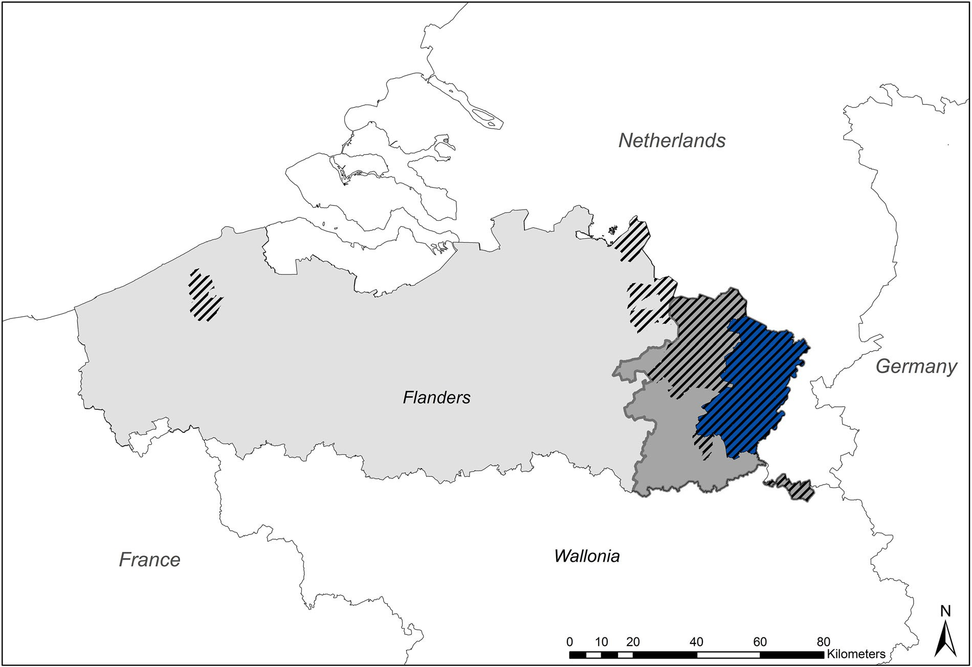

Figure 1. Location of study area (blue) in the province of Limburg (dark gray) and Flanders (northern part of Belgium, light gray) in which 133 crop fields damaged by wild boar have been photographed via drone between 2015 and 2017. Dashed areas: distribution area of wild boar in Flanders in 2014.

Image segmentation.—Geographic Object-Based Image Analysis starts with a segmentation step in which we segmented orthophotos into objects representing meaning- ful landscape elements. We performed this segmentation using the eCognition1 Developer software (Trimble Inc., Westminster, CO, USA). We grouped pixels into homogeneous objects using multiresolution segmentation, which is based on a heterogeneity threshold considering both spectral similarity and shape characteristics. In subsequent steps, we merged small objects into larger objects until the heterogeneity threshold is reached (Benz et al. 2004). We visually optimized the threshold such that the objects were as large as possible while representing
either damaged or undamaged crops, avoiding a combina- tion of the 2 classes (Fig. 2).

Random Forest Models
We performed classification of objects using the Random Forest (RF) algorithm (Breiman 2001) based on a set of 25 attributes describing shape (4), texture (8), and spectral properties (13) of the objects (Excel Table S2, available online in Supporting Information). The Random Forest is a robust classifier that makes predictions based on a training set (independent variables) using multiple decision trees. Random Forests are increasingly used in land-use and land-cover classifications (Rodriguez-Galiano et al. 2012). We created the Random Forests in this study using the
randomForest package (Liaw and Wiener 2002) available in the R software environment (R Studio, Boston, MA, USA). We built a RF-model separately for maize and grasslands, with the number of trees set to 10,000 for each model. We initially trained the RF-models on information from the maize fields and grasslands of 2016. Ideally, the RF-model would classify data from any year with similar accuracy values, without the need for calibration when a new set of photos arrives. When the accuracy for the 2016 RF-model was rather low (we set an arbitrary limit of 80% overall accuracy, which we regarded the absolute minimum), we added fields from other years (2015 and 2017) to include interannual variation because this notably influences model performance. For maize fields, preliminary model building indeed showed that based on 22 segmented orthophotos of maize fields of 2016, model performance did not reach 80% overall accuracy; therefore, we added 5 extra maize fields of 2015 and 5 of 2017 resulting in 32 total fields. This was not the case for grasslands because model performance reached the 80% threshold of accuracy, so we only used 26 fields of
2016 for the RF-grassland model.
For each field, we constructed a training and a validation data set by visually interpreting randomly selected objects: in each field we assigned 2:100 objects to damage, 100 to crop (maize or grass), 100 to bare soil (for maize fields only, to differentiate damage from bare soil between maize rows), and 100 objects to undamaged areas shaded by nearby trees

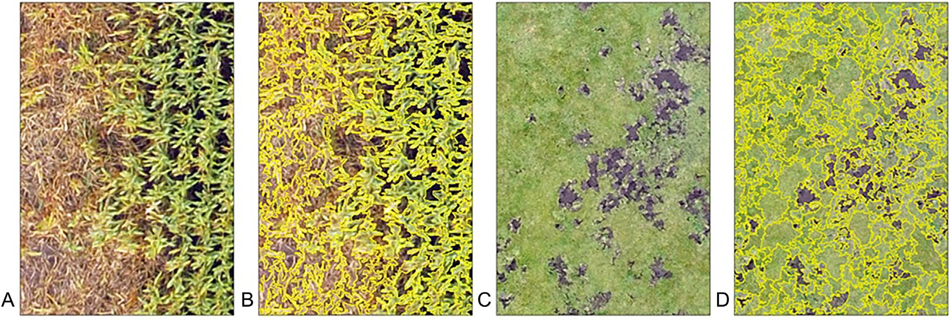

Figure 2. Illustration of segmentation (using eCognition) of a crop field damaged by wild boar, photographed via drone between 2015 and 2017 in the study area in Flanders (northern part of Belgium). Segmentation of orthophotos of damaged fields is the first step in Geographic Object-Based Image Analysis (GEOBIA) in which pixels are grouped in homogeneous objects using multiresolution segmentation. Left: Maize field orthophoto derived from drone photographs (A) and with segments outlined derived from the eCognition software (B). Right: Grassland orthophoto derived from drone photographs (C) and with segments outlined derived from the eCognition software (D).

(for grasslands only and only if shadow was present in the orthophoto; in these cases, we also included sufficient damaged objects intheshaded area toincorporatethedifferencebetween shaded and unshaded damage). In total, we assigned 5,292 objects to maize, 3,802 to damage, and 5,048 to soil in the 32 maize fields. In the 26 grasslands, we allocated 3,700 objects to grass, 3,126 to damage, and 373 to shadow. Subsequently, we used 70% of these objects for training the RF-model. We derived variable importance for each attribute, expressed by MDA (Mean Decrease in Accuracy, Excel Table S2, available online in Supporting Information), which is a measure of loss of accuracy when the variable is left out (Cutler et al. 2007).

Validation Measures
To evaluate the accuracy of the model-deduced damage maps, we used 3 types of validation measures (Fig. 3). We grouped the categories maize and soil (for maize fields), and
grass and shadow (for grasslands), in the single category “no damage” because their individual accuracies were not of interest to the study. This allowed for a binary accuracy assessment of “damage” versus “no damage.”
Validation of the model.—We used the remaining 30% of the labeled objects (i.e., other than the 70% training set) for validation of each model. We calculated a confusion matrix with a set of accuracy measures corrected for object area using the binary assignment. The accuracy measures include user’s accuracy, which is the area of correctly classified objects of a class divided by the total area of predicted objects in a class; producer’s accuracy, which is the area of correctly classified objects of a class divided by the total area of reference objects in a class; and, overall accuracy and the kappa coefficient, which is a measure of how well the model performed compared with performance by chance (Cutler et al. 2007).

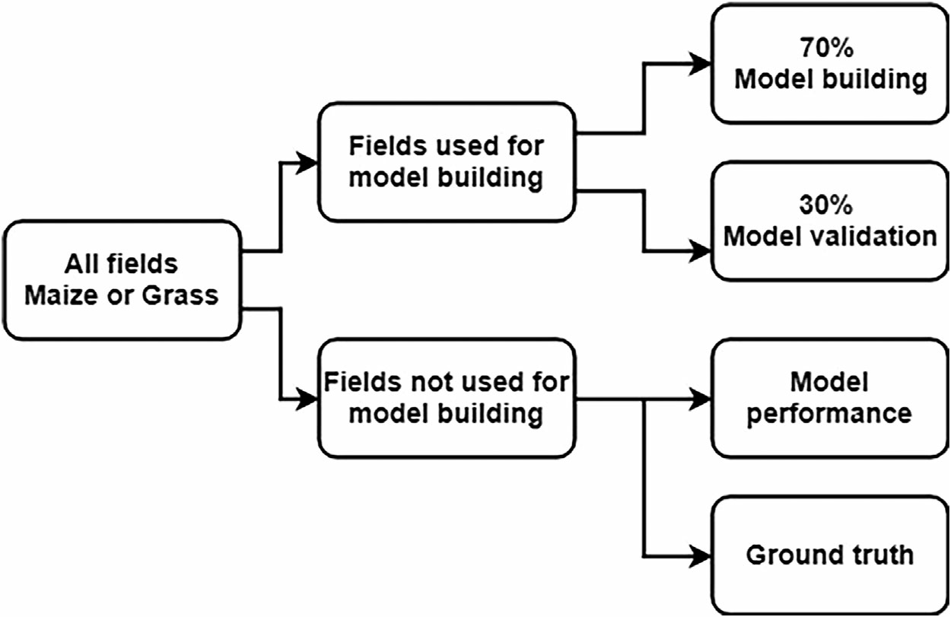

Figure 3. Workflow used for the calculation of the accuracy measures of the damaged area, which is derived from Geographic Object-Based Image Analysis (GEOBIA) and Random Forest models, to estimate the damaged area in 133 crop fields damaged by wild boar, which were photographed via drone between 2015 and 2017 in Flanders (northern part of Belgium).

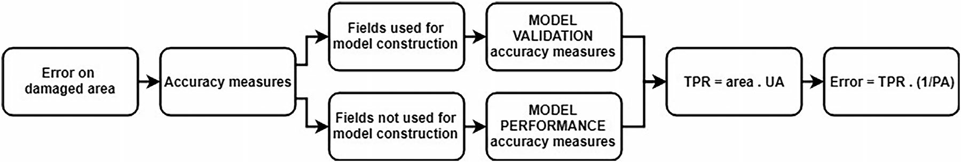

Figure 4. Workflow for calculating the error on damaged area, which is derived from Geographic Object-Based Image Analysis (GEOBIA) and Random Forest models, to estimate the damaged area in 133 crop fields damaged by wild boar, which were photographed via drone between 2015 and 2017 in Flanders (northern part of Belgium). The error on the damaged area is calculated using accuracy measures of corresponding classes (model validation or model performance), true positive rate (TPR), user’s accuracy (UA), and producers’ accuracy (PA).

Performance as a crop-damage assessment tool.—We assessed the value of the model for its practical application to evaluate damage for newly collected field imagery by testing its performance on all fields not used for model construction. We manually assigned 2:50 objects on each of these independent fields to 1 of 3 possible classes (i.e., damage, crop, soil in maize fields; and damage, crop, shadow in grasslands). We then used this set of objects to validate the RF-models. We set up a confusion matrix and we calculated the same accuracy measures as mentioned corrected for object area size.
Ground-truthing.—We provided a third validation mea- sure by a ground-truthing check. In 10 maize fields and 10 grasslands photographed in 2017, we took 10 GPS locations for damage and 10 GPS locations for undamaged crop (maize or grass) using a Trimble advanced RTK R6 (Trimble, Sunnyvale, CA, USA; 0.012-m horizontal accuracy on average) on the same day that we photographed the field. This resulted in 400 ground-truthing points. We overlaid these GPS locations with the corresponding object after segmentation and classification of the orthophoto by
the RF-model. Based on this comparison, we set up a third confusion matrix and we calculated accuracy measures (not based on area calculations but on presence–absence of damage).
Assessment of damaged area.—Using accuracy measures of corresponding model classes, we could calculate damaged area and damaged percentage of a field (Fig. 4). The error on these calculations involved both user’s and producer’s accuracy of the objects classified as damage and was calculated in 2 steps. First, we calculated the true positive rate (TPR) of damaged area (percentage of damaged area that were correctly classified as damaged) by multiplying damaged area by the user’s accuracy (UA; TPR ¼ area x UA). Secondly, we corrected the damaged area for the false negative rate (FNR) using the producer’s accuracy (PA): percentage of damage area which was probably missed (FNR ¼ 1/PA). The error is thus calculated using the following formula:

Error ¼ TPR x FNR

Table 1. Confusion matrices (a ¼ area [m2] and between brackets: n ¼ no. of objects) and accuracy measures (corrected for object area) for the Random Forest model for assessing maize fields damaged by wild boar, for which 79 damaged maize fields were photographed via drone between 2015 and 2017 in Flanders (northern part of Belgium), and a Geographic Object-Based Image Analysis and Random Forest model was developed.

Model validation, a ¼ 91.20 m2 (n ¼ 4,243 objects) Reference

Predicted Damage No damage User’s accuracy (%)

Damage | 29.62 (1,065) | 1.53 (70) | 95.10
No damage | 1.71 (76) | 58.35 (3,032) | 97.16
Producer’s accuracy (%) | 94.55 | 97.45
Overall accuracy (%) | 96.45
Kappa coeff. | 0.92
Model performance, a ¼ 39.19 m2 (n ¼ 2,422 objects) Reference

Predicted Damage No damage User’s accuracy (%)

Damage | 21.52 (990) | 1.82 (135) | 92.21
No damage | 4.26 (151) | 11.60 (1,146) | 73.16
Producer’s accuracy (%) | 83.49 | 86.45
Overall accuracy (%) | 84.50
Kappa coeff. | 0.67
Ground-truth (n ¼ 200 objects) |  | Reference
Predicted | Damage | No damage | User’s accuracy (%)
Damage | 95 | 6 | 94.06
No damage | 5 | 94 | 94.95
Producer’s accuracy (%) | 95.00 | 94.00
Overall accuracy (%) | 94.50
Kappa coeff. | 0.89

Table 2. Confusion matrices (a ¼ area [m2] and between brackets: n ¼ no. of objects) and accuracy measures (corrected for object area) for the Random Forest model for assessing damaged grasslands by wild boar, for which 54 damaged grasslands were photographed via drone between 2015 and 2017 in Flanders (northern part of Belgium), and a Geographic Object-Based Image Analysis and Random Forest model was developed.

Model validation, a ¼ 92.54 m2 (n ¼ 2,160 objects) Reference

Predicted Damage No damage User’s accuracy (%)

Damage | 21.45 (857) | 1.86 (64) | 92.03
No damage | 2.12 (81) | 67.12 (1,158) | 96.94
Producer’s accuracy (%) | 91.03 | 97.31
Overall accuracy (%) | 95.71
Kappa coeff. | 0.89
Model performance, a ¼ 47.23 m2 (n ¼ 1,245 objects) Reference

Predicted Damage No damage User’s accuracy (%)

Damage | 10.44 (515) | 1.00 (72) | 91.24
No damage | 1.64 (75) | 34.15 (658) | 95.40
Producer’s accuracy (%) | 86.39 | 97.15
Overall accuracy (%) | 94.40
Kappa coeff. | 0.85
Ground-truth (n ¼ 200 objects) Reference
Predicted Damage No damage User’s accuracy (%)

Damage | 99 | 1 | 99.00
No damage | 3 | 97 | 97.00
Producer’s accuracy (%) | 97.01 | 98.90
Overall accuracy (%) | 98.00
Kappa coeff. | 0.96

RESULTS

Validation and Performance of the Model
Maize fields.—Model validation (i.e., 30% of objects of the fields used for model construction) showed a high overall accuracy of 96.45%, whereas the model performance with an accuracy of 84.50% shows that classification is more difficult for fields not used for model construction (Table 1). However, ground-truthing showed 94.50% overall accuracy for the constructed RF-model.
Grasslands.—In the final RF-model for grasslands, 26 orthophotos of 2016 were used (model performance exceeded an overall accuracy of 80% only using fields of 2016).
For grasslands, model validation shows an overall accuracy of 95.71% and model performance resulted in an accuracy of
  - % (Table 2). Ground-truthing showed 98.00% accuracy.

Crop Damage Assessment
The average damaged area (see Fig. 5 for examples) was 17.2% in maize fields and 20.6% in grasslands (Table 3). Using corresponding accuracy measures, the error on damaged area could be calculated as well as the error on the damaged percentage of a field (Excel Table S3, available online in Supporting Information).
In terms of time- and cost-efficiency of our drone method, we made a comparison (Table 4) with ground-based estimations as applied in Wallonia (southern Belgium; J. Widar, Fourrages Mieux, personal communication). Start- up costs for our presented drone method are lower than the

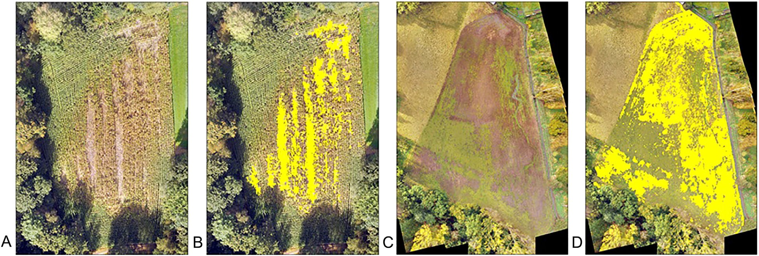

Figure 5. Visualization of the resulting Geographic Object-Based Image Analysis (GEOBIA) Random-Forest model classification of the area damaged by wild boar (yellow) in a maize field (A ¼ original field, B ¼ classified damage) and grassland (C ¼ original field, D ¼ classified damage) as 1 of the 133 crop fields damaged by wild boar photographed via drone between 2015 and 2017 in Flanders (northern part of Belgium).

Table 3. Average percent damaged area within a field (with min. and max.) over all 133 fields damaged by wild boar, which were photographed via drone between 2015 and 2017 in Flanders (northern part of Belgium), as derived from a Geographic Object-Based Image Analysis and Random-Forest model classification that was developed.

Crop |  | No. of fields | Average percent damaged (min.–max.)
Maize | 2015 | 21 | 16.50 (0.83–44.89)
 | 2016 | 26 | 12.70 (0.36–45.11)
 | 2017 | 32 | 22.40 (2.09–52.87)
 | Total | 79 | 17.20
Grass | 2015 | 1 | 19.00
 | 2016 | 33 | 19.10 (3.98–87.77)
 | 2017 | 20 | 24.00 (4.11–48.82)
 | Total | 54 | 20.60

method of ground-based estimations (Table 4). The labor time for a field visit and damage processing varies widely depending on the accuracy of ground-based estimation (from 90 min for an estimation of 10% of a damaged field of 5 ha to nearly 26 hr for a full exhaustive assessment), whereas the labor time and accuracy is fixed using the drone method (150 min for the same field).

DISCUSSION
Our presented method applies machine learning using GEOBIA on UAV imagery of damaged drop fields by wild boar to calculate damaged area, which is shown to be an objective, time-efficient, and accurate approach. Model performance showed high overall accuracies, with greater accuracies for grasslands than for maize fields. We consider the presented method to be useful as a tool to get a detailed and objective estimation of damaged areas in maize and grasslands.
To reach an acceptable model performance of >80% (as an arbitrary limit we set), we needed to combine maize field data
from several years, indicating a larger variation among maize fields. Including fields from >3 years might improve model performances for damaged maize fields substantially. Given the high accuracy for grasslands, the expected gain when
adding grasslands for >1 year seems not sufficiently advantageous compared with the required time investment.
We applied our method to maize and grasslands because we did not have sufficient reported damage cases for other crops. As long as damage is visually distinguishable in aerial photographs (Blaschke 2010, Addink et al. 2012), we are confident that our method can be applied to other crops such as wheat, oats, etc. Michez et al. (2016) pointed out that object-based image analysis improved their classification method in which they used digital elevation models and height thresholds to distinguish damaged from undamaged crops. We studied damage from wild boar (ground check in all cases), but other damage causes do exist, such as those caused by other wildlife species (e.g., badger [Meles meles]). These sources of damage can have similar visual character- istics in aerial photographs and might be distinguishable by our GEOBIA-RF model as well. We did not have any cases of damage by other species, so we could not check this nor the possibility to distinguish damage sources.
In the assessed maize fields we found that, on average, 17.2% of the area in fields was damaged, whereas in grasslands this figure was 20.6%, although a large variation was found for both crops. Bueno et al. (2010) reported 16% of the assessed area in damaged livestock pastures in Spain to be uprooted (plants pulled out of soil), Engeman et al. (2016) found between 11.2% and 13.5% of the damaged grasslands in Romanian mountains to be rooted. Bueno et al. (2009) reported up to 12% of the total areas of damaged Pyrenean alpine and subalpine grasslands to be actually damaged.
Using local crop prices (average yield (euro [s]/ha) over the period 2013–2017 in Flanders, prices according to local

Table 4. Overview of costs and time requirement involved in damage assessment of fields damaged by wild boar during 2015 and 2017 using the presented drone method or ground visit like done in Wallonia (southern part of Belgium, J. Widar, Fourrages Mieux, personal communication), in which often only a part of the fields is estimated depending on the intensity of the damage. Hourly wages are not included as these can be variable. Passive processing time is not included as this does not influence active labor time. s ¼ euros.

Drone Ground visit

Start-up costs

ENVI Onebutton license s890 Estimation software development
s25.000

Agisoft Photoscan Pro license s2.900
eCognition license s1.716
DJI Phantom 3 Advanced s1.200

Sufficient batteries for a full day field assessments
s1.500

Total cost s8.206 Total cost s25.000 Field visit
Photographing field 5 min/ha Ground assessment Surveying 10%: 15 min/ha Surveying 20–25%: 30 min/ha
Full exhaustive assessment: 5 hr and 6 min/ha

Data processing
    - Stitch photo’s
    - Segment photo’s
    - Apply RF-model

Average processing labor time: 2 hr/field

Applying estimation software

15 min/field

Total field of 5 ha 2 hr 30 min Total field of 5 ha From 1 hr 30 min to 25 hr 45 min

farmers’ union Boerenbond), direct yield losses in maize fields would be on average 342s/ha of maize field and 282s/ ha of grassland. However, this is only a rough estimate because regional and year-dependent yield differences are not taken into account. Moreover, economic losses to farmers are likely greater than merely yield losses. For example in grasslands, uneven surfaces as a result of wild boar rooting may cause damage to mowing machines and restoration measures are needed to repair the damaged grassland (Frederik 1998).
The economic effect of damage is the main limiting factors in stakeholders’ tolerance toward wildlife (Carpenter et al. 2013). Compensation schemes may increase tolerance of wildlife and promote more positive attitudes toward concerns and therefore decrease the number of human–wildlife conflicts (Nyhus et al. 2005). However, often there is little quantitative evidence and costs are mostly estimated (Nyhus et al. 2003, 2005). When comparing labor time of ground-based estimations with our drone method, we see that time use depends on the accuracy of the ground-based estimation. Start-up costs seem accountable to us when compared with figures like our reported cost per
hectare, given that our study area was >330 ha, and the reported damage costs in Europe alone is approximately 80
million euros annually (Putman and Apollonio 2014).

ACKNOWLEDGMENTS
A. Rutten holds a PhD grant (IWT.141377) from the Agency Flanders Innovation & Entrepreneurship (VLAIO), Flanders, Belgium. We thank K. Mertens and P. Lootens from the Flemish Research Institute for Agriculture, Fisheries and Food (ILVO) and J. De Reu from the Flemish Research Institute for Nature and Forest (INBO) for their help with photo preprocessing, and Prof. Dr. Ir. B. Somers from KULeuven for methodological suggestions. Special gratitude goes to the Associate Editor and reviewers for their contributions.

LITERATURE CITED
Acevedo, P., J. Vicente, U. H€ofle, J. Cassenello, F. Ruiz-Fons, and C. Gortazar. 2007. Estimation of European wild boar relative abundance and aggregation: a novel method in epidemiological risk assessment. Epidemiology and Infections 135:519–527.
Addink, E. A., S. M. De Jong, S. A. Davis, V. Dubyanskiy, L. A. Burdelov, and
H. Leirs. 2010. The use of high-resolution remote Sensing for plague surveillance in Kazakhstan. Remote Sensing of Environment 114:674–681. Addink, E. A., F. M. B. Van Coillie, and S. M. De Jong. 2012. Introduction to the GEOBIA 2010 special issue: from pixels to geographic objects in remote sensing image analysis. International Journal of Applied Earth
Observation and Geoinformation 15:1–6.
Amici, A., F. Serrani, C. M. Rossi, and R. Primi. 2012. Increase in crop damage caused by wild boar (Sus scrofa L.): the “refuge effect”. Agronomy for Sustainable Development 32:683–692.
Barrios-Garcia, M. N., and S. A. Ballari. 2012. Impact of wild boar (Sus scrofa) in its introduced and native range: a review. Biological Invasions 14:2283–2300.
Benz, U. C., P. Hofmann, G. Willhauck, I. Lingenfelder, and M. Heynen. 2004. Multi-resolution, object-oriented fuzzy analysis of remote sensing data for GIS-ready information. ISPRS Journal of Photogrammetry and Remote Sensing 58:239–258.
Bieber, C., and T. Ruf. 2005. Population dynamics in wild boar Sus scrofa: ecology, elasticity of growth rate and implications for the management of pulsed resource consumers. Journal of Applied Ecology 42:1203–1213.
Blaschke, T. 2010. Object based image analysis for remote sensing. Journal of Photogrammetry and Remote Sensing 65:2–16.
Blaschke, T., G. J. Hay, M. Kelly, S. Lang, P. Hofmann, E. A. Addink,
R. Q. Feitosa, F. van der Meer, H. van der Werff, F. M. B. van Coillie, and
D. Tiede. 2014. Geographic object-based image analysis—towards a new paradigm. Journal of Photogrammetry and Remote Sensing 87:180–191.
Breiman, L. 2001. Random forests. Machine Learning 41:5–32.
Bueno, C. G., C. L. Alados, D. Gomez-Garcia, I. C. Barrio, and R. Garcia- Gonzalez. 2009. Understanding the main factors in the extent and distribution of wild boar rooting on alpine grasslands. Journal of Zoology 279:195–202.
Bueno, C. G., I. C. Barrio, R. Garcia-Gonzalez, C. L. Alados, and D. Gomez-Garcia. 2010. Does wild boar rooting affect livestock grazing areas in alpine grasslands? European Journal of Wildlife Research 56:765–770.
Carnis, L., and F. Facchini. 2012. Une approche 'economique des d'eg^ats de gibier. Indemnisation, prix et propri'et'e. E' conomie Rurale (Janvrier–Mars)
327-328:126–142. [In French].
Carpenter, L., D. Decker, and J. F. Lipscomb. 2013. Stakeholder acceptance capacity in wildlife management. Human Dimensions of Wildlife 5:5–19. Chavarria, P. M., R. R. Lopez, G. Bowser, and N. J. Silvy. 2007. A landscape-level survey of feral hog impacts to natural resources of the
Big Thicket National Preserve. Human-Wildlife Conflicts 1:199–204.
Cushman, J. H., T. A. Tierney, and J. M. Hinds. 2004. Variable effects of feral pig disturbances on native and exotic plants in a California grasslands. Ecological Applications 14:1746–1756.
Cutler, D. R., T. C. Edwards, K. H. Beard, A. Cutler, K. T. Hess, J. Gibson, and J. J. Lawler. 2007. Random forests for classification in ecology. Ecology 88:2783–2792.
Demolder, H., A. Schneiders, T. Spanhove, D. Maes, W. Van Landuyt, and
T. Adriaens. 2014. Hoofdstuk 4: toestand biodiversiteit. Pages 0–83 in Natuurrapport—Toestand en trend van ecosystemen en ecosysteemdiens- ten in Vlaanderen. Technisch rapport. Mededelingen van het Instituut voor Natuur—en Bosonderzoek, INBO.M.2014.1988582, Brussel D/ 2014/3241/349 INBO.R.2014.6194611, Brussels, Belgium. [In Dutch]. Engeman, R., R. Cattaruzza, M. Cattaruzza, and J. Fischer. 2016. Photographic estimation of wild boar damage to alpine grazing pastures in the Carpathian Mountains of central Romania. Environmental Science
and Pollution Research 23:4949–4952.
Engeman, R. M., A. Stevens, J. Allen, J. Dunlap, and M. Dunlap. 2007a. Feral swine management for conservation of an imperiled wetland habitat: Florida’s vanishing seepage slopes. Biological Conservation 134:440–446.
Engeman, R. M., J. Woolard, H. T. Smith, J. Bourassa, and B. U. Constantin. 2007b. An extraordinary patch of feral hog damage in Florida before and after initiating hog removal. U.S. Department of Agriculture National Wildlife Research Center—Staff Publications 755, Lincoln, Nebraska, USA. https://digitalcommons.unl.edu/icwdm_usdanwrc/755. Accessed 14 Jan 2018.
Faunafonds. 2014. Jaarverslag Faunafonds: 2014. https://www.bij12.nl/
assets/Jaarverslag-Faunafonds-2014.pdf. Accessed 9 Dec 2017.
Felix, R. K. J., S. L. Orzall, E. A. Tillman, R. M. Engeman, and M. L. Avery. 2014. Fine-scale, spatial and temporal assessment methods for feral swine disturbances to sensitive plant communities in south-central Florida. Environmental Science and Pollution Research 21:10399–10406. DOI: 10.1007/s11356-014-2956-y
Frederik, J. M. 1998. Overview of wild pig damage in California. Pages 82–86 in Proceedings of the Eighteenth Vertebrate Pest Conference, March 2–5 1998, Costa Mesa, California, USA.
Johansen, K., A. Robson, P. Samson, N. Sallam, K. Chandler, L. Derby, and
J. Jennings. 2014. Mapping sugarcane grub damage from high spatial resolution satellite imagery. South-Eastern European Journal of Earth Observation and Geomatics 3:549–553.
Johansen, K., N. Sallam, A. Robson, P. Samson, K. Chandler, L. Derby, A. Eaton, and J. Jennings. 2017. Using GeoEye-1 imagery for multi- temporal object-based detection of canegrub damage in sugarcane fields in Queensland, Australia. GIScience & Remote Sensing 55:285–305.
Keuling, O., T. Podg'orski, A. Monaco, M. Melletti, D. Merta, M. Albrycht,
P. V. Genov, F. Geth€offer, S. G. Vetter, F. Jori, R. Scalera, and J. Gongora. 2018. Eurasian wild boar Sus scrofa (Linnaeus, 1758). Pages 202–234 in M. Melletti, and E. Meijaard, editors. Ecology, conservation and management of wild pigs and peccaries. Cambridge University Press, Cambridge, England, United Kingdom.

Ku�zelka, K., and P. Surov'y. 2018. Automatic detection and quantification of wild game crop damage using an unmanned aerial vehicle (UAV) equipped with an optical sensor payload: a case study in wheat. European Journal of Remote Sensing 51:241–250.
Liaw, A., and M. Wiener. 2002. Classification and regression by randomForest. R News 2:18–22.
Linell, J. D. C., J. E. Swenson, and R. Andersen. 2001. Predators and people:
conservation of large carnivores is possible at high human densities if management policy is favourable. Animal Conservation 4:345–349.
Massei, G., and P. V. Genov. 2004. The environmental impact of wild boar.
Galemys 16:135–145.
Massei, G., J. Kindberg, A. Licoppe, D. Gacic, N. Sprem, J. Kamler, E. Baubet, U. Hohmann, A. Monaco, J. Ozolins, S. Cellina, T. Podgorski, C. Fonseca, G. Markov, B. Pokorny, C. Rosell, and A. Nahlik. 2015. Wild boar populations up, numbers of hunters down? A review of trends and implications for Europe. Pest Management Science 71:492–500.
Michez, A., K. Morelle, F. Lehaire, J. Widar, M. Authelet, C. Vermeulen,
and L. Philippe. 2016. Use of unmanned aerial system to assess wildlife (Sus scrofa) damage to crops (Zea mays). Journal of Unmanned Vehicle Systems 4:266–275.
Morelle, K., F. Lehaire, and P. Lejeune. 2013. Spatio-temporal patterns of
wildlife-vehicle collisions in a region with a high-density road network. Nature Conservation 5:53–73.
Nyhus, P., H. Fischer, F. Madden, and S. Osofsky. 2003. Taking the bite out
of wildlife damage: the challenges of wildlife compensation schemes. Conservation in Practice 4. https://doi.org/10.1111/j.1526-4629.2003. tb00061.x. Accessed 21 Feb 2018.
Nyhus, P. J., S. A. Osofsky, P. Farraro, H. Fischer, and F. Madden. 2005.
Bearing the costs of human-wildlife conflict: the challenges of compensation schemes. Pages 107–121 in R. Woodroffe, editor. People and wildlife, conflict or co-existence. Faculty Scholarship Paper 15. Cambridge University Press, Cambridge, England, United Kingdom. http://digitalcommons.colby.edu/faculty_scholarship/15.
Puig, E., F. Gonzalez, G. Hamilton, and P. Grundy. 2015. Assessment of
crop insect damage using unmanned aerial systems: a machine learning approach. Pages 1420–1426 in T. Weber, M. J. McPhee, and R. S. Anderssen, editors. 21st International Congress on Modelling and Simulation, Gold Coast, Australia, 29 Nov–4 Dec 2015. www.mssanz.org. au/modsim2015. Accessed 18 Feb 2018.
Putman, R., and M. Apollonio, editors. 2014. Behaviour and management
of European ungulates. Whittles, Dunbeath, Scotland, United Kingdom. Reyns, N., J. Casaer, L. De Smet, K. Devos, F. Huysentruyt, P. A. Robertson, T. Verbeke, and T. Adriaens. 2018. Cost-benefit analysis for invasive species control: the case of greater Canada goose Branta canadensis
in Flanders (northern Belgium). Peer J 6:e4283.
Riley, S., W. Siemer, D. Decker, L. Carpenter, J. Organ, and L. Berchielli. 2003. Adaptive impact management: an integrative approach to wildlife management. Human Dimensions of Wildlife 8:81–95.
Rodriguez-Galiano, V. F., B. Ghimire, J. Rogan, M. Chica-Olmo, and J. P.
Rigol-Sanchez. 2012. An assessment of the effectiveness of a random forest classifier for land-cover classification. ISPRS Journal of Photo- grammetry and Remote Sensing 67:93–104.
Rutten, A., J. Casaer, T. Onkelinx, L. De Smet, N. Witters, F. Huysentruyt, and
H. Leirs. unpublished. Using an online survey to assess the spatial distribution of wild boar (Sus scrofa L.) crop damage and factors influencing this distrubution.
Saez-Royuela, C., and J. L. Telleria. 1986. The increased population of the wild boar (Sus scrofa L.) in Europe. Mammal Review 16:97–101.
Salami, E., C. Barrado, and P. Enric. 2014. UAV flight experiments
applied to the remote sensing of vegetated areas. Remote Sensing 6:11051–11081.
Scheppers, T., F. Huysentruyt, A. Neukermans, E. Verschaffel, and J. Casaer. 2014. Grofwildjacht in Vlaanderen—cijfers en statistieken 2013. Research Institute for Nature and Forest. Rapport: 1–93. [In Dutch].
Schley, L., M. Dufr^ene, A. Krier, and A. C. Frantz. 2008. Patterns of crop
damage by wild boar (Sus scrofa) in Luxembourg over a 10-year period. European Journal of Wildlife Research 54:589–599.
Treves, A., R. B. Wallace, L. Naughton-Treves, and A. Morales. 2006. Co- managing human-wildlife conflicts: a review. Human Dimensions of Wildlife 11:383–396.
Vogels, M. F. A., S. M. De Jong, G. Sterk, and E. A. Addink. 2017. Agricultural cropland mapping using black-and-white aerial photog- raphy, object-based image analysis and random forests. International Journal of Applied Earth Observation and Geoinformation 54:114–123.
Widar, J., and P. Luxen. 2016. Statistiques de d'eg^ats agricoles de la faune
sauvage, issues des donn'ees des experts: 'evolution de 2008 'a 2014. <http:// www.fourragesmieux.be/gibiers_document_degat.html>. Accessed 10 Dec 2017. [In French].

Table S1. Overview of fields and photos crop field damaged by wild boar, photographed via drone between 2015 and 2017 in the study area in Flanders (northern part of Belgium).

Table S2. Mean decreasing accuracies of Random Forest (RF) algorithm based on a set of 25 attributes describing shape (4), texture (8), and spectral properties (13) of the objects of segmented photos of damaged fields by wild boar, photographed via drone between 2015 and 2017 in the study area in Flanders (northern part of Belgium).

Table S3. Damaged area calculations using the resulting Random Forest model of damaged fields by wild boar, photographed via drone between 2015 and 2017 in the study area in Flanders (northern part of Belgium).

