A comparative hierarchical analysis of bacterioplankton and biofilm metacommunity structure in an interconnected pond system

Caroline Souffreau ,1* Pieter Busschaert,2 Carla Denis,1 Jeroen Van Wichelen,3,4
Bart Lievens,2 Wim Vyverman3 and Luc De Meester1
1Laboratory of Aquatic Ecology Evolution & Conservation, KU Leuven, Leuven, Belgium.
2Laboratory for Process Microbial Ecology and Bioinspirational Management, KU Leuven, Campus De Nayer, St.-Katelijne-Waver, Belgium.
3Laboratory of Protistology and Aquatic Ecology, Ghent University, Gent, Belgium.
4Research Institute for Nature and Forest (INBO), Brussels, Belgium.

Summary
It is unknown whether bacterioplankton and biofilm communities are structured by the same ecological processes, and whether they influence each other through continuous dispersal (known as mass effects). Using a hierarchical sampling approach we compared the relative importance of ecological pro- cesses structuring the dominant fraction (relative abundance ;::0.1%) of bacterioplankton and biofilm communities from three microhabitats (open water, Nuphar and Phragmites sites) at within- and among- pond scale in a set of 14 interconnected shallow ponds. Our results demonstrate that while bacterio- plankton and biofilm communities are highly distinct, a similar hierarchy of ecological processes is acting on them. For both community types, most variation in community composition was determined by pond identity and environmental variables, with no effect of space. The highest b-diversity within each community type was observed among ponds, while microhabitat type (Nuphar, Phragmites, open water) significantly influenced biofilm communities but not bacterio- plankton. Mass effects among bacterioplankton and biofilm communities were not detected, as suggested

by the absence of within-site covariation of biofilm and bacterioplankton communities. Both biofilm and plankton communities were thus highly structured by environmental factors (i.e., species sorting), with among-lake variation being more important than within-lake variation, whereas dispersal limitation and mass effects were not observed.

Introduction
A fundamental aim in ecology is to understand the pro- cesses that structure local communities. Metacommunity theory (Leibold, 1998; Leibold et al., 2004) provides a framework to get insight in the relative importance of differ- ent mechanistic processes structuring metacommunities [i.e., sets of local communities linked through dispersal of multiple, potentially interacting species (Holyoak et al., 2005)]. Leibold et al. (2004) suggest four paradigms that vary in the relative importance given to competitive and dispersal abilities of species and in the levels of heteroge- neity among patches. These include species sorting (emphasizing individual species responses to environmen- tal heterogeneity without dispersal limitation), mass effects (emphasizing high dispersal and source-sink dynamics), neutral dynamics (emphasizing stochastic demographic processes and dispersal of equivalent species) and patch- dynamics (emphasizing colonization-competition trade-offs among species). For freshwater lake bacterioplankton, most field studies have shown that community composition is predominantly driven by species sorting (e.g., Beisner et al., 2006; Van der Gucht et al., 2007; Logue and Lindstro€m, 2010; De Bie et al., 2012; Langenheder et al., 2012; Souffreau et al., 2015), while a number of studies reported patterns in accordance with neutral dynamics, dispersal limitation and mass effects (Drakare and Liess, 2010; Ofiteru et al., 2010; O€ stman et al., 2010; Langen- heder and Sze'kely, 2011; Hanson et al., 2012; Lindstro€m and Langenheder, 2012; Shabarova et al., 2013). In con- trast to bacterioplankton, explicit metacommunity analyses on freshwater bacterial biofilms are rare, despite the numerical and functional importance of bacterial biofilms in freshwater systems. The studies on stream (Beier et al.,

2008; Besemer et al., 2012) and marsh (Buesing et al., 2009) biofilm communities suggest that also for freshwater biofilms the local environment is the dominant driver of community structure.
Freshwater plankton and biofilm communities are in gen- eral highly differentiated (Buesing et al., 2009; Hiraki et al., 2009; Tsuchiya et al., 2011; Besemer et al., 2012; Wang et al., 2013), but to our knowledge no study has explicitly compared the structuring drivers of biofilm and plankton communities in a metacommunity context in the same landscape. Yet, such an analysis would reveal whether metacommunities in these two very different types of microbial communities are structured by the same hierar- chy of processes and thus inform us on how general the processes driving bacterial metacommunity structure are. Additionally, plankton and biofilm communities co-occur and might therefore interact and influence each other at small spatial scales, making mass effects across commu- nity types a potentially important structuring process for both community types within ponds. Besemer et al. (2012) assessed in three streams whether bacterioplankton acted as a source for biofilm communities by following the bacter- ioplankton community over time during the first 3 weeks of biofilm colonization. They found no evidence for mass effects or stochastic dispersal from the bacterioplankton into the biofilm community. However, while biofilm and bac- terioplankton communities were highly dissimilar, the biofilm communities were similar across the three lakes, suggesting that a specific subset of bacteria from the source community proliferates in the biofilms and that spe- cies sorting is the major structuring process in stream biofilms. In ponds, however, water flow rates are much lower, retention times higher and mass effects across com- munity types might therefore be more important within ponds compared with streams. Finally, most metacom- munity studies on lakes and ponds ignore environmental heterogeneity within water bodies, although it can inform us on the small-scale processes at work in bacterial com- munities (Besemer et al., 2009). The few small-scale, within-lake metacommunity studies that have been performed reported some heterogeneity for both bacterio- plankton (Yannarell and Triplett, 2004; Zeng et al., 2012; Lear et al., 2014) and biofilm communities (Buesing et al., 2009), but these studies were limited to one single habitat type or to a single system. Data on the relative contribution of among- and within-lake variation to community structure is therefore lacking. By integrating both the among- and within-lake spatial levels in one hierarchical analysis, we can assess their relative importance in structuring bacterial metacommunities in natural systems.
In this study, we assessed the factors structuring the dominant fraction (relative abundance ;::0.1% of the total abundance) of freshwater plankton and biofilm bacterial communities within and among ponds for three different
microhabitat types in a hierarchical analysis. For 14 shal- low ponds of an interconnected pond system (Fig. 1A and B), we characterized the bacterial community composition of bacterioplankton and of biofilms on artificial and (if pre- sent) natural substrate (Nuphar lutea, Phragmites australis) within patches dominated by open water, Nuphar (if present) and Phragmites (Fig. 1C) using 16S rRNA gene amplicon-sequencing. We tested four hypotheses: (i) the strongest structuring factor in our dataset is the bacterioplankton-biofilm division; (ii) local environmental conditions are more important than spatial variables in explaining variation in both bacterioplankton and biofilm communities in this hierarchical system of interconnected habitats, (iii) among-pond variation is more important than within-pond variation and (iv) bacterioplankton and biofilm communities influence each other at local sites through mass effects.

Results
Relative importance of community type (bacterioplankton/biofilm) on community structure and taxonomic composition (Hypothesis 1)
Although the number of sequences was rarefied to only 709 sequences per sample, most samples approached saturation for the dominant OTUs (relative abundance
;::0.1% of the total dataset), indicating that the dominant fraction of the communities could be accurately character- ized using this number of sequences (Supporting Information Fig. S1). Figure 1D visualizes the variation in community composition over all 100 samples using princi- pal component analysis (PCA). The first PC axis explains 27.9% of the variation and separates the bacterioplankton and biofilm samples. When partitioning the variation in community composition in the total dataset (bacterioplank- ton and biofilm data) into fractions explained by community type (biofilm, plankton), pond identity, and microhabitat (open water, Nuphar, Phragmites), in total 49.8% of the variation could be explained (redundancy analysis, RDA, R2adj). Community type explained 37.7% of the variation in community composition (partial RDA, pRDA, R2adj; p 5 0.0001), pond identity explained 11.3% (pRDA, R2adj;
p 5 0.0001), and microhabitat explained 1.5% (pRDA, R2adj; p 5 0.0001), confirming our first hypothesis that community type (biofilm vs. plankton) was the strongest structuring factor for taxonomic composition. The shared effect of community type and microhabitat explained 0.7% (RDA, R2adj); there were no other shared effects. Also based on Bray–Curtis community dissimilarity, plankton and biofilm communities were highly dissimilar (Fig. 2), both within and among ponds, while the dissimilarity between biofilm samples from artificial and natural sub- strates was lower.

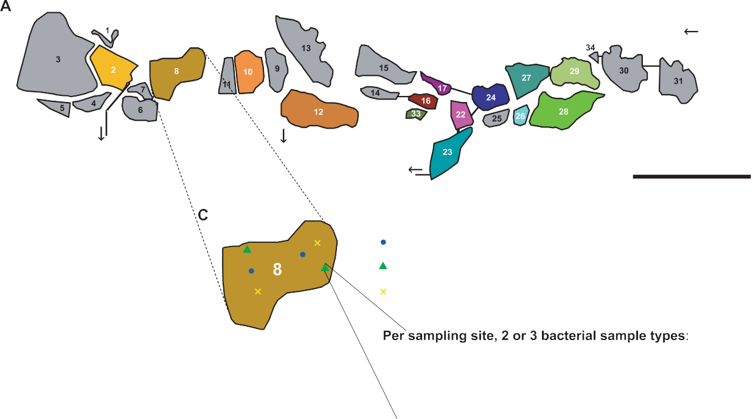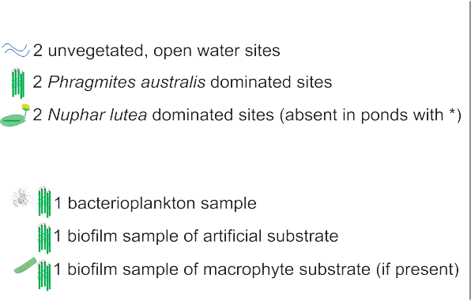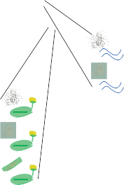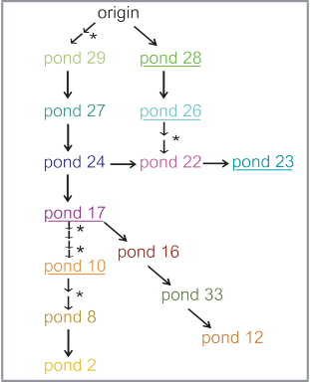

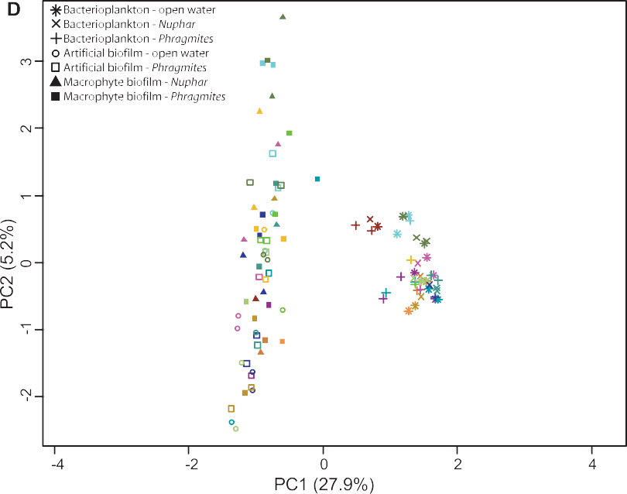

Fig. 1. Overview of the study area, study design and PCA plot.
- Map of the De Maten pond system; ponds selected for this study are in colour; black lines are rivulets and overflows; the arrows indicate the direction of the water flow; ponds which are underlined have no Nuphar lutea.
- Diagram visualizing the connections and direction of water flow between the sampled ponds, used to calculate Asymmetric Eigenvector Maps; * indicates locations where an additional pond was situated between two sampled ponds; colours as in A.
- Schematic sampling design of the ponds; see text for more information.
- PCA plot showing the strongest variation in bacterial community composition based on all 100 samples. Symbols distinguish bacterioplankton, artificial biofilm and macrophyte biofilm samples, and microhabitat (open water, Nuphar or Phragmites sites). Colours represent the 14 ponds as in A. Only the 169 OTUs having a relative abundance ;::0.1% of the total dataset were taken into account for the PCA. [Colour figure can be viewed at wileyonlinelibrary.com]

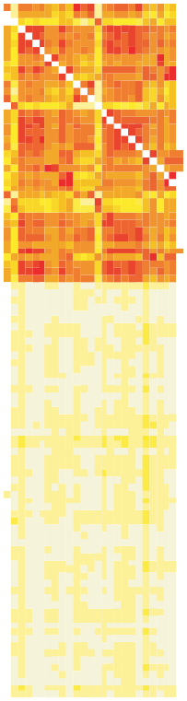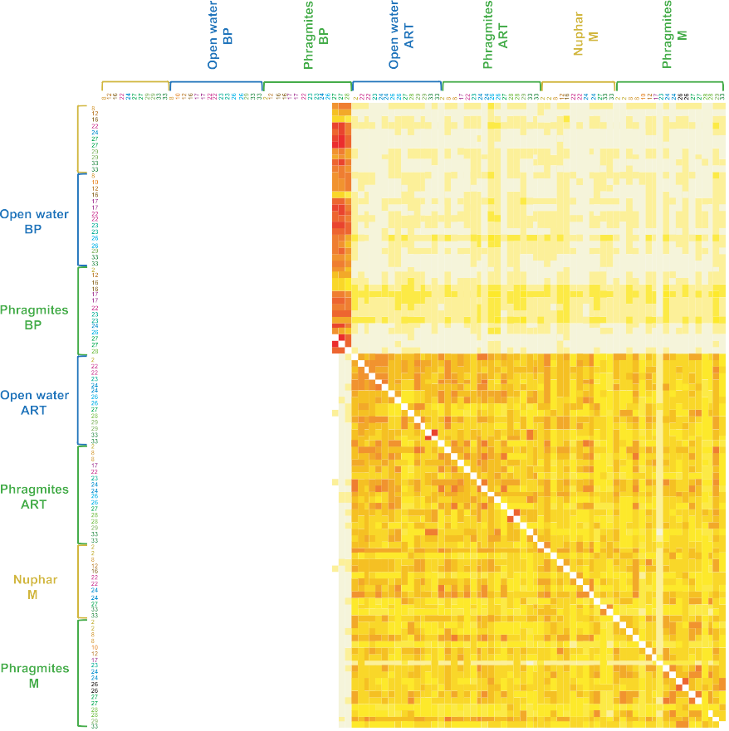Fig. 2. Community dissimilarity levels visualized by a heatmap of Bray–Curtis dissimilarities calculated for all pair-wise combinations of the 100 samples; samples are grouped by community type (bacterioplankton, artificial biofilm, macrophyte biofilm), then by microhabitat (Nuphar, open water, Phragmites);
white 5 high dissimilarity,
red 5 low dissimilarity. Numbers are the pond identities, coloured following Fig. 1. Only the 169 OTUs having a relative abundance ;::0.1% of the total dataset were taken into account. [Colour figure can be viewed at wileyonlinelibrary. com]

Concerning taxonomic composition, the largest differ- ences in average sequence frequency at class level were among bacterioplankton and biofilm communities (Fig. 3). Bacterioplankton communities had on average higher rela- tive abundances of Betaproteobacteria and Actinobacteria compared with biofilm communities, whereas biofilm com- munities had on average higher relative abundances of Alphaproteobacteria, Gammaproteobacteria and unidenti- fied Bacteria.
Relative importance of environmental and spatial variables on bacterioplankon and biofilm community structure (Hypothesis 2)
Although environmental variables (E), spatial variables (S), pond identity (P) and microhabitat (M) explained in total a higher percentage of variance in community com- position for bacterioplankton (64.4%–66.3%, RDA, R2adj) compared with biofilms (36.0%–59.9%) (Table 1), the results corroborate our second hypothesis that for

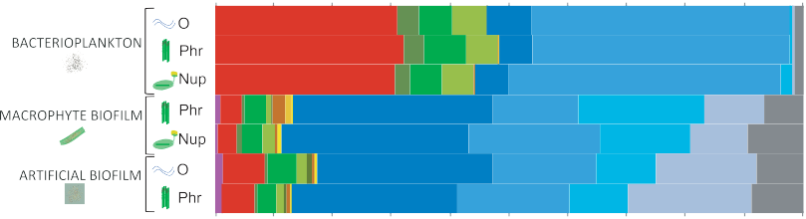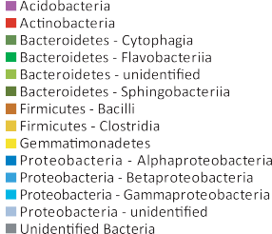

Fig. 3. Average sequence frequency at class level in bacterioplankton, macrophyte biofilm and artificial biofilm communities, per microhabitat (O 5 open water sites; Phr 5 Phragmites sites; Nup 5 Nuphar sites). Only the 169 OTUs having a relative abundance ;::0.1% of the total dataset were taken into account. [Colour figure can be viewed at wileyonlinelibrary.com]

Table 1. Percentage of variation in bacterioplankton, macrophyte biofilm and artificial biofilm communities explained by local environmental variables (E), spatial variables (S), pond identity (P) and microhabitat (M; open water, Nuphar, Phragmites site), confounded effects (\), unexplained variation, and variables selected for the environmental models (E) by forward selection.

 | Bacterioplankton O 1 N1P | Bacterioplankton N 1 P | Macrophyte biofilm N 1 P | Artificial biofilm O 1 N 1 P
Fractions (%)
Total explained | 64.4 | 66.3 | 59.9 | 36
Pure Environment (E) | 0.5 | 2.8 | 6.7 | 5.4
Pure Space (S) | 0 | 3 | 1.6 | 3.4
Pure Pond (P) | 20.2** | 18.4** | 12.7** | 14.4**
Pure Microhabitat (M) | 1.1 | 0 | 0 | 1.5
E\S | 0 | 0 | 0 | 0.1
E\P | 34.1 | 39.6 | 3 | 9.7
E\M | 0 | 0 | 5.5 | 3.1
S\P | 3.2 | 1.2 | 7.1 | 0
S\M | 0 | 0 | 2 | 0.6
P\M | 0 | 0 | 1.4 | 0
E\S\P | 7.6 | 2.5 | 6.1 | 2
E\P\M | 0 | 1.4 | 0 | 0
E\S\M | 0 | 0.6 | 0 | 1.2
S\P\M | 0.6 | 0.4 | 0 | 0
E\S\P\M | 0 | 0 | 2.8 | 0
Unexplained | 35.6 | 33.7 | 40.1 | 64
 | % Open water (pond) | % Phragmites (pond) | % Potamogeton (pond) | % Potamogeton (pond)
 | % Phragmites (pond) | [Si] | % Nuphar (site) | [Si]
 | [Si] | % Open water (pond) | [Si] | pH
 | % Potamogeton (pond) | % Nuphar (pond) | [DOC] | % Phragmites (site)
 | % Nuphar (pond) | % Potamogeton (pond) | % open water (site) | [Chl-a]
 | [Chl-a] | [available PO43-] |  | [available PO43-]
 |  | pH
 |  | [total PO43-]
O, Open water sites; N, Nuphar sites; P, Phragmites sites; [Si], concentration of silicon; [Chl-a], concentration of chlorophyll a; [DOC], concen- tration of dissolved organic carbon. Values >3 are given in bold. Significant fractions are indicated with asterisks (* 5 p < 0.05; ** 5 p < 0.01). Only the 169 OTUs having a relative abundance ;::0.1% of the total dataset were taken into account.

both bacterioplankton and biofilms local environmental conditions are more important than spatial variables. Pond identity (P, corrected for other factors) captured a significant part of the variation in bacterioplankton and biofilms (12.7%–20.2%; p < 0.01; pRDA, R2adj). There was a large shared effect of environment and pond (E\P) in bacterioplankton (34.1%–39.6%) and biofilms on artificial substrate (9.7%) and a small shared effect of space and pond identity (S\P) in bacterioplankton (1.2%–3.2%) and biofilms (0%–7.1%). The shared effect of environment, space and pond identity (E\S\P) explained a small fraction of the variation in bacterio- plankton (2.5%–7.6%) and biofilms (2.0%–6.1%). Pure environmental variables (E, corrected for other factors; 0.5%–6.7%), pure spatial variables (S; 0%–3.4%) and pure microhabitat (M; 0%–1.5%) did not explain a signifi- cant part of the variation in any of the datasets, but there was a small shared effect of environment and microhabi- tat (E\M) in biofilms (3.1%–5.5%). The environmental variables retained for each dataset by forward selection are given in Table 1.
Relative importance of among-pond and within-pond variation for diversity (Hypothesis 3)
For all community types (bacterioplankton, artificial and macrophyte biofilm) of the different microhabitat types (open water, Phragmites and Nuphar patches), b- diversity among ponds (b2) was higher compared with b-diversity within ponds (b1) (Fig. 4), corroborating our third hypothesis. This was the case for both additive spe- cies richness (Fig. 4A and B) and additive Shannon entropy (Fig. 4C and D). Combining all microhabitat types for a certain community type resulted in the same pattern, although the within-pond b-diversity slightly increased (Fig. 4).

Bacterioplankton-biofilm interactions (Hypothesis 4)
Within-site similarities between bacterioplankton and bio- film communities (from artificial substrate or macrophytes separately) were not significantly different from their among-site similarities within pond, and this for both

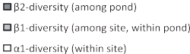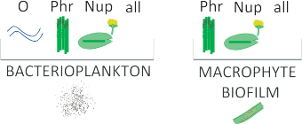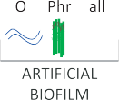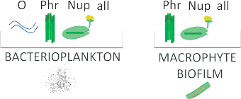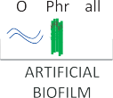

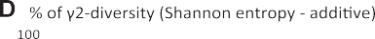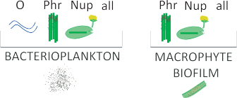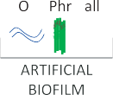

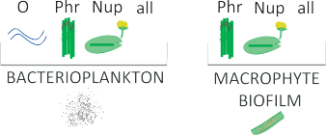Fig. 4. Diversity partitioning of bacterioplankton, macrophyte biofilm and artificial biofilm communities per microhabitat (O 5 open water sites; Phr 5 Phragmites sites; Nup 5 Nuphar sites; all 5 all microhabitats) into the a1-component (within-site diversity), b1-component (among-site diversity within pond) and b2-component (among-pond diversity).
- Additive OTU richness.
- Relative additive OTU richness as % of the total diversity over all ponds (i.e., as percentage of g2-diversity, the total richness depicted in A).
- Additive Shannon entropy.
- Additive Shannon entropy as % of the total diversity over all ponds (g2-diversity). Sample size (number of ponds) is given above the bars in
A. All 2154 OTUs (no global singletons) were taken into account. [Colour figure can be viewed at wileyonlinelibrary.com]

microhabitats (Phragmites and Nuphar sites) tested (t- tests for dependent samples; p > 0.05), refuting our fourth hypothesis. Artificial and macrophyte communities in
Phragmites sites had a higher similarity within-sites com- pared with among-sites within pond (t-test for dependent samples; N 5 11; t 5 23.011; p 5 0.013095).

Discussion
We used a hierarchical sampling approach to characterize and compare the structuring factors of the dominant frac- tion (relative abundance ;::0.1% of the total dataset) of bacterioplankton and biofilm communities from three microhabitats (open water, Nuphar and Phragmites sites) at the within- and among-pond scale in a set of 14 inter- connected shallow ponds. Our results show that while bacterioplankton and biofilm communities are highly dis- tinct, a similar hierarchy of ecological processes is acting on the dominant bacteria of these two community types. When comparing the relative importance of factors driving the variation in community structure within the two commu- nity types, variation partitioning showed that for both biofilm and plankton communities the local environment explained a higher fraction of the total variation in commu- nity composition than space, further demonstrating the importance of species sorting in structuring bacterial com- munities, including biofilms. Variation partitioning has been criticized (e.g., Gilbert and Bennett, 2010), and the results should be interpreted with caution. The use of MEMs to model spatial variation has been shown to produce inflated explained variances by space (Gilbert and Bennett, 2010). Given that we report an absence of pure spatial effects in our dataset, this potential bias strengthens our interpreta- tion. Conversely, the environmental signal might be underestimated. RDA assumes linear species–environ- ment relationships, an assumption that might not hold for all variables included. We are also cautious not to compare the absolute values of explained variance among different sets of communities, and used adjusted R2 values to cor- rect for the number of explanatory variables included.
In this study the local environment included pond iden- tity, which was interpreted as a proxy for unmeasured environmental variation among ponds such as flagellate or zooplankton densities. While pure space did not explain a significant part of the variation in any community type, it explained some variation as a shared effect with pond identity (S\P) (1.2%–7.1%), or with pond identity and envi- ronmental factors (E\S\P) (2%–7.6%). Because the sampled study ponds are interconnected through over- flows, the confounded effect of pond identity and space might reflect mass effects, but our analyses with AEMs did not suggest an effect of the unidirectional water flow. Most likely this reflects spatially structured unmeasured environ- mental factors, such as differences in biotic variables among the ponds. Biomasses of dinoflagellates and cala- noid copepods were found to be significant drivers of bacterioplankton community structure in the same system of interconnected ponds by Van der Gucht et al. (2007), and the ponds are known to differ strongly in zooplankton biomass and community composition (Cottenie et al., 2003).
Interestingly, a higher fraction of the total variation in community composition could be explained for bacterio- plankton (64.4%–66.3%) compared with biofilm communities (36%–59.9%), mainly resulting from the high explanatory power of environmental factors (directly or indirectly) in bacterioplankton. The measured environmen- tal variables were typical water chemistry and nutrient variables, whereas biofilms might be more affected by structuring factors in the biofilm matrix, including biotic fac- tors such as quorum sensing and complex biotic interactions, as well as abiotic factors such as microscale environmental heterogeneity within the biofilm (e.g., anoxic zones) and hydrodynamics (Purevdorj et al., 2002; Matz et al., 2005; An et al., 2006). However, we did not quantify any of these factors for the studied biofilms. Alternatively, the relatively high unexplained variation in biofilms might reflect long-lasting effects of stochasticity during initial bio- film formation (Jackson et al., 2001).
For all our sampled community types and microhabitat types, beta-diversity was higher among ponds than within ponds. This indicates that the environmental gradients were stronger among ponds than within ponds, even though we sampled different microhabitat types within indi- vidual ponds. Microhabitat (open water, Nuphar and Phragmites sites) was less important than pond identity and only had a significant influence on biofilm communities (E\M: 3.1%–5.5%), which could be due (directly or indi- rectly) to species-specific excretions of macrophytes (Hempel et al., 2008). Compared with biofilm communities, bacterioplankton were more similar within ponds and were not affected by microhabitat, potentially because plankton communities are spatially more homogenized, or because the habitat structure is less complex. These results are in contrast to the scarce results from other study systems. For instance, Hempel et al. (2008; 2009) showed that dif- ferences in biofilm communities mainly depended on lake environmental factors and not on plant species, while Zeng et al. (2012) reported that lake bacterioplankton was signif- icantly influenced by macrophyte species.
Our results do not provide support for mass effects between bacterioplankton and biofilm communities, as within-site similarities among plankton and biofilm commu- nities were not significantly higher than among-site similarities within ponds. However, our results reflect a snapshot in which we sampled the biofilm and bacterio- plankton communities at the same time point. Our result, therefore, do not exclude that bacterioplankton and biofilm communities might influence each other’s assembly, such that the bacterioplankton community at a given time point might influence the biofilm community at some later stage. Especially during early assembly of the biofilm, it is not unlikely that differential seeding from the bacterioplankton community might influence community assembly trajectory, for example, through priority effects (Fukami, 2015). Mass

effects are defined as source-sink dynamics reflecting an impact on community composition caused by the continu- ous inflow of individuals from another site (Leibold et al., 2004). Even if the target habitat is a sink that cannot sus- tain a growing population of the immigrating species, the species can still be detected in samples because of the high dispersal rates. If such source-sink dynamics would be important, we would have detected them in our sam- pling strategy in which we sampled all microhabitats and both bacterioplankton and biofilm communities at the same time. Future studies might benefit from repeated sampling to detect delayed impacts of bacterioplankton- biofilm interactions. Nevertheless, our results add to the studies suggesting that mass effects are not common in aquatic bacterial communities (Souffreau et al., 2014), in line with results reported on biofilms and bacterioplankton in streams (Besemer et al., 2012) and on inflowing and resident bacterioplankton in lakes (Lindstro€m et al., 2010). Such a low impact of mass effects likely reflects the strong capacity for population growth and thus of local dynamics in bacterial communities (Van der Gucht et al., 2007). Interestingly, we did observe that biofilms on artificial and natural substrates in Phragmites sites were significantly more similar within sites than among sites of same ponds. This could be the result of mass effects among the biofilm communities, but also of a higher similarity in environmen- tal conditions within compared with among sites of a same pond.
Our results also show that plankton and biofilm commu- nities are highly dissimilar within sites, within ponds and among ponds, confirming and extending previous studies reporting strong differentiation among bacterial plankton and biofilm communities in freshwater lakes (Hiraki et al., 2009; Tsuchiya et al., 2011; Wang et al., 2013), marshes (Buesing et al., 2009) and streams (Beier et al., 2008; Besemer et al., 2012). Already at the class level, bacterio- plankton and biofilm communities were differentiated, with bacterioplankton having higher levels of Betaproteobacte- ria and Actinobacteria compared with biofilm communities, and biofilm communities having higher levels of Alphapro- teobacteria, Gammaproteobacteria and unidentified Bacteria, in line with literature data (Zwart et al., 2002; Eiler
community structure remained unexplained by the varia- bles measured in this study, especially for biofilm communities. There are several processes, such as priority effects (Fukami, 2015) and evolutionary dynamics (Tur- cotte et al., 2012) that we did not account for in the present study. We also did not study whether the same patterns hold for the rare fraction of bacteria as for the dominant fraction. For further studies, it is worthwhile exploring whether accounting for additional processes would result in a larger contribution of variation being explained, and whether the dominant and rare fractions of bacterial com- munities are structured by different processes.

Experimental procedures
Design of the field survey and sampling
Our study site consisted of 34 interconnected ponds in nature reserve De Maten (Genk, Belgium, 5085700200N–582605800E), used in earlier metacommunity studies on zooplankton (Cotte- nie et al., 2003), phytoplankton (Vanormelingen et al., 2008) and bacterioplankton (Van der Gucht et al., 2007). The ponds are connected but differ strongly in ecological characteristics, with some ponds in a turbid, phytoplankton dominated state and others in a clear-water state with abundant submerged vegetation (Cottenie et al., 2003). To perform our study we selected fourteen ponds (Fig. 1A and B) based on the pres- ence of Phragmites australis and/or Nuphar lutea, and covering a gradient in Phragmites density. Within each pond, we selected two sites without macrophytes (open water micro- habitat), two sites dominated by Phragmites australis (Phragmites microhabitat), and (if present) two sites domi- nated by Nuphar lutea (Nuphar microhabitat) (Fig. 1C). Five ponds had no Nuphar microhabitats. Between 9 and 14 July 2012, artificial substrates – three green PVC strips (11 mm width; Max Tape, Max Co. Ltd., NY) of 30 cm each fixed on a polystyrene floating device – were placed at each site. This enabled us to compare biofilms formed in open water sites with biofilms formed in Phragmites or Nuphar sites, while con- trolling for biofilm formation time and for substrate type. Our design allowed us to analyse microhabitat effects within biofilm communities and mass effects among bacterioplankton and biofilm communities. From 2 to 10 September 2012, we sam- pled at each site the bacterioplankton, the biofilm on the PVC substrates, and (if present) the biofilm on the living, dominat- ing macrophyte (Phragmites or Nuphar). For bacterioplankton,
2

and Bertilsson, 2004; Hempel et al., 2008; Buesing et al.,
2 L water was taken at three spots within one m
(20 cm

2009; Newton et al., 2011; Besemer et al., 2012; Zhang
et al., 2014).

The current study on 14 ponds of a pond complex showed that, while bacterioplankton and biofilm communi- ties are highly dissimilar, a similar hierarchy of ecological processes is acting on the dominant bacteria of these two community types. Both biofilm and plankton communities were highly structured by species sorting, with among-lake variation being more important than within-lake variation, whereas dispersal limitation and mass effects were not observed. An important fraction of the variation in
depth) and sieved over 250 mm. Subsequently, 50 ml was fil-
tered over a 0.22 mm pore size nitrocellulose filter (EMD Millipore, Massachusetts) and the filter was stored at 2808C. For biofilm communities on artificial substrate and macro- phytes, the three PVC strips or three plant stems (cut off at 30 cm depth) were taken, rinsed with sterile MilliQ, and the three pieces were each scraped over a length of 20 cm with a sterile cell scraper into a centrifugation tube filled with 15 ml phosphate-buffered saline. From this solution, 4 ml was fil- tered over a 0.22 mm pore size nitrocellulose filter (EMD Millipore), and the filter stored at 2808C. For 14 sites (of which 13 Nuphar sites), no biofilm samples on artificial substrate could be taken due to drift of the floating devices, so that their

positions could not be adequately linked to microhabitat any- more. This resulted in 74 bacterioplankton and 106 biofilm samples for further molecular analysis.
At each sampling site, pH, conductivity, temperature and dissolved oxygen concentration were measured with a 650MDS connected to a 600R multi-parameter probe (YSI, Hampshire, UK), and geographical coordinates determined with a GPSMAPVR 62s (Garmin Ltd., Southampton, UK). For each microhabitat type per pond (open water, Phragmites, Nuphar), 5 L water was collected per sampling site (20 cm depth), and mixed before samples were taken for concentra- tions of total nitrogen, total phosphorus, sulphates, suspended solids, dissolved nutrients and chlorophyll a, and for alkalinity, hardness, and water transparency (Sneller’s depth). For con- centrations of available nutrients (Si, ammonium, soluble reactive phosphorus, nitrite, nitrate and dissolved organic car- bon), water was filtered over 0.45 mm pore size (AcrodiscVR , Pall Corporation, NY). Total and available nutrient concentra- tions, and suspended solids were quantified as described in De Bie et al. (2012). Chlorophyll a concentration was quanti- fied by High Performance Liquid Chromatography (Gilson, WI) according to Wright and Jeffrey (2006). Percentages of the dominant macrophytes (identified at species level), emergent and submerged vegetation, and open water area were esti- mated per site and per pond.

DNA extraction, PCR amplification and 454 amplicon- pyrosequencing
Bacterial community structure was characterized using 454 Life SciencesVR (Roche, CT) pyrosequencing of 16S rRNA gene amplicons. DNA was extracted using the PowerSoilVR DNA Isolation Kit (MoBio Laboratories, CA) following the man- ufacturer’s instructions using the filter as starting material. DNA concentration of each sample was measured spectro- photometrically (NanoDropVR ND-1000, Thermo Fisher Scientific Inc., DE) and subsequently standardized over sam- ples. For pyrosequencing, an amplicon library representing all 180 samples was prepared using the eubacterial universal pri- mers E338F and E797R covering the V3 region of the 16S rRNA gene (Wang and Qian, 2009). We used the composite forward primer 50-CGTATCGCCTCCCTCGCGCCATCAG MID
ACTCCTACGGGAGGCAGCAGT-30 (where the underlined sequence is the 454 Life SciencesVR primer A-key, MID (multi- plex identifier) is a 10 bp barcode specific for each sample, and the sequence written in italics is the broad range bacterial primer E338F), and the composite reverse primer 50- CTATGCGCCTTGCCAGCCCGCTCAG GGGTATCTAATCC
TG-03 (where the underlined sequence is the 454 Life Scien- cesVR primer B-key and the sequence written in italics is the broad range bacterial primer E797R). PCR mixture was as fol- lows: 2.5 ll 103 PCR buffer (Eurogentec, Seraing, Belgium),
1 ll MgCl2 (50 mM; Eurogentec), 2.5 ll dNTPs (2 mM; Thermo Scientific, MA), 1.0 ll of each primer (20 pmol ll21 each; Eurogentec), 0.2 ll Silverstar Taq DNA polymerase (5.0 U ml21; Eurogentec) and 1 ml standardized template DNA (10.74 ng ml21) in a total reaction volume of 25 lL. PCR condi- tions were as follows: 2 min denaturation at 948C followed by 30 cycles of 1 min denaturation at 948C, 1 min annealing at 558C and 1 min elongation at 728C, with a final extension at 728C for 5 min. We caution that the use of 30 cycles might
have enhanced PCR biases, resulting in skewed distributions of populations. PCR products were pooled (33 PCR for 1 sample) and separated from contaminants and primer dimers by electrophoresis (1.5–2 h at 120 V) on a 1.5% agarose gel stained with GelRedTM (Biotium, CA) (10 0003) in 13 TAE buffer. Gel bands were excised and purified using the Qiaquick Gel extraction kit (Qiagen, Venlo, Netherlands). Concentra- tions of the purified PCR products were determined using Quant-ITTM PicoGreen (Life Technologies, CA) and pooled in equimolar quantities. Pyrosequencing was performed on a Roche GS-FLX with Titanium chemistry according to the man- ufacturer’s instructions. Sequence data are available at the NCBI Sequence Read Archive as BioProject with accession number PRJNA324165.

Bioinformatic analyses
The sequences generated from pyrosequencing were con- verted to FASTQ file format using Roche’s sffinfo program. UPARSE version 7.0.1001 (Edgar, 2013) was used to process and cluster the sequences. The barcode and forward primer sequence were stripped, and sequences were trimmed to a fixed length of 250 nucleotides. Quality filtering was performed with a UPARSE maximum expected error (parameter fastq_- maxee) of 0.5. Sequences were clustered into operational taxonomic units (OTUs) at 97% identity. To obtain an indica- tion of taxonomic lineage, representative sequences (determined by UPARSE) of each OTU were BLASTed against the NCBI nt-database (excluding database entries of uncultured/unidentified samples). The ID of the first BLAST hit was used to query NCBI’s taxonomy database. The number of sequences was rarefied to the least number of sequences obtained per sample (709 reads per sample; 100 out of 180 original samples) using the function rrarefy from the R- package vegan version 2.0–10.

Statistical analyses
The total dataset (100 samples) was subdivided into three subsets based on community type [bacterioplankton: 40 sam- ples; artificial biofilm: 30 samples; macrophyte biofilm: 30 samples]. Additionally, these three subsets were subdivided based on microhabitat [open water (O); Nuphar sites (Nup); Phragmites sites (Phr)], resulting in for bacterioplankton 15 O-, 11 Nup- and 14 Phr-samples, for artificial biofilm 14 O-, 0 Nup- and 16 Phr-samples, and for macrophyte biofilm 12 Nup- and 18 Phr-samples. Diversity partitioning was per- formed using all 2154 OTUs (no global singletons). For all other analyses, the dataset was reduced to the most abun- dant OTUs having a relative abundance ;::0.1% in the rarefied total dataset, resulting in 169 remaining OTUs. Com- munity analyses were performed on Hellinger-transformed relative abundance data.
To visualize the largest variation in the overall community data, principal component analysis (PCA) was performed on the total dataset using function rda of the package vegan (Oksanen et al., 2013) in R v3.0.1 (R Core Team, 2013). To test whether the strongest structuring effect in our total data- set was the bacterioplankton-biofilm division (Hypothesis 1), we quantified the relative contribution of community type

(bacterioplankton, biofilm; dummy variables), pond identity (ID of pond, Fig. 1A, a proxy for the environmental variation among pond, including unmeasured variables such as higher trophic levels; dummy variables) and microhabitat (open water, Nuphar, Phragmites; dummy variables) on the variation in community composition of the total dataset by variation par- titioning (Borcard et al., 1992) using function varpart of the R- package vegan. Conditional effects of each group of explana- tory variables (corrected for the other groups) were calculated as adjusted R2 (R2adj) values by partial redundancy analysis (pRDA) using function rda of the R-package vegan, followed by a permutational test of significance (10 000 permutations) using function anova.cca of the same package.
To visualize the effects of community type (bacterioplank- ton, artificial biofilm, macrophyte biofilm) and microhabitat (open water, Nuphar, Phragmites) on community dissimilarity levels and taxonomic composition (Hypothesis 1), Bray–Curtis dissimilarities were calculated among samples using function vegdist of the R-package vegan and taxonomic composition was visualized for each microhabitat per community type by plotting relative abundances per taxonomic class.
To test the relative importance of local environmental condi- tions and space in explaining variation in bacterioplankton, artificial biofilm and macrophyte biofilm communities (Hypoth- esis 2), we assessed the relative contribution of environmental variables, spatial variables, pond identity and microhabitat in explaining the variation in community structure by variation partitioning in each subset. The analyses were performed as described in Souffreau et al. (2015). Summarized, an environ- mental model E was generated for each community type separately based on forward selection (Blanchet et al., 2008b) of the environmental variables. A spatial model S was gener- ated for each subset using forward selection of Moran’s Eigenvector Maps (MEMs) eigenvectors constructed based on geographical coordinates (Borcard and Legendre, 2002; Borcard et al., 2004; Peres-Neto et al., 2006). Geographical coordinates and the MEMs with positive eigenvalues were used as spatial factors and submitted to forward selection. To assess the influence of unidirectional pond connections on community structure we also created Asymmetric Eigenvector Maps (AEMs; Blanchet et al., 2008a) eigenvectors based on a connections table (Fig. 1B). However, the AEMs selected by forward selection explained exactly the same community vari- ation as pond identity, indicating that pond connections did not explain an additional part of the community variation, and we therefore did not incorporate AEMs in our final variation parti- tioning. Variation partitioning of the community data into fractions explained by the environmental and spatial models, pond identity and microhabitat was performed using function varpart, and conditional effects and levels of significance were tested as described above.
To test whether among-pond variation was more important than within-pond variation (Hypothesis 3), we performed diver- sity partitioning. We partitioned the total diversity of a dataset (g-diversity) into the average local diversity (a-diversity) and the average turnover in diversity between localities (b-diver- sity). We did this for species richness (Q 5 0) and Shannon diversity (Q 5 1) and for each microhabitat type per commu- nity type at two spatial scales: (i) within ponds and (ii) among ponds within the pond complex. Species richness was parti- tioned in the additive way, with g5 a 1 b1 1 b2 (Lande,
1996), because additive partitioning has the advantage over multiplicative partitioning that the different components can be compared with each other and with the components of other communities (Lande, 1996; Veech et al., 2002). To make the a, b and g components of Shannon diversity relate additively, we transformed these components into Shannon entropies using the natural logarithm (Jost, 2007). Analyses were per- formed based on relative abundances (2154 OTUs) using the software PARTITION v3 (Veech and Christ, 2009). Samples were not weighted, and randomization was individual-based using 1000 randomizations.
Finally, we tested whether bacterioplankton and biofilm communities influenced each other at local sites through mass effects (Hypothesis 4). Under this hypothesis, within-site similarities of the two communities are expected to be signifi- cantly higher than among-site similarities within the same pond. Within microhabitat type (Nuphar and Phragmites) Bray–Curtis similarities among bacterioplankton and biofilm communities were calculated separately for artificial and mac- rophyte substrate within sites and among sites within ponds. Only the 169 OTUs having a relative abundance ;::0.1% of the total dataset were taken into account. Within-site and among- site similarities of each combination of community types per microhabitat were compared across ponds by dependent t- tests in STATISTICA 7.0.

Acknowledgements
This study was financially supported by FWO-Vlaanderen (Fund for Scientific Research Flanders, Belgium, research projects G.0978.10N and G061916N), Belspo IAP project P7/ 04 SPEEDYand KU Leuven Research Fund project PF/2010/
07. We thank the Flemish nature conservation organization Natuurpunt for allowing us to sample within protected area. We thank Jasper Blomme, Zahra Geraylou, Junzhuo Liu, Koen Rummens, Pieter Vanormelingen and Io Verdonck for assistance during field work, and Ilse Daveloose, Tine Ver- straete and Michael Waud for assistance during lab work.

References
An, D.D., Danhorn, T., Fuqua, C., and Parsek, M.R. (2006) Quorum sensing and motility mediate interactions between Pseudomonas aeruginosa and Agrobacterium tumefaciens in biofilm cocultures. Proc Natl Acad Sci U S A 103: 3828–3833.
Beier, S., Witzel, K.P., and Marxsen, J. (2008) Bacterial com- munity composition in central European running waters examined by temperature gradient gel electrophoresis and sequence analysis of 16S rRNA genes. Appl Environ Micro- biol 74: 188–199.
Beisner, B.E., Peres Neto, P.R., Lindstrom, E.S., Barnett, A., and Longhi, M.L. (2006) The role of environmental and spa- tial processes in structuring lake communities from bacteria to fish. Ecology 87: 2985–2991.
Besemer, K., Singer, G., Hodl, I., and Battin, T.J. (2009) Bac- terial community composition of stream biofilms in spatially variable-flow environments. Appl Environ Microbiol 75: 7189–7195.
Besemer, K., Peter, H., Logue, J.B., Langenheder, S., Lindstrom, E.S., Tranvik, L.J., and Battin, T.J. (2012)

Unraveling assembly of stream biofilm communities. Isme J
6: 1459–1468.
Blanchet, F.G., Legendre, P., and Borcard, D. (2008a) Model- ling directional spatial processes in ecological data. Ecol Model 215: 325–336.
Blanchet, F.G., Legendre, P., and Borcard, D. (2008b) Forward selection of explanatory variables. Ecology 89: 2623–2632. Borcard, D., and Legendre, P. (2002) All-scale spatial analysis of ecological data by means of principal coordinates of
neighbour matrices. Ecol Model 153: 51–68.
Borcard, D., Legendre, P., and Drapeau, P. (1992) Partialling out the spatial component of ecological variation. Ecology 73: 1045–1055.
Borcard, D., Legendre, P., Avois-Jacquet, C., and Tuomisto, H. (2004) Dissecting the spatial structure of ecological data at multiple scales. Ecology 85: 1826–1832.
Buesing, N., Filippini, M., Bu€rgmann, H., and Gessner, M.O. (2009) Microbial communities in contrasting freshwater marsh microhabitats. FEMS Microbiol Ecol 69: 84–97.
Cottenie, K., Michels, E., Nuytten, N., and De Meester, L. (2003) Zooplankton metacommunity structure: regional vs. local processes in highly interconnected ponds. Ecology 84: 991–1000.
De Bie, T., Meester, L., Brendonck, L., Martens, K., Goddeeris, B., Ercken, D., et al. (2012) Body size and dis- persal mode as key traits determining metacommunity structure of aquatic organisms. Ecol Lett 15: 740–747.
Drakare, S., and Liess, A. (2010) Local factors control the community composition of cyanobacteria in lakes while het- erotrophic bacteria follow a neutral model. Freshw Biol 55: 2447–2457.
Edgar, R.C. (2013) UPARSE: highly accurate OTU sequences from microbial amplicon reads. Nat Methods 10: 996–998.
Eiler, A., and Bertilsson, S. (2004) Composition of freshwater bacterial communities associated with cyanobacterial blooms in four Swedish lakes. Environ Microbiol 6: 1228–1243.
Fukami, T. (2015) Historical contingency in community assem- bly: integrating niches, species pools, and priority effects. Annu Rev Ecol Evol Syst 46: 1–23.
Gilbert, B., and Bennett, J.R. (2010) Partitioning variation in ecological communities: do the numbers add up?. J Appl Ecol 47: 1071–1082.
Hanson, C.A., Fuhrman, J.A., Horner-Devine, M.C., and Martiny, J.B.H. (2012) Beyond biogeographic patterns: pro- cesses shaping the microbial landscape. Nat Rev Microbiol 10: 497–506.
Hempel, M., Blume, M., Blindow, I., and Gross, E.M. (2008) Epiphytic bacterial community composition on two common submerged macrophytes in brackish water and freshwater. BMC Microbiol 8: 58.
Hempel, M., Grossart, H.-P., and Gross, E.M. (2009) Commu- nity composition of bacterial biofilms on two submerged macrophytes and an artificial substrate in a pre-alpine lake. Aquat Microb Ecol 58: 79–94.
Hiraki, A., Tsuchiya, Y., Fukuda, Y., Yamamoto, T., Kurniawan, A., and Morisaki, H. (2009) Analysis of how a biofilm forms on the surface of the aquatic macrophyte Phragmites aus- tralis. Microbes Environ 24: 265–272.
Holyoak, M., Leibold, M.A., and Holt, R.D. (eds) (2005) Meta-
communities: Spatial Dynamics and Ecological Communi- ties. Chicago: University of Chicago Press.
Jackson, C.R., Churchill, P.F., and Roden, E.E. (2001) Suc- cessional changes in bacterial assemblage structure during epilithic biofilm development. Ecology 82: 555–566.
Jost, L. (2007) Partitioning diversity into independent alpha and beta components. Ecology 88: 2427–2439.
Lande, R. (1996) Statistics and partitioning of species diver- sity, and similarity among multiple communities. Oikos 76: 5–13.
Langenheder, S., and Sze'kely, A.J. (2011) Species sorting and neutral processes are both important during the initial assembly of bacterial communities. Isme J 5: 1086–1094.
Langenheder, S., Berga, M., O€ stman, O€ ., and Sze'kely, A.J. (2012) Temporal variation of beta-diversity and assembly mechanisms in a bacterial metacommunity. Isme J 6: 1107–1114.
Lear, G., Bellamy, J., Case, B.S., Lee, J.E., and Buckley, H.L. (2014) Fine-scale spatial patterns in bacterial community composition and function within freshwater ponds. Isme J 8: 1715–1726.
Leibold, M.A. (1998) Similarity and local co-existence of spe- cies in regional biotas. Evol Ecol 12: 95–110.
Leibold, M.A., Holyoak, M., Mouquet, N., Amarasekare, P., Chase, J.M., Hoopes, M.F., et al. (2004) The metacommun- ity concept: a framework for multi-scale community ecology. Ecol Lett 7: 601–613.
Lindstro€m, E.S., and Langenheder, S. (2012) Local and regional factors influencing bacterial community assembly. Env Microbiol Rep 4: 1–9.
Lindstro€m, E.S., Feng, X.M., Graneli, W., and Kritzberg, E.S. (2010) The interplay between bacterial community compo- sition and the environment determining function of inland water bacteria. Limnol Oceanogr 55: 2052–2060.
Logue, J.B., and Lindstro€m, E.S. (2010) Species sorting affects bacterioplankton community composition as deter- mined by 16S rDNA and 16S rRNA fingerprints. Isme J 4: 729–738.
Matz, C., McDougald, D., Moreno, A.M., Yung, P.Y., Yildiz, F.H., and Kjelleberg, S. (2005) Biofilm formation and pheno- typic variation enhance predation-driven persistence of Vib- rio cholerae. Proc Natl Acad Sci U S A 102: 16819–16824.
Newton, R.J., Jones, S.E., Eiler, A., McMahon, K.D., and Bertilsson, S. (2011) A guide to the natural history of fresh- water lake bacteria. Microbiol Mol Biol Rev 75: 14–49.
Ofiteru, I.D., Lunn, M., Curtis, T.P., Wells, G.F., Criddle, C.S., Francis, C.A., and Sloan, W.T. (2010) Combined niche and neutral effects in a microbial wastewater treatment commu- nity. Proc Natl Acad Sci U S A 107: 15345–15350.
Oksanen, J., Blanchet, F., Kindt, R., Legendre, P., Minchin, P., and O’Hara, R. (2013) vegan: Community Ecology Pack- age. R-package version 2.0–7. URL http://CRAN.R-project. org/package5vegan.
O€ stman, O.R., Drakare, S., Kritzberg, E.S., Langenheder, S., Logue, J.B., and Lindstrom, E.S. (2010) Regional invari- ance among microbial communities. Ecol Lett 13: 118–127. Peres-Neto, P.R., Legendre, P., Dray, S., and Borcard, D. (2006)
Variation partitioning of species data matrices: estimation and comparison of fractions. Ecology 87: 2614–2625.
Purevdorj, B., Costerton, J.W., and Stoodley, P. (2002) Influ- ence of hydrodynamics and cell signaling on the structure and behavior of Pseudomonas aeruginosa biofilms. Appl Environ Microbiol 68: 4457–4464.

R Core Team (2013) R: A Language and Environment for Sta- tistical Computing. Vienna, Austria: R Foundation for Statis- tical Computing. URL http://www.R-project.org/.
Shabarova, T., Widmer, F., and Pernthaler, J. (2013) Mass effects meet species sorting: transformations of microbial assemblages in epiphreatic subsurface karst water pools. Environ Microbiol 15: 2476–2488.
Souffreau, C., Pecceu, B., Denis, C., Rummens, K., and De Meester, L. (2014) An experimental analysis of species sorting and mass effects in freshwater bacterioplankton. Freshw Biol 59: 2081–2095.
Souffreau, C., Van der Gucht, K., van Gremberghe, I., Kosten, S., Lacerot, G., Loba~o, L.M., et al. (2015) Envi- ronmental rather than spatial factors structure bacterio- plankton communities in shallow lakes along a
>6,000 km latitudinal gradient in South America. Environ Microbiol 17: 2336–2351.
Tsuchiya, Y., Hiraki, A., Kiriyama, C., Arakawa, T., Kusakabe, R., and Morisaki, H. (2011) Seasonal change of bacterial community structure in a biofilm formed on the surface of the aquatic macrophyte Phragmites australis. Microbes Environ 26: 113–119.
Turcotte, M.M., Corrin, M.S.C., and Johnson, M.T.J. (2012) Adaptive evolution in ecological communities. Plos Biol 10: e1001332.
Van der Gucht, K., Cottenie, K., Muylaert, K., Vloemans, N., Cousin, S., Declerck, S., et al. (2007) The power of species sorting: local factors drive bacterial community composition over a wide range of spatial scales. Proc Natl Acad Sci U S A 104: 20404–20409.
Vanormelingen, P., Cottenie, K., Michels, E., Muylaert, K., Vyverman, W., and De Meester, L. (2008) The relative importance of dispersal and local processes in structuring phytoplankton communities in a set of highly interconnected ponds. Freshw Biol 53: 2170–2183.
Veech, J.A., and Christ, T.O. (2009) PARTITION: Software for Hierarchical Partitioning of Species Diversity, Version 3.0. URL wwwusersmuohioedu/cristtopartitionhtm.
Veech, J.A., Summerville, K.S., Crist, T.O., and Gering, J.C. (2002) The additive partitioning of species diversity: recent revival of an old idea. Oikos 99: 3–9.
Wang, Y., and Qian, P.-Y. (2009) Conservative fragments in bac- terial 16S rRNA genes and primer design for 16S ribosomal DNA amplicons in metagenomic studies. Plos One 4: e7401.
Wang, J., Shen, J., Wu, Y., Tu, C., Soininen, J., Stegen, J.C., et al. (2013) Phylogenetic beta diversity in bacterial assemblages across ecosystems: deterministic versus sto- chastic processes. Isme J 7: 1310–1321.
Wright, S.W., and Jeffrey, S.W. (2006) Pigment markers for phytoplankton production. In Handbook of Environmental Chemistry. Volkman, J.K. (ed), pp. 71–104. Berlin: Springer.
Yannarell, A.C., and Triplett, E.W. (2004) Within- and between-lake variability in the composition of bacterioplank- ton communities: investigations using multiple spatial scales. Appl Environ Microbiol 70: 214–223.
Zeng, J., Bian, Y., Xing, P., and Wu, Q.L. (2012) Macrophyte species drive the variation of bacterioplankton community composition in a shallow freshwater lake. Appl Environ Microbiol 78: 177–184.
Zhang, L., Gao, G., Tang, X., and Shao, K. (2014) Impacts of different salinities on bacterial biofilm communities in fresh water. Can J Microbiol 60: 319–326.
Zwart, G., Crump, B.C., Agterveld, M., Hagen, F., and Han,
S.K. (2002) Typical freshwater bacteria: an analysis of avail- able 16S rRNA gene sequences from plankton of lakes and rivers. Aquat Microb Ecol 28: 141–155.

