Head shape disparity impacts pollutant accumulation in European eel*

Jens De Meyer a, *, Claude Belpaire b, Pascal Boeckx c, Lieven Bervoets d, Adrian Covaci e,
Govindan Malarvannan e, Barbara De Kegel a, Dominique Adriaens a
a Evolutionary Morphology of Vertebrates, Ghent University, K.L. Ledeganckstraat 35, 9000 Ghent, Belgium
b Research Institute for Nature and Forest Research (INBO), Dwersbos 28, 1630 Linkebeek, Belgium
c Isotope Bioscience Laboratory e ISOFYS, Ghent University, Coupure Links 635, 9000 Ghent, Belgium
d Systemic Physiological and Ecotoxicological Research (SPHERE), Antwerp University, Groenenborgerlaan 171, 2020 Antwerp, Belgium
e Toxicological Centre, University of Antwerp, Universiteitsplein 1, 2610 Wilrijk, Belgium

Keywords: Pollution Biomagniﬁcation Dimorphism POPs
Trace metals

a b s t r a c t

Several aspects of the life cycle of the critically endangered European eel (Anguilla anguilla) remain poorly understood. One such aspect is the broad-versus narrow-head dimorphism, and how this impacts their overall performance at different stages of their life cycle. At the yellow eel stage, the phenotypes show a trophic divergence. We investigated whether pollutant accumulation is affected by this disparity. We show that broad-headed eels contained higher concentrations of mercury and several lipophilic organic pollutants, compared to narrow-headed ones, irrespective of their fat content. The hereby conﬁrmed link between the phenotypic disparity, its associated feeding ecology and its impact on pollutant accumulation thus raises further concerns about their migratory and reproductive success. Considering that pollution is an important contributor to the European eel's decline, our results demonstrate that broad-headed eels are more vulnerable to detrimental pollutant accumulation. This compromises their successful contribution to their population's reproduction and its restoration.

- Introduction

While European eels (Anguilla anguilla) have been studied extensively, many questions regarding their unique life cycle still remain unanswered. Dependent on oceanic current dynamics, this catadromous ﬁsh arrives as an un-pigmented glass eel at the con- tinental waters of Europe (Baltazar-Soares et al, 2014). They continue their journey up the rivers, where they feed and grow into yellow eels. For several years, they accumulate a fat reserve of at least 12% of their body weight, which is required for their migration back across the ocean and for gonadal development, to become the mature silver eels that will eventually spawn in the Sargasso Sea (Tesch, 2003, Van den Thillart et al., 2007). Worryingly, the analysis

* This paper has been recommended for acceptance by Charles Wong.
* Corresponding author. Evolutionary Morphology of Vertebrates - Ghent Uni- versity, K.L. Ledeganckstraat 35, 9000 Ghent, Belgium.
E-mail addresses: Jendmeye.demeyer@ugent.be (J. De Meyer), claude.belpaire@ inbo.be (C. Belpaire), pascal.boecxk@ugent.be (P. Boeckx), lieven.bervoets@ uantwerpen.be (L. Bervoets), adrian.covaci@uantwerpen.be (A. Covaci), Barbara. dekegel@ugent.be (B. De Kegel), Dominique.adriaens@ugent.be (D. Adriaens).
of the current glass eel recruitment indices at European monitoring stations have revealed a decrease to only 1%, compared to the late 1970's, in the North Sea region and to less than 5% in the rest of Europe (ICES, 2016). Consequently, the European eel is considered critically endangered on the International Union for Conservation of Nature (IUCN) red list. Following the EU Eel Regulation put in place in 2007 to restore the European eel stock (Council Regulation (EC) No. 1100/2007), EU Member States have developed Eel Man- agement Plans (EMPs) with the objective to obtain a silver eel biomass escapement of 40%, compared to a situation without anthropogenic disturbances. Alarmingly, more than 50% of the current EMP progress reports show a failing to meet this target (ICES, 2013), indicating that much more effort is needed to be put wards the European eel's recovery. A thorough understanding of its ecology is thereby crucial to develop proper management mea- sures. Among other factors, such as habitat loss (Kettle et al., 2011), migration barriers (Durif et al., 2002), parasites (Palstra et al., 2007), overﬁshing (Dekker, 2003), climate change and changes in oceanic conditions (Friedland et al., 2007, Bonhommeau et al, 2008), the accumulation of pollutants could be one of the possible synergistic

causes that are contributing to the decline of the eel population (Belpaire et al., 2016).
Eels bio-accumulate many lipophilic pollutants in their fat tissue throughout their life. When eels start migrating and turn into silver eels, they stop feeding and thrive on their fat reserves. The continuous fat burning, in combination with endocrine-induced morphological and physiological changes during migration, in- duces a remobilization of pollutants into the bloodstream and leads to a subsequent increase in tissue concentrations of target organs, such as the developing gonads (Lewander et al., 1974, Geeraerts and Belpaire, 2010, Freese et al, 2017). Bio-accumulation of toxic com- pounds can lead to physiological disturbances, lowered resistance, disturbed reproduction and possibly even death, before eels reach the spawning area (Geeraerts and Belpaire, 2010, Robinet and Feunteun, 2002). Even when eels successfully complete the migration, evidence has shown that 17e52% of the original fat re- serves, together with its pollutants, are incorporated in the oocytes. This maternal transfer of contaminants to eggs is expected to in- crease the mortality of larvae, especially when the eels come from highly polluted environments (Foekema et al., 2016). Thus, pollu- tion impacting physiological processes during the European eel's life cycle is thought to be a crucial factor contributing to their decline.
While eels can absorb pollutants through their gills and skin, the major uptake of Persistent Organic Pollutants (POPs) and trace metals, such as mercury, occurs through the ingestion of contam- inated food. European yellow eels demonstrate trophic divergence which is associated with a head shape dimorphism: broad-headed eels consume more ﬁsh and crustaceans, whereas narrow-headed
eels mainly feed on benthic invertebrates (To€rlitz, 1922, Thurow,
1958, Lammens and Visser, 1989, Proman and Reynolds, 2000). Also anatomically, the dimorphism involves variation in the musculoskeletal components of the feeding apparatus, which in- creases biting performance in broader heads (De Schepper, 2007). Here, we investigated whether this disparity in trophic ecology could also affect the accumulation of pollutants, which could alter reproductive ability. We hypothesize that broad-headed eels, which feed higher in the food chain (Cucherousset et al, 2011), are more vulnerable to pollutant accumulation and are thus more susceptible to the detrimental pollutant effects, due to the con- sumption of more contaminated prey. Gaining insight into the interaction of the eel's morphology with its feeding ecology and pollutant accumulation would not only be a key element for improving recovery efforts, but it would also shed some much needed light onto how feeding-associated morphological variation can cause differential pollutant accumulation in eels.

- Material and methods

  - Experimental design

    - Sample collection
European eels (N ¼ 377) were captured by fyke nets and electric ﬁshing in Lake Weerde (Belgium) in October 2015. Lake Weerde is a small (14 ha) lake in the Scheldt catchment, which is located in a recreational and agricultural area, with no important industrial activity. There is no open connection to a river system and all eels originated from glass eel restocking. It was initially a lake with a depth of approximately 8 m, resulting from sand excavation be- tween 1968 and 1973. In order to create a more shallow lake with
different shallow water zones to increase biodiversity, 250,000 m3
of inert demolition material was used to partially ﬁll the lake during the 1990s. However, apparently, also toxic material had been dumped, resulting in Lake Weerde being a highly contaminated lake for polychlorinated biphenyls (PCBs) and other contaminants
(considering the Flanders Eel Pollution Monitoring Network). Because of these conditions, this lake was chosen for the present study. By annual monitoring, it was shown that PCB body burden of eels were decreasing from 1998 to 2005 (Belpaire, 2008). However, a steep increase of PCB contamination was observed in 2006, which was suspected to be due to a local discharge or spilling of toxic waste containing PCBs (Belpaire et al., 2011).
All eels were anaesthetized with MS222 (Tricaine methanesul- fonate). Subsequently, total length (TotL) and total weight (W) were measured. Additionally, pictures of the head were taken in dorsal view and head width (HW) was measured between the jaw hinges at the nearest 0.1 mm, using a Mauser digital caliper. HW/TotL was calculated in the ﬁeld. Eye size was used to determine whether an eel was in the yellow or silver eel stage, as eye size increases extensively during silvering (Pankhurst, 1982). Out of the 377 eels, 75 yellow eels were selected over a wide range of HW/TotL for further analyses. All the selected eels were larger than 46 cm (TotLmin-max: 46.5e67 cm), and thus were also all female (Durif et al., 2009), hence a sex effect could be excluded. The other eels were released again into the wild once they had recovered from anesthesia. The condition of the 75 eels was determined by calcu- lating the Le Cren's condition factor K (Le Cren, 1951) as follows: K ¼ W/W0 where W is the observed weight and W0 the calculated
weight based on the length-weight relationship (W ¼ a x TotLb,
where a is the intercept of the slope and b the slope of the rela- tionship). Subsequently, the 75 eels were anaesthetized by MS222 and euthanized by an MS222 overdose, in accordance with the Belgian legislation. The eels were decapitated and the heads were ﬁxed in 10% formalin and preserved in 70% ethanol. The body was skinned, intestines were removed and after decapitation, the body was cut into four equal parts. The muscle tissue of the ﬁrst three parts was used for further analyses, while the ﬁnal part acted as a reserve (Fig. S3). The muscle tissue of the ﬁrst part was used for stable isotope analysis, while the muscle tissue of the second part was used for analysis of Persistent Organic Pollutants and the third part for the analysis of trace metals. This protocol has been applied according to the methods developed by INBO during the Eel Pollution Monitoring Network in Flanders (Maes et al., 2008) and described in ICES (ICES (2015). It has been further used during other international eel assessments (CORDIS, 2013; Pujolar et al., 2012).

    - Head shape determination
We used a mixture analysis in PAST to visualize a bimodal dis- tribution, based on the HW/TL of the selected eels. We selected the point where the two unimodal distributions of the frequency his- togram overlapped as the separation value between broad- and narrow-heads. The separation value was found at a HW/TL of 0.030. Based on this value, we considered eels with a HW/TL lower than 0.0275 as narrow-heads, eels with a HW/TL higher than 0.0325 as broad-heads and eels with a HW/TL between these values as in- termediates. Using these cut-off values, our dataset consisted of 26 narrow-heads (NH), 25 intermediates (INT) and 24 broad-heads (BH).

  - Analyses

    - Age determination
The left and right sagittal otoliths were removed from the head, to determine the age of the eels by the burning and cracking method (Hu and Todd, 1981; Moriarty, 1973). This method is rec- ommended for eel ageing, especially for large eels (ICES, 2011). In short, the otoliths were ﬁrst cut into two equal pieces and were subsequently burned in a ﬂame, revealing the annuli on the broken face. The otoliths were then mounted cut face up onto a glass slide in silicone. Pictures of the otoliths were taken using an SZX9

stereomicroscope, equipped with a ColorView 8 digital camera (Olympus, Tokyo, Japan). These pictures were then used to deter- mine the age of each eel. The age of each eel was determined independently by two researchers in order to decrease possible errors.

    - Body part 1: stable isotope analyses
One body part was used to obtain approximately 10 g of muscle tissue. These samples were immediately frozen in liquid N2 at -80 oC and sent to ISOFYS (Isotope Bioscience lab, Ghent Uni- versity, Belgium), where they were stored in a freezer at -24 oC. For analyses, the muscle tissue was dried in an oven at 60 oC for at least
48 h. The dried muscle tissues were then completely homogenized and 100 mg per sample was used for stable isotope analyses. Total N and d15N were measured using an elemental analyzer (ANCA-SL, SerCon, UK) coupled to an isotope ratio mass spectrometer (20-22,
SerCon, UK) (EA-IRMS). We used casein (%N ¼ 13.32 and d15N ¼ 5.94 per mil (Elemental Micro-analyses, UK)) as a laboratory standard that was certiﬁed against NIST cysteine 143d for %N and IAEA-CH-6 for d15N.

    - Body part 2: Persistent Organic Pollutants (POPs)
The second body part of the eels was also stored in a freezer at -20 oC and sent to the Toxicological Centre of Antwerp Univer- sity. Lipids and POPs were extracted and quantiﬁed according to the method described by Malarvannan et al. (2014). The measured analytes included 36 PCB congeners (IUPAC numbers 18, 28, 31, 44,
47, 49, 52, 66, 70, 74, 87, 95, 99, 101, 105, 110, 118, 128, 138, 146, 149,
151, 153, 156, 167, 170, 171, 177, 180, 183, 187, 194, 196, 199, 206, 209),
7 PBDE congeners (IUPAC numbers: 28, 47, 99, 100, 153, 154, 183),
three DDTs (p,p’-DDT, p,p’-DDD and p,p’-DDE), hexachlorobenzene (HCB), three HCBDs (a-, b- and g-isomers), cis- and trans-nonachlor (CN and TN, respectively), cis- and trans-chlordane (CC and TC), oxychlordane (OxC) and anti- and syn-Dechlorane Plus (a-DP and s- DP). In short, a homogenized sample of approximately 1 g eel
muscle (ww) was weighed, then mixed with anhydrous Na2SO4 and spiked with internal standards (BDE 77, BDE 128, 13C-BDE 209, CB
143 and 13C-HBCDs). Next, the samples were extracted for 2h by hot Soxhlet with 100 mL hexane/acetone (3:1; v/v) and cleaned up on acidiﬁed silica. The lipid content was determined gravimetrically on an aliquot of the extract (105 oC, 1 h). The remaining extract was cleaned on 8 g of acidiﬁed silica (44%) and the analytes were then eluted with 20 mL hexane and 15 mL dichloromethane. The cleaned extract was concentrated to near dryness under a gentle nitrogen stream, re-dissolved in 0.5 mL hexane and loaded on silica car- tridges (500 mg/3 mL, Agilent). The ﬁrst fraction was eluted with 6 mL hexane and contained PCBs, DDTs, CHLs, HCB, PBDEs and DPs, whereas the second fraction, containing the HBCDs, was eluted with 8 mL DCM. Both fractions were evaporated to near dryness. The ﬁrst fraction was re-solubilized in 100 mL iso-octane, while the second was re-solubilized in 100 mL methanol. PCBs, DDTs, CHLs, HCB, PBDEs and DPs were analyzed by GC-MS, whereas the HBCDs were quantiﬁed by LC-MS/MS (Belpaire et al., 2011; Roosens et al., 2010). The detection limit was 0.05 ng/g ww for the PBDEs, 0.2 ng/g ww for the lower chlorinated PCBs (CB18-CB66), 0.3 ng/g ww for the DDTs, and 0.1 ng/g for the remaining analytes.
The POP analysis was evaluated by measuring the absolute re- coveries of the internal standards. Two criteria were used to quantify the peaks as target compounds. First, the retention time of the peak had to match the retention time of the standard com- pound within ±0.1 min. Secondly, a signal-to-noise ratio (S/N) of 3:1 or higher was required. We determined the limit of quantiﬁca- tion (LOQ) by multiplying the standard deviation of the mean of the blank measurements by three. Each batch contained seven samples and a procedural blank. The latter was needed in order to detect
possible interferences and/or contamination by solvents, reagents or glassware. As consistent procedural blanks, with an RSD below 30%, were obtained, we calculated the mean blank value of each compound. The values in the samples were then subtracted by this mean value. The internal standard PCB 143 had a mean ± SD re- covery of 86 ± 6%, while the recovery was 93 ± 10% for BDE77. In order to validate the analytical procedures, we analyzed the certi- ﬁed material SRM 1945 (organic contaminants in whale blubber) which deviated less than 10% from certiﬁed values.

    - Body part 3: trace metals
The third body part of the eels was stored in a freezer at -20 oC and sent to SPHERE (Systematic Physiological & Ecotoxicological Research, University of Antwerp, Belgium). Of this body part, 0.5 g wet weight (ww) of homogenized ﬁsh muscle tissue was accurately weighed. Digestion and analysis of the samples was done according to Mataba et al. (2016). Dry weight (dw) was determined after
freeze drying. 1500 mL of HCl (37%), 500 mL of concentrated HNO3 (69%), 200 mL H2O2 and a magnetic stirrer were added to each of the
samples. The samples were subsequently digested using a SP- Discover microwave (CEM, USA) in two steps. The ﬁrst step ran at 120 oC, ramp and hold time of 5 min, with a maximum pressure of 34 bars at 300 W and low stirring. Step 2 was identical to step 1 but ran at 160 oC. To analyze Hg, the samples were diluted upon 5e6% acid, whereas 1e2% acid was used for the other trace metals (zinc, lead, nickel, copper, chromium, cobalt, cadmium and arsenic).
In order to control the quality, blanks and certiﬁed reference material (CRM) were added and processed identical to the other samples. As CRM, both lyophilised Cod Muscle (BCR 422) provided by the Institute for Reference Materials and Measurements (IRMM, Geel, Belgium) and freeze dried muscle tissue (no. 2976) from NIST (National Institute of Standards and Technology-USA) were used.
Subsequently, all eel samples were analyzed for total mercury in cold plasma mode by High Resolution Inductively Coupled Mass Spectrometry (HR-ICP-MS; Thermo scientiﬁc Finnigan element 3, Waltham, MA, USA), which has an instrumental detection limit of
0.01 mg/L. An Inductively Coupled Plasma-Mass Spectrometer (ICP-
MS, Varian UltraMass 700, Victoria, Australia), with a detection limit of 0.1 mg/L, was used to measure the concentrations of the remaining trace metals. The obtained concentrations are very similar to the certiﬁed concentrations in the reference material, with a range from 90 to 110%, depending on the metal.

2.3. Data analysis

Analytes that were below detection limit (BDL) in more than 50% of the specimens were not used for further analysis (Table S1). Consequently, the BDEs 28, 99, 153, 154 and 180, the b- and g- isomers of HBCD and the trace metals Cd, Co and Ni were not used. Measurements that were BDL in the remaining pollutants were estimated as detection limit*1/2. We need to note, however, that the replacement of censored values by an arbitrary one, may have an inﬂuence on the given means and standard deviation (Helsel, 2012). While little inﬂuence is expected for the pollutants a-hex- abromocyclododecane (a-HBCD; only 4% of the eels BDL), HCB (4%) and BDE100 (1%), the replacement of the censored values could be more pronounced for OxC (27%), Cr (23%), p,p’-DDT (20%) and TN (11%). Six PCBs (IUPAC numbers 28, 52, 101, 138, 153 and 180) and their sum were used for further statistical analysis, as these are used to control for food safety according to European legislation. In
addition, the sum of p,p’-DDD, p,p’-DDT and p,p’-DDE (PDDT) was
determined as a proxy of total DDTs.
A Shapiro-Wilk test was performed to investigate whether age, total length, weight, trophic position, condition and fat content followed a normal distribution in the different phenotypes (BHs,

INTs and NHs). In case the assumptions were met, an ANOVA was performed to test whether these variables differed signiﬁcantly between the three phenotypes. If the data were not normally distributed, a non-parametric permutation test (10,000 replicates) was used. In addition, the measurements of these variables were log-transformed and were then used for a Between-group Principal Component analysis (PCA) to ﬁnd potential differences between the phenotypes.
Next, the lipid weight concentrations of the different POPs and the wet weight concentrations of the trace metals were log- transformed. Subsequently, a Shapiro-Wilk test was performed to test whether these concentrations in each phenotype followed a normal distribution. Potential outliers were identiﬁed by per- forming a mixture analysis. In case one specimen differed strongly from all the others, it was removed for further analysis. In case multiple outliers were present, we performed non-parametric tests. Subsequently, we calculated the Pearson (if data were nor- mally distributed) or Spearman's ranked (if data were not normally distributed) correlation between POPs (lipid weight basis), metals (wet weight basis), age and TotL.
Furthermore, in case a normal distribution was not supported, we used a non-parametric permutation test (10,000 replicates) to detect signiﬁcant differences in the log-transformed pollutant concentrations between the different phenotypes. When the as- sumptions were met, an ANCOVA was performed to ﬁnd signiﬁcant differences in the log-transformed pollutant concentrations be- tween the different phenotypes. The ANCOVAs were performed both with the log-transformed total length (TotL) and age as co- variate.
In addition, a between-group PCA were performed on the log- transformed lipid weight concentrations of the POPs.
Finally, we determined the mean lipid weight POPs concentra- tions in the three phenotypes and then calculated the mean(INT)/ mean(NH) and mean(BH)/mean(INT) ratios. These were then plotted against the log(Kow)-values of these POPs (Hayward et al., 2006; Kuramochi et al., 2004; ATSDR, 2004; Zhou et al., 2005). This allowed for a simpliﬁed data model, and comprehensible graphical representations, in order to clearly visualize POP behaviour over the different phenotype groups. Kow represents the octanol/water partition coefﬁcient and the higher this value, the more hydro- phobic (and thus lipophilic) a chemical is. For the POPs that included eels with concentrations BDL (OxC, TN, HCB, a-HBCD, p,p’- DDT and BDE100), we ﬁrst performed a sensitivity analysis by replacing the censored value by the minimum-value (0), by detection limit*1/2 and by the detection limit and then calculating the means of each phenotype. In case different patterns were observed, depending on the replacement value, the POP was not used for this analysis.

- Results

  - Head shape and trophic position

Based on the head width/total length ratio (HW/TotL), 26 narrow-headed (NH), 25 intermediate (INT) and 24 broad-headed (BH) female yellow (size class: 46.5e67 cm) eels were selected. These groups did not differ signiﬁcantly in total length, condition factor and body weight. Intermediates were, however, signiﬁcantly younger (Table 1). The fat content of NHs was signiﬁcantly higher compared to INTs and BHs (Table 1). Accordingly, a signiﬁcant,
negative correlation was found between HW/TotL and fat content (r ¼ -0.36; P < 0.01; Fig. 1A). Trophic position (measured as d15N), on the contrary, was positively correlated with HW/TotL (r ¼ 0.66; P < 0.01; Fig. 1B), but showed no correlation with TotL (r ¼ -0.07;
P ¼ 0.57). The d15N concentrations were signiﬁcantly higher in BHs
compared to INTs, while the concentrations of the latter were signiﬁcantly higher compared to NHs (Table 1). The difference in average d15N between BHs and NHs equalled only 2.82‰, indicating that the different phenotypes were less than one trophic position
apart (Post, 2002), which corresponds to results obtained previ- ously (Cucherousset et al, 2011). Rather, the increase of d15N with HW/TotL indicates that eels with a broader head consume relatively more prey items that are higher in trophic position. This observa- tion is supported by the literature, where a shift in d15N from 3.0 to
3.6 in omul (Coregonus migratorius), for example, suggested that this ﬁsh did not only feed on benthic invertebrates, but also on carnivores and omnivores (Ohkouchi et al., 2015). Our observations are also consistent with the results obtained from stomach ana- lyses, which indicated that broad-headed eels consume propor- tionally more, but not exclusively larger prey items, such as ﬁsh and crustaceans (Tesch, 2003). The above described results are consis- tent with those of the between-group PCA (Fig. S1).

  - Head shape and pollution

Because of the lipophilic nature of POPs (Kelly et al., 2007), we used the lipid-normalized concentrations (expressed as ng/g fat) for our analyses. This also prevented a confounding effect of dif- ferences in fat content. Several pollutants were found to be below the detection limit in more than 50% of the eels and were, therefore, not included for further statistical analyses (Table S1). Furthermore, of all measured PCBs, only the six ICES indicator PCBs and their sum were included for further analyses (CB 28, 52, 101, 138, 153 and 180). The median ± SD of the pollutant concentrations is found in Table S2. None of the pollutants correlated with size or age (Table S3). The results of the ANCOVA with TotL and age were comparable (Table 2). For p,p’-DDE and eDDT, BDE47 and 100, OxC and TN, a non-parametric permutation test was used since these data did not fall within a normal distribution (Table S4). HCB con- centrations were found to be signiﬁcantly lower in eels with a
broader head. The concentrations of the higher chlorinated PCBs (CB 138-180), p,p’-DDE, p,p’-DDT and both PPCB and PDDT were
found to be similar between INTs and BHs, with only the concen- trations of the higher chlorinated PCBs and p,p’-DDT being highest in BHs, although for the latter, the median is used (Tables 2 and 3). These concentrations were signiﬁcantly higher compared to NHs. The p,p’-DDD, BDE100 and CB101 concentrations, on the other hand, were comparable between NHs and BHs, with higher values measured in INTs. Finally, BDE47 and a-HBCD, OxC and TN differed strongly between the three groups, with the concentrations being signiﬁcantly higher in INTs (Tables 2 and 3). Interestingly, the mean concentration of a-HBCD and BDE47 and the median concentration of OxC and TN were generally the highest in INTs.
However, the between-group PCA on the log-transformed pollutant concentrations indicated that PC1 scores showed a lot of variation in BHs (Fig. 2). The lower mean values of BHs, compared to those of INTs, resulted from some BHs having low pollutant concentrations. Furthermore, the between-group PCA indicated that BHs were generally characterized by a combination of lower PC1-scores and higher PC2-scores, while the opposite was true for NHs. INTs take up a rather intermediate morphospace. As such, BHs are mainly associated with higher concentrations of higher chlo- rinated CBs (CB 138, 153, 180), p,p’-DDE and p,p’-DDT, whereas NHs have a higher amount of CB28, a-HBCD and especially HCB. While INTs also have high pollutant concentrations, these concentrations are not as high as in BHs or NHs (as PCA shows).
Interestingly, the compounds with the highest concentrations in BHs are also the most lipophilic ones. Therefore, the mean POP concentrations (not log-transformed) of NHs, INTs and BHs were determined and used to calculate the mean(INT)/mean(NH),

Table 1
Basic characteristics in narrow-head, intermediate and broad-head eels.

 | Mean ± SD |  |  |  | ANOVA
 | NH | INT | BH |  | P | PNH-Int | PInt-BH | PNH-BH
Head Width/TotL (¡) | 0.025 ± 0.002 | 0.030 ± 0.002 | 0.035 ± 0.002 |  | < 0.01 | < 0.01 | < 0.01 | < 0.01
Total Length (cm) | 52.1 ± 3.4 | 53.2 ± 4.9 | 54.5 ± 6.0 |  | 0.22 | 0.71 | 0.61 | 0.20
Total Weight (g) | 224 ± 56 | 253 ± 86 | 273 ± 112 |  | 0.10 | 0.46 | 0.58 | 0.08
Age (y) | 15 ± 3 | 13 ± 2 | 15 ± 3 |  | <0.01 | 0.01 | 0.01 | 0.99
Trophic Position (d15N, ‰) | 10.2 ± 1.1 | 11.6 ± 1.8 | 13.0 ± 1.7 |  | < 0.01 | <0.01 | < 0.01 | 0.01
Le Cren Condition Factor (¡) | 0.996 ± 0.022 | 1.00 ± 0.02 | 1.00 ± 0.02 |  | 0.38 | 0.40 | 0.97 | 0.54
Muscle Fat Content (%) | 13.4 ± 5.5 | 9.80 ± 4.88 | 8.77 ± 4.88 |  | <0.01 | 0.03 | 0.72 | <0.01
SD: Standard Deviation. NH: Narrow-head.
INT: Intermediate. BH: Broad-head.

mean(BH)/mean(INT) and mean(BH)/mean(NH) ratios. The sensi- tivity analysis showed only different patterns for TN depending on the value by which a concentration BDL was replaced and was therefore not included in this analysis (Table S5). All three ratios were signiﬁcantly positively correlated with lipophilicity (Kow; r ¼ 0.84, r ¼ 0.83 and r ¼ 0.88 for INT/NH, BH/INT and BH/H respectively; P < 0.01 in all cases; Fig. 3 and Fig. S2), indicating that the more lipophilic a pollutant is, the higher its concentration will be in broad-headed eels. Lipophilicity has also been related to bio- magniﬁcation potential, i.e. the more lipophilic a chemical is, the more likely it is to accumulate in food chains (Kelly et al., 2007; Borga et al., 2001). As such, the positive correlation between the POP ratios and lipophilicity can be explained by differences in prey consumption, since the studied eels did not differ in age, length or sex, except for the signiﬁcantly younger age of INTs compared to BHs and NHs. This indicates that the proportionally higher
consumption of such prey items leads to a cumulative uptake of highly lipophilic pollutants, which is consistent with previous studies suggesting that the uptake of such pollutants occurs through food (Bremle et al., 1995; Tapie et al., 2011).
Finally, to analyze the accumulation of trace metals, wet weight muscle concentrations (ng/g eel) were used. Of all trace metals, only the measurements of mercury (Hg) and zinc (Zn) followed a normal distribution (Table S4). According to the ANCOVA with Totl and age as co-variate, the mercury concentrations were found to be signiﬁcantly higher in BHs, compared to INTs and NHs (Table 2), whereas no signiﬁcant differences were found for Zn. Using a permutation test, we also found that copper (Cu) concentrations were signiﬁcantly higher in BHs, compared to NHs (Table 3). Chromium (Cr) and arsenic (As), on the other hand, were found to be signiﬁcantly lower in BHs, compared to NHs. Arsenic mainly accumulates in the exoskeleton of small invertebrates (Mason et al.,

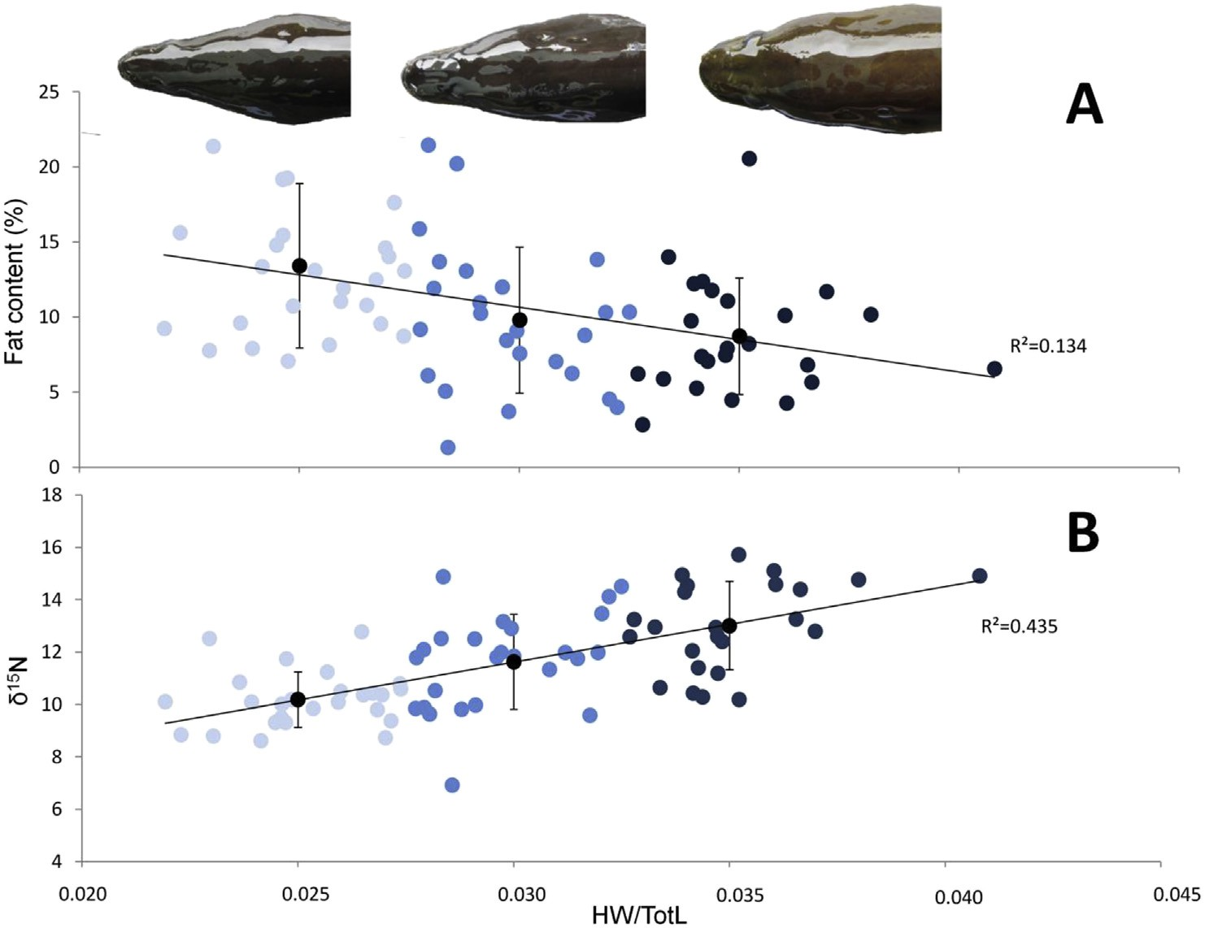

Fig. 1. Relation between fat content and trophic position with relative eel head width. A: Relation of fat content with eel head width relative to total length (HW/TotL). B: Relation of trophic position (d15N) with eel head width relative to total length (HW/TotL). Light blue dots represents narrow-heads, blue dots intermediates and dark blue dots broad-headed eels. A representative of each phenotype is given above. Black dots represent the means of each phenotype; the error bars represent standard deviation. (For interpretation of the references to colour in this ﬁgure legend, the reader is referred to the Web version of this article.)

Table 2
Results obtained from the ANCOVA of the different pollutant concentrations between narrow-heads, intermediates and broad-heads. The adjusted means for each group are given, as well as the P-values for slope equality (P > 0.05 for ANCOVA) and the P-values of the ANCOVA (P anc). Signiﬁcant values are shown in bold.
TotL (log-transformed)
 |  | Adj. Means |  |  |  | Slope
 |  | NH | INT | BH |  | NH | INT | BH |  | P sl eq |  | P anc
Wet Weight/Lipid Weight (log-transformed) | Hg | -1.02 | -0.97 | -0.81 |  | -1.028 | -0.451 | 0.471 |  | 0.62 |  | < 0.01
 | Zn | 1.00 | 1.01 | 1.04 |  | -1.133 | 1.247 | 0.400 |  | 0.06 |  | 0.52
 | CB 101 | 2.62 | 2.77 | 2.59 |  | 1.730 | 0.775 | 0.710 |  | 0.91 |  | 0.07
 | CB 153 | 3.12 | 3.29 | 3.30 |  | 0.179 | 0.978 | 0.719 |  | 0.93 |  | 0.01
 | CB 138 | 3.05 | 3.23 | 3.24 |  | -0.139 | 0.176 | 0.213 |  | 0.98 |  | < 0.01
 | CB 180 | 2.62 | 2.80 | 2.86 |  | -0.576 | 0.527 | 0.582 |  | 0.81 |  | < 0.01
 | HCB | 1.08 | 1.00 | 0.85 |  | 3.030 | -0.092 | 0.731 |  | 0.26 |  | < 0.01
 | p,p'-DDE | 2.45 | 2.60 | 2.58 |  | 0.380 | -0.007 | 0.300 |  | 0.97 |  | 0.03
 | a-HBCD | 0.99 | 1.03 | 0.81 |  | -3.444 | -1.017 | -1.394 |  | 0.73 |  | 0.08
 | ∑PCB | 3.58 | 3.74 | 3.72 |  | 0.383 | 0.518 | 0.639 |  | 0.99 |  | 0.02
 | ∑BDE | 1.13 | 1.27 | 1.09 |  | 1.442 | 0.581 | 0.619 |  | 0.92 |  | 0.03
 | ∑DDT | 2.53 | 2.68 | 2.64 |  | 0.597 | -0.062 | 0.285 |  | 0.94 |  | 0.05
Age (not log-transformed)
 | Hg | -1.02 | -0.96 | -0.82 |  | 0.058 | -0.015 | -0.001 |  | <0.01 |  | < 0.01
 | Zn | 1 | 1.03 | 1.05 |  | -0.001 | -0.005 | -0.002 |  | 0.97 |  | 0.29
 | CB 101 | 2.62 | 2.79 | 2.64 |  | -0.044 | 0.009 | 0.021 |  | 0.10 |  | 0.18
 | CB 153 | 3.11 | 3.31 | 3.35 |  | -0.044 | 0.011 | 0.007 |  | 0.04 |  | < 0.01
 | CB 138 | 3.04 | 3.25 | 3.27 |  | -0.039 | 0.015 | 0.011 |  | 0.04 |  | < 0.01
 | CB 180 | 2.6 | 2.82 | 2.89 |  | -0.028 | 0.009 | 0.007 |  | 0.24 |  | < 0.01
 | HCB | 1.07 | 1.01 | 0.85 |  | 0.003 | 0.018 | 0.023 |  | 0.77 |  | 0.01
 | p,p'-DDE | 2.44 | 2.61 | 2.61 |  | -0.031 | 0.008 | 0.015 |  | 0.11 |  | 0.01
 | a-HBCD | 0.98 | 1.05 | 0.88 |  | 0.010 | 0.034 | -0.001 |  | 0.70 |  | 0.33
 | ∑PCB | 3.57 | 3.75 | 3.76 |  | -0.039 | 0.013 | 0.011 |  | 0.05 |  | < 0.01
 | ∑BDE | 1.1 | 1.28 | 1.13 |  | -0.021 | 0.016 | 0.000 |  | 0.47 |  | 0.07
 | ∑DDT | 2.52 | 2.69 | 2.67 |  | -0.033 | 0.008 | 0.016 |  | 0.08 |  | 0.02
TotL: Total Length.
NH: Narrow-head.
INT: Intermediate.
BH: Broad-head.

2000). Consequently, the higher consumption of these in- vertebrates by NHs could explain this observation. Lead (Pb) con- centrations were found to be signiﬁcantly lower in NHs compared to INTs, but did not differ signiﬁcantly from BHs. The results of the trace metal analysis were thus consistent with results obtained previously, showing that Hg demonstrates a tendency to bio- magnify in food chains (Atwell et al., 1998), whereas this is gener- ally not the case for the other metals (Cardwell et al., 2013). Moreover, most metals are hydrophilic and will be taken up via the
water rather than via the food. Additionally, most metals accu- mulate in the organs rather than in the muscle tissue (Mataba et al., 2016). Together with Hg, the only exception in our study is Cu, which also increased with head width and thus trophic position.
Our novel ﬁndings show that there is a link between head shape, trophic position and pollutant accumulation. Eels with broader heads feed more on prey items which are higher up in the food chain, leading to an increased uptake of more lipophilic POPs and Hg, compared to eels with a narrower head.

Table 3
Results of the non-parametric permutation test (10,000 replicates) performed on the log-transformed pollutant concentrations. Wet weight concentrations were used for metals, lipid weight concentrations for Persistent Organic Pollutants. Signiﬁcant differences are shown in bold. * indicate pollutants for which the median is presented (as the measured concentrations were not above detection limit in all eels).

Mean/Median ±SD P-values

NH INT BH NH-INT INT-BH BH-NH Wet Weight/Lipid Weight As -1.36 ± 0.22 -1.49 ± 0.42 -1.55 ± 0.15 0.12 0.75 < 0.01
 | Cu | 0.92 ± 0.11 | -0.88 ± 0.14 | -0.77 ± 0.25 | 0.24 | 0.07 | < 0.01
 | Pb | -1.81 ± 0.40 | -1.33 ± 0.66 | -1.55 ± 0.67 | < 0.01 | 0.26 | 0.10
 | Se | -0.84 ± 0.31 | -1.00 ± 0.62 | -1.06 ± 0.63 | 0.26 | 0.72 | 0.10
 | Cr* | -1.56 ± 0.49 | -1.57 ± 0.96 | -2.23 ± 0.92 | 0.24 | 0.12 | < 0.01
 | OxC* | 0.40 ± 0.20 | 0.46 ± 0.21 | 0.35 ± 0.26 | 0.37 | 0.07 | 0.24
 | TN* | 0.53 ± 0.13 | 0.63 ± 0.18 | 0.54 ± 0.33 | 0.07 | 0.02 | 0.17
 | p,p'-DDD | 1.70 ± 0.19 | 1.81 ± 0.16 | 1.67 ± 0.33 | < 0.01 | 0.70 | 0.04
 | p,p'-DDT* | 0.77 ± 0.20 | 0.88 ± 0.21 | 0.91 ± 0.30 | < 0.01 | 0.69 | 0.04
 | CB 28 | 1.81 ± 0.22 | 1.84 ± 0.19 | 1.53 ± 0.46 | 0.55 | < 0.01 | < 0.01
 | CB 52 | 2.60 ± 0.20 | 2.68 ± 0.17 | 2.47 ± 0.40 | 0.14 | 0.02 | 0.15
 | BDE47 | 0.94 ± 0.21 | 1.09 ± 0.20 | 0.85 ± 0.40 | 0.01 | < 0.01 | 0.31
 | BDE100* | 0.45 ± 0.18 | 0.55 ± 0.21 | 0.58 ± 0.54 | 0.02 | 0.32 | 0.99
SD: Standard Deviation.
NH: Narrow-head.
INT: Intermediate.
BH: Broad-head.

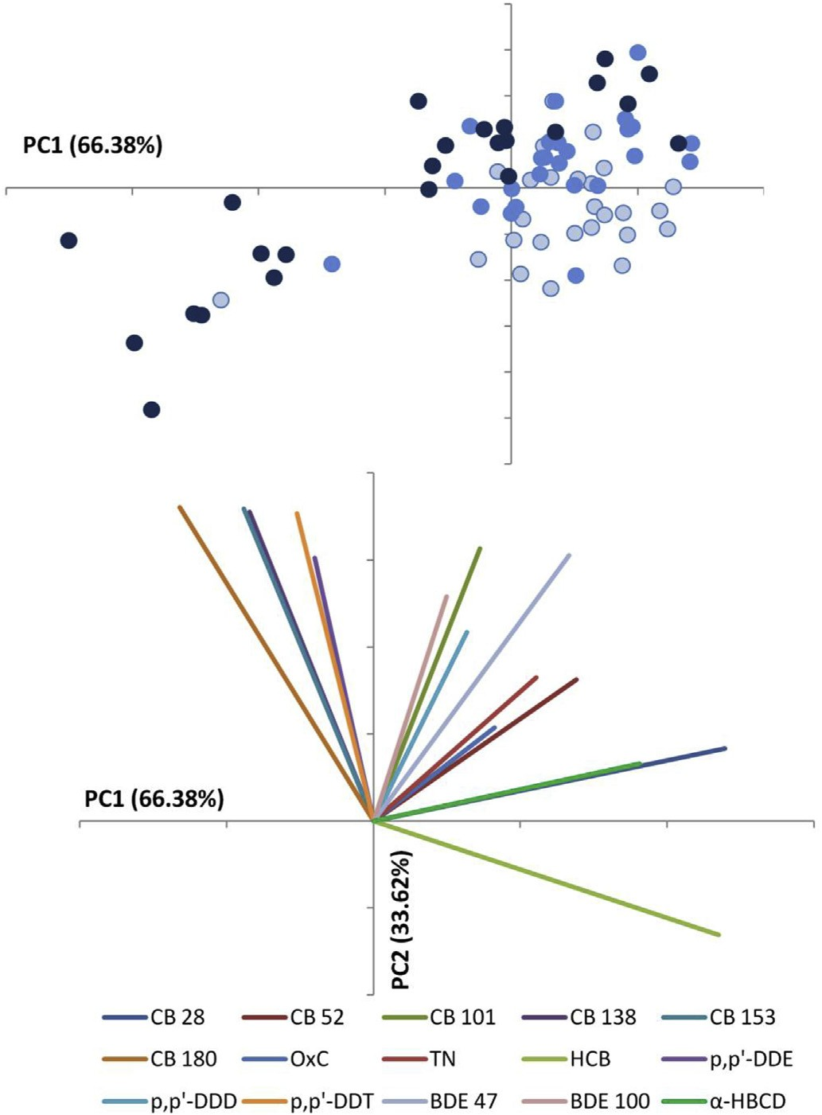

Fig. 2. Between-group PCA on the log-transformed pollutant concentrations and the corresponding biplot. The pollutant concentrations were expressed as lipid weight. Light blue dots represents narrow-heads, blue dots intermediates and dark blue dots broad-headed eels. The amount of variation explained by each Principal Component (PC) is shown in parentheses. (For interpretation of the references to colour in this ﬁgure legend, the reader is referred to the Web version of this article.)

- Discussion

A driver for phenotypic-trophic disparity in European yellow eels could be to alleviate the pressure on food competition, thus increasing their survival rates (Schoener, 1974). Additionally, a recent study has indicated that eels can adapt to differences in diet; young eels that were given hard prey, such as crustaceans, devel- oped broader heads than eels that were given soft prey, such as chironomid larvae (De Meyer et al., 2016). The broader heads were associated with larger jaw muscles that facilitate consumption of hard prey (De Schepper, 2007). The capability to show such an adaptive, phenotypic response to differences in food accessibility and the decrease in intra-speciﬁc competition through this dimorphism are likely to increase the eel's survival. As such, the dimorphism could be sustained in the population through natural selection, and thus be considered as adaptive. However, our results suggest that the causality between diet and head shape also con- trols the pollutant accumulation. Anthropogenic inﬂuences may thus turn an adaptive trait into a maladaptive one, as the advantage of adapting towards consuming larger and harder preys in the broad-headed yellow eel may ultimately lead to a lower repro- duction potential as silver eel, due to increased pollutant accumu- lation (Foekema et al., 2016).
While measurements of fat content in a particular subsample of muscle tissue may not be representative for the complete ﬁsh (Persson et al., 2007), we observed that the fat content of broad- head eels was signiﬁcantly lower than that of NHs. This phenom- enon could be explained by the trophic difference, with broad-head eels feeding proportionally more on larger and harder prey items, such as ﬁsh and crustaceans. The consumption of such larger prey is energetically more proﬁtable than the consumption of small, benthic invertebrates (Galarowicz et al., 2006). However, obtaining such prey items requires biting or spinning behaviour, in contrast to NHs sucking in small, benthic invertebrates. It has been demon- strated that the net energy gain when using biting and spinning behaviour is lower than when relying on suction feeding (Helfman and Winkelman, 1991). It is thus possible that the observed dif- ferences in fat content are a consequence of the different feeding methods. Secondly, it is possible that prey items, such as benthic invertebrates, are more abundant and thus easier to capture than the more evasive ﬁsh and crustaceans and that NHs hence require less energy for prey capture.

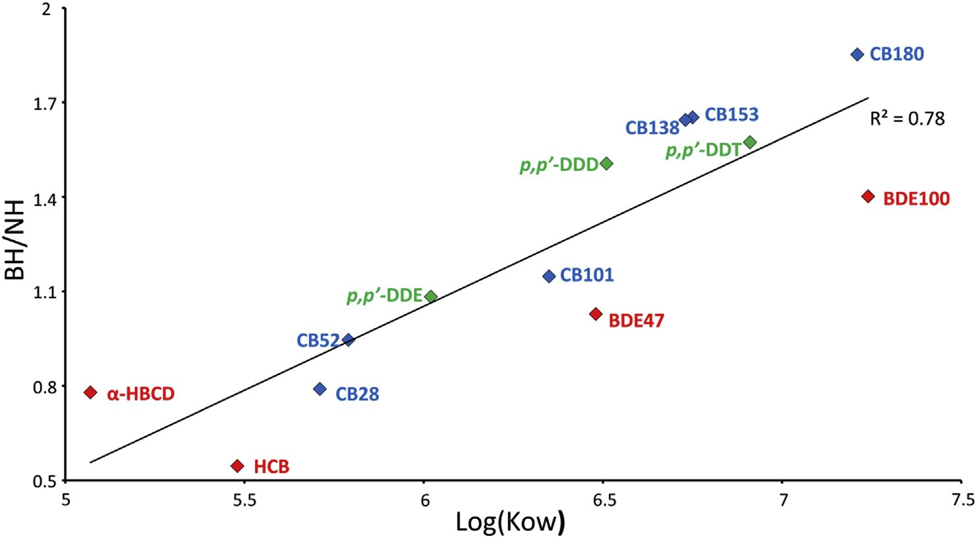

Fig. 3. Relation of the mean(BH)/mean(NH) ratio of the different pollutants plotted against the log of their octanol/water partition coefﬁcient (Kow). The pollutants are expressed as lipid weight. NH: Narrow-heads, BH: Broad-heads. Blue diamonds represent pentachlorobiphenyls (PCBs), green diamonds Dichlorodiphenyltrichloroethanes (DDTs) and red the remaining measured pollutants. (For interpretation of the references to colour in this ﬁgure legend, the reader is referred to the Web version of this article.)

Alternatively, several pollutants could have a negative impact on the eel's fat content, for example due to a higher energy demand induced by chemical stress (Geeraerts and Belpaire, 2010, Robinet and Feunteun, 2002). The lower lipid energy reserves of BHs may thus also be a consequence of signiﬁcantly higher concentrations of the more lipophilic pollutants (Belpaire et al., 2009). The measured lower fat content of BHs could, in turn, imply that BHs will also require a longer time to accumulate enough fat to start migration due to pollution. Indeed, while similar in age, 54% of the NHs had accumulated enough fat (12% of body weight (Van den Thillart et al., 2007)) to start migrating, while this was only 17% for the BHs. For INTs, this was 28%, but they were signiﬁcantly younger. Pollution therefore may affect the BHs at four levels. Firstly, during the fat accumulation period as yellow eels, where BHs need considerably more time to accumulate enough lipid energy to migrate success- fully. A delayed migration inevitably increases the risk of being killed by predators or other factors. Secondly, if BHs would still start their migration as silver eels, but with low fat concentrations, en- ergy storage would potentially be insufﬁcient to fuel the trans- atlantic migration and production of gametes, and thus leads to lowered reproduction potential (Belpaire et al., 2009). Thirdly, BHs have a higher risk of being exposed to the detrimental effects of higher concentrations of pollutants, when fat is being metabolised during migration. These effects may include disturbances of the immune, reproductive, nervous and endocrine systems (Geeraerts and Belpaire, 2010). Finally, being more loaded with the most toxic pollutants, such as PCBs, could have a negative impact on the mean weight of eggs by interfering with the development of the ovaries (Johnson et al., 1998), possibly resulting in less viable eggs. Our results therefore strongly indicate that BHs are expected to suffer more from POP and mercury pollution than NHs at several (potentially cumulative) concentrations, due to the trophic ecology related to head shape disparity. Additionally, the eel's head morphology has also been related to parasite infection, showing that the higher piscivorous behaviour of BHs leads to a higher exposure and thus infection with the parasite Anguillicoloides crassus (Pegg et al., 2015). This parasite damages the swim bladder and drains the eel's energy by sucking blood, thus also impairing the eel's migration success (Palstra et al., 2007; Neto et al., 2010). So, while natural selection would favour dimorphism because of decreased intra-speciﬁc competition, anthropogenic effects may well disrupt this adaptive process in polluted areas as the repro- duction potential of BHs is expected to be lower than that of narrow-heads. This is especially worrisome since current eel restoration measures in the EU member states focus on producing maximal quantities of silver eels leaving the river catchments (at least a 40% silver eel biomass escapement), and do not take into consideration their overall body quality. It has been argued, how- ever, that also the health status of silver eels should be improved at the level of pollution load, infection levels by pathological agents and ﬁtness indicators, such as lipid levels and condition. These are all factors that are crucial for maximizing the eel's reproductive potential, and hence for the successful restoration of the European eel stock. Our results indicate that there could be differences in reproductive potential between broad- and narrow-headed eels from polluted environments. We would advise that the current stock assessment, which is based on quantitative indicators, should be jointly merged with indicators characterizing the quality of the eels leaving our catchments. This could potentially lead to an overall, much needed, successful restoration of European eel stocks.

Acknowledgements

We thank the personnel of INBO (Instititute for Nature and Forest Research) for their help with collecting and processing the
eels. We thank K. Van Nieuland for her help with preparing the stable isotope analysis. This research was supported by BOF (Special Research Fund; BOF 01J05213 and BOF 13/24J/052).
.

References

ATSDR, 2004. Toxicological Proﬁle for Polybrominated Biphenyls and Poly- brominated Diphenyl Ethers. (ATSDR (Agency for Toxic Substances and Disease Registry). Public Health Service, U.S. Department of Health and Human Services, Atlanta, GA.
Atwell, L., Hobson, K.A., Welch, H.E., 1998. Biomagniﬁcation and bioaccumulation of mercury in an arctic marine food web Insights from stable nitrogen isotope analysis. Can. J. Fish. Aquat. Sci. 55, 1114e1121.
Baltazar-Soares, M., et al., 2014. Recruitment collapse and population structure of the european eel shaped by local ocean current dynamics. Curr. Biol. 24, 104e108.
Belpaire, C., 2008. Pollution in Eel: a Cause of Their Decline? PhD thesis Catholic University Leuven, Brussels.
Belpaire, C., et al., 2009. Decreasing eel stocks: survival of the fattest? Ecol. Freshw.
Fish 18, 197e214.
Belpaire, C., Geeraerts, C., Roosens, L., Neels, H., Covaci, A., 2011. What can we learn from monitoring PCBs in the European eel? A Belgian experience. Environ. Int. 37, 354e364.
Belpaire, C., Pujolar, J.M., Geeraerts, C., Maes, G.E., 2016. Contaminants in eels and their role in the collapse of the eel stocks. In: Arai, T. (Ed.), Biology and Ecology of Anguillid eels. CRC Press - Taylor & Francis Group, Boca Raton, FL, pp. 225e250.
Bonhommeau, S., et al., 2008. Impact of climate on eel populations of the Northern Hemisphere. Mar. Ecol. Prog. Ser. 373, 71e80.
Borga, K., Gabrielsen, G.W., Skaare, J.U., 2001. Biomagniﬁcation of organochlorines along a Barents Sea food chain. Environ. Pollut. 113, 187e198.
Bremle, G., Okla, L., Larsson, P., 1995. Uptake of PCBs in ﬁsh in a contaminated river system: bioconcentration factors measured in the ﬁeld. Environ. Sci. Technol. 29, 2010e2015.
Cardwell, R.D., DeForest, D.K., Brix, K.V., Adams, W.J., 2013. Do Cd, Cu, Ni, Pb, and Zn biomagnify in aquatic ecosystems? Rev. Environ. Contam. Toxicol. 226, 101e122.
CORDIS, 2013. Final Report Summary - EELIAD (European Eels in the Atlantic: Assessment of Their Decline ). The Secretary of State for Environment, Food and Rural Affairs, Lowestoft, U.K.
Cucherousset, J., et al., 2011. Fitness consequences of individual specialisation in resource use and trophic morphology in European eels. Oecologia 167 (1), 75e84.
De Meyer, J., Christiaens, J., Adriaens, D., 2016. Diet-induced phenotypic plasticity in European eel (Anguilla anguilla). J. Exp. Biol. 219, 354e363.
De Schepper, N., 2007. Evolutionary Morphology of Body Elongation in Teleosts: Aspects of Convergent Evolution. PhD dissertation. Ghent University, Ghent, Belgium.
Dekker, W., 2003. On the distribution of the European eel (Anguilla anguilla) and its
ﬁsheries. Can. J. Fish. Aquat. Sci. 60, 787e799.
Durif, C., Elie, P., Gosset, C., Rives, J., Travade, F., 2002. Behavioral study of down- stream migrating eels by radio-telemetry at a small hydroelectric power plant. Am. Fish. Soc. Symp. 33, 343e356.
Durif, C.M.F., van Ginneken, V., Dufour, S., Müller, T., Elie, P., 2009. Seasonal evo- lution and individual differences in silvering eels from different locations. Spawning migration of the European eel: reproduction index, a useful tool for conservation management. In: Van den Thillart, G., Dufour, S., Rankin, J.C. (Eds.). Springer Netherlands, pp. 13e38.
Foekema, E.M., Kotterman, M., de Vries, P., Murk, A.J., 2016. Maternally transferred dioxin-like compounds can affect the reproductive success of European eel. Environ. Toxicol. Chem. 35, 241e246.
Freese, M., et al., 2017. Maternal transfer of dioxin-like compounds in artiﬁcally matured European eels. Environ. Pol. 227, 348e356.
Friedland, K.D., Miller, M.J., Knights, B., 2007. Oceanic changes in the Sargasso Sea and declines in recruitment of the European eel. ICES J. Mar. Sci. 64, 519e530. Galarowicz, T.L., Adams, J.A., Wahl, D.H., 2006. The inﬂuence of prey availability on ontogenetic diet shifts of a juvenile piscivore. Can. J. Fish. Aquat. Sci. 63,
1722e1733.
Geeraerts, C., Belpaire, C., 2010. The effects of contaminants in European eel: a review. Ecotoxicology 19, 239e266.
Hayward, S., Lei, Y., Wania, F., 2006. Comparative evaluation of three high- performance liquid chromatography-based Kow estimation methods for high- ly hydrophobic organic compounds : polybrominated diphenyl ethers and hexabromocyclododecane. Environ. Toxicol. Chem. 25, 2018e2027.
Helfman, G.S., Winkelman, D.L., 1991. Energy trade-offs and foraging mode choice in american eels. Ecology 72 (1), 310e318.

Helsel, D.R., 2012. Statistics for Censored Environmental Data Using Minitab and R, second ed. John Wiley & Sons, Inc.
Hu, L.C., Todd, P.R., 1981. An improved technique for preparing eel otoliths for aging.
New Zeal. J. Mar. Fresh. 15, 445e446.
ICES, 2011. Report of the Workshop on Age Reading of European and American Eel (WKAREA 2). ICES, Bordeaux, France.
ICES, 2013. Report of the Workshop on Evaluation Progress Eel Management Plans (WKEPEMP). ICES, Copenhagen, Denmark, p. 759.
ICES, 2015. Report of the Workshop of a Planning Group on the Monitoring of Eel Quality under the Subject "Development of Standardized and Harmonized Protocols for the Estimation of Eel Quality" (WKPGMEQ). ICES, Brussels, Belgium, p. 274.
ICES, 2016. ICES WG Eel Report - Report of the Working Group on Eels (WGEEL). (Cordoba, Spain).
Johnson, L.L., et al., 1998. Contaminant effects on ovarian development and spawning success in rock sole from Puget Sound, Washingtion. Trans. Am. Fish. Soc. 127, 375e392.
Kelly, B.C., Ikonomou, M.G., Blair, J.D., Morin, A.E., Gobas, F.A.P.C., 2007. Food web- speciﬁc biomagniﬁcation of persistent organic pollutants. Science 317 (5835), 236e239.
Kettle, A.J., Asbjørn Vøllestad, L., Wibig, J., 2011. Where once the eel and the elephant were together: decline of the European eel because of changing hy- drology in southwest Europe and northwest Africa? Fish Fish. 12, 380e411.
Kuramochi, H., Maeda, K., Kawamoto, K., 2004. Physiochemical properties of selected polybrominated diphenylethers and comparison with some bromi- nated aromatics and PCDDs. Organohalogen Compd. 66, 2420e2425.
Lammens, E.H.R.R., Visser, J.T., 1989. Variability of mouth width in European eel, Anguilla anguilla, in relation to varying feeding conditions in three Dutch lakes. Environ. Biol. Fish. 26, 63e75.
Le Cren, E.D., 1951. The length-weight relationship and seasonal cycle in gonad weight and condition in the perce Perca ﬂuviatilis. J. Anim. Ecol. 20, 201e219.
Lewander, K., Dave, G., Johansson, M.L., Larsson, A., Lidman, U., 1974. Metabolic and haematological studies on the yellow and silver phases of the European eel, Anguilla anguilla L. e I. carbohydrate, lipid, protein and inorganic ion meta- bolism. Comp. Biochem. Physiol. 47B, 571e581.
Maes, J., Belpaire, C., Goemans, G., 2008. Spatial variations and temporal trends between 1994 and 2005 in polychlorinated biphenyls, organochlorine pesti- cides and heavy metals in European eel (Anguilla anguilla L.) in Flanders, Belgium. Environ. Pollut. 153, 223e237.
Malarvannan, G., et al., 2014. Assessment of persistent brominated and chlori- nated organic contaminants in the European eel (Anguilla anguilla) in Flan- ders, Belgium: levels, proﬁles and health risk. Sci. Total Environ. 482e483, 222e233.
Mason, R.P., Laporte, J., Andres, S., 2000. Factors controlling the bioaccumulation of mercury, methylmercury, arsenic, selenium, and cadmium by freshwater in- vertebrates and ﬁsh. Arch. Environ. Contam. Toxicol. 38, 283e297.
Mataba, G.R., Verhaert, V., Blust, R., Bervoets, L., 2016. Distribution of trace elements in the aquatic ecosystem of the Thigithe river and the ﬁsh Labeo victorianus in
Tanzania and possible risks for human consumption. Sci. Total Environ. 547, 48e59.
Moriarty, C., 1973. A technique for examining eel otoliths. J. Fish. Biol. 5, 183e184. Neto, A.F., Costa, J.L., Costa, M.J., Domingos, I., 2010. Epidemiology and pathology of Anguillicoloides crassus in European eel Anguilla anguilla from the Tagus es-
tuary (Portugal). Dis. Aquat. Org. 88, 225e233.
Ohkouchi, N., Ogawa, N.O., Chikaraishi, Y., Tanaka, H., Wada, E., 2015. Biochemical and physiological bases for the use of carbon and nitrogen isotopes in envi- ronmental and ecological studies. Prog. Earth Plan. Sci. 2 (1).
Palstra, A.P., Heppener, D.F.M., van Ginneken, V.J.T., Sze,kely, C., van den
Thillart, G.E.E.J.M., 2007. Swimming performance of silver eels is severely impaired by the swim-bladder parasite Anguillicola crassus. J. Exp. Mar. Biol. Ecol. 352, 244e256.
Pankhurst, N.W., 1982. Changes in body musculature with sexual maturation in the European eel Anguilla anguilla L. J. Fish. Biol. 21, 417e428.
Pegg, J., Andreou, D., Williams, C.F., Britton, J.R., 2015. Head morphology and pis- civory of European eels,Anguilla anguilla, predict their probability of infection by the invasive parasitic nematodeAnguillicoloides crassus. Freshw. Biol. 60, 1977e1987.
Persson, M.E., Larsson, P., Holmqvist, N., Stenroth, P., 2007. Large variation in lipid content, SPCB and d13C within individual Atlantic salmon (Salmo salar). Envi- ron. Pollut. 145, 131e137.
Post, D.M., 2002. Using stable isotopes to estimate trophic position: models, Methods, and assumptions. Ecology 83, 703e718.
Proman, J.M., Reynolds, J.D., 2000. Differences in head shape of the european eel.
Fish. Manag. Ecol. 7, 349e354.
Pujolar, J.M., et al., 2012. Surviving in a toxic world: transcriptomics and gene expression proﬁling in response to environmental pollution in the critically endangered European eel. BMC Genom. 13, 507.
Robinet, T., Feunteun, E., 2002. Sublethal effects of exposure to chemical com- pounds: a cause for the decline in Atlantic eels? Ecotoxicology 11, 265e277.
Roosens, L., et al., 2010. Spatial variations in the levels and isomeric patterns of PBDEs and HBCDs in the European eel in Flanders. Environ. Int. 36, 415e423.
Schoener, T.W., 1974. Resource partitioning in ecological communities. Science 185, 27e39.
Tapie, N., et al., 2011. PBDE and PCB contamination of eels from the Gironde estuary: from glass eels to silver eels. Chemosphere 83 (2), 175e185.
Tesch, F.W., 2003. The Eel, ﬁfth ed. Blackwell Science, Oxford.
Thurow, F., 1958. Untersuchungen uber die spitz und breitko€pﬁgen Varianten des Flussaales. Arch. Fischereiwiss. 9, 79e97.
To€rlitz, H., 1922. Anatomische und entwicklungsgeschichtliche Beitra€ge zur Artfrage
unseres Flussaales. Z. für Fisch. 21, 1e48.
Van den Thillart, G.E.E.J.M., Palstra, A.P., van Ginneken, V.J.T., 2007. Stimulated migration of European silver eel: swim capacity and cost of transport. J. Mar. Sci. Technol. 15 (special issue), 1e16.
Zhou, W., Zhai, Z., Wang, Z., Wang, L., 2005. Estimation of n-octanol/water partition coefﬁcients (Kow) of all PCB congeners by density functional theory. J. Mol. Struct.: THEOCHEM 755, 137e145.

