GPS tracking during parental care does not affect early offspring development in lesser black‑backed gulls

Marwa M. Kavelaars1,2 · Eric Stienen3 · Hans Matheve2 · Roland‑Jan Buijs4 · Luc Lens2 · Wendt Müller1

Abstract
Tracking devices are increasingly used to monitor individual movement patterns continuously and in high resolution. How- ever, carrying a device could potentially compromise an individual’s physiology or behaviour, thereby making tracking data unreliable for detailed behavioural measurements. To this end, we assessed the possible consequences of the application of GPS devices on offspring development in an opportunistic seabird species, the lesser black-backed gull (Larus fuscus), by comparing the growth and survival of nestlings of which none, one or both parents were equipped with a GPS device. We found that the developmental trajectories of the nestlings were not affected, and there were no differences in skeletal size and body mass at the fledging stage. A lack of negative effects on offspring development strongly suggests that the parental behaviour, and thus likely the foraging behaviour, did not differ between tagged and non-tagged individuals. The evidence that GPS data can be used to reliably study parental care, as well as other aspects of the bird’s behaviour, opens up new pos- sibilities to study behavioural and evolutionary ecological questions in ever-increasing resolution.

Introduction

Recent technological advances facilitated the continuous improvement of avian-tracking devices allowing the study of individual movement patterns in ever-increasing detail (Vardanis et al. 2011; Shamoun-Baranes et al. 2012; Patrick and Weimerskirch 2014). The emergence of cutting-edge tracking devices caused great leaps in the study of movement ecology in the past couple of decades, thereby increasing our knowledge about the global space-use of wide-ranging birds

(Sokolov 2011). Nowadays, several state-of-the-art tracking devices, ranging from light-weight, short range transmitters to heavier, long-life satellite transmitters are available for this purpose (reviewed in: Klaassen and Reneerkens 2014). The application of such cutting-edge tracking devices not only facilitated a significant progress in the field of migra- tion (Berthold et al. 2002; Croxall et al. 2005), but also offered new opportunities in the study of optimal foraging (Patrick et al. 2015), navigation (Orchan et al. 2016), and conservation (Costa et al. 2012).
Despite the advantages of the application of tracking systems, carrying a tracking device could potentially

have deleterious eff on an individual’s physiology

* Marwa M. Kavelaars marwa.kavelaars@uantwerpen.be

1 Behavioural Ecology and Ecophysiology research group (BECO), University of Antwerp, Universiteitsplein 1, 2610 Antwerp, Belgium
2 Terrestrial Ecology Unit (TEREC), Ghent University,
K.L. Ledeganckstraat 35, 9000 Ghent, Belgium
3 Research Institute for Nature and Forest (INBO), Kliniekstraat 25, 1070 Brussels, Belgium
4 Buijs Eco Consult B.V., Philips van Dorpstraat 49, 4698 RV Oud-Vossemeer, The Netherlands
or behaviour (see e.g. Phillips et al. 2003; Barron et al. 2010), even when manufactured and attached in a way that should minimise adverse eff Minimising the device eff is not only important for ethical reasons, but it is also essential when aiming to collect data that are rep- resentative of an organism’s natural behaviour. Whether the data is representative may not necessarily become evident from tracking data when these are not compared to data collected from non-tagged control groups. Hence, the underlying assumption that tagged individuals behave naturally often remains untested. To add to the level of complexity, deleterious eff are likely to vary among species and devices (Ropert-Coudert et al. 2007; Thaxter

et al. 2016; Vandenabeele et al. 2011). Along this line, some studies found no deleterious eff from carrying tracking devices (Hernández et al. 2004; Davis et al. 2008; Lamb et al. 2016), while others showed a reduction in body mass (Irvine et al. 2007) or an increased mortality rate (Dixon et al. 2016) (but for a comprehensive over- view see Barron et al. 2010). However, even in the absence of direct survival effects, more subtle eff ts on behav- ioural components (such as foraging; Phillips et al. 2003) or metabolic costs and energetics (Godfrey et al. 2003) might be present. Increased foraging costs resulting from carrying tracking devices might be highest during paren- tal care, when the foraging eff t is at its maximum (e.g. Shaff et al. 2003), and could thereby aff parental care and thus reproductive success when birds are tracked dur- ing the breeding period. The examination of the potential eff on breeding success (e.g. chick growth, off ing survival along with clutch mass and laying date in the year following deployment of a GPS device) may thus form a test case for analysing harmful side eff of carrying a device, which may act via changes in foraging behaviour (Beaulieu et al. 2009; Kidawa et al. 2012; Robinson and Jones 2014). But the studies focussing on these eff on off ing development show contrasting results (for exam- ple, see for no eff Agnew et al. (2013) and Sergio et al. (2015) vs. an eff in Ackerman et al. (2004) and Whid- den et al. (2007)), making it diffi to fi any general patterns across species.
While gulls are among the most commonly tracked sea- birds (Ceia et al. 2014; Corman and Garthe 2014; Cam- phuysen et al. 2015; Thaxter et al. 2015; Isaksson et al. 2016; Rock et al. 2016; Stienen et al. 2016; Shaff et al. 2017), data on the eff of GPS devices on breeding per- formance are, as of yet, inconclusive. Thaxter et al. (2016) did not fi a negative eff on nestling survival and col- ony attendance in lesser-backed gulls (Larus fuscus), but off ing development was not monitored until fl
Camphuysen (2011) showed the pronounced daily fl - tuations in body mass of nestlings of which one parent carried a GPS device, but this was not statistically tested. However, even when no direct eff on nestling survival are detected, susceptible traits such as nestling growth may still be aff
The aim of this study was to assess potential negative effects of the application of GPS tracking devices on paren- tal care through the study of offspring growth and survival. We monitored the growth and survival of nestling lesser black-backed gulls that were raised by parents of which either none, one or both individuals were carrying a GPS device. We cross-fostered eggs shortly before hatching using eggs of similar size. So we synchronised hatching thereby preventing growth and survival differences due to hatching asynchrony. Via cross-fostering, we could also standardise
brood size (2 nestlings), chick quality, and match laying dates of tagged and untagged pairs.

Methods

Fieldwork and bird instrumentation

This study was carried out in the colonies of the industrial ports Vlissingen-Oost, the Netherlands (51°27′N, 3°42′E) and Zeebrugge, Belgium (51°20′N, 3°10′E) that host, respectively, ± 4500 and ± 1500 ground-breeding pairs (Fig. 1). Adult lesser black-backed gulls were captured in Vlissingen-Oost (n = 9) and Zeebrugge (n = 10) between 14 May and 31 May 2016. All individuals were captured on the nest with a wire mesh walk-in cage trap in the second or third week of incubation. UvA-BiTS GPS devices were attached to the birds using a Teflon wing harness, weigh- ing combined approximately 2.3% of the bird’s body mass [61 × 25 × 10 mm, 13.5 g (+ 5 g harness), for more detailed information on the UvA-BiTS GPS devices see Bouten et al. 2013; for wing harness attachment see Thaxter et al. 2014]. Data can be retrieved remotely, allowing us to follow indi- viduals over consecutive years. In 16 nests, only one of the parents was tagged, and in three nests, double-tagged pairs were created by tagging the partners of individuals that had already been deployed with a GPS device in the previous year.

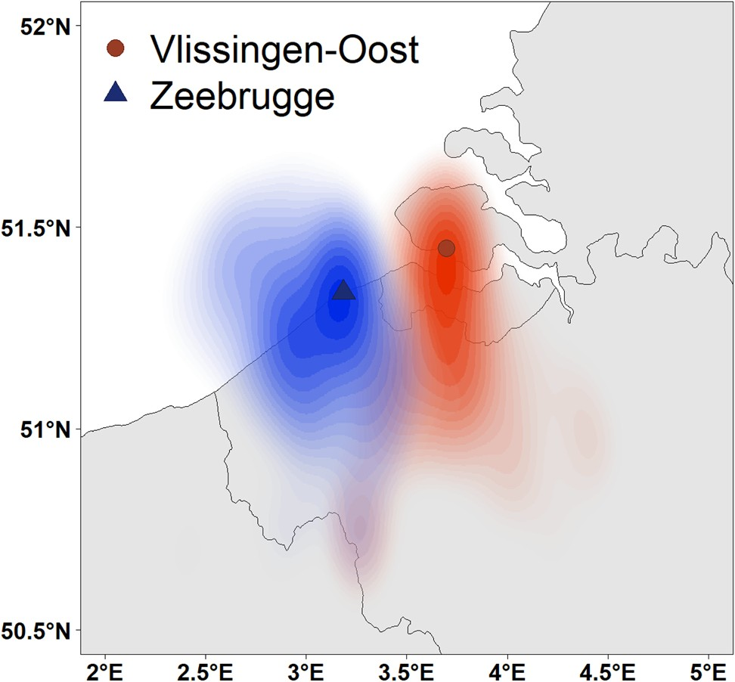

Fig. 1 Kernel density distribution of the GPS tagged lesser black- backed gulls in Vlissingen-Oost (red) and Zeebrugge (blue) dur- ing the chick rearing period. Location of the breeding colonies are marked with a circle (Vlissingen-Oost) and a triangle (Zeebrugge)

The colonies were visited every 2–3 days, and nests were monitored from the moment of egg laying. Newly laid eggs were marked by writing the date on the egg shell with a black, non-toxic marker, which also allowed us to identify the laying order. We replaced the eggs in each nest by two pipping eggs from two different donor nests at the moment of hatching, the timing of which was estimated based on the laying dates of the respective clutches. Concurrently, we selected nests of unringed pairs in the vicinity of the GPS nests with similar laying date to function as control nests, which also received two unrelated pipping eggs (Vlissingen- Oost n = 15; Zeebrugge n = 9). The eggs were cross-fostered to reduce the biasing effect of variables not related to GPS devices, such as genetic and phenotypic quality eff on offspring development. It also allowed us to synchronise hatching and prevent growth and survival diff ences due to hatching asynchrony. Through the cross-foster design we could also ensure that all parents experienced the same offspring demand by standardising the brood size with two nestlings. Chicken wire enclosures were built around each GPS and control nest (circa 2 × 2 m in size, and 0.3 m high) to ensure that the nestlings stayed close to the nest for the entire nestling period, and PVC tubes were added to pro- vide shelter. On the hatching day, nestlings were individually marked with coloured tape and down feathers were collected for molecular sexing. Off ing development (body mass, tarsus length) was measured every 2–3 days until day 30 and nestling mortality was recorded during each visit.

Statistical analysis

All statistical analyses were performed in R (R Core Devel- opment Team 2016). Nestling growth was modelled with a logistic function: Wt= A∕1 + e(K(1 − t)) in which Wtis the body mass at time t (g), t is the nestling age (days), A is the asymp- totic mass (g), K is the growth rate constant, and I is the inflection point of the growth curve (days) (for more details see Sofaer et al. 2013). The “nlme’’ R package (Pinheiro et al. 2018) was used to build nonlinear mixed effect models. Growth data represent repeated measurements for each individual nestling, excluding the individuals that died too early so that their growth function could not be fi In addition, nestlings within the same nest receive parental care from the same parents and are therefore not independent from each other. Both levels of statistical dependence were accounted for by including nestling ID nested in nest ID as random eff in all models. Additionally, colony was included as a random effect to account for potential among-
colony variation in growth (nest ID nested in colony ID).
In a fi t analysis, we included ‘gps’ [number of GPS devices per couple; 0 (n = 24), 1 (n = 16), 2 (n = 3)] and nestling sex [male nestlings [Vlissingen-Oost (= vl) n = 20, Zeebrugge (= zb) n = 21 or female nestlings (vl n = 20, zb
n = 12)] as fi ed eff In a second analysis, we com- bined nests with one and two GPS devices and referred to this as ‘treatment’ (number of nestlings with GPS tagged parent (vl n = 15, zb n = 18) or control parents (vl n = 25, zb n = 15). This allowed us to include the interaction between treatment and sex, which was not possible in the fi t model due to lack of variation in nestling sex within the double-tagged GPS nests. Stepwise backward elimina- tion using log-likelihood ratio (LR) tests was performed to obtain p values.
Body condition index was calculated for the last meas- urement before fl (day 28 ± 1) by dividing body mass by skeletal growth (i.e. tarsus length) to correct for a possible correlation between body mass and body size. Body condition and tarsus length at fledging were analysed with linear mixed models using the “lme4’’ R package (Bates et al. 2015). These models included ‘gps’ (0, 1, 2) and ‘sex’ (female, male) as fi ed eff Nest ID nested in colony ID was included as random eff A Pearson’s Chi-squared test was used to compare the number of nest- lings that survived until fl between control and GPS pairs, excluding nestlings that died during or right after hatching, because their mortality was unlikely related to the provisioning of the parents, but rather a consequence of diffi during hatching.

Results

Effects on early development

Carrying a GPS device did not have a signifi eff on the growth trajectory of the nestlings. Nestlings that were reared by parents of which none, one or both were carry- ing a GPS device did not diff in their growth parameters A, I, K (Tables 1, 2). Nestling data of both GPS groups were subsequently pooled and compared with control nests for a statically more powerful analysis, e.g. with respect to interactions. In addition, there was no eff of GPS devices on tarsus length (F2,40.09 = 1.72, p = 0.19), or body condition (F2,68.08 = 0.46, p = 0.63) at the moment of fl
There was a signifi sex eff on asymptotic body mass (Fig. 2) and infl ction point (Table 1), and the tar- sus length (F1,63.92 = 53.75, p < 0.001) and body condition index (F1,70.09 = 7.86, p = 0.01) at the moment of fl
Males were heavier (asymptotic body mass 778.4 ± 20.3 g), larger (tarsus length 64.7 ± 0.5 mm), and in better body con- dition (11.5.5 ± 0.7) than females (asymptotic body mass
660.3 ± 17.7 g; tarsus length 59.6 ± 0.6 mm; body condition index 10.8 ± 0.7) (Fig. 3). There was no significant interac- tion between sex and treatment (Table 1).

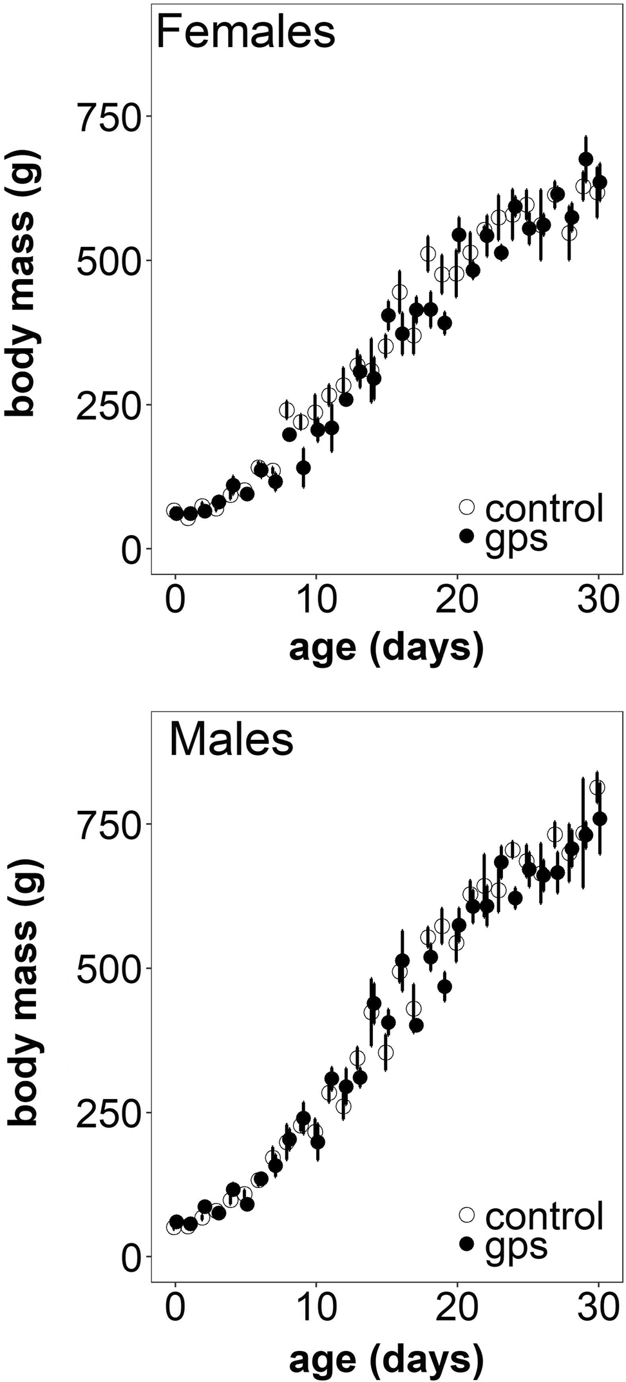Table 1 Outcome of the nonlinear mixed effect models, summaris- ing all fixed effects from the first analysis (model 1: gps: 0, 1, 2; sex: male, female) and the second analysis with the GPS groups pooled (model 2: treatment: control, GPS; sex: male, female) on the growth parameters (asymptote A, inflection point I, growth constant K)

Model Growth
 | parameters
1 | A | gps | 1.267894 | 0.53
 | I | gps | 3.558161 | 0.17
 | K | gps | 4.025455 | 0.14
 | A | Sex | 25.7476 | < 0.0001*
 | I | Sex | 3.846712 | 0.05*
 | K | Sex | 0.9289894 | 0.34
2 | A | Treatment:sex | 0.2632467 | 0.61
 | I | Treatment:sex | 1.400607 | 0.24
 | K | Treatment:sex | 0.05445519 | 0.82
 | A | Treatment | 0.8245793 | 0.37
 | I | Treatment | 0.1505484 | 0.70
 | K | Treatment | 0.6659029 | 0.41
 | A | Sex | 28.84547 | < 0.0001*
 | I | Sex | 3.966338 | 0.05*
 | K | Sex | 0.7825131 | 0.38

*Statistical significance
Fixed effects LR p value

Table 2 Parameter estimates (± SE) of the null model including ‘gps’ and ‘sex’ as fixed effects

Growth param- eters
Fixed effects Value SE

A Intercept 676.44 21.50
gps 0 – –
gps 1 − 30.14 28.32
gps 2 + 4.73 61.35
Female – –
Male + 111.67 21.86
I Intercept 14.29 0.43
gps 0 – –
gps 1 -0.51 0.61
gps 2 +1.92 1.26
Female – –
Male + 0.31 0.31
K Intercept 0.18 0.01
gps 0 – –
gps 1 + 0.01 0.01

Fig. 2 Mean (± SE) body mass of nestlings with tagged parents (closed symbols) or control parents (open symbols) according to age, plotted for females and males separately

Effects on survival
 | gps 2 | − 0.03 | 0.01
 | Female | – | –
 | Male | + 0.01 | 0.01

Mortality rates did not significantly differ between control and GPS nestlings (χ2(1) = 0.02, p = 0.89). A total of 4 out of 44 (9.1%) control nestlings did not survive up to day 30, while 2 out of 35 (5.7%) GPS nestlings died.

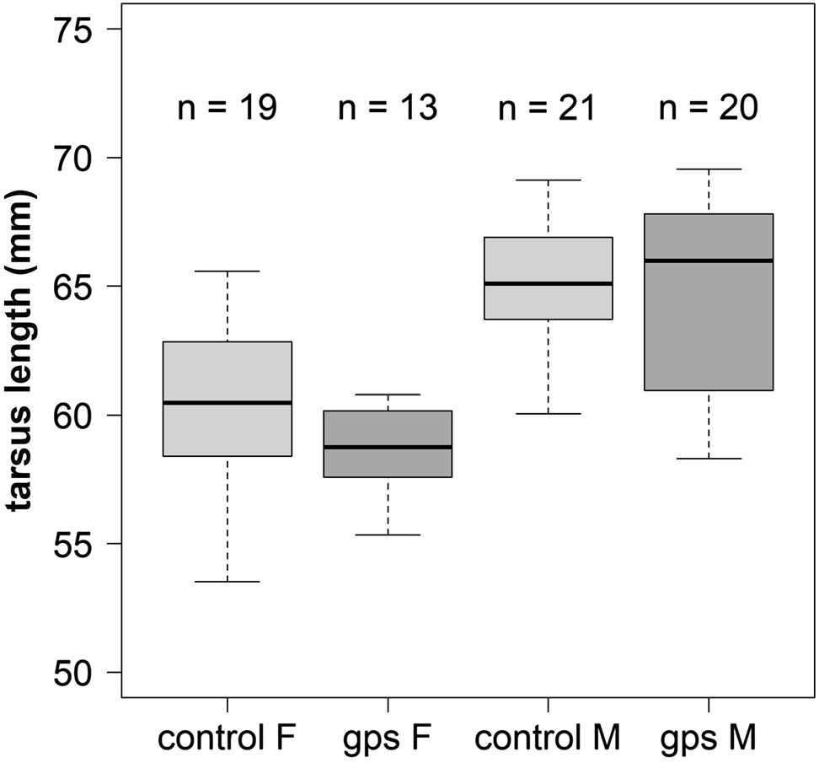

Fig. 3 Median (thick horizontal line), 50% range (box) and range (whiskers) of tarsus length at the moment of fledging for nestlings from male (M) and female (F) control (non-tagged) parents (light grey) and tagged parents (dark grey)

Discussion

In this study, we investigated whether the application of GPS tracking devices has negative effects on early offspring development and survival in lesser black-backed gulls. Such a reduction in off ing quality could occur when parents deployed with a GPS device are impaired in their foraging behaviour which in turn limits their parental rearing abili- ties. However, we did not find any negative effects on nest- ling growth or on body measurements and body condition at fledging. The lack of difference in offspring development between our three different groups [single-tagged, double- tagged (albeit small sample size) and control pairs] suggests that parental feeding behaviour did not differ between tagged and non-tagged individuals. This implies there is likely no harmful effect of carrying the GPS device on the foraging behaviour. A handicap for foraging behaviour induced by the GPS attachment should be most apparent during the period of chick rearing, as parents have to collect food not only for themselves, but also for their offspring. The period of chick rearing is thus a very demanding phase that may place par- ents at their limits.
The lack of negative eff for the off ing of GPS tagged parents is in line with two earlier studies on lesser black-backed gulls that also did not find a negative impact of GPS devices on nestling growth and survival (Camphuysen 2011; Thaxter et al. 2016). However, the effects in these ear- lier studies were inconclusive as offspring growth and sur- vival was not consistently monitored throughout the entire
nestling period. In this study, we meticulously measured offspring development and survival while controlling for potentially biasing effects of brood size and laying date and taking off ing sex into account. Still, all growth param- eters as well as the size and mass at fledging were similar in nestlings of single-tagged, double-tagged and control pairs. The only parameter affecting nestling growth was offspring sex. Males obtained a higher asymptotic body mass than females, which can be ascribed to the development of the sexual size dimorphism in lesser black-backed gulls (Grif- fiths 1992). As in most Laridae, this dimorphism becomes more evident towards the end of the nestling period, as males reach a higher asymptotic mass (Jordi and Arizaga 2016). In accordance with Thaxter et al. (2016) and Camphuysen (2011), we did not find an effect of GPS attachment on nest- ling survival either.
Earlier studies could not exclude compensatory parental effort by the non-tagged partner, interpreting a GPS device as a handicap (reviewed in Harrison et al. 2009). When only a single parent is tagged, its non-tagged partner may com- pensate for the reduced levels of parental care by the former (Harrison et al. 2009), thereby masking potential negative consequences of GPS tracking (Paredes et al. 2005). In this study, we included for the first time, breeding pairs of which both partners carried a GPS device. Unfortunately, this was a small sample size, also because of the time it takes to create such couples, as only one pair member was tagged per breeding season, and ideally the effect of this should be further explored with a larger sample. Simultaneously track- ing both parents amplified the potential impacts on offspring development while excluding partner compensation. Under this combined treatment, we did not detect negative effects on off ing growth or survival either. Still, annual varia- tion in environmental conditions, such as weather (Newell et al. 2015; Sicurella et al. 2015), habitat quality (Kaiser et al. 2015) or food abundance (Steigerwald et al. 2015) could modulate GPS device eff on off pring develop- ment. These aspects should be considered, as they could change how parents allocate their resources. While our study was conducted during 1 year only, we studied breeding suc- cess in two different colonies in which individuals vary in habitat use, and preliminary analyses of the GPS data show that tagged individuals diff ed in foraging specialisation, using marine, terrestrial and anthropogenic resources. Some foraging strategies might be energetically costlier than oth- ers, and this could mean that marine specialists that have to spend more time flying (Camphuysen et al. 2015) could be aff by the device to a greater extent than individuals that are waiting for human waste in urban environments. Further research on the costs of different foraging strategies would therefore be valuable.
Finally, a negative eff ct of GPS tagging on parental behaviour may not become evident if tagged parents invest

less in self-maintenance, thereby impairing future reproduc- tion, while keeping the investment in current offspring high. However, a meta-analysis by Barron et al. (2010) showed that tagged birds do not sacrifice self-feeding in favour of off pring feeding, or vice versa. Such absence of a trade- off in our study species is further supported by life history theory where long-lived species are predicted to prioritise survival over reproductive success in a given year (Wil- liams 1966; Drent and Daan 1980). If parents carrying a GPS device would sacrifi self-maintenance in favour of offspring survival, this could affect their survival probabil- ity and future reproductive investment in subsequent years. Unfortunately, the colony in Zeebrugge was disturbed by construction work and individuals could therefore not return to their familiar breeding spot, so that we are unable to test for long-term negative effects of the GPS devices on future reproductive investment and adult survival. However, other studies that used the same UvA-BiTS GPS devices found similar over-winter survival in tagged and non-tagged lesser black-backed gulls (Camphuysen 2011; Thaxter et al. 2016). Our results are in compliance with other studies on large seabirds (gannets (Morus bassanus) (Hamer et al. 2000), European shags (Phalacrocorax aristotelis) (Daunt et al. 2006), fi no eff of attached devices. Phillips et al. (2003) found no eff of satellite tag deployment on trip duration, meal mass or breeding success in black-browed (Thalassarche melanophris) and grey-headed (T. chrysos- toma) albatrosses. A comparison between studies of alba- trosses and petrels suggests that deleterious effects are pre- dominantly present when the transmitter exceeded 3% of the body mass of the tagged individual, which was not the case in our study. However, Bodey et al. (2017) and Van- denabeele et al. (2011) show that other aspects such as the shape of the device could have a much stronger eff on energy expenditure. Some species may be more vulnerable to tagging, e.g. when carrying a tracking device, diving spe- cies might encounter complications with their insulation or
experience increased drag (Bannasch et al. 1994).

Implications for future work

Taken together, this is hitherto the most fi study on potential negative fitness effects of GPS tracking. Carry- ing GPS devices did not have negative effects on offspring development or survival in lesser black-backed gulls. We are therefore confident that GPS data can be used to reli- ably study parental care in very high resolution. This opens new possibilities to study the important behavioural and evolutionary ecological questions such as in the context of (sex differences in) the costs of parental care, the resolution of evolutionary confl of interest, parental cooperation, or the evolution of bi-parental care. However, long-lasting
eff of GPS tracking have still been studied too little, which certainly requires further attention. Furthermore, it has to be stressed that our conclusions are limited to this particular attachment method and species only, as the behav- iour and ecology of a species are important facets that need to be considered in each case before implementing track- ing systems. It is therefore of importance that researchers keep studying and reporting potential effects on behaviour or fitness for each particular species. All of this will help to optimise tracking methods whenever possible or necessary.

Acknowledgements We are grateful to LifeWatch and NaturaPeople for funding of GPS devices and infrastructure; Fransisco Hernandes and Robin Houthoofdt (VLIZ) for logistical support; Peter Desmet (INBO), Bart Aelterman (INBO), Fransisco Hernandez (VLIZ) and Willem Bouten (UvABiTS) for data support; ANB, Hilbran Verstraete, Nicolas Vanermen, Marc Van de Walle, Wouter Courtens, Aurélie Dai- lledouze and Jorn Suijkerbuijk for their support in the field. We thank the authorities of Zeebrugge Port (MBZ) and Zeeland Seaports for their permission to access the ports, and PSA, APM, COVRA, EPZ, Pacorini and Van Citters Beheer BV for access to their sites. We are also grateful to the reviewers for their constructive comments on a previous version of the manuscript. This study was funded by the Research Foundation Flanders (FWO ID: 11ZI716N and G0E1614N).

Compliance with ethical standards

Conflict of interest The authors declare that they have no conflict of interest.

Research involving animals All procedures performed in this study have been approved by the University of Antwerp ethical committee (file number 2013-73) and the University of Groningen ethical com- mittee (file number 6986/6986A).

References

Ackerman JT, Adams J, Takekawa JY, Carter HR, Whitworth DL, Newman SH, Golighty RT, Orthmeyer DL (2004) Effects of radi- otransmitters on the reproductive performance of Cassin’s auk- lets. Wildl Soc Bull 32:1229–1241. https://doi.org/10.2193/0091- 7648(2004)032[1229:eorotr]2.0.co;2
Agnew P, Lalas C, Wright J, Dawson S (2013) Eff of attached data-logging devices on little penguins (Eudyptula minor). Mar Biol 160:2375–2382. https://doi.org/10.1007/s00227-013-2231-7
Bannasch R, Wilson RP, Culik B (1994) Hydrodynamic aspects of design and attachment of a back-mounted device in penguins. J Exp Biol 194:83–96
Barron DG, Brawn JD, Weatherhead PJ (2010) Meta-analysis of trans- mitter effects on avian behaviour and ecology. Methods Ecol Evol 1:180–187. https://doi.org/10.1111/j.2041-210x.2010.00013.x
Bates D, Mächler M, Bolker B, Walker S (2015) Fitting linear mixed- effects models using lme4. J Stat Softw 67:1–48. https://doi. org/10.18637/jss.v067.i01
Beaulieu M, Raclot T, Dervaux A, Le Maho Y, Ropert-Coudert Y, Ancel A (2009) Can a handicapped parent rely on its partner? An experimental study within Adélie penguin pairs. Anim Behav 78:313–320. https://doi.org/10.1016/j.anbehav.2009.05.006
Berthold P, Bossche WVD, Jakubiec Z, Kaatz C, Kaatz M, Querner U (2002) Long-term satellite tracking sheds light upon variable

migration strategies of White Storks (Ciconia ciconia). J Ornithol 143:489–495. https://doi.org/10.1046/j.1439-0361.2002.02044.x
Bodey TW, Cleasby IR, Bell F, Parr N, Schultz A, Votier SC, Bearhop S (2017) A phylogenetically controlled meta-analysis of biolog- ging device eff cts on birds: deleterious effects and a call for more standardized reporting of study data. Methods Ecol Evol 2017:1–10. https://doi.org/10.1111/2041-210X.12934
Bouten W, Baaij EW, Shamoun-Baranes J, Camphuysen KCJ (2013) A fl xible GPS tracking system for studying bird behaviour at multiple scales. J Ornithol 154:571–580. https://doi.org/10.1007/ s10336-012-0908-1
Camphuysen KCJ (2011) Lesser black-backed gulls nesting at texel: foraging distribution, diet, survival, recruitment and breeding biology of birds carrying advanced GPS loggers. NIOZ Rep. https
://doi.org/10.13140/RG.2.1.3574.5364
Camphuysen KCJ, Shamoun-Baranes J, van Loon EE, Bouten W (2015) Sexually distinct foraging strategies in an omnivorous seabird. Mar Biol. https://doi.org/10.1007/s00227-015-2678-9
Ceia FR, Paiva VH, Fidalgo V, Morais L, Baeta A, Crisóstomo P, Mourato E, Garthe S, Marques JC, Ramos JA (2014) Annual and seasonal consistency in the feeding ecology of an opportunistic species, the yellow-legged gull Larus michahellis. Mar Ecol Prog Ser 497:273–284. https://doi.org/10.3354/meps10586
Corman AM, Garthe S (2014) What flight heights tell us about forag- ing and potential conflicts with wind farms: a case study in lesser black-backed gulls (Larus fuscus). J Ornithol 155:1037–1043. https://doi.org/10.1007/s10336-014-1094-0
Costa DP, Breed GA, Robinson PW (2012) New insights into pelagic migrations: implications for ecology and conservation. Annu Rev Ecol Evol Syst 43:73–96. https://doi.org/10.1146/annurev-ecols ys-102710-145045
Croxall JP, Silk JRD, Phillips RA, Afanasyev V, Briggs DR (2005) Global circumnavigations: tracking year-round ranges of non- breeding albatrosses. Science 80(307):249–250. https://doi. org/10.1126/science.1106042
Daunt F, Afanasyev V, Silk JRD, Wanless S (2006) Extrinsic and intrinsic determinants of winter foraging and breeding phenol- ogy in a temperate seabird. Behav Ecol Sociobiol 59:381–388. https://doi.org/10.1007/s00265-005-0061-4
Davis AK, Diggs NE, Cooper RJ, Marra PP (2008) Hematological stress indices reveal no effect of radio-transmitters on wintering hermit thrushes. J Ornithol 79:293–297. https://doi.org/10.111 1/j.1557-9263.2008.00176.x
Development Core Team R (2016) R: a language and environment for statistical computing. Austria, Vienna
Dixon A, Ragyov D, Purev-Ochir G, Rahman ML, Batbayar N, Bru- ford MW, Zhan X (2016) Evidence for deleterious eff of harness-mounted satellite transmitters on saker falcons Falco cherrug. Bird Study 63:96–106. https://doi.org/10.1080/00063 657.2015.1135104
Drent R, Daan S (1980) The prudent parent: energetic adjustments in avian breeding. Ardea 68:225–252
Godfrey JD, Bryant DM, Williams MJ (2003) Radio-telemetry increases free-living energy costs in the endangered Takahe Por- phyrio mantelli. Biol Conserv 114:35–38. https://doi.org/10.1016/ S0006-3207(02)00416-0
Griffiths R (1992) Sex-biased mortality in the lesser black-backed gull Larus fuscus during the nestling stage. Ibis 134:237–244. https:// doi.org/10.1111/j.1474-919X.1992.tb03805.x
Hamer KC, Phillips RA, Wanless S, Harris MP, Wood AG (2000) Foraging ranges, diets and feeding locations of gannets Morus bassanus in the North Sea: Evidence from satellite telemetry. Mar Ecol Prog Ser 200:257–264. https://doi.org/10.3354/meps200257 Harrison F, Barta Z, Cuthill I, Székely T (2009) How is sexual con- fl over parental care resolved? A meta-analysis. J Evol Biol 22:1800–1812. https://doi.org/10.1111/j.1420-9101.2009.01792.x
Hernández F, Arredondo JA, Hernandez F, Hewitt DG, DeMaso SJ, Bingham RL (2004) Eff of radiotransmitters on body mass, feed consumption, and energy expenditure of north- ern bobwhites. Wildl Soc Bull 32:394–400. https://doi. org/10.2193/0091-7648(2004)32[394:EOROBM]2.0.CO;2
Irvine RJ, Leckie F, Redpath SM (2007) Cost of carrying radio trans- mitters: a test with racing pigeons Columba livia. Wildl Biol 13:238–243. https://doi.org/10.2981/0909-6396(2007)13
Isaksson N, Evans TJ, Shamoun-Baranes J, Åkesson S (2016) Land or sea? Foraging area choice during breeding by an omnivo- rous gull. Mov Ecol 4:1–14. https://doi.org/10.1186/s4046 2-016-0078-5
Jordi O, Arizaga J (2016) Sex diff ences in growth rates of yellow- legged gull Larus michahellis chicks. Bird Study 63:273–278. https://doi.org/10.1080/00063657.2016.1182966
Kaiser SA, Sillett TS, Risk BB, Webster MS (2015) Experimen- tal food supplementation reveals habitat-specifi reproductive investment in a migratory bird. Proc R Soc Lond Ser B Biol Sci 282:20142523. https://doi.org/10.1098/rspb.2014.2523
Kidawa D, Jakubas D, Wojczulanis-Jakubas K, Iliszko L, Stempnie- wicz L (2012) The eff cts of loggers on the foraging eff rt and chick-rearing ability of parent little auks. Polar Biol 35:909–917. https://doi.org/10.1007/s00300-011-1136-5
Klaassen R, Reneerkens J (2014) Bird tracking. Limosa 87:58–73 Lamb JS, Satgé YG, Fiorello CV, Jodice PGR (2016) Behavioral and
reproductive eff of bird-borne data logger attachment on brown pelicans (Pelecanus occidentalis) on three temporal scales. J Ornithol. https://doi.org/10.1007/s10336-016-1418-3
Newell M, Wanless S, Harris MP, Daunt F (2015) Effects of an extreme weather event on seabird breeding success at a North Sea colony. Mar Ecol Prog Ser 532:257–268. https://doi.org/10.3354/meps1 1329
Orchan Y, Ovaskainen O, Bouten W, Nathan R (2016) Novel insights into the map stage of true navigation in nonmigratory wild birds (stone curlews, Burhinus oedicnemus). Am Nat 187:E000. https
://doi.org/10.1086/686054
Paredes R, Jones IL, Boness DJ (2005) Reduced parental care, com- pensatory behaviour and reproductive costs of thick-billed murres equipped with data loggers. Anim Behav 69:197–208. https://doi. org/10.1016/j.anbehav.2003.12.029
Patrick SC, Weimerskirch H (2014) Personality, foraging and fitness consequences in a long lived seabird. PLoS One 9:e87269. https
://doi.org/10.1371/journal.pone.0087269
Patrick SC, Bearhop S, Bodey TW, Grecian WJ, Hamer KC, Lee J, Votier SC (2015) Individual seabirds show consistent foraging strategies in response to predictable fi ies discards. J Avian Biol 46:431–440. https://doi.org/10.1111/jav.00660
Phillips RA, Xavier JC, Croxall JP (2003) Effects of satellite transmit- ters on albatrosses and petrels. Auk 120:1082–1090. https://doi. org/10.1642/0004-8038(2003)120[1082:EOSTOA]2.0.CO;2
Pinheiro J, Bates D, DebRoy S, Sarkar D, R Core Team (2018) nlme: Linear and nonlinear mixed eff models. R package version 3.1-137. https://CRAN.R-project.org/package=nlme. Accessed
12 Mar 2018
Robinson JL, Jones IL (2014) An experimental study measuring the eff of a tarsus-mounted tracking device on the behaviour of a small pursuit-diving seabird. Behaviour 151:1799–1826. https
://doi.org/10.1163/1568539X-00003217
Rock P, Camphuysen KCJ, Shamoun-Baranes J, Ross-Smith VH, Vaughan IP (2016) Results from the fi t GPS tracking of roof- nesting herring gulls Larus argentatus in the UK. Ringing Migr 31:47–62. https://doi.org/10.1080/03078698.2016.1197698
Ropert-Coudert Y, Knott N, Chiaradia A, Kato A (2007) How do dif- ferent data logger sizes and attachment positions affect the diving behaviour of little penguins? Deep Res Part II Top Stud Oceanogr 54:415–423. https://doi.org/10.1016/j.dsr2.2006.11.018

Sergio F, Tavecchia G, Tanferna A, López Jiménez L, Blas J, De Stephanis R, Marchant TA, Kumar N, Hiraldo F (2015) No effect of satellite tagging on survival, recruitment, longevity, productiv- ity and social dominance of a raptor, and the provisioning and condition of its offspring. J Appl Ecol 52:1665–1675. https://doi. org/10.1111/1365-2664.12520
Shaffer SA, Costa DP, Weimerskirch H (2003) Foraging effort in relation to the constraints of reproduction in free-rang- ing albatrosses. Funct Ecol 17:66–74. https://doi.org/10.104 6/j.1365-2435.2003.00705.x
Shaffer SA, Cockerham S, Warzybok P, Bradley RW, Jahncke J, Clatterbuck CA, Lucia M, Jelincic JA, Cassell AL, Kelsey EC, Adams J (2017) Population-level plasticity in foraging behavior of western gulls (Larus occidentalis). Mov Ecol 5:27. https://doi. org/10.1186/s40462-017-0118-9
Shamoun-Baranes J, Bom R, van Loon EE, Ens BJ, Oosterbeek K, Bouten W (2012) From sensor data to animal behaviour: an oys- tercatcher example. PLoS One 7:28–30. https://doi.org/10.1371/ journal.pone.0037997
Sicurella B, Caffi M, Caprioli M, Rubolini D, Saino N, Ambrosini R (2015) Weather conditions, brood size and hatching order affect common swift Apus apus nestlings survival and growth. Bird Study 62:64–77. https://doi.org/10.1080/00063657.2014.989193 Sofaer HR, Chapman PL, Sillett TS, Ghalambor CK (2013) Advan- tages of nonlinear mixed models for fitting avian growth curves.
J Avian Biol 44:469–478. https://doi.org/10.1111/j.1600- 048X.2013.05719.x
Sokolov LV (2011) Modern telemetry: New possibilities in ornithol- ogy. Biol Bull 38:885–904. https://doi.org/10.1134/S106235901 1090081
Steigerwald EC, Igual JM, Payo-Payo A, Tavecchia G (2015) Effects of decreased anthropogenic food availability on an opportunistic gull: evidence for a size-mediated response in breeding females. Ibis (Lond 1859) 157:439–448. https://doi.org/10.1111/ibi.12252
Stienen EWM, Desmet P, Aelterman B, Courtens W, Feys S, Vaner- men N, Verstraete H, Van de Walle M, Deneudt K, Hernandez
F, Houthoofdt R, Vanhoorne B, Bouten W, Buijs R-J, Kavelaars MM, Müller W, Herman D, Matheve H, Sotillo A, Lens L (2016) GPS tracking data of lesser black-backed gulls and herring gulls breeding at the southern North Sea coast. Zookeys 555:115–124. https://doi.org/10.3897/zookeys.555.6173
Thaxter CB, Ross-Smith VH, Clark JA, Clark NA, Conway GJ, Marsh M, Leat EHK, Burton NHK (2014) A trial of three harness attach- ment methods and their suitability for long-term use on lesser black-backed gulls and Great skuas. Ringing Migr 29:65–76. https
://doi.org/10.1080/03078698.2014.995546
Thaxter CB, Ross-Smith VH, Bouten W, Clark NA, Conway GJ, Rehfisch MM, Burton NHK (2015) Seabird–wind farm interac- tions during the breeding season vary within and between years: A case study of lesser black-backed gull Larus fuscus in the UK. Biol Conserv 186:347–358. https://doi.org/10.1016/j.bioco n.2015.03.027
Thaxter CB, Ross-Smith VH, Clark JA, Clark NA, Conway GJ, Masden EA, Wade HM, Leat EHK, Gear SC, Marsh M, Booth C, Furness RW, Votier SC, Burton NHK (2016) Contrasting effects of GPS device and harness attachment on adult survival of lesser black- backed gulls Larus fuscus and Great skuas Stercorarius skua. Ibis 158:279–290. https://doi.org/10.1111/ibi.12340
Vandenabeele SP, Wilson R, Grogan A (2011) Tags on seabirds; how seriously are we considering instrument-induced behaviors? Anim Welf 20:559–571
Vardanis Y, Klaassen RHG, Strandberg R, Alerstam T (2011) Individu- ality in bird migration: routes and timing. Biol Lett 7:502–505. https://doi.org/10.1098/rsbl.2010.1180
Whidden SE, Williams CT, Breton AR, Buck CL (2007) Eff of transmitters on the reproductive success of tufted puffins. J Orni- thol 78:206–212. https://doi.org/10.1111/j.1557-9263.2007.00103
.x
Williams GC (1966) Natural selection, the costs of reproduction, and a refinement of Lack’s principle. Am Nat 100:687–690

