European silver eel (Anguilla anguilla L.) migration behaviour in a highly regulated shipping canal

Pieterjan Verhelsta,b,c,d,⁎, Raf Baeyensb, Jan Reubensc, Jean-Phillippe Benitezf, Johan Coeckb,
Peter Goethalsd, Michaël Ovidiof, Jenna Vergeynste, Tom Moensa, Ans Moutonb
a Marine Biology Research Group, Ghent University, Krijgslaan 281, 9000 Ghent, Belgium
b Research Institute for Nature and Forest (INBO), Havenlaan 88, bus 73, 1000 Brussels, Belgium
c Flanders Marine Institute, Wandelaarkaai 7, 8400 Ostend, Belgium
d Laboratory of Environmental Toxicology and Aquatic Ecology, Ghent University, Coupure Links 653, 9000 Ghent, Belgium
e Department of Mathematical Modelling, Statistics, and Bioinformatics, Ghent University, Coupure Links 653, 9000 Ghent, Belgium
f Laboratory of Fish Demography and Hydroecology, UR FOCUS, University of Liège, Quai Edouard van Beneden 22, 4020 Liège, Belgium

A R T I C L E I N F O

Handled by George A. Rose
Keywords: Diadromous Canal Migration
Water regulation Shipping locks
A B S T R A C T

Among the many man-made structures that facilitate shipping, navigable canals take an important position. These canals may oﬀer energetically favourable migration routes for diadromous ﬁsh, but they may also obstruct ﬁsh migration, for instance at shipping locks. Because the use of shipping canals by, and their eﬀects on, mi- grating ﬁsh remain unknown, we assessed whether these canals can play a signiﬁcant role in the migration of the critically endangered European eel. Only one third of 70 acoustically tagged silver eels completed migration through a shipping canal, and did so at a very low pace (average < 0.06 m s−1) due to delays at shipping locks and most likely also due to the disruption of water ﬂow. These delays may come at an energetic cost, hampering the chances of successful migration. Knowledge on the impact of shipping canals on diadromous ﬁsh is crucial for proper management regulations. For instance, the observation that eels mostly migrated at night and during spring and autumn can support water managers to deﬁne adequate measures to improve eel migration in shipping canals.

- Introduction

Canals for navigation and irrigation are among the most anthro- pogenically altered water bodies worldwide (Vitousek et al., 1997). Not only are they widely distributed, their number is likely to increase in the future due to climate change and a growing human population (Hannah et al., 2007). Canals are commonly characterised by a low structural variability (e.g. concrete embankments without riparian ve- getation) with shipping locks, weirs and turbine stations, resulting in a regulated water ﬂow. In addition to navigation, canals support in- dustrial water management by facilitating water withdrawal and waste water disposal. It has already been shown that shipping canals may have a negative eﬀect on local freshwater ﬁsh communities (Arlinghaus et al., 2002; Wolter and Arlinghaus, 2003). Such negative eﬀects can be direct (e.g. shear stress, ship waves, dewatering and backwash…) or indirect (e.g. habitat fragmentation and simpliﬁcation, loss of spawning and nursery habitats…) (see Wolter and Arlinghaus, 2003 for an ex- tensive review). Although the impact of shipping canals on non-mi- gratory ﬁsh species has been extensively studied (Arlinghaus et al.,

2002; Wolter, 2001; Wolter and Arlinghaus, 2003), knowledge on their eﬀects on diadromous ﬁsh species remains scant. Shipping canals generate threats for diadromous ﬁsh species: structures such as shipping locks, weirs and turbine stations, as well as the regulated water ﬂow, may hamper migration behaviour (e.g. by disorientation). However, shipping canals may also provide alternative opportunities such as new migration routes, by connecting river basins or creating shorter mi- gration routes to the sea. Depending on the impact of these canals on ﬁsh migration, proposed management measures could for instance in- clude adjusted ﬂow regulation or mitigation measures at turbine sta- tions and shipping locks. A group of diadromous ﬁsh species of parti- cular interest, are catadromous anguillid eels, as species have declined tremendously during the last decades. Speciﬁcally, the recruitment of the European eel (Anguilla anguilla L.) has declined over 90% since the 1970s (Dekker and Casselman, 2014). This decline is the consequence of various causes, such as migration barriers, habitat deterioration, pollution, human-introduced parasites, ﬁsheries and changes in ocean climate (Buysse et al., 2014; Feunteun, 2002; Køie, 1991; Miller and Tsukamoto, 2016; Moriarty and Dekker, 1997). Habitat fragmentation

⁎ Corresponding author at: Ghent University, Biology Department, Marine Biology Research Group, Krijgslaan 281/S8, 9000 Gent, Belgium.
E-mail address: Pieterjan.Verhelst@UGent.be (P. Verhelst).

by migration barriers, preventing the downstream migration of silver eels and upstream migration of glass eels, is regarded as an important bottleneck for this species (Mateo et al., 2017; Mouton et al., 2011). A changed ﬂow regime may also negatively impact silver eel migration, especially since water ﬂow is considered a crucial factor for eel mi- gration (Travade et al., 2010; Verhelst et al., 2018; Vøllestad et al., 1986). To bridge this knowledge gap, we investigated the downstream migratory behaviour of the European eel (hereafter referred as ‘eel’) in a shipping canal.
European silver eel migration behaviour has been studied in various systems such as rivers (Piper et al., 2015; Stein et al., 2015; White and Knights, 1997; Winter et al., 2007), polders (Buysse et al., 2015; Verhelst et al., 2018), estuaries (Aarestrup et al., 2008; Bultel et al., 2014) and the marine environment (Aarestrup et al., 2009; Amilhat et al., 2016; Huisman et al., 2016; Righton et al., 2016; Wysujack et al., 2015), but migration behaviour in large canals with shipping locks is still underexplored. We tracked 70 silver eels in the Belgian Albert Canal using acoustic telemetry. This shipping canal connects the two largest river catchments of Belgium (i.e. Schelde and Meuse), resulting in diﬀerent potential migration routes.
We assessed three research questions related to silver eel migration behaviour in the Albert Canal: (1) are eels able to migrate out of the system, (2) are they delayed in their migration, and (3) how does their behaviour relate to eel migration behaviour in other systems?

- Methods

  - Study area

The Albert Canal is ca 130 km long, 86 m wide, 5 m deep and functions as a shipping route between the rivers Schelde (Antwerp) and Meuse (Liège) for ships up to 12,000 tonnes, illustrating its economic importance. Secondary canals are connected to the Albert Canal for irrigation and navigation purposes (mainly recreational navigation): Zuid-Willemsvaart, Canal Briegden-Neerharen, Canal Beverlo, Canal Dessel-Kwaadmechelen, Canal Bocholt-Herentals and Canal Dessel- Turnhout-Schoten (Fig. 1).
The Albert Canal is fed by the Meuse, with which it has an open connection (i.e. no shipping locks are present). The water level is kept constant by the weir at Monsin, at the junction between the Meuse and the Albert Canal. Part of the water is used to ﬁll the shipping locks in Lanaye and Wezet, after which the water runs back into the Meuse (see Fig. S1 for details regarding the diﬀerent connections of the Albert Canal with the Meuse). The other part is used to water the Albert Canal and has an average water ﬂow of 9 m³ s−1 in Genk (Baetens et al., 2005). The Albert Canal is divided in seven navigation sections (A–G) by six shipping lock complexes (each complex consists of three shipping locks) without weirs (from Schelde to Meuse, these are located at Wijnegem, Olen, Ham, Hasselt, Diepenbeek and Genk) to overcome the 56-m head drop. During the 27-month study period (3rd September 2014 till 20th December 2016), the majority of the ships came from the harbour of Antwerp and were transported via the shipping locks in Wijnegem (Table S1). The number of transported ships gradually de- creased over the shipping locks towards the Meuse, since the destina- tion of some ships was along the Albert Canal, after which they re- turned to Antwerp. Only in 2014 a substantial number of ships was transported over the shipping lock in Genk (De Vlaamse Waterweg nv, unpublished data). Although the net ﬂow direction is towards the Schelde, shipping lock operation and accompanying navigation result in a highly disrupted ﬂow regime. Opening the locks happens relatively fast (i.e. within 15 min), resulting in back-and-forth moving waterfronts in the canal sections and a water ﬂow that temporarily diﬀers between sections. Notably, section G has the lowest water ﬂow of the system because the water mass is distributed over the docks (Hydrological Information Center, pers. comm.). The shipping locks operate from Monday morning 6 a.m. till Saturday evening 10 p.m, and remain
inactive on Sundays and holidays. Due to limitations of nocturnal na- vigation, the locks mainly operate during daytime. Speciﬁcally, for the period November 2014 till January 2016, 66% of shipping lock op- erations occurred during daytime compared to 30% at night. During dusk and dawn, shipping locks were both operational for 2% each of the time (shipping lock operation data obtained by De Vlaamse Waterweg nv). On top of shipping lock ﬁlling, the water manager discharges water via an underground canal when the Meuse discharge is high (especially in winter and spring). However, we do not have data about that ac- tivity.
Based on a ﬁsh monitoring survey from 2012 till 2015, the Albert Canal is characterised by a low ﬁsh biomass, ranging from 12.9 kg ha−1 to 24.2 kg ha−1 (Visser and Kroes, 2016). The diversity ranges between 15 and 18 species. The majority of the species are eurytopic, such as roach (Rutilus rutilus L.), bream (Abramis brama L.) and perch (Perca ﬂuviatilis L.). Note that especially roach and bream are stocked for re- creational angling purposes. Rheophilic and phytophilic species are scarce, while the numbers of invasive round goby (Neogobius melanos- tomus P.) are increasing over the years.

  - Tagging procedure

118 Eels were caught in the upstream part of the canal during summer, autumn and winter of two consecutive years (i.e. 2014 and 2015) using double fyke nets, just upstream of the shipping lock com- plexes in Genk, Diepenbeek and Hasselt. Of those, 70 silver eels were tagged and released on site in the Albert Canal (Fig. 1): 13 eels were caught and released in 2014 at Hasselt, ﬁve were caught and released in 2014 at Diepenbeek, 27 eels were caught and released in 2014 at Genk. Another 36 eels were caught at Genk in 2015, of which ten were re- leased at that location and the latter 26 were released at one point in canal section D. Several morphometric features were measured in order to determine the eel maturation stage according to Durif et al. (2005): total length (TL, to the nearest mm), body weight (W, to the nearest g), the vertical and horizontal eye diameter (EDv and EDh, respectively, to the nearest 0.01 mm) and the length of the pectoral ﬁn (FL, to the nearest 0.01 mm) (Table 1). Only females were tagged, since males are smaller than the minimum size handled in this study (< 450 mm (Durif et al., 2005)). Both FIV (n = 1) and FV (n = 69) silver eels were tagged. Eels were tagged with V13-1 L coded acoustic transmitters (13 × 36 mm, weight in air 11 g, frequency 69 kHz) and V13P-1 L coded acoustic transmitters (13 × 48 mm, weight in air 13 g, frequency 69 kHz) from VEMCO Ltd (Canada, http://www.vemco.com) (Table S2). The latter transmitter type has a pressure sensor, but those data were not used in this study. After anaesthetising the eels with
0.3 ml L−1 clove oil, tags were implanted according to Thorstad et al.
(2013) and the wound stitched with resorbable polyﬁlament. Eels re- covered in a quarantine reservoir for approximately 1 h and were subsequently released at the ﬁrst acoustic listening station (ALS) up- stream of their catch location or in section D (Fig. 1).

  - Acoustic network

Within the framework of the Belgian LifeWatch observatory, a network of ALSs (VR2W, VR2Tx and VR2AR, VEMCO Ltd) has been deployed in Belgium and The Netherlands (Fig. S2). These ALSs register the transmitter ID with date and time of the detection. Note that the data of the ALSs not located in the Albert Canal were only used to determine if eels were able to leave the Albert Canal and are therefore not described or discussed here. 23 ALSs were deployed in the Albert Canal itself and another four in the entry of the secondary canals connected to the Albert Canal (Fig. 1). In the Albert Canal, ALSs were deployed up- and downstream of every shipping lock (n = 13), near the tidal sluices in Antwerp (n = 3), at the junction with the Schelde-Rijn canal (n = 1), at the junction with the Meuse (n = 2) and evenly spread in section A (n = 4) to cover the sluice complexes of Wezet and Lanaye

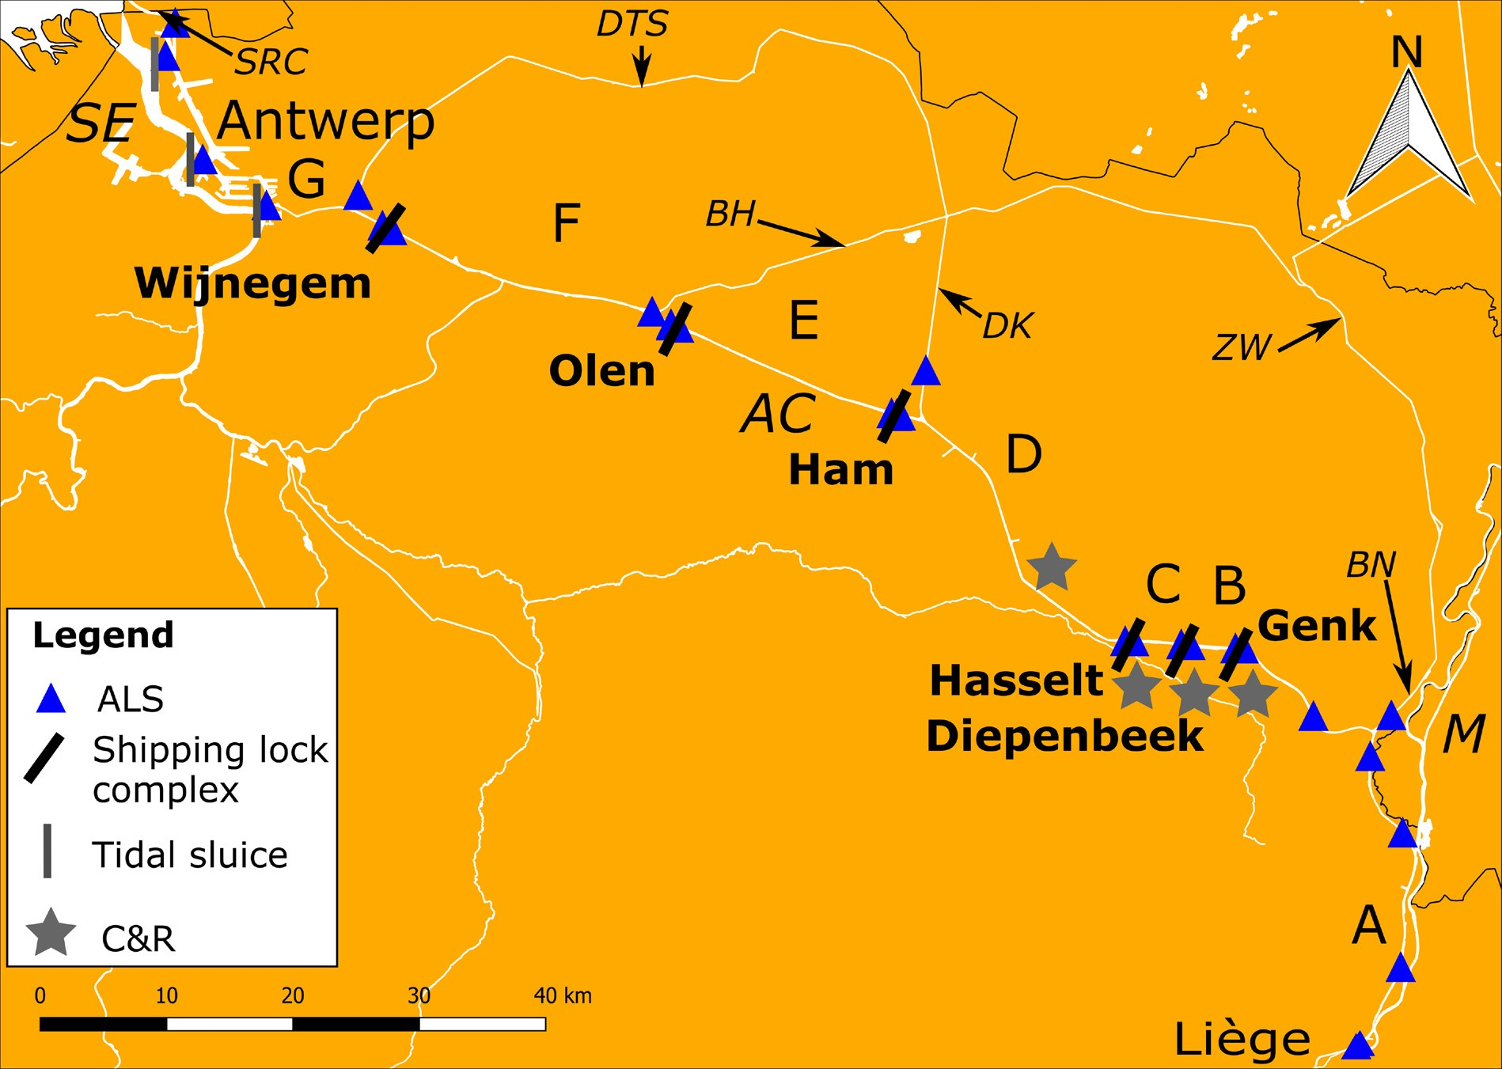

Fig. 1. Study area with the Albert Canal (AC) and its network of secondary canals: ZW (Zuid-Willemsvaart), BN (Canal Briegden-Neerharen), DK (Canal Dessel- Kwaadmechelen), BH (Canal Bocholt-Herentals) and DTS (Canal Dessel-Turnhout-Schoten). Also the Schelde-Rijn Canal (SRC) is indicated. The Albert Canal connects the Schelde Estuary (SE) in Antwerp (tidal sluices indicated by grey bars) with the Meuse river (M) in Liège. The Albert Canal is divided in seven canal sections (A–G) by six shipping lock complexes (indicated by black bars; Genk, Diepenbeek, Hasselt, Ham, Olen, Wijnegem). Positions of acoustic listening stations (ALSs) are indicated as blue triangles and catch-release locations (C&R) as grey asterisks. (For interpretation of the references to colour in this ﬁgure legend, the reader is referred to the web version of this article).

(Fig. S1). As such, eels were not detected when residing between two ALSs in the same canal section. However, this set-up was chosen to maximise the probability of detection for migrating eels. The stations were moored at the bank with weights and a small buoy. In this way, the hydrophone was directed upwards in the water column.

  - Data processing

The 70 tagged silver eels were tracked between 3rd September 2014 and 20th December 2016, resulting in a dataset with 1,541,521 de- tections. To determine residency times (i.e. the time between arrival and departure at an ALS), residency searches were performed with the VUE software (Vemco Users Environment, VEMCO Ltd, Canada). This allowed reducing the data by accumulating the number of detections during a ﬁxed period of time. We applied an absence threshold of one hour (i.e. the maximum time permitted between detections within a single residency period) and a detection threshold of one detection (i.e. the minimum number of detections required for a residency period). The residency search resulted in intervals with arrival and departure
times per eel at each ALS. Between an arrival and departure within the same detection interval, the number of detections and the residence time were calculated (Verhelst et al., 2018).
To address the research question about migration success, the entire dataset was used. Research questions about migration speed and tem- poral behaviour were further subdivided into several speciﬁc sub- questions (see 2.5.1–2.5.3 and Table 2) which were addressed using data on the migration period only (in other words, the residence time preceding a migration period was removed). An eel was considered migratory when the previous and next detection intervals were at an ALS preceding and following that ALS in the migration direction (Verhelst et al., 2018). For two eels, no migration intervals were ob- tained, although they were detected in the Meuse. Hence, these two eels were removed from the analysis for research questions related to mi- gration speed and temporal behaviour. Note that all but one of the eels detected in the Meuse were released in canal section A, which has an open connection with the river Meuse, and therefore did not encounter shipping locks in the Albert Canal. Hence, eels detected in the Meuse were not taken into account for the analysis of research questions about

Table 1
Number of tagged female eels per stage with their diﬀerent morphometrics: total length (TL), body weight (BW), horizontal and vertical eye diameters (EDh and EDv, respectively) and pectoral ﬁn length (FL). Means ± sd and ranges (between brackets) are indicated.

Stage | Number | TL (mm) | BW (g) | EDh (mm) | EDv (mm) | FL (mm)
FIV | 1 | 837 | 1050 | 10.80 | 12.49 | 24.03
FV | 69 | 821 ± 71 (620 – 957) | 1137 ± 306 (522 – 1970) | 10.95 ± 1.01 (9.10 – 15.00) | 10.40 ± 0.89 (8.10 – 12.13) | 40.96 ± 3.94 (31.04 – 51.60)

Table 2
For each research question and subquestion (see 2.5.1–2.5.3 for a detailed description of the subquestions), a diﬀerent subset of the data was used (the number of detections and percentage of data relative to the total dataset are given) and the statistical test was chosen accordingly.

Research question | Number of detections | Percentage of total dataset | Statistical test
1 Migration success and routes 2 Migration speed and delays  - Overall migration speed | 1,541,521  326,970 | 100 %  20.1 % | None  One-way ANOVA with Games-Howell post-hoc test
b. Migration speed canal section | 326,970 | 20.1 % | Kruskal-Wallis test with Dunn's-Test
c. Migration speed shipping lock | 20,550 | 1.3 % | Kruskal-Wallis test
d. Shipping lock delay | 269,567 | 17.5 % | Kruskal-Wallis test
3 Temporal behaviour  - Circadian canal section passage pattern | 9,768 | 0.6 % | Nested generalized least squares model
b. Monthly travelled distance | 276,697 | 17.9 % | Poisson generalised linear mixed model

migration speed in shipping locks, shipping lock delays and the circa- dian pattern. All data analyses were performed with the free R software (Team, 2017).

  - Data analysis

    - Migration success
Eels were categorized in four movement classes: eels migrating to- wards the Schelde Estuary (S-eels) or towards the Meuse (M-eels), po- tential migrants towards the Schelde Estuary (Sp-eels) and non-mi- gratory eels (NM-eels) (Fig. 1). Eels were considered of class S when they were last detected at the ALSs in the Schelde Estuary, while M-eels were last detected in the Meuse (Fig. S2). Eels were classiﬁed as Sp if they were successively detected in at least three diﬀerent canal sections, pointing at a directed movement towards the Schelde Estuary; eels detected in two canal sections or less, were classiﬁed as NM-eels. In addition, for the Sp- and NM-eels we checked at which detection station they had last been detected.

    - Migration speed and delays
To analyse if the migrating eels were delayed, we calculated four metrics: 1) the overall migration speed of the S-, M- and Sp-eels (NM- eels were removed from the statistical analysis) as the time needed to cross the distance between the ﬁrst and last detection. A one-way ANOVA with Welch correction was performed on log-transformed data, since the variances were not homogenous. Following a signiﬁcant ANOVA result, a Games-Howell post-hoc test for multiple pairwise comparisons was applied (Games and Howell, 1976).
- We calculated the migration speed per canal section as the time needed to cross that canal section (i.e. the time of the ﬁrst detection at the ALS at the upstream end of a canal section till the last detection at the ALS at the downstream end of the canal section, divided by the distance of that section). We tested if the migration speed diﬀered ac- cording to movement class and canal sections (A–G) by applying a non- parametric Kruskal-Wallis test, since assumptions of normality and homogeneity of variances were not met. If the test proved to be sig- niﬁcant, a pairwise test for multiple comparisons of mean rank sums (Dunn's-Test) with Bonferroni correction was applied.
- For S- and Sp-eels we calculated the time needed to cross a shipping lock complex (i.e. the time between the last detection at an ALS upstream of the shipping lock till the ﬁrst detection at an ALS downstream of the shipping lock). To test if the calculated time diﬀered over the six shipping lock complexes, a non-parametric Kruskal-Wallis test was performed, since the assumptions of normality and homo- geneity of variances were not met.
- We analysed waiting behaviour near the shipping locks for S- and Sp-eels by calculating the residence times at the ALSs up- and down- stream of the shipping locks. A non-parametric Kruskal-Wallis test was performed to test if the residence time upstream of the shipping locks diﬀered signiﬁcantly with the residence time downstream of the locks. If this proved to be signiﬁcant, we checked if there was a diﬀerence in
residence time between the ALSs located upstream of the shipping locks by means of a non-parametric Kruskal-Wallis test.

    - Temporal behaviour
Both seasonal and circadian behaviour patterns were analysed. For the seasonal patterns, we calculated the distance travelled per month (i.e. the distance between the ﬁrst and last detection at an ALS for a particular month) for each eel and within each movement class (i.e. S-, M- and Sp-eels). A nested generalized least squares (GLS) model was applied as the variances were not homogenous, and for each movement class we set the month with the highest average distance as the re- ference level. To help interpreting these results, we calculated the average monthly water ﬂow and water temperatures of section F for 2015 based on data obtained by the Hydrological Information Center (Fig. S3). Note that environmental data was not available for every canal section. However, water ﬂow and temperature did not diﬀer substantially between the canal sections and over the diﬀerent years (Hydrological Information Center, pers. comm.).
Regarding the circadian pattern, we analysed when eels migrate from one canal section to another. The number of detection records was summed per circadian phase. Consequently, four diﬀerent circadian phases were determined and linked to each departure in the dataset: dawn (start of civil twilight to sunrise), day (sunrise to sunset), dusk (sunset to end of civil twilight and night (end of civil twilight to start of civil twilight) (Verhelst et al., 2018). Timestamps of sunset, sunrise and twilight were obtained from the Astronomical Applications Department of the U.S. Naval Observatory (http://aa.usno.navy.mil/index.php; coordinates: 50°57′N 5°20′E). To analyse if eels moved between canal sections during the night, a nested (we analysed circadian activity within the diﬀerent movement classes) Poisson generalised linear mixed model (GLMM) with transmitter ID as random eﬀect was applied. One Sp-eel did not migrate between diﬀerent canal sections and was therefore not included in the analysis.

- Results

  - Migration success

In total, 24 eels succeeded to leave the system. Equal numbers of silver eels reached the Schelde Estuary and the Meuse (n = 12 in both cases); another 15 eels migrated towards the Schelde but did not leave the system during the study period. The majority of the eels (n = 31) were classiﬁed as non-migratory (Fig. 1a). For both the Sp- and NM-eels, approximately one third was last detected at a detection station downstream of a shipping lock. Another third of the Sp-eels was last detected in section G (the docks of Antwerp). Only a minority was last seen at a side canal of the Albert Canal (i.e. canal Dessel-Kwaadme- chelen) (one and two eels for the NM- and Sp-eels, respectively).

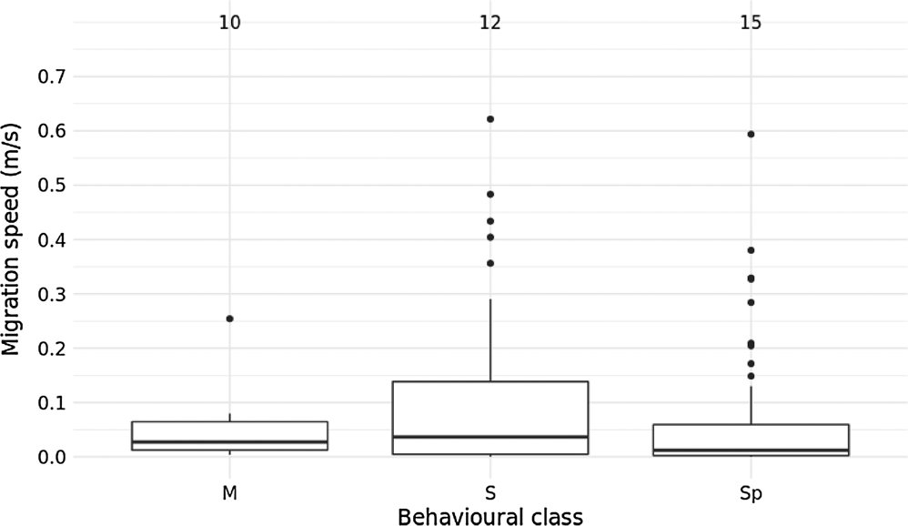

Fig. 2. The migration speeds, calculated within the canal sections, between the diﬀerent movement classes (M, Sp and S). The number of eels taken into ac- count for each class is indicated above the boxplots.

  - Migration speed and delays

The mean overall migration speed (i.e. the speed between the ﬁrst and last detection) diﬀered signiﬁcantly between the movement classes (Welch ANOVA, F = 5.809, df = 2.000, p < 0.05) (Fig. S4), being
approximately three times higher in M-eels (0.054 m s−1) than in Sp- eels (0.018 m s−1) (Games-Howell post-hoc test, t = 3.393, df = 18.5, p < 0.05) and S-eels (0.012 m s−1) (t = 2.790, df = 15.7, p = 0.067),
the latter two not diﬀering from each other (t = 0.956, df = 24.9,
p = 0.611).
In contrast, the median migration speeds, calculated within the canal sections, diﬀered not signiﬁcantly between the diﬀerent move- ment classes (KW-test, χ² (2) = 4.1211, p = 0.1274), even though they were threefold higher for S-eels (0.036 m s−1) than for Sp-eels (0.012 m s−1) (Fig. 2).
Median migration speed diﬀered signiﬁcantly between canal sec- tions (KW-test, χ² (6) = 15.912, p = 0.014), a diﬀerence which could be largely attributed to a signiﬁcantly higher swimming speed in sec- tions E (0.071 m s−1 (range: 0.0007–0.6217 m s−1)) compared to G (0.002 m s−1 (range: 0.0013–0.1487 m s−1)) (Dunn’s Test, t = 3.54, p = 0.0082) (Fig. 3, Table S3). Note that the highest maximum mi- gration speeds were found in section D, E and F (0.5939 m s−1, 0.6217 m s−1 and 0.4833 m s−1, respectively).
The median time needed to cross a canal section for S- and Sp-eels was 1.36 h (range: 0.30–435.13 h) and 1.54 h (range: 0.07–671.74 h), respectively, and did not diﬀer signiﬁcantly between canal sections (KW-test, χ² (5) = 8.9555, p > 0.05 and KW-test, χ² (5) = 10.661,
p > 0.05 for S- and Sp-eels, respectively) (Fig. 4).

The median residence time for S- and Sp-eels was 74 min (range for S-eels: 0.5–13719 min; range for Sp-eels: 0.4–18739 min) and was twice as high upstream of the shipping locks (KW-test, χ² (1) = 16.328, p = 5.328e−5 and KW-test, χ² (1) = 105.76, p < 2.2e-16, respectively)
compared to the downstream located ALSs (Fig. 5). No signiﬁcant dif- ferences in median residence time between the diﬀerent upstream ALSs were found (KW-test, χ² (5) = 7.1454, p > 0.05) (Fig. S5).

  - Temporal behaviour

    - Temporal patterns in migration distance
In general, all movement classes showed essentially the same monthly pattern with migration distances being signiﬁcantly longer in autumn and spring (Fig. 6) (for model details, see Table S4). Both S- and M-eels covered the largest distances in October (59 km and 22 km, re- spectively), while Sp-eels travelled the largest distance in November (31 km). High migration distances of all three classes were also found in May and/or June, whereas the lowest migration distances were found in February (from 2 km for S- and Sp-eels to 8 km for M-eels).

    - Circadian migration patterns of eels in a shipping canal
For both S- and Sp-eels, the majority of the shipping lock complex passages happened during the night (Fig. 7), but only for the Sp-eels nocturnal passage was signiﬁcantly higher than passage during daytime (Poisson GLMM, z = −2.169; p = 0.03; for model details, see Table S5).

- Discussion

The eels tracked in our study were classiﬁed in four diﬀerent movement classes (S, M, Sp and NM). Although all tagged eels were considered silver eels (FIV and FV) which should be migrating (Durif et al., 2005), the deﬁnition of migrating eel should be interpreted with care. Speciﬁcally, 31 eels did not show a clear migration pattern and were therefore classiﬁed as NM-eels. Even if these eels would show migratory behaviour after our study, they will have been delayed substantially. Since some dispersion events may strongly resemble failed migration attempts, eels may have been classiﬁed migratory, while they were actually showing long distance dispersion; it is diﬃcult to distinguish between a failed migration event and a dispersion event.

  - Migration success

During the study period, only 34% of the tagged eels left the Albert Canal while another 21% made attempts, indicating that eels face

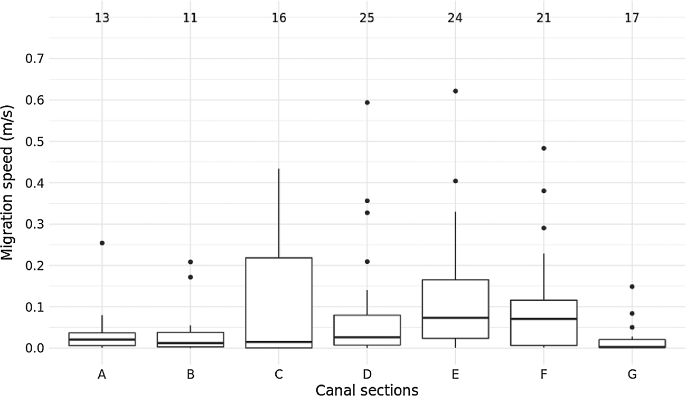
Fig. 3. The migration speeds per canal section (A–G). Numbers of eels detected in each canal section are indicated above the boxplots.

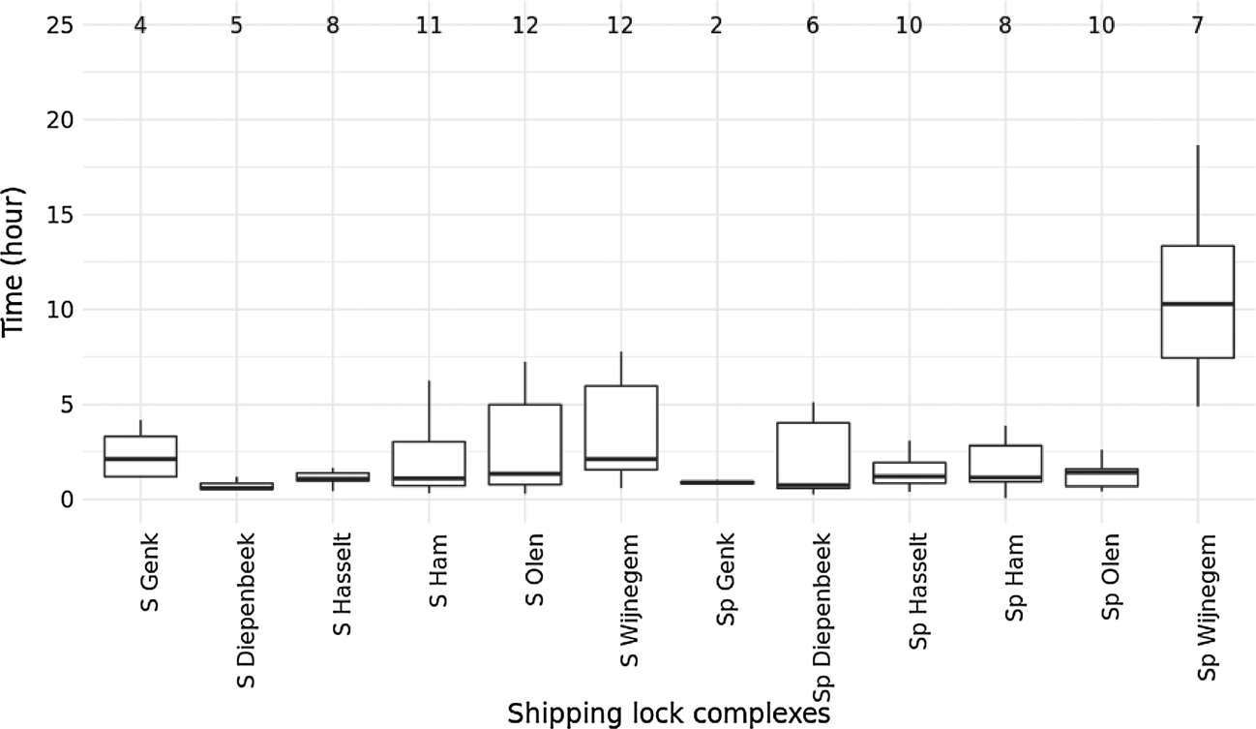
Fig. 4. The time (in hour) needed to cross the six shipping lock complexes (Genk, Diepenbeek, Hasselt, Ham, Olen, Wijnegem) for S- and Sp-eels. Outliers are not shown in the ﬁgure.

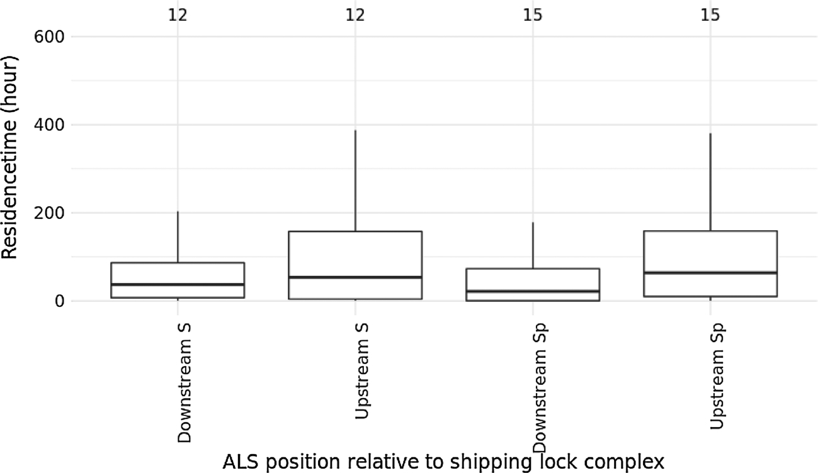
Fig. 5. Residence times at up- and downstream locations of the shipping locks for S- and Sp-eels. Note that outliers are not shown in the ﬁgure.

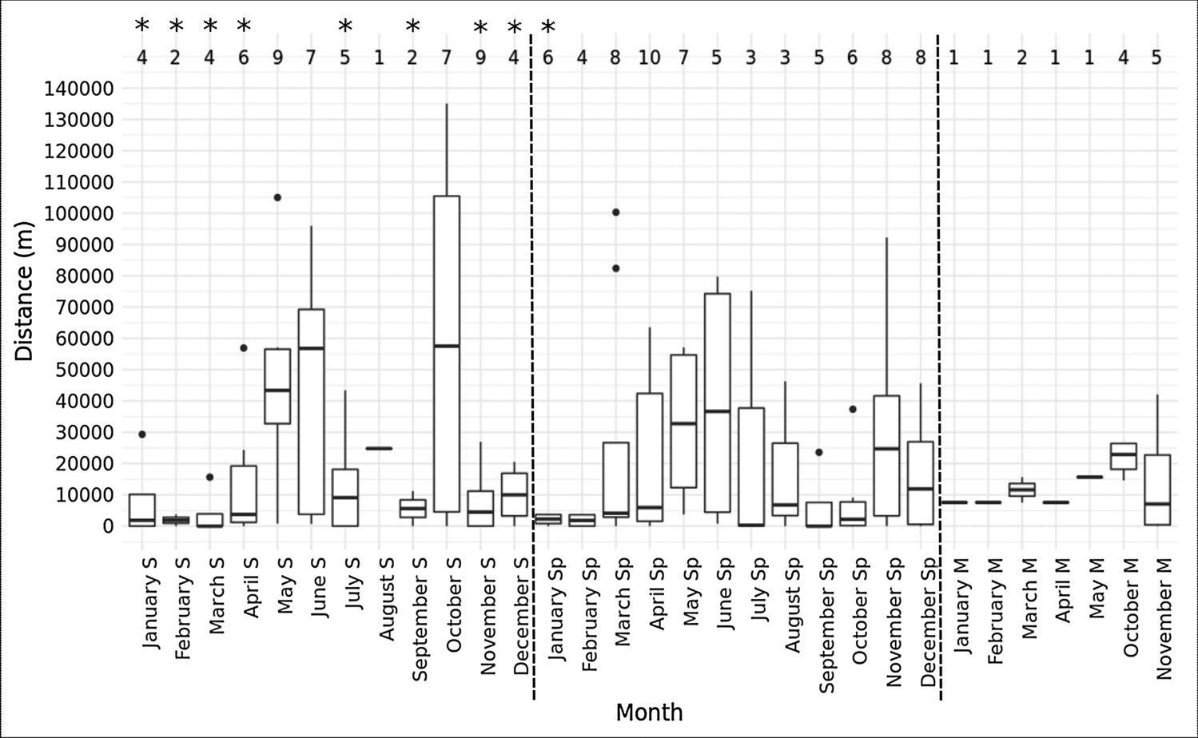Fig. 6. The monthly migration distances of the three movement classes (S, M and Sp; seperated by dashed lines). The number of eels detected during each month are indicated above the boxplots. Asteriscs indicate a signiﬁcant dif- ference (p < 0.05) with the reference level (i.e. the month with the highest distance). For S- and M- eels, this was October and for Sp-eels November.

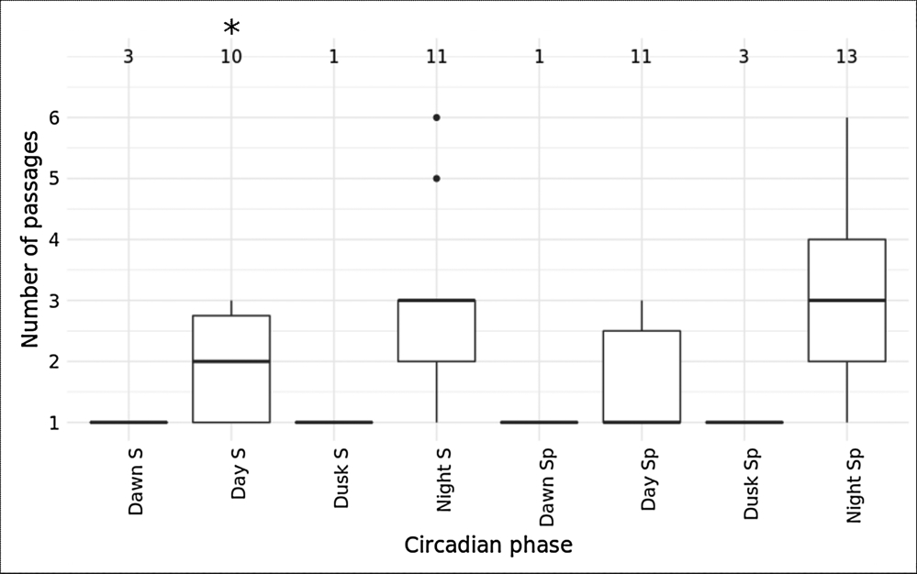

Fig. 7. The number of shipping lock passages during the four diﬀerent circadian phases (dawn, day, dusk and night) for the movement classes S and Sp. The number of eels taken into account is indicated above the boxplots. The asterisk indicates a signiﬁcant diﬀerence (p < 0.05) between diurnal and nocturnal passages for S-eels.

diﬃculties when migrating through shipping canals. In the Schelde Estuary, for instance, 71% of FIV and FV silver eels tagged at the upper limit of the estuary reached the lower part of the system. This also in- dicates that the applied method to classify silver eels and surgery did not aﬀect our results substantially (Verhelst et al. unpublished data). In the Loire Estuary, a large number of silver eels (86%) were detected at the most downstream locations as well (Bultel et al., 2014). Since eels depend on ﬂow direction to migrate from freshwater systems into the marine environment (Travade et al., 2010; Verhelst et al., 2018; Vøllestad et al., 1986), the low number of successful migrants may be due to the highly regulated water ﬂow of the Albert Canal. Indeed, the operation of the shipping locks causes frequent and irregular changes in ﬂow direction (i.e. a couple of times per hour). Nonetheless, the ma- jority of the migrating eels followed the net ﬂow direction in the canal and moved towards the Schelde Estuary. A smaller part migrated downstream towards the Meuse, but this may be the consequence of the location where these eels were released: all but one of the M-eels were released in canal section A, which has multiple connections with the River Meuse via the shipping locks in Lanaye and Wizet and the open connection at Monsin. Consequently, eels migrating towards the Meuse encountered fewer or no barriers than S- and Sp-eels, explaining why they were successful in reaching the Meuse. In addition to an irregular water ﬂow and direction, tag expulsion (although normally rare) (Jepsen et al., 2002; Thorstad et al., 2013) and mortality may have been a potential cause of unsuccessful migration of Sp- and NM-eels. Mor- tality could have occurred as a consequence of predation, ﬁshing or injuries resulting from turbine or sluice passage or ship propellers. Al- though interference of shipping vessels with the transmitter emissions may be possible, it is diﬃcult to assess because the impact can vary according to the size of the ships and whether they are moving or docked.
The present results are in line with the idea that the silver eel stage is reversible to a semi-yellow stage in freshwater environments when they fail to migrate to the sea (Feunteun et al., 2000; Svedäng and Wickström, 1997). It is unknown what proportion of eels which did not migrate or failed to leave the canal during the study period may still do so in the future. In any case, these eels have been substantially delayed.

  - Migration speed and delays

The average migration speed of M-eels (0.054 m s−1) was > three times higher than that of S- and Sp- eels (0.012 m s-1 and 0.018 m s−1, respectively) and similar to the overall migration speed in a free ﬂowing tidal river (0.052 m s−1 (Bultel et al., 2014)). The higher mi- gration speed of the M-eels is likely explained by the fact that all but
one of them were released in the canal section next to the Meuse, leaving them fewer or no barriers to pass compared to the S- and Sp- eels. Moreover, that canal section has multiple routes to the Meuse, among which an open connection at Monsin. Nonetheless, migration speeds for M-, S- and Sp-eels was substantially lower than average mi- gration speeds in other studies conducted in freshwater systems, i.e.
0.30 m s−1–1.13 m s−1 (Breukelaar et al., 2009; Piper et al., 2017; Verbiest et al., 2012). Average migration speeds may be partly mis- leading, since it may mask large diﬀerences in swim speeds between diﬀerent habitats. Bultel et al. (2014) observed that eels actually mi- grate faster when approaching an estuarine environment: their slower migration speed is likely attributed to waiting behaviour in the upper sections of the estuary as the directional speed found in the lower sections was similar to silver eel swim speed in previous studies (i.e.
0.56 m s−1). This contrasts markedly with our results, where migration
behaviour was disrupted in the Albert Canal shipping canal: migration speed was low throughout the diﬀerent canal sections, reaching a minimum in the most downstream section. Since water ﬂow direction in the diﬀerent sections of the canal changes numerous times per day, we suggest that the slow migration speeds in the canal are likely caused by disorientation due to a lack of a consistent unidirectional water ﬂow. The relatively higher maximum migration speeds in sections D, E and F of the canal may then be explained by the more frequent operation of their respective shipping locks. Speciﬁcally, in Ham, Olen and Wij- negem, more ships were transported over those three shipping locks, but note that multiple ships per lock could be transported. In contrast, the slowest migration speed in section G of the Albert Canal can be attributed to the distribution of the water mass over the docks of An- twerp, resulting in a decrease of water ﬂow (Hydrological Information Center, pers. comm.). For their orientation in this section, eels may depend on currents caused by tidal shipping lock operation, which can only be detected in the vicinity of the locks. In this context, it is striking that one third of the Sp-eels reached section G, but were never detected in the Schelde Estuary. It is possible that the dynamic environment of the estuary impairs the detection probability (Reubens et al., 2018), yet 71% of the silver eels tagged in the Schelde Estuary were detected in the lower part (Verhelst et al. unpublished data). A faster and more uni- directional movement towards the sea could be facilitated by the de- tection of olfactory cues in the estuarine and marine environment (Barbin et al., 1998). As tidal shipping locks (but also non-tidal shipping locks further upstream) prevent the intrusion of marine water and its migration cues for eels, this may also have an impact on the eels’ delay and slower swim speeds in shipping canals. Indeed, once inside the Schelde Estuary, S-eels migrated at an average speed of 0.74 m s−1 (unpublished data).
Our study also demonstrates that eels were signiﬁcantly delayed upstream of shipping locks and it took them relatively long to pass these locks. This indicates that the locks may act as a direct migration barrier for downstream migrating eels. Pumping stations and hydropower plants have been reported before as migration barriers for migrating eels (Buysse et al., 2015; Verhelst et al., 2018; Winter et al., 2006) and several mitigation measures have been proposed (e.g. acoustic fences (Sand et al., 2000), bar racks (Russon et al., 2010), ﬁsh friendly adaptations (Hecker and Cook, 2005) and ﬁsh passes (Clay, 1994)). Shipping locks have only been reported sporadically as migration bar- riers for upstream migrating ﬁsh (Buysse et al., 2008; Klinge, 1994). Yet, American eels (A. rostrata Lesueur) have been shown to use ship- ping locks to migrate upstream (Verdon and Desrochers, 2003). Our study is therefore the ﬁrst to demonstrate that they may also aﬀect downstream ﬁsh migration. Weirs, which can be opened during an excess of water, can provide a solution for this problem; however, their eﬃciency may be very low, as was the case for the Schelde river in Belgium (Buysse et al., 2008). The shipping locks in the Albert Canal don’t have weirs. Hence, adequate management measures such as sti- mulating gravitational ﬂow or ﬁsh passes are necessary to facilitate eel migration over shipping locks.

Encountering substantial delays, eels may be more prone to dis- eases, predation and ﬁshing, and consequently, mortality (Acou et al., 2008; Marmulla, 2001; Sjöberg et al., 2017; Verhelst et al., 2018). Delays may also cause eels not reaching the spawning grounds on time. Although being an anadromous species, for Sockeye salmon (Oncor- hynchus nerka Walbaum) it has been shown that spawning success was correlated with the date of arrival (Burnett et al., 2017). Nonetheless, Righton et al. (2016) hypothesized that the eels’ migration may be more ﬂexible than thought. Also, it is unknown if obstructed migratory ﬁsh encounter an increased state of physiological stress or what the impact may be on the ﬁsh’ ﬁtness. As such, knowledge on ﬁsh migration delays needs further research and is currently insuﬃcient to provide proper management measures (Silva et al., 2017).

  - Temporal behaviour

    - Temporal patterns in migration distance
There is scientiﬁc consensus that European silver eels generally migrate in autumn, although migration peaks in spring have occa- sionally been observed (Aarestrup et al., 2008; Sandlund et al., 2017; Verbiest et al., 2012). In this study, the successful migrants (S- and M- eels) migrated the longest distances in autumn, but substantial large distances were also travelled in spring. Sp-eels even bridged longer distances in spring than autumn. For these Sp eels, it is plausible that the longer travelled distances during both autumn and spring months are linked with migration behaviour. During spring and autumn, the average water temperature range of the Albert Canal (quantiﬁed by a temperature measurement in section F in 2015) was 7.5 °C–17.10 °C and 11.4 °C–18.6 °C, respectively, which is approximately within the temperature window during which Vøllestad et al. (1986) (i.e. 4 °C–18 °C) found the majority of silver eels migrating downstream in the river Imsa, Norway. In addition, although the average monthly water ﬂow was low, peaks were found in May and October. This may have triggered or even guided seaward migration of silver eels in our study. It is unlikely that water ﬂow alone could trigger migration, since another water ﬂow peak in February did not elicit migration, perhaps because the water temperature was too low (i.e. 4.3 °C) (Vøllestad et al., 1986). As such, an interaction between water ﬂow and other triggers like water temperature may be relevant (Buysse et al., 2015). Spring migration, then, might be the result of insuﬃcient migration triggers during the preceding autumn (Westin, 1990), or an insuﬃcient body condition (Aarestrup et al., 2008).

    - Circadian migration patterns of eels in a shipping canal
Although S- and Sp-eels showed a delayed and potentially dis- oriented migration behaviour, they still primarily moved from one canal section to the next at night, which is in line with the eel’s natural behaviour pattern reported in previous studies (Travade et al., 2010; Vøllestad et al., 1986). The low number of passages during dusk and dawn may be attributed by the short duration time of those circadian phases. Nocturnal migration is likely a predator-avoidance mechanism in the canal, since turbidity in the canal is low and large numbers of cormorants (Phalacrocorax carbo L.) frequently hunt in the area, which have been shown to predate on eels (Ibbotson et al., 2006). This means that although sluices are primarily operated during daytime, eels are likely to pass them at night. Consequently, potential management ac- tions may be most eﬀective at night.

4.4. Implications for management

To our knowledge, this study is the ﬁrst to describe silver eel mi- gration behaviour in a shipping canal (here the Albert Canal). Only a small part of the silver eels was able to leave the Albert Canal during a study period of 27 months and their migration speed was typically very low, probably as a result of the regulated water ﬂow and presence of shipping locks in the canal. This implies that eels may get trapped or be
slowed down substantially inside shipping canals, making them more prone to predation and diseases. Hence, heavily regulated shipping canals are most likely an unsuitable migration route for European eel. However, migration through anthropogenic canals may be the best available option if canals can provide a shortcut for migrating eels or if the alternative route is more hazardous (e.g. the Meuse contains several hydropower plants, resulting in substantial mortality rates of silver eels (Verbiest et al., 2012; Winter et al., 2006)). Therefore, we propose several management actions to reduce migration delays. First, an in- creased gravitational ﬂow in the canal could provide a better cue for eels to ﬁnd their way downstream. Based on the temporal results of this study, this measurement may be most eﬀective at night and during spring and autumn. A second option would be to construct ﬁsh passes to overcome shipping locks. For instance, it has been shown that eels can make use of undershot sluice gates at small-scale hydropower plants (Egg et al., 2017). However, eﬃcient downstream ﬁsh passes are scarce and there is an urgent need for improved knowledge on this issue. The results of the present study also have repercussions for the im- plementation of stocking of glass eels as part of the eel management plan imposed by the European Eel Regulation (in order to recover the population, the European Union adopted a Council Regulation (Eur- opean Eel Regulation; EC no. 1100/2007)). For instance, in 2017, 21% (i.e. 18 out of 85 kg) of the glass eels imported in Flanders for seeding purposes were stocked in the Albert Canal. Our study strongly indicates that only 34% of these eels will successfully migrate out of the system and hence potentially contribute to the population. Therefore, unless the passability for eels is improved, we suggest to reduce, or even stop stocking glass eels in large shipping canals and apply stockage in sys- tems where the chances to reach the sea are suﬃciently high, such as polder systems which are mainly dewatered via gravitational ﬂow through tidal sluices or via ﬁsh friendly pumps.

Acknowledgments

P. Verhelst holds a doctoral grant from the Flemish Agency for Innovation & Entrepreneurship (VLAIO), now under the auspices of the National Science Fund FWO. N. De Maerteleire, E. Gelaude, Y. Jacobs,
S. Pieters and K. Robberechts assisted with the data collection. This manuscript has beneﬁtted from a statistical consult with the Ghent University FIRE service (Fostering Innovative Research based on Evidence). Part of this research was ﬁnanced by nv De Scheepvaart. Furthermore, this work was supported by data and infrastructure pro- vided by the INBO and VLIZ as part of the Flemish contribution of the LifeWatch ESFRI observatory.

References

Aarestrup, K., Økland, F., Hansen, M.M., Righton, D., Gargan, P., Castonguay, M., Bernatchez, L., Howey, P., Sparholt, H., Pedersen, M.I., 2009. Oceanic spawning migration of the European eel (Anguilla anguilla). Science 325 1660-1660.
Aarestrup, K., Thorstad, E., Koed, A., Jepsen, N., Svendsen, J.C., Pedersen, M.I., Skov, C., Økland, F., 2008. Survival and behaviour of European silver eel in late freshwater and early marine phase during spring migration. Fish. Manage. Ecol. 15, 435–440.
Acou, A., Laﬀaille, P., Legault, A., Feunteun, E., 2008. Migration pattern of silver eel (Anguilla anguilla, L.) in an obstructed river system. Ecol. Freshw. Fish 17, 432–442.
Amilhat, E., Aarestrup, K., Faliex, E., Simon, G., Westerberg, H., Righton, D., 2016. First evidence of European eels exiting the Mediterranean Sea during their spawning mi- gration. Sci. Rep. 6, 21817.
Arlinghaus, R., Engelhardt, C., Sukhodolov, A., Wolter, C., 2002. Fish recruitment in a canal with intensive navigation: implications for ecosystem management. J. Fish Biol. 61, 1386–1402.
Baetens, J., van Eerdenbrugh, K., Meire, P., Mostaert, F., 2005. Watersysteem van het Albertkanaal en de Kempense kanalen: inventarisatie voor de opmaak van zoetwa- terstrategieën. Universiteit Antwerpen, pp. 102.
Barbin, G.P., Parker, S.J., McCleave, J.D., 1998. Olfactory clues play a critical role in the

estuarine migration of silver-phase American eels. Environ. Biol. Fishes 53, 283–291. Breukelaar, A., Ingendahl, D., Vriese, F., De Laak, G., Staas, S., Klein Breteler, J., 2009. Route choices, migration speeds and daily migration activity of European silver eels Anguilla anguilla in the River Rhine, north‐west Europe. J. Fish Biol. 74, 2139–2157.
Bultel, E., Lasne, E., Acou, A., Guillaudeau, J., Bertier, C., Feunteun, E., 2014. Migration behaviour of silver eels (Anguilla anguilla) in a large estuary of Western Europe in- ferred from acoustic telemetry. Estuar. Coast. Shelf Sci. 137, 23–31.
Burnett, N.J., Hinch, S.G., Bett, N.N., Braun, D.C., Casselman, M.T., Cooke, S.J., Gelchu, A., Lingard, S., Middleton, C.T., Minke-Martin, V., White, C.F.H., 2017. Reducing carryover eﬀects on the migration and spawning success of sockeye salmon through a management experiment of dam ﬂows. River Res. Appl. 33, 3–15.
Buysse, D., Coeck, J., Maes, J., 2008. Potential re-establishment of diadromous ﬁsh species in the River Scheldt (Belgium). Hydrobiologia 602, 155–159.
Buysse, D., Mouton, A., Baeyens, R., Coeck, J., 2015. Evaluation of downstream migration mitigation actions for eel at an Archimedes screw pump pumping station. Fish.
Manage. Ecol. 22, 286–294.
Buysse, D., Mouton, A., Stevens, M., den Neucker, T., Coeck, J., 2014. Mortality of European eel after downstream migration through two types of pumping stations. Fish. Manage. Ecol. 21, 13–21.
Clay, C.H., 1994. Design of Fishways and Other Fish Facilities. CRC Press.
Dekker, W., Casselman, J.M., 2014. The 2003 Québec declaration of concern about eel declines—11 years later: are eels climbing back up the slippery slope? Fisheries 39, 613–614.
Durif, C., Dufour, S., Elie, P., 2005. The silvering process of Anguilla anguilla: a new classiﬁcation from the yellow resident to the silver migrating stage. J. Fish Biol. 66, 1025–1043.
Egg, L., Mueller, M., Pander, J., Knott, J., Geist, J., 2017. Improving European silver eel (Anguilla anguilla) downstream migration by undershot sluice gate management at a small-scale hydropower plant. Ecol. Eng. 106, 349–357.
Feunteun, E., 2002. Management and restoration of European eel population (Anguilla anguilla): an impossible bargain. Ecol. Eng. 18, 575–591.
Feunteun, E., Acou, A., Laﬀaille, P., Legault, A., 2000. European eel (Anguilla anguilla): prediction of spawner escapement from continental population parameters. Can. J. Fish. Aquat. Sci. 57, 1627–1635.
Games, P.A., Howell, J.F., 1976. Pairwise multiple comparison procedures with unequal n's and/or variances: a Monte Carlo study. J. Educ. Stat. 1, 113–125.
Hannah, D.M., Sadler, J.P., Wood, P.J., 2007. Hydroecology and Ecohydrology: Challenges and Future Prospects. John Wiley and Sons, Hoboken, NJ.
Hecker, G.E., Cook, T.C., 2005. Development and evaluation of a new helical ﬁsh-friendly hydroturbine. J. Hydraul. Eng. 131, 835–844.
Huisman, J., Verhelst, P., Deneudt, K., Goethals, P., Moens, T., Nagelkerke, L.A., Nolting, C., Reubens, J., Schollema, P.P., Winter, H.V., 2016. Heading south or north: novel insights on European silver eel Anguilla anguilla migration in the North Sea. Mar. Ecol. Prog. Ser. 554, 257–262.
Ibbotson, A., Beaumont, W., Pinder, A., Welton, S., Ladle, M., 2006. Diel migration pat- terns of Atlantic salmon smolts with particular reference to the absence of crepus- cular migration. Ecol. Freshw. Fish 15, 544–551.
Jepsen, N., Koed, A., Thorstad, E.B., Baras, E., 2002. Surgical Implantation of Telemetry Transmitters in Fish: How Much Have We Learned? Aquatic Telemetry. Springer.
Klinge, M., 1994. Fish migration via the shipping lock at the Hagestein barrage: results of an indicative study. Water Sci. Technol. 29, 357–361.
Køie, M., 1991. Swimbladder nematodes (Anguillicola spp.) and gill monogeneans (Pseudodactylogyrus spp.) parasitic on the European eel (Anguilla anguilla). ICES J. Mar. Sci. 47, 391–398.
Marmulla, G., 2001. Dams, Fish and Fisheries: Opportunities, Challenges and Conﬂict Resolution. Food Agriculture Org.
Mateo, M., Lambert, P., Tétard, S., Drouineau, H., 2017. Impacts that cause the highest direct mortality of individuals do not necessarily have the greatest inﬂuence on temperate eel escapement. Fish. Res. 193, 51–59.
Miller, M.J., Tsukamoto, K., 2016. The ecology of oceanic dispersal and survival of an- guillid leptocephali. Can. J. Fish. Aquat. Sci. 74, 958–971.
Moriarty, C., Dekker, W., 1997. Management of European eel ﬁsheries. Ir. Fish. Bull. 15.
Mouton, A.M., Stevens, M., Van den Neucker, T., Buysse, D., Coeck, J., 2011. Adjusted barrier management to improve glass eel migration at an estuarine barrier. Mar. Ecol. Prog. Ser. 439, 213–222.
Piper, A.T., Manes, C., Siniscalchi, F., Marion, A., Wright, R.M., Kemp, P.S., 2015.
Response of seaward-migrating European eel (Anguilla anguilla) to manipulated ﬂow ﬁelds. Proc. R. Soc. B 282 20151098.
Piper, A.T., Svendsen, J.C., Wright, R.M., Kemp, P.S., 2017. Movement patterns of sea- ward migrating European eel (Anguilla anguilla) at a complex of riverine barriers: implications for conservation. Ecol. Freshw. Fish 26, 87–98.
Reubens, J., Verhelst, P., van der Knaap, I., Deneudt, K., Moens, T., Hernandez, F., 2018. Environmental factors inﬂuence the detection probability in acoustic telemetry in a
marine environment: results from a new setup. Hydrobiologia 1–14.
Righton, D., Westerberg, H., Feunteun, E., Økland, F., Gargan, P., Amilhat, E., Metcalfe, J., Lobon-Cervia, J., Sjöberg, N., Simon, J., 2016. Empirical observations of the spawning migration of European eels: the long and dangerous road to the Sargasso Sea. Sci. Adv. 2, e1501694.
Russon, I., Kemp, P., Calles, O., 2010. Response of downstream migrating adult European eels (Anguilla anguilla) to bar racks under experimental conditions. Ecol. Freshw. Fish 19, 197–205.
Sand, O., Enger, P.S., Karlsen, H.E., Knudsen, F., Kvernstuen, T., 2000. Avoidance re- sponses to infrasound in downstream migrating European silver eels, Anguilla an- guilla. Environ. Biol. Fishes 57, 327–336.
Sandlund, O.T., Diserud, O.H., Poole, R., Bergesen, K., Dillane, M., Rogan, G., Durif, C., Thorstad, E.B., Vøllestad, L.A., 2017. Timing and pattern of annual silver eel mi- gration in two European watersheds are determined by similar cues. Ecol. Evol. 7, 5956–5966.
Silva, A.T., Lucas, M.C., Castro-Santos, T., Katopodis, C., Baumgartner, L.J., Thiem, J.D., Aarestrup, K., Pompeu, P.S., O’Brien, G.C., Braun, D.C., Burnett, N.J., Zhu, D.Z., Fjeldstad, H.-P., Forseth, T., Rajaratnam, N., Williams, J.G., Cooke, S.J., 2017. The future of ﬁsh passage science, engineering, and practice. Fish Fish. 19, 340–362.
Sjöberg, N.B., Wickström, H., Asp, A., Petersson, E., 2017. Migration of eels tagged in the Baltic Sea and Lake Mälaren—in the context of the stocking question. Ecol. Freshw. Fish 26, 517–532.
Stein, F., Doering-Arjes, P., Fladung, E., Brämick, U., Bendall, B., Schröder, B., 2015. Downstream migration of the European eel (Anguilla anguilla) in the Elbe river, Germany: movement patterns and the potential impact of environmental factors. River Res. Appl. 32, 666–676.
Svedäng, H., Wickström, H., 1997. Low fat contents in female silver eels: indications of insuﬃcient energetic stores for migration and gonadal development. J. Fish Biol. 50, 475–486.
Team, R.C., 2017. R: A Language and Environment for Statistical Computing (Version 3.4.3). R Foundation for Statistical Computing, Vienna, Austria. http://wwwR- projectorg.
Thorstad, E.B., Økland, F., Westerberg, H., Aarestrup, K., Metcalfe, J.D., 2013. Evaluation of surgical implantation of electronic tags in European eel and eﬀects of diﬀerent suture materials. Mar. Freshw. Res. 64, 324–331.
Travade, F., Larinier, M., Subra, S., Gomes, P., De-Oliveira, E., 2010. Behaviour and passage of European silver eels (Anguilla anguilla) at a small hydropower plant during their downstream migration. Knowl. Manage. Aquat. Ecosyst. 01.
Verbiest, H., Breukelaar, A., Ovidio, M., Philippart, J.C., Belpaire, C., 2012. Escapement success and patterns of downstream migration of female silver eel Anguilla anguilla in the River Meuse. Ecol. Freshw. Fish 21, 395–403.
Verdon, R., Desrochers, D., 2003. Upstream migratory movements of American eel (Anguilla rostrata) between the Beauhornois and Moses-Saunders power dams on the St. Lawrence River. Biol. Manage. Prot. Catadromous eels 139.
Verhelst, P., Buysse, D., Reubens, J., Pauwels, I., Aelterman, B., Van Hoey, S., Goethals, P., Coeck, J., Moens, T., Mouton, A., 2018. Downstream migration of European eel (Anguilla anguilla) in an anthropogenically regulated freshwater system: implications for management. Fish. Res. 199, 252–262.
Visser, E.C., Kroes, M.J., 2016. Onderzoek Naar Het Visbestand in Het Albertkanaal 2012– 2015.96.
Vitousek, P.M., Mooney, H.A., Lubchenco, J., Melillo, J.M., 1997. Human domination of earth’s ecosystems. Science 277, 494–499.
Vøllestad, L., Jonsson, B., Hvidsten, N., Naesje, T., Haraldstad, Ø., Ruud-Hansen, J., 1986.
Environmental factors regulating the seaward migration of European silver eels (Anguilla anguilla). Can. J. Fish. Aquat. Sci. 43, 1909–1916.
Westin, L., 1990. Orientation mechanisms in migrating European silver eel (Anguilla anguilla): temperature and olfaction. Mar. Biol. 106, 175–179.
White, E., Knights, B., 1997. Dynamics of upstream migration of the European eel, Anguilla anguilla (L.), in the Rivers Severn and Avon, England, with special reference to the eﬀects of man‐made barriers. Fish. Manage. Ecol. 4, 311–324.
Winter, H., Jansen, H., Bruijs, M., 2006. Assessing the impact of hydropower and ﬁsheries on downstream migrating silver eel, Anguilla anguilla, by telemetry in the River Meuse. Ecol. Freshw. Fish 15, 221–228.
Winter, H.V., Jansen, H.M., Breukelaar, A.W., 2007. Silver eel mortality during down- stream migration in the River Meuse, from a population perspective. ICES J. Mar. Sci.: J. Conseil 64, 1444–1449.
Wolter, C., 2001. Conservation of ﬁsh species diversity in navigable waterways. Landsc.
Urban Plann. 53, 135–144.
Wolter, C., Arlinghaus, R., 2003. Navigation impacts on freshwater ﬁsh assemblages: the ecological relevance of swimming performance. Rev. Fish Biol. Fish. 13, 63–89.
Wysujack, K., Westerberg, H., Aarestrup, K., Trautner, J., Kurwie, T., Nagel, F., Hanel, R., 2015. The migration behaviour of European silver eels (Anguilla anguilla) released in open ocean conditions. Mar. Freshw. Res. 66, 145–157.

View publication stats

