The impact of spatial isolation and local habitat conditions on colonization of recent forest stands by ectomycorrhizal fungi

Margaux Boeraevea,⁎, Olivier Honnaya, Nele Mullensa, Kris Vandekerkhoveb,
Luc De Keersmaekerb, Arno Thomaesb, Hans Jacquemyna
a Department of Biology, Plant Conservation and Population Biology, KU Leuven, B-3001 Leuven, Belgium
b Research Institute for Nature and Forest (INBO), Gaverstraat 4, B–9500 Geraardsbergen, Belgium

A R T I C L E I N F O

Keywords:
Dispersal limitation Colonization Ectomycorrhizal fungi Forest restoration
A B S T R A C T

Successful colonization of empty habitat patches depends both on the capacity of a species to reach the patch and its ability to establish and persist. Getting better insights into the various factors that aﬀect colonization success is especially relevant in the context of restoration projects that aim at restoring biodiversity in newly created habitats like aﬀorestation. While it is generally known that soil microbial communities play a key role in forest ecosystems, it remains largely unknown how they recover in recently restored forests on former agricultural land. Here, we used next-generation sequencing to investigate how spatial isolation and abiotic conditions af- fected the diversity and composition of ectomycorrhizal fungal communities in recent forest stands. Soil samples and roots of Quercus robur were sampled in ancient forest stands and recent stands both adjacent and spatially isolated from the ancient stands. Our results showed that ectomycorrhizal fungal community composition was aﬀected by a combination of isolation and local soil conditions. Although communities of recently restored forest stands more resembled those of ancient stands when they immediately bordered ancient forest, there were still signiﬁcant diﬀerences in community composition, most likely as a result of diﬀerences in edaphic conditions. Isolated stands had a signiﬁcantly lower diversity and were mainly colonized by highly dispersive species. Overall, these results indicate that ectomycorrhizal fungal communities may develop faster in recent forest stands connected to ancient forest than in isolated stands, and that isolated stands may remain impoverished for many decades or even for indeterminate time.

- Introduction

Anthropogenic activities over the last few centuries have severely reduced and fragmented natural habitats around the world (Meyer and Turner, 1992; De Keersmaeker et al., 2015; Lewis et al., 2015). The resulting decline in biodiversity has sparked many initiatives to miti- gate biodiversity loss through restoring habitats on formerly agri- cultural and degraded land. The Bonn Challenge, for example, aims to restore 150 million hectares of degraded and deforested lands by 2020 (Bonn Challenge, 2011). However, whether species will be able to successfully colonize these newly created habitat patches remains to be seen (Huxel and Hastings, 1999).
Successful colonization of an empty habitat patch by a species de- pends both on its capacity to reach the patch and its ability to establish and persist (Palmer et al., 2008). Although recovery of biodiversity following aﬀorestation has predominantly been studied on ﬂoral and faunal groups (Meli et al., 2017), most these studies indicate that many

species fail to colonize recently established forest patches and that full species recovery may therefore take several decades or even centuries (Flinn and Vellend, 2005; Hermy and Verheyen, 2007). Both dispersal limitation, i.e. the inability of an organism to travel large distances across a hostile landscape matrix, and recruitment limitation, i.e. the inability of an organism to establish and reach adulthood, have been considered to be important hurdles for forest biodiversity recovery following aﬀorestation (Honnay et al., 2002; Verheyen et al., 2003; Flinn and Vellend, 2005; Baeten et al., 2008; Lõhmus et al., 2014). Post- agricultural recent forests typically diﬀer from ancient forests in terms of edaphic factors, which can enhance recruitment limitation (Verheyen and Hermy, 2001). The former generally have elevated soil pH and P levels, and lower soil organic matter, C and N concentrations (Hooker and Compton, 2003; Ritter et al., 2003; Falkengren-Grerup et al., 2006; De Schrijver et al., 2012; De Keersmaeker et al., 2013). These soil characteristics can both directly and indirectly (via microbiological processes) aﬀect species establishment and survival (de la Peña et al.,

⁎ Corresponding author.
E-mail address: margaux.boeraeve@kuleuven.be (M. Boeraeve).

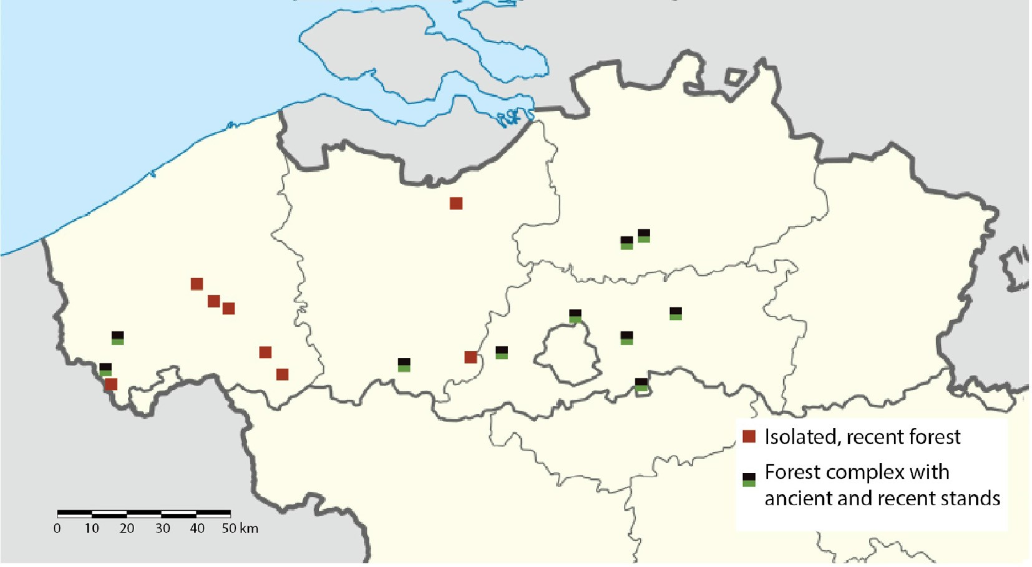
Fig. 1. Sampling took place in 18 forest complexes across the northern part of Belgium. In 10 forests both recent stands (< 45 years old) and ancient stands were sampled (black-green squares).The other 8 forests were recent forest stands (< 45 years old) isolated from ancient forest (red squares). (For interpretation of the references to colour in this ﬁgure legend, the reader is referred to the web version of this article.)

2016; Wooliver et al., 2016).
Whereas the factors that aﬀect plant and animal species composi- tion of ageing forests on former agricultural land have been relatively well studied (Flinn and Vellend, 2005; Hermy and Verheyen, 2007), much less is known about the recovery of the soil microbial commu- nities (Sun et al., 2017). Yet, soil microbial communities play key roles in forest ecosystems, including regulating nutrient cycles and inter- acting with and connecting the root systems of plant species (Baldrian, 2017). One important functional group within the forest soil micro- biome are ectomycorrhizal (EcM) fungi (Bahram et al., 2011; Tedersoo et al., 2012; Peay et al., 2016). As obligate symbionts of many dominant tree species in boreal and temperate forests, EcM fungi are indis- pensable components of forest ecosystems (Smith and Read, 2008). They mobilize inorganic nutrients from the soil and transfer them to their host in exchange for carbon (Read and Perez-Moreno, 2003), and they protect the host root system against pathogens, resulting in posi- tive plant-soil feedbacks (Bennett et al., 2017).
Due to their small propagule size, enabling long-distance wind dispersal, and their mass propagule production, micro-organisms, in- cluding EcM fungi, have long been considered not to be dispersal-lim- ited (Baas Becking, 1934; Finlay and Clarke, 1999). However, recent research has shown that eﬀective dispersal of fungi may be more lim- ited than expected (Peay et al., 2007, 2010, Norros et al., 2012, 2015). This is due to the strong decrease of the spore loads with distance from the fruiting body (Galante et al., 2011), and hence from the forest edge (Peay et al., 2012). Furthermore, EcM fungal spores have low germi- nation rates in the absence of host roots, and even in the presence of host roots, they vary widely in how long they remain viable and retain their germination capacity (Ishida et al., 2008; Nara, 2009). After germination, the haploid mycelium of most EcM fungi need to fuse with another, sexually compatible haploid mycelium, in order to be able to establish and form functioning mycorrhiza (Horton, 2017). Ad- ditionally, some EcM fungi form below-ground fruiting bodies which depend on animals for dispersal (Colgan and Claridge, 2002). As a re- sult, EcM fungal species can be expected to diﬀer widely in their ca- pacity to establish from spores (Newton, 1992), and pronounced dif- ferences in ectomycorrhizal fungal communities may arise between forest stands of diﬀerent age and spatial isolation. As ectomycorrhizal fungi also diﬀer in their capacity to, and preference for taking up dif- ferent forms of soil nutrients (Erland and Taylor, 2002; Dickie et al.,
2013; Bogar and Peay, 2017), diﬀerences in edaphic factors (e.g. pH, soil moisture content, accumulation in soil organic material) between forests of varying age can also be expected to aﬀect EcM fungal com- munity composition.
Here we studied how spatial isolation and environmental conditions aﬀected ectomycorrhizal fungal diversity and community composition in recently (< 50 years ago) aﬀorested stands. For this purpose, we compared ectomycorrhizal fungal communities between isolated recent stands and recent stands adjacent to ancient forest with those of ancient forest stands in order to diﬀerentiate between eﬀects of isolation and eﬀects due to diﬀerences in soil conditions. We hypothesized that EcM fungal communities of isolated recent forest stands are less diverse and dominated by species that establish easily from spores due to dispersal limitation, while EcM fungal communities from recent stands adjacent to ancient forests have already accumulated more fungi, and are therefore more diverse and more similar to those of ancient forest. Nonetheless, we still expect that ectomycorrhizal fungal communities diﬀer between connected recent stands and ancient stands due to dif- ferences in environmental conditions, aﬀecting recruitment.

- Material and methods

  - Study system and sampling

The study was conducted in Flanders (Northern Belgium), a region with traditionally a low amount of forest cover (11% in 2000) and a low degree of forest continuity (only 16% of the forested area in 2000 was continuously present at least since 1775) (De Keersmaeker et al., 2015). Climatic conditions within the study area show very little variation, with temperatures ranging from 10 to 11 °C and average yearly rainfall from 700 to 900 mm (www.meteo.be). We selected 17 recently estab- lished (between 18 and 45 years old) forest stands and nine ancient forest stands (continuous forest land use since at least 1775) (Fig. 1). Nine of the recent forest stands were adjacent to ancient forest, and 8 were isolated from ancient forests (minimum, median and maximum distance from ancient forest: respectively 219, 1901 and 7605 m). The recent forest stands were all homogeneous stands of Quercus robur planted on former agricultural land, while the tree layer of the ancient forest stands was dominated by Q. robur, with admixtures of other tree species (Acer pseudoplatanus, Betula pendula, Castanea sativa, Fagus

sylvatica, Tilia sp. and Q. rubra). For more information on the stands, see also Thomaes et al. (2012). In each stand, a 10x10m plot was estab- lished in such a way that only Q. robur was present in and around the plot to be sure that sampled roots were from Q. robur. In each plot, 10 soil cores were randomly taken with a narrow-bladed gouge auger (diameter 3 cm). The F, H and A horizon, depth 0–15 cm were collected. The samples were pooled in two composite soil samples (ﬁve soil cores pooled in one sample, resulting in two samples per plot). Soil samples were stored on ice until processing.

  - Molecular analyses

Roots from pedunculate oak (Quercus robur) were isolated from all samples (n = 52), pooled and brushed to remove remaining soil parti- cles. From the pooled roots, 0.25 g of root was used to extract DNA using the Power Soil DNA Isolation Kit (MO BIO Laboratories, Inc., Carlsbad, CA, USA) following the manufacturer’s protocol. After DNA extraction, the ITS1 region of the nuclear ribosomal RNA genes was ampliﬁed using modiﬁed versions of the primer set ITS1F and ITS2 (Smith and Peay, 2014). PCR was carried out in 20 µL reactions con- sisting of 1 µL genomic DNA, 0.5 µL of each 10 µM primer, 1 µL dNTPs, 4 µL 5X Green GoTaq Reaction Buﬀer (Promega, Madison, WI, USA),
0.2 µL GoTaq DNA Polymerase (Promega, Madison, WI, USA) and
12.8 µL of nuclease-free water. PCR cycles started with 2 min. dena- turation at 94 °C, followed by 30 ampliﬁcation cycles of 94 °C for 30 sec, 52 °C for 30 sec, 72 °C for 30 sec and a ﬁnal extension of 72 °C for 7 min. PCR products were separated by gel electrophoresis and amplicons within the appropriate size range were cut out and puriﬁed with QIA- quick Gel Extraction Kit (Qiagen, Hilden, Germany). Amplicons were quantiﬁed using Qubit dsDNA HS Assay Kit (Invitrogen, Carlsbad, CA,
reference data set (Nilsson et al., 2015) and to map the input sequences onto representative sequences. These representative sequences were then assigned a taxonomy using RDP Classiﬁer (Wang et al., 2007) and the UNITE fungal ITS reference data set. Representative sequences that could not be assigned a taxonomy at genus-level were subjected to a BLAST-search against the NCBI nucleotide database. Sequences from environmental or uncultured samples were excluded from the results and the ten best matches with maximum e-value e−100 and minimum sequence similarity of 90% (genus level) and 97% (species level) were used to assign a taxonomy. In an additional quality ﬁltering step, OTUs represented by less than 0.01% of the reads in a sample were considered absent from that sample. Finally, the results were put in an OTU table, which was run through FUNGuild (Nguyen et al., 2015), in order to select the ectomycorrhizal OTUs from the dataset. A subset of the OTU table (with only the ectomycorrhizal OTUs) was further analyzed as described below.
Rarefaction curves were ﬁtted in order to check whether they were suﬃciently deep sequenced. Samples of which the rarefaction curve did not reach an asymptote were removed. If the two samples from the same plot still remained after the removal, their results were merged by averaging their read numbers.

2.5. Statistical analyses

One-way ANOVA followed by Fisher’s Least Signiﬁcant Diﬀerence multiple comparisons (agricolae package (De Mendiburu, 2014) in R (R Core Team, 2015)) were used to test for diﬀerences in soil variables among the three forest types. As soil variables are known to correlate with forest age, Pearson correlation tests between the soil variables and forest age were carried out for the recent forests. Due to correlations

+ −

USA) on a Qubit Fluorometer. Samples were then pooled in equimolar
between them, all soil variables (pH, NH4
, NO3
, P, moisture and

concentrations and sent to Genomics Core UZ Leuven for 250 bp paired- end sequencing on an Illumina Miseq.

  - Soil analyses

Nitrate, ammonium, plant available phosphorus, pH, gravimetric water content and organic carbon content were analyzed for each of the two composite soil samples. Soil pH was measured with a pH probe in a 1:10 ratio mixture of soil with deionized water, which was shaken for 10 min prior to measuring. Nitrate and ammonium were determined by shaking a solution of 5 g of soil in 25 mL of 1 M KCl for 30 min, followed
+
organic material) were combined in soil principal components using the
prcomp-function in R, which were used in further analyses.
In order to compare ectomycorrhizal diversity among the three forest types, Hill numbers were used (Hill, 1973; Lucas et al., 2016). Hill numbers have the advantage over other diversity measures that they are more intuitively interpretable. They are denoted as the ‘di- versity of order q’, with q a parameter that determines how strongly the diversity index qD is inﬂuenced by rare OTUs. When q = 0, the diversity is equal to the eﬀective number of OTUs (richness). With increasing q, rare OTUs weigh less on the diversity index. 1D (q = 1) can be inter- preted as the number of common OTUs and 2D (q = 2) can be inter-

by centrifugation for 5 min at 3500g to clarify the sample. NH4
- and
preted as the number of dominant OTUs. A Generalized Linear Model

NO3
-nitrogen was then quantiﬁed colorimetrically from the super-
(GLM) with Poisson distribution and log link function was used to test

−

natant using an Evolution 201 UV–Visible spectrophotometer (Thermo Scientiﬁc, Madison, USA). The Olsen P test (Olsen, 1954) was used to determine plant available phosphorus. To determine gravimetric water content, 10 g of fresh soil was ﬁrst weighed, and subsequently dried at 105 °C for 24 h and weighed again. The remaining dry soil was then heated up to 630–700 °C for two hours and weighed again to determine organic matter content.

  - Bio-informatics analysis

The demultiplexed reads provided by Genomics Core UZ Leuven were quality ﬁltered, clustered into OTUs and assigned a taxonomy through the PIPITS pipeline (Gweon et al., 2015). In a ﬁrst step, read- pairs were joined on the overlapping regions using PEAR (Zhang et al., 2014) and quality ﬁltered with FASTQ_QUALITY_FILTER (Fastx toolkit: Gordon and Hannon, 2010) with minimum quality score 30 and minimum 80% of the bases that must have this quality score. In a next step, the ITS1 subregion of fungal origin was extracted from the se- quences (after dereplication) with ITSx (Bengtsson-Palme et al., 2013). In a third and ﬁnal step, VSEARCH was used to remove short (< 100 bp) and unique sequences, to cluster sequences with min. 97% sequence similarity, to remove chimeras using the UNITE UCHIME
how forest type (ancient, recent adjacent and recent isolated), forest area (both area of the forest stand and area of the forest complex) and soil variables (in the form of soil PC1, PC2 and PC3) aﬀected OTU richness. Linear Models (LMs) were used to test how forest type, area and soil variables (in the form of soil PC1, PC2 and PC3) aﬀected the box-cox-transformed number of common and abundant OTUs. In order to correct for unequal sequencing depth, number of reads per sample was added as a variable to each model and was retained in the ﬁnal model regardless of signiﬁcance. Model selection was done using Akaike’s Infomation Criterion (AIC). Multiple comparisons were carried out using the multcomp package in R (Hothorn et al., 2008).
Eﬀects of forest type, area and soil variables on EcM community composition were assessed by a partial Redundancy Analysis (pRDA) on Hellinger-transformed species composition data (Legendre and Gallagher, 2001). To account for spatial structuring in constrained or- dination, a spatial vector was created using Principal Coordinates of Neighbourhood Matrix (PCNM) on a distance matrix through the pcnm function of the vegan package (Oksanen et al., 2016). The ﬁrst spatial vector was subsequently used in the pRDA to partial out spatial varia- tion in community composition. Forward stepwise model selection based on adjusted R2 and p-values with permutation tests was carried out using the ordiR2step function in vegan. A permutation test was used

to assess the signiﬁcance of the axes and the terms. To distinguish be- tween eﬀects due to diﬀerences in soil variables among the forest types and eﬀects due to diﬀerences in degree of isolation, forward stepwise

Indicator species analysis was carried out using the indicspecies package (Cáceres and Legendre, 2009) to determine which OTUs were speciﬁcally associated with the three forest types and their combina- tions. Separate Generalized Linear Models (GLMs) with negative bino- mial distribution were ﬁtted on log-transformed read numbers per genus to study more in detail how the ﬁfteen most abundant EcM fungal lineages are aﬀected by forest type and soil variables. Forest type and the ﬁrst three soil principal components were added as explaining variables and plot as random factor. Models were ﬁtted using the MASS package (Venables and Ripley, 2013) and the best model was selected by comparing AIC-values. The multcomp package (Hothorn et al., 2008)

Table 1
Results of the best ﬁt Generalized Linear Model with Poisson distribution and log-link function (on OTU richness) and best ﬁt Linear Models (on the number

bold.

Estimate SE z value p value

OTU richness
intercept 3.86 0.08 46.66 < 0.001
recent connected forest stand 0.27 0.07 3.81 0.0001
ancient forest stand 0.28 0.08 3.75 0.0002
soil PC 2 0.06 0.03 2.26 0.024
soil PC 3 −0.08 0.03 −2.39 0.017
reads per sample −1.70E-8 1.95E-7 −0.087 0.931

Estimate SE t value p value
Number of common OTUs (Diversity 1D)
intercept 2.69 0.44 6.12 < 0.001

was used to test for diﬀerences among the three forest types.
recent forest, adjacent to ancient forest
0.91 0.40 2.26 0.034

- Results

Quality ﬁltering resulted in 10,636,535 reads, assigned to 1538
ancient forest 0.87 0.42 2.08 0.050
reads per sample 4.96E-7 1.05E-6 0.47 0.640
Number of abundant OTUs (Diversity 2D)
intercept 1.33 0.11 12.24 < 0.001

OTUs. 818 of these could not be assigned a taxonomy at genus-level and
could thus also not be assigned to an ecological guild. Of the remaining
recent forest, adjacent to ancient forest
0.22 0.10 2.19 0.040

720 OTUs, 359 had an ectomycorrhizal (EcM) lifestyle. Others were
ancient forest 0.20 0.10 1.91 0.069

(31 OTUs), animal pathogens (25 OTUs), plant pathogens (23 OTUs), other parasites (18 OTUs) or had an unknown lifestyle (9 OTUs). The EcM OTUs predominantly belonged to the families Russulaceae, Sclerodermataceae and Thelephoraceae (respectively 64.5%, 11.6% and 10.6% of the reads). Rarefaction curves showed insuﬃcient sam- pling in ﬁve samples, which were removed from further analysis. All statistical analyses were done on 25 samples which had a sequencing depth varying between 18,738 and 479,315 reads per sample. Over all samples 165 OTUs from 22 genera were found in recent, isolated forests (8 samples), 244 OTUs from 32 genera in recent, connected forests (9 samples) and 196 OTUs from 30 genera in ancient forests (8 samples). The most abundant OTUs could be assigned to Lactarius quietus, Russula amoenolens, Scleroderma areolatum, Tomentella sp. and Lactarius tabidus. Recent forest stands had a lower soil moisture content (isolated recent - ancient: diﬀerence = 9.9%, p = 0.04; connected recent - an- cient: diﬀerence = 8.7%, p = 0.07), slightly lower organic matter content (isolated recent – ancient: diﬀerence = 5.3%, p = 0.096; con- nected recent – ancient: diﬀerence = 6.9%, p = 0.05) and a higher pH (isolated recent - ancient: diﬀerence = 1.20, p = 0.004; connected re- cent - ancient: diﬀerence = 0.75, p = 0.02) than ancient forest stands, but did not diﬀer signiﬁcantly from each other. Moisture availability and plant-available phosphorus content of the recent forest soils were marginally signiﬁcantly related with forest age (respectively r = 0.43, p = 0.083 and r = −0.44, p = 0.074). The ﬁrst three soil principal components, together explaining 73% of the variation, were used in further analysis. The ﬁrst soil principal component (soil PC1) was mainly explained by moisture content and pH, the second (soil PC2) by

the EcM communities from the three forest types. Forward model se- lection showed that forest type signiﬁcantly aﬀected EcM community composition (F2,21 = 1.56, p = 0.03). In order to distinguish between eﬀects of forest type due to diﬀerences in soil characteristics and due to diﬀerences in isolation, two additional forward selection procedures were run where forest type was excluded. A forward selection proce- dure on an RDA containing the three soil principal components and two area variables (size of the stand and size of the forest complex), only retained the third soil principal component, which was marginally signiﬁcant (F1,22 = 1.52, p = 0.073). And a forward selection procedure on the soil variables and area variables retained pH and moisture availability, both also marginally signiﬁcant (respectively F1,21 = 1.5168, p = 0.097; F1,21 = 1.5187, p = 0.064). Two OTUs were
found to be indicative of isolated, recent forest stands (Table 2), two
indicative for connected, recent forest stands and 10 for ancient forest stands. Two OTUs were indicative for both recent forest stand types and four OTUs were indicative for ancient forest stands and the recent forest stands connected with those.
The three forest types showed clear diﬀerences in abundance of several genera (Fig. 4). Separate GLMs per genus on abundance found four of the ﬁfteen most abundant genera to be signiﬁcantly aﬀected by forest type (Fig. 5), and eight genera to be (marginally) signiﬁcantly aﬀected by one of the soil principal components (Fig. 6). Of the other twenty, less abundant genera, nine were absent from isolated, recent forest stands and present in both connected recent forest stands and
ancient forest stands (Sebacina, Clavulina, Hydnotrya, Pachyphloeus,

NH4+, NO3
−
, organic material and phosphorus and the third (soil PC3)
Pseudoboletus, Elaphomyces, Amanita, Tylopilus and Acephala). Multiple

by organic material and pH.
The best supported generalized linear model (GLM) on the eﬀective number of OTUs included forest type, soil PC2, soil PC3 and number of reads per sample (not signiﬁcant but included in the model to correct for unequal sequencing depth) (Table 1). OTU richness was sig- niﬁcantly lower in isolated recent forests compared to ancient forests and connected recent forests, but did not diﬀer between connected recent forests and ancient forests (Fig. 2). For the number of common OTUs (1D) and dominant OTUs (2D), best ﬁt models included forest type and number of reads per sample (not signiﬁcant but included to correct for unequal sequencing depth). Multiple comparisons between forest types only found a marginally signiﬁcant diﬀerence between the two types of recent forest for both diversity metrics (Fig. 2).
Constrained ordination (Fig. 3) showed a clear separation between
comparisons of genera that were signiﬁcantly aﬀected by forest type showed that in Russula read numbers were signiﬁcantly lower in iso- lated recent forest stands compared to both connected recent stands and ancient stands, which did not diﬀer from each other. Xerocomellus was signiﬁcantly more abundant in connected, recent forest stands com- pared to the other two types, which did not diﬀer from each other. Hebeloma and Entoloma were signiﬁcantly more abundant in both types of recent forest, compared to ancient forest stands. These two genera were also signiﬁcantly correlated with one of the soil principal com- ponents, the ﬁrst by soil PC2 and the second by soil PC3. Apart from Hebeloma and Entoloma, one of the soil principal components correlated with read numbers of Lactarius (soil PC2), Scleroderma (soil PC2), To- mentella (soil PC3), Laccaria (soil PC1), Peziza (soil PC1) and

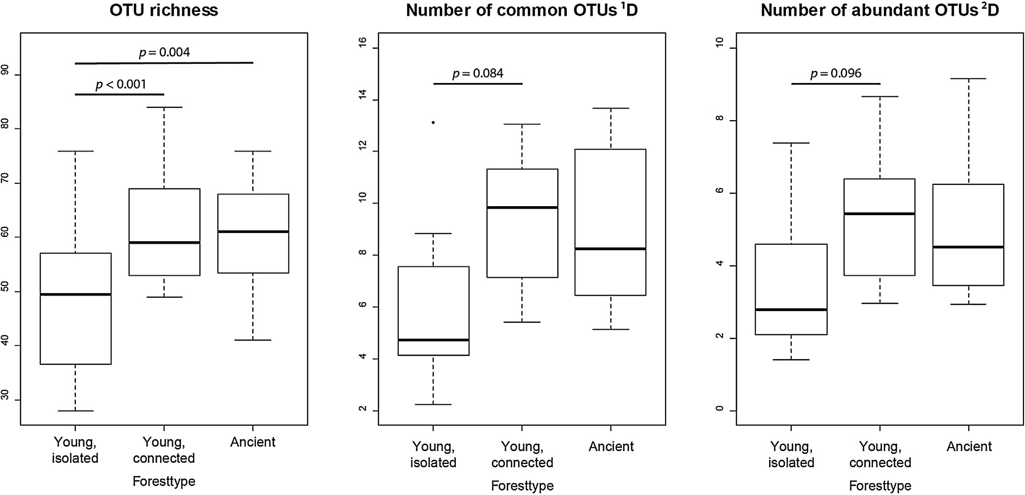

Fig. 2. Diversity measures show a clear eﬀect of forest type on ectomycorrhizal fungal diversity. Signiﬁcance levels of pairwise comparisons smaller than 0.1 are shown.

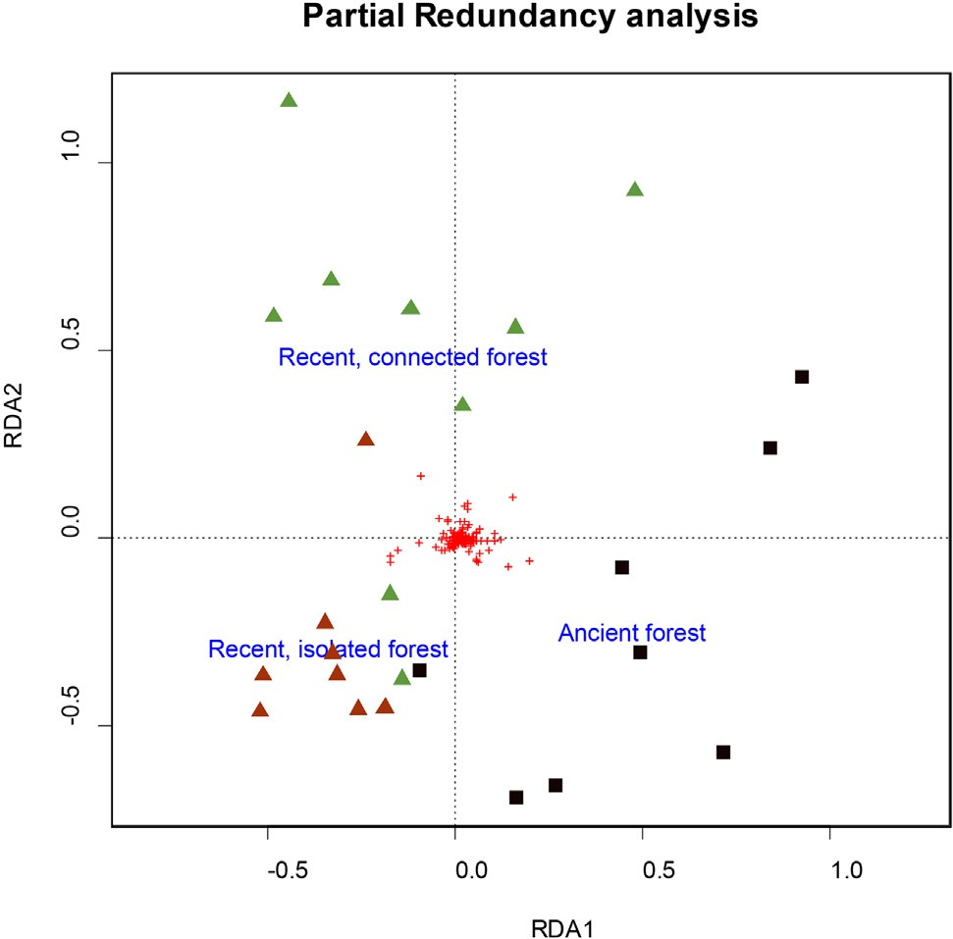Table 2
Results of the indicator species analysis.

OTU Nr. Family Species Indicator value

p value

Isolated, recent forest stands
OTU1035 Thelephoraceae Tomentella cf.
sublilacina

0.679 0.035

OTU377 Inocybaceae Inocybe cf. curvipes 0.612 0.050
connected, recent forest stands
OTU2031 Cortinariaceae Cortinarius sp. 0.841 0.010
OTU601 Clavulinaceae Clavulina sp. 0.704 0.045
Ancient forest stands
 | OTU787 | Russulaceae | Russula cf. ochroleuca | 0.807 | 0.015
 | OTU1438 | Sclerodermataceae | Scleroderma cf. | 0.729 | 0.030
 |  |  | citrinum
 | OTU591 | Russulaceae | Lactarius sp. | 0.704 | 0.030
 | OTU544 | Russulaceae | Lactarius cf. quietus | 0.688 | 0.030
 | OTU721 | Russulaceae | Lactarius sp. | 0.686 | 0.045
 | OTU693 | Russulaceae | Lactarius cf. tabidus | 0.664 | 0.040
 | OTU573 | Boletaceae | Tylopilus cf. felleus | 0.601 | 0.040
 | OTU1539 | Sclerodermataceae | Scleroderma cf. | 0.601 | 0.040
 |  |  | citrinum
 | OTU704 | Russulaceae | Lactarius cf. quietus | 0.595 | 0.045
 | OTU1489 | Sclerodermataceae | Scleroderma cf. | 0.590 | 0.040
Fig. 3. Partial redundancy analysis with forest type as explaining factor and |  |  | citrinum
spatial eﬀects (in the form of spatial vector PCNM2) partialled out. Labels of the Isolated and connected recent forest stands
three forest types are placed on the centroids. Green triangles depict samples OTU785 |  | Thelephoraceae | Tomentella sp. | 0.907 | 0.015
OTU302 |  | Entolomataceae | Entoloma cf. | 0.873 | 0.005
from recent, connected forest stands, red triangles from recent, isolated forest |  |  | inusitatum
stands and black squares from ancient forest stands. Red plusses depict OTUs.

(For interpretation of the references to colour in this ﬁgure legend, the reader is referred to the web version of this article.)

Connected, recent forest stands and ancient forests stands
OTU505 Russulaceae Russula cf. amoenolens 0.932 0.005
OTU690 Russulaceae Lactarius cf. tabidus 0.874 0.015
OTU727 Russulaceae Lactarius cf. tabidus 0.840 0.035

Hymenogaster (soil PC2) (Fig. 6).
OTU1672 Sclerodermataceae Scleroderma cf.
citrinum
0.767 0.030

- Discussion
Our results showed that spatial isolation of recently restored forest stands had a marked eﬀect on diversity and community composition of ectomycorrhizal (EcM) fungal communities. The number of ectomy- corrhizal fungal OTUs in isolated recent forest stands was signiﬁcantly
lower than in recent forest stands located adjacent to ancient forest and ancient forest stands, clearly demonstrating that spatial isolation has a negative impact on EcM fungal communities. Dickie and Reich (2005) already found a steep decline in ectomycorrhizal colonization of Quercus macrocarpa seedlings over a distance of 20 m from the forest

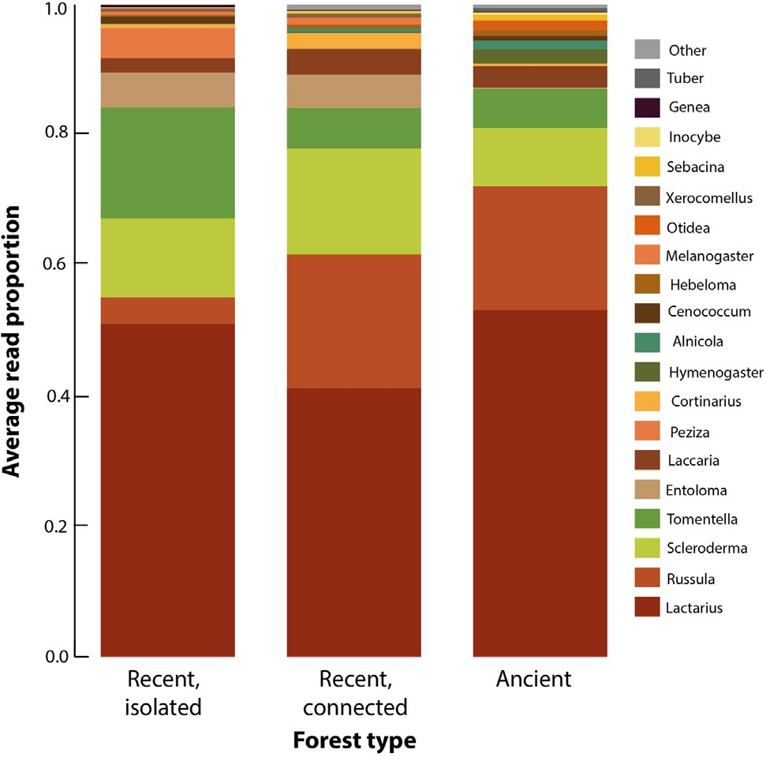

Fig. 4. Average proportional red numbers of the diﬀerent genera, for each forest type. (For interpretation of the references to colour in this ﬁgure legend, the reader is referred to the web version of this article.)

edge, indicating the importance of mycelial expansion as a dispersal mechanism. By placing spore traps across a landscape with scattered even-aged stands of Pinus muricata, Peay and Bruns (2014) discovered high spatial and temporal variability in composition of fungal spores, which could partly be explained by dispersal limitation. In another study on islands of P. muricata seedlings, Peay et al. (2012) found a signiﬁcant reduction in ectomycorrhizal colonization of the seedlings with increasing distance from potential spore sources. Similarly, Vannette et al. (2016) found more diverse and more similar root-as- sociated fungal communities in highly connected forest fragments on the island of Hawaii. These results indicate that dispersal plays an im- portant role in the community assembly of ectomycorrhizal fungal communities.
While recent forest stands situated adjacent to ancient forest can be colonized both through mycelial growth and spores and are situated very close to spore sources, recent forest stands isolated from ancient forest can only be colonized by spores and are situated at longer dis- tance from spore sources. While isolation probably is of less importance for highly mobile species, it will have a clear eﬀect on species with limited dispersal capabilities. As a result, isolation will not only aﬀect diversity but also community composition, with isolated recent forest stands dominated by highly-dispersive species that establish easily from spores, while connected recent forest stands harbor both species that spread mostly vegetatively and species that establish from spores.
One genus that was clearly more abundant in both ancient forests and recent stands adjacent to ancient forest, was Russula. This genus often dominates mature forests and is considered ‘late-successional’ (Taylor and Bruns, 1999; Smith and Read, 2008; Dickie et al., 2013). Nevertheless, Russula was equivalently abundant in the recent forest stands bordering ancient forest, which is most likely caused by its dis- persal strategy. Spores of Russula do not easily germinate and coloni- zation of tree seedling roots mostly happens through hyphal expansion from mature tree roots (Dickie and Reich, 2005; Nara, 2009). Of the nine genera absent from isolated recent stands and present in both connected recent stands and ancient stands, three genera form below- ground fruiting bodies (Elaphomyces, Hydnotrya and Pachyphloeus) and thus most likely depend on animals as vectors for dispersal (Kataržytė and Kutorga, 2011; Horton, 2017; Soteras et al., 2017), although the possibility that some of the spores are dispersed by wind cannot be fully
ruled out (Ingold, 1973; Trappe and Maser, 1977; Reynolds, 2011). This suggests that diﬀerences in dispersal capacities are most likely the driving factor behind the diﬀerences in community composition be- tween isolated recent forests and recent forests adjacent to ancient forest.
Results from the indicator species analysis support these ﬁndings. The OTUs indicative of isolated recent forest stands belonged to Tomentella sublilacina and Inocybe curvipes. Although Tomentella sub- lilacina is known to be abundant in mature forests, bio-assays have shown it can easily establish from spores (Taylor and Bruns, 1999) and it has been shown to be a good disperser (Peay et al., 2012). Inocybe species are also known to establish easily from spores (Smith and Read, 2008; Nara, 2009). On the other hand, the indicator OTUs of the con- nected, recent stands and the indicator OTUs of the connected, recent and ancient stands together, belonged to genera known to colonize a new host mostly through mycelial growth and to establish less easily from spores (e.g. Cortinarius, Lactarius, Russula and Scleroderma) (Smith and Read, 2008; Nara, 2009). Our results further showed that the number of indicator OTUs that recent, connected forests had in common with ancient forest was higher than the number of indicator OTUs for this type alone (four compared to two). This suggests that the accessibility of the newly established habitat is more important than the diﬀering abiotic conditions for colonization by EcM fungi. Indicator OTUs of ancient forests also mostly belonged to these genera. It is striking that Lactarius was equally abundant in the three forest types despite its low spore dispersal capacities. One possibility is that the oak trees were colonized by Lactarius in tree nurseries, prior to aﬀoresta- tion.
Besides eﬀects of isolation, variation in ectomycorrhizal fungal communities was also driven by variation in soil variables, although their eﬀect was smaller than that of isolation. When forest type (an- cient, recent connected or recent isolated) was removed as a variable, a marginally signiﬁcant eﬀect of soil variables was found in the re- dundancy analysis and eight of the ﬁfteen most abundant genera were signiﬁcantly aﬀected by one of the soil principal components. The ﬁrst soil principal component, which was positively correlated with moisture availability and negatively with pH, had an eﬀect on the read numbers of the genera Laccaria and Peziza. Lactarius, Scleroderma, Hymenogaster, Hebeloma and Entoloma were signiﬁcantly aﬀected by the second soil principal component, which was positively correlated with ammonium concentration and soil organic material and negatively correlated with nitrate and phosphorus concentration. Lactarius and Scleroderma were negatively aﬀected by soil PC2 and Hebeloma was positively correlated with it. Care has to be taken when interpreting the results on variation in OTU abundance, because read numbers not ne- cessarily correspond to EcM root-tip abundance (Amend et al., 2010). However, our results are in line with previous studies that have in- vestigated variation in EcM fungal communities in European oak forests using root-tip abundance (Suz et al., 2014), suggesting that the ob- served variation in read numbers displays real variation in EcM root-tip abundance rather than sequencing artefacts.
Inorganic nitrogen concentration has been found to aﬀect EcM species richness and community composition both in natural gradients and due to anthropogenic inﬂuences (e.g. N deposition, fertilization) (Wallenda and Kottke, 1998; Erland and Taylor, 2002; Lilleskov et al., 2002; Toljander et al., 2006; Cox et al., 2010; Suz et al., 2014). This is most likely due to diﬀerences in uptake capacity of inorganic N sources (Kranabetter et al., 2015), the capacity to acquire N from organic sources (Pena et al., 2013; Shah et al., 2016) and N transfer to the host (van der Heijden and Kuyper, 2003). Due to a tradeoﬀ between enzy- matic function (aﬀecting nutrient acquisition ability) and competi- tiveness, nitrogen concentration and the forms in which it is present can aﬀect EcM fungal community composition (Moeller and Peay, 2016). While Hebeloma prefers inorganic nitrogen sources (Avolio et al., 2012) and mainly occurs in habitat patches with little competitors (e.g. dunes with scattered trees and disturbed patches in forests (Guidot et al.,

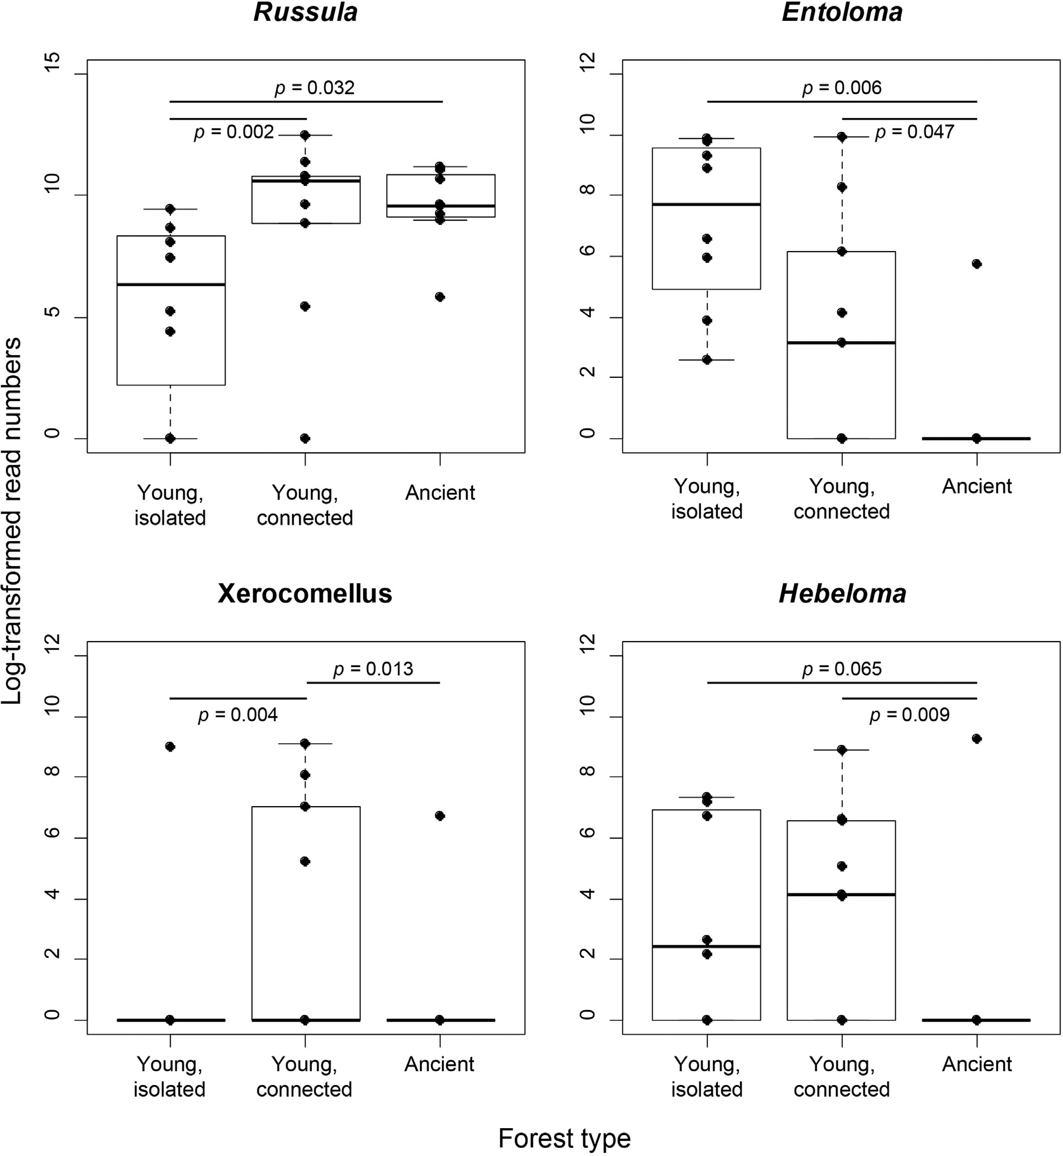

Fig. 5. Eﬀects of forest type on the log-transformed read numbers of four of the most abundant genera, which were signiﬁcantly aﬀected by forest type according to the generalized linear model with negative binomial distribution. P-values from pairwise comparisons smaller than 0.1 are provided.

2002)), Lactarius quietus is known to possess the ability to mobilize nutrients from organic substrates and to behave saprotrophically when carbon demands are high (Courty et al., 2006, 2007). This also explains why Hebeloma was more abundant in recent forests, where less litter and humus accumulated and competition is lower. The third soil principal component, positively correlated with soil organic matter and negatively with pH, aﬀected abundances in Tomentella. Clearly, EcM fungal community composition in recent forest stands is not only af- fected by which species are able to reach it, but also by which species are able to establish and survive. Still, more experimental work is needed to study how edaphic factors aﬀect recruitment of ectomycor- rhizal fungi. As some of these soil variables are known to be correlated with forest age (Thomaes et al., 2012) and simply due to increasing colonization success over time, we can expect that with increasing age the EcM fungal community composition of the recent forest stands will diﬀer less compared to the ancient forest. Our results are in accordance
with the global meta-analysis by Crouzeilles et al. (2016), who showed that time and landscape context represent key drivers of forest re- storation success.

- Conclusion

Our results clearly showed that ectomycorrhizal community com- position in recently restored forest patches was aﬀected by a combi- nation of spatial isolation and environmental conditions. EcM fungal communities recovered much faster when recently restored forest fragments were physically connected to ancient forest, but still diﬀered in composition from those of ancient forests, most likely due to dif- ferences in edaphic conditions. This diﬀerence in community compo- sition can be expected to decrease over time, as the forest ecosystem develops. Nevertheless, it is unclear how long it will take before, if ever, the isolated stands develop a comparable community, both in species

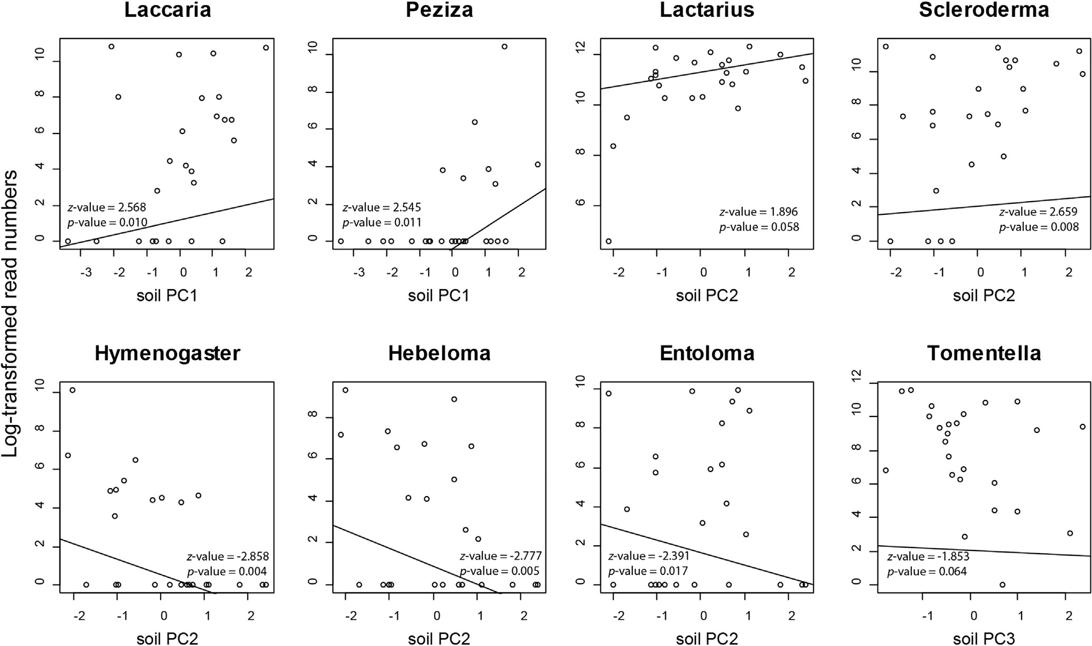

Fig. 6. Eﬀects of the soil principal components on log-transformed read numbers of the most abundant genera which were (marginally) signiﬁcantly correlated with one of the soil principal components according to the generalized linear models with negative binomial distribution The z-statistics and corresponding p-values are provided. Soil PC1 is positively correlated with pH and negatively with moisture. Soil PC2 is positively correlated with ammonium and phosphorous and negatively with nitrate and organic material. Soil PC3 is positively correlated with organic material and negatively with pH.

richness and composition, as the ancient woodland sites.

Data accessibility

Raw sequence data was submitted to the NCBI Sequence Read Archive under Bioproject PRJNA477418.

Acknowledgements

We thank Kasper Van Acker for help with the soil analyses.

References

Amend, A.S., Seifert, K.A., Bruns, T.D., 2010. Quantifying microbial communities with 454 pyrosequencing: does read abundance count? Mol. Ecol. 19, 5555–5565.
Avolio, M., Müller, T., Mpangara, A., et al., 2012. Regulation of genes involved in ni- trogen utilization on diﬀerent C/N ratios and nitrogen sources in the model ecto- mycorrhizal fungus Hebeloma cylindrosporum. Mycorrhiza 22, 515–524.
Baas Becking, L.G.M., 1934. Geobiologie of Inleiding tot de Milieukunde. W.P. Van Stockum & Zoon, The Hague, the Netherlands.
Baeten, L., Jacquemyn, H., Calster, H. Van, et al., 2008. Low recruitment across life stages partly accounts for the slow colonization of forest herbs. J. Ecol. 97, 109–117.
Bahram, M., Põlme, S., Kõljalg, U., Tedersoo, L., 2011. A single European aspen (Populus tremula) tree individual may potentially harbour dozens of Cenococcum geophilum ITS genotypes and hundreds of species of ectomycorrhizal fungi. FEMS Microbiol. Ecol. 75, 313–320.
Baldrian, P., 2017. Forest microbiome: diversity, complexity and dynamics. FEMS Microbiol. Rev. 41, 109–130.
Bengtsson-Palme, J., Ryberg, M., Hartmann, M., et al., 2013. Improved software detection and extraction of ITS1 and ITS2 from ribosomal ITS sequences of fungi and other eukaryotes for analysis of environmental sequencing data. Methods Ecol. Evol. 4, 914–919.
Bennett, J.A., Maherali, H., Reinhart, K.O., et al., 2017. Plant-soil feedbacks and my- corrhizal type inﬂuence temperate forest population dynamics. Science 355, 181–184.
Bogar, L.M., Peay, K.G., 2017. Processes maintaining the coexistence of ectomycorrhizal fungi at a ﬁne spatial scale. In: Tedersoo, L. (Ed.), Biogeography of Mycorrhizal Symbiosis. Springer, Cham, pp. 79–105.

International Union for Conservation of Nature, 2011. Bonn Challenge.
Cáceres, M. De, Legendre, P., 2009. Associations between species and groups of sites: indices and statistical inference. Ecology 90, 3566–3574.
Colgan, W., Claridge, A.W., 2002. Mycorrhizal eﬀectiveness of Rhizopogon spores re- covered from faecal pellets of small forest-dwelling mammals. Mycol. Res. 106, 314–320.
Courty, P.-E., Pouysegur, R., Buée, M., Garbaye, J., 2006. Laccase and phosphatase ac- tivities of the dominant ectomycorrhizal types in a lowland oak forest. Soil Biol. Biochem. 38, 1219–1222.
Courty, P.-E., Bréda, N., Garbaye, J., 2007. Relation between oak tree phenology and the secretion of organic matter degrading enzymes by Lactarius quietus ectomycorrhizas before and during bud break. Soil Biol. Biochem. 39, 1655–1663.
Cox, F., Barsoum, N., Lilleskov, E.A., Bidartondo, M.I., 2010. Nitrogen availability is a primary determinant of conifer mycorrhizas across complex environmental gradients. Ecol. Lett. 13, 1103–1113.
Crouzeilles, R., Curran, M., Ferreira, M.S., et al., 2016. A global meta-analysis on the ecological drivers of forest restoration success. Nat. Commun. 7.
De Keersmaeker, L., Rogiers, N., Vandekerkhove, K., et al., 2013. Application of the an- cient forest concept to potential natural vegetation mapping in ﬂanders, a strongly altered landscape in northern belgium. Folia Geobotanica 48, 137–162.
De Keersmaeker, L., Onkelinx, T., De Vos, B., et al., 2015. The analysis of spatio-temporal forest changes (1775–2000) in Flanders (northern Belgium) indicates habitat-speciﬁc levels of fragmentation and area loss. Landscape Ecol. 30, 247–259.
de la Peña, E., Baeten, L., Steel, H., et al., 2016. Beyond plant–soil feedbacks: mechanisms driving plant community shifts due to land-use legacies in post-agricultural forests. Funct. Ecol. 30, 1073–1085.
De Mendiburu, F., 2014. Agricolae: statistical procedures for agricultural research. R package version, 1.
De Schrijver, A., Vesterdal, L., Hansen, K., et al., 2012. Four decades of post-agricultural forest development have caused major redistributions of soil phosphorus fractions. Oecologia 169, 221–234.
Dickie, I.A., Reich, P.B., 2005. Ectomycorrhizal fungal communities at forest edges. J. Ecol. 93, 244–255.
Dickie, I.A., Martínez-García, L.B., Koele, N., et al., 2013. Mycorrhizas and mycorrhizal fungal communities throughout ecosystem development. Plant Soil 367, 11–39.
Erland, S., Taylor, A.F.S., 2002. Diversity of ecto-mycorrhizal fungal communities in re- lation to the abiotic environment. In: van der Heijden, M.G.A., Sanders, I.R. (Eds.), Mycorrhizal Ecology. Springer, Berlin, Heidelberg, pp. 163–200.
Falkengren-Grerup, U., ten Brink, D.-J., Brunet, J., 2006. Land use eﬀects on soil N, P, C and pH persist over 40–80 years of forest growth on agricultural soils. For. Ecol.
Manage. 225, 74–81.
Finlay, B.J., Clarke, K.J., 1999. Ubiquitous dispersal of microbial species. Nature 400,

828.
Flinn, K.M., Vellend, M., 2005. Recovery of forest plant communities in post-agricultural landscapes. Front. Ecol. Environ. 3, 243–250.
Galante, T.E., Horton, T.R., Swaney, D.P., 2011. 95% of basidiospores fall within 1 m of the cap: a ﬁeld-and modeling-based study. Mycologia 103, 1175–1183.
Gordon, A., Hannon, G.J., 2010. Fastx-toolkit. FASTQ/A short-reads pre-processing tools.
Guidot, A., Gryta, H., Gourbière, F., Debaud, J.-C., Marmeisse, R., 2002. Forest habitat characteristics aﬀect balance between sexual reproduction and clonal propagation of the ectomycorrhizal mushroom Hebeloma cylindrosporum. Oikos 99, 25–36.
Gweon, H.S., Oliver, A., Taylor, J., et al., 2015. PIPITS: an automated pipeline for ana- lyses of fungal internal transcribed spacer sequences from the Illumina sequencing platform. Methods Ecol. Evol. 6, 973–980.
Hermy, M., Verheyen, K., 2007. Legacies of the past in the present-day forest biodiversity: a review of past land-use eﬀects on forest plant species composition and diversity. Ecol. Res. 22, 361–371.
Hill, M.O., 1973. Diversity and evenness: a unifying notation and its consequences.
Ecology 54, 427–432.
Honnay, O., Bossuyt, B., Verheyen, K., et al., 2002. Ecological perspectives for the re- storation of plant communities in European temperate forests. Biodivers. Conserv. 11, 213–242.
Hooker, T.D., Compton, J.E., 2003. Forest ecosystem carbon and nitrogen accumulation during the ﬁrst century after agricultural abandonment. Ecol. Appl. 13, 299–313.
Horton, T.R., 2017. Spore dispersal in ectomycorrhizal fungi at ﬁne and regional scales.
In: Biogeography of Mycorrhizal Symbiosis. Springer, Cham, pp. 61–78.
Hothorn, T., Bretz, F., Westfall, P., 2008. Simultaneous inference in general parametric models. Biomet. J. 50, 346–363.
Huxel, G.R., Hastings, A., 1999. Habitat loss, fragmentation, and restoration. Restor. Ecol.
7, 309–315.
Ingold, C.T., 1973. The gift of a truﬄe. Bull. Brit. Mycol. Soc. 7, 32–33.
Ishida, T.A., Nara, K., Tanaka, M., Kinoshita, A., Hogetsu, T., 2008. Germination and infectivity of ectomycorrhizal fungal spores in relation to their ecological traits during primary succession. New Phytologist 180, 491–500.
Kataržytė, M., Kutorga, E., 2011. Small mammal mycophagy in hemiboreal forest com- munities of Lithuania. Open Life Sci. 6, 446.
Kranabetter, J.M., Hawkins, B.J., Jones, M.D., et al., 2015. Species turnover (β-diversity)
in ectomycorrhizal fungi linked to NH4+ uptake capacity. Mol. Ecol. 24, 5992–6005. Legendre, P., Gallagher, E.D., 2001. Ecologically meaningful transformations for ordi-
nation of species data. Oecologia 129, 271–280.
Lewis, S.L., Edwards, D.P., Galbraith, D., 2015. Increasing human dominance of tropical forests. Science 349, 827–832.
Lilleskov, E.A., Fahey, T.J., Horton, T.R., Lovett, G.M., 2002. Belowground ectomycor- rhizal fungal community change over a nitrogen deposition gradient in Alaska.
Ecology 83, 104–115.
Lõhmus, K., Paal, T., Liira, J., 2014. Long-term colonization ecology of forest-dwelling species in a fragmented rural landscape – dispersal versus establishment. Ecol. Evol. 4, 3113–3126.
Lucas, R., Groeneveld, J., Harms, H., et al., 2016. A critical evaluation of ecological in- dices for the comparative analysis of microbial communities based on molecular datasets. FEMS Microbiol. Ecol. 93, ﬁw209.
Meli, P., Holl, K.D., Rey Benayas, J.M., et al., 2017. A global review of past land use, climate, and active vs. passive restoration eﬀects on forest recovery. Plos One 12, 1–17.
Meyer, W.B., Turner II, B.L., 1992. Human population growth and global land-use/cover change. Annu. Rev. Ecol. Syst. 23, 39–61.
Moeller, H.V., Peay, K.G., 2016. Competition-function tradeoﬀs in ectomycorrhizal fungi.
PeerJ 4, e2270.
Nara, K., 2009. Spores of ectomycorrhizal fungi: ecological strategies for germination and dormancy. New Phytologist 181, 245–248.
Newton, A.C., 1992. Towards a functional classiﬁcation of ectomycorrhizal fungi.
Mycorrhiza 2, 75–79.
Nguyen, N.H., Song, Z., Bates, S.T., et al., 2015. FUNGuild: an open annotation tool for parsing fungal community datasets by ecological guild. Fungal Ecol. 1–8.
Nilsson, R.H., Tedersoo, L., Ryberg, M., et al., 2015. A Comprehensive, automatically updated fungal ITS sequence dataset for reference-based chimera control in en- vironmental sequencing eﬀorts. Microbes Environ. 30, 145–150.
Norros, V., Penttilä, R., Suominen, M., Ovaskainen, O., 2012. Dispersal may limit the occurrence of specialist wood decay fungi already at small spatial scales. Oikos 121, 961–974.
Norros, V., Karhu, E., Nordén, J., Vähätalo, A.V., Ovaskainen, O., 2015. Spore sensitivity to sunlight and freezing can restrict dispersal in wood-decay fungi. Ecol. Evol. 5, 3312–3326.
Oksanen, J., Blanchet, F.G., Minchin, P.R., et al., 2016. vegan: Community Ecology Package.
Olsen, S.R., 1954. Estimation of available phosphorus in soils by extraction with sodium bicarbonate. U.S. Dept. of Agriculture, Washington.
Palmer, M.A., Ambrose, R.F., Poﬀ, N.L., 2008. Ecological theory and community
restoration ecology. Restor. Ecol. 5, 291–300.
Peay, K.G., Bruns, T.D., Kennedy, P.G., Bergemann, S.E., Garbelotto, M., 2007. A strong species-area relationship for eukaryotic soil microbes: island size matters for ecto- mycorrhizal fungi. Ecol. Lett. 10, 470–480.
Peay, K.G., Bruns, T.D., 2014. Spore dispersal of basidiomycete fungi at the landscape scale is driven by stochastic and deterministic processes and generates variability in plant-fungal interactions. New Phytologist 204, 180–191.
Peay, K.G., Garbelotto, M., Bruns, T.D., 2010. Evidence of dispersal limitation in soil microorganisms: isolation reduces species richness on mycorrhizal tree islands. Ecology 91, 3631–3640.
Peay, K.G., Schubert, M.G., Nguyen, N.H., Bruns, T.D., 2012. Measuring ectomycorrhizal fungal dispersal: macroecological patterns driven by microscopic propagules. Mol. Ecol. 21, 4122–4136.
Peay, K.G., Kennedy, P.G., Talbot, J.M., 2016. Dimensions of biodiversity in the Earth mycobiome. Nat. Rev. Micro. 14, 434–447.
Pena, R., Tejedor, J., Zeller, B., Dannenmann, M., Polle, A., 2013. Interspeciﬁc temporal and spatial diﬀerences in the acquisition of litter-derived nitrogen by ectomycorrhizal fungal assemblages. New Phytologist 199, 520–528.
R Core Team, 2015. R version 3.2.0.
Read, D.J., Perez-Moreno, J., 2003. Mycorrhizas and nutrient cycling in ecosystems – a journey towards relevance? New Phytologist 157, 475–492.
Reynolds, H.T., 2011. Systematics, phylogeography and ecology of Elaphomycetaceae.
Ritter, E., Vesterdal, L., Gundersen, P., 2003. Changes in soil properties after aﬀorestation of former intensively managed soils with oak and Norway spruce. Plant Soil 249, 319–330.
Shah, F., Nicolás, C., Bentzer, J., et al., 2016. Ectomycorrhizal fungi decompose soil or- ganic matter using oxidative mechanisms adapted from saprotrophic ancestors. New Phytologist 209, 1705–1719.
Smith, D.P., Peay, K.G., 2014. Sequence depth, not PCR replication, improves ecological inference from next generation DNA sequencing. Plos One 9, e90234.
Smith, S.E., Read, D.J., 2008. Mycorrhizal Symbiosis. Academic Press, Amsterdam. Soteras, F., Ibarra, C., Geml, J., et al., 2017. Mycophagy by invasive wild boar (Sus scrofa)
facilitates dispersal of native and introduced mycorrhizal fungi in Patagonia, Argentina. Fungal Ecol. 26, 51–58.
Sun, S., Li, S., Avera, B.N., Strahm, B.D., Badgley, B.D., 2017. Soil bacterial and fungal communities show distinct recovery patterns during forest ecosystem restoration. Appl. Environ. Microbiol. 83.
Suz, L.M., Barsoum, N., Benham, S., et al., 2014. Environmental drivers of ectomycor- rhizal communities in Europe’s temperate oak forests. Mol. Ecol. 23, 5628–5644.
Taylor, D.L., Bruns, T.D., 1999. Community structure of ectomycorrhizal fungi in a Pinus muricata forest: minimal overlap between the mature forest and resistant propagule communities. Mol. Ecol. 8, 1837–1850.
Tedersoo, L., Bahram, M., Toots, M., et al., 2012. Towards global patterns in the diversity and community structure of ectomycorrhizal fungi. Mol. Ecol. 21, 4160–4170.
Thomaes, A., De Keersmaeker, L., Van, Calster H, et al., 2012. Diverging eﬀects of two contrasting tree species on soil and herb layer development in a chronosequence of post-agricultural forest. Forest Ecol. Manage. 278, 90–100.
Toljander, J.F., Eberhardt, U., Toljander, Y.K., Paul, L.R., Taylor, A.F.S., 2006. Species composition of an ectomycorrhizal fungal community along a local nutrient gradient in a boreal forest. New Phytologist 170, 873–884.
Trappe, J.M., Maser, C., 1977. Ectomycorrhizal Fungi: Interactions of Mushrooms and Truﬄes with Beasts and Trees. Department of Agriculture, Forest Service.
van der Heijden, E.W., Kuyper, T.W., 2003. Ecological strategies of ectomycorrhizal fungi of Salix repens: root manipulation versus root replacement. Oikos 103, 668–680.
Vannette, R.L., Leopold, D.R., Fukami, T., 2016. Forest area and connectivity inﬂuence root-associated fungal communities in a fragmented landscape. Ecology 97, 2374–2383.
Venables, W.N., Ripley, B.D., 2013. Modern Applied Statistics with S-PLUS. Springer Science & Business Media.
Verheyen, K., Hermy, M., 2001. The relative importance of dispersal limitation of vas- cular plants in secondary forest succession in Muizen Forest, Belgium. J. Ecol. 89, 829–840.
Verheyen, K., Guntenspergen, G.R., Biesbrouck, B., Hermy, M., 2003. An integrated analysis of the eﬀects of past land use on forest herb colonization at the landscape scale. J. Ecol. 91, 731–742.
Wallenda, T., Kottke, I., 1998. Nitrogen deposition and ectomycorrhizas. New Phytologist 139, 169–187.
Wang, Q., Garrity, G.M., Tiedje, J.M., Cole, J.R., 2007. Naive Bayesian classiﬁer for rapid assignment of rRNA sequences into the new bacterial taxonomy. Appl. Environ.
Microbiol. 73, 5261–5267.
Wooliver, R., Pfennigwerth, A.A., Bailey, J.K., Schweitzer, J.A., 2016. Plant functional constraints guide macroevolutionary trade-oﬀs in competitive and conservative growth responses to nitrogen. Funct. Ecol. 30, 1099–1108.
Zhang, J., Kobert, K., Flouri, T., Stamatakis, A., 2014. PEAR: a fast and accurate Illumina Paired-End reAd mergeR. Bioinformatics 30, 614–620.

