Selective tidal stream transport in silver European eel (Anguilla anguilla L.) –
Migration behaviour in a dynamic estuary

Pieterjan Verhelsta,b,c,d,∗, Stijn Bruneelb, Jan Reubensc, Johan Coeckd, Peter Goethalsb,
Damiano Oldonid, Tom Moensa, Ans Moutond
a Marine Biology Research Group, Ghent University, Krijgslaan 281, 9000 Ghent, Belgium
b Laboratory of Environmental Toxicology and Aquatic Ecology, Ghent University, Coupure Links 653, 9000 Ghent, Belgium
c Flanders Marine Institute, Wandelaarkaai 7, 8400 Ostend, Belgium
d Research Institute for Nature and Forest (INBO), Havenlaan 88, Bus 73, 1000 Brussels, Belgium

A R T I C L E I N F O

Keywords: Diadromous Migration Estuary
Selective tidal stream transport Telemetry
Conservation
A B S T R A C T

Diﬀerent ﬁsh species use selective tidal stream transport (STST) to eﬃciently migrate through strong tidal systems to complete their life cycle, but the use of STST by silver European eels (Anguilla anguilla L.) is still controversial. In this study, we found strong evidence that silver European eels apply STST. The results illustrate that eels can distinguish between ebb and ﬂood and suggest that tides play a role in orientation, either directly or indirectly. The general migration speed was higher in the downstream part of the estuary compared to the upstream part, while tidal migration speed was equal in both parts, indicating that eels migrated more con- sistently in the downstream part. The results of this study give insight in how a diadromous species migrates through an estuary and underline the importance of the tides.

- Introduction

Animal migration is a persistent and unidirectional movement, characterized by the temporary inhibition of station keeping responses such as foraging, territorial behaviour and commuting (Kennedy, 1985). In the animal kingdom, many groups rely on successful migra- tion to complete their life cycle (e.g. arthropods, ﬁsh, birds, mammals
…), each with diﬀerent goals such as reproduction or reaching a more qualitative habitat (Berger, 2004; Dingle, 2006; Stern, 2009; Weitkamp and Neely, 2002). Many ﬁsh species, for instance, migrate between freshwater and marine environments for spawning (i.e. diadromy) (e.g. Acipenseridae, Alosinae, Anguillidae, Salmonidae). Consequently, dia- dromous ﬁsh have to overcome substantial distances which come with a high energetic cost. Due to the high energetic cost of migration and the low adult survival, some of these species have developed semelparity (Crespi and Teo, 2002). Consequently, a bioenergetic trade-oﬀ between migration and reproduction may exist for semelparous ﬁsh species, especially since many will stop feeding during migration (Bernatchez and Dodson, 1987): the smaller the energy expenditure during migra- tion, the larger the amount of energy that may remain available for gonad maturation (Glebe and Leggett, 1981; Jonsson et al., 1991; Marshall et al., 1999).
An example where migration can have important bioenergetic

repercussions is migration through strong tidal systems. To reduce en- ergy loss in such systems, ﬁsh may perform selective tidal stream transport (STST): an animal ascends into the water column with the appropriate tide and rests on or in the bottom during the opposite tide (Walker et al., 1978). STST has been observed for diﬀerent marine ﬁsh species, such as cod (Gadus morhua L.) (Arnold et al., 1994), sole (Solea solea L.) (Walker et al., 1980) and plaice (Pleuronectes platessa L.) (Metcalfe et al., 1990; Walker et al., 1978), but also for diadromous ﬁsh species in estuaries such as sockeye salmon (Oncorhynchus nerka Wal- baum) (Levy and Cadenhead, 1995) and ﬂounder (Platichthys ﬂesus L.) (Jager, 1999). Yet, the behaviour is not universal: Silva et al. (2017) did not observe STST for upstream migrating river lamprey (Lampetra ﬂu- viatilis L.) in an English estuary.
A ﬁsh species of particular interest is the European eel (Anguilla anguilla L.), a facultatively catadromous ﬁsh which grows in coastal and freshwater systems as yellow eel, but migrates as silver eel to the Sargasso Sea for spawning, approximately 5000 km west of the European continent (Tesch, 2003). During the last decades, recruitment of the European eel has declined between 90% and 99% (Dekker and Casselman, 2014), making it a critically endangered species according to the IUCN Red List (Jacoby and Gollock, 2014). Since it is se- melparous and does not feed during migration, it must rely on its ac- cumulated fat reserve for successful spawning (Tesch, 2003). In rivers

∗ Corresponding author. Ghent University, Biology Department, Marine Biology Research Group, Krijgslaan 281, S8 9000 Gent, Belgium.
E-mail address: Pieterjan.Verhelst@UGent.be (P. Verhelst).

and polders, for example, silver eels migrate during peak discharges (Piper et al., 2015; Travade et al., 2010; Verhelst et al., 2018b; Vøllestad et al., 1986). Migration during peak discharges might help silver eels to conserve energy by reducing swimming activity and shorten the period required to reach the sea (Trancart et al., 2018). In estuaries, however, current direction changes twice a day following a sinusoidal pattern (i.e. the tide). In those systems, it would be en- ergetically beneﬁcial to use STST during migration.
STST has been observed in the glass eel stage (i.e. the young recruits reaching coastal waters and entering freshwater systems) of diﬀerent eel species (European eel (Beaulaton and Castelnaud, 2005; Creutzberg, 1961; Trancart et al., 2012), American eel (A. rostrata) (Sheldon and McCleave, 1985), shortﬁn eel (A. australis) (Jellyman, 1979), New- Zealand longﬁn eel (A. dieﬀenbachii) (Jellyman, 1979), Japanese eel (A. japonica) (Dou and Tsukamoto, 2003), Celebes longﬁn eel (A. cel- ebesensis) (Sugeha et al., 2001), Giant mottled eel (A. marmorata) (Sugeha et al., 2001) and Indian shortﬁn eel (A. bicolor paciﬁca) (Sugeha et al., 2001)). Due to their small size and accompanying weak swimming strength, it is unlikely that glass eels can migrate against the strong tidal forces and river currents for extended periods of time (Adam et al., 2008); hence, STST allows them to migrate upstream. In addition, STST has been found in the silver eel stage of both American (Barbin et al., 1998; Béguer-Pon et al., 2014; Parker and McCleave, 1997) and European eels (McCleave and Arnold, 1999). However, for the latter, conclusions were based on only two individuals, which were translocated from freshwater to the marine environment and then tracked for a very short time (max 58 h) and net distance (max
72.2 km). Yet, both Barry et al. (2016) and Huisman et al. (2016) ob- served that the majority of their tracked silver eels migrated during ebbing tide in an estuary and in the North Sea, respectively. In contrast, tracking studies by Tesch (1992) and Bultel et al. (2014) found no re- lationship with the tides, illustrating ambiguity regarding the use of STST in European eels.
We challenge the hypothesis that European silver eels use STST in a highly dynamic estuary and addressed two research questions: 1) Do migratory eels apply STST, and 2) at what speed do they migrate through the estuary? This study provides insight in silver eel migration behaviour in a highly dynamic ecosystem and may support manage- ment measures for estuary restauration and tidal barrier passage.

- Methods

  - Study area

The River Schelde is approximately 360 km long and has a drainage area of 21,863 km2; it originates on the plateau of Saint-Quentin in France, runs through Belgium and ﬂows into the North Sea in The Netherlands. The Schelde Estuary is approximately 160 km long and has a complete salinity gradient from a tidal freshwater zone to marine, including extensive freshwater, brackish and salt marshes in its eco- system (Fig. 1). It is a well-mixed estuary characterized by strong tidal currents (still prominently present during periods of high discharge (www.waterinfo.be)), high turbidity and a large tidal amplitude, up to 6m (Seys et al., 1999). The estuary can be divided in two sections (upstream to downstream): the Zeeschelde (ZS), which spans 105 km from Gent to Antwerp (Belgium), and the Westerschelde (WS), which covers the 55 km from Antwerp to the mouth of the river at Vlissingen (The Netherlands) (Table 1). Due to the funnel shape of the estuary, the maximal average tidal amplitude is reached in the freshwater tidal zone in the ZS. Further upstream, the river (Boven-Schelde) is obstructed by sluices and weirs, which reduce tidal action. Our study area comprised the estuary from Gent to Vlissingen, so it did not include any physical migration barriers.
  - Tagging procedure

100 Eels were caught and tagged at the tidal weir in Merelbeke in the ZS during late summer and autumn (September–November) of three consecutive years (2015 till 2017) using double fyke nets (Fig. 1). Several morphometric features were measured in order to determine the eel maturation stage according to Durif et al. (2005): total length (TL, to the nearest mm), body weight (W, to the nearest g), the vertical and horizontal eye diameter (EDv and EDh respectively, to the nearest
0.01 mm) and the length of the pectoral ﬁn (FL, to the nearest 0.01 mm)
(Table S1). Only females were tagged, since males are smaller than the minimum size handled in this study (< 450 mm (Durif et al., 2005)). Eels of three diﬀerent maturation stages were tagged: premigrant (FIII, n = 51) and the two migrant stages FIV and FV (n = 21 and n = 28, respectively).
The eels were tagged with V13 coded acoustic transmitters (13 × 36 mm, weight in air 11 g, frequency 69 kHz, ping frequency: 60–100 s; estimated battery life: 1021–1219 days (battery life time depended on speciﬁc transmitter settings) (Table S2)) from VEMCO Ltd (Canada, http://www.vemco.com). After anaesthetising them with
0.3 ml L−1 clove oil, tags were implanted according to Thorstad et al.
(2013) with permanent monoﬁlament. Eels recovered in a quarantine reservoir for approximately one hour and were subsequently released at the nearest acoustic listening station (ALS).

  - Acoustic network

Within the framework of the Belgian LifeWatch observatory, a permanent network of ALSs (VR2W, VEMCO Ltd, Canada) has been deployed since the spring of 2014 in the Schelde Estuary. In the WS, 39 ALSs are moored on marine navigational buoys in three arrays (from west to east: WS1: 12 ALSs, average interdistance: 1132 m; WS2: 21 ALSs, average interdistance: 909 m; and WS3: six ALSs, average inter- distance: 800 m) (Fig. 1). The hydrophones were directed downward, as they were attached to a three-meter long chain with a weight at the end for stability. In the ZS, 25 ALSs are deployed from the river bank with coated wire, a weight to keep the ALS ﬁxed on the bottom, and a buoy to direct the hydrophone upwards in the water column. The ALSs in the ZS are on average 4969 m apart. The detection range in both the WS and ZS varied from < 300 m to 1005 m and was highly dependent on current strength and wave action (unpublished data, but see Reubens et al. (2018) for the eﬀect of environmental variables on the detection range in the Belgian part of the North Sea). Where the detection range was constrained by the current, we deployed an ALS on each side of the ZS river bank. Since in the WS we are dependent on navigational buoys, we could not reduce the distance between ALSs and therefore cannot guarantee full coverage at all times and all ALSs.

  - Data collection and processing

Of the 100 tagged eels, one was never detected and the other 99 were tracked between 16th September 2015 and 31st January 2018, resulting in a dataset with 302,824 detections (Fig. 2). The residency periods (i.e. the time between arrival and departure at an ALS) were calculated, which allowed to reduce the data by accumulating the number of detections during a ﬁxed period of time. The delineation of these residency periods was based on three assumptions: we applied 1) an absence threshold of one hour (i.e. if the time between detections was ≤1 h, an eel was considered resident near that ALS), 2) a detection threshold of one detection (i.e. a single detection was considered to justify the presence of a tagged eel), and 3) a detection range of 1005 m (i.e. detections at two ALSs < 1005 m apart were assigned to one ALS since eels passing ALSs < 1005 m apart were detected at both ALSs at the same time due to the overlapping detection range). As such, the residency search resulted in detection intervals with arrival and de- parture times per eel at each ALS. Between an arrival and departure

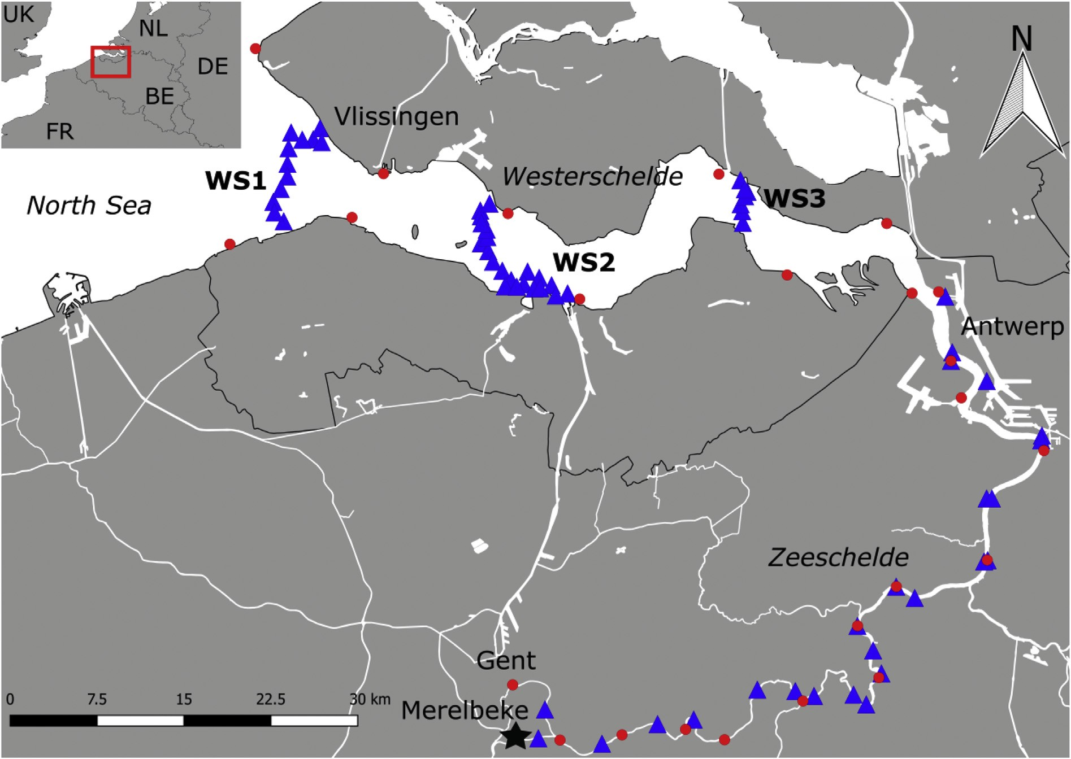
Fig. 1. The Schelde Estuary comprises the Zeeschelde (Gent – Antwerp) and Westerschelde (Antwerp – Vlissingen). Acoustic listening stations are represented as blue triangles and the tidal measuring stations as red spheres. The black asterisk indicates the catch location in Merelbeke. (For interpretation of the references to color in this ﬁgure legend, the reader is referred to the Web version of this article.)

Table 1
Characteristics (length, width, average discharge and average tidal amplitude) of the Schelde Estuary.

Zeeschelde Westerschelde
Length (km) 105 55
Width (m) 50–1350 2000–8000
Average discharge (m³∙s−1) 100 120
Average tidal amplitude (m) 5.24 4.5
eels and a dataset of 104,737 detections over the period of 16th Sep- tember 2015 till 2nd January 2018 (Fig. 2). All were detected in the ZS and 49 in the WS. Of the latter, 48 were detected at WS3, 36 at WS2 and 31 at WS1. The average migration distance per eel was 131 ± 35.8 km (range: 24–156 km) (Fig. S3) and the average tracking time (i.e. the time between the ﬁrst and last detection of the considered migration phase) was 39 ± 20.2 days (range: 3–89 days) (Fig. S4).
To analyse if eels apply STST, the timing of high and low water were

used (Levy and Cadenhead, 1995; Silva et al., 2017). Tidal data of the
Schelde Estuary was obtained for Belgium and The Netherlands from

within the same detection interval, the number of detections and the residency period were calculated (Verhelst et al., 2018b).
Not all eels migrated, and those that did, did not always migrate upon tagging (Fig. S1). Therefore, an eel was considered migratory (and consequently a silver eel) when it travelled a net distance ≥ 20 km downstream during ≤40 days. Within that period, we selected the re- cords from the most upstream till the most downstream station. The 20- km threshold is based on the maximum home range distance found for yellow eels (i.e. 18 km) (Verhelst et al., 2018c) plus two times the de- tection range of an ALS in the SE (i.e. the spatial error of the ALSs). The 40-days threshold is based on the ﬁnding that eels that did not migrate
≥20 km downstream during that period, arrested their migration to proceed only during a next season. Indeed, applying the above as- sumption resulted in the selection of two migration phases for three individual eels: they arrested their migration, subsequently moved back upstream towards the vicinity of their catch location, and resumed migration two, ten and twelve months later, respectively (Fig. S2). For those three eels, we only took the second migration phase into account for analysis to avoid pseudo-replication. Data ﬁltering, based on re- sidency periods and migratory behaviour, resulted in the selection of 58
the Hydraulic Information Centre (HIC) and Rijkswaterstaat (RWS), respectively. To account for the distances between the locations of the ALS and of the tidal measuring stations, a weighted average method was applied to estimate the precise moments of low and high water at the ALS. The closest upstream and downstream tidal measuring stations were assigned to each ALS. Based on the distances between these tidal stations and the ALS, weights were assigned to both tidal stations. When tidal data at the respective upstream or downstream tidal station was absent or of low quality at the time interval of interest, the next up- stream or downstream tidal station was chosen.

  - Data analysis

    - Tidal migration
To analyse if eels use STST, we determined what distance the eels travelled during each tidal phase (i.e. ebb or ﬂood). Therefore, we calculated tidal movement intervals (TMIs) as the distance travelled per tidal phase, where upstream migration was regarded as a negative distance and downstream migration as a positive distance. Note that this was not possible for every inter-ALS movement, due to the

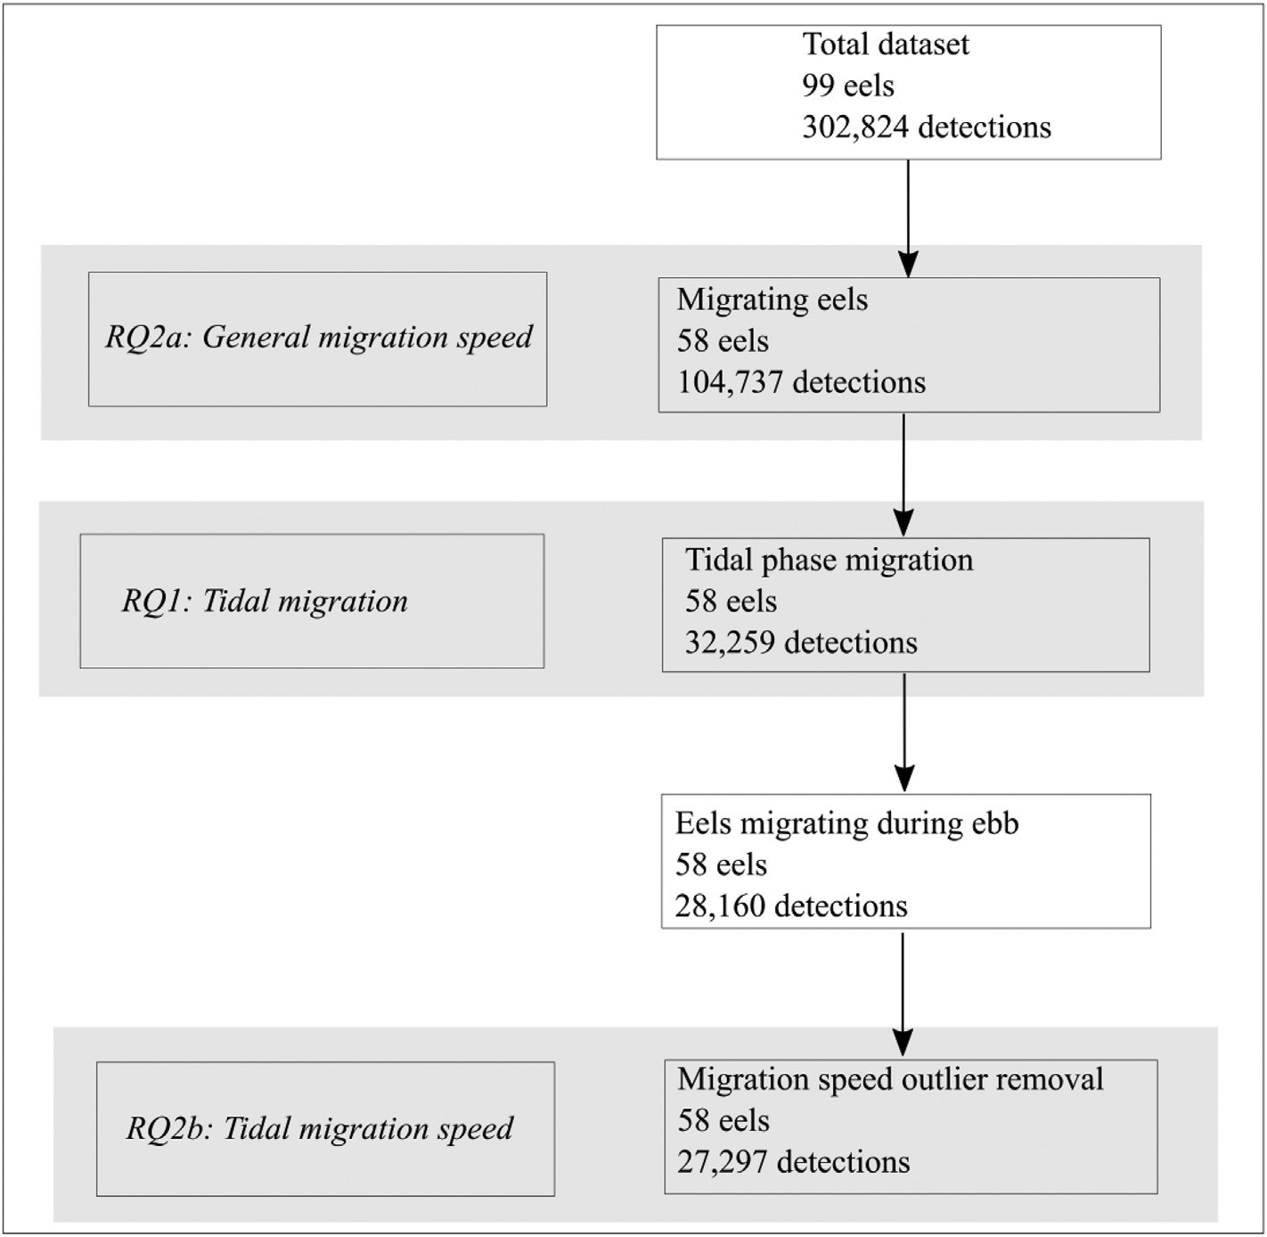Fig. 2. Illustration of the data selection ﬂow with the number of eels and detections taken into account for each research question (RQ) (indicated with a grey frame) (RQ1: Do migratory eels apply STST?; RQ2a: What is the general migration speed in both the whole Schelde Estuary and the Zeeschelde and Westerschelde?; RQ2b: What is the migration speed during ebb in the Zeeschelde and Westerschelde?).

resolution of our acoustic network. Movements occurring during dif- ferent tidal phases were removed from the dataset as this data could not resolve whether eels eﬀectively applied STST. This resulted in the re- moval of 72,378 detections; consequently, the remaining dataset con- tained 32,259 detections.
An eel was considered using STST if it moved downstream during ebb and showed no movement during ﬂood. Therefore, the migration distances for ebb and ﬂood were calculated per individual eel for each TMI. Consequently, eels were classiﬁed in two groups: those that ex- clusively migrated downstream during ebb TMIs (A) and those that showed downstream migration during ﬂood TMIs as well (B). For the latter group, the records were further divided in downstream migration occurrences during ebb (Be) and other, i.e. up- and downstream mi- gration occurrences during ﬂood (Bf). Note that Be and Bf refer to re- cords rather than to distinct individuals, and that a single eel thus yield records in both group Be and Bf. We applied a linear mixed eﬀects model (transmitter ID as a random eﬀect to account for autocorrelation) to test if group A (reference group) migrated over larger absolute dis- tances than groups Be and Bf (Zuur et al., 2009). We also added the dependent structure of the groups Be and Bf to the model as a random eﬀect by assigning each eel of both groups a unique identiﬁer. The nlme R package was used to conduct the linear mixed eﬀects model (R Development Core Team, 2017).

    - Migration speed
Migration speed was calculated in three diﬀerent ways. The ﬁrst two methods consider general migration speeds and used the dataset without TMI extraction (i.e. 104,737 detections) (Fig. 2). First, we calculated the general migration speed over the whole study area as the time needed to cross the distance between the ﬁrst and last detection. Second, general migration speeds were calculated for the ZS and WS separately for three reasons: (1) migration speeds may diﬀer between
up- and downstream parts of the estuary (Bultel et al., 2014), (2) the morphology of both systems diﬀers with the ZS being linear with one main channel and the WS having multiple channels, gullies and sand bars, and (3) the ALS networks in the ZS and WS each have a diﬀerent setup (single points relatively close to each other vs distant arrays, re- spectively). The general migration speeds in the ZS and WS were cal- culated as the time needed to cross the distance between the two most distant ALS in each subarea. Since the data did not follow a normal distribution, a non-parametric Kruskal-Wallis test was applied to test for a signiﬁcant diﬀerence in migration speed between the ZS and WS. Finally, the tidal migration speed was calculated as the time needed to complete the distances of the ebbing TMIs (i.e. group A and Be), again for the ZS and WS separately. The maximum reported migration speed found in literature was 1.93 m s−1 (Verbiest et al., 2012), consequently, speeds > 2 m s−1 were considered outliers and were removed from the dataset, resulting in a dataset of 27,297 detections (i.e. range outliers: 2.24–29.18 m s−1) (Fig. 2). These outliers were likely due to the de- tection ranges of the ALSs (up to 1 km), resulting in an overestimation of the migration speed. To test if the tidal migration speed diﬀered between the subareas, a linear mixed eﬀects model was applied with transmitter ID as a random eﬀect (Zuur et al., 2009); the nlme R package was used (R Development Core Team, 2017).

- Results

  - Tidal migration

Of the 58 tracked migratory eels, 37 migrated exclusively down- stream during ebb (group A), with an average ( ± SD) migration dis- tance of 6590 ± 5283.7 m (range: 147–20877 m) per ebbing interval (Fig. 3). All 21 remaining eels (group B) showed both downstream migration during ebb (group Be) and up- and downstream migration

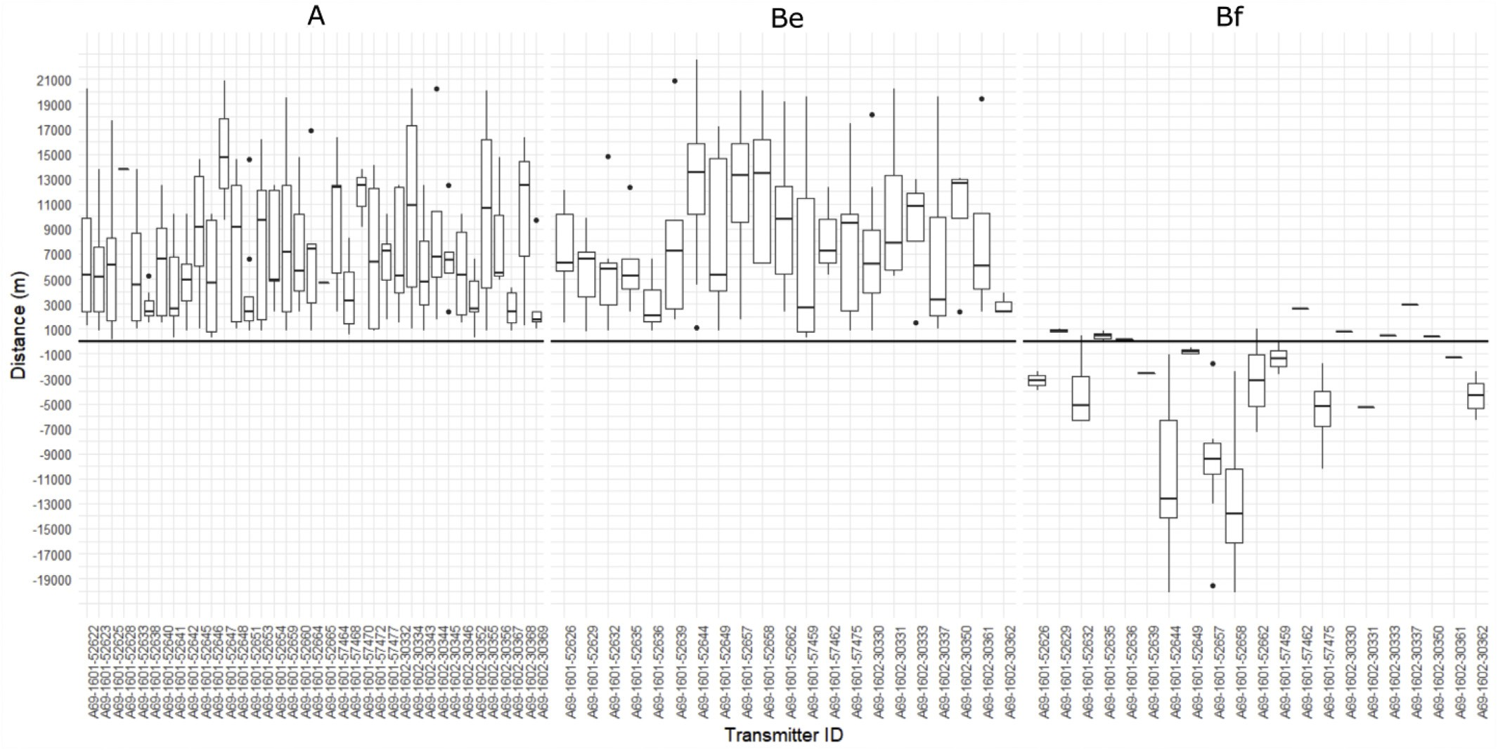

Fig. 3. Migration distances (positive downstream, negative upstream) per eel (Transmitter ID) and group. Group A represents eels migrating solely during ebb while eels of group B migrate both during ebb (group Be) and ﬂood (group Bf). The solid black line indicates the borderline between up- and downstream distance (i.e. distance zero).

Table 2
The output of the linear mixed eﬀects model comparing downstream migration distances of eels exclusively moving downstream during ebb (group A; the re- ference group) with migration distances of eels migrating up- and downstream during ﬂood as well (group B; showing both downstream migration during ebb (group Be) and up- and downstream migration during ﬂood (group Bf)). The values, standard errors (SE), degrees of freedom (DF), t-values and p-values are indicated.

Fixed eﬀects Value SE DF t-value p-value
- Discussion

  - Migration classiﬁcation and detection eﬃciency

It is important to point out that not all tagged eels migrated, probably because in many cases tagged eels were still immature (Bultel et al., 2014; Stein et al., 2015). The majority (n = 51) of the tagged eels were in the premigratory stage (i.e. FIII) and apparently did not develop into migratory silver eels (i.e. FIV and FV) during the study period. As

Intercept | 6796 | 508 | 441 | 13.37 | 1.79e-34 | such, 40 of the 58 migrating eels were silver eels (FIV (n = 15) and FV  (n = 25)) the moment of tagging. Yet, six FIV and three FV eels did not show migration behaviour. Other possible reasons why eels did not
Group Be | 1140 | 800 | 441 | 1.43 | 0.15
Group Bf | −769 | 901 | 441 | −0.85 | 0.39

during ﬂood (group Bf); the downstream migration during ebb of group Be was not signiﬁcantly diﬀerent from that of group A: 9503 ± 5672.1 m (range: 341–22528 m) (p > 0.05; Table 2). The
distances migrated during ﬂood of group Bf (−8860 ± 6098.0 m (range: 20069–2951 m)) did not diﬀer signiﬁcantly either from group A (p > 0.05; Table 2). Note that three and six of the Bf-eels exhibited upstream and downstream migration only once, respectively.

3.2. Migration speed

The average ( ± SD) general migration speed over the whole study area was 0.06 ± 0.07 m s−1 (range: 0.01–0.43 m s-1). Eels migrated on average eight times faster in the WS compared to the ZS (KW-test, χ2
(1) = 70.07, p < 0.05), with an average migration speed of
0.42 ± 0.21 m s−1 (range: 0.05–1.30 m s−1) in the WS and 0.05 ± 0.07 m s−1 (range: 0.01–0.40 m s−1) in the ZS (Fig. 4).
The average tidal migration speed did not diﬀer signiﬁcantly be- tween the ZS (0.93 ± 0.34 m s−1 (range: 0.08–1.87 m s−1)) and WS (0.95 ± 0.41 m s−1 (range: 0.04–1.64 m s−1)) (linear mixed eﬀects model, DF = 305, t-value = −0.50, p > 0.05) (Fig. 4).
show migration behaviour include predation, tag expulsion or post- operative mortality. For instance, Thorstad et al. (2013) observed tag expulsion of 12% of the tagged eels six months after tagging. However, no mortality occurred during their study. Eel migration was also not always continuous, despite the deﬁnition of Kennedy (1985). However, when eels migrated a net distance ≥20 km downstream during ≤40 days, they almost always proceeded within the same migration season. Three eels did not and migrated back upstream to the vicinity of their catch location, indicating homing behaviour (Parker, 1995) (Fig. S2). These eels recommenced their migration two (i.e. the following spring), ten and twelve (i.e. the following autumn) months later. The reason for their arrested migration is unclear and may be attributed to an in- suﬃcient body condition or a change in the environmental migration triggers (Elie et al., 2002; Stein et al., 2015; Svedäng and Wickström, 1997).
Not all eels were detected till the downstream end of the ZS in Antwerp or the arrays in the WS. Speciﬁcally, ﬁve eels (9%) were not detected in Antwerp and of the remaining 53 eels, ﬁve (9%) were not detected at WS3, 17 (29%) not at WS2, and 22 (38%) not at WS1. Eight eels were detected at WS3 and WS1, but not at WS2 and one eel was detected at WS2 and WS1, but not at WS3. Diﬀerent factors may explain why migrating eels were not detected over the whole ALS network downstream of their release location: migration arrest, mortality due to predation, disease or ﬁshing, or an undetected migration through the

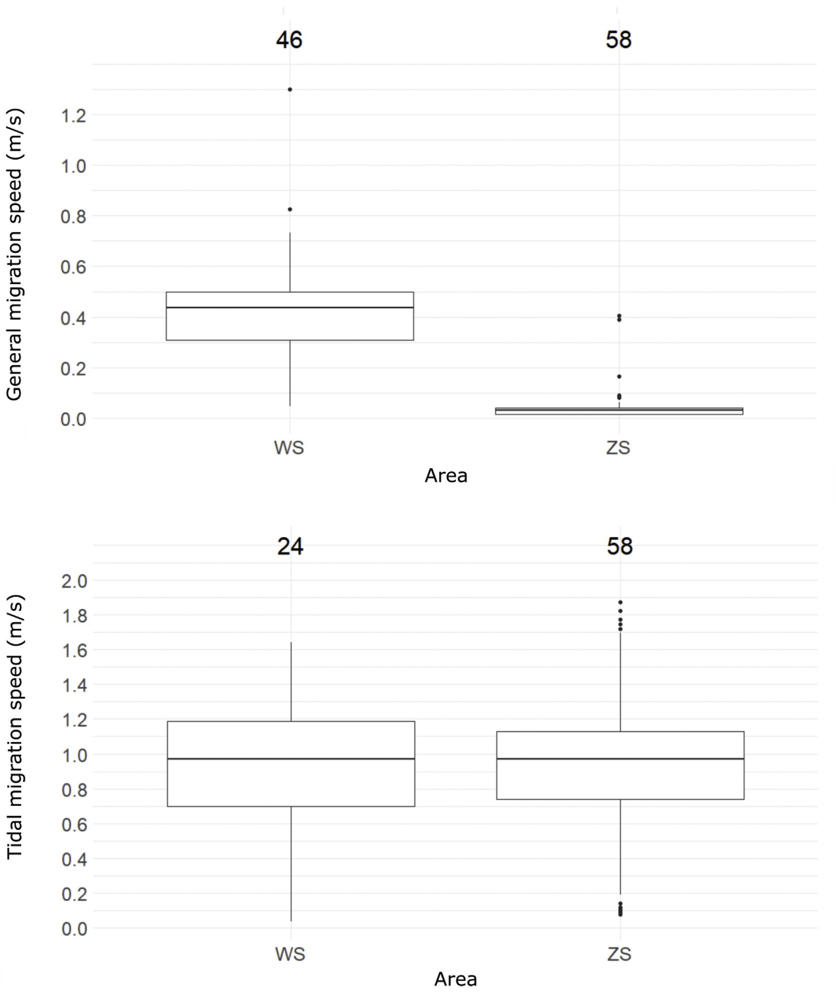

Fig. 4. Boxplots representing the general (top) and tidal migration speeds (bottom) of the eels for the Westerschelde (WS) and Zeeschelde (ZS). Numbers of eels taken into account are indicated above the boxplots. Note that due to calculation of the tidal movement intervals and outlier removal, 22 eels were not taken into account to calculate tidal migration speed (n = 24) in the WS compared to the general migration speed (n = 46).

three arrays in the WS as a consequence of, e.g., strong tidal currents, which can limit the detection range of the acoustic receivers (Reubens et al., 2018).

  - Tidal migration

This is the ﬁrst study to unambiguously illustrate that European silver eels use STST, since the majority of the tagged eels exclusively migrated downstream during ebb. Moreover, never before has STST been observed for a large number of silver eels of any eel species. Passive acoustic telemetry allowed tracking of a large number of in- dividuals for a long period of time and avoided potential biases from, e.g., a pursuing ship (i.e. disturbance of the environment), as was the
case in active tracking studies on American and European silver eels, where only a handful of eels could be tracked for a limited period (McCleave and Arnold, 1999; Tesch, 1992, 1994). Prior to tracking, these previous studies kept the eels in holding tanks or laboratories for several days, while eels in our study were released immediately upon catching and tagging. Hence, acoustic telemetry and the methodology described in this study are a promising tool to apply to other diadro- mous species as well.
We want to note that tidal phases, based on the measured water levels, do not always coincide with tidal currents as bottom friction and channel geometry can cause a phase shift between both (Van Rijn, 2010). Yet, previous studies analysing ﬁsh movement behaviour related to the tides did use water levels as well (Levy and Cadenhead, 1995;

Silva et al., 2017). Nonetheless, future research linking animal tracking data to hydrological models may reveal substantial insight in animal movement behaviour, but requires innovative development of model- ling and analysis tools.
Further, STST implies no movement during the inappropriate tide (McCleave and Arnold, 1999; Walker et al., 1978). Inherent to acoustic telemetry is the Eulerian nature of the data: ﬁxed stations detect moving objects with spatiotemporal irregularity (Bruneel et al., 2018; Merki and Laube, 2012). Consequently, we can mainly conclude on movement and seldom on stationary events in an acoustic network with such a broad-scale resolution, unless the network is divided in zones delineated by ALSs serving as checkpoints, where eels can be con- sidered resident if they did not pass a checkpoint (Trancart et al., 2018). High-resolution positioning systems with depth sensor tags may reveal additional insights, but could be constrained by logistics, spatial scale (such studies are often applied on a relatively small area) or the dy- namics of the estuary. Pop-up satellite tags or data storage tags, re- sulting in Lagrangian data with regular temporal animal positions (i.e. both movement and stationary behaviour), can therefore provide fur- ther complementary insight into STST behaviour (Metcalfe et al., 1990).
In this study, 37 eels migrated exclusively downstream during ebb- TMIs, while another 21 mainly did so. Consequently, the eels migrated substantially larger distances during ebbing tide compared to ﬂooding tide, indicating that they indeed used STST to migrate in an en- ergetically eﬃcient way through the estuary. This not only holds true for eels: salmonids and ﬂounder also show STST (Jager, 1999; Levy and Cadenhead, 1995; Moore et al., 1995; Stasko, 1975). Estuaries play an important role in the life cycle of diadromous ﬁsh. The gradual tran- sition from freshwater to the sea may be necessary to adapt to a wide range of salinities during their life cycle which accompanies physiolo- gical stress. Consequently, diadromous ﬁsh undergo gradual physiolo- gical changes (Arai, 2016; McCormick et al., 1998). When the transition is too abrupt, for example at a tidal sluice, this may have detrimental eﬀects on the ﬁtness of the ﬁsh. The canalization of rivers and espe- cially the construction of tidal sluices has strongly reduced and even eliminated estuaries with the accompanying tides. This results in in- accessibility of important habitat, delays near tidal borders, and dis- orientation behaviour when diadromous ﬁsh abruptly enter the marine environment (Limburg and Waldman, 2009; Verhelst et al., 2018a, 2018b).
STST also demonstrates that eels are able to distinguish the ebbing tide from the ﬂooding tide and hence do not solely rely on water ﬂow as a directional cue. It is plausible that silver eels detect speciﬁc cues in the ebbing tide, or that interactions between diﬀerent variables trigger the migration. Glass eels have a good perception of the earth's magnetic ﬁeld (Cresci et al., 2017), so it is possible that silver eels rely on such a system as well for orientation (Durif et al., 2013; Tesch, 1974). This illustrates the ﬂexibility of the species, especially since it is plausible that at least a part of the migrating eels grew up in the upper reaches of the river, not encountering tides during the largest part of their life. Nonetheless, we did observe movement during ﬂooding tide in 21 eels, the majority of which migrated with the ebbing tide for downstream migration. Various explanations for up- and downstream movement during ﬂood can be given, such as disorientation by the tide, predator avoidance, foraging behaviour due to insuﬃcient energy storage, or a change in environmental migration triggers. It is not sure if these eels will contribute to the spawning population, but it illustrates that STST can be interrupted or may not even be vital to migrate through systems with tidal dynamics.
Although these results indicate silver eels use the ebbing tide to migrate, in non-tidal systems such as rivers and polders, it has been shown that an increase in discharge is an important variable (Bruijs and Durif, 2009; Buysse et al., 2015; Travade et al., 2010; Verhelst et al., 2018b; Vøllestad et al., 1986). Consequently, in tidal systems where the river discharge is stronger than the tidal currents during moments of,
for instance, high rainfall, eels may use that increase in discharge to overcome ﬂood events. Yet, the Schelde Estuary is a strong tidal system where discharge never exceeds the tidal forces (www.waterinfo.be; UAntwerpen pers. comm.). Consequently, it is unlikely that eels mi- grated against the ﬂood due to a high discharge event.
The STST found in our study also followed temporal patterns in relation to the moon phase, circadian phase and tidal phase (Appendix). Downstream migration during ebbing tide mainly occurred around new and full moon, i.e. spring tide, and indicated that eels may time their downstream migration mostly during the periods with the strongest ebbing currents. Experimental studies found a relationship between eel migration and the moon phase (Boëtius, 1967; Edel, 1976; Hain, 1975; Tesch, 2003; Todd, 1981), but studies in a natural environment had hitherto failed to do so (Béguer-Pon et al., 2014; Vøllestad et al., 1986). A relationship of eel migration with the moon phase has previously been explained by the negative eﬀect of light on eel behaviour, sug- gesting that eels would be more active during new moon (Boëtius, 1967; Edel, 1976; Hain, 1975). Yet, we observed at least as many mi- gratory movements during full as during new moon, contradicting the idea that the lunar eﬀect merely relates to illumination (Hain, 1975). It may rather represent a tidal relationship, although we cannot exclude that direct illumination eﬀects would be obscured in our data as a result of other factors such as cloud cover (LaBar et al., 1987; McGovern and McCarthy, 1992) and/or the high turbidity (Bruijs and Durif, 2009) of the Schelde Estuary. Indeed, we found substantial migration during daytime while silver eels are primarily nocturnal, a behaviour likely attributed to predator avoidance (Aarestrup et al., 2010; Travade et al., 2010; Verhelst et al., 2018b; Westerberg et al., 2007). Further, the majority of the TMIs started between 12% and 36% of the time duration of the ebbing tide after high water (0%). Generally, the strongest water ﬂows are recorded during these moments of the tidal cycle (Meire et al., 2015). Speciﬁcally, during ebb, water ﬂow increases from high water till two hours after high water (ca. 0%–28% relative to the tidal cycle) and then gradually decreases till low water to abruptly stop. However, note that the start of a TMI may not exactly reﬂect the onset of an eel's migration during a tidal phase; it is rather the ﬁrst recording of an eel at an ALS, which does not exclude the possibility that the eel had started migrating at an earlier moment during the tidal phase.

  - Migration speed

Since eels mainly migrate during ebbing tide, a trade-oﬀ between migration speed (and consequently the timing of spawning) and energy expenditure may exist. Indeed, the general migration speed was rela- tively low (0.06 m s−1) and insuﬃcient to reach the spawning sites in time, given they need to swim over 6000 km and spawning peaks in February (Righton et al., 2016). However, eels tend to migrate faster as they move downstream the estuary. Bultel et al. (2014) found a higher migration speed in the lower parts of the Loire Estuary. Although we found that the tidal migration speeds in both the ZS (0.93 m s−1) and WS (0.95 m s−1) were similar during ebbing tide, overall migration speeds were considerably higher in the WS (0.42 m s−1 vs 0.05 m s−1 in the ZS). This indicates that eels migrate more consistently in the lower parts of the estuary and suggests that after a hesitant start of migration during which they may test for a suﬃcient body condition or en- vironmental triggers, eels may ﬁnally ‘decide’ to migrate out (Hain, 1975). A gradient of increasing marine cues may support the more consistent migration further downstream the estuary. Nonetheless, the general migration speeds found in the SE and the WS and ZS separately are in line with the speeds observed in the marine environment (0.03–0.54 m s−1) (Huisman et al., 2016; Righton et al., 2016). This result therefore supports the hypothesis of a mixed migration strategy as proposed by Righton et al. (2016): a part of the eel population reaches the spawning grounds only during the following season.
Notably, it is plausible that some of the outliers (tidal migration speeds > 2 m s−1) were approximately real tidal migration speeds

instead of outliers. Yet, further research with other techniques (i.e. with less spatial variation than the detection ranges of acoustic telemetry) can shed light on this topic.

  - Conclusion

The results of this study demonstrate that silver European eels use STST and underlines the importance of tides in eel migration. Hence, eels can make a distinction between ebbing and ﬂooding tide, in- dicating that cues other than currents play a role in orientation. Apparently, tides help eels to migrate in a bioenergetically eﬃcient way through estuaries, just like for other diadromous ﬁsh species such as salmonids and ﬂounder. Therefore, restauration of estuaries, for ex- ample via tidal barrier management (Mouton et al., 2011; Stuart and Mallen-Cooper, 1999), may not only aid recovery of the European eel population, but of diadromous ﬁsh species in general.

Acknowledgements

P. Verhelst holds a doctoral grant from the Flemish Agency for Innovation & Entrepreneurship (VLAIO), now under the auspices of the National Science Fund FWO. R. Baeyens, N. De Maerteleire, S. Franquet, E. Gelaude, T. Lanssens, S. Pieters, K. Robberechts, T. Saerens, R. van der Speld and Y. Verzelen assisted with the data col- lection. This manuscript has beneﬁtted from a statistical consult with the Ghent University FIRE service (Fostering Innovative Research based on Evidence). This work was supported by data and infrastructure provided by the INBO and VLIZ (RV Simon Stevin and RHIB Zeekat) as part of the Flemish contribution to the LifeWatch ESFRI observatory. We would also like to thank the Royal Belgian Institute of Natural Sciences, Operational Directorate Natural Environment (RHIB Tuimelaar) for infrastructure provision and Rijkswaterstaat (The Netherlands) for their cooperation and the permission to use their marine buoys.

.

References

Aarestrup, K., Thorstad, E.B., Koed, A., Svendsen, J.C., Jepsen, N., Pedersen, M.I., Økland, F., 2010. Survival and progression rates of large European silver eel Anguilla anguilla in late freshwater and early marine phases. Aquat. Biol. 9, 263–270.
Adam, G., Feunteun, E., Prouzet, P., Rigaud, C., 2008. L'anguille européenne: indicateurs d'abondance et de colonisation. Quae.
Arai, T., 2016. Biology and Ecology of Anguillid Eels. CRC Press.
Arnold, G., Walker, M.G., Emerson, L., Holford, B., 1994. Movements of cod (Gadus morhua L.) in relation to the tidal streams in the southern North Sea. ICES (Int. Counc. Explor. Sea) J. Mar. Sci. 51, 207–232.
Barbin, G.P., Parker, S.J., McCleave, J.D., 1998. Olfactory clues play a critical role in the estuarine migration of silver-phase American eels. Environ. Biol. Fish. 53, 283–291.
Barry, J., Newton, M., Dodd, J., Lucas, M., Boylan, P., Adams, C., 2016. Freshwater and coastal migration patterns in the silver‐stage eel Anguilla anguilla. J. Fish. Biol. 88, 676–689.
Beaulaton, L., Castelnaud, G., 2005. The eﬃciency of selective tidal stream transport in glass eel entering the Gironde (France). Bull. Fr. Peche Piscic. 5–21.
Béguer-Pon, M., Castonguay, M., Benchetrit, J., Hatin, D., Verreault, G., Mailhot, Y., Tremblay, V., Lefaivre, D., Legault, M., Stanley, D., 2014. Large-scale migration patterns of silver American eels from the St. Lawrence River to the Gulf of St. Lawrence using acoustic telemetry. Can. J. Fish. Aquat. Sci. 71, 1579–1592.
Berger, J., 2004. The last mile: how to sustain long-distance migration in mammals.
Conserv. Biol. 18, 320–331.
Bernatchez, L., Dodson, J.J., 1987. Relationship between bioenergetics and behavior in anadromous ﬁsh migrations. Can. J. Fish. Aquat. Sci. 44, 399–407.
Boëtius, J., 1967. Experimental indication of lunar activity in European silver eels,
Anguilla anguilla (L.). Meddr Danm. Fisk. og Havunders 6, 1–6.
Bruijs, M.C., Durif, C.M., 2009. Silver Eel Migration and Behaviour, Spawning Migration of the European Eel. pp. 65–95.
Bruneel, S., Gobeyn, S., Verhelst, P., Reubens, J., Moens, T., Goethals, P., 2018.
Implications of movement for species distribution models-Rethinking environmental data tools. Sci. Total Environ. 628, 893–905.
Bultel, E., Lasne, E., Acou, A., Guillaudeau, J., Bertier, C., Feunteun, E., 2014. Migration behaviour of silver eels (Anguilla anguilla) in a large estuary of Western Europe in- ferred from acoustic telemetry. Estuar. Coast Shelf Sci. 137, 23–31.
Buysse, D., Mouton, A., Baeyens, R., Coeck, J., 2015. Evaluation of downstream migration mitigation actions for eel at an Archimedes screw pump pumping station. Fish.
Manag. Ecol. 22, 286–294.
Cresci, A., Paris, C.B., Durif, C.M., Shema, S., Bjelland, R.M., Skiftesvik, A.B., Browman, H.I., 2017. Glass eels (Anguilla anguilla) have a magnetic compass linked to the tidal cycle. Science Advances 3, e1602007.
Crespi, B.J., Teo, R., 2002. Comparative phylogenetic analysis of the evolution of se- melparity and life history in salmonid ﬁshes. Evolution 56, 1008–1020.
Creutzberg, F., 1961. On the orientation of migrating elvers (Anguilla vulgaris Turt.) in a tidal area. Neth. J. Sea Res. 1 257IN1303IN3325-1302IN2324IN4338.
Dekker, W., Casselman, J.M., 2014. The 2003 Québec Declaration of Concern about eel declines—11 years later: are eels climbing back up the slippery slope? Fisheries 39, 613–614.
Dingle, H., 2006. Animal migration: is there a common migratory syndrome? J. Ornithol.
147, 212–220.
Dou, S.-Z., Tsukamoto, K., 2003. Observations on the nocturnal activity and feeding be- havior of Anguilla japonica glass eels under laboratory conditions. Environ. Biol. Fish. 67, 389–395.
Durif, C., Dufour, S., Elie, P., 2005. The silvering process of Anguilla anguilla: a new classiﬁcation from the yellow resident to the silver migrating stage. J. Fish. Biol. 66, 1025–1043.
Durif, C.M., Browman, H.I., Phillips, J.B., Skiftesvik, A.B., Vøllestad, L.A., Stockhausen, H.H., 2013. Magnetic compass orientation in the European eel. PLoS One 8, e59212. Edel, R., 1976. Activity rhythms of maturing American eels (Anguilla rostrata). Mar. Biol.
36, 283–289.
Elie, C.D.P., Gosset, C., Rives, J., Travade, F., 2002. Behavioral Study of Downstream Migrating Eels by Radio-telemetry at a Small Hydroelectric Power Plant.
Glebe, B., Leggett, W., 1981. Temporal, intra-population diﬀerences in energy allocation and use by American shad (Alosa sapidissima) during the spawning migration. Can. J. Fish. Aquat. Sci. 38, 795–805.
Hain, J., 1975. The behaviour of migratory eels, Anguilla rostrata, in response to current, salinity and lunar period. Helgoländer Wissenschaftliche Meeresuntersuchungen 27, 211–233.
Huisman, J., Verhelst, P., Deneudt, K., Goethals, P., Moens, T., Nagelkerke, L.A., Nolting, C., Reubens, J., Schollema, P.P., Winter, H.V., 2016. Heading south or north: novel insights on European silver eel Anguilla anguilla migration in the North Sea. Mar. Ecol. Prog. Ser. 554, 257–262.
Jacoby, D., Gollock, M., 2014. Anguilla anguilla. The IUCN Red List of Threatened Species. Version 2014.2. .
Jager, Z., 1999. Selective tidal stream transport of ﬂounder larvae (Platichthys ﬂesus L.) in the Dollard (Ems Estuary). Estuarine. Coastal and Shelf Science 49, 347–362.
Jellyman, D.J., 1979. Upstream migration of glass‐eels (Anguilla spp.) in the Waikato River. New Zealand Journal of Marine and Freshwater Research 13, 13–22.
Jonsson, N., Jonsson, B., Hansen, L., 1991. Energetic cost of spawning in male and female Atlantic salmon (Salmo salar L.). J. Fish. Biol. 39, 739–744.
Kennedy, J.S., 1985. Migration, behavioral and ecological. In: In: Rankin, M.A. (Ed.), Migration: Mechanisms and Adaptive Signiﬁcance. Contributions in Marine Science, vol. 27. pp. 5–27.
LaBar, G.W., Hernando Casal, J.A., Delgado, C.F., 1987. Local movements and population size of European eels, Anguilla anguilla, in a small lake in southwestern Spain.
Environ. Biol. Fish. 19, 111–117.
Levy, D.A., Cadenhead, A.D., 1995. Selective tidal stream transport of adult sockeye salmon (Oncorhynchus nerka) in the Fraser River Estuary. Can. J. Fish. Aquat. Sci. 52, 1–12.
Limburg, K.E., Waldman, J.R., 2009. Dramatic declines in North Atlantic diadromous
ﬁshes. Bioscience 59, 955–965.
Marshall, C.T., Yaragina, N.A., Lambert, Y., Kjesbu, O.S., 1999. Total lipid energy as a proxy for total egg production by ﬁsh stocks. Nature 402, 288–290.
McCleave, J., Arnold, G., 1999. Movements of yellow-and silver-phase European eels (Anguilla anguilla L.) tracked in the western North Sea. ICES (Int. Counc. Explor. Sea)
J. Mar. Sci.: Journal du Conseil 56, 510–536.
McCormick, S.D., Hansen, L.P., Quinn, T.P., Saunders, R.L., 1998. Movement, migration, and smolting of Atlantic salmon (Salmo salar). Can. J. Fish. Aquat. Sci. 55, 77–92.
McGovern, P., McCarthy, T., 1992. Local movements of freshwater eels (Anguilla anguilla L.) in western Ireland. In: Wildlife Telemetry: Remote Monitoring and Tracking of Animals, pp. 319.
Meire, D., Levy, Y., Vereecken, H., Plancke, Y., Deschamps, M., Verwaest, T., Mostaert, F., 2015. MONEOS, Metingen halftij-eb in de Beneden-Zeeschelde. Factual data rapport 2014. WL Rapporten. pp. 81.
Merki, M., Laube, P., 2012. Detecting reaction movement patterns in trajectory data, Avignon, France. In: Proceedings of the AGILE 2012 International Conference on Geographic Information Science, Pp. 25-27.
Metcalfe, J., Arnold, G., Webb, P., 1990. The energetics of migration by selective tidal stream transport: an analysis for plaice tracked in the southern North Sea. J. Mar. Biol. Assoc. U. K. 70, 149–162.
Moore, A., Potter, E., Milner, N., Bamber, S., 1995. The migratory behaviour of wild Atlantic salmon (Salmo salar) smolts in the estuary of the River Conwy, North Wales. Can. J. Fish. Aquat. Sci. 52, 1923–1935.
Mouton, A.M., Stevens, M., Van den Neucker, T., Buysse, D., Coeck, J., 2011. Adjusted barrier management to improve glass eel migration at an estuarine barrier. Mar. Ecol. Prog. Ser. 439, 213–222.
Parker, S., 1995. Homing ability and home range of yellow-phase American eels in a tidally dominated estuary. J. Mar. Biol. Assoc. U. K. 75, 127–140.

Parker, S.J., McCleave, J.D., 1997. Selective tidal stream transport by American eels during homing movements and estuarine migration. J. Mar. Biol. Assoc. U. K. 77, 871–889.
Piper, A.T., Manes, C., Siniscalchi, F., Marion, A., Wright, R.M., Kemp, P.S., 2015.
Response of seaward-migrating European eel (Anguilla anguilla) to manipulated ﬂow ﬁelds. In: Proceedings of the Royal Society B, P. 20151098.
R Development Core Team, 2017. R: a Language and Environment for Statistical Computing (Version 3.4.3). R Foundation for Statistical Computing, Vienna, Austria. http://www.R-project.org.
Reubens, J., Verhelst, P., van der Knaap, I., Deneudt, K., Moens, T., Hernandez, F., 2018. Environmental factors inﬂuence the detection probability in acoustic telemetry in a marine environment: results from a new setup. Hydrobiologia 1–14.
Righton, D., Westerberg, H., Feunteun, E., Økland, F., Gargan, P., Amilhat, E., Metcalfe, J., Lobon-Cervia, J., Sjöberg, N., Simon, J., 2016. Empirical observations of the spawning migration of European eels: the long and dangerous road to the Sargasso Sea. Science Advances 2, e1501694.
Seys, J., Vincx, M., Meire, P., 1999. Spatial Distribution of Oligochaetes (Clitellata) in the Tidal Freshwater and Brackish Parts of the Schelde Estuary (Belgium), Aquatic Oligochaetes. Springer, pp. 119–132.
Sheldon, M., McCleave, J., 1985. Abundance of glass eels of the American eel, Anguilla rostrata, in mid-channel and near shore during estuarine migration. Nat. Can. 112, 425–430.
Silva, S., Macaya-Solis, C., Lucas, M.C., 2017. Energetically eﬃcient behaviour may be common in biology, but it is not universal: a test of selective tidal stream transport in a poor swimmer. Mar. Ecol. Prog. Ser. 584, 161–174.
Stasko, A.B., 1975. Progress of migrating Atlantic salmon (Salmo salar) along an estuary, observed by ultrasonic tracking. J. Fish. Biol. 7, 329–338.
Stein, F., Doering-Arjes, P., Fladung, E., Brämick, U., Bendall, B., Schröder, B., 2015. Downstream migration of the European eel (Anguilla anguilla) in the Elbe river, Germany: movement patterns and the potential impact of environmental factors. River Res. Appl. 32, 666–676.
Stern, S.J., 2009. Migration and Movement Patterns, Encyclopedia of Marine Mammals, second ed. Elsevier, pp. 726–730.
Stuart, I., Mallen-Cooper, M., 1999. An assessment of the eﬀectiveness of a vertical-slot ﬁshway for non-salmonid ﬁsh at a tidal barrier on a large tropical/sub tropical river. Regul. Rivers Res. Manag. 15, 575–590.
Sugeha, H.Y., Arai, T., Miller, M.J., Limbong, D., Tsukamoto, K., 2001. Inshore migration of the tropical eels Anguilla spp. recruiting to the Poigar River estuary on north Sulawesi Island. Mar. Ecol. Prog. Ser. 221, 233–243.
Svedäng, H., Wickström, H., 1997. Low fat contents in female silver eels: indications of insuﬃcient energetic stores for migration and gonadal development. J. Fish. Biol. 50, 475–486.
Tesch, F.-W., 1974. Inﬂuence of geomagnetism and salinity on the directional choice of eels. Helgoländer wissenschaftliche Meeresuntersuchungen 26, 382.
Tesch, F.-W., 1992. Insigniﬁcance of tidal currents for silver eel migration as studied by eel tracking and current measurements. Ir. Fish. Investig. Ser. A (Freshw.) 36, 105–109.
Tesch, F., 1994. Verfolgung von Blankaalen in Weser und Elbe. Fischökologie 7, 47–59. Tesch, F., 2003. The Eel. Oxford, UK. .
Thorstad, E.B., Økland, F., Westerberg, H., Aarestrup, K., Metcalfe, J.D., 2013. Evaluation of surgical implantation of electronic tags in European eel and eﬀects of diﬀerent suture materials. Mar. Freshw. Res. 64, 324–331.
Todd, P.R., 1981. Timing and periodicity of migrating New Zealand freshwater eels (Anguilla spp.). New Zealand Journal of Marine and Freshwater Research 15, 225–235.
Trancart, T., Feunteun, E., Danet, V., Carpentier, A., Mazel, V., Charrier, F., Druet, M., Acou, A., 2018. Migration behaviour and escapement of European silver eels from a large lake and wetland system subject to water level management (Grand‐Lieu Lake, France): new insights from regulated acoustic telemetry data. Ecol. Freshw. Fish 27, 570–579.
Trancart, T., Lambert, P., Rochard, E., Daverat, F., Coustillas, J., Roqueplo, C., 2012.
Alternative ﬂood tide transport tactics in catadromous species: Anguilla anguilla, Liza ramada and Platichthys ﬂesus. Estuarine. Coastal and Shelf Science 99, 191–198.
Travade, F., Larinier, M., Subra, S., Gomes, P., De-Oliveira, E., 2010. Behaviour and passage of European silver eels (Anguilla anguilla) at a small hydropower plant during their downstream migration. Knowl. Manag. Aquat. Ecosyst. 01.
Van Rijn, L., 2010. Tidal phenomena in the scheldt estuary. Report, Deltares 105, 99.
Verbiest, H., Breukelaar, A., Ovidio, M., Philippart, J.C., Belpaire, C., 2012. Escapement success and patterns of downstream migration of female silver eel Anguilla anguilla in the River Meuse. Ecol. Freshw. Fish 21, 395–403.
Verhelst, P., Baeyens, R., Reubens, J., Benitez, J.-P., Coeck, J., Goethals, P., Ovidio, M., Vergeynst, J., Moens, T., Mouton, A., 2018a. European silver eel (Anguilla anguilla L.) migration behaviour in a highly regulated shipping canal. Fish. Res. 206, 176–184. Verhelst, P., Buysse, D., Reubens, J., Pauwels, I., Aelterman, B., Van Hoey, S., Goethals, P., Coeck, J., Moens, T., Mouton, A., 2018b. Downstream migration of European eel (Anguilla anguilla) in an anthropogenically regulated freshwater system: implications
for management. Fish. Res. 199, 252–262.
Verhelst, P., Reubens, J., Pauwels, I., Buysse, D., Aelterman, B., Hoey, S., Goethals, P., Moens, T., Coeck, J., Mouton, A., 2018c. Movement behaviour of large female yellow European eel (Anguilla anguilla L.) in a freshwater polder area. Ecol. Freshw. Fish 27, 471–480.
Vøllestad, L., Jonsson, B., Hvidsten, N., Naesje, T., Haraldstad, Ø., Ruud-Hansen, J., 1986.
Environmental factors regulating the seaward migration of European silver eels (Anguilla anguilla). Can. J. Fish. Aquat. Sci. 43, 1909–1916.
Walker, M.G., Jones, F.H., Arnold, G., 1978. The movements of plaice (Pleuronectes pla- tessa L.) tracked in the open sea. ICES (Int. Counc. Explor. Sea) J. Mar. Sci. 38, 58–86.
Walker, M.G., Riley, J., Emerson, L., 1980. On the movements of sole (Solea solea) and dogﬁsh (Scyliorhinus canicula) tracked oﬀ the East Anglian coast. Neth. J. Sea Res. 14, 66–77.
Weitkamp, L., Neely, K., 2002. Coho salmon (Oncorhynchus kisutch) ocean migration patterns: insight from marine coded-wire tag recoveries. Can. J. Fish. Aquat. Sci. 59, 1100–1115.
Westerberg, H., Lagenfelt, I., Svedäng, H., 2007. Silver eel migration behaviour in the Baltic. ICES (Int. Counc. Explor. Sea) J. Mar. Sci.: Journal du Conseil 64, 1457–1462.
Zuur, A., Ieno, E., Walker, N., Saveliev, A., Smith, G., 2009. In: Gail, M., Krickeberg, K., Samet, J.M., Tsiatis, A., Wong, W. (Eds.), Mixed Eﬀects Models and Extensions in Ecology with R. Spring Science and Business Media, New York, NY.

268

View publication stats

