Differential effects of dominant and subordinate plant species on the establishment success of target species in a grassland restoration experiment
Vania Torrez, Joachim Mergeay, Luc De Meester, Olivier Honnay & Kenny Helsen

Keywords
Community assembly; Competition; Niche modification; Niche preemption; Nutrient-poor conditions; Priority effects

Torrez, V. (corresponding author, torflorvania@gmail.com)1,
Mergeay, J. (joachim.mergeay@inbo.be)2, Meester, L.D. (luc.demeester@kuleuven.be)3, Honnay, O. (olivier.honnay@kuleuven.be)1, Helsen, K. (kenny.helsen@ntnu.no)1,4
1Department of Biology, Plant Conservation and Population Biology, University of Leuven, Kasteelpark Arenberg 31, 3001 Heverlee, Belgium;
2Research Institute for Nature and Forest
(INBO), Gaverstraat 4, 9500 Geraardsbergen, Belgium;
3Laboratory of Aquatic Ecology, Evolution and
Conservation, Department of Biology, University of Leuven, Charles Deberiotstraat 32, 3000 Leuven, Belgium;
4Department of Biology, Norwegian University
of Science and Technology, Høgskoleringen 5, 7034 Trondheim, Norway

Abstract
Questions: We investigated how the establishment of sown target species for ecological restoration is affected by the early introduction of either dominant or subordinate species during the assembly of a restored topsoil-stripped, nutrient- poor grassland. Do dominant or subordinate species exert different priority effects on either wanted target species or unwanted pioneer species? If priority effects are detected, are these exerted via niche preemption or niche modifica- tion mechanisms? Are the resulting patterns of species establishment related to differences in functional trait composition?
Location: Meerdaal forest, Oud-Heverlee, Belgium.
Methods: A 2-yr field experiment on a topsoil-stripped site of 8.5 ha was car- ried out. We manipulated the early arrival of dominant and subordinate species. The ‘dominant species’ set consisted of three generalist grass species, and the ‘sub- ordinate species’ set consisted of nine species of forbs and graminoids that often occur in nutrient-poor grasslands. After 4 wk, we sowed nine target species for ecological restoration. We recorded plant species cover during 2 yr. We used repeated measures ANOVA to test for effects of time (2013, 2014) and treatment (dominant, subordinate and control) on plant species richness, evenness, cover, functional diversity and species and trait composition dissimilarity.
Results: Both dominant and subordinate species successfully suppressed unde- sirable early colonizing species. Dominants did not exert priority effects on target species. However, subordinate species exerted strong priority effects via niche preemption, and suppressed their establishment of target species.
Conclusions: Manipulating the arrival order of dominant species has potential as a restoration tool that can allow restoration practitioners to enhance the establishment success of target species for restoration. We suggest that seed mix- tures for restoration should contain dominant species, because they will not affect the establishment of subordinate (target) species, but will impede the establishment of unwanted pioneer and ruderal species. We also demonstrate that implementing trait-based measures in restoration projects can help to adequately predict assembly processes.

Introduction
Plant community assembly has often been considered to be deterministic at the species level, with habitat filtering and competitive exclusion among species of the regional species pool primarily driving the community assembly process, thus resulting in predictable and fixed assembly end states (Clements 1916; Weiher & Keddy 1999).

Although evidence is increasing that deterministic com- munity assembly rarely occurs at the species level, deter- ministic assembly has been argued to likely predominate at the functional trait level (Kahmen & Poschlod 2004; Fukami et al. 2005). Indeed, both habitat filtering and competitive exclusion are expected to be driven by niche- based processes. Since functional traits are features (mor- phological, physiological or phenological) that represent

ecological strategies (Perez-Harguindeguy et al. 2013), they are by definition closely linked to a species’ niche.
Alternatively, the community assembly process has been proposed to be historically contingent (Gleason 1927; Diamond 1975), with species composition diverg- ing among communities that experience similar envi- ronmental conditions, even when sharing the same regional species pool (Drake 1990; Law & Morton 1993). Such historical contingency has especially been observed at the species level, with the species composi- tion being determined by multiple factors such as land- use legacies, priority effects, historical landscape effects and inter-annual variation in biotic and abiotic condi- tions (Brudvig 2011). Recently, much attention has been given to the influence of priority effects on com- munity assembly and restoration outcome (Brudvig 2011; Fukami 2015). Priority effects occur when one or more early arriving species affect the establishment, growth, reproduction or abundance of later arriving species through niche preemption or niche modification effects (Fukami et al. 2005; Fukami 2015). Niche pre- emption occurs when early and later arriving species have overlapping niches, and thus resource use (Harper 1961). In this scenario, the early arriving species reduces the amount of available resources, thus nega- tively impacting the later arriving species (Fargione et al. 2003). For niche preemption to occur, early and late arriving species should be competitively similar. When competitive abilities differ strongly, the most competitive species can dominate, regardless of arrival order (Chase 2003; Fukami 2015). Niche modification, on the other hand, occurs when early arriving species modify the environment, thus affecting species occupy- ing unrelated niches. The impact of niche modification can be inhibitory or facilitative (Fukami 2015). Niche preemption is often expected to predominate as the main cause of contingent community assembly, thus explaining the often-observed deterministic trait level assembly. Niche modification effects, however, might nonetheless result in less predictable changes during assembly, even at the trait level (Fukami 2015).
The above-described theoretical background is of high relevance in ecological restoration practices where target plant species are actively introduced through sowing. Indeed, here potentially undesirable consequences of pri- ority effects may impede restoration success and result in undesirable end states (Grman & Suding 2010). On top- stripped soils, which are the common starting point in the restoration of degraded nutrient-poor grasslands (e.g. Tor- rez et al. 2016), regionally abundant non-target species may colonize the habitat patch before target species do, thereby inhibiting establishment of the latter (Dobson et al. 1997; Bakker & Berendse 1999; Kiehl et al. 2010).
However, the early arrival of these undesirable species can- not be easily controlled in open areas. In order to avoid pri- ority effects exerted by such undesirable early colonizing species, early sowing of desirable species might overcome this problem. In this study we wanted to investigate whether the sowing of either species that can rapidly grow and reach high cover (hereafter called ‘dominant species’) and species that rather remain at lower densities (hereafter called ‘subordinate species’) differentially affects target spe- cies establishment. Target species for ecological restoration are typically subordinates. They contribute considerably less to primary production, and occupy restricted micro- habitats that are delimited by the architecture and phenol- ogy of their associated dominants (Grime 1998). Such species have also been referred to as fugitive (Platt & Weis 1985), interstitial (Keddy et al. 1994), minor (Walker et al. 1999) or redundant (Rastetter & Shaver 1996). Apart from their clear differences in relative abundance and cover, dominant and subordinate species also differ in morphol- ogy and plant functional traits. This likely results in priority effects on both unwanted pioneer species and wanted tar- get species (Grime 1998; Peltzer et al. 2009; Doherty et al. 2011; Mariotte et al. 2013). For example, dominant spe- cies might be expected to constrain species establishment success and diversity (Baer et al. 2004; McCain et al. 2010), either through niche modification due to their fast growth, resulting in severe light reduction for later arriving pioneer species or subordinates, or through direct competi- tive exclusion. Subordinates species, on the other hand, can be expected to strongly affect target species that occupy the same niche, through niche preemption (Tilman 1994; Amarasekare 2003).
Here, we investigated how the establishment of sown target species for ecological restoration is affected by the early introduction of either dominant or subordinate spe- cies during the first 2 yr of the assembly of a restored top- soil-stripped, nutrient-poor grassland. We applied two treatments with different initial sown species sets: a ‘domi- nant species’ treatment and ‘subordinate species’ treatment, and the control treatment without initial sowing. Next, we evaluated richness and composition of the plot at the spe- cies and the functional trait level, both in terms of the introduced target species and all species present. We were especially interested in whether dominant vs subordinate species exert different priority effects on the wanted target species, and in making inferences regarding the domi- nance of niche preemption or niche modification mecha- nisms. Furthermore, we were interested in whether both treatments resulted in competitive suppression of unwanted pioneer species. Finally, we also wanted to find out whether the resulting patterns of species establish- ment could be related to differences in functional trait composition.

Methods
Site description
We conducted a 2-yr field experiment on a former military domain (ca 8.5 ha) in a heathland clearing of the Meerdaal forest, south of Leuven (Belgium). Meerdaal forest is a mixed deciduous forest mainly consisting of Fagus sylvatica, Quercus robur and planted Pinus sylvestris stands. The under- storey is dominated by Calluna vulgaris, Molinia caerulea, Pteridium aquilinum and Vaccinium myrtillus. Military build- ings, roads, shrubs and trees were removed for nutrient- poor grassland restoration purposes. In addition, the top- soil was removed down to the mineral soil (to a depth of 10 cm) in Jan 2011, resulting in a strongly reduced, to potentially absent, seed bank. However, scattered patches of well-developed grassland communities were left to allow spontaneous secondary succession on the open soil. These patches contain the original vegetation with charac- teristic and regionally endangered species of nutrient-poor grasslands and grassy heathlands such as Campanula rotun- difolia, Polygala serpyllifolia and Thymus pulegioides.

Experimental design
The effect of differential species arrival on community assembly was tested by step-wise sowing of different com- binations of plant species typical of nutrient-poor grass- lands. More specifically, two initial seed addition treatments were imposed: the ‘dominant species’ treatment and ‘subordinate species’ treatment, together with a control treatment where no initial species were sown. The ‘domi- nant species’ set consisted of three generalist grass species that naturally occur in these grasslands. In nutrient- enriched soils, these species generally tend to monopolize the area and are strong competitors (Jacques 1974; Taylor
et al. 2001; Damgaard et al. 2009): Deschampsia flexuosa, Holcus lanatus and Molinia caerulea. The ‘subordinate species’ set consisted of nine species of forbs and grasses that often occur in nutrient-poor grasslands and grassy heathlands. These species do not monopolize habitats (Peeters 2004): Achillea millefolium, Agrostis capillaris, Anthoxanthum odora- tum, Festuca rubra, Hieracium umbellatum, Hypericum perfora- tum, Hypochaeris radicata, Rumex acetosella and Teucrium scorodonia. The species of both sets where chosen from the regional species pool, based on a combination of local abundance data in the study area and expert’s knowledge (Luyten 2002).
In Feb 2013, we set up the experiment with ten repli- cates per treatment. Thirty plots of 1 m2 were installed in an area of 30 m 9 12 m. Both the ‘dominant species’ and ‘subordinate species’ treatment consisted of sowing three species of the respective species set in each plot. This resulted in ten different triplets for the ‘subordinate species’ plots through constrained random sampling such that all triplets contained at least one grass species (Appendix S1). Since the ‘dominant species’ set contained only three species,
the same triplet was sown in the ten plots. For each species of the triplets 0.18 g of seeds were sown for reasons of standardization. After 4 wk, we sowed nine target species for ecological restoration in the three treatments: Calluna vulgaris, Festuca filiformis, Luzula campestris, Nardus stricta, Potentilla erecta, Solidago virgaurea, Stachys officinalis, Succisa pratensis and Veronica officinalis. These species are consid- ered specialists of nutrient-poor grasslands and grassy heathlands, and are also subordinate species (Fig. 1). We took care to always sow similar ratios of graminoid species vs forbs for both the subordinate and the target communities.
Natural colonization of external species was allowed in all plots. These non-sown species present in the plots are further referred to as external immigrant species, and most of

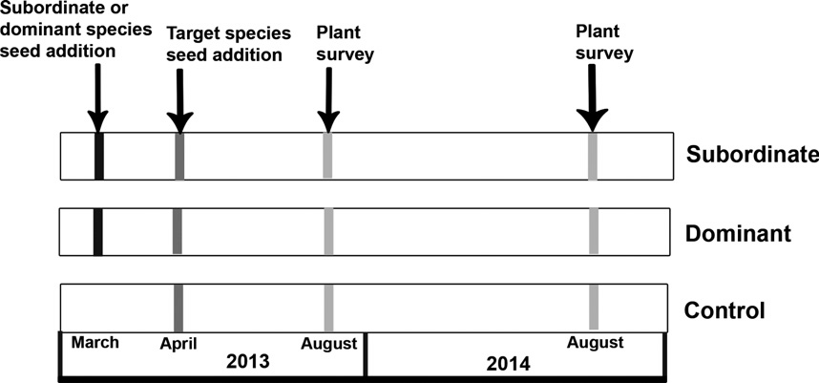

Fig. 1. Schematic representation of the study design to evaluate whether the sowing of either dominant species or subordinate species differentially affects target species. Vertical arrows indicate the time when seeds of dominant, subordinate and target species were added; and when plant surveys were performed.

these were pioneer species, which were abundant in the regional species pool.

Data collection
Species occurrence and abundance (% cover) of all plant species were recorded in all 30 plots once per year in Aug 2013 and 2014. Fifteen functional plant traits were com- piled for all observed species (54 species in total). The traits were chosen on their relevance for plant growth, repro- duction, dispersal and competitive ability (establishment and persistence). Trait values were obtained from BIOL- FLOR (Klotz et al. 2002), LEDA (Kleyer et al. 2008) and the Ecological Flora Database (Fitter & Peat 1994). Trait information was available for at least 76.4% of all species for each trait (Table 1).

Data analyses
To assess species diversity (a-diversity) between treat- ments, we calculated the species richness (S), Pielou even- ness (E) and total plant cover per plot for (1) all species, (2) target species and (3) external immigrant species. To evalu- ate the effect of initial sowing treatment on all measures of species diversity, we performed full-factorial repeated- measures ANOVAs (RM-ANOVA) for each measure of spe- cies diversity including treatment (dominant, subordinate, control) and time (2013, 2014) as factors. Post-hoc com- parisons were performed with Tukey’s HSD tests.
To examine the effect of the early introduction of either dominant or subordinate species on the functional diver- sity (FD), we calculated three different FD measures: (1) community-based functional diversity (FDc; Petchey &
Gaston 2006), (2) weighted FDc (wFDc; Casanoves et al. 2011) and (3) quadratic entropy (RAO; Rao 1982). These three FD measures were calculated for (1) all species, (2) target species and (3) external immigrant species. All mea- sures of FD were used as response variables in similar RM- ANOVAs and Tukey HDS tests, as those described for spe- cies diversity. Before FD calculations, nominal traits were recoded as dummy variables and ordinal and continuous traits were standardized. Furthermore, missing trait values were replaced with the CWM for the given trait in the given plot (see below; D,ıaz et al. 2007).
Most FD measures are known as highly correlated with species richness (Mouchet et al. 2010; Cadotte et al. 2011). To disentangle the effects of treatment from the effects of species richness on FD, we performed simple lin- ear regressions between the three measures of FD and spe- cies richness. These linear regressions were conducted separately for the FD values of all species, target species and external immigrant species. Afterwards, the residuals of these regressions were used as response variables in RM-ANOVAs (Helsen et al. 2014) analogous to those previously described.
To analyse how the species composition and the func- tional trait composition were affected by the early intro- duction of either dominant or subordinate species, we calculated the Bray-Curtis dissimilarities in species compo- sition between plots for each year separately (1) within treatments and (2) among treatments using the plot 9 species abundance matrices (b-diversity). Similarly, Bray-Curtis dissimilarities in functional trait composition were derived from CWM between plots for each year sepa- rately. Trait dissimilarities were also calculated among treatments and within treatments. CWMs were calculated

Table 1. Overview of plant traits used in analyses of functional trait diversity and community-weighted mean traits.

Trait Type of Variable Availability (%)
Woodiness Binary (0 = non, 1 = yes) 100
Growth Form Nominal (1 = Phanerophyte, 2 = Chamaephyte, 3 = Hemicryptophyte, 4 = Therophyte) 100
Life Span Ordinal (1 = annual, 2 = biannual, 3 = perennial < 5 yr, 4 = perennial > 5 yr) 100
Flowering Start Ordinal, month in which flowering begins 100
Flowering Time Ordinal, age at which the first flowering occurs (in yr) 100
Growth Height Continuous (m) 100
Rosette Nominal (1 = rosette, 2 = semi-rosette, 3 = leaves regularly distributed along the stem) 100
Seed Length Continuous (mm) 100
Seed Weight Continuous (mg) 98.2
Specific Leaf Area Continuous (mm2/mg) 98.2
Pollen Vector Nominal (1 = insects, 2 = selfing, 3 = wind) 100
Mycorrhizal Type Nominal (1 = arbuscular, 2 = ecto, 3 = ericoid) 100
Ellenberg Indicator: Nitrogen Ordinal, ranging from 1 (plants of nutrient-poor soils) to 9 (plants of nutrient rich soils) 76.4
Ellenberg Indicator: Light Ordinal, ranging from 1 (plants of deep shade) to 9 (plants of full sun) 81.8

Compatibility System Nominal (1 = self-compatible, 2 = ± self-compatible, 3 = ± self-incompatible,
4 = self-incompatible)
100

per plot for each individual functional trait as the average trait value weighted by the abundances of species with the respective trait value (D,ıaz et al. 2007). CWMs were standardized before calculating Bray-Curtis dissimilarities. RM-ANOVAs with treatment and time as factors were con- ducted on within-treatment Bray-Curtis species and trait dissimilarities. Among treatment Bray-Curtis species and trait dissimilarities were also analysed with RM-ANOVAs, with the treatment factor consisting of three groups (control/dominant, control/subordinate, dominant/subor- dinate). All analyses on Bray-Curtis dissimilarities were performed for all species, for target species and for external immigrant species separately, with post-hoc comparisons performed with Tukey’s HSD tests.
The R-package vegan was used to calculate the species richness, evenness and Bray-Curtis dissimilarities in R
3.0.2 (R Foundation for Statistical Computing, Vienna,
AT). Functional diversity and CWMs were computed with FDiversity (Casanoves et al. 2011). Repeated measures ANOVAs and Tukey’s HSD tests were performed with SPSS (v 22; SPSS, Chicago, IL, US).

Results
Species diversity
Whereas overall species richness and evenness were con- stant through time (Table 2, Figs 2a and 3a), cover signifi- cantly increased (Table 2, Fig. 2b). The treatments had a significant effect on total cover and overall evenness, but not on overall species richness. More specifically, the sub- ordinate treatment had higher total cover, but lower over- all evenness compared to the other two treatments (Figs 2b and 3a). For target species, the overall species rich- ness, evenness and cover increased over time (Table 2,

Table 2. F-values of full-factorial repeated measures ANOVAs testing for the effects of time, treatment (Treat) and their interaction (Ti 9 Tr) on species richness (S), cover, Pielou evenness (E), Quadratic entropy of Rao (RAO), community based functional diversity (FDc), weighted FDc (wFDc), RAO corrected for species richness (cRAO), FDc corrected for species richness (cFDc), wFDc corrected for species richness (cwFDc).

All Target External Immigrants

 | Time | Treat | Ti 9 Tr |  | Time | Treat | Ti 9 Tr |  | Time | Treat | Ti 9 Tr
S | 1.2 | 1.7 | 2.1 |  | 23.3*** | 3.6* | 0.01 |  | 13.2*** | 8.6*** | 4.8*
Cover | 31.3*** | 4.9** | 1.1 |  | 42.2*** | 1.9 | 0.06 |  | 8.4** | 24.5*** | 2.3
E | <0.001 | 10.6*** | 2.2 |  | 4.675* | 7.5** | 3.01 |  | 11.7** | 0.9 | 2.1
RAO | 51.4*** | 0.5 | 1.4 |  | 0.5 | 0.2 | 0.1 |  | 0.3 | 0.1 | 0.7
FDc | 1.3 | 1.03 | 1.8 |  | 19.3*** | 4.4* | 0.03 |  | 6.1* | 1.2 | 2.2
wFDc | 2.1 | 0.8 | 1.5 |  | 11.9** | 1.9 | 0.04 |  | 16.8*** | 0.3 | 0.1
cRAO | 51.9*** | 0.5 | 1.4 |  | 3.3 | 0.1 | 0.1 |  | 0.001 | 0.4 | 1.5
cFDc | 0.2 | 2.2 | 1.7 |  | 1.1 | 1.5 | 0.1 |  | 0.4 | 2.6 | 0.9
cwFDc | 10.5** | 0.2 | 2.3 |  | <0.001 | 0.7 | 0.1 |  | 9.6** | 4.1* | 1.9
***P < 0.001; **P < 0.01; *P < 0.05.

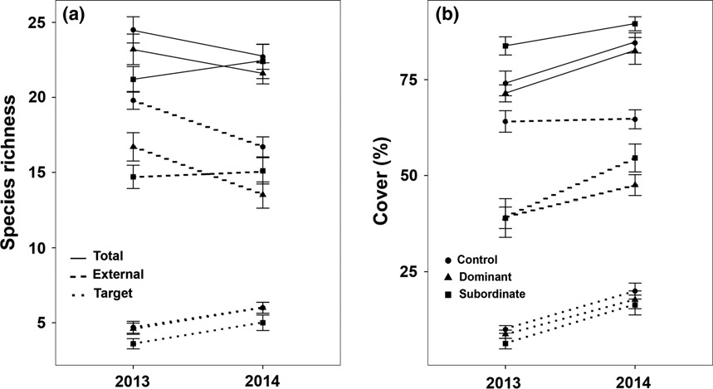

Fig. 2. Changes in (a) species richness and (b) cover through time, for all species (total), external immigrants and target species separately. Time effects given for each treatment separately (control, dominant and subordinate). Values are means ± 1 SE.

Figs 2a,b and 3b). The treatments significantly affected tar- get species richness and evenness, with lower target species richness and evenness in the subordinate treatment (Figs 2a and 3b). For external immigrant species, the spe- cies richness and evenness decreased, while cover increased over time (Table 2, Figs 2a,b and 3c). The effect of treatment was significant on external immigrant species richness and cover, but not on evenness (Table 2). The control treatment had higher species richness and cover of external immigrants compared to the other treatments (Fig. 2a,b, respectively). While species richness levels of external immigrants decreased through time for the con- trol and dominant treatments, it slightly increased for the subordinate treatment (significant interaction term; Table 2, Fig. 2a).

Functional diversity
In the analysis of all species, RAO significantly increased through time, even after species richness
correction (Table 2). Although FDc and wFDc were constant through time, after correction for species rich- ness, wFDc increased in time. None of the functional diversity measures for all species were affected by the treatments. The functional diversity of target species (FDc and wFDc) significantly increased in time but once corrected for species richness, the time effect was no longer significant (Table 2). The FDc of target spe- cies was furthermore significantly affected by the treat- ments, with significantly lower FDc in the subordinate treatment compared to the other treatments (Table 2, Fig. 4a). The functional diversity of external immi- grants (FDc and wFDc) significantly decreased through time, a pattern that remained significant after correc- tion for species richness for wFDc, but not for FDc (Table 2). The treatment effect was only significant when wFDc was corrected for species richness (Table 2); the dominant and subordinate treatments had significantly higher values of wFDc corrected for species richness than the control treatment (Fig. 4b).

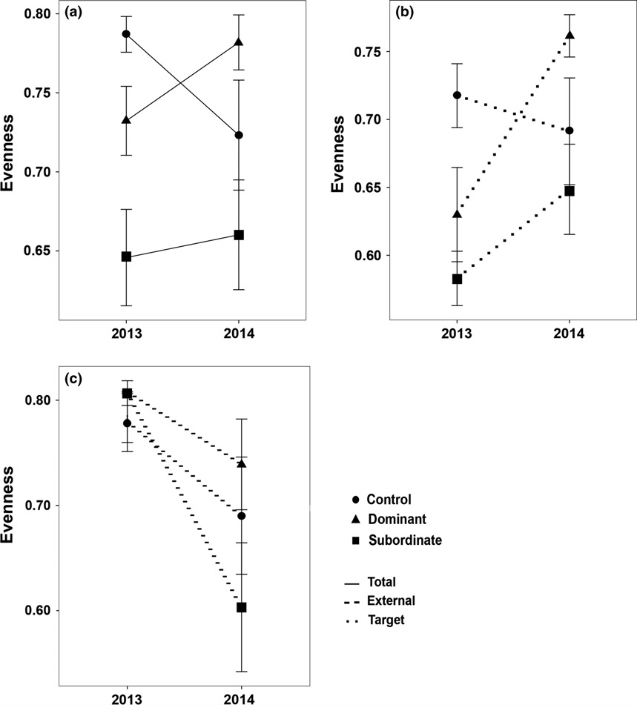

Fig. 3. Changes in evenness through time for (a) all species (total), (b) target species and (c) external immigrant species separately. Time effects given for each treatment separately (control, dominant and subordinate). Values are means ± 1 SE.

Community dissimilarity in species and functional trait composition
Community dissimilarities in species and functional trait composition within and among treatments decreased through time when considering all species (Table 3, Figs 5a,b and 6a,b). Within-treatment dissimilarities of species and functional trait composition were significantly higher for the subordinate treatment compared to the other treatments (Fig. 5a,b). Among treatments, dissimi- larities of species and functional trait composition were sig- nificantly lower between the dominant and control treatments than between the other treatments, suggesting that the subordinate treatment was more dissimilar in both species and trait composition from the other two treat- ments (Fig. 6a,b).
Community dissimilarities of target species in functional trait and species composition within and among treat- ments decreased through time (Table 3, Figs 5c,d and 6c,
d). Community dissimilarities of target species in species composition within and among treatments were further- more significantly higher in the subordinate treatment (Figs 5c and 6c, respectively). Community dissimilarities of target species in trait composition within and among treatments were not significantly affected by treatments (Table 3).
Community dissimilarities of external immigrants in species composition within and among treatments decreased through time (Table 3, Figs 5e and 6e, respectively). However, the community dissimilarity of external immigrants in functional trait composition within and among treatments increased through time (Figs 5f and 6f, respectively). The treatments did not affect among- and within-species dissimilarities, but did nonetheless affect among- and within-trait dissimilari- ties of external immigrants (Table 3). Within-treatment trait dissimilarities of external immigrant species were significantly higher in the dominant and subordinate

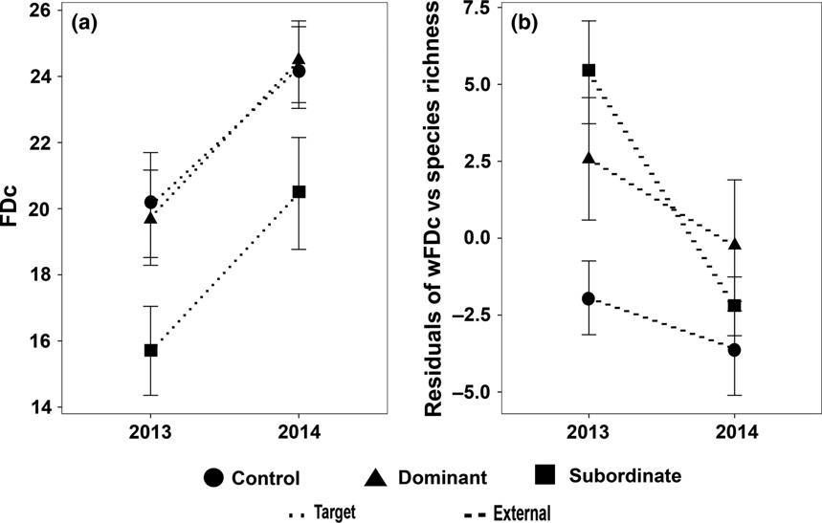

Fig. 4. Changes in (a) community-based functional diversity (FDc) of target species and (b) weighted FDc (wFDc) corrected for species richness of external immigrants through time. Time effects given for each treatment separately (control, dominant and subordinate). Values are means ± 1 SE.

Table 3. F values of full-factorial repeated measures ANOVAs testing for the effects of time, treatment (Treat) and their interaction (Ti 9 Tr) on among and within Bray-Curtis dissimilarities in species and functional trait (CWM) composition.

All Target External Immigrants

 | Time | Treat | Ti 9 Tr |  | Time | Treat | Ti 9 Tr |  | Time | Treat | Ti 9 Tr
Species  Within | 11.2*** | 40.5*** | 13.9*** |  | 3.6 | 3.8* | 0.8 |  | 15.1*** | 1.9 | 3.5*
Among | 94.9*** | 155.7*** | 0.9 |  | 7.4** | 2.6 | 0.3 |  | 27.7*** | 0.8 | 0.2
Trait
Within | 13.2*** | 30.8*** | 2.6 |  | 7.01** | 0.9 | 0.3 |  | 7.4** | 4.3* | 0.2
Among | 127.1*** | 45.6*** | 6.4** |  | 9.4** | 0.3 | 0.3 |  | 11.3*** | 4.04* | 0.2
***P < 0.001; **P < 0.01; *P < 0.05.

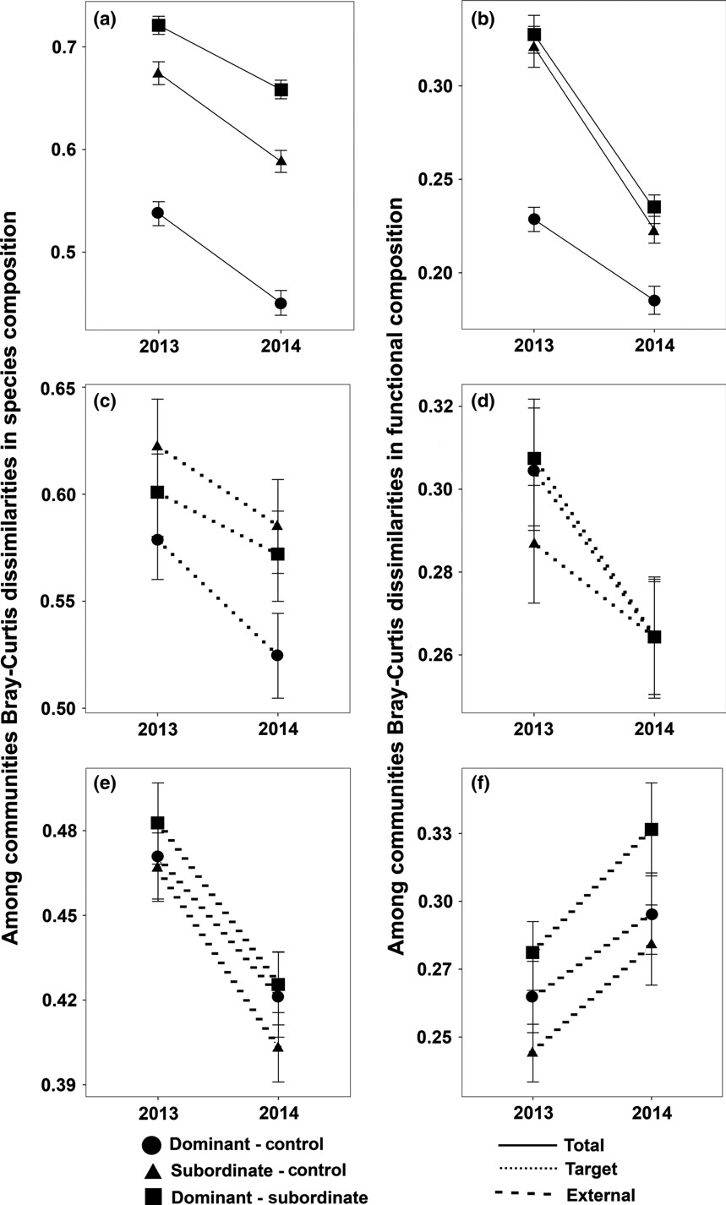

Fig. 5. Changes in within-community dissimilarities in species (a, c, e) and functional (b, d, f) composition through time for (a, b) all species, (c, d) target species and (e, f) external immigrant species. Time effects given for each treatment separately (control, dominant and subordinate). Values are means ± 1 SE.

treatments than in control treatment (Fig. 5f). Among treatments trait dissimilarities of external immigrant species were significantly higher between the dominant and subordinate treatment compared to among the other treatments (Fig. 6f).

Discussion
Species level
We evaluated the occurrence of potential priority effects effectuated by dominant and subordinate species on the

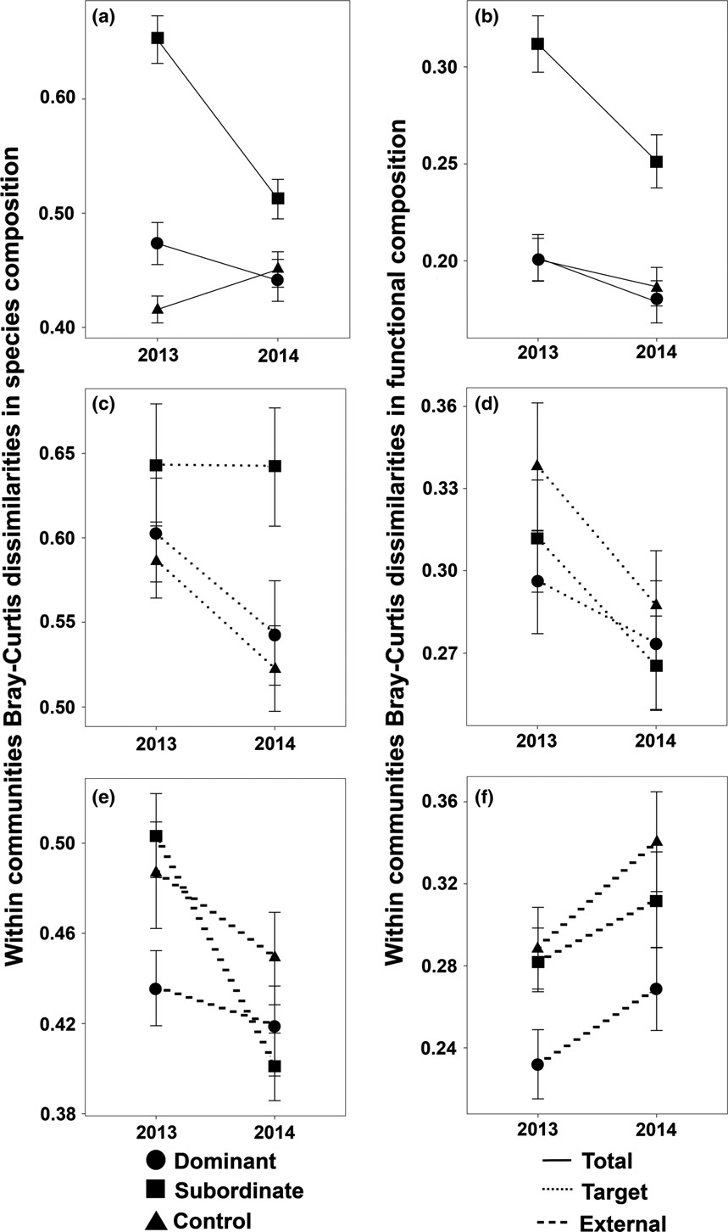

Fig. 6. Changes in among-community dissimilarities in species (a, c, e) and functional (b, d, f) composition through time for (a, b) all species, (c, d) target species and (e, f) external immigrant species. Time effects given for each treatment separately (control, dominant and subordinate). Values are means ± 1 SE.

establishment success of target species and external immi- grant species after 2 yr. We found that neither dominant nor subordinate species affected total species richness. These results are in accordance with previous priority effect experiments on nutrient-poor soils (Kardol et al.
2013; Plu€ckers et al. 2013). Also, it has been proposed that once spontaneous colonization is allowed, plant communi- ties tend to reach equilibrium in species richness indepen- dently of the initial richness levels (Pfisterer et al. 2004; Fukami et al. 2005; Cadotte et al. 2011).

Even though total species richness was constant over time, species composition shifted, independent of treat- ment, with an increase in the number of target species through time, seemingly compensated by declining num- bers of external immigrant species. These results might be explained by the fact that the nine target species that were added to the plots were mainly specialist species of mature nutrient-poor grasslands, while the external immigrant species contained a large proportion of pioneer species (an- nuals and woody species; Appendix S2). Interestingly, although target species were not added in the second year, target species richness increased over time, possibly due to the presence of target species in the intact remnant vegeta- tion patches. Nevertheless, the establishment success of target species was very low (44%). These results fit well with results reported from Northwest and Central Euro- pean grassland restoration projects (Kiehl et al. 2010), where between 32 to 96% of target species managed to establish, with the lowest target species establishment in nutrient-poor sites.
External immigrant species were strongly suppressed, both regarding species richness and total cover, when dominant or subordinate species were first sown. Further- more, we observed similar levels of total species richness and total cover for both priority treatments compared to the control, even though external immigrant species rich- ness and cover were significantly higher in the control treatment. This suggests that external immigrant species strongly compete with subordinate and dominant species, regardless of species identity. Hence, their exclusion from these communities is driven by competitive exclusion (for light) rather than niche modification. This is in line with the expected low competitive abilities of the external immigrant species, as most of them were annuals (Grime 2006; Bernard-Verdier et al. 2012; Gerhold et al. 2013).
Unlike for the external immigrants, the cover of tar- get species was not affected by any of the treatments. However, the increased total cover due to subordinate species presence did result in a significant decrease in target species richness. As could be expected, dominant species compete less with target species because domi- nant and target species have less overlapping niches, while target species, which mainly consist of ‘subordi- nate species’, can be expected to experience stronger niche overlap, and resulting niche preemption effects of the sown subordinate species (Fukami 2015). Our results are in accordance with the study in a tallgrass prairie of Gibson et al. (2013), who did not find that dominant species affected subordinate species during the first 2 yr of community assembly.
Overall, all plots tended to become more similar through time regarding their species composition. However, differ- ences among treatments were evident. Although
dominant and control treatment plots tended to become more similar through time, the subordinate treatment did not. Subordinate treatment plots showed strong differ- ences in species composition, both among subordinate plots, and with the other treatments, mainly driven by tar- get species differences. This suggests that subordinate spe- cies cause strong niche preemption priority effects on the target species.

Functional trait level
Unlike FDc and wFDc, RAO not only encompasses the functional richness component (the amount of filled trait space) of functional diversity, but also functional diver- gence (the spread or divergence in the distribution of abundance within the trait space; Mouchet et al. 2010). While functional richness gives us insight in the total num- ber of different trait attributes in the community, func- tional divergence informs us on the strength of niche differentiation between the different species in the com- munity. While RAO increased through time in our study, FDc and wFDc remained constant for the whole commu- nity. This suggests that short-term assembly resulted in an increase of functional divergence, which can be inter- preted as a high degree of niche differentiation among the co-occurring species, a pattern that remained consistent after correction for species richness (Mason et al. 2003). Interestingly, our results suggest similar levels of func- tional diversity across communities regardless of the applied treatment or species composition. Unlike our results, Roscher et al. (2014) found a parallel increase of species and functional trait richness in a 4-yr priority effects experiment in a semi-natural grassland in Germany, in which species richness and number of functional groups were manipulated. The functional richness (FDc and wFDC) of target species, however, significantly increased in time in our study. This change was driven by increased target species richness in the second year. The lower func- tional richness for target species in the subordinate treat- ment was also driven by target species richness. This pattern confirms the findings at the species level, and sug- gests that target species are strongly affected by subordi- nate species via niche preemption.
Functional richness (FDc and wFDc) of external immi- grant species sharply decreased through time, a pattern even present after correction for the declining number of external immigrant species. Part of this reduction might be a result of environmental filtering. Indeed, initially, colo- nizing external immigrant species consisted of a wide range of functionally different species (annuals, woody species, hemicryptophytes), of which many were lost in the second year. Additionally, this reduction suggests that these external immigrant species were weak competitors

in that particular environment. Indeed, competitive exclu- sion in grasslands produces a niche reduction in favour of perennial species with higher ability for resource competi- tion (Grime 2006; Bernard-Verdier et al. 2012; Gerhold et al. 2013), as actually observed at the species level in our study.
Our results demonstrate that deterministic assembly rules governed the assembly at the trait level (increased trait similarity). Similarly, Fukami et al. (2005), who studied a 9-yr grassland assembly experiment after initial community composition manipulation, and Helsen et al. (2012), who surveyed a chronosequence of restored semi- natural grassland patches, found functional convergence across communities. Both, however, found divergence at the species level.
Trait differentiation patterns were relatively similar to those observed for species differentiation when taking into account all species in the community, with higher differ- entiation of subordinate plots, both within and across treatments, than in the other plots. Unlike species patterns, however, this strong trait dissimilarity in subordinate plots was driven by differences in subordinate species trait com- position, and not by target species trait composition. This strongly suggests that target species were experiencing trait-based filtering in combination with niche preemption effects of several subordinate species.
The trait composition of external species became more dissimilar in all treatments, which is somewhat unex- pected. As discussed, both species and functional richness were strongly reduced through time, suggesting strong functional filtering within the communities. However, apparently this filtering is not similar in each plot, resulting in increasing dissimilarity across plots. These results sug- gest that external immigrants are not filtered through deterministic trait-based processes, but might indicate that external immigrants are mainly governed by more general competition for light, rather than real niche-based processes.

Conclusions and implications
Overall, our study aimed to test whether the sowing of either dominant species or subordinate species differen- tially affects target and external immigrant species estab- lishment. We observed that both dominant and subordinate species successfully suppressed undesirable early colonizing species (external immigrants). However, subordinates also exerted strong priority effects on target species and suppressed their establishment. Thus, in case restoration practitioners have to rely on the spontaneous colonization of target species, e.g. because of difficulties in obtaining or sowing seeds of target species, they should only sow in dominant species to suppress and control early
colonizing species and as such facilitate the successful restoration of target species. Our findings show the impor- tance of implementing trait-based measures in restoration projects for adequate prediction of assembly processes and possibly priority effects, and to promote successful restora- tion. For instance, the seed mixtures used in restoration projects should be formed of species that do not have over- lapping niches to reduce interspecific competition and to promote higher rates of establishment of diverse species. In addition, these seed mixtures should contain dominant species because, as we have found, they will not affect the establishment of subordinate (target) species, but will impede the establishment of pioneer and ruderal species, which is positive for restoration projects. Note that our results may critically depend on the fact that we carried out our experiment on a soil with nutrient-poor condi- tions, which limits the rapid growth of dominant species, preventing them from negatively affecting establishment success of target species through severe competition for space. In order to clarify the possible effect of nutrient con- ditions on the obtained results, our study should be repli- cated under high nutrient conditions.

Acknowledgements
VT benefited from a DBOF fellowship from the KU Leuven Research fund. We acknowledge financing from the KU Leuven Research Fund project PF/2010/07 and Belspo IAP project P7/04. We thank the Nature and Forest Agency (ANB) for permission to perform the experiments in Meer- daal. We thank Dr. Tobias Ceulemans for his comments on the experimental design, and Kasper van Acker, Veronika Martinov,a and David San,ın for fieldwork assistance.

References

Amarasekare, P. 2003. Competitive coexistence in spatially structured environments: a synthesis. Ecology Letters 6: 1109– 1122.
Baer, S.G., Blair, J.M., Collins, S.L. & Knapp, A.K. 2004. Plant community responses to resource availability and hetero- geneity during restoration. Oecologia 139: 617–639.
Bakker, J.P. & Berendse, F. 1999. Constraints in the restoration of ecological diversity in grassland and heathland communi- ties. Trends in Ecology & Evolution 14: 63–68.
Bernard-Verdier, M., Navas, M.L., Vellend, M., Violle, C., Fay- olle, A. & Garnier, E. 2012. Community assembly along a soil depth gradient: contrasting patterns of plant trait conver- gence and divergence in a Mediterranean rangeland. Journal of Ecology 100: 1422–1433.
Brudvig, L.A. 2011. The restoration of biodiversity: where has research been and where does it need to go? American Jour- nal of Botany 98: 549–558.

Cadotte, M.W., Carscadden, K. & Mirotchnick, N. 2011. Beyond species: functional diversity and the maintenance of ecologi- cal processes and services. Journal of Applied Ecology 48: 1079–1087.
Casanoves, F., Pla, L., Di Rienzo, J.A. & D,ıaz, S. 2011. FDiversity: a software package for the integrated analysis of functional diversity. Methods in Ecology and Evolution 2: 233–237.
Chase, J.M. 2003. Community assembly: when should history matter? Oecologia 136: 489–498.
Clements, F.E. 1916. Plant succession: an analysis of the development of vegetation. Carnegie Institution of Washington, Washing- ton, DC, US.
Damgaard, C., Riis-Nielsen, T. & Schmidt, I.K. 2009. Estimating plant competition coefficients and predicting community dynamics from non-destructive pin-point data: a case study with Calluna vulgaris and Deschampsia flexuosa. Plant Ecology 201: 687–697.
Diamond, J.M. 1975. Assembly of species communities. In: Cody, M.L. & Diamond, J.M. (eds.) Ecology and evolution of communities, pp. 342–444. Harvard University Press, Cam- bridge, MA, US.
D,ıaz, S., Lavorel, S., de Bello, F., Qu,etier, F., Grigulis, K. & Rob- son, T.M. 2007. Incorporating plant functional diversity effects in ecosystem service assessments. Proceedings of the National Academy of Sciences of the United States of America 104: 20684–20689.
Dobson, A.P., Bradshaw, A.D. & Baker, A.J. 1997. Hopes for the future: restoration ecology and conservation biology. Science 277: 515–522.
Doherty, J.M., Callaway, J. & Zedler, J.B. 2011. Diversity–func- tion relationships changed in a long-term restoration experi- ment. Ecological Applications 21: 2143–2155.
Drake, J.A. 1990. Communities as assembled structures: do rules govern pattern? Trends in Ecology & Evolution 5: 159–164.
Fargione, J., Brown, C.S. & Tilman, D. 2003. Community assem- bly and invasion: an experimental test of neutral versus niche processes. Proceedings of the National Academy of Sciences of the United States of America 100: 8916–8920.
Fitter, A.H. & Peat, H.J. 1994. The ecological flora database. Jour- nal of Ecology 82: 415–425.
Fukami, T. 2015. Historical contingency in community assembly: integrating niches, species pools, and priority effects. Annual Review of Ecology and Systematics 46: 1–23.
Fukami, T., Bezemer, M.T., Mortimer, S.R. & Putten, W.H. 2005. Species divergence and trait convergence in experimental plant community assembly. Ecology Letters 8: 1283–1290.
Gerhold, P., Price, J.N., Pu€sa, K., Kalamees, R., Aher, K., Kaasik,
A. & P€artel, M. 2013. Functional and phylogenetic commu- nity assembly linked to changes in species diversity in a long- term resource manipulation experiment. Journal of Vegetation Science 24: 843–852.
Gibson, D., Baer, S.G., Klopf, R.P., Redd, L.K., Wodika, B. & Wil- land, J.E. 2013. Limited effects of dominant species popula- tion source on community composition during community assembly. Journal of Vegetation Science 24: 429–440.
Gleason, H.A. 1927. Further views on the succession-concept.
Ecology 8: 299–326.
Grime, J.P. 1998. Benefits of plant diversity to ecosystems: immediate, filter and founder effects. Journal of Ecology 86: 902–910.
Grime, J.P. 2006. Trait convergence and trait divergence in herbaceous plant communities: mechanisms and conse- quences. Journal of Vegetation Science 17: 255–260.
Grman, E. & Suding, K.N. 2010. Within-year soil legacies contribute to strong priority effects of exotics on native California grassland communities. Restoration Ecology 18: 664–670.
Harper, J.L. 1961. Approaches to the study of plant competition. In: Milthorpe, F.L. (ed.) Mechanisms in biology competition, pp. 1–39. Cambridge University Press, Cambridge, UK.
Helsen, K., Hermy, M. & Honnay, O. 2012. Trait but not species convergence during plant community assembly in restored semi-natural grasslands. Oikos 121: 2121–2130.
Helsen, K., Ceulemans, T., Stevens, C.J. & Honnay, O. 2014. Increasing soil nutrient loads of European semi-natural grasslands strongly alter plant functional diversity indepen- dently of species loss. Ecosystems 17: 169–181.
Jacques, W.R. 1974. Yorkshire fog (Holcus lanatus). Its potential as a pasture species. Proceedings of the New Zealand Grassland Association 35: 249–257.
Kahmen, P. & Poschlod, P. 2004. Plant functional trait responses to grassland succession over 25 years. Journal of Vegetation Science 15: 21–32.
Kardol, P., Souza, L. & Classen, A.T. 2013. Resource availability mediates the importance of priority effects in plant commu- nity assembly and ecosystem function. Oikos 122: 84–94.
Keddy, P.A., Twolan-Strutt, L. & Wisheu, I.C. 1994. Competitive effect and response rankings in 20 wetland plants: are they consistent across three environments? Journal of Ecology 82: 635–643.
Kiehl, K., Krmer, A., Donath, T.W., Rasran, L. & Ho€lzel, N. 2010. Species introduction in restoration projects – Evaluation of different techniques for the establishment of semi-natural grassland in Central and Northwestern Europe. Basic and Applied Ecology 11: 285–299.
Kleyer, M., Bekker, R.M., Knevel, I.C., Bakker, J.P., Thompson, K., Sonnenschein, M., Poschlod, P., Van Groenendael, J.M., Klime�s, L., (.. .) & Peco, B. 2008. The LEDA traitbase: a data- base of life-history traits of the Northwest European flora. Journal of Ecology 96: 1266–1274.
Klotz, S., Ku€hn, I. & Durka, W. 2002. BIOLFLOR – Eine Daten- bank zu biologisch-€okologischen Merkmalen der Gef€aßpflanzen in Deutschland, 38. Bundesamt fu€r Naturschutz, Schriftenreihe fu€r Vegetationskunde, Bonn, DE.
Law, R. & Morton, R.D. 1993. Alternative permanent states of ecological communities. Ecology 74: 1347–1361.
Luyten, L. 2002. Een vegetatiestudie van het militair domein in Meer- daalwoud. Masterthesis. Faculteit Landbouwkundige en Toegepaste Biologische Wetenschappen. Katholieke Universiteit, Leuven, BE.

Mariotte, P., Vandenberghe, C., Meugnier, C., Rossi, P., Bard- gett, R.D. & Buttler, A. 2013. Subordinate plant species impact on soil microbial communities and ecosystem functioning in grassland: findings from a removal experi- ment. Perspectives in Plant Ecology, Evolution and Systematics 15: 77–85.
Mason, N.W.H., MacGillivray, K., Steel, J.B. & Wilson, J.B. 2003. An index of functional diversity. Journal of Vegetation Science 14: 571–578.
McCain, K.N.S., Baer, S.G., Blair, J.M. & Wilson, G.W.T. 2010. Dominant grasses suppress local diversity in restored tallgrass prairie. Restoration Ecology 18: 40–49.
Mouchet, M.A., Vill,eger, S., Mason, N.W.H. & Mouillot, D. 2010. Functional diversity measures: an overview of their redundancy and their ability to discriminate community assembly rules. Functional Ecology 24: 867–876.
Peeters, A. 2004. Wild and Sown Grasses, Profiles of a temperate spe- cies selection: ecology, biodiversity, and use, pp. 82–84. Food and Agriculture Organization of the United Nations & Blackwell, Rome, IT.
Peltzer, D.A., Bellingham, P.J., Kurokawa, H., Walker, L.R., Wardle, D.A. & Yeates, G.W. 2009. Punching above their weight: low-biomass non-native plant species alter proper- ties during primary succession. Oikos 118: 1001–1014.
Perez-Harguindeguy, N., D,ıaz, S., Garnier, E., Lavorel, S., Poor- ter, H., Jaureguiberry, P., Bret-Harte, M.S., Cornwell, W.K., Craine, J.M., (.. .) & Cornelissen, J.H.C. 2013. New hand- book for standardized measurement of plant functional traits worldwide. Australian Journal of Botany 61: 167–234.
Petchey, O.L. & Gaston, K.J. 2006. Functional diversity: back to basics and looking forward. Ecology Letters 9: 741–758.
Pfisterer, A.B., Joshi, J., Schmid, B. & Fischer, M. 2004. Rapid decay of diversity–productivity relationships after invasion of experimental plant communities. Basic and Applied Ecology 5: 5–14.
Platt, W.J. & Weis, I.M. 1985. An experimental study of competi- tion among fugitive prairie plants. Ecology 66: 702–720.
Plu€ckers, C., Rascher, U., Scharr, H., Von Gillhaussen, P., Beierkuhnlein, C. & Temperton, V.M. 2013. Sowing
different mixtures in dry acidic grassland produced priority effects of varying strength. Acta Oecologica 53: 110–116.
Rao, C.R. 1982. Diversity and dissimilarity coefficients: a unified approach. Theoretical Population Biology 21: 24–43.
Rastetter, E.B. & Shaver, G.R. 1996. Functional redundancy and process aggregation: linking ecosystems to species. In: Law- ton, J.H. (ed.) Linking species and ecosystems, pp. 215–223. Chapman & Hall, New York, NY, US.
Roscher, C., Schumacher, J., Gerighausen, U. & Schmid, B. 2014. Different assembly processes drive shifts in species and func- tional composition in experimental grasslands varying in sown diversity and community history. PLoS ONE 9: e101928.
Taylor, K., Rowland, A.P. & Jones, H.E. 2001. Molinia caerulea
(L.) Moench. Journal of Ecology 89: 126–144.
Tilman, D. 1994. Competition and biodiversity in spatially struc- tured habitats. Ecology 75: 2–16.
Torrez, V., Ceulemans, T., Mergeay, J., de Meester, L. & Honnay,
O. 2016. Effects of adding an arbuscular mycorrhizal fungi inoculum and of distance to donor sites on plant species recolonization following topsoil removal. Applied Vegetation Science 19: 7–19.
Van der Meijden, R. 2005. Heukel’s Flora van Nederland. Noordh- off Uitgevers, Groningen, NL.
Walker, B., Kinzig, A. & Langridge, J. 1999. Plant attribute diver- sity, resilience and ecosystem function: the nature and signifi cance of dominant and minor species. Ecosystems 2: 95–113.
Weiher, J.B. & Keddy, P.A. 1999. Ecological assembly rules: perspec- tives, advances, retreats. Cambridge University Press, Cam- bridge, UK.

