Changes in pathways and vectors of biological invasions in Northwest Europe
Alexandra Zieritz . Belinda Gallardo . Simon J. Baker .
J. Robert Britton . Johan L. C. H. van Valkenburg .
Hugo Verreycken . David C. Aldridge

Abstract We assessed how establishment patterns of non-native freshwater, marine and terrestrial species into Northwest Europe (using Great Britain, France, Belgium and the Netherlands as the study countries) have changed over time, and identified the prevalent pathways and vectors of recent arrivals. Data were extracted from 33 sources on (a) presence/absence and
(b) first year of observation in the wild in each country, and (c) continent(s) of origin, (d) invasion pathway(s),
(e) invasion vector(s) and (f) environment(s) for 359

A. Zieritz (&)
School of Geography, University of Nottingham Malaysia Campus, Jalan Broga, 43500 Semenyih, Malaysia
e-mail: Alexandra.zieritz@nottingham.edu.my

- Zieritz · B. Gallardo · D. C. Aldridge Department of Zoology, University of Cambridge, Downing Street, Cambridge CB2 3EJ, UK

- Gallardo
Department of Biodiversity Conservation and Ecosystem Restoration, Pyrenean Institute of Ecology - Spanish National Research Council (IPE-CSIC), Avda. Montan˜ana 1005, 50059 Zaragoza, Spain

S. J. Baker
Natural England, York, UK
species, comprising all non-native Mollusca, Oste- ichthyes (bony fish), Anseriformes (wildfowl) and Mammalia, and non-native invasive Angiospermae present in the area. Molluscs, fish and wildfowl, particularly those originating from South America, arrived more recently into Northwest Europe than other groups, particularly mammals, invasive plants and species originating from North America. Non-deliber- ate introductions, those of aquatic species and those from elsewhere in Europe and/or Asia increased strongly in importance after the year 2000 and were responsible for 69, 83 and 89 % of new introductions between 2001 and 2015, respectively. Non-deliberate introductions and those from Asia and North America contributed significantly more to introductions of invasive species in comparison to other non-native

J. R. Britton
Department of Life and Environmental Sciences, Faculty of Science and Technology, Bournemouth University, Fern Barrow, Poole, Dorset BH12 5BB, UK

J. L. C. H. van Valkenburg
Netherlands Food and Consumer Product Safety Authority, National Reference Centre, P.O. Box 9102, 6700 Wageningen, The Netherlands

H. Verreycken
Research Institute for Nature and Forest, Kliniekstraat 25, 1070 Brussels, Belgium

species. From the 1960s, ornamental trade has increased in importance relative to other vectors and was responsible for all deliberate introductions of study groups since 2001. Non-deliberate introductions of freshwater and marine species originating from South- east Europe and Asia represent an increasingly impor- tant ecological and economic threat to Northwest Europe. Invertebrates such as molluscs may be partic- ularly dangerous due to their small size and difficulties in detection. Prevention of future invasions in this respect will require intensive screening of stowaways on boats and raising of public awareness.

Keywords Freshwater · Invasive · Marine ·
Non-native · Pathways · Terrestrial

Introduction

Diverse strategies exist that aim at minimising the environmental and economic costs of Invasive non- native species (INNS), i.e. those that ‘‘cause harm to biodiversity or ecosystem services’’ (Convention on Biological Diversity definition of terms, www.cbd.int/ invasive/terms.shtml). These include horizon scanning and monitoring of the most likely future invaders to help prevent introductions, the actual prevention of future introductions by reducing pathways, intercept- ing movements at borders and assessing risk for intentional imports, and early warning, eradication and long-term control measures when prevention fails (Simberloff et al. 2013). As eradication of established INNS in natural habitats has proved impossible or extremely costly in most cases (Myers et al. 2000; Zavaleta et al. 2001; Mack and Lonsdale 2002; Britton et al. 2011; Oreska and Aldridge 2011; Pluess et al. 2012), implementation of proactive approaches that focus efforts on preventing introductions has been shown to provide considerable conservation and eco- nomic benefits (Simberloff et al. 2013). This approach has manifested in several recent trans-national legis- lations, including the Convention on Biological Diversity’s Aichi biodiversity target for 2020 (Secre- tariat of the Convention on Biological Diversity 2011) listing the management of introduction pathways in the key target #9 (Anderson et al. 2014), and the European Union Regulation No 1143/2014 on the prevention and management of the introduction and spread of INNS (European Commission 2014; Genovesi et al. 2015).
The successful prevention of future introductions of NNS requires a good understanding of the history of previous introductions and invasions (Hulme 2009; Essl et al. 2015). For example, information about the introduction pathways and donor regions of the most invasive species for a particular region can help prioritise limited resources to managing particular vectors and pathways. Consequently, quantifying the spatio-temporal changes in the importance of different donor regions, vectors [i.e. ‘‘any means that allows the entry or spread of […] alien species’’ (FAO 2007)] and/or pathways of previously introduced NNS, and especially INNS, provides evidence on which man- agement approaches can be based (Essl et al. 2015). To this end, a number of studies are available that quantify the contribution of specific vectors and pathways of a specific environment, region and/or group of NNS. These include assessments of the introduction history of freshwater taxa in Great Britain (Keller et al. 2009), Italy (Gherardi et al. 2008) and Lake Naivasha, Kenya (Gherardi et al. 2011), terres- trial plants in Brazil (Zenni 2014), and eight vectors responsible for the introduction of non-native marine species to California (Williams et al. 2013).
Whilst these and a number of similar studies are useful for developing more effective measures to prevent new introductions to restricted environments or of taxonomic groups, wider assessments across environments, taxa and international borders are needed to draw a more complete picture of the most important pathways, routes and vectors of NNS (Essl et al. 2015). Moreover, as transport networks have developed, global trade routes and regulatory structures have evolved, and climatic conditions have changed at a rapid rate, the prevalent pathways, routes and vectors of NNS have also changed (Galil et al. 2007; Hulme 2009; Keller et al. 2009). Consequently, it is likely that the invasion histories of contemporary NNS differ to those histor- ically, and this needs to be reflected in policies and practises that also acknowledge that only a small proportion of NNS will develop invasive populations (Wilson et al. 2009; Gallardo and Aldridge 2013). INNS that are particularly harmful have been highlighted in a number of ‘blacklists’, such as those of the DAISIE portal and the IUCN’s Invasive Species Specialist Group (Vila` et al. 2009; Invasive Species Specialist Group ISSG 2016). These lists can be used to identify whether especially harmful INNS are characterised by particular donor regions, pathways and vectors.

The aim of the present study was thus to provide a holistic assessment of the invasion histories of NNS in Northwest Europe across major taxa and freshwater, marine and terrestrial habitats, and with a focus on newly arrived and invasive non-native species, through systematic extraction of information from literature, online databases and expert opinion. GB, France, Belgium and the Netherlands were used as the study countries. The region is a recognised global NNS hot spot, hosting 6661 NNS (Zieritz et al. 2014). Reasons for this high number of NNS is the intensity of travel and trade across borders with several ports of international relevance, high human population den- sity, dense transport network, intensively used land- scapes and high vulnerability of degraded ecosystems (MacDougall and Turkington 2005; Hulme 2009; Johnson et al. 2012; Seebens et al. 2013; Gallardo et al. 2015). Objectives were to determine the patterns across Northwest Europe and across groupings of NNS according to: (1) their time of arrival; (2) their continents of origin; and (3) their pathways and vectors of introduction. These data were analysed to
(1) show whether taxa from different taxonomic groups, environments, continents of origin and inva- siveness established in the area at different times; (2) show whether taxa from different taxonomic groups and invasiveness originated from different continents of origin; and (3) reveal the spatio-temporal trends in the prevalent pathways and vectors used by taxa of different taxonomic groups and invasiveness. Initial data gathering was performed in the course of the project RINSE (Reducing the Impact of Non-native Species in Europe; www.rinse-europe.eu), which seeks to improve awareness of the threats posed by INNS, and the methods to address them.

Methods

Data gathering

Data gathering methodology was designed to provide high-quality data on a maximum number of taxa with different ecologies and life histories. Data were gathered on the following taxonomic groups, each of which inhabit at least two different environments: (1) Angiospermae (i.e. flowering plants; including terres- trial, freshwater and marine species), (2) Mollusca (including terrestrial, freshwater and marine species),
(3) Osteichthyes (i.e. bony fish; including freshwater and marine species), (4) Anseriformes [i.e. wildfowl; including geese, ducks, swans and relatives, all of which are terrestrial and aquatic (predominantly freshwater) species], and (5) Mammalia (including terrestrial and freshwater species). For Mollusca, Osteichthyes, Anseriformes and Mammalia, all NNS that were listed as established (i.e. producing viable populations) or previously established (i.e. extinct) in at least one of the four countries of concern in a recently compiled registry of NNS of the study region (Zieritz et al. 2014) were included in the dataset. The Angiospermae dataset had to be treated differently due to the very high number (i.e. 3470) of non-native species recorded in the area and the fact that data sources consulted by Zieritz et al. (2014) did not use standardised categories to describe the status of angiosperm species. As a result, a considerable proportion of the 3470 listed Angiospermae are garden escapes or casual species rather than established species (i.e. only 15 out of 50 randomly selected species from the database can be considered as established in the region; Johan van Valkenburg, pers. obs.). To circumvent this problem, the Angiospermae dataset was confined to only the 73 non-native invasive species present in the area, as listed in a recently published meta-list comprising information from 17 blacklists of the worst INNS (Gallardo et al. 2016).
For an in-depth analysis of patterns of introductions and invasion histories, the following data were collected for each species: (a) presence/absence in each of the four study countries (i.e. GB, France, Netherlands and Belgium), (b) first year of observation in the wild in each country as a proxy for year of arrival, (c) continent(s) of origin, (d) invasion path- way(s), (e) invasion vector(s) and (f) environment(s) of each species.
As a first step, all relevant data were extracted from
13 general web portals and print sources (Suppl. Table 1, ‘Primary sources’). Secondly, three of the most relevant scientific journals specialised in pub- lishing first records, i.e. Neobiota, Aquatic Invasions and BioInvasions Records, were systematically scanned for any further, potentially relevant informa- tion. This recovered eight additional publications from which information was included in the database (Suppl. Table 1, ‘Journal screening’). Finally, we performed targeted searches to fill in gaps in the

database, which resulted in inclusion of a further 12 sources in the database (Suppl. Table 1, ‘Targeted search’). After completion of the data-gathering stage, the database was reviewed by all co-authors and additional experts who participated in the RINSE project (see Acknowledgements).

Data analysis

Following the data gathering exercise, the initial task was to identify contradictory and other problematic entries in the dataset. These were handled as follows: in cases where different sources listed different years of first observation in the wild for a given country, only the earliest year was considered in subsequent analyses. This was with the exception of values of ‘‘1500’’ in the DAISIE portal that pre-dated records of other portals for the same species by several centuries, and which were therefore considered unreliable and ignored, and the next earliest year considered in subsequent analyses. In addition, any species recorded before the year 1500 was excluded from the dataset.
Europe was considered the continent of origin of an NNS if it was native to a European territory excluding the four study countries.
Classification of pathways, i.e. the processes that result in the introduction of species from one location to another, and vectors of introduction was based on Hulme et al. (2008). However, due to the different terminologies adopted by the 33 data sources included in the present work, simplification of Hulme et al.’s (2008) system was necessary. In addition, due to a lack of reliable data, vectors of accidentally introduced species were not analysed in the present study. Consequently, the final categories of pathways were
(1) deliberate import and release, (2) deliberate import and escape, (3) accidental introduction [i.e. merging categories ‘contaminant’ and ‘stowaway’ of Hulme et al. (2008)], and (4) dispersal from other introduced populations [i.e. merging categories ‘corridor’ and ‘unaided’ of Hulme et al. (2008)]. Final categories of vectors of deliberately introduced species were (1) ornamental (e.g. horticulture), (2) leisure (e.g. hunt- ing, recreational angling), (3) industry (e.g. agricul- ture, aquaculture, fur farming), (4) biocontrol and (5) research. If more than one continent of origin,
environment, pathway and/or vector was listed for a given species, all of these were considered in subse- quent analysis (see below for details).
Differences in the completeness of datasets between taxonomic groups was tested using v2 tests. To elucidate differences in invasion histories between different taxonomic groups as well as INNS versus other NNS, we also used v2 tests to analyse differences in the proportion of different continents of origin, environments, pathways and vectors, respectively, between species of different taxa, and INNS and other NNS, respectively. A species was thereby considered an invasive non-native species (INNS) if it was listed in the meta-list of 17 blacklists developed by Gallardo et al. (2016). We adopted this categorisation, as blacklisted species can reasonably be assumed harm- ful although some invasive species in our dataset may not be blacklisted (yet) and our invasive list is in this sense conservative. To avoid an artificial bias towards Angiospermae, comparisons between INNS and other NNS excluded the Angiospermae dataset, as this consisted exclusively of INNS (see above). To avoid a bias towards species with multiple continents of origin, environments, pathways and/or vectors, for each category and species, each cell count (i.e. 1 or 0) was divided by the sum of cell counts for each category. For example, if a species’ native range occupied three continents, each continent was given a value of 1/3 = 0.33.
Differences in the time of introduction between taxonomic groups, continents, environments, INNS versus other NNS, pathways and vectors were assessed by non-parametric (Kruskal–Wallis, Mann– Whitney) tests of the first year of observation in the wild, followed by post hoc Tukey and Kramer (Nemenyi) tests. A bias towards species with multiple continents of origin, environments, pathways and/or vectors was avoided by assigning each species the same number of data points (i.e. year of first record). For example, since species native ranges’ occupied one to four continents, the year of first record of species with one continent was featured 12 times, of species with two continents six times per continent, of species with three continents four times per continent, and of species with four continents three times per continent.
Statistical analyses were performed in R v. 3.1.1.

Results

Description and completeness of dataset

The dataset comprised 359 NNS (73 Angiospermae [flowering plants], 96 Mollusca, 83 Osteichthyes [bony fish], 82 Anseriformes [wildfowl] and 25 Mammalia; Suppl. Table 2), of which 126 species (73 Angiospermae [=100 %], 17 Mollusca [=18 %],
16 Osteichthyes [=19 %], 8 Anseriformes [=10 %] and 12 Mammalia [48 %]) are INNS. The pathway of introduction for 55 species could not be determined nor the year of first record for 46 species (3 and 5 Angiospermae, 26 and 15 Mollusca, 16 and 24
Osteichthyes, 9 and 2 Anseriformes, and 1 and 0 Mammalia, respectively). The proportion of species for which at least one data point was missing was significantly different between the five taxonomic groups (Chi square test: v2 = 32.67, df = 4, P \ 0.0001). Data were missing from significantly more fish and mollusc species than wildfowl, mammal and invasive plant species (Table 1a).

Differences in invasion histories

The species within the five taxonomic groups were introduced to the study region from significantly different sets of continents of origin both when analysing the whole dataset (Chi square test: v2 = 129.89, df = 24, P \ 0.0001) and when exclud- ing Arctic, Australian and African species due to low cell counts (Chi square test: v2 = 90.63, df = 12, P \ 0.0001; Fig. 1a). Non-native invasive plants originated predominantly from North America, non- native molluscs and fish from Europe, Asia and North America, mammals from North America and Asia, and wildfowl from all six continents to almost equal proportions (Fig. 1a). In comparison to other NNS, INNS (dataset excluding Angiospermae for reasons explained above) showed a significantly higher pro- portion of species originating from Asia or North America, with 76 % of introductions of INNS coming from these two continents (Fig. 1a; Chi square test; v2 = 23.16, df = 6, P = 0.0007). Europe, on the other hand, was relatively underrepresented as donor region of INNS when compared to other NNS (Fig. 1a).
The dataset comprised 42 % terrestrial, 41 % freshwater and 17 % marine species, with obvious differences in the environment(s) inhabited by
different taxonomic groups (Chi square test: v2 = 230.24, df = 8, P \ 0.0001; Fig. 1b). Invasive non-native plants and non-native mammals were exclusively or predominantly terrestrial, whereas all wildfowl were both terrestrial and freshwater, fish were predominantly freshwater and molluscs were predom- inantly marine (plants: 55 terrestrial, 14 freshwater, 3 freshwater ? terrestrial, 1 terrestrial ? marine; mol- luscs: 45 marine, 30 terrestrial, 14 freshwater, 7 marine ? freshwater; fish: 63 freshwater, 15 marine ? freshwater, 5 marine; wildfowl: 82 fresh- water ? terrestrial; mammals: 19 terrestrial, 6 fresh- water ? terrestrial; Suppl. Table 2). INNS and other NNS did not significantly differ in this respect (Chi square test: v2 = 0.74, df = 2, P = 0.692).
Taxonomic groups differed significantly in their
pathways and vectors of introduction (Chi square tests; pathways: v2 = 196.44, df = 12, P \ 0.0001; vec- tors: whole dataset: v2 = 129.01, df = 16, P \ 0.0001; excluding categories ‘research’ and ‘bio- control’ due to low cell counts: v2 = 116.02, df = 8, P \ 0.0001; Fig. 1c, d). Deliberate introductions were the cause for arrival of the vast majority of the three chordate groups, i.e. fish, wildfowl and mammals (i.e. to 80, 98 and 94 % respectively; Fig. 1c). In contrast, deliberate introductions were responsible only for 57 % of invasive plants and 31 % of non-native
mollusc introductions, with accidental introductions dominating in molluscs (i.e. 60 %). Another 9 % of molluscs as well as 27 % of invasive plants arrived through dispersal from other introduced populations through natural means or man-made corridors. Dis- persal from regions already invaded was also a significantly more important pathway of INNS than other NNS, despite the omission of Angiospermae in this analysis (Fig. 1c; Chi square test; v2 = 15.32, df = 3, P = 0.0016). Combined, non-deliberate intro- ductions amounted to 41 % of INNS introductions (excluding Angiospermae from the dataset for reasons explained above) but only to 24 % of other NNS introductions (Fig. 1c).
Ornamental trade was the most common reason for deliberate introductions of wildfowl, mammals and invasive plants (i.e. 90, 62 and 73 % of deliberate introductions, respectively; Fig. 1d), while industry (i.e. aquaculture) was the main vector of deliberately introduced molluscs and, together with leisure (i.e. recreational angling), fish (i.e. 81 and 34 % of delib- erate mollusc and fish introductions for aquaculture;

Table 1 Results of (a) posthoc Chi square tests (v2\P) comparing the relative proportion of NNS with incomplete and complete datasets between higher taxa; and posthoc Tukey and Kramer (Nemenyi) tests (P) for Kruskal–Wallis tests comparing first year of observation in the wild (b) between
higher taxa; between NNS (c) from different continents;
(d) from different environments and (e) arriving through different pathways of introductions; and (f) between deliber- ately introduced NNS arriving through different vectors of introduction

(a) Data completeness Angiospermae* | Angiospermae* Mollusca  – 0.0001 | Osteichthyes 0.0001 | Anseriformes 0.438 | Mammalia 0.797
Mollusca | 14.54 – | 1 | 0.002 | 0.0058
Osteichthyes | 14.44 0 | – | 0.002 | 0.0056
Anseriformes | 0.60 9.35 | 9.27 | – | 0.345
Mammalia | 0.07 7.62 | 7.69 | 0.89 | –
(b) First year | Mollusca Osteichthyes | Anseriformes | Mammalia
Angiospermae* | \0.0001 \0.0001 | \0.0001 | 0.218
Mollusca | – 0.996 | 0.140 | 0.338
Osteichthyes | – – | 0.092 | 0.546
Anseriformes | – – | – | 0.0051
(c) First year | Asia Australia | Europe | N-America | S-America
Africa | 0.974 0.581 | 0.561 | \0.0001 | 0.023
Asia | – 0.066 | 0.764 | \0.0001 | \0.0001
Australia Europe  North America  (d) First year | – –  – –  – –  Marine Terrestrial | 0.004  –  – | \0.0001  \0.0001  – | 0.849  \0.0001  \0.0001
Freshwater Marine  (e) First year | 0.051 \0.0001  – \0.0001  Deliberate and escape Accidental | Dispersal
Del. and release Del. and escape Accidental | \0.0001 \0.0001  – \0.0001  – – | 0.98  \0.0001  \0.0001
(f) First year | Industry Leisure | Ornamental
Biocontrol Industry | \0.0001 0.012  – 0.0005 | \0.0001 0.243
Leisure | – – | \0.0001
*Angiospermae represented | by only INNS
31 % of deliberate fish | introductions for recreational than | molluscs, fish | and wildfowl; | and mammals

angling). Deliberate introductions for environmental control and research played only a minor role. No significant differences were observed in the vectors for deliberately introduced INNS or other NNS (Fig. 1d; Chi square test; v2 = 6.70, df = 4, P = 0.152).

Temporal development of invasion characteristics

Species from different taxonomic groups arrived to the region at significantly different times (Kruskal–Wal- lis: v2 = 65.538, df = 4, P \ 0.0001; Figs. 2, 3a).
Invasive plants arrived on average significantly earlier
arrived significantly earlier than wildfowl (Table 1b). Half of the invasive plant species assessed in this study had been reported in the region by 1882, whilst this was true in 1927 for mammals, in 1960 for bony fish, in 1963 for molluscs and in 1980 for wildfowl (Fig. 2). As such, on average, invasive plants arrived about 100 years and mammals about 30–50 years earlier than wildfowl, molluscs and fish.
Species from different continents of origin arrived to the region at significantly different times (Kruskal– Wallis: v2 = 208.77, df = 5, P \ 0.0001; excluding Arctic species due to low replicate number; Fig. 3b).

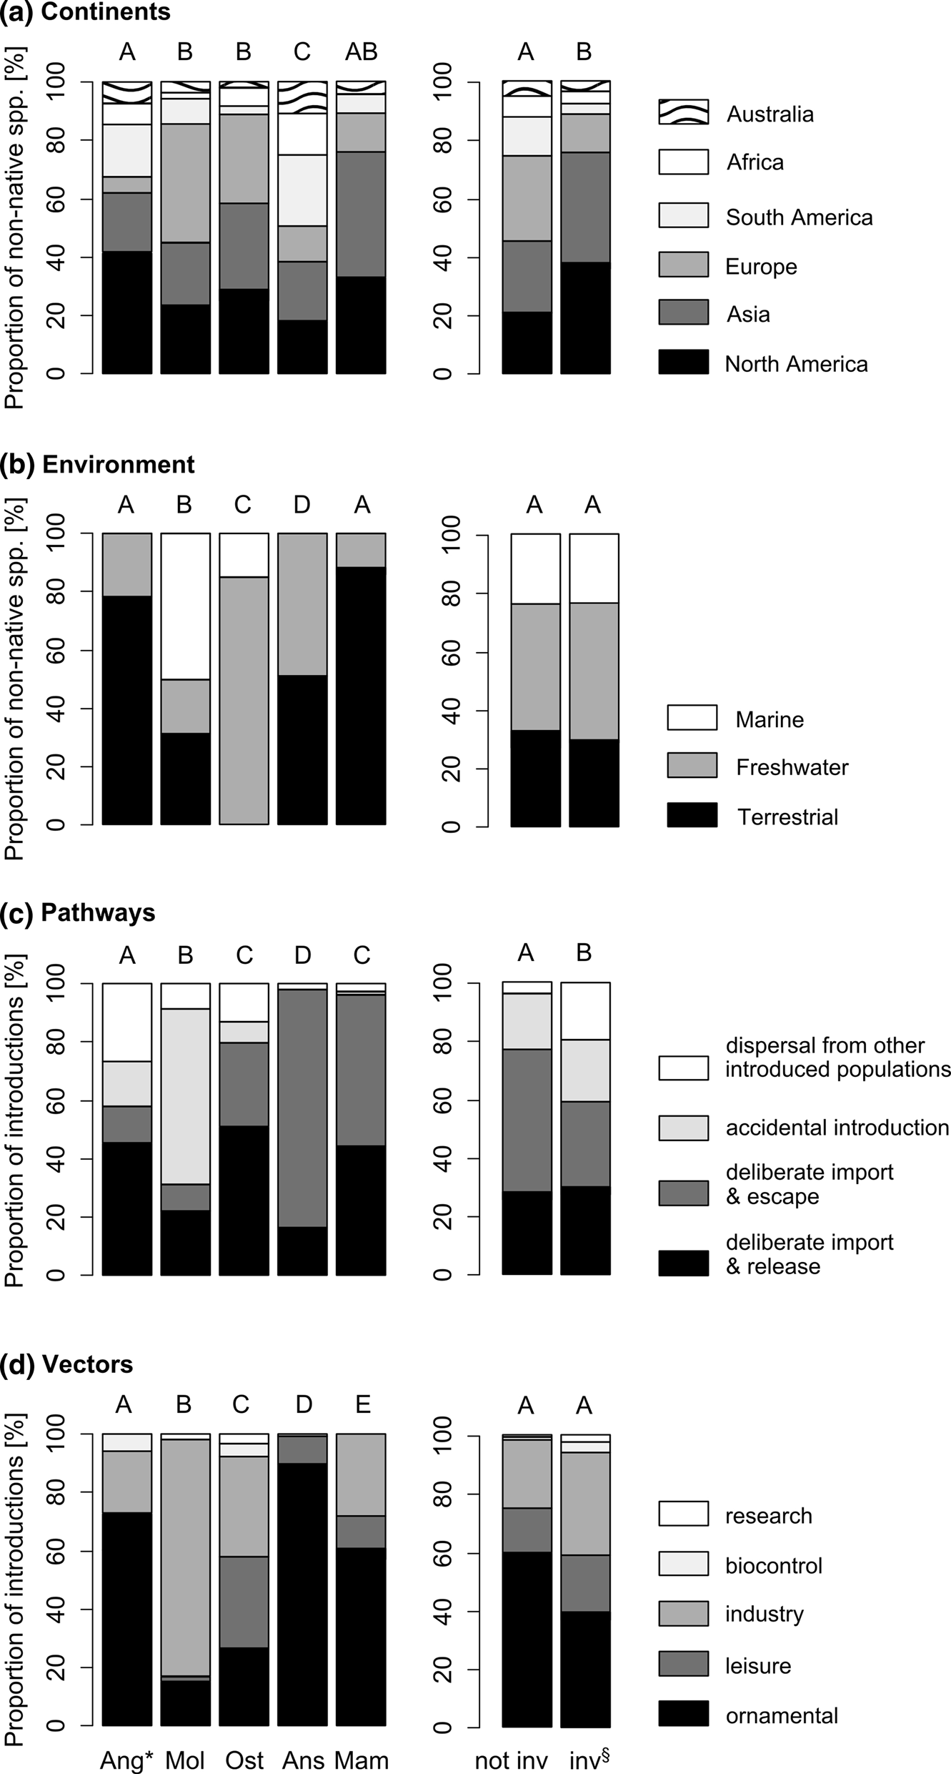
Fig. 1 Relative proportion of a continents of origin,
b environments inhabited, c pathways of
introduction and d vectors of deliberate introduction of non-native Angiospermae (Ang), Mollusca (Mol), Osteichthyes (Ost), Anseriformes (Ans) and Mammalia (Mam) species to Northwest Europe (i.e. GB, France, Belgium and the Netherlands). Different letters above columns indicate significant differences between taxonomic groups, and INNS (inv) versus other NNS (not inv), respectively (see text for details).
*Angiospermae represented by INNS only, §excluding Angiospermae

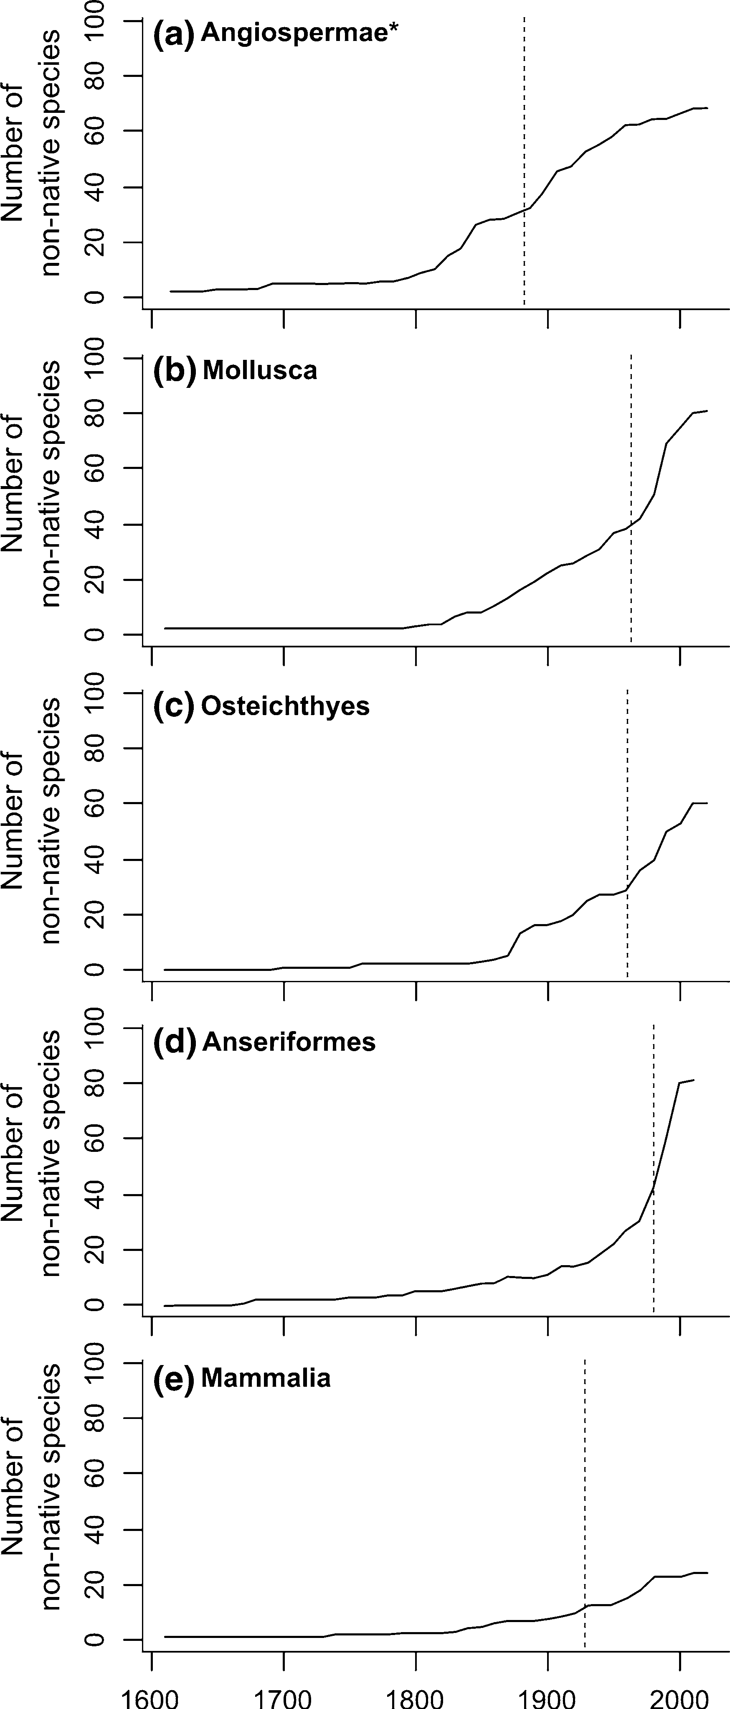

Fig. 2 Rate of establishment of NNS from five taxonomic groups into Northwest Europe (i.e. GB, France, Belgium and the Netherlands) from 1600 to 2015. Dashed line indicates time at which 50 % of NNS per group have arrived. *Angiospermae represented by INNS only
Species from North America arrived significantly earlier than species from all other continents, whilst South American species arrived significantly later than species from all continents except Australia
(Table 1c; Fig. 3b). While the importance of North America as a donor continent to the region decreased notably after the 1920s, and no North American species in the dataset was introduced after the year 2000, the relative importance of Asia and Europe in this respect increased after 2000 (Fig. 4a). In fact, 89 % of new introductions between 2001 and 2015 originated from Europe and/or Asia.
Species from different environments arrived at different times (Kruskal–Wallis: v2 = 37.493, df = 2, P \ 0.0001; Fig. 3c). Terrestrial species on average arrived significantly earlier than freshwater and marine ones (Table 1d; Fig. 3c). 61 and 22 % of introductions of analysed groups to the region after the year 2000 were by freshwater and marine organisms, respectively (Fig. 4b).
INNS were shown to have arrived to the region signifi earlier than other NNS (dataset excluding Angiospermae for reasons explained above; Mann– Whitney: U = 18, 205, P \ 0.0001; Fig. 3d). Median arrival dates were 1884 for INNS and 1975 for other NNS. Introductions by different pathways happened at different times (Kruskal–Wallis: v2 = 316.000, df = 3, P \ 0.0001; Fig. 3e). Deliberately intro- duced-released and dispersed species arrived signifi- cantly earlier than accidentally introduced and deliberately introduced-escaped species (Table 1e; Fig. 3e). The number of non-deliberate introductions (i.e. dispersal and accidental introductions) increased strongly after the year 2000 relative to deliberate introductions and represented 69 % of introductions
between 2001 and 2015 (Fig. 4c).
Deliberate introductions by different vectors hap- pened at different times (Kruskal–Wallis: v = 69.330, df = 3, P \ 0.0001; excluding ‘‘research’’ due to low replicate number; Fig. 3f). Species that were deliber- ately introduced for industrial, ornamental or research purposes arrived significantly later than those intro- duced for leisure and biocontrol purposes (Table 1f; Fig. 3f). Ornamental trade has become increasingly more important from the 1960s and was responsible for all deliberate introductions of the study groups since 2001 (Fig. 4d).

Discussion

Our dataset revealed that recent years (i.e. between 2001 and 2015) experienced a relative but marked

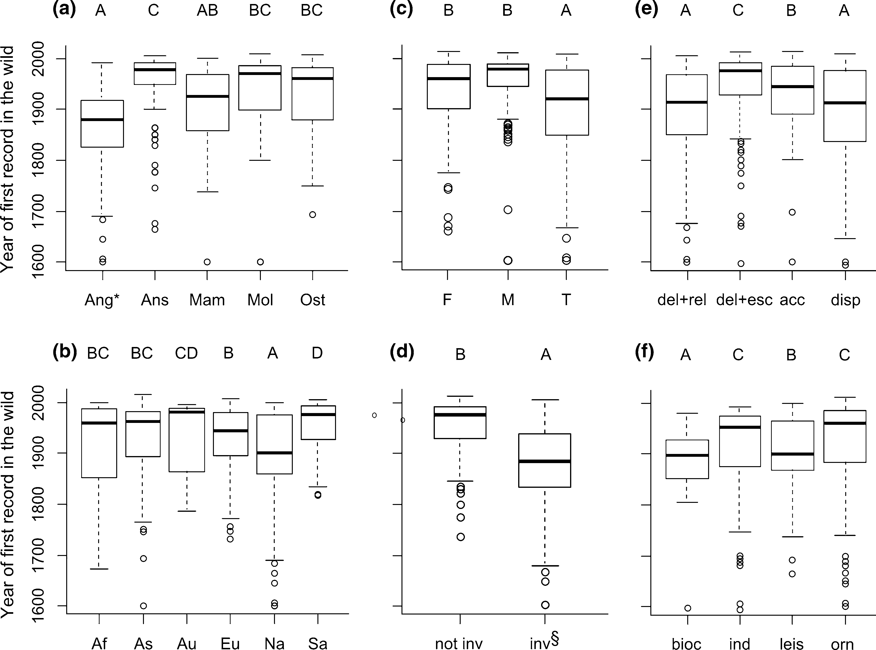

Fig. 3 Boxplots of year of first record in the wild in Northwest Europe (i.e. GB, France, Belgium and the Netherlands), grouped by a taxa, b continents of origin, c environments inhabited, d INNS versus other NNS, e pathways of introduction and f vectors of introduction. Different letters above columns indicate significant differences between groups (see text for details). Abbreviations: acc accidental introduction; Af Africa; Ang Angiospermae; Ans Anseriformes; As Asia; Au Australia;
bioc biocontrol; del ? esc deliberate import and escape; del ? rel deliberate import and release; disp dispersal; ind industry; Eu Europe; F freshwater; inv invasive; leis leisure; M marine; Mam Mammalia; Mol Mollusca; Na North America; not inv not invasive; orn ornamental; Ost Osteichthyes; Sa South America; T terrestrial. *Angiospermae represented by INNS only,
§excluding Angiospermae

increase of introductions by freshwater and marine species that originate from Europe and Asia and arrived in Northwest Europe through accidental introductions or escape. Non-native molluscs and fish are particularly prone to future introductions to the region, as indicated by the relatively large proportion of recent arrivals observed. Particularly for molluscs, many of the introductions were non-deliberate, which is related to their small size and difficulties in detecting and monitoring in aquatic habitats (Hulme et al. 2008). In conclusion, non-deliberate introduc- tions of aquatic NNS from Asia and Europe are thus likely to represent a severely increasing ecological and
economic threat to Northwest Europe in the imminent future.
Recent non-deliberate introductions of aquatic INNS of European/Asian origin to Northwest Europe in our dataset include a number of notorious Ponto- Caspian invaders, such as the western tubenose goby [Proteorhinus semilunaris (Heckel 1837)], the round goby [Neogobius melanostomus (Pallas 1814)] and the quagga mussel [Dreissena rostriformis bugensis (An- drusov 1897)]. These INNS were introduced to the Netherlands through dispersal and/or ballast water exchange in the early 2000s and within a few years, had spread to Belgium and France, and in the case of

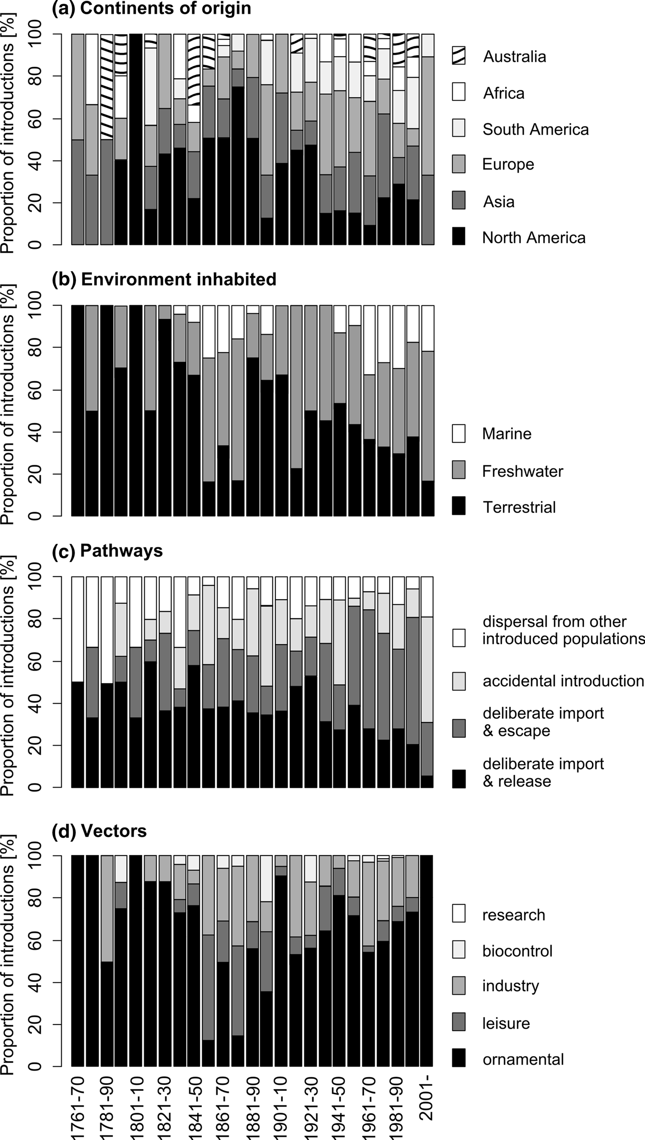
Fig. 4 Temporal changes in the relative proportion of different a continents of origin, b environments inhabited, c pathways of
introduction and d vectors of deliberate introduction of non-native Angiospermae, Mollusca, Osteichthyes, Anseriformes and Mammalia to Northwest Europe (i.e. GB, France, Belgium and the Netherlands) per decade from 1761 to 2015

D. r. bugensis, also Great Britain (van Beek 2006; Molloy et al. 2007; Mombaerts et al. 2010; Marescaux et al. 2012; Aldridge et al. 2014). The recent steep increase of Ponto-Caspian mollusc, fish, crustacean and other INNS in Northwest Europe reflects the impact of man-made connections between naturally unconnected river basins (Bij de Vaate et al. 2002; Gallardo and Aldridge 2012, 2015; Rabitsch et al. 2013), and the broad climatic and environmental tolerance of these taxa (Gallardo and Aldridge 2012). Once established, Ponto-Caspian species often become dominant, displace native species, and may severely affect fisheries and whole ecosystem pro- cesses (Ojaveer et al. 2002). The eradication of aquatic INNS is strategically difficult, rarely feasible, expen- sive and ultimately unlikely to be of considerable ecological benefit (Mack and Lonsdale 2002; Britton et al. 2011). Ponto-Caspian species thus constitute a group of high concern for environmental managers and stakeholders that requires scientifically informed tools for their prevention and control.
The future threat of aquatic introductions from Asia has recently been confirmed by a horizon scanning exercise for the study region, which placed three aquatic Asian species, i.e. the riverine Amur sleeper (Perccottus glenii Dybowski 1877), the marine Amur clam (Corbula amurensis Schrenck 1861) and the marine Japanese seastar (Asterias amurensis Lutken 1871), among the worst 10 species not yet introduced to the region (Gallardo et al. 2016). On the other hand, this list does not feature a single species from North America, the continent of origin of one-third of INNS in our dataset. Similarly, the importance of North America as an NNS donor has decreased markedly since the 1930s, without a single introduction from this continent since 2001. The underlying factors for this shift in the relative contribution of Asia and North America as donor continents of NNS to Northwest Europe might be rooted in their different histories of trade and travel with Europe. Trade and travel between Europe and North America has been intense for over a century, so that the most aggressive and dangerous invaders from North America have long since crossed the ocean. Economic growth of Asia (most importantly China) and its trade with Europe, on the other hand, has risen steeply since the early 1990s (Yueh 2012). Propagule pressure of new Asian NNS in Europe is thus likely to continue in the future.
The contribution of deliberate introductions to Northwest Europe’s NNS pool has decreased mark- edly and made up merely 31 % of new introductions between 2001 and 2015. This drop in deliberate introductions in both absolute and relative numbers is likely a result of the tougher legislation and controls in place due to and combined with an increased aware- ness of the potential impact of NNS, as acknowledged, for example, by its recognition as a global challenge in the UN Convention on Biological Diversity in 1992. The EU Regulation No 1143/2014 promises to reduce these numbers even further by essentially banning the keeping, sale and transport of specific INNS of EU concern, with a focus on intentional release and escape pathways (European Commission 2014; Essl et al. 2015). Our data indicate that efforts in this respect should be placed on the ornamental/pet trade, which we showed to be the single most important vector of deliberate NNS introductions into Northwest Europe today. Special attention should be paid to Internet commerce, which has facilitated the import of plants and animals (Duggan 2010; Lenda et al. 2014; Mazza et al. 2015).
Despite past and ongoing achievements in con- stricting deliberate introductions, preventing non- deliberate introductions (i.e. accidental introductions and introductions by dispersal) is much more chal- lenging. This is particularly true for aquatic inverte- brate species, such as molluscs, which are especially difficult to detect. For this reason, the EU Regulation No 1143/2014 considers it crucial to manage the pathways of unintentional introduction more effec- tively, as opposed to particular species, and refers to the International Ballast Water Regulation as an example (International Maritime Organisation IMO 2004). Prevention of aquatic introductions may indeed improve through more intense ballast water control, ship inspections and control of imports. DNA barcod- ing using environmental DNA represents a promising new tool for a more effective detection of small, aquatic NNS (Jerde et al. 2011; Dejean et al. 2012). Gathering data and filling gaps in our knowledge on the prevalent pathways, vectors and continents of origin will further help focus efforts towards prevent- ing accidental aquatic introductions. As prevalent patterns in this respect are changing over time, management strategies must take those changes into account to be effective in the long term. In addition, educational outreach programs are needed to raise

awareness amongst the general public (in particular, boat-users and fishermen) and to promote the early detection of newcomers. That said, halting the dispersal of aquatic NNS through human-made connections of waterways such as the Rhine–Main–Danube canal is challenging, though evaluation of the risks associated to new hydrological structures and ecological restoration of natural flows might help to prevent the situation from deteriorating (Panov et al. 2009).
In contrast to aquatic molluscs and fish, the threat of introductions of new mammal and wildfowl species can be considered of less concern due to the following reasons. Since the year 2000, not a single new non- native mammal species has established viable popu- lations in the study region. This follows a long history of deliberate mammal introductions for food, hunting, sport, commercial enterprises, pest control, wildlife collections, pet trade and aesthetic reasons (Long 2003). It includes deliberate attempts to establish a range of mammals made by, for example, La Socie´te´ Impe´riale d’Acclimatation founded in France in 1854, and a similar society in the UK from the 1860s (Long 2003). Against this background, it is likely that most of the obvious candidates for introduction are already established or have failed in the attempt. Though a considerable number of non-native wildfowl species arrived relatively recently to the region, the threat of future introductions from this group is negligible. The majority of wildfowl species described globally and not native to the region (i.e. 109 species in GB, British Trust for Ornithology http://www.bto.org/about-birds/ birdfacts/bird-families) are either already established NNS (82 species) or listed as ‘endangered or critically endangered’ on the IUCN Red-List and therefore unlikely to be introduced (17 species; IUCN 2016). In addition, both mammals and wildfowls are relatively visible and well-studied, and thus less likely to be accidentally introduced.
The threat of new Angiospermae introductions to the region, on the other hand, should not be underes- timated, despite what our data may suggest on the first glance. Whilst our dataset revealed a very small number of first introductions of invasive plant species between 2001 and 2015, this refers to only the 73 invasive Angiospermae recorded in the region. An in- depth analysis including non-invasive plants is likely to present a very different picture than that obtained in the present study. Specifically, based on our findings on other taxonomic groups, we would expect that non-
invasive Angiospermae species present in the region are characterised by considerably later dates of introduction and a greater proportion of non-deliberate introductions than the set of invasive Angiospermae species we analysed here. Unfortunately, such an exercise was out of the scope of this study, as it would need to include a thorough revision of the exact status (i.e. established versus garden escapes) of all 3470 non-native Angiospermae species listed by Zieritz et al. (2014) for the region. The value of a more comprehensive knowledge on the prevailing pathways and vectors of plant invaders is, however, substantial. This has recently been illustrated by Gallardo et al. (2016), who identified two invasive Angiospermae species, i.e. Sosnowski’s hogweed (Heracleum sos- nowskyi Manden) and big sage (Lantana camara Linnaeus), as the worst two species that have not yet been recorded from the region.

Acknowledgments Research leading to this study was funded by the European Regional Development Fund through the EU co-funded Interreg 2Seas project RINSE (reducing the impact of non-native species in Europe; www.rinse-europe.eu), which seeks to improve awareness of the threats posed by INNS, and the methods to address them. AZ and BG received financial support from RINSE. AZ is supported by a Postdoctoral Research Fellowship of the University of Nottingham, Malaysia Campus. BG holds a Postdoctoral Research Fellowship from the Spanish Ministry of Economy and Competitiveness (JCI-2012- 11908). We are grateful to RINSE colleagues for their contri- bution during the data review stage (in alphabetical order): Tim Adriaens, Catherine Chatters, Patrick Crestot, Kim De Bus, Dieter Depraetere, Ce´line Fontaine, Cindy Fournier, Melanie Gillings, Ans Mouton, Jonathan Newman, Corin Pratt, Dick Shaw, Sofie Standaert and Karel van Moer.

References

Aldridge DC, Ho S, Froufe E (2014) The Ponto-Caspian quagga mussel, Dreissena rostriformis bugensis (Andrusov, 1897), invades Great Britain. Aquat Invasions 9:529–535
Anderson LG, White PCL, Stebbing PD et al (2014) Biosecurity and vector behaviour: evaluating the potential threat posed by anglers and canoeists as pathways for the spread of invasive non-native species and pathogens. PLoS ONE 9:e92788
Bij de Vaate A, Jazdzewski K, Ketelaars HAM et al (2002) Geographical patterns in range extension of Ponto-Caspian macroinvertebrate species in Europe. Can J Fish Aquat Sci 59:1159–1174
Britton JR, Gozlan RE, Copp GH (2011) Managing non-native fish in the environment. Fish Fish 12:256–274
Dejean T, Valentini A, Miquel C et al (2012) Improved detec- tion of an alien invasive species through environmental

DNA barcoding: the example of the American bullfrog Lithobates catesbeianus. J Appl Ecol 49:953–959
Duggan IC (2010) The freshwater aquarium trade as a vector for incidental invertebrate fauna. Biol Invasions 12:3757–3770
Essl F, Bacher S, Blackburn TM et al (2015) Crossing frontiers in tackling pathways of biological invasions. Bioscience 65:769–782
European Commission (2014) Regulation (EU) no 1143/2014 of the European parliament and of the council of 22 October 2014 on the prevention and management of the introduc- tion and spread of invasive alien species. Off J Eur Union 57(L317):35–55
Galil BS, Nehring S, Panov V (2007) Waterways as invasion highways—Impact of climate change and globalization. Ecological, Studies, pp 59–74
Gallardo B, Aldridge DC (2012) Priority setting for invasive species management: risk assessment of Ponto-Caspian invasive species into Great Britain. Ecol Appl 23:352–364 Gallardo B, Aldridge DC (2013) The ‘dirty dozen’: socio-eco- nomic factors amplify the invasion potential of 12 high-risk aquatic invasive species in Great Britain and Ireland.
J Appl Ecol 50:757–766
Gallardo B, Aldridge DC (2015) Is Great Britain heading for a Ponto-Caspian invasional meltdown? J Appl Ecol 52:41–49
Gallardo B, Zieritz A, Aldridge DC (2015) Considering the human footprint: the importance of non-environmental factors in shaping the global distribution of terrestrial, aquatic and marine invaders. PLoS ONE 10:e0125801
Gallardo B, Zieritz A, Adriaens T et al (2016) Trans-national horizon scanning for invasive non-native species: a case study in western Europe. Biol Invasions 18:17–30
Genovesi P, Carboneras C, Vila` M et al (2015) EU adopts innovative legislation on invasive species: A step towards a global response to biological invasions? Biol Invasions 17:1307–1311
Gherardi F, Bertolino S, Bodon M et al (2008) Animal xen- odiversity in Italian inland waters: distribution, modes of arrival, and pathways. Biol Invasions 10:435–454
Gherardi F, Britton JR, Mavuti KM et al (2011) A review of allodiversity in Lake Naivasha, Kenya: Developing con- servation actions to protect East African lakes from the negative impacts of alien species. Biol Conserv 144:2585–2596
Hulme PE (2009) Trade, transport and trouble: managing invasive species pathways in an era of globalization. J Appl Ecol 46:10–18
Hulme PE, Bacher S, Kenis M et al (2008) Grasping at the routes of biological invasions: a framework for integrating path- ways into policy. J Appl Ecol 45:403–414
International Maritime Organisation IMO (2004) International convention for the control and management of ships’ bal- last water and sediments. BWM/CONF/36
Invasive Species Specialist Group ISSG (2016) Global invasive species database. http://www.issg.org/database. Accessed 2016
IUCN (2016) IUCN Red List of Threatened Species. Version 2015-3. www.iucnredlist.org. Accessed 2016
Jerde CL, Mahon AR, Chadderton WL et al (2011) ‘‘Sight- unseen’’ detection of rare aquatic species using environ- mental DNA. Conservation Letters 4:150–157
Johnson L, Brawley S, Adey W (2012) Secondary spread of invasive species: historic patterns and underlying mecha- nisms of the continuing invasion of the European rockweed Fucus serratus in eastern North America. Biol Invasions 14:79–97
Keller RP, Ermgassen PSEz, Aldridge DC (2009) Vectors and timing of freshwater invasions in Great Britain. Conserv Biol 23:1526–1534
Lenda M, Sko´rka P, Knops JMH et al (2014) Effect of the
internet commerce on dispersal modes of invasive alien species. PLoS ONE 9:e99786
Long J (2003) Introduced mammals of the world: their history, distribution and influence. CABI Publishing, UK
MacDougall AS, Turkington R (2005) Are invasive species the drivers or passengers of change in degraded ecosystems? Ecology 86:42–55
Mack R, Lonsdale W (2002) Eradicating invasive plants: Hard- won lessons for islands. In: Veitch CR and Clout MN (eds) Turning the tide: the eradication of invasive species. Pro- ceedings of the international conference on eradication of island invasives IUCN SSC Invasive Species Specialist Group. pp. 164–172
Marescaux J, de Vaate Bij A, Van Doninck K (2012) First records of Dreissena rostriformis bugensis (Andrusov, 1897) in the Meuse River. BioInvasions Rec 1:119–124
Mazza G, Aquiloni L, Inghilesi AF et al (2015) Aliens just a click away: the online aquarium trade in Italy. Manag Biol Invasions 6:253–261
Molloy DP, de Vaate Ab, Wilke T et al (2007) Discovery of Dreissena rostriformis bugensis (Andrusov 1897) in Western Europe. Biol Invasions 9:871–874
Mombaerts M, Verreycken H, Volckaert FAM et al (2010) The invasive round goby Neogobius melanostomus and tube- nose goby Proterorhinus semilunaris: two introduction routes into Belgium. Aquat Invasions 9:305–314
Myers JH, Simberloff D, Kuris AM et al (2000) Eradication revisited: dealing with exotic species. Trends Ecol Evol 15:316–320
Ojaveer H, Leppa¨koski E, Olenin S et al (2002) Ecological impact of ponto-caspian invaders in the Baltic Sea, Euro- pean inland waters and the great lakes: an inter-ecosystem comparison. In: Leppa¨koski E, Gollasch S, Olenin S (eds) Invasive aquatic species of Europe. Distribution, impacts and management. Springer, Netherlands, pp 412–425
Oreska MPJ, Aldridge DC (2011) Estimating the financial costs of freshwater invasive species in Great Britain: a stan- dardized approach to invasive species costing. Biol Inva- sions 13:305–319
Panov VE, Alexandrov B, Arbacˇiauskas K et al (2009) Assessing the risks of aquatic species invasions via euro- pean inland waterways: from concepts to environmental indicators. Integr Environ Assess Manag 5:110–126
Pluess T, Cannon R, JaroA˚ ¡A˜ k V et al (2012) When are eradi- cation campaigns successful? A test of common assump-
tions. Biol Invasions 14:1365–1378
Rabitsch W, Milasowszky N, Nehring S et al (2013) The times are changing: temporal shifts in patterns of fish invasions in central European fresh waters. J Fish Biol 82:17–33
Secretariat of the Convention on Biological Diversity (2011) Strategic Plan for Biodiversity 2011–2020 and the Aichi Targets ‘‘Living in Harmony with Nature.’’

Seebens H, Gastner MT, Blasius B (2013) The risk of marine bioinvasion caused by global shipping. Ecol Lett 16:782–790
Simberloff D, Martin J-L, Genovesi P et al (2013) Impacts of biological invasions: what’s what and the way forward.
Trends Ecol Evol 28:58–66
van Beek GCW (2006) The round goby Neogobius melanosto- mus first recorded in the Netherlands. Aquat Invasions 1:42–43
Vila` M, Basnou C, Gollasch S et al (2009) One Hundred of the most invasive alien species in Europe. In: DAISIE (De- livering Alien Invasive Species Inventories for Europe) (ed) Handbook of alien species in Europe. Springer, Netherlands, pp 265–268
Williams SL, Davidson IC, Pasari JR et al (2013) Managing multiple vectors for marine invasions in an increasingly connected world. Bioscience 63:952–966
Wilson JRU, Dormontt EE, Prentis PJ et al (2009) Something in the way you move: dispersal pathways affect invasion success. Trends Ecol Evol 24:136–144
Yueh L (2012) The economy of China. Edward Elgar Pub, Cheltenham, UK
Zavaleta ES, Hobbs RJ, Mooney HA (2001) Viewing invasive species removal in a whole-ecosystem context. Trends Ecol Evol 16:454–459
Zenni RD (2014) Analysis of introduction history of invasive plants in Brazil reveals patterns of association between biogeographical origin and reason for introduction. Austral Ecol 39:401–407
Zieritz A, Gallardo B, Aldridge DC (2014) Registry of non- native species in the Two Seas region countries (Great Britain, France, Belgium and the Netherlands). Neobiota 23:65–80

