Multiple nitrogen saturation indicators yield contradicting conclusions on improving nitrogen status of temperate forests
Arne Verstraetena,b,⁎, Johan Neiryncka, Nathalie Coolsa, Peter Roskamsa, Gerald Louettea,
Stefaan De Neveb, Steven Sleutelb
a INBO, Research Institute for Nature and Forest, Kliniekstraat 25, 1070 Brussels, Belgium
b University of Ghent, Department of Soil Management, Coupure Links 653, 9000 Ghent, Belgium

A R T I C L E I N F O

Keywords: Nitrogen status Soil solution DON:TDN ratio
DOC:NO3−
Ratio
Foliar N:P ratio Foliar Bc:N ratio ICP Forests
A B S T R A C T

Nitrogen (N) depositions in Europe are decreasing, but this could not explain faster than expected improvement of N saturation indicators in temperate forests. Alongside there were local signs of initial recovery from acid- iﬁcation during the past three decades and enhanced leaching of dissolved organic carbon and nitrogen (DOC, DON). These two global change processes both aﬀect total dissolved nitrogen (TDN) levels and often occur simultaneously, hence complicating mechanistic explanations for changing European forest N status. We aimed to test the hypothesis that forest N status in northwest Europe has started to improve. If this hypothesis is conﬁrmed, we wanted to investigate to what extent such improvement is due to reduced N deposition. We evaluated the evolution of multiple N saturation indicators in ﬁve ICP Forests Level II plots in northern Belgium, using long-term soil solution and foliage datasets. The DON:TDN ratio (molar) in soil solution increased overall in the O horizon (mean 0.279–0.463, slope 0.023–0.037 yr−1) and in the mineral soil (mean 0.134–0.78, slope
−

0.007–0.051 yr−1) between 2005 and 2014. The DOC:NO3
ratio (molar) in soil solution increased in three plots

in the O horizon (mean 6.84–22.15, slope 0.58–1.92 yr−1) and in four plots in the mineral soil (mean 2.07–25.32, slope −0.06–5.76 yr−1) between 2002 and 2014. The ratio of N and phosphorus (P) concentrations in foliage (mg g−1) and the ratio of base cations (Bc = Ca + K + Mg) and N concentrations in foliage (molar) remained unaltered between 1999 and 2013. Changes in the soil solution chemical composition thus conﬁrmed an improvement in forest N status, despite sustained high NO3− concentrations, but biotic recovery appeared to be lagging behind. This demonstrates that insight in forest recovery from N saturation requires a multiple in- dicator approach, and further monitoring of tree nutritional status alongside soil processes is needed to monitor the evolution of European forest N status.

- Introduction

Atmospheric deposition of inorganic nitrogen (N) and sulphate (SO42−) caused an accelerated acidiﬁcation and N saturation of tem- perate forest soils and surface waters in large parts of Europe and the US mainly during the second half of the 20th century (van Breemen et al., 1984; Aber et al., 1989). In temperate forests, soil acidiﬁcation often depleted base cations (calcium, potassium, magnesium), in- creased soil solution aluminium (Al3+) concentrations and nitrate (NO3−) leaching, and disrupted dissolved organic matter cycling (Kalbitz et al., 2000; Aber et al., 2003; McDowell et al., 2004; Pregitzer et al., 2004; Monteith et al., 2007).
Despite a substantial decrease of inorganic N depositions in large regions of Europe during the past decade (Waldner et al., 2014), critical loads and limits, i.e. the level below which signiﬁcant harmful eﬀects

do not occur according to present knowledge (Nilsson and Grennfelt, 1988) for inorganic N are still frequently exceeded in many European forests (Iost et al., 2012; Waldner et al., 2015). Despite publication of several papers on this matter it is still unclear how long N saturated forests will take to recover. Indeed, many factors, including manage- ment, SO42− deposition and natural succession, change alongside in- organic N deposition, and individual compartments of the forest eco- system (e.g., vegetation, below-ground communities, soil and soil solution) react with varying speed to changes in N availability (Stevens, 2016). Nitrogen availability also depends on forest size, forest type, soil type and sampling time and the complex interplay between biotic and abiotic processes (Pastor and Post, 1986; Callesen et al., 1999). In the present study we evaluate the evolution of forest N saturation in Flanders, a region in West-Europe where both inorganic N and SO 2– depositions strongly decreased, using a selection of indicators based on
4

⁎ Corresponding author at: INBO, Research Institute for Nature and Forest, Kliniekstraat 25, 1070, Brussels, Belgium.
E-mail address: arne.verstraeten@inbo.be (A. Verstraeten).

long-term data of the elemental concentrations in soil solution and tree mineral nutrition at intensive monitoring sites with varying soil types and tree species.
Long-term data on the concentrations of N species in soil solution collected at intensive forest monitoring plots yield crucial information about N availability and N saturation in forests. While unpolluted for- ests generally exhibit very limited N losses, consisting almost entirely of dissolved organic nitrogen (DON), N saturated forests with low C:N ratio in organic layers typically show elevated NO3− leaching below the rooting zone (Aber et al., 1989, 2003; Perakis and Hedin, 2002; Perakis and Sinkhorn, 2011). The ratio between DON and dissolved inorganic nitrogen (DIN) in soil solution, DON:DIN, has therefore been used as an indicator for N saturation in forests (Williams et al., 2001, 2004; Park and Matzner, 2006). Similarly, low ratios of DON to total dissolved nitrogen (TDN) in soil solution, DON:TDN, and of dissolved organic carbon (DOC) to NO3−, DOC:NO3−, are often used as indicators of soil N saturation (Currie et al., 1996; Sleutel et al., 2009; Taylor and Townsend, 2010).
The evaluation of forest N status may, however, be confounded when DOC and DON concentrations change alongside TDN and NO − concentrations. Recovery from acidiﬁcation was indeed found to mo- bilize DOC and DON (Verstraeten et al., 2016) in ﬁve ICP Forests Level II plots in northwest Europe. The concomitant evolutions in N deposi- tion and recovery from acidiﬁcation, both aﬀecting DON mobility, therefore leads us to question the true share of reduced N depositions in a possible improving N status of these forests. The prime aim of this research was thus to assess recent evolutions in the N status of these ﬁve ICP Forests Level II plots in Flanders, northern Belgium. We monitored the concentrations of DON and TDN (2005–2014) in the deposition and soil solution and of DOC and NO3− (2002–2014) in the soil solution and critically assessed trends in classic molecular-ratio based in- dicators. Because throughfall DIN deposition in the plots decreased from 42.1 kg ha−1 yr−1 to 20.2 kg ha−1 yr−1 during the period 1994 to 2010 (Verstraeten et al., 2012), we hypothesized that the DON:TDN
3
−
meteo.be). A detailed description of these plots can be found in Verstraeten et al. (2012). Detailed soil characteristics (C:N ratio, pH- CaCl2, cation exchange capacity, base saturation and soil texture per morphogenetic horizon) were published in Verstraeten et al. (2016). Two plots are located in coniferous forest: Pinus sylvestris L. (BRA) and Pinus nigra ssp. laricio var. Corsicana Loud. (RAV). Three other plots are located in deciduous forest: Fagus sylvatica L. (WIJ, HOE) and a mixture of F. sylvatica L. and Quercus robur L. (GON). The soil texture of the plots at RAV and BRA was sand, at WIJ loamy sand and at GON and HOE loam (USDA textural triangle) (Verstraeten et al., 2012). The stands have an age of 82–108 years, a basal area of 29.2–44.9 m2 ha−1 and a very low pH-CaCl2 of 2.5–4.1 in the mineral soil. The ﬁve plots are part of the LTER-Europe network (Long-term Ecosystem Research Network).

  - Sample collection and measurements

Samples of deposition and soil solution were collected fortnightly from January 2005 till December 2014, according to the guidelines of the ICP Forests manual, part XI and XIV (Clarke et al., 2016; Nieminen et al., 2016). A detailed description of the procedures used for de- position and soil solution sampling can be found in Verstraeten et al. (2012, 2016).
Samples of fresh tree foliage were collected biennially from 1999 till 2013 by professional tree climbers. Samples were always collected from the same ﬁve dominant trees in each plot and from the upper third of the crown (needles or leaves that developed in light), according to the guidelines of the ICP Forests manual, part XII (Rautio et al., 2016).

  - Chemical analysis

Samples were treated and analysed as prescribed by the ICP Forests manual, part XI, XII and XIV (Clarke et al., 2016; Nieminen et al., 2016; Rautio et al., 2016). Quality control included the analysis of control samples (blanks, reference material, replicates) and participation in the

ratio (molar) and thus the DOC:NO3
ratio (molar) increased over the
ICP Forests water and foliar ring tests, according to the guidelines of the

past decade. We expect, however, that increased DON and DOC mobi- lization due to concomitant recovery from acidiﬁcation renders these shifting ratios only partly indicative for the actual improvement in forest N status. Moreover, concentrations of DOC, DON, TDN and NO − in throughfall and soil solution obviously are not representative of the tree biological status. Instead, the N status of forests can alternatively
3
ICP Forests manual, part XVI (König et al., 2016).
Water samples (500-mL subsamples of each collected fraction) were kept cool during transportation, ﬁltered (0.45 μm), stored in darkness at 4 °C, and analysed within 48 h after sampling. Concentrations of Total Kjeldahl Nitrogen (TKN) (mg L−1) were determined using the continuous ﬂow method (Skalar, limit of quantiﬁcation,
+
−

be derived from the foliar concentrations of N and phosphorus (P) and
LOQ = 0.5 mg L−1). Concentrations of ammonium (NH4
), NO3
and

their ratio, N:P, in relation to tree species speciﬁc critical limits (Mellert and Göttlein, 2012; Veresoglou et al., 2014). A similar indicator is the ratio of the foliar concentrations of base cations (Bc = Ca + K + Mg) and N, Bc:N (Meesenburg et al., 2016). Tree nutritional status provides an integrative criterion for the assessment of site conditions and en- vironmental factors (e.g. soil acidiﬁcation, N saturation, climate change) and is important to control the success of restoration measures and to follow the natural recovery of forest ecosystems from former anthropogenic impacts (Mellert and Göttlein, 2012). To more broadly track the impact of reduced N deposition on forest N status, we ex- tended the evaluation with the 1999–2013 trends in the foliar N:P ra- tios and Bc:N ratios and hypothesized that these had decreased and increased, respectively, as a consequence of lowered soil mineral N availability.

- Material and methods

  - Study area

Five plots of the ICP Forests intensive monitoring network (Level II)
nitrite (NO2−) (mg L−1) were determined using ion chromatography (Dionex ICS-3000, LOQ = 0.1 mg L−1). Concentrations of DOC were determined using a TOC-analyser (Shimadzu TOC 5050A, LOQ = 0.1 mg L−1).
Foliage samples were dried in an oven at 40 °C until constant weight and pulverised with a suitable mill (Retsch SM 2000). For each of the sampled trees a homogenized subsample was analysed at every sam- pling event. Foliar N concentrations (mg g−1 dry weight at 105 °C) were determined using the Kjeldahl method with NH4+-back titration (Gerhardt KB8S, LOQ = 1 mg kg−1). Foliar concentrations of P, Ca, K and Mg (mg g−1 dry weight at 105 °C) were determined using ICP-AES (Varian Liberty Series II, LOQ = 50 mg kg−1) after microwave diges- tion with HNO3/H2O2.

  - Data handling

Concentrations of DOC and DON for 2005–2013 were taken from previous studies (Verstraeten et al., 2014, 2016), and were supple- mented with new data for 2014. Concentrations of DON were calcu- lated as TKN − NH4+. Concentrations of TDN were calculated as TKN
3
2

in Flanders (northern part of Belgium) were included in this study.
+ NO −
+ NO −
. The ratio of DON and TDN concentrations (molar),
−

Flanders has a moderate Atlantic climate with a mean annual pre-
DON:TDN, and the ratio of DOC and NO3
concentrations (molar),

cipitation of 852 mm and mean temperature of 10.5 °C (long-term averages for 1981–2010 for the meteorological station of Uccle, www.
DOC:NO3−, were calculated for each sample for which both con- centrations were measured. Deposition ﬂuxes of DIN (kg ha−1) were

calculated as the product of concentration (mg N L−1) and the collected volume (L m−2) of precipitation in the open ﬁeld and below the canopy

Table 1
Median values and seasonal Mann-Kendall trends for the DON:TDN ratio (2005–2014)
— ratio (2002–2014), with the Theil-Sen slope (annual change) and

(throughfall + stemﬂow, further denoted as throughfall). The ratio of nitrogen to phosphorus concentration (mg g−1) in foliage, N:P, and the
and the DOC:NO3
signiﬁcance for the ﬁve locations (ns: not signiﬁcant, (*): p < 0.1,
ﬀ

*: p < 0.05,

**:

p < 0.01,
***
: p < 0.001). Di erent lowercase letters (a–d) denote plots with sig-

ratio of base cations to nitrogen concentration (molar) in foliage, Bc:N,
were calculated for each foliage sample.
To determine the stage of N saturation in the plots based on the DON:TDN ratio we used critical limits as proposed by Williams et al. (2004) (stage 0: > 67% DON, stage 1: 33–67% DON, stage 2: < 33% DON). To check whether plots were N saturated based on the
niﬁcantly diﬀerent means between locations within groups/layers (p < 0.05).

Plot Depth DON:TDN (molar) DOC:NO − (molar)
3

Median Slope Median Slope
cm

DOC:NO3
−
ratio we used the critical inﬂection point for soils
Precipitation (open ﬁeld)
**

(DOC:NO3− = 5.22) (Taylor and Townsend, 2010). Foliar nutritional status was judged by tree species speciﬁc critical limits for N and P concentrations and N:P ratios (van den Burg and Schaap, 1995; Mellert and Göttlein, 2012).

  - Statistical analysis

Data exploration and statistical analysis were performed in R ver- sion 3.3.0 (R Core Team, 2016). Since the data were not normally distributed (evaluated using the Shapiro-Wilk test included in the ‘stats’ package), the non-parametric Seasonal Mann-Kendall Test (Hirsch et al., 1982) included in the ‘rkt’ package (Marchetto, 2015) was used to detect monotonic trends in the DON:TDN ratio (2005–2014) and the
−
RAV 0.188a 0.008
BRA 0.191a 0.007(*)
WIJ 0.216a 0.008*
GON 0.179a 0.009**
HOE 0.210a 0.010*
Throughfall + stemﬂow
RAV 0.218ab 0.013***
BRA 0.202a 0.010***
WIJ 0.214ab 0.010**
GON 0.240bc 0.017***
HOE 0.261c 0.023***
O horizon
RAV 0.377b 0.033*** 15.54b 1.63***
BRA 0.429c 0.028*** 22.15c ns
WIJ 0.306a 0.027*** 6.84a 0.58***
GON 0.279a 0.023*** 8.48a ns

DOC:NO3
ratio (2002–2014). The rate of annual change (increase or
HOE 0.463c 0.037*** 17.35b 1.92***

decrease) was expressed as a percentage in function of the Theil-Sen
slope (% yr−1). Cross-site statistics (for inter-comparison of sites) were

A horizon

***

***

performed using the non-parametric Kruskalmc test (Multiple compar-
RAV 10–25 0.346b 0.028
10.72b 1.16

ison test after Kruskal-Wallis) included in the ‘pgirmess’ package (Giraudoux, 2015). Correlations between the fortnightly throughfall
BRA 15–25 0.372b 0.028*** 14.18bc 1.64***
WIJ 10–20 0.564c 0.023*** 21.27c 3.83***
GON 10–20 0.147a 0.007** 2.73a −0.06(*)

deposition of DIN and the DON:TDN ratio and DOC:NO −
3
ratio in soil
HOE 10–15 0.746c 0.013***
25.32c 4.49
***

solution were evaluated using the Spearman’s rank correlation test in- cluded in the ‘stats’ package. The nonparametric Mann-Kendall Test
B horizon
RAV 30–45 0.349b 0.042*** 12.03c 1.81***

(Mann, 1945) included in the ‘rkt’ package (Marchetto, 2015) was ap-
BRA 30–55 0.343b 0.037***
10.16c 1.93
***

plied to detect monotonic trends in the foliar concentrations and ratios, using the mean value for the ﬁve sampled trees in the same year.

- Results

  - Trends in the DON:TDN ratio
WIJ 45–70 0.447c 0.030*** 14.59c 2.09***
GON 25–40 0.134a 0.008** 2.55a ns
HOE 20–30 0.396bc 0.020*** 6.41b 0.47***
C horizon
RAV 70–95 0.325b 0.051*** 9.52b 1.91***
BRA 70–90 0.290b 0.045*** 7.05b 1.40***
WIJ 75–110 0.428c 0.031*** 11.61bc 2.43***
GON 45–55 0.135a 0.007* 2.07a ns

The DON:TDN ratio in precipitation in the open ﬁeld was compar- able among plots (median 0.179–0.216) whereas there were small
HOE 35–55 0.780d 0.032***
17.12c 5.76
***

diﬀerences in this ratio in the throughfall (median 0.202–0.261) (Table 1, Fig. 1). In the O horizon (forest ﬂoor) the DON:TDN ratio was lowest in GON and WIJ (median respectively 0.279 and 0.306) and highest in BRA and HOE (median respectively 0.429 and 0.463). In the mineral soil (A, B, C horizons), the DON:TDN ratio was much lower in GON (median 0.134–0.147) compared to the other plots (median 0.290–0.780) and higher in HOE and WIJ than in RAV and BRA.
The DON:TDN ratio showed a limited general increase in pre- cipitation in the open ﬁeld (0.007–0.01 yr−1) and a slightly stronger general increase in the throughfall in the ﬁve forest plots (0.01–0.023 yr−1) between 2005 and 2014 (Table 1, Fig. A1). In the soil solution, the DON:TDN ratio signiﬁcantly increased with time at all depths. In the O horizon the smallest increase of the DON:TDN ratio was observed in GON (0.023 yr−1) and the largest in HOE (0.037 yr−1). In the mineral soil, the largest increase in the DON:TDN ratio was found in the two plots in coniferous forest (RAV and BRA) (0.028–0.051 yr−1) and the smallest in GON (0.007–0.008 yr−1). The annual rate of in-
−
the criteria from Williams et al. (2004). The N status of the two plots in coniferous forest (RAV and BRA) improved from Williams’ N saturation stage 2 to 1 (N saturation stage 1: DON 33–67% of TDN in soil solution). The N status in the WIJ site temporarily improved from stage 2 to 1 in the organic layer and from 2 to 0 (N saturation stage 0: DON > 67% of TDN in soil solution) in the mineral soil between 2005 and 2012, but fell back to stage 1 in 2013–2014. The N status in the HOE site im- proved from stage 2 to 1 in the B horizon and from stage 2 to 0 in the O, A and C horizon between 2005 and 2014.
In the O horizon, the DON:TDN ratio showed a strong negative correlation with the deposition of DIN in all plots (Fig. 2). In the mi- neral soil the DON:TDN ratio was negatively correlated with the de- position of DIN in RAV, HOE (A, B and C horizon) and BRA (B horizon).

  - Trends and patterns of the DOC:NO3− ratio

crease augmented from the A horizon (0.013–0.028 yr−1) towards the
The concentrations of DOC and NO3
in soil solution were nega-

C horizon (0.031–0.051 yr−1) in all plots except the GON site, where it
was constant with depth. In 2005 the 2nd critical limit for N saturation of Williams et al. (2004) was exceeded in all plots (N saturation stage 2: DON < 33% of TDN in soil solution) (Fig. 1). The forest soil at the
tively correlated at all depths in WIJ and HOE, in the mineral soil in BRA and in the A horizon in RAV (Fig. A3). In the O horizon the DOC:NO3− ratio was markedly lower in WIJ and GON (median re- spectively 6.84 and 8.48) compared to the other three plots (median
−

GON site remained N saturated during the 10-year period according to
15.54–22.15) (Table 1). The DOC:NO3
ratio in the O horizon

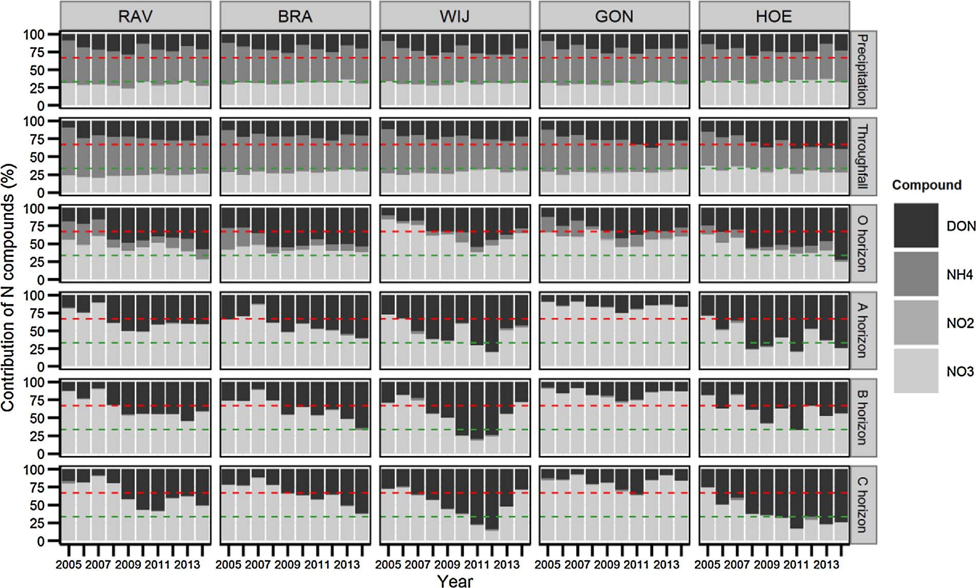

Fig. 1. Annual contribution (%) of N compounds in deposition and soil solution for the ﬁve locations with Williams et al. (2004)’s critical limits for stages of N saturation (0: > 67% DON indicated by the green dashed line, 1: 33–67% DON, 2: < 33% DON indicated by the red dashed line). (For interpretation of the references to colour in this ﬁgure legend, the reader is referred to the web version of this article.)

signiﬁcantly increased in RAV, WIJ and HOE and remained unchanged

inﬂection point for N saturation (DOC:NO3
−

= 5.22) in the O horizon

in BRA and GON between 2002 and 2014 (Table 1, Fig. 3, Fig. A2). In
−
in all plots except the BRA site, while in 2014 the critical limit was

2002, the DOC:NO3
ratio was still frequently below the critical
respected in BRA, RAV and HOE (Fig. 3).

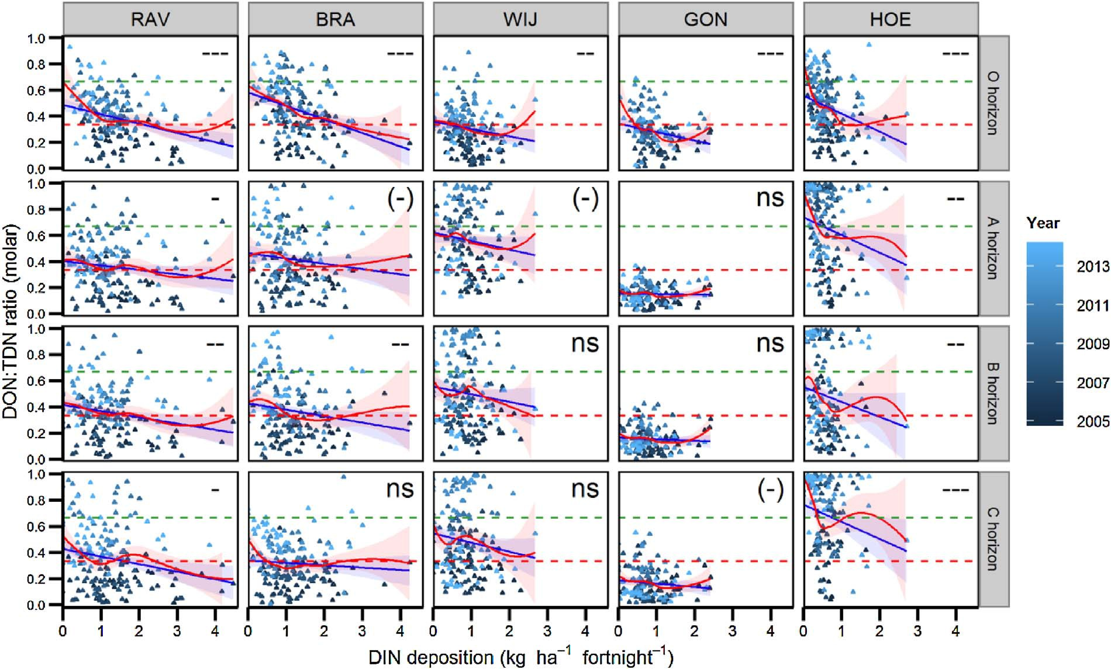

Fig. 2. Soil solution DON:TDN ratio in function of throughfall DIN deposition (2002−2014) for the ﬁve locations with signiﬁcance of the correlation (ns: not signiﬁcant, (−): p < 0.1, -: p < 0.05, –: p < 0.01, —: p < 0.001), Williams et al. (2004)’s critical limits for stages of N saturation (0: DON:TDN > 0.67 indicated by the green dashed line, 1:
0.33 < DON:TDN < 0.67, 2: DON:TDN < 0.33 indicated by the red dashed line), and trend lines (blue solid line: linear regression line, red solid line: LOESS curve). The LOESS curve (locally weighted polynomial regression) shows that the relationship is often close to linear in the range with suﬃcient data. (For interpretation of the references to colour in this ﬁgure legend, the reader is referred to the web version of this article.)

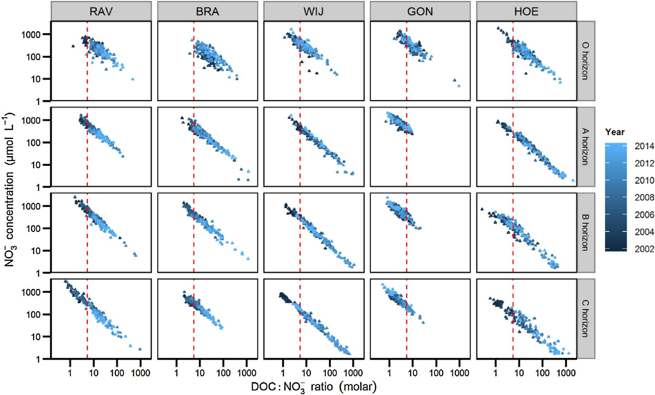

Fig. 3. Soil solution NO3
−

concentration in function of the DOC:NO3
−
ratio (2002–2014) for the ﬁve locations and critical inﬂection point for soils (DOC:NO3

= 5.22) as proposed by

Taylor and Townsend (2010) indicated by the red dashed line. The DOC:NO3− ratio should be above the critical inﬂection point. (For interpretation of the references to colour in this
−
ﬁgure legend, the reader is referred to the web version of this article.)

In the mineral soil, the DOC:NO3
−
ratio was signiﬁcantly lower in GON
- Discussion

(median 2.07–2.73) compared to the other plots (median 6.41–25.32)

(Table 1). The DOC:NO3
−
ratio in the mineral soil increased signiﬁcantly
4.1. Nitrogen status based on soil solution chemistry

with time in the A, B and C horizon in all plots except GON, where it remained stable (B and C horizon) or even slightly decreased (A horizon). In 2002, the critical inﬂection point for N saturation was permanently sur-

Trend analysis demonstrated an increase in the soil solution DON:TDN ratio in the ﬁve studied Level II plots between 2005 and
−

passed in the mineral soil in all plots, while in 2014 this was still often the
2014. In parallel, the soil solution DOC:NO3
ratio increased in the

case in WIJ and GON but no longer in RAV, BRA and HOE (Fig. 3).
In RAV, BRA and WIJ, the DOC:NO3− ratio showed a negative correlation with the deposition of DIN (Fig. 4). In GON and HOE we
−
RAV, BRA, WIJ and HOE plots between 2002 and 2014. This conﬁrms our hypothesis that these N saturated forest ecosystems are evolving, to a variable extent, towards abiotic conditions typical for unpolluted

found no consistent relationship between the DOC:NO3
deposition of DIN.

3.3. Trends in tree mineral nutrition
ratio and the
forest ecosystems (Aber et al., 1989; Perakis and Hedin, 2002; Perakis
and Sinkhorn, 2011). The lack of recovery from N saturation at the GON site could likely be explained by the higher clay content of that soil (Verstraeten et al., 2016), with a 4–10 times higher cation exchange
capacity (CEC) compared to the other (coarser textured) soils, and therefore also higher N retention capacity, and N availability and NO −
3

The mean foliar N concentration (Table 2) was constantly above the
upper limit in all plots, indicating luxury consumption of N by the trees (Fig. A4). The foliar N concentration decreased in the BRA site (p < 0.05) and remained unchanged in the other plots between 1999 and 2013. The mean foliar P concentration was in the normal range in all plots, but on the lower side of this range in BRA, WIJ and GON (Fig. A5). The foliar P concentration remained unchanged in the plots be- tween 1999 and 2013. The foliar concentration of Ca, K and Mg re- mained unchanged between 1999 and 2013 (data not shown), except for an increase in the foliar concentration of Ca in WIJ (p < 0.01). The mean foliar N:P ratio of current year needles was above the upper critical limit (unbalanced nutrition) both for Scots pine Pinus sylvestris
L. (14.1) in BRA (15.37) between 1999 and 2013 (Fig. 5) and for Corsican pine Pinus nigra ssp. laricio var. Corsicana Loud. (12) in RAV (14.85). The mean foliar N:P ratio of common oak Quercus robur L. leaves was in the normal range (balanced nutrition, 9.3–19.6) in GON (18.45), and for European beech Fagus sylvatica L. leaves (10–18.9) in HOE (16.34). It was above the upper critical limit in WIJ (19.65). Both the mean foliar N:P ratio and Bc:N ratio did not change in the plots between 1999 and 2013 (Fig. 6).
concentrations in soil solution (Pastor and Post, 1986; Callesen et al., 1999). The soil C:N ratio at 20–40 cm and 40–80 cm depth were indeed only 12.0 and 7.8, respectively (Verstraeten et al., 2012), and lower than in the RAV, BRA and WIJ plots. At the same time, the presence of a clay lens at 40–80 cm depth at GON (Verstraeten et al., 2016), must have restricted vertical water ﬂuxes and therefore NO3 leaching, leading to generally lower DOC:NO3− ratios. These results suggest that ﬁner textured soils recover more slowly from N saturation, possibly due to their stronger capacity to retain DON and NH4+ and limited leaching of excess NO3−, but this would need to be conﬁrmed on a larger set of soils.
It is diﬃcult to frame our results within a European context, because unfortunately Europe-wide studies on recent evolutions in the N status of temperate forests are lacking (Stevens, 2016). Trends reported by local or regional studies using long-term data from intensive forest monitoring plots are inconsistent, varying between a tendency towards recovery from N saturation in the Czech Republic (Oulehle et al., 2011), mixed trends in the UK depending on the level of DIN deposition (Vanguelova et al., 2010) and increasing N saturation in the southern
−

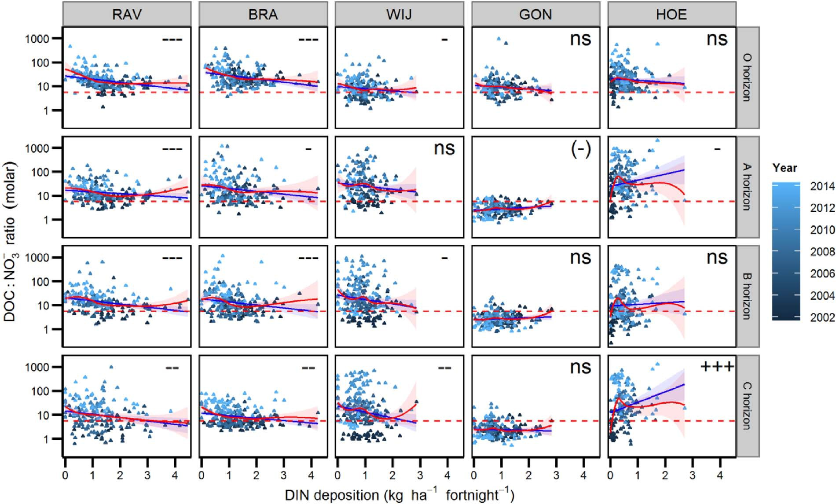
Fig. 4. Soil solution DOC:NO3− ratio in function of throughfall DIN deposition (2002−2014) for the ﬁve locations with signiﬁcance of the correlation (ns: not signiﬁcant, (−): p < 0.1,
-: p < 0.05, –: p < 0.01, — or +++: p < 0.001), critical inﬂection point for soils (DOC:NO3− = 5.22) as proposed by Taylor and Townsend (2010) indicated by the red dashed line, and trend lines (blue solid line: linear regression line, red solid line: LOESS curve). The LOESS curve (locally weighted polynomial regression) shows that the relationship is often close to

linear in the range with suﬃcient data. The DOC:NO3
−
ratio should be above the critical inﬂection point. (For interpretation of the references to colour in this ﬁgure legend, the reader is

referred to the web version of this article.)

Table 2
Mean foliar concentrations of N, P and base cations (mg g−1 dry weight at 105 °C) for leaves and current year needles in the ﬁve Level II plots in Flanders (1999–2013).

Plot Tree species N P Ca K Mg
mg g−1 mg g−1 mg g−1 mg g−1 mg g−1

Coniferous forests
solution NO3− and DON are often positively and negatively correlated, respectively, with the throughfall deposition of DIN (Perakis and Hedin, 2002; Park and Matzner, 2006). The predominantly negative correla- tion that we observed between the throughfall deposition of DIN and the DON:TDN ratio (Fig. 2) and DOC:NO3− ratio (Fig. 4) in soil solution would thus conﬁrm that the decrease in throughfall DIN deposition
contributed to higher ratios, suggesting a possible improvement of the

RAV Pinus nigra ssp. laricio
var. Corsicana Loud.
20.5 1.40 1.68 7.41 0.73
N status in the plots. This was also supported by the increasing

BRA Pinus sylvestris L. 22.1 1.45 2.81 6.84 0.87
Deciduous forests
WIJ | Fagus sylvatica L. | 26.4 | 1.35 | 4.02 | 10.39 | 0.87
GON | Quercus robur L. | 27.8 | 1.53 | 7.34 | 11.83 | 1.71
HOE | Fagus sylvatica L. | 24.1 | 1.49 | 8.86 | 8.93 | 1.27

DON:TDN ratio in precipitation and throughfall (Table 1). However,
NO3− leaching in the plots decreased faster than could be expected from the annual decrease in throughfall DIN deposition, which still exceeded considerably the critical load of 10 kg N ha−1 yr−1 above which European temperate forests are susceptible to elevated NO − leaching (Dise and Wright, 1995; Verstraeten et al., 2012). This is in
3
−

line with the faster than expected decline of NO3
leaching observed at

part of Belgium (Jonard et al., 2012) and in Solling, Germany
(Meesenburg et al., 2016). These inconsistent varying results could be explained by regional diﬀerences in the evolution of S and inorganic N depositions, driven by industrial and agricultural development, and by local diﬀerences in the strength of sinks (vegetation, soil) and N cycling processes, which determine how N saturation is manifested in the ecosystem (Lovett and Goodale, 2011; Niu et al., 2016).
The two most obvious drivers for the tendency towards recovery from N saturation in the ﬁve studied forests are the relatively fast de- crease of both acidifying and eutrophicating depositions in the past two
decades. Throughfall depositions of DIN decreased by 2.4–5.0% yr−1 in
three intensive forest monitoring plots receiving high DIN depositions in the Czech Republic and the UK (Vanguelova et al., 2010; Oulehle et al., 2011).
The decrease of DIN depositions alone could not fully explain the initial recovery from N saturation in the Flemish Level II plots. Simultaneously with the deposition of DIN the deposition of SO4 sharply decreased in the Flemish Level II plots, by 4.2–7.5% yr−1 be- tween 1994 and 2010 (Verstraeten et al., 2012), which is comparable to the European average of 6% yr−1 between 2000 and 2010 (Waldner et al., 2014). Oulehle et al. (2011) identiﬁed the strong decrease of
2–
2–

SO4
depositions, and subsequent recovery from acidiﬁcation, as the

these plots between 1994 and 2010, which can be explained by a
substantial reduction of NH3 emissions mainly by the agricultural sector (particularly the large scale adoption of low-NH3-emission stables, soil- injection of animal slurry and a slight decrease of livestock numbers)
2–
main driver for the fast decrease of NO3 leaching at a highly acidiﬁed spruce forest in the Czech Republic. Recovery from acidiﬁcation is manifested by increasing pH and decreasing Al3+ concentrations in soil
solution (Vanguelova et al., 2010; Oulehle et al., 2011; Verstraeten
−

but also by decreased co-deposition with SO4
(Verstraeten et al.,
et al., 2012). The latter is expected to reduce the formation of organo-

2012; VMM, 2016). The study area (Flanders) is thus among the regions
in Europe where DIN depositions decreased more than the European average of 2% yr−1 between 2000 and 2010 (Waldner et al., 2014). Soil
metal complexes and increase the solubility of organic matter, which could partly explain the predominantly increasing trends of DOC and

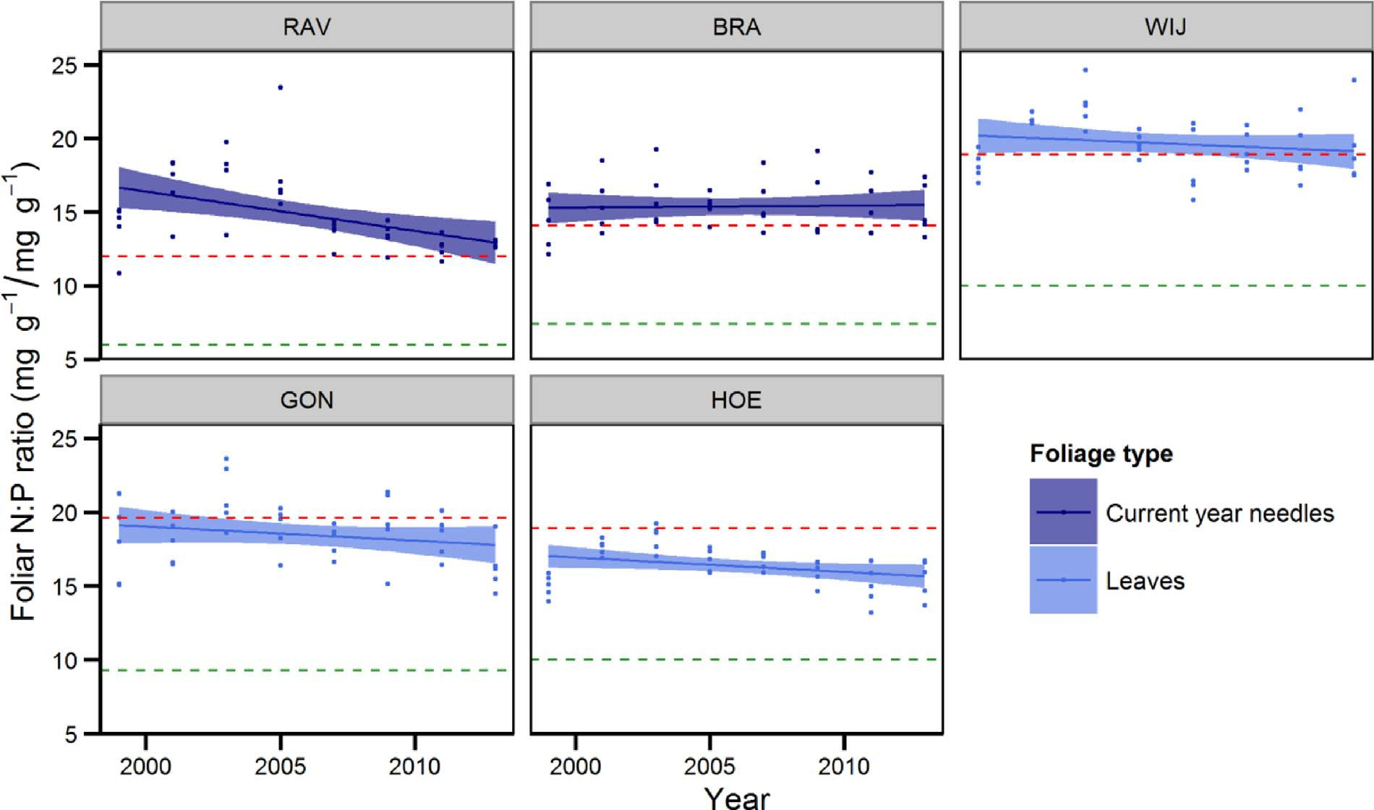

Fig. 5. Foliar N:P ratio (1999–2013) for the ﬁve locations with critical lower limit (green dashed line) and upper limit (red dashed line) (van den Burg and Schaap, 1995; Mellert and Göttlein, 2012). Trends were not signiﬁcant. (For interpretation of the references to colour in this ﬁgure legend, the reader is referred to the web version of this article.)

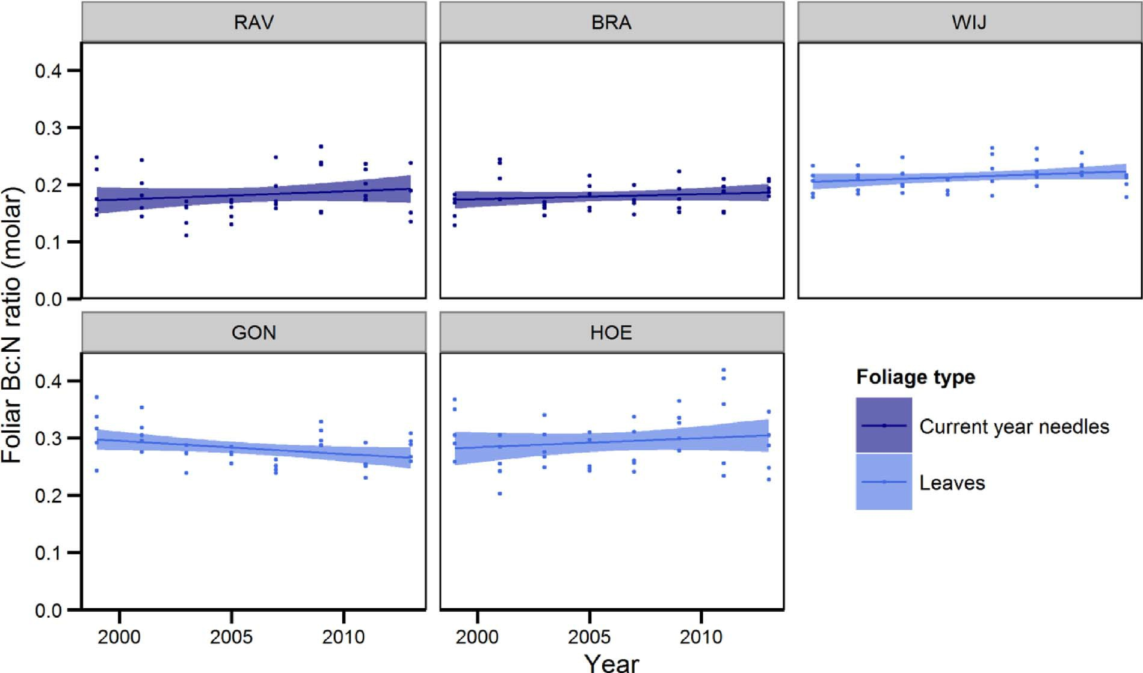

Fig. 6. Foliar Bc:N ratio (1999–2013) for the ﬁve locations. Trends were not signiﬁcant. (For interpretation of the references to colour in this ﬁgure legend, the reader is referred to the web version of this article.)

DON concentrations in the soil solution of forests and connected surface waters (de Wit et al., 2007; Monteith et al., 2007; Scheel et al., 2007). Also in the Flemish Level II plots the increasing DON:TDN ratio and
between 2005 and 2013 (Verstraeten et al., 2012, 2014, 2016). Verstraeten et al. (2016) furthermore explained increased mobilization of DOC and DON by lowered ionic strength as a result of decreasing

DOC:NO −
3
ratio are probably closely linked to recovery from acid-
temporal trends in soil solution Al3+
and SO 2–
, both linked to dimin-

iﬁcation, given the fact that soil solution Al3+ concentrations strongly decreased, soil solution DOC and DON concentrations both increased and soil solution pH in the mineral soil increased by about 0.5 units
4
ishing acid deposition in these ﬁve Level II plots. Lastly, in well-oxy- genated environments like the rooting zone in forests on well-drained soils the increase of DOC concentrations under recovery from

acidiﬁcation is also expected to stimulate the activity of heterotrophic bacteria in the mineral soil by alleviating the C limitation. When re- source C:N ratios match the stoichiometric demands of microbial ana- bolism, heterotrophic microbes maintain low NO3− concentrations through intensiﬁed N turnover and retention of incoming N from the organic layer (Taylor and Townsend, 2010; Helton et al., 2015). The
−
European beech, the mean foliar N:P ratio in HOE (16.34) and WIJ (19.65) was lower than the European mean (20.31), suggesting that the phosphorus nutrition of beech forests in Flanders is slightly better than the European mean. The stable foliar Bc:N ratios that we observed are in line with stable N:Mg and N:K ratios observed for common oak, European beech and Scots pine at the European scale (Jonard et al.,

increasing trends of the DOC:NO3
ratio that we observed in four plots
2015).

could indicate that recovery from N saturation is not necessarily limited to abiotic conditions, but could also involve initial recovery of soil
A discrepancy between the evolution in soil N status and the re- sponse at plant level was also found by Jonard et al. (2012), who ob-
−

microbial communities. A strong microbial recovery at the plots in
served increasing NO3
concentrations in soil solution and stable foliar

Flanders seems unlikely though, considering the very low pH-CaCl2 of about 3–4 in the mineral soil.
N content. The explanation why tree nutritional status did not respond yet to the recovery from N saturation indicated by changes in the soil

The fast response of the DOC:NO3
−
ratio and DON:TDN ratio in soil
solution chemical composition in the ﬁve studied forests could possibly

solution to changing environmental conditions makes them suitable indicators for early detection of shifts in forest N status. However, it
−
be found in the N saturation hypothesis (Aber et al., 1989, 1998; Galloway et al., 2003). Nitrate leaching is negligible in the early stages

should be noted that the critical limit for the molar DOC:NO3
ratio
of N saturation, but increases exponentially in the late stage of N sa-

proposed by Taylor and Townsend (2010) for soils (5.22) coincided
−
turation. According to the N saturation hypothesis revised by Galloway

with soil solution NO3
concentrations ranging between 100 and
et al. (2003) foliar N concentration is expected to increase linearly in

1000 μmol L−1 (1.4–14 mg N L−1) (Fig. 3). Compared with the critical limits for N concentration in soil solution published in Waldner et al.
−
the early stages of N saturation and to slightly decrease during the late stage of N saturation. Therefore, it is to be expected that strong re-

(2015) and adopted from Iost et al. (2012) (0.2–0.4 mg N L−1 in the O
ductions in NO3
leaching during the initial phase of recovery from N

horizon, 1 mg N L−1 in the mineral soil) NO3
−
concentrations were still
saturation will not yet result in signiﬁcant changes in the foliar N

elevated, although the critical limit for DOC:NO3− in our plots was respected. This raises the question whether the critical limit of Taylor
and Townsend (2010) is stringent enough for European forest soils. Taylor and Townsend (2010) derived their critical limit from an ex-
+
content. It is impossible to predict future timing for normalization of foliar N:P ratios because of two main reasons. Firstly, on-going soil pH increases are still in the Al-buﬀer range (pH 4.0 for gibbsite). Further rises in pH and lowering of ionic strength could then both abruptly

ponential model based on data from 100 soils mostly located in the
lower soil solution levels of Al3+, Al(OH)2+ and Al(OH)2
with pos-

USA, including a mixture of diﬀerent soil types (wetlands, moorlands, temperate deciduous and coniferous forests along a longitudinal and altitudinal gradient). Further research is needed to check whether the results of our study could be generalized and whether the critical
−
sible positive eﬀects on P availability as well (Kochian et al., 2004). Secondly, at the currently very low soil pH in all studied soils, bacterial activity must be minimal, but could also increase non-linearly when pH- inﬂection points are reached. If so, NO3− levels may increase again due

DOC:NO3
soils.
limit should be adjusted for European temperate forest
to microbial decomposition of native soil organic matter (Aber et al.,
1989), while DOC and DON levels would change in unpredictable di- rections alongside. Continued monitoring is needed to conﬁrm whether

4.2. Nitrogen status based on tree mineral nutrition status

The foliar N:P ratio and Bc:N ratio remained unchanged in the
there exists a time lag between chemical and biological restoration.
As explained in a review by Stevens (2016) the response time of ecosystem compartments to changes in inorganic N depositions can
–

Flemish Level II plots between 1999 and 2013. Foliar N concentrations
vary greatly among ecosystem compartments. Soil solution NO3
+
and

also remained near or above the critical limits determined by Mellert
NH4
concentrations can recover relatively rapidly, but this could take

and Göttlein (2012), indicating luxury consumption of N by the trees, while P nutrition generally was in the lower part of the normal range, and tending towards latent deﬁciency at the BRA site. Consequently, tree nutritional status does not conﬁrm our hypothesis that these tem- perate forests are under recovery from N saturation, but rather points to a nearly stable but unbalanced mineral nutrition. For common oak (Quercus robur L.), Jonard et al. (2015) also reported a stable tree nu- trient status for Level II plots across Europe, but the mean foliar N:P ratio in GON (18.45) was higher, and thus less balanced, than the European mean (16.35). The stable trends that we observed for Eur- opean beech (Fagus sylvatica L). and Scots pine (Pinus sylvestris L). were in line with parallel long-term trends for tree defoliation observed in the plots of the ICP Forests large-scale forest condition monitoring network (Level I) in Flanders (Cools et al., 2016) but contrasted with the predominantly increasing trends of the foliar N:P ratio in Level II plots across Europe, which indicated a deterioration of tree mineral nutrition at the European scale (Jonard et al., 2015). For Scots pine, this could be explained by the fact that the foliar N:P ratio in current year needles in BRA (15.37) was already much higher, and thus less fa- vourable, than the European mean (11.09). On the other hand, for
many years or even decades for vegetation species composition, tree mineral nutrition, below-ground communities and soil processes (Meesenburg et al., 2016; Stevens, 2016). It is thus not possible to evaluate ecosystem N status correctly based on a single type of indicator only, leading us to the key message of our study: recovery from N sa- turation in forests should be evaluated using a multiple indicator ap- proach, with a selection of indicators that provide information about the diﬀerent ecosystem compartments.

Acknowledgements

This work was based on monitoring ﬁnanced by the Flemish Government and co-ﬁnanced by the European Commission under reg- ulations (EC) No 3528/86, Forest Focus (EC) No 2152/2003 for data from 2002 till 2006, FutMon (EC) LIFE07 ENV/D/218 for data from 2009 till June 2011. We would like to thank everyone who assisted with the collection and analysis of samples, especially Yvan De Bodt. Our special thanks go to Mark W. Williams for his valued advice on the use of element ratios in soil solution for the evaluation of ecosystem N status.

Appendix A

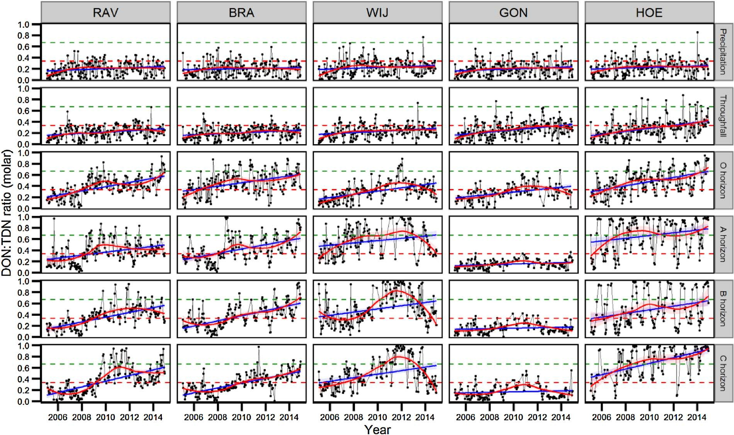

Fig. A1. Fortnightly DON:TDN ratio in deposition and soil solution for the ﬁve locations, with Williams et al. (2004)’s critical limits for stages of N saturation (0: DON:TDN > 0.67 indicated by the green dashed line, 1: 0.33 < DON:TDN < 0.67, 2: DON:TDN < 0.33 indicated by the red dashed line) and trend lines (blue: linear regression line, red: LOESS curve). (For interpretation of the references to colour in this ﬁgure legend, the reader is referred to the web version of this article.)

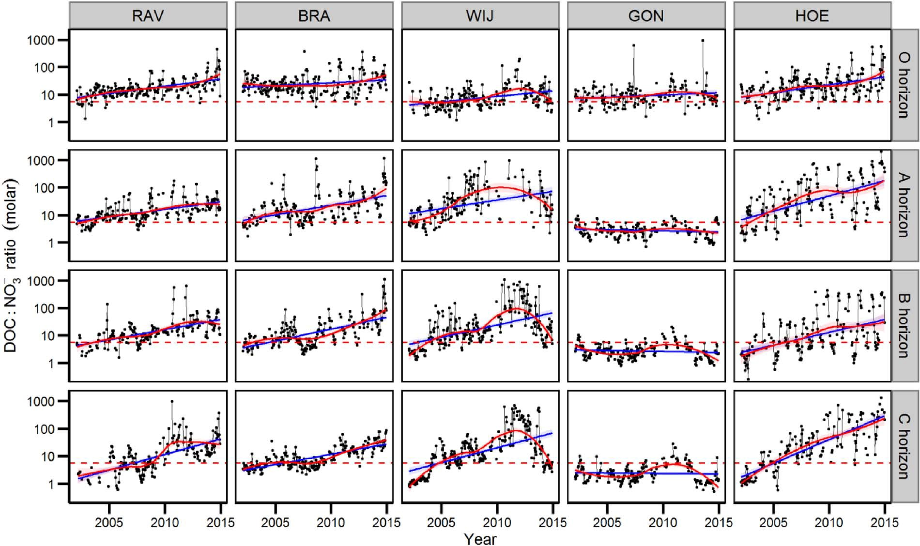

Fig. A2. Fortnightly DOC:NO3− ratio in soil solution for the ﬁve locations, with critical inﬂection point for soils (DOC:NO3− = 5.22) as proposed by Taylor and Townsend (2010) indicated by the red dashed line and trend lines (blue: linear regression line, red: LOESS curve). (For interpretation of the references to colour in this ﬁgure legend, the reader is referred to the web version of this article.)

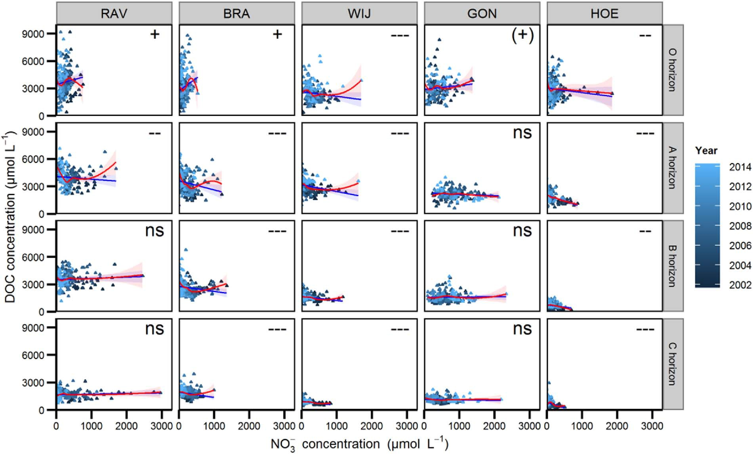

Fig. A3. Soil solution DOC concentration in function of NO3
−
concentration for the ﬁve locations (2002–2014) with trend lines (blue: linear regression line, red: LOESS curve) and

signiﬁcance of the correlation (ns: not signiﬁcant, (+): p < 0.1, +: p < 0.05, -: p < 0.01, —: p < 0.001). (For interpretation of the references to colour in this ﬁgure legend, the reader is referred to the web version of this article.)

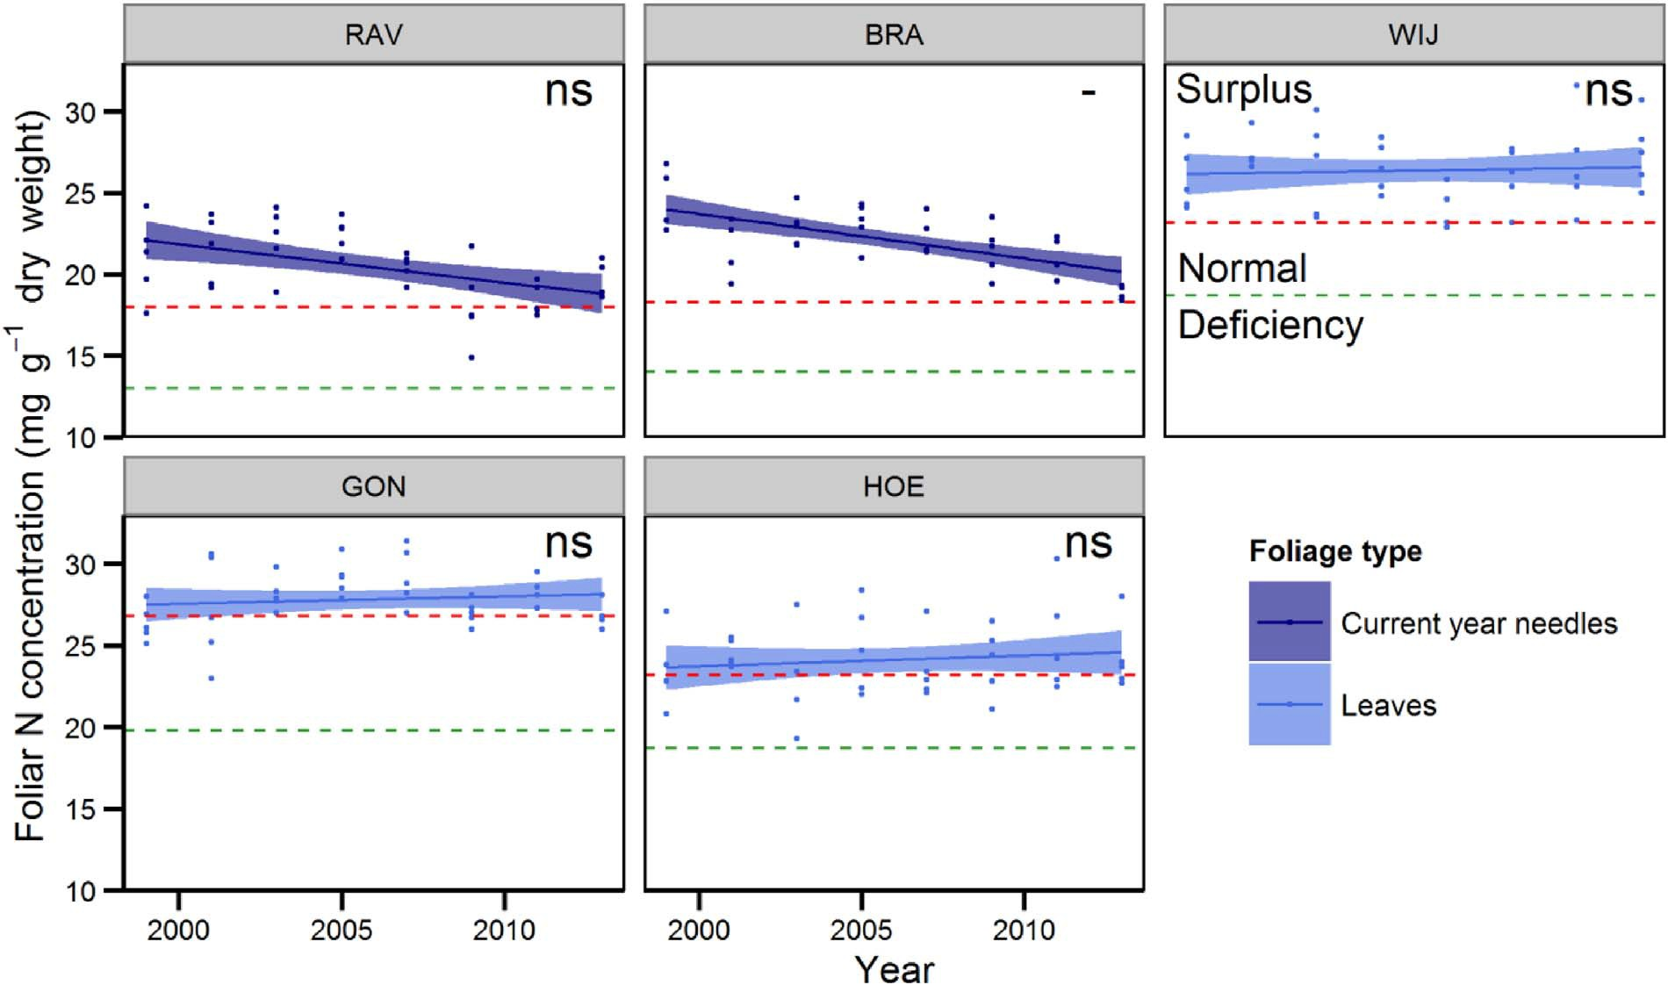

Fig. A4. Foliar N concentration for the ﬁve locations (1999–2013) with critical lower limit (green) and upper limit (orange) (van den Burg and Schaap, 1995; Mellert and Göttlein, 2012), with signiﬁcance of Mann-Kendall trends (ns: not signiﬁcant, -: p < 0.05). (For interpretation of the references to colour in this ﬁgure legend, the reader is referred to the web version of this article.)

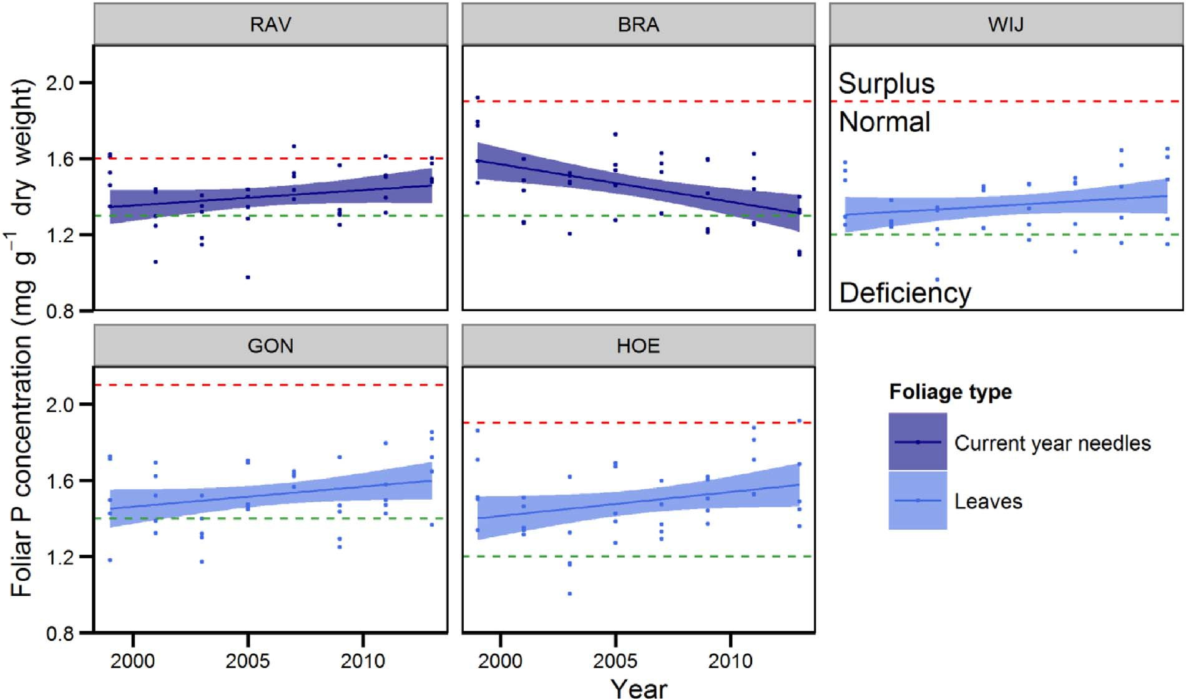

Fig. A5. Foliar P concentration for the ﬁve locations (1999–2013) with critical lower limit (green) and upper limit (orange) (van den Burg and Schaap, 1995; Mellert and Göttlein, 2012). Trends were not signiﬁcant. (For interpretation of the references to colour in this ﬁgure legend, the reader is referred to the web version of this article.)

References

Aber, J.D., Nadelhoﬀer, K.J., Steudler, P., Melillo, J.M., 1989. Nitrogen saturation in northern forest ecosystems: excess nitrogen from fossil fuel combustion may stress the biosphere. Bioscience 39, 378–386. http://dx.doi.org/10.2307/1311067.
Aber, J., McDowell, W., Nadelhoﬀer, K., Magill, A., Berntson, G., Kamakea, M., McNulty, S., Currie, W., Rustad, L., Fernandez, I., 1998. Nitrogen saturation in temperate forest ecosystems. Bioscience 48, 921–934. http://dx.doi.org/10.2307/1313296.
Aber, J.D., Goodale, C.L., Ollinger, S.V., Smith, M.-L., Magill, A.H., Martin, M.E., Hallett, R.A., Stoddard, J.L., 2003. Is nitrogen deposition altering the nitrogen status of northeastern forests? Bioscience 53, 375–389. http://dx.doi.org/10.1641/0006- 3568(2003)053[0375:indatn]2.0.co;2.
Callesen, I., Raulund-Rasmussen, K., Gundersen, P., Stryhn, H., 1999. Nitrate con- centrations in soil solutions below Danish forests. For. Ecol. Manage. 114, 71–82. http://dx.doi.org/10.1016/S0378-1127(98)00382-X.
Clarke, N., Žlindra, D., Ulrich, E., Mosello, R., Derome, J., Derome, K., König, N., Lövblad, G., Draaijers, G.P.J., Hansen, K., Thimonier, A., Waldner, P., 2016. Part XIV: sam- pling and analysis of deposition. UNECE ICP Forests Programme Co-ordinating Centre (ed.): Manual on Methods and Criteria for Harmonized Sampling, Assessment, Monitoring and Analysis of the Eﬀects of Air Pollution on Forests. Thünen Institute of Forest Ecosystems, Eberswalde 66 p. Available from: http://icp-forests.net/page/icp- forests-manual.
Cools, N., Verstraeten, A., Sioen, G., Neirynck, J., Roskams, P., Louette, G., Hoﬀmann, M., 2016. LTER-Belgium – Results of Long-term, Large-scale and Intensive Monitoring at the Flemish Forest Condition Monitoring Sites Within the LTER-Belgium Network. Rapporten van het Instituut voor Natuur- en Bosonderzoek, Brussels INBO.R.2016.11433903.
Currie, W.S., Aber, J.D., McDowell, W.H., Boone, R.D., Magill, A.H., 1996. Vertical transport of dissolved organic C and N under long-term N amendments in pine and hardwood forests. Biogeochemistry 35, 471–505. http://dx.doi.org/10.1007/ BF02183037.
de Wit, H.A., Mulder, J., Hindar, A., Hole, L., 2007. Long term increase in dissolved organic carbon in stream waters in Norway is response to reduced acid deposition. Environ. Sci. Technol. 41, 7706–7713. http://dx.doi.org/10.1021/es070557f.
Dise, N.B., Wright, R.F., 1995. Nitrate leaching from European forests in relation to ni- trogen deposition. For. Ecol. Manage. 71, 153–161. http://dx.doi.org/10.1016/0378- 1127(94)06092-W.
Galloway, J.N., Aber, J.D., Erisman, J.W., Seitzinger, S.P., Howarth, R.W., Cowling, E.B., Cosby, J.B., 2003. The nitrogen cascade. Bioscience 53, 341–356. http://dx.doi.org/ 10.1641/0006-3568(2003)053[0341:TNC]2.0.CO;2.
Giraudoux, P., 2015. Pgirmess: Data Analysis in Ecology, R Package Version 1.6.3. Accessed 7 November 2016. http://CRAN.R-project.org/package=pgirmess.
Helton, A.M., Ardón, M., Bernhardt, E.S., 2015. Thermodynamic constraints on the utility of ecological stoichiometry for explaining global biogeochemical patterns. Ecol. Lett. 18, 1049–1056. http://dx.doi.org/10.1111/ele.12487.
Hirsch, R.M., Slack, J.R., Smith, R.A., 1982. Techniques of trend analysis for monthly
water-quality data. Water Resour. Res. 18, 107–121. http://dx.doi.org/10.1029/ WR018i001p00107.
Iost, S., Rautio, P., Lindroos, A.-J., 2012. Spatio-temporal trends in soil solution Bc/Al and N in relation to critical limits in European forest soils. Water Air Soil Pollut. 223, 1467–1479. http://dx.doi.org/10.1007/s11270-011-0958-7.
Jonard, M., Legout, A., Nicolas, M., Dambrine, E., Nys, C., Ulrich, E., van der Perre, R., Ponette, Q., 2012. Deterioration of tree vitality despite a sharp decline in acid de- position: a long-term regional perspective. Glob. Change Biol. 18, 711–725. http:// dx.doi.org/10.1111/j.1365-2486.2011.02550.x.
Jonard, M., Fürst, A., Verstraeten, A., Thimonier, A., Timmermann, V., Potočić, N., Waldner, P., Benham, S., Hansen, K., Merilä, P., Ponette, Q., de la Cruz, A., Roskams, P., Nicolas, M., Croisé, L., Ingerslev, M., Matteucci, M., Decinti, B., Bascietto, M., Rautio, P., 2015. Tree mineral nutrition is deteriorating in Europe. Glob. Change Biol. 21, 418–430. http://dx.doi.org/10.1111/gcb.12657.
König, N., Kowalska, A., Brunialti, G., Ferretti, M., Clarke, N., Cools, N., Derome, J., Derome, K., De Vos, B., Fürst, A., Jakovlevič, T., Marchetto, A., Mosello, R., O’Dea, P., Tartari, G.A., Ulrich, E., 2016. Part XVI: quality assurance and control in laboratories. UNECE ICP Forests Programme Co-ordinating Centre (ed.): Manual on Methods and Criteria for Harmonized Sampling, Assessment, Monitoring and Analysis of the Eﬀects of Air Pollution on Forests. Thünen Institute of Forest Ecosystems, Eberswalde 53 p. Available from: http://icp-forests.net/page/icp-forests-manual.
Kalbitz, K., Solinger, S., Park, J.-H., Michalzik, B., Matzner, E., 2000. Controls on the dynamics of dissolved organic matter in soils: a review. Soil Sci. 165, 277–304. http://dx.doi.org/10.1097/00010694-200004000-00001.
Kochian, L.V., Hoekenga, O.W., Piñeros, M.A., 2004. How do crop plants tolerate acid soils? Mechanisms of aluminum tolerance and phosphorous eﬃciency. Annu. Rev. Plant Biol. 55, 459–493. http://dx.doi.org/10.1146/annurev.arplant.55.031903.
141655.
Lovett, G.M., Goodale, C.L., 2011. A new conceptual model of nitrogen saturation based on experimental nitrogen addition to an oak forest. Ecosystems 14, 615–631. http:// dx.doi.org/10.1007/s10021-011-9432-z.
Mann, H.B., 1945. Nonparametric tests against trend. Econometrica 13, 245–249. http:// dx.doi.org/10.2307/1907187.
Marchetto, A., 2015. rkt: Mann-Kendall test, Seasonal and Regional Kendall Tests, R package version 1.4. http://CRAN.R-project.org/package=rkt.
McDowell, W.H., Magill, A.H., Aitkenhead-Peterson, J.A., Aber, J.D., Merriam, J.L., Kaushal, S.S., 2004. Eﬀects of chronic nitrogen amendment on dissolved organic matter and inorganic nitrogen in soil solution. For. Ecol. Manage. 196, 29–41. http:// dx.doi.org/10.1016/j.foreco.2004.03.010.
Meesenburg, H., Ahrends, B., Fleck, S., Wagner, M., Fortmann, H., Scheler, B., Klinck, U., Dammann, I., Eichhorn, J., Mindrup, M., Meiwes, K.J., 2016. Long-term changes of ecosystem services at Solling, Germany: recovery from acidiﬁcation, but increasing nitrogen saturation? Ecol. Indic. 65, 103–112. http://dx.doi.org/10.1016/j.ecolind. 2015.12.013.
Mellert, K.H., Göttlein, A., 2012. Comparison of new foliar nutrient thresholds derived from van den Burg’s literature compilation with established central European

references. Eur. J. For. Res. 131, 1461–1472. http://dx.doi.org/10.1007/s10342- 012-0615-8.
Monteith, D.T., Stoddard, J.L., Evans, C.D., de Wit, H.A., Forsius, M., Høgåsen, T., Wilander, A., Skjelkvåle, B.L., Jeﬀries, D.S., Vuorenmaa, J., Keller, B., Kopácek, J., Vesely, J., 2007. Dissolved organic carbon trends resulting from changes in atmo- spheric deposition chemistry. Nature 450, 537–540. http://dx.doi.org/10.1038/ nature06316.
Nieminen, T.M., De Vos, B., Cools, N., König, N., Fischer, R., Iost, S., Meesenburg, H., Nicolas, M., O’Dea, P., Cecchini, G., Ferretti, M., De La Cruz, A., Derome, K., Lindroos, A.-J., Graf Pannatier, E., 2016. Part XI: soil solution collection and analysis. UNECE ICP Forests Programme Co-ordinating Centre (ed.): Manual on Methods and Criteria for Harmonized Sampling, Assessment, Monitoring and Analysis of the Eﬀects of Air Pollution on Forests. Thünen Institute of Forest Ecosystems, Eberswalde 29 p.
Available from: http://icp-forests.net/page/icp-forests-manual.
Nilsson, J., Grennfelt, P.E., 1988. Critical Loads for Sulphur and Nitrogen. UNECE/Nordic Council of Ministers, Copenhagen, Denmark.
Niu, S., Classen, A.T., Dukes, J.S., Kardol, P., Liu, L., Luo, Y., Rustad, L., Sun, J., Tang, J.,
Templer, P.H., Thomas, R.Q., Tian, D., Vicca, S., Wang, Y.-P., Xia, J., Zaehle, S., 2016. Global patterns and substrate-based mechanisms of the terrestrial nitrogen cycle.
Ecol. Lett. 19, 697–709. http://dx.doi.org/10.1111/ele.12591.
Oulehle, F., Evans, C.D., Hofmeister, J., Krejci, R., Tahovska, K., Persson, T., Cudlin, P., Hruska, J., 2011. Major changes in forest carbon and nitrogen cycling caused by declining sulphur deposition. Glob. Chang. Biol. 17, 3115–3129. http://dx.doi.org/ 10.1111/j.1365-2486.2011.02468.x.
Park, J.-H., Matzner, E., 2006. Detrital control on the release of dissolved organic ni- trogen (DON) and dissolved inorganic nitrogen (DIN) from the forest ﬂoor under chronic N deposition. Environ. Pollut. 143, 178–185. http://dx.doi.org/10.1016/j. envpol.2005.10.045.
Pastor, J., Post, W.M., 1986. Inﬂuence of climate, soil moisture, and succession on forest carbon and nitrogen cycles. Biogeochemistry 2, 3–27. http://dx.doi.org/10.1007/ BF02186962.
Perakis, S.S., Hedin, L.O., 2002. Nitrogen loss from unpolluted South American forests mainly via dissolved organic compounds. Nature 415, 416–419. http://dx.doi.org/ 10.1038/415416a.
Perakis, S.S., Sinkhorn, E.R., 2011. Biogeochemistry of a temperate forest nitrogen gra- dient. Ecology 92, 1481–1491. http://dx.doi.org/10.1890/10-1642.1.
Pregitzer, K.S., Zak, D.R., Burton, A.J., Ashby, J.A., MacDonald, N.W., 2004. Chronic nitrate additions dramatically increase the export of carbon and nitrogen from northern hardwood ecosystems. Biogeochemistry 68, 179–197. http://dx.doi.org/10. 1023/B:BIOG.0000025737.29546.fd.
R. Core Team, 2016. R: A Language and Environment for Statistical Computing. R Foundation for Statistical Computing, Vienna, Austria. http://www.R-project.org/.
Rautio, P., Fürst, A., Stefan, K., Raitio, H., Bartels, U., 2016. Part XII: sampling and analysis of needles and leaves. UNECE ICP Forests Programme Co-ordinating Centre (ed.): Manual on Methods and Criteria for Harmonized Sampling, Assessment, Monitoring and Analysis of the Eﬀects of Air Pollution on Forests. Thünen Institute of Forest Ecosystems, Eberswalde 19 p. Available from: http://icp-forests.net/page/icp- forests-manual.
Scheel, T., Dörﬂer, C., Kalbitz, K., 2007. Precipitation of dissolved organic matter by aluminum stabilizes carbon in acidic forest soils. Soil Sci. Soc. Am. J. 71, 64–74. http://dx.doi.org/10.2136/sssaj2006.0111.
Sleutel, S., Vandenbruwane, J., De Schrijver, A., Wuyts, K., Moeskops, B., Verheyen, K., De Neve, S., 2009. Patterns of dissolved organic carbon and nitrogen ﬂuxes in de- ciduous and coniferous forests under historic high nitrogen deposition.
Biogeosciences 6, 2743–2758. http://dx.doi.org/10.5194/bg-6-2743-2009.
Stevens, C.J., 2016. How long do ecosystems take to recover from atmospheric nitrogen deposition? Biol. Conserv. 200, 160–167. http://dx.doi.org/10.1016/j.biocon.2016.
06.005.
Taylor, P.G., Townsend, A.R., 2010. Stoichiometric control of organic carbon-nitrate re- lationships from soils to the sea. Nature 464, 1178–1181. http://dx.doi.org/10.1038/ nature08985.
VMM, 2016. Lozingen in de lucht 2000–2015. p 141–145. (in Dutch).
van Breemen, N., Driscoll, C.T., Mulder, J., 1984. Acidic deposition and internal proton sources in acidiﬁcation of soils and waters. Nature 307, 599–604. http://dx.doi.org/ 10.1038/307599a0.
van den Burg, J., Schaap, W., 1995. Richtlijnen voor mineralentoediening en bekalking als eﬀectgerichte maatregelen in bossen. Rapport IKC natuurbeheer nr. 16, Wageningen, The Netherlands.
Vanguelova, E.I., Benham, S., Pitman, R., Moﬀat, A.J., Broadmeadow, M., Nisbet, T., Durrant, D., Barsoum, N., Wilkinson, M., Bochereau, F., Hutchings, T., Broadmeadow, S., Crow, P., Taylor, P., Durrant Houston, T., 2010. Chemical ﬂuxes in time through forest ecosystems in the UK – soil response to pollution recovery. Environ. Pollut. 158, 1857–1869. http://dx.doi.org/10.1016/j.envpol.2009.10.044.
Veresoglou, S.D., Peñuelas, J., Fischer, R., Rautio, P., Sardans, J., Merilä, P., Tabakovic- Tosic, M., Rillig, M.C., 2014. Exploring continental-scale stand health N: P ratio re- lationships for European forests. New Phytol. 202, 422–430. http://dx.doi.org/10. 1111/nph.12665.
Verstraeten, A., Neirynck, J., Genouw, G., Cools, N., Roskams, P., Hens, M., 2012. Impact of declining atmospheric deposition on forest soil solution chemistry in Flanders, Belgium. Atmos. Environ. 62, 50–63. http://dx.doi.org/10.1016/j.atmosenv.2012.
08.017.
Verstraeten, A., De Vos, B., Neirynck, J., Roskams, P., Hens, M., 2014. Impact of air-borne or canopy-derived dissolved organic carbon (DOC) on forest soil solution DOC in Flanders, Belgium. Atmos. Environ. 83, 155–165. http://dx.doi.org/10.1016/j. atmosenv.2013.10.058.
Verstraeten, A., Verschelde, P., De Vos, B., Neirynck, J., Cools, N., Roskams, P., Hens, M., Louette, G., Sleutel, S., De Neve, S., 2016. Increasing trends of dissolved organic nitrogen (DON) in temperate forests under recovery from acidiﬁcation in Flanders, Belgium. Sci. Total Environ. 553, 107–119. http://dx.doi.org/10.1016/j.scitotenv. 2016.02.060.
Waldner, P., Marchetto, A., Thimonier, A., Schmitt, M., Rogora, M., Granke, O., Mues, V., Hansen, K., Karlsson, G.P., Žlindra, D., Clarke, N., Verstraeten, A., Lazdins, A., Schimming, C., Iacoban, C., Lindroos, A.-J., Vanguelova, E., Benham, S., Meesenburg, H., Nicolas, M., Kowalska, A., Apuhtin, V., Nappa, U., Lachmanová, Z., Kristöfel, F., Bleeker, A., Ingerslev, M., Vesterdal, L., Molina, J., Fischer, U., Seidling, W., Jonard, M., O’Dea, P., Johnson, J., Fischer, R., Lorenz, M., 2014. Detection of temporal trends in atmospheric deposition of inorganic nitrogen and sulphate to forests in Europe. Atmos. Environ. 95, 363–374. http://dx.doi.org/10.1016/j.atmosenv.2014.06.054.
Waldner, P., Thimonier, A., Graf Pannatier, E., Etzold, S., Schmitt, M., Marchetto, A., Rautio, P., Derome, K., Nieminen, T.M., Nevalainen, S., Lindroos, A.-J., Merilä, P., Kindermann, M., Neumann, M., Cools, N., De Vos, B., Roskams, P., Verstraeten, A., Hansen, K., Karlsson, G.P., Dietrich, H.-P., Raspe, S., Fischer, R., Lorenz, M., Iost, S., Granke, O., Sanders, T.G.M., Michel, A., Nagel, H.-D., Scheuschner, T., Simončič, P., von Wilpert, K., Meesenburg, H., Fleck, S., Benham, S., Vanguelova, E., Clarke, N., Ingerslev, M., Vesterdal, L., Gundersen, P., Stupak, I., Jonard, M., Potočić, N., Minaya, M., 2015. Exceedance of critical loads and of critical limits impacts tree nutrition across Europe. Ann. For. Sci. 72, 929–939. http://dx.doi.org/10.1007/ s13595-015-0489-2.
Williams, M.W., Hood, E., Caine, N., 2001. Role of organic nitrogen in the nitrogen cycle of a high-elevation catchment, Colorado front range. Water Resour. Res. 37, 2569–2581. http://dx.doi.org/10.1029/2001WR000485.
Williams, M.W., Clow, D., Blett, T., 2004. A novel indicator of ecosystem N status: DIN to DON ratio in riverine waters. American Geophysical Union, Fall Meeting. http:// adsabs.harvard.edu/abs/2004AGUFM.H53F.05W.

