Coexistence and niche differentiation at large spatial scale in a West-European softwater plant community

Floris Vanderhaeghe . Sofie Ruysschaert . Leon J. L. van den Berg . Jan G. M. Roelofs . Alfons J. P. Smolders . Maurice Hoffmann

Abstract There is growing evidence that species are able to coexist in communities through niche separa- tion, and that consistent community structuring can take place at the biogeographical scale, as the same biotic interactions can determine species’ fate at large scales. In this study, we document niche differentia- tion at a larger scale within a specific plant community of softwater lakes in Western Europe. Five species were selected for their relative frequency and wide geographical distribution within the dataset that we collected. Their niches were modelled both from

Communicated by Anne Bonis.

F. Vanderhaeghe · S. Ruysschaert · M. Hoffmann Terrestrial Ecology Unit, Department of Biology, Ghent University, K.L. Ledeganckstraat 35, 9000 Ghent, Belgium

F. Vanderhaeghe (&) · M. Hoffmann
Research Institute for Nature and Forest, Kliniekstraat 25, 1070 Brussels, Belgium
e-mail: floris.vanderhaeghe@inbo.be

L. J. L. van den Berg · J. G. M. Roelofs ·
A. J. P. Smolders
Department of Aquatic Ecology & Environmental Biology, Institute for Water and Wetland Research, Huygens Building, Radboud University Nijmegen, Heyendaalseweg 135, 6525 AJ Nijmegen,
The Netherlands
presence–absence data and from ordinal abundance data, using mixed regression techniques (generalized linear mixed models and proportional odds mixed models, respectively). The modelled realized niches differed among the species on the West-European scale, although strict separation was not shown and geographical coverage is not complete. Plant strategy characterization of the species supported the assump- tion that functional traits underpin the niche differen- tiation among the species through fitness trade-offs. Mechanistic experimental research at a range of spatial scales is needed to test the importance of different community structuring mechanisms at the biogeographical scale, such as biotic interactions and environmental filtering.

L. J. L. van den Berg
Unie van Bosgroepen, Postbus 8187, 6710 AD Ede, The Netherlands

A. J. P. Smolders
B-WARE Research Centre, Radboud University Nijmegen, P.O. Box 9010, 6500 GL Nijmegen, The Netherlands

Keywords Softwater lake · Resource partitioning · Habitat 3130 · Proportional odds models · Generalized linear mixed models · Species distribution models

Abbreviations
GLMM Generalized linear mixed model POMM Proportional odds mixed model VIF Variance inflation factor

Introduction

Niches are a convenient instrument to describe conditions under which species survive, reproduce and coexist in a community (Mueller-Dombois and Ellenberg 1974; Austin and Smith 1989; Amarasekare 2003; Silvertown 2004). Following the view of Hutchinson (1957) and Silvertown (2004) the niche is described as the abstract hypervolume defined by axes of conditions and resources within which popu- lations of a species can maintain a long-term average net reproductive rate C1. The concept is especially used to visualize how biotic interactions shape the species’ realized niche, in relation to its physiological capabilities, also known as its fundamental niche (Austin 1990; Keddy 2001). Why species can be the ‘winner’ only in a part of their fundamental niche, is supposed to be linked to an inherent trade-off (Kneitel and Chase 2004; Silvertown 2004), e.g. a high ability to quickly take advantage of new light and nutrient supplies would not be compatible with a high ability to compete in a more resource-limited environment.
There is growing evidence that species are able to coexist in communities through niche separation (McKane et al. 2002; Levine and HilleRisLambers 2009), often referred to as resource partitioning in the case of resource gradients (Tilman 1982). Niche separa- tion, then, is typically the result of changing competitive interactions among the same species along environmental gradients in a community (Keddy 2001). Also, growing evidence exists of consistent community structuring at the biogeographical scale, as the same biotic interactions can determine species’ fate at large scales (Wisz et al. 2013), and hence coexistence. On the other hand, coexistence in a community can occur through neutral processes, i.e. as a result of local stochastic dispersal and demographic events (Hubbell 2001; Kneitel and Chase 2004; Tilman 2004; Leibold et al. 2004).
We present a study on the realized niches of five semi-aquatic plant species within a West-European vegetation type of nutrient-poor softwater lake shores: the Eleocharition multicaulis Vanden Berghen 1969 alliance. The niches of its characteristic species have not been subject to much quantitative research (but see Vanderhaeghe et al. (2005) on the realized niche of Eleocharis multicaulis, the most characteristic species of the community). Actually testing community struc- turing mechanisms in nature is difficult (Amarasekare 2003) and we did not consider testing them as a goal. Nevertheless we explored niche separation at the biogeographical scale, between these specific species and within the vegetation type, though geographical balance was not complete. By maintaining focus on one vegetation type and not extending to the species’ niches outside this community, we expected to observe a more consistent outcome of the same (or similar) community assembly mechanisms, that operate in this community throughout the investigated area. Within this vegetation type, several characteristic species are present that are competitively suppressed or replaced by other species (Vanderhaeghe et al. 2013). Among the five investi- gated species were two characteristic species and three potentially dominant species. As competitive trade-offs are related to functional trait trade-offs (Kneitel and Chase 2004; Westoby and Wright 2006), we also looked at whether large-scale niche differentiation coincides with functional species classification.
In the current study, we (1) determine the realized niche, in terms of occurrence and ground cover, of five selected amphibious perennials, within one vegetation type, the Eleocharition multicaulis; (2) seek for the existence of niche differentiation and resource sepa- ration between these species at larger scale; (3) compare niche differentiation with strategy types, in order to seek a competitive trade-off for resource acquisition between neighbouring species.

Methods

Studied community and location of plots

To describe the realized niche of an entire species with niche models (species distribution models or habitat models), the ideal approach is to sample along the whole biogeographical and environmental distribution range (Austin 2007; Thuiller et al. 2008;

Franklin and Miller 2009; Elith and Leathwick 2009). However, to verify niche differentiation within one vegetation type, it is necessary to focus only on sites and areas where this community is present. 46 softwater lakes with characteristic species of the Eleocharition multicaulis alliance were therefore selected within the geographical range of the alliance (Fig. 1), which is Atlantic (Schoof-van Pelt 1973; Dierssen 1975; Pietsch 1977, 1985; Arts and Den Hartog 1990; Szmeja and Cle´ment 1990; Schamine´e et al. 1992; Rodriguez- Oubina et al. 1997). This alliance is often brought into synonymy with the somewhat broader Hydro- cotylo-Baldellion Tu¨ xen & Dierssen 1972, and is part of the European habitat 3130 of Atlantic softwater lakes (European Commission 2007). The Eleocharition multicaulis is characterized by Eleo- charis multicaulis (Smith) Desv., Hypericum elodes
L. and Scirpus fluitans L. Within each lake, mostly one or two plots of 2 m2 were investigated. Their location was chosen based on the on-site variation in species composition. In this way, data were col- lected from 79 plots, all representing an Eleochari- tion multicaulis community, with an internal gradient from ‘pristine’ (low productivity) to more or less ‘degraded’ (high productivity). More details on the locations of lakes and plots are given in Online Resources 1 and 2.

Data collection

In each plot, ground cover was visually estimated for all plant species during the summer of 2001 using the ordinal Londo cover-abundance scale (Londo 1984). For the current study, we selected five species for further examination, based on their frequency and geographical spread in the dataset (frequency of 58, 32, 46, 58 and 71 % of the sampled plots, respec- tively): Eleocharis multicaulis and Hypericum elodes, both characteristic of the Eleocharition multicaulis alliance, and Agrostis canina L., Hydrocotyle vulgaris
L. and Juncus bulbosus L. The latter three can dominate over characteristic species of the Littorel- letea (Lucassen et al. 1999; Arts 2002), and are less confined to the environment of softwater lakes alone. Consequently, the dataset contains both presences and absences of the targeted species, necessary to define their realized niches. The original cover classes were merged for analysis: 0 % (absent), 0–4.99 and
5–100 % ground cover. This is because the frequency of the higher cover classes was too low.
Both in summer of 2001 and during the following winter in 2002, surface water and soil samples were collected in each plot. In this way we captured different seasonal states to characterize a species’ environment. Furthermore, we used four bioclimatic variables extracted from the WorldClim 1.3 grid, supplemented with mean height of the water layer above the plot (see Table 1; Hijmans et al. (2005)). More explanations on soil, water and climate variables are given in Online Resource 2.

Species association

In order to assess local (plot)-scale coexistence between the selected species in the dataset, gamma was used as a non-parametric measure of ordinal association between species. It was applied both to presence–absence and to ordinal cover responses. The same statistic was used to assess discriminative accuracy of the ordinal niche models (see Online Resource 2 for further information). Ordinal association measures are based on the concor- dance between two variables, of which at least one is ordinal (Gonzalez and Nelson 1996; Guisan and Harrell 2000; Harrell 2001; Vaughan and Ormerod 2005). More specifically, each possible pair of sites is evalu- ated. If the ranking orders of both variables are the same, the pair of sites is counted as a concordance. If the ranking orders between both variables are opposite, it is counted as a discordance. Three further cases can be distinguished, based on ties (in which case both sites have an equal value): i.e. for ties on one, on the other or on both variables. We used gamma as the association measure because it does not penalize ties in either of both variables, as this would introduce artefacts for ordinal cover and in bootstrap model evaluations (Gonzalez and Nelson 1996). Gamma is defined as (C - D)/(C ? D), where C is the number of concor- dances and D the number of discordances, when comparing the ranks between both variables for all possible pairs of sites. Its values are between -1 and
?1.

Niche models

For the objective of niche comparison, we selected 39 environmental variables (Table 1) out of all initially

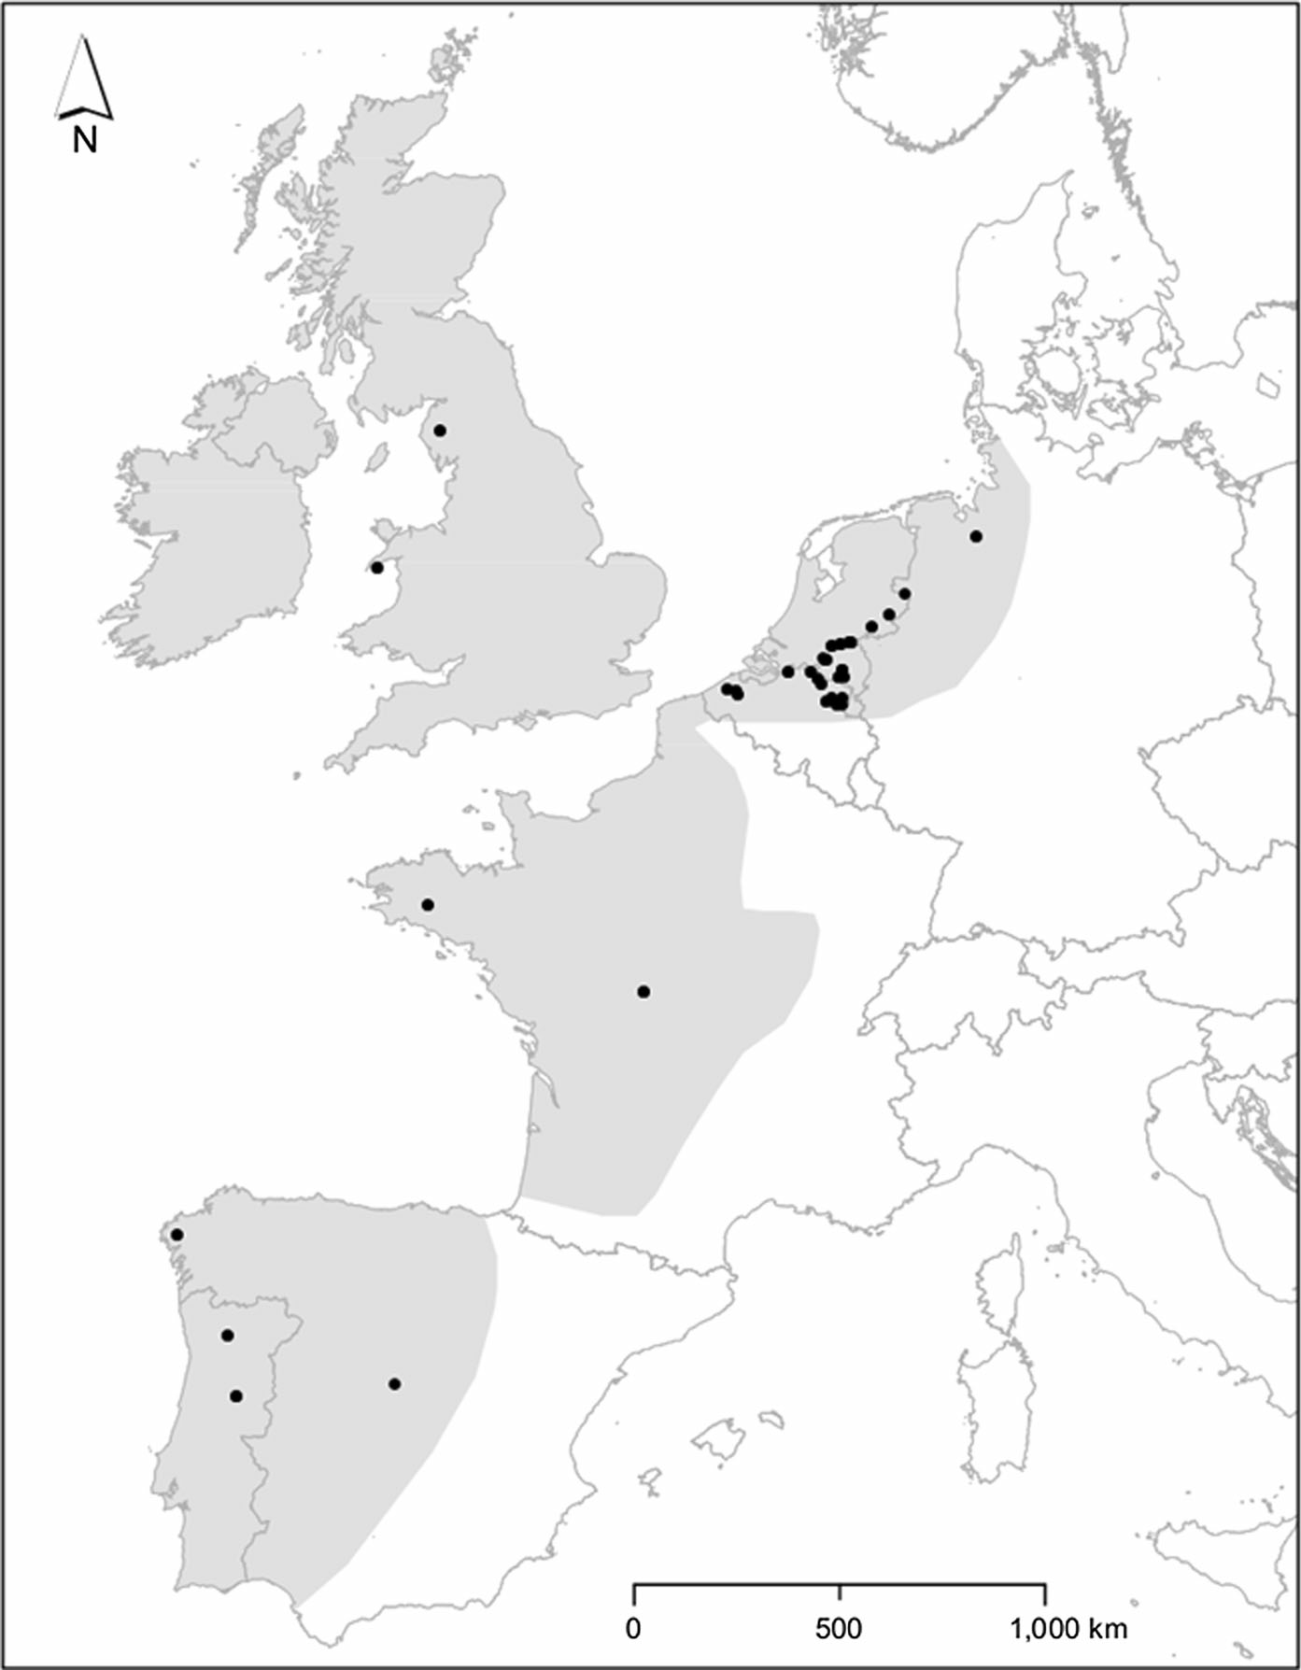Fig. 1 Geographical location of the sampled softwater lakes (see Online Resource 1 for more details). The shaded zone is the area where all three characteristic species of the Eleocharition multicaulis occur: Eleocharis multicaulis, Hypericum elodes and Scirpus fluitans (after Fitter (1978), Hulte´n and Fries (1986) and the GBIF data portal, data.gbif.org)

measured environmental variables. This selection was based both on the assumed primary importance of several variables for the physiology and fitness of plant species (Austin and Smith 1989; Austin 2007; Franklin and Miller 2009), and on additional variables that had previously been shown to predict the cover of one characteristic species (Vanderhaeghe et al. 2005). A preliminary correlation analysis led to the predictors shown in Table 2, in which subsequent selection steps are shown. As a proxy of diffuse competition, we also included total cover of the neighbouring species as a predictor. More explanations on variable selection are given in Online Resource 2.

Comparison between species needs to be done in the same niche hyperspace. Therefore, the fitted niche models of different species contained the same predictors (species distribution models or habitat models, see Guisan and Zimmermann (2000), Austin (2007), Thuiller et al. (2008), Elith and Leathwick (2009)). Models were fitted to the data with as few predictors as possible, in order to minimize the degree of overfitting, using the Akaike Information Criterion (AIC) as the main criterion for model selection (Johnson and Omland 2004; Ginzburg and Jensen 2004; Zuur et al. 2009). We used generalized linear mixed models (GLMM; Raudenbusch and Bryk 2002;

Soil Soil Soil Soil Soil Soil Soil Soil Soil Soil Soil Soil Soil | C C C C C C C C C C C C P | S S S S S S W W W W W W S | Ammonium NaCl extraction (lmol/kg DW) Nitrate water extraction (lmol/kg DW) Phosphorus digestion (lmol/kg DW) Orthophosphate lactate extraction (lmol/kg DW) Phosphorus NaCl extraction (lmol/kg DW)  Total N content (lmol/kg DW)  Ammonium NaCl extraction (lmol/kg DW) Nitrate water extraction (lmol/kg DW) Phosphorus digestion (lmol/kg DW) Orthophosphate lactate extraction (lmol/kg DW) Phosphorus NaCl extraction (lmol/kg DW)  Total N content (lmol/kg DW) Moisture (%) | S_AMMS S_NO3W S_PD S_PO4L S_PS S_TOTN W_AMMS W_NO3W W_PD W_PO4L W_PS W_TOTN S_MOIS
Surface water Surface water Surface water Surface water Direct gradients  Air | C C C C  P | W W W W  S | Ammonium (lmol/L) Carbon dioxide (lmol/L) Nitrate (lmol/L) Orthophosphate (lmol/L)  Max. Temperature of Warmest Month | AMM CO2 NO3 PO4  BIO5
Air | P | W | Min. Temperature of Coldest Month | BIO6
Air | P | S | Mean Temperature of Warmest Quarter | BIO10
Air | P | W | Mean Temperature of Coldest Quarter | BIO11
Soil Soil Soil | C C C | S W S | Calcium NaCl extraction (lmol/kg DW) Calcium NaCl extraction (lmol/kg DW) N/P ratio (NaCl extraction) | S_CAS W_CAS S_NP
Soil | C | W | N/P ratio (NaCl extraction) | W_NP
Surface water Surface water Surface water | C C C | W W W | Alkalinity (leq/L) Calcium (lmol/L) pH | ALK CA PH
Surface water | C | W | NH4/NO3 ratio | ANI
Indirect gradients
Soil Soil Soil Soil Soil | C C C C C | S S S W W | Iron NaCl extraction (lmol/kg DW) Loss on ignition (LOI) (%)  Silicon digestion (lmol/kg DW) Iron NaCl extraction (lmol/kg DW) Loss on ignition (LOI) (%) | S_FES S_LOI S_SID W_FES W_LOI
Soil Soil | C P | W  – | Silicon digestion (lmol/kg DW) Thickness of organic soil layer (cm) | W_SID OS_THIC
Surface water | C | W | Ion Ratio (Ca/(Ca ? Cl)) | IR
Surface water | P | S | Mean thickness of water layer (cm) | WATLATHS
Surface water | P | W | Mean thickness of water layer (cm) | WATLATHW

Table 1 The 39 environmental variables that were originally selected for analysis

Compartment Type Season Variable Abbreviation Resource gradients

C chemical, P physical, S summer, W winter

Table 2 Pearson correlation between 24 environmental covariates of ecological interest (after transformation)

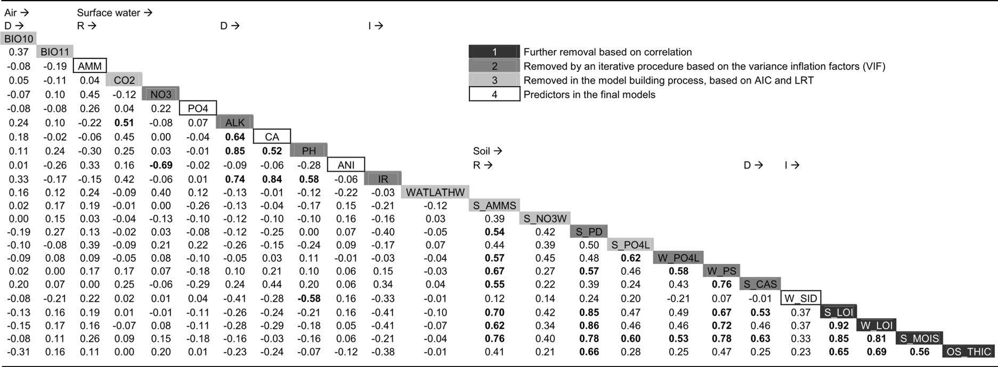
Boldface coefficients are higher than 0.5 (as absolute values); for abbreviations of variables, see Table 1. To get this subset, several variables were removed from the list in Table 1, based on correlations between summer and winter variables and chosen according to strongest univariate response pattern. The variables are ordered according to environmental compartment and plant ecological role (R: resource gradients, D: direct gradients, I: indirect gradients). Further predictor selection steps are explained in the legend

Bolker et al. 2009) for the presence–absence response as well as proportional odds mixed models (POMM; Guisan and Harrell 2000; Harrell 2001) to distinguish between cover classes. We considered the use of cover classes as ecologically more appealing as, under the assumption of equilibrium with the environment (Guisan and Zimmermann 2000), it reflects perfor- mance, and therefore fitness, a property preferred to describe a species’ niche (Austin 1999; Thuiller et al. 2010). Furthermore, cover classes are relatively stable over the year. The results were plotted as probabilities of occurrence (GLMM) or of cover classes (POMM), separately for each predictor, setting the other predictors at constant values. We opted for the use of the outer and central border (Heegaard 2002) to set the lower limits of the visualized species niche.
Regarding the models’ predictive accuracies, we report apparent performance (trained model), test performance (bootstrap evaluation) and overfit (of the trained model) for each accuracy statistic. As a discrimination statistic, we selected the non-paramet- ric concordance index, which we derived from gamma (c-index; Harrell (2001)). As a calibration statistic, we calculated mean calibration, which we define as the mean predicted response divided by the prevalence of the species. Furthermore, for GLMM and for each cover threshold in POMM, we inspected calibration
plots of the trained model (Harrell 2001; Vaughan and Ormerod 2005) to assess calibration conditional on the predicted response.
More explanations on model building and model evaluation are given in Online Resource 2.

Species’ functional characterization

Several approaches are available for the functional classification of macrophytes: Grime’s (1979) trian- gular strategy scheme (Rørslett 1989; Murphy et al. 1990), a rectangular modification for macrophytes (Kautsky 1988) or starting from numerical classifica- tion of an elaborate trait dataset (Willby et al. 2000). We applied the functional classification system for macrophytes by Kautsky (1988). It is an extension of the triangular scheme of Grime (1979) with a fourth ‘stunted’ strategy, occurring in an environment that combines disturbance and stress. The strategies are competitive (C), ruderal (R), biomass storer (B) and stunted (S), in which biomass storer is the equivalent of the stress-tolerant strategy of Grime (1979). Several functional traits of the considered species were determined using the LEDA database (Knevel et al. 2003; Kleyer et al. 2008) and literature (Grime 1988; Willby et al. 2000). The species were then assigned to

one or more strategies applying Table 2 in Kautsky (1988).

Software

All data exploration, variable selection and modelling steps were written in the free and open source statistical package R version 2.14.0 (R Development Core Team 2011), additionally making use of func- tions from the packages lme4 for GLMM (Bates et al. 2011), ordinal for POMM (Christensen 2012), boot for bootstrap resampling (Davison and Hinkley 1997; Canty and Ripley 2012) and Hmisc for the calculation of the c-index (Harrell and with contributions from many other users 2012). For graphical presentation, the ggplot2 package was used (Wickham 2009).

Results

Both the GLMM and POMM final models ended with the same variable subset, consisting of five variables: the four surface water variables ammonium, calcium (second degree), orthophosphate (second degree) and ammonium/nitrate ratio, plus the total soil silicon content in winter. Juncus didn’t respond to most variables, except to the ammonium/nitrate ratio to which it had a positive presence response (Fig. 2). On the contrary, Eleocharis was the most ecologically separated species compared to the remaining three species, and performed better at high ammonium concentrations but at a low ammonium/nitrate ratio (\1), and at low orthophosphate concentrations and high silicon content. This species showed these responses both for its presence as for its high cover class, while the low cover class was non-specific.
The predictive discriminatory ability of the models,
i.e. the test performance of the concordance index, was moderate (though rather poor for Juncus) and compa- rable between GLMM and POMM (Table 3). The predictive calibration as well as the calibration plots (not shown) were very good for the POMM models and slightly less for the GLMM models (however poor for Hypericum GLMM). The degree of overfitting was much less in the POMM models than in the GLMM models, both for the concordance index and the calibration index. For the concordance index this was due to the higher apparent performance in the GLMM models, which is, as such, misleading.
Hypericum and Agrostis showed a negative response to ammonium and a positive response to ammonium/nitrate ratio and orthophosphate, at least in their response based on presence and high cover class, and with Agrostis always having a larger niche width for these variables. Hypericum, Agrostis and Hydrocotyle all showed a negative response to silicon for their presence response and low cover class, with Hypericum having the smallest niche width and Hydrocotyle the largest. All three showed an optimum for calcium, for which they can be ranked as Hypericum \ Agrostis \ Hydrocotyle (both for presence response and low cover class). Contrary to Hypericum and Agrostis, Hydrocotyle responded to orthophosphate in a negative way for all response types.
The species association analysis indicated that Hypericum, Agrostis and Hydrocotyle tend to grow together on the plot scale. They showed a positive intercorrelation for their cover response (Table 4). Eleocharis had a weaker, but positive plot-scale association with Juncus. No further association was found between both groups, so sometimes species from both groups co-occur, and sometimes they don’t. All species have a mixed strategy (Table 5).
Eleocharis is functionally distinct from the other species, especially because it neither has lateral spread, nor is vegetative reproduction important in the species. Hypericum, Agrostis and Hydrocotyle share many functional traits. Finally, Juncus has the widest functional characterization.

Discussion

Species patterns and niche differentiation

The realized niches for the tested species differed on the large (West-European) scale, although strict separation was not shown as Juncus bulbosus showed no clear pattern, and Agrostis canina and Hypericum elodes showed overlaps for every predictor. The species often coexisted in a plot, as no negative correlations between species were revealed (Table 4). Three species showed positive association, coinciding with a similarity of their modelled niches at the biogeographical scale. Interestingly, the two species entitled ‘characteristic’ of the vegetation alliance (Eleocharis multicaulis and Hypericum elodes)

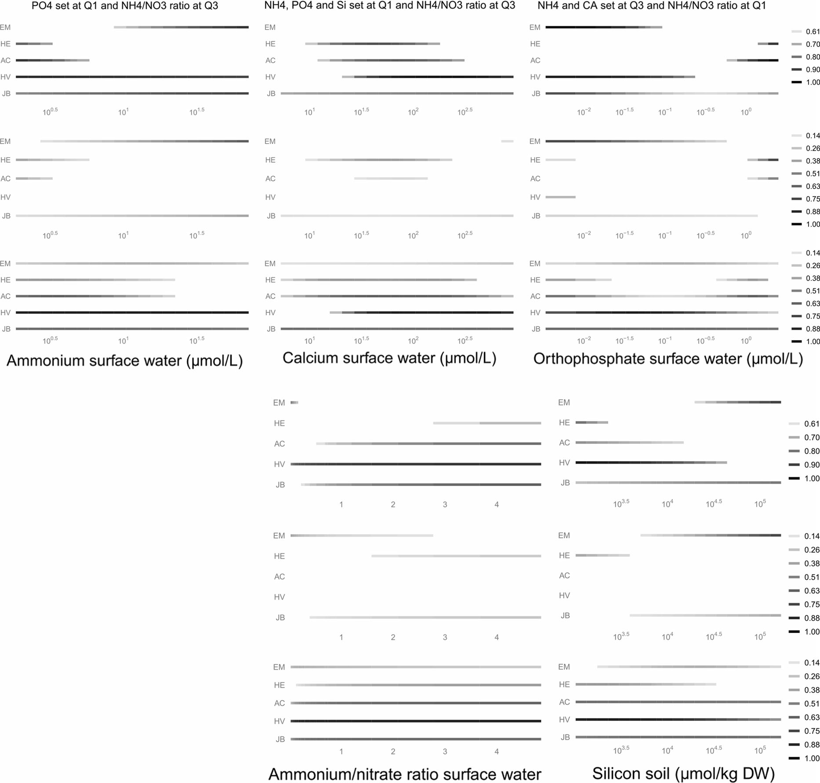

Fig. 2 The modelled realized niche of the five species. Predicted probabilities of occurrence (GLMM; first row), and of high and low cover classes (POMM; second and third row, respectively) are shown separately for each predictor. The probabilities are shown above a specific value (see ‘‘Methods’’ section for further details). For each predictor, all other covariates are kept constant at their median observed value,
unless stated otherwise. Because for several variables, working with median values results in predictions outside the niche of some species (near-zero probabilities), some graphs are for other than median values of the other covariates, i.e. at their first (Q1) or third quartile (Q3). EM Eleocharis multicaulis, HE Hyper- icum elodes, AC Agrostis canina, HV Hydrocotyle vulgaris, JB Juncus bulbosus

showed an opposite response to several predictors. This had also been noted in a univariate analysis of a subset of the same data (Vanderhaeghe et al. 2005).
Juncus bulbosus clearly had a wider niche width than the other species within the sampled environ- mental range. It was present in 71 % of the plots. Therefore, the rather poor predictive performance of
this species’ model is not surprising, as the higher the presence of a species in an investigated sample or area, the more difficult it becomes to model its niche due to less absence records (Jime´nez-Valverde et al. 2008; Franklin and Miller 2009).
It must be remarked that measuring environment at a plot resolution of 2 m2, although matching the scale at

Table 3 Predictive accuracy evaluation of the binomial mixed GLM models (GLMM) and the proportional odds mixed models (POMM)

GLMMa |  | Concordance index | Mean calibration
Eleocharis multicaulis |  | 0.885/0.766/0.210 | 1.006/1.020/-0.016
Hypericum elodes |  | 0.967/0.768/0.222 | 0.944/0.614/0.359
Agrostis canina |  | 0.848/0.770/0.209 | 1.000/1.028/-0.028
Hydrocotyle vulgaris |  | 0.974/0.888/0.105 | 1.012/1.028/-0.024
Juncus bulbosus |  | 0.707/0.663/0.310 | 1.000/1.144/-0.127
POMMb | Concordance index | Mean calibration of first threshold (high cover class) | Mean calibration  of second threshold  (high ? low cover class)
Eleocharis multicaulis | 0.776/0.753/0.051 | 1.013/0.993/0.018 | 1.015/1.011/0.000
Hypericum elodes | 0.803/0.763/0.078 | 0.984/1.001/-0.013 | 0.986/0.988/-0.001
Agrostis canina | 0.764/0.738/0.068 | 1.021/1.044/-0.013 | 0.994/0.987/0.012
Hydrocotyle vulgaris | 0.860/0.832/0.049 | 0.968/1.018/-0.032 | 0.994/1.000/-0.003
Juncus bulbosus | 0.643/0.631/0.096 | 1.016/1.039/-0.023 | 1.005/0.993/0.011
Values are presented in the following order: apparent performance/test performance/overfit. For a definition of concordance index and mean calibration, see Online Resource 2. Apparent performance compares the original data with the fitted model (how well does the model perform for the data?), test performance compares the original data with the bootstrap model (how well do the bootstrap models perform for the data on average?), and overfit compares the difference between bootstrap performance and test performance (the degree to which the original model is overfitted according to the bootstrap method; see text for more details). The model’s performance is to be assessed by its test performance (Verbyla and Litvaitis 1989)
a Generalized linear mixed models for a binomial response
b Proportional odds mixed models

Table 4 Association analysis between the five species within the plant community, using the gamma coefficient

Eleocharis | 0.05 | -0.20 | 0.13 | 0.50
-0.06 | Hypericum | 0.59 | 0.71 | 0.19
-0.19 | 0.51 | Agrostis | 0.66 | 0.30
0.13 | 0.60 | 0.53 | Hydrocotyle | 0.17
0.47 | 0.05 | 0.07 | -0.07 | Juncus

Top-right represents gamma for presence–absence response; bottom-left for cover response. Bold values: P \ 0.05, italicized values: P \ 0.10, in Pearson correlation tests

which population performance (cover) can be well estimated, integrates within-plot environmental hetero- geneity that may coincide with fine-scale, unmeasured niche differentiation between coexisting species (Mou- quet and Loreau 2002; Miller et al. 2005). Hence, the obtained ‘niche overlaps’, i.e. where species coexist and are positively associated at plot scale, represent results of measuring the environment (niche) at plot scale and not environmental variation within plots. This demonstrates the difficulty to detect the presence of actual niche differentiation in a community. On the other hand, by measuring many different sites, it
should be expected that species-specific niche patterns emerge and can differ, which was the case in this study and which is consistent with the paradigm of coexis- tence at regional level through niche differentiation (Amarasekare 2003; Kneitel and Chase 2004; Silver- town 2004).
Apart from unmeasured fine-scale resource heterogeneity, other mechanisms can also be at work that have led to coexistence within plots: niche separation along unmeasured gradients, including functional ones such as spatial resource partitioning (e.g. rooting depth) or partitioning in time (McKane et al. 2002); moderate local-scale dispersal in an environmentally homogeneous environment (Hub- bell 2001; Kneitel and Chase 2004); coexistence through cyclic patterns in resource consumption (Huisman and Weissing 1999). Also, frequent regional dispersal may in principle lead to local coexistence, but between-lake dispersal is probably unimportant, as this habitat is highly fragmented in space and several softwater macrophytes do not succeed to quickly recolonize sites after habitat restoration (Brouwer et al. 2002).

Table 5 Traits and strategies of the investigated plant species
Plant trait Corresponding challengea Eleocharis multicaulis

Hypericum elodes

Agrostis canina

Hydrocotyle vulgaris

Juncus bulbosus

‘?’ meaning: Interpretation
of ‘?’ in PESS contextb

Plant morphology
Lateral spread Persistence (space acquisition) ? ? ? ? Present to extensive Competitive/
biomass storer Height Persistence (competitive ability) ? ? ? ? ? Higher than 15 cm Competitive

Specific leaf area Establishment (relative growth rate) &
Persistence (competitive ability)
? Higher than 40 mm2/mg Competitive

Heterophylly Persistence (plasticity) ? Present Competitive

Carbon capture from air
Life history
Persistence (competitive ability) ? ? ? ? Prevailing Competitive

Evergreen leaves Persistence (stress tolerance) ? Present Biomass storer/ stunted

Onset of flowering
Persistence (disturbance avoidance) Early Ruderal

Seed investmentc Dispersal, establishment, persistence
(disturbance avoidance)
? ? Higher than 100 mm3 of seeds per shoot
Ruderal

Vegetative reproduction
Life strategy (Kautsky 1988)
Persistence (disturbance tolerance) ? ? ? ? Important Ruderal

CS CR CR CR CBRS

All species are perennials with anchored leaves
a Gaudet and Keddy (1988), Tilman (1988), Westoby (1998), Weiher et al. (1999), Knevel et al. (2003)
b PESS = Plant Ecology Strategy Scheme. Interpretation after Grime (1988), Kautsky (1988), Maillette and Keddy (1989), Rørslett (1989), Murphy et al. (1990), Westoby (1998), Willby et al. (2000), Grime (2001), and using terminology of Kautsky (1988)
c Based on the product of estimated seed number per shoot and seed volume (LEDA database)

Practical constraints in this study led to an unequal geographical sampling intensity, with a larger weight of Belgium and The Netherlands (Fig. 1). We there- fore assessed the degree of representativeness of the presented niche models for the West-European range (Online Resource 3). These results confirm that the representativeness is considerable but not high, and this should not surprise given the unbalanced dataset. Consequently, the presented niche results should not be considered as conclusive for the West-European scale, although from the spatial variation of the predictors it can be seen that important parts of the modelled realized niches were effectively provided by the large geographical extent of the sampling scheme (see Online Resource 2).

Interpretation of the predictors

Considering the predictors retained in the models, we notice that both ammonium and the ammonium/nitrate ratio were selected, meaning that nitrate would have been equally informative in the model as the ammo- nium/nitrate ratio, in the presence of the predictor ammonium. Orthophosphate was a third resource that was effective in defining the realized niches.
It could be that other correlated environmental variables, discarded in an earlier stage or not even measured, have an actual causal relationship to the species’ response. This may for example be the case for surface water calcium, which strongly refl cts pH and alkalinity in our dataset. Apart from nutrients, alkalinity and pH are known to explain much variation when considering the diversity among aquatic macrophyte communities (Bloemendaal and Roelofs 1988; Wetzel 2001; Smolders et al. 2002; Lacoul and Freedman 2006). Total soil silicon content was the only soil variable in the niche models. It is the silicon concentration made available after digestion with a HNO3–H2O2 solution. This variable is not an expected explaining variable according to macrophyte ecology literature (Smolders et al. 2002; Lacoul and Freedman 2006; Bornette and Puijalon 2011). Soil silicon, however, was negatively correlated with surface water pH. It is possible that pH is an actual causal variable, and that soil silicon better integrates past pH variability and was therefore more informative to the models than a one-time pH mea- surement. Soil silicon was highest in countries with more agricultural activity. In such areas, acidification is more likely to have occurred in isolated lakes due to
atmospheric nitrogen deposition (Roelofs et al. 1996; Vanderhaeghe et al. 2005; Bobbink et al. 2010).
It can be hypothesized from our findings that atmospheric ammonium deposition favours Eleocharis multicaulis at first, but eventually leads to its decline and disappearance. Hypericum elodes did not prefer high ammonium concentrations. It can be expected that these characteristic species will profit from restoration measures against acidification.

Support for competitive trade-offs

It is very remarkable that opposite dominance hierar- chies were observed depending on the resource gradient considered (e.g. ammonium compared to orthophosphate). A possible explanation is that com- petitive trade-offs exist for access to these different resources, conferring competitive advantage of one species over another for one resource, whilst the opposite is true for another resource. A similar trade- off between different resources was shown for two grass species, in a competition experiment by Ven- terink and Gu¨sewell (2010). They found that one species was a stronger competitor under phosphorus limitation while the other species was strongest under nitrogen limitation. The patterns we found within most gradients are compatible with assumptions of the competitive hierarchy model (Keddy 1989, 2001), in which dominant species with higher competitive ability outcompete subordinant species from a part of their fundamental niche, resulting in a competitive ranking along the resource gradient. In contrast with earlier studies however (Gaudet and Keddy 1988; Keddy et al. 1994; Ro¨sch et al. 1997; Keddy et al. 2000) our observed ranking changed and even reversed depending on the resource.
The mixed ecological strategy of the five species makes hypothesizing a ranking from traits not at all straightforward. The distinct strategy of Eleocharis multicaulis coincides with its observed pattern of niche separation. On the other hand, the three species that had a rather similar niche pattern also share many functional traits. Further, the broad characterization of Juncus bulbosus in terms of functional traits coincides with its wider realized niche. These findings support the assumption that functional characteristics under- pin, at least in part, niche differentiation among species through fitness trade-offs.

Needs for further research

In this study we investigated niche differentiation in a specific system, between specific species and at a specific resolution and extent. It must therefore be seen as a contribution to observed community struc- tures in nature at large scale, rather than being designed to distinguish between the actual mecha- nisms. It must be kept in mind that multiple mecha- nisms may lead to a similar observed pattern. Ideally, the study of patterns is done at multiple spatial scales in order to capture relevant mechanisms and to achieve generality (Levin 1992; Kunin 1998; Crawley and Harral 2001; Hartley and Kunin 2003; Rahbek 2005). Moreover, experiments are the ultimate means of testing the relevance of a proposed mechanism. Hence, mechanistic experimental research at a range of spatial scales is needed to test the importance of different community structuring mechanisms at the biogeographical scale, such as biotic interactions and environmental filtering. Following Wisz et al. (2013), we suggest that this research path would greatly benefit insights in community biogeography.
The characteristic isoetid species that grow deeper in these softwater lakes than the Eleocharition mul- ticaulis alliance have received much more attention by researchers (Arts 2002; Brouwer et al. 2002; Murphy 2002; Smolders et al. 2002). More ecological knowl- edge on target species of the Eleocharition multicaulis would be very useful for their conservation. Models like the ones in this paper can be used to support restoration of their abiotic environment. Our models may be refined by collecting more data. Furthermore, several experiments could be set up in order to test the expectations on species’ performance in different environments, and in order to elucidate physiological mechanisms.

Acknowledgments We are very grateful to the many scientists, colleagues and friends who helped in finding appropriate sampling locations. We especially mention (in alphabetical order) C. Aguiar, G.H.P. Arts, F. Bioret, D. Boeye, A.M. Darwell,
G. De Blust, J. Dirkx, I. Edgar & family, L. Gora, J. Jansen, R.A. Jones, J.A. Molina, F. Pinet, K. Rombouts, K. Urban, J. van Groenendael, W. Van Landuyt and L. van Tweel-Groot. We are grateful to two anonymous reviewers for their helpful comments. We further thank the owners and nature managers that gave access to the sampled softwater lakes. We thank J. Eygensteyn, R. Steeno and J. Bernaerts for their advice when doing the chemical analyses. The first author did part of this work as Ph.D. fellow of the Research Foundation – Flanders (FWO).
References

Amarasekare P (2003) Competitive coexistence in spatially structured environments: a synthesis: spatial coexistence mechanisms. Ecol Lett 6:1109–1122. doi:10.1046/j.1461- 0248.2003.00530.x
Arts GH (2002) Deterioration of Atlantic soft water macrophyte communities by acidification, eutrophication and alkalini- sation. Aquat Bot 73:373–393
Arts GHP, Den Hartog C (1990) Phytogeographical aspects of the west European soft-water macrophyte flora. Acta Bot Neerlandica 39:369–378
Austin MP (1990) Community theory and competition in veg- etation. In: Grace JB, Tilman D (eds) Perspectives on plant competition. The Blackburn Press, Caldwell, pp 215–238 Austin MP (1999) A silent clash of paradigms: some inconsis-
tencies in community ecology. Oikos 86:170–178
Austin MP (2007) Species distribution models and ecological theory: a critical assessment and some possible new approaches. Ecol Model 200:1–19. doi:10.1016/j. ecolmodel.2006.07.005
Austin M, Smith T (1989) A new model for the continuum concept. Vegetatio 83:35–47. doi:10.1007/BF00031679
Bates D, Maechler M, Bolker B (2011) lme4: linear mixed- effects models using S4 classes. R package version 0.999375-42
Bloemendaal FHJL, Roelofs JGM (1988) Waterplanten en waterkwaliteit. Koninklijke Nederlandse Natuurhis- torische Vereniging, Utrecht
Bobbink R, Hicks K, Galloway J, Spranger T, Alkemade R, Ashmore M, Bustamante M, Cinderby S, Davidson E, Dentener F (2010) Global assessment of nitrogen deposi- tion effects on terrestrial plant diversity: a synthesis. Ecol Appl 20:30–59
Bolker BM, Brooks ME, Clark CJ, Geange SW, Poulsen JR, Stevens MHH, White J-SS (2009) Generalized linear mixed models: a practical guide for ecology and evolution. Trends Ecol Evol 24:127–135. doi:10.1016/j.tree.2008.10.008
Bornette G, Puijalon S (2011) Response of aquatic plants to abiotic factors: a review. Aquat Sci 73:1–14
Brouwer E, Bobbink R, Roelofs JG (2002) Restoration of aquatic macrophyte vegetation in acidified and eutrophied softwater lakes: an overview. Aquat Bot 73:405–431
Canty A, Ripley B (2012) boot: Bootstrap R (S-Plus) Functions.
R package version 1.3-4
Christensen RHB (2012) ordinal—regression models for ordinal data. R package version 2012.01-19
Crawley MJ, Harral JE (2001) Scale dependence in plant bio- diversity. Science 291:864–868
Davison AC, Hinkley DV (1997) Bootstrap methods and their applications. Cambridge University Press, Cambridge
Dierssen K (1975) Littorelletea uniflorae. J. Cramer, Vaduz Elith J, Leathwick JR (2009) Species distribution models: eco-
logical explanation and prediction across space and time. Annu Rev Ecol Evol Syst 40:677–697. doi:10.1146/ annurev.ecolsys.110308.120159
European Commission (2007) Interpretation manual of Euro- pean Union habitats
Fitter A (1978) An atlas of the wild flowers of Britain and Northern Europe. Collins, London

Franklin J, Miller JA (2009) Mapping species distributions. Spatial inference and prediction. Cambridge University Press, New York
Gaudet CL, Keddy PA (1988) A comparative approach to predicting competitive ability from plant traits. Nature 334:242–243 Ginzburg LR, Jensen CXJ (2004) Rules of thumb for judging
ecological theories. Trends Ecol Evol 19:121–126. doi:10. 1016/j.tree.2003.11.004
Gonzalez R, Nelson TO (1996) Measuring ordinal association in situations that contain tied scores. Psychol Bull 119:159 Grime JP (1979) Plant strategies and vegetation processes.
Wiley, Chichester
Grime JP (1988) Comparative plant ecology. A functional approach to common British species. Unit Comparative Plant Ecology (NERC), Department of Plant Science, University of Sheffield, Sheffield
Grime JP (2001) Plant strategies, vegetation processes, and ecosystem properties. Wiley, Chichester
Guisan A, Harrell FE (2000) Ordinal response regression models in ecology. J Veg Sci 11:617–626
Guisan A, Zimmermann NE (2000) Predictive habitat distri- bution models in ecology. Ecol Model 135:147–186
Harrell FE (2001) Regression modeling strategies: with appli- cations to linear models, logistic regression, and survival analysis. Springer, New York
Harrell FE, with contributions from many other users (2012) Hmisc: Harrell Miscellaneous. R package version 3.9-3
Hartley S, Kunin WE (2003) Scale dependency of rarity, extinction risk, and conservation priority. Conserv Biol 17:1559–1570
Heegaard E (2002) The outer border and central border for species–environmental relationships estimated by non- parametric generalised additive models. Ecol Model 157:131–139
Hijmans RJ, Cameron SE, Parra JL, Jones PG, Jarvis A (2005) Very high resolution interpolated climate surfaces for global land areas. Int J Climatol 25:1965–1978
Hubbell SP (2001) The unified neutral theory of biodiversity and biogeography. Princeton University Press, Princeton
Huisman J, Weissing FJ (1999) Biodiversity of plankton by species oscillations and chaos. Nature 402:407–410
Hulte´n E, Fries M (1986) Atlas of the North European vascular plants: north of the Tropic of Cancer. Koeltz, Ko¨ nigstein
Hutchinson HE (1957) Concluding Remarks. Cold Spring Harb Symp Quant Biol 22:415–427
Jime´nez-Valverde A, Lobo JM, Hortal J (2008) Not as good as
they seem: the importance of concepts in species distri- bution modelling. Divers Distrib 14:885–890. doi:10.1111/ j.1472-4642.2008.00496.x
Johnson JB, Omland KS (2004) Model selection in ecology and evolution. Trends Ecol Evol 19:101–108. doi:10.1016/j. tree.2003.10.013
Kautsky L (1988) Life strategies of aquatic soft bottom macrophytes. Oikos 53:126–135
Keddy PA (1989) Competition. Chapman & Hall, London Keddy PA (2001) Competition, 2nd edn. Kluwer, Dordrecht Keddy PA, Twolanstrutt L, Wisheu IC (1994) Competitive
effect and response rankings in 20 wetland plants—are they consistent across 3 environments. J Ecol 82:635–643
Keddy P, Gaudet C, Fraser LH (2000) Effects of low and high nutrients on the competitive hierarchy of 26 shoreline plants. J Ecol 88:413–423
Kleyer M, Bekker RM, Knevel IC, Bakker JP, Thompson K, Sonnenschein M, Poschlod P, van Groenendael JM, Klimesˇ L, Klimesˇova´ J, Klotz S, Rusch GM, Hermy M, Adriaens D, Boedeltje G, Bossuyt B, Dannemann A, Endels P, Go¨tzenberger L, Hodgson JG, Jackel A-K, Ku¨ hn I, Kunz- mann D, Ozinga WA, Ro¨ mermann C, Stadler M, Sch- legelmilch J, Steendam HJ, Tackenberg O, Wilmann B, Cornelissen JHC, Eriksson O, Garnier E, Peco B (2008) The LEDA Traitbase: a database of life-history traits of the Northwest European flora. J Ecol 96:1266–1274. doi:10. 1111/j.1365-2745.2008.01430.x
Kneitel JM, Chase JM (2004) Trade-offs in community ecology: linking spatial scales and species coexistence. Ecol Lett 7:69–80
Knevel IC, Bekker RM, Bakker JP, Kleyer M (2003) Life-his- tory traits of the northwest European flora: the LEDA database. J Veg Sci 14:611–614
Kunin WE (1998) Extrapolating species abundance across spatial scales. Science 281:1513–1515
Lacoul P, Freedman B (2006) Environmental influences on aquatic plants in freshwater ecosystems. Environ Rev 14:89–136. doi:10.1139/a06-001
Leibold MA, Holyoak M, Mouquet N, Amarasekare P, Chase JM, Hoopes MF, Holt RD, Shurin JB, Law R, Tilman D, Loreau M, Gonzalez A (2004) The metacommunity con- cept: a framework for multi-scale community ecology: the metacommunity concept. Ecol Lett 7:601–613. doi:10. 1111/j.1461-0248.2004.00608.x
Levin SA (1992) The problem of pattern and scale in ecology.
Ecology 73:1943–1967
Levine JM, HilleRisLambers J (2009) The importance of niches for the maintenance of species diversity. Nature 461:254–257. doi:10.1038/nature08251
Londo G (1984) The decimal scale for releve´s of permanent quadrats. In: Knapp R (ed) Sampling methods and taxon analysis in vegetation science. Dr. W. Junk Publishers, The Hague, pp 45–49
Lucassen ECHE, Bobbink R, Oonk MMA, Brandrud TE, Roe- lofs JGM (1999) The effects of liming and reacidification on the growth of Juncus bulbosus: a mesocosm experiment. Aquat Bot 64:95–103
Maillette L, Keddy PA (1989) 2 plants with contrasting archi- tectures—growth responses to light gradients. Can J Bot 67:2825–2828
McKane RB, Johnson LC, Shaver GR, Nadelhoffer KJ, Rastetter EB, Fry B, Giblin AE, Kielland K, Kwiatkowski BL, Laundre JA, Murray G (2002) Resource-based niches provide a basis for plant species diversity and dominance in arctic tundra. Nature 415:68–71
Miller TE, Burns JH, Munguia P, Walters EL, Kneitel JM, Richards PM, Mouquet N, Buckley HL (2005) A critical review of twenty years’ use of the resource-ratio theory. Am Nat 165:439–448
Mouquet N, Loreau M (2002) Coexistence in metacommunities: the regional similarity hypothesis. Am Nat 159:420–426
Mueller-Dombois M, Ellenberg H (1974) Aims and methods of vegetation ecology. Wiley, New York

Murphy KJ (2002) Plant communities and plant diversity in softwater lakes of northern Europe. Aquat Bot 73:287–324 Murphy KJ, Rørslett B, Springuel I (1990) Strategy analysis of submerged lake macrophyte communities—an interna-
tional example. Aquat Bot 36:303–323
Pietsch W (1977) Beitrag zur Soziologie und O¨ kologie der europa¨ischen Littorelletea- und Utricularietea-Ge- sellschaften. Feddes Repert 88:141–245
Pietsch W (1985) Chorologische Pha¨nomene in Wasserpflanzengesellschaften Mitteleuropas. Vegetatio 59:97–109
R Development Core Team (2011) R: a language and environ- ment for statistical computing. R Foundation for Statistical Computing, Vienna http://www.R-project.org
Rahbek C (2005) The role of spatial scale and the perception of large-scale species-richness patterns. Ecol Lett 8:224–239 Raudenbusch SW, Bryk AS (2002) Hierarchical linear models: applications and data analysis methods, 2nd edn. Sage,
Newbury Park
Rodriguez-Oubina J, Romero MI, Ortiz S (1997) Communities of the class Littorelletea uniflorae in the northwest Iberian Peninsula. Acta Bot Gallica 144:155–169
Roelofs JGM, Bobbink R, Brouwer E, de Graaf MCC (1996) Restoration ecology of aquatic and terrestrial vegetation on non-calcareous sandy soils in The Netherlands. Acta Bot Neerlandica 45:517–541
Rørslett B (1989) An integrated approach to hydropower impact assessment 2. Submerged macrophytes in some Norwegian hydroelectric lakes. Hydrobiologia 175:65–82
Ro¨sch H, Van Rooyen MW, Theron GK (1997) Predicting competitive interactions between pioneer plant species by using plant traits. S Afr J Bot 8:489–494
Schamine´e JHJ, Westhoff V, Arts GHP (1992) Die Stran- dlinggesellschaften (Littorelletea Br.-Bl. et Tx. 43) der Niederlande, in europa¨ischem Rahmen gefasst. Phyto- coenologia 20:529–558
Schoof-van Pelt MM (1973) Littorelletea: a study of the vege- tation of some amphiphytic communities of western Europe. PhD Thesis, Katholieke Universiteit Nijmegen, Nijmegen
Silvertown J (2004) Plant coexistence and the niche. Trends Ecol Evol 19:605–611. doi:10.1016/j.tree.2004.09.003 Smolders AJP, Lucassen E, Roelofs JGM (2002) The isoetid
environment: biogeochemistry and threats. Aquat Bot 73:325–350
Szmeja J, Cle´ment B (1990) Comparaison de la structure et du de´terminisme des Littorelletea uniflorae en Pome´ranie (Pologne) et en Bretagne (France). Phytocoenologia 19:123–148
Thuiller W, Albert C, Arau´jo MB, Berry PM, Cabeza M, Guisan A, Hickler T, Midgley GF, Paterson J, Schurr FM, Sykes MT, Zimmermann NE (2008) Predicting global change impacts on plant species’ distributions: future challenges. Perspect Plant Ecol Evol Syst 9:137–152. doi:10.1016/j. ppees.2007.09.004
Thuiller W, Albert CH, Dubuis A, Randin C, Guisan A (2010) Variation in habitat suitability does not always relate to variation in species’ plant functional traits. Biol Lett 6:120–123
Tilman D (1982) Resource competition and community struc- ture. Princeton University Press, Princeton
Tilman D (1988) Plant strategies and the dynamics and structure of plant communities. Princeton University Press, Princeton
Tilman D (2004) Niche tradeoffs, neutrality, and community structure: a stochastic theory of resource competition, invasion, and community assembly. Proc Natl Acad Sci USA 101:10854–10861
Vanderhaeghe F, Smolders AJP, Ruysschaert S, Roelofs JGM, Hoffmann M (2005) Understanding the realised niche of an amphibious softwater plant, Eleocharis multicaulis. Arch Fu¨r Hydrobiol 163:329–348. doi:10.1127/0003-9136/ 2005/0163-0329
Vanderhaeghe F, Smolders AJP, Roelofs JGM, Hoffmann M (2013) Water table and species identity outweigh carbon and nitrogen availability in a softwater plant community. Acta Oecol 47:57–67. doi:10.1016/j.actao.2012.09.001
Vaughan IP, Ormerod SJ (2005) The continuing challenges of testing species distribution models. J Appl Ecol 42:720–730. doi:10.1111/j.1365-2664.2005.01052.x
Venterink HO, Gu¨sewell S (2010) Competitive interactions between two meadow grasses under nitrogen and phos- phorus limitation: competition under N and P limitation. Funct Ecol 24:877–886. doi:10.1111/j.1365-2435.2010. 01692.x
Verbyla D, Litvaitis J (1989) Resampling methods for evalu- ating classification accuracy of wildlife habitat models. Environ Manag 13:783–787. doi:10.1007/BF01868317
Weiher E, van der Werf A, Thompson K, Roderick M, Garnier E, Eriksson O (1999) Challenging Theophrastus: a com- mon core list of plant traits for functional ecology. J Veg Sci 10:609–620
Westoby M (1998) A leaf-height-seed (LHS) plant ecology strategy scheme. Plant Soil 199:213–227
Westoby M, Wright IJ (2006) Land-plant ecology on the basis of functional traits. Trends Ecol Evol 21:261–268. doi:10. 1016/j.tree.2006.02.004
Wetzel RG (2001) Limnology. Lake and River Ecosystems.
Academic Press, London
Wickham H (2009) ggplot2: elegant graphics for data analysis.
Springer, New York
Willby NJ, Abernethy VJ, Demars BOL (2000) Attribute-based classification of European hydrophytes and its relationship to habitat utilization. Freshw Biol 43:43–74
Wisz MS, Pottier J, Kissling WD, Pellissier L, Lenoir J, Damgaard CF, Dormann CF, Forchhammer MC, Grytnes J-A, Guisan A, Heikkinen RK, Høye TT, Ku¨hn I, Luoto M, Maiorano L,
Nilsson M-C, Normand S, O¨ ckinger E, Schmidt NM, Ter-
mansen M, Timmermann A, Wardle DA, Aastrup P, Sven- ning J-C (2013) The role of biotic interactions in shaping distributions and realised assemblages of species: implica- tions for species distribution modelling. Biol Rev 88:15–30. doi:10.1111/j.1469-185X.2012.00235.x
Zuur AF, Ieno EN, Walker NJ, Saveliev AA, Smith GM (2009) Mixed effects models and extensions in ecology with R. Springer, New York

