An approach to intercalibrate ecological classiﬁcation tools using ﬁsh in transitional water of the North East Atlantic
Mario Lepagea,∗, Trevor Harrisonb, Jan Breinec, Henrique Cabrald, Steve Coatese, Cristina Galvánf, Pilar Garcíag, Zwanette Jagerh, Fiona Kellyi, Eva Christine Moschj,
Stephanie Pasquaudd, Jörg Schollek, Ainhize Uriartel, Angel Borjal
a Irstea, UR EABX, 50 av. de Verdun, F-33612 Cestas, France
b Marine Division, Department of the Environment (Northern Ireland), 17 Antrim Rd, Tonagh, Lisburn BT28 3AL, United Kingdom
c Research Institute for Nature and Forest, Duboislaan 14, B-1560 Groenendaal, Belgium
d Centro de Oceanograﬁa, Faculdade de Ciências da Universidade de Lisboa, Campo Grande, 1749-016 Lisbon, Portugal
e SLR Consulting, G3 7QF Glasgow, Scotland, United Kingdom
f Instituto de Hidráulica Ambiental “IH Cantabria”, Universidad de Cantabria, C/ Isabel Torres n◦ 15, Parque Cientíﬁco y Tecnológico de Cantabria, 39011 Santander, Spain
g INDUROT, Universidad de Oviedo, Campus de Mieres, 33600 Mieres, Asturias, Spain
h ZiltWater Advies, 9905 TD Holwierde, The Netherlands
i Inland Fisheries Ireland, Swords Business Campus Swords, Co., Dublin, Ireland
j Lower Saxony State Ofﬁce for Consumer Protection and Food Safety, Dep.34 – Department of Inland Fisheries, Eintrachtweg 19, D-30173 Hannover,
Germany
k BIOCONSULT Schuchardt & Scholle GbR, 28757 Bremen, Germany
l AZTI-Tecnalia, Marine Research Division, Herrera Kaia, Portualdea s/n, 20110 Pasaia, Spain

a b s t r a c t

Keywords:
Water Framework Directive Estuaries
Fish index Pressure index Classiﬁcation Ecological class
A simple procedure to harmonise and intercalibrate eight national methods classifying the ecological status using ﬁsh in transitional waters of the North East Atlantic is described. These methods were initially intercalibrated and a new method recently developed was added to this exercise. A common human pressure index pre-classiﬁed the status of each water body in an independent way. Ecological class boundaries values were established according to the level of anthropogenic pressure using regression analyses. A simulated dataset was used to assess the level of agreement between the ﬁsh classiﬁcation methods. Fleiss’ multi-rater kappa analysis indicated that boundary harmonisation was achieved; all classiﬁcations fell within one class of each other and class agreement between methods exceeded 70%. The use of a pressure index to establish boundary thresholds provides a practical method of deﬁning and harmonizing the quality classes associated with human pressures, as required by the European Water Framework Directive.

- Introduction

The European Water Framework Directive (WFD; 2000/60/EC) outlines a framework for the assessment of European surface and ground waters, including transitional waters (estuaries) (Hering et al., 2010). Member States are required to assess the ecolog- ical status of water bodies using biological, hydromorphological and physico-chemical quality elements. Biological quality elements are assessed by comparing data obtained from monitoring pro- grammes to some form of reference (natural) condition based on

∗ Corresponding author. Tel.: +33 557890810.
E-mail address: mario.lepage@irstea.fr (M. Lepage).
a network of reference sites, on historical data or on modelling, or a mixture of all of them (Borja et al., 2012). The ecological status of a particular water body is assessed on the basis of an Ecological Quality Ratio (EQR), which ranges from zero to one. The water body is then assigned to one of ﬁve status classes (high, good, moderate, poor, bad), where EQR values close to zero representing ‘bad’ status and EQR values close to one representing ‘high’ status.
Fish is one of the biological quality elements for transitional waters and numerous ﬁsh-based indices have been developed for transitional waters across Europe, as part of the requirements of the WFD (Birk et al., 2012; Pérez-Domínguez et al., 2012a,b). However, since many of these classiﬁcation methods differ across member states, the results may not necessarily be compara- ble. To this end, the WFD requires that the various biological

Table 1
Fish classiﬁcation methods employed in transitional waters in the North East Atlantic region.

Method Code Country References

AZTI’s Fish Index AFI Spain (Basque Country) Borja et al. (2004)
Estuarine Biotic Index EBI Belgium Breine et al. (2007)
Estuarine Fish Classiﬁcation Index EFAI Portugal Cabral et al. (2012)
Estuarine and Lagoon Fish Index ELFI France Delpech et al. (2010)

Fish-based Classiﬁcation Tool for Transitional Waters – Germany Fish-based Classiﬁcation Tool for
Transitional Waters – Netherlands Transitional Fish Classiﬁcation Index –
Ireland
Transitional Fish Classiﬁcation Index – Spain
FAT-TW-G Germany Scholle and Schuchardt (2012)

FAT-TW-NL The Netherlands Scholle and Schuchardt (2012) TFCI-Irl Republic of Ireland and Northern Ireland (UK) Coates et al. (2007)
TFCI-Sp Spain (Asturias and Cantabria) Coates et al. (2007)

Estuarine multi-metrics index -Ireland EMFI Republic of Ireland and Northern Ireland (UK) Harrison and Kelly (2013)

classiﬁcation tools are intercalibrated between Member States; this ensures that national classiﬁcation methods are harmonised and provide consistent and comparable status classiﬁcations (Poikane et al., 2014). A key focus of intercalibration for the WFD is to harmonise the ‘high-good’ and ‘good-moderate’ boundaries. It is important to note that the aim of intercalibration is to harmonise the results obtained from national classiﬁcation tools and not the classiﬁcation tools themselves (Bennett et al., 2011; Buffagni and Furse, 2006; Sandin and Hering, 2004). The most important boundary is that of good-moderate, since water bodies below good status will require management measures to reduce pressures and achieve good status in the future.
As a consequence European member states were obliged to compare the results of classiﬁcation among countries that share common water body types in similar biogeographic regions. This is one of the main challenges of the WFD implementation, since Member States must demonstrate that different methods provide similar ecological status classiﬁcation across different countries (Poikane et al., 2014). For this, countries have been organised into Geographic Intercalibration Groups (GIGs). Although the intercal- ibration results of some biological quality elements (e.g. benthic invertebrates, angiosperms), have been already published (Borja et al., 2009; Lopez y Royo et al., 2011), nothing has been done until now with transitional ﬁsh methods. Hence, the objectives of our research are: (i) to provide an intercalibration method for transitional water ﬁsh classiﬁcation tools within the North East Atlantic GIG, where class boundaries are established and harmonised according to the level of anthropogenic impact or pres- sure; and (ii) to demonstrate if new methods (or updated methods) can be added furtherly to the intercalibration.

- Materials and methods

  - Fish classiﬁcation methods in North East Atlantic GIG transitional waters

Eleven member states are included within the North East Atlantic GIG; these include Belgium, Denmark, France, Germany, Ireland, the Netherlands, Norway, Portugal, Spain, Sweden, and the United Kingdom (European Commission, 2011). Apart from Denmark, Norway, and Sweden, the remaining eight countries have all developed WFD ﬁsh classiﬁcation methods for transi- tional waters (Table 1). While some countries (e.g. Germany, the Netherlands) used similar ﬁsh classiﬁcation methods, these were treated separately to account for regional differences in the appli- cation of the methods and reference conditions. In the case of the Republic of Ireland and United Kingdom, a common approach was adopted in the application of the Transitional Fish Classiﬁca- tion Index (TFCI) and these data are presented together (TFCI-Irl). Although the TFCI was also applied to Spanish transitional waters
(regions of Asturias and Cantabria), these data were treated sepa- rately (TFCI-Sp) to account for some differences in the application of the method (i.e. sampling gears and effort).

  - Water Framework Directive compliance

Prior to proceeding with the intercalibration process, all ﬁsh classiﬁcation methods were checked for compliance with the WFD requirements. This included the assignment of typologies to transitional waters, the establishment of type-speciﬁc reference conditions for biological quality element parameters, as speciﬁed within the WFD, monitoring and assessment protocols for the various ﬁsh classiﬁcation methods, ensuring comparability of mon- itoring results through ecological quality ratios (EQRs), and the categorization of EQR values into ﬁve classes (high, good, moderate, poor and bad). All ﬁsh classiﬁcation methods included in this inter- calibration exercise were found to comply with the requirements of the WFD.

    - Typology
The WFD requires that Member States assign a typology to each of their transitional waters based on a number of physico- chemical characteristics as outlined in WFD Annex II. The typology includes factors such as ecoregion (latitude, longitude), salinity, tidal range, depth, current, exposure, temperature, mixing, turbid- ity, substratum, and shape. All Member States participating in the intercalibration exercise have developed typologies for their transi- tional waters; however, no common typology was evident among participating countries. Only one broad type was ofﬁcially desig-
nated as an intercalibration common type for transitional waters in North East Atlantic: oligohaline to polyhaline (0–35 mg l−1), mesotidal (2–5 m tidal range), shallow (<30 m depth) with medium
current velocity (1–3 knots), sheltered or moderately exposed, par- tially or permanently stratiﬁed and with residence time between days and weeks (TW-NEA11). The common intercalibration type TW-NEA11 encompasses all the transitional water bodies used in this study.

    - Reference conditions
The assignment of typologies to transitional waters allows the characteristics and the biological communities present to be described. For transitional waters, the biological quality elements speciﬁed in WFD Annex X includes composition and abundance of ﬁsh fauna as well as disturbance-sensitive species. Type-speciﬁc reference conditions can be established using spatially based near- natural sites, modelling using historical or available data, expert judgement, or a combination of the above approaches. All Mem- ber States have developed type-speciﬁc reference conditions for their transitional waters. The national reference conditions take into account monitoring technique and strategy (sampling gear,

Table 2
Metrics included in NEAGIG Member State ﬁsh classiﬁcation methods and compliance with WFD biological quality element (BQE) parameters.

Metric Fish classiﬁcation method WFD BQE Parameters

Species richness
AFI | EBI | EFAI | ELFI | FAT-TW | TFCI | EMFI |  | Taxonomic composition | Abundance | Sensitive taxa
X X X | X | X  X | X  X | X | X | X X X |  | X X X | X | X X X
 | X | X X | X | X  X | X  X | X X X |  | X X X | X | X X X
X | X |  |  | X |  | X |  | X X | X | X X
X | X | X |  |  | X X  X X | X X  X X |  | X X X X | X X | X X X
 | X |  |  | X | X | X |  |  | X X | X
X |  |  |  | X |  |  |  |  | X
 |  |  |  | X X X |  |  |  |  | X X X | X
 |  | X | X | X |  |  |  |  | X X | X
X |  |  |  |  |  | X |  | X X | X | X X
X |  |  |  |  |  |  |  | X | X | X
 |  |  | X |  |  |  |  | X | X
 |  |  | X |  |  |  |  | X | X | X
 |  |  |  |  |  | X |  | X | X | X
 |  |  | X |  | X |  |  | X X | X | X
X |  |  |  |  | X |  |  | X |  | X

No. estuarine resident species Abundance/density of estuarine
resident species
No. diadromous species Abundance/density of marine migrants No. marine migrant/juvenile species No. marine seasonal species Abundance/density of piscivores
No. piscivore species
No. zoobenthivore species Abundance/density of omnivores Species composition
Species relative abundance Dominance (90%n)
Abundance/density of Osmerus eperlanus
Abundance/density of Platichthys ﬂesus
(ﬂatﬁsh)
Abundance/density of Alosa fallax Abundance/density of Clupea harengus Abundance/density of Gymnocephalus
cernua
Abundance/density of Liparis liparis
Total density
No. disturbance sensitive species No. introduced species Abundance/density of introduced
species
Abundance/density of pollution indicator species
Abundance/density of freshwater species
Abundance/density of diadromous species
Abundance/density of zoobenthivore species
Abundance/density of benthic species No. functional guilds
No. trophic guilds
Fish health (% affection)

effort and season). The most common approach used historical data and expert judgement; very few modelling, near-natural or least disturbed sites were used. Reference conditions follow the WFD normative deﬁnition of ‘high’ status where ‘species composition and abundance is consistent with undisturbed conditions’.

  - Intercalibration options

The guidance on the intercalibration process provided by the WFD Common Implementation Strategy has described three options depending on the nature of data acquisition and numer- ical evaluation (European Commission, 2011). For countries using the same data sampling and processing techniques, and sharing the same classiﬁcation tool, intercalibration can be achieved by directly comparing the classiﬁcation boundaries (Option 1) (Birk et al., 2013). Where sampling methodologies, data processing, and clas- siﬁcation tools differ among countries, intercalibration is achieved indirectly through the development of common biological metrics for which each national method should show a high correlation before being compared (Option 2). In cases where data sampling techniques are similar among countries but classiﬁcation tools differ, intercalibration is achieved by applying each classiﬁcation tool to every national dataset within the common intercalibra- tion type of the GIG and comparing directly the classiﬁcation results (Option 3) (Birk et al., 2013). A variety of ﬁsh classiﬁcation tools have been developed to assess transitional waters within the
North East Atlantic GIG (Table 1). The different metrics included in each classiﬁcation tools are given in Table 2. Each national method was designed based on speciﬁc sampling methods and data requirements. Intercalibration of the various methods there- fore was undertaken indirectly using a common metric (Option 2). However, rather than using a common biological metric, a common pressure index was used to compare and intercalibrate the various methods in an independent way. The dataset used to realise the intercalibration exercise was derived from 91 estuaries that were sampled and assessed with the different classiﬁcation tools and for which pressure data were estimated (Fig. 1).

  - The pressure index

A pressure index (PI) was developed as intercalibration com- mon metric (ICM) for the WFD intercalibration exercise and was based on pressures described by Aubry and Elliott (2006). The index comprised eight indicators that were classiﬁed into three broad cat- egories of disturbance: coastal morphological change, resource use change, and environmental quality (Table 3).
Each indicator was allocated a score between 0 and 9 according to the severity of the disturbance (Appendix 1). The ﬁnal pressure index was calculated for the whole estuary as the sum of all indi- cator scores. It could have a minimum value of 0 (no disturbance) and a maximum value of 72 (very high disturbance). The inter- calibration procedure ensured that the scoring of indicators and

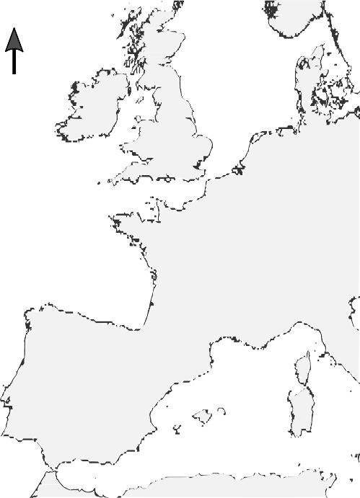 N 10°W 0° Estuaries :
12 35 37 71 1. Adour

- Elbe

62. Newport Bay

50°N

45°N
29 38 42 81
78
62 58
23 47
68
46
11 51

7 15 17
40 49 74
8 60
9 22 63
14 25 72
18 29 77
19 48 80
20 52 85
43 89 31
33 32
44 90 91
75 5 24

55
- Ajo
- Arade
- Artibai
- Authie
- Ave
- Aven
- Aviles
- Avoca
- Santander
- Bandon
- Bann
- Barbadun
- Barrow Nore
- Belon
- Bidassoa
- Ems
- Eo
- Erne
- Esva
- Faughan
- Foyle
- Gironde
- Goyen
- Guadiana
- Gweebarra
- Humber
- IJzer
- Joyel
- Kenmare
- Kinvarra Bay
- Newry
- Oiartzun
- Oka
- Oria
- Oriñón
- Owenacurra
- Oyambre
- Ribadesella
- Roe
- Rogerstown
- Sado
- Scorff
- Seine
- Seudre
- Slaney

34 69
36 70 1079
59 88 4583
76 26
39
  - Blavet
  - Boyne
- Lagan
- laïta
- Sruwaddacon Bay
- Suances

84 19. Bridgetown
20. Broad Lough
- Lea
- Lee
  - Suir
  - Swily

53 21. Broad Meadow 52. Liffey
  - Tejo

30 6
54 57
1 22 65
2 28 66
4 50 67
13 56 86
    - Butroe
    - Camus Bay
    - Canche
- Lima
- Lis
- Loire
  - Tina Mayor
  - Tina Menor
  - Tolka

82 16
73
41
3
35°N
61 87
64

0 250 500 km
    - Castletown
    - Charente
    - Connswater
    - Deba
    - Donegal Bay
    - Douro
    - Eider
- Santoña
- Mondego
- Moy
- Nalon
- Navia
- Nervion
  - Urola
  - Urumea
  - Villaviciosa
  - Weser
  - Westerschelde
  - Zeeschelde

Fig. 1. Location of the 91 European estuaries considered for the intercalibration exercise.
80

Good−Moderate High−Good
Pressure index
0
20
60

AFI
EBI
EFAI ELFI EMFI FAT−TW− FAT−TW− TFCI−Irl TFCI−Sp
40
values were then established by calculating the global mean pres- sure value of all classiﬁcation methods for the high/good and good/moderate boundaries.

2.6. Harmonisation

The comparability of ecological classiﬁcations is a product of two components: (a) boundary bias and (b) class agreement. Bound- aries bias is represented by the gap between the harmonised class boundary value (global mean of all methods) and the individual national values (Birk et al., 2013). Boundary harmonisation rep- resents a state of agreement between classiﬁcation tools only for two boundaries ‘high-good’ and ‘good-moderate’. The guidance

0.0 0.2 0.4 0.6 0.8 1.0
EQR

Fig. 2. Regression relationships between transitional water ﬁsh classiﬁcation method Ecological Quality Ratio (EQR) and the Intercalibration common metric (pressure index); dashed horizontal lines represent the harmonised (global mean) ‘high-good’ and ‘good-moderate’ boundaries (on the pressure index scale).

calculation of the pressure index was applied consistently through- out all participating countries by having two dedicated workshops between experts to guarantee a common understanding of the pressure assessment. The assessment was made according to the best available knowledge (scientiﬁc, public or calculated data, expert knowledge). The available numerical data were converted into one of the six quality classes.

  - Regression analysis and boundary setting

Relationships between each of the ﬁsh classiﬁcation method EQRs and the corresponding pressure index values were estab- lished through linear regressions (Fig. 2). We use the pressure index as our ICM to deﬁne the corresponding EQR for the bound- ary harmonisation. The linear regression equations were then used to translate ecological status class boundaries for each method into the common pressure index scale. Harmonised boundary
suggests that for any national boundary the highest acceptable deviation from the global mean was ±0.25 class width (European Commission, 2011). The deviation of boundary values for the ‘high-good’ and ‘good-moderate’ thresholds for each classiﬁcation method (on the pressure index scale) was calculated in relation to its position relative to the harmonised boundary value (global mean pressure index corresponding to global mean of all methods); these were then expressed as a proportion of class equivalent values for each method. Where required, individual boundary values were adjusted to fall within 0.25 of a class equivalent if a national bound- ary is too low, but a more stringent boundary could be accepted. Class boundary values were then translated into EQR values for each classiﬁcation method using the appropriate pressure index – EQR regression results.
Class agreement is a measure of the conﬁdence that two or more methods will report the same classiﬁcation status for a given site (Landis and Koch, 1977; Birk et al., 2013; European Commission, 2011). The level of agreement between methods was examined using a kappa analysis on a simulated dataset of 300 random pressure index values spanning the range 0–72 (nine pressures scoring between 0 and 9). For each classiﬁcation method, a set of simulated biological EQR values correspond- ing to the 300 random pressure index values was generated using the regression relationship with the pressure index. A random offset effect based on the prediction error of each

Table 3
Description of indicators that comprise the pressure index.
Pressure | Indicator | Description
1 | Intertidal area | This indicator includes both
 | lost/Realignment | anthropogenically induced changes
 | schemes/Land | and natural variations over the last
 | claim/Gross change in | century. Historical maps and/or
 | the bathymetry and | aerial photography can be used to
 | topography | estimate the area lost
2 | Interference with the | This indicator measures the
 | hydrographical regime | percentage of area impacted by
 |  | man-made structures affecting the
 |  | current patterns, wave regime and
 |  | sediment transport patterns within a
 |  | system. Structures include: (i) the
 |  | entrance of ports, docks or marinas if
 |  | a jetty or wharf is built below the
 |  | mean high water (MHW) mark, (ii)
 |  | jetties and pontoons, (iii) groynes,
 |  | (iv) bridge supports, (v) wharves, and
 |  | (vi) offshore constructions (e.g.
 |  | artiﬁcial forts, platforms for gas and
 |  | oil production or exploration).
 |  | Channel modiﬁcations that affect
 |  | water ﬂows are also included in this
 |  | indicator. Dams and weirs, however,
 |  | are not included. This indicator is
 |  | largely based on expert judgement;
 |  | aerial photography can also be used
 |  | to evaluate the number and extent of
 |  | potential sources of impact
3 | Anthropogenically | This indicator estimates the
 | affected coastline | percentage of land use given over to
 |  | industrial and urban development,
 |  | and agriculture within the coastal
 |  | zone (1 km landward from the
 |  | MHW). This parameter should reﬂect
 |  | the naturalness around the estuary
 |  | and can be estimated through the
 |  | use of aerial photography
4 | Water chemical quality | Water chemical quality is measured
 |  | as the degree of compliance with
 |  | Environmental Quality Standards
 |  | (EQSs) for List I and List II substances
 |  | of the EU Dangerous Substances
 |  | Directive (e.g. metals, organic
 |  | compounds, pesticides). Where no
 |  | monitoring data are available, expert
 |  | judgement is exercised
5 | Water quality | This indicator is based on heavy
 | biological effects | metal and biological effects
 |  | monitoring data (e.g. imposex, oyster
 |  | embryo bioassays, bioaccumulation
 |  | studies). Biological effects may not
 |  | be monitored for water bodies that
 |  | are classiﬁed as ‘good status’ under
 |  | the Water Framework Directive. In
 |  | such instances, the score would be
 |  | very low (1)
6 | Benthos | This indicator is based on WFD
 |  | intertidal and subtidal benthic
 |  | invertebrate monitoring. Where such
 |  | monitoring is not available,
 |  | assessments can be based on other
 |  | benthic studies and local expertise.
 |  | Benthos status is used as a proxy for
 |  | the quality of the benthic habitats. It
 |  | is not considered as a pressure but as
 |  | a good indicator of the seabed
 |  | alteration
7 | Dissolved oxygen | This indicator is based on the
 | (temporal) | percentage of oxygen saturation
 |  | within a system over an annual
 |  | period
8 | Dissolved oxygen | This indicator measures the spatial
 | (spatial) | extent of reduced or elevated
 |  | (supersaturated) dissolved oxygen
 |  | problems within a system

regression was included. The simulated EQR values for each classiﬁcation method was then classiﬁed into one of two categories (high and good, or less than good) according to (a) the original class boundary values, (b) the harmonized class boundary values (global mean) and (c) the adjusted, intercalibrated class boundary values (Table 4). Afterwards, to obtain the intercalibration of all meth- ods, Fleiss’ multi-rater kappa analysis was applied to compare the level of agreement between the ﬁsh classiﬁcation tool using each set of boundary values (Fleiss, 1981; Borja et al., 2007). The syn- thetic dataset was also used to examine class agreement between methods based on the absolute average class difference and per- centage of class agreement using Cohen’s kappa (Cohen, 1960). Absolute average class difference was established by calculating the non-directional difference between two classiﬁcation methods averaged across every pair of samples. Percentage of class agree- ment was calculated as the number of cases where classiﬁcations agreed between each method.

2.7. Intercalibration of a new method

After completing an intercalibration exercise, the European Commission allows to include new or updated methods and/or new countries into the completed intercalibration, but using the results of the already completed exercise. We have used a new ﬁsh classiﬁcation method, the Estuarine Multi-metric Fish Index (EMFI), which was developed for Irish (Republic of Ireland and Northern Ireland) transitional waters (Harrison and Kelly, 2013) to demonstrate that the ﬁnished intercalibration approach is suit- able to incorporate new methods. Hence, some 29 EMFI-EQR values together with associated pressure index values were included for analysis. The process broadly followed the European Commission and Joint Research Centre procedure to ﬁt new or updated clas- siﬁcation methods to the results of a completed intercalibration (Willby et al., 2014).
A regression analysis was performed on the EMFI-EQR values and the associated pressure index values. The results of this regres- sion were used to translate the EMFI-EQR class boundary values into pressure index values. Class boundary values for the EMFI were assessed in relation to their position relative to the harmonised (global mean) boundary values established earlier in the intercali- bration process.
Class agreement between the previously intercalibrated meth- ods and the EMFI was examined using the same simulated dataset of 300 random pressure index values previously used. Simulated EMFI-EQR values for each pressure index value were generated using the regression relationship with the pressure index and also included a random offset based on the prediction error of the regression. Fleiss’ multi-rater kappa analysis was then applied to compare the level of agreement between the ﬁsh classiﬁcation methods using (a) the original EMFI class boundaries together with the intercalibrated class boundaries of the other methods and (b) the intercalibrated EMFI class boundaries together with the inter- calibrated class boundaries of the other methods. The synthetic dataset was also used to examine absolute average class differ- ence and percentage of class agreement between the EMFI and the previously intercalibrated methods.
The kappa analysis was performed using R statistical software (R Core Team, 2014) and the package irr v0.84.

- Results

  - Intercalibration of existing classiﬁcation methods

Initially, eight ﬁsh classiﬁcation methods representing eight countries were included in the intercalibration exercise (Table 1). The data comprised 179 ﬁsh assessment EQR values and

Table 4
Ecological Quality Ratios class boundary values for each ﬁsh classiﬁcation method based on (a) original boundary values, (b) harmonised (global mean) boundary values, and
(c) intercalibrated boundary values.

Classiﬁcation method

 | AFI | EBI | EFAI | ELFI | FAT-TW-G | FAT-TW-NL | TFCI-Irl | TFCI-Sp
Original boundaries
High/good | 0.82 | 0.90 | 0.85 | 0.90 | 0.90 | 0.80 | 0.80 | 0.80
Good/moderate | 0.55 | 0.75 | 0.60 | 0.68 | 0.68 | 0.60 | 0.60 | 0.60
Moderate/poor | 0.34 | 0.50 | 0.42 | 0.45 | 0.50 | 0.40 | 0.40 | 0.40
Poor/bad | 0.17 | 0.25 | 0.31 | 0.23 | 0.25 | 0.20 | 0.20 | 0.20
Harmonised boundaries
High/good | 0.73 | 0.85 | 0.90 | 0.95 | 0.81 | 0.78 | 0.86 | 0.96
Good/moderate | 0.58 | 0.64 | 0.70 | 0.67 | 0.59 | 0.61 | 0.53 | 0.70
Intercalibrated boundaries
High/good | 0.78 | 0.85 | 0.87 | 0.91 | 0.84 | 0.80 | 0.81 | 0.90
Good/moderate | 0.55 | 0.62 | 0.70 | 0.68 | 0.62 | 0.60 | 0.58 | 0.65

Table 5
Summary statistics of regressions between ﬁsh classiﬁcation method Ecological Quality Ratios and the pressure index (r2 – coefﬁcient of determination, r – correlation coefﬁcient, p – signiﬁcance, n – number of observations).

 | AFI | EBI | EFAI | ELFI | FAT-TW-G | FAT-TW-NL | TFCI-Irl | TFCI-Sp
Intercept (c) | 88.97 | 72.96 | 82.28 | 62.69 | 67.69 | 81.66 | 49.52 | 69.92
Slope (m) | −116.51 | −81.17 | −87.46 | −62.09 | −78.74 | −99.65 | −53.16 | −69.17
r2 | 0.86 | 0.53 | 0.80 | 0.76 | 0.76 | 0.75 | 0.45 | 0.37
r | 0.92 | 0.73 | 0.89 | 0.87 | 0.87 | 0.87 | 0.67 | 0.61
p | <0.001 | <0.001 | <0.01 | <0.001 | <0.001 | <0.01 | <0.001 | <0.05
n | 18 | 49 | 9 | 26 | 12 | 10 | 39 | 16

corresponding pressure index values. Overall, ﬁsh assessment EQR values ranged between 0.12 and 0.89 while pressure index values spanned the range 2–72. All ﬁsh classiﬁcation methods showed a signiﬁcant relationship with the pressure index (Table 5). The coefﬁcient of determination (r2), which indicates how well the regression ﬁts the data, ranged from 0.37 to 0.86 (Table 5). The har- monised ‘high-good’ boundary value on the pressure index scale was 3.55, while the ‘good-moderate’ boundary value was 21.20. Analysis of boundary bias indicates that for the ‘high-good’ bound- ary, most methods required some adjustment.
Three methods (AFI, EBI and FAT-TW-G) required downward boundary adjustments i.e. lowering threshold values while two methods (TFCI-Irl and TFCI-Sp) required upward adjustment; only the FAT-TW-NL and ELFI did not require adjustment even though ELFI was at the limit of the acceptable deviation (Fig. 3a).
For the ‘good-moderate’ boundary, three methods (EBI, FAT- TW-G and TFCI-Irl) required downward boundary adjustment while two methods (EFAI and TFCI-Sp) required upward adjust- ment; three methods (AFI, ELFI and FAT-TW-NL) did not require adjustment (Fig. 3a). After harmonisation, all methods respected the rule of ±0.25 deviation (Fig. 3b). Classiﬁcation agreement based on the original class boundaries yielded a kappa multi-rater statis- tic of 0.44 (±0.02), this value increased to 0.74 (±0.03) when the harmonised (global mean) boundaries were used (Fig. 4).
The kappa analysis between each pair of methods provided results on the agreement for each method taken individually. The percentage of class agreement using harmonised boundaries
ranged between 27.5 and 92.6%. Some slight modiﬁcations of the boundaries for EBI and TFCI-Sp enabled to increase the classiﬁcation agreements with all other methods. The percentage of class agree- ment after readjustment ranged between 50.0 and 90.6% (Table 6). The classiﬁcation agreement based on the adjusted boundary values yielded a kappa multi-raters statistic of 0.70 (±0.03) (Fig. 4).

  - Intercalibration of a new classiﬁcation method

EMFI-EQR values varied between 0.36 and 0.88 while pressure index values ranged from 2 to 48. The EMFI exhibited a signiﬁ- cant (p < 0.01) relationship with the pressure index; the regression yielded an r2 value of 0.35 (Fig. 5). ‘High-good’ and ‘good-moderate’ class boundaries required adjustment towards the harmonised val- ues to fall within ±0.25 of a class equivalent (Table 7). When including original boundaries of EMFI with the other intercali- brated methods, the kappa multi-rater yielded statistic of 0.69 (±0.03), this increased to 0.73 (±0.02) when the harmonised (global mean) boundaries were used. Classiﬁcation agreement based on the adjusted boundary values yielded a kappa statistic of 0.71 (±0.03), which indicates that boundary harmonisation was achieved (Fig. 6). According to Willby and Birk (2010), boundary harmonisation between methods is achieved when the kappa value does not dif- fer signiﬁcantly from the guideline value (the 95% conﬁdence limit of the kappa values overlap). And Birk et al. (2013) indicated that countries must classify the majority of a common set of sites the

Table 6
Percentage of agreement between the various transitional water ﬁsh classiﬁcation methods after boundary readjustment.

 | AFI | EBI | EFAI | ELFI | FAT-TW-G | FAT-TW-NL | TFCI-Irl
EBI | 71.26
EFAI | 89.60 | 50.00
ELFI | 88.90 | 79.22 | 79.79
FAT-TW-G | 70.20 | 80.57 | 70.20 | 76.91
FAT-TW-NL | 81.01 | 80.59 | 81.00 | 83.63 | 80.59
TFCI-Irl | 85.94 | 74.95 | 80.96 | 90.57 | 72.70 | 82.72
TFCI-Sp | 90.15 | 65.54 | 84.69 | 86.52 | 61.20 | 69.72 | 73.82

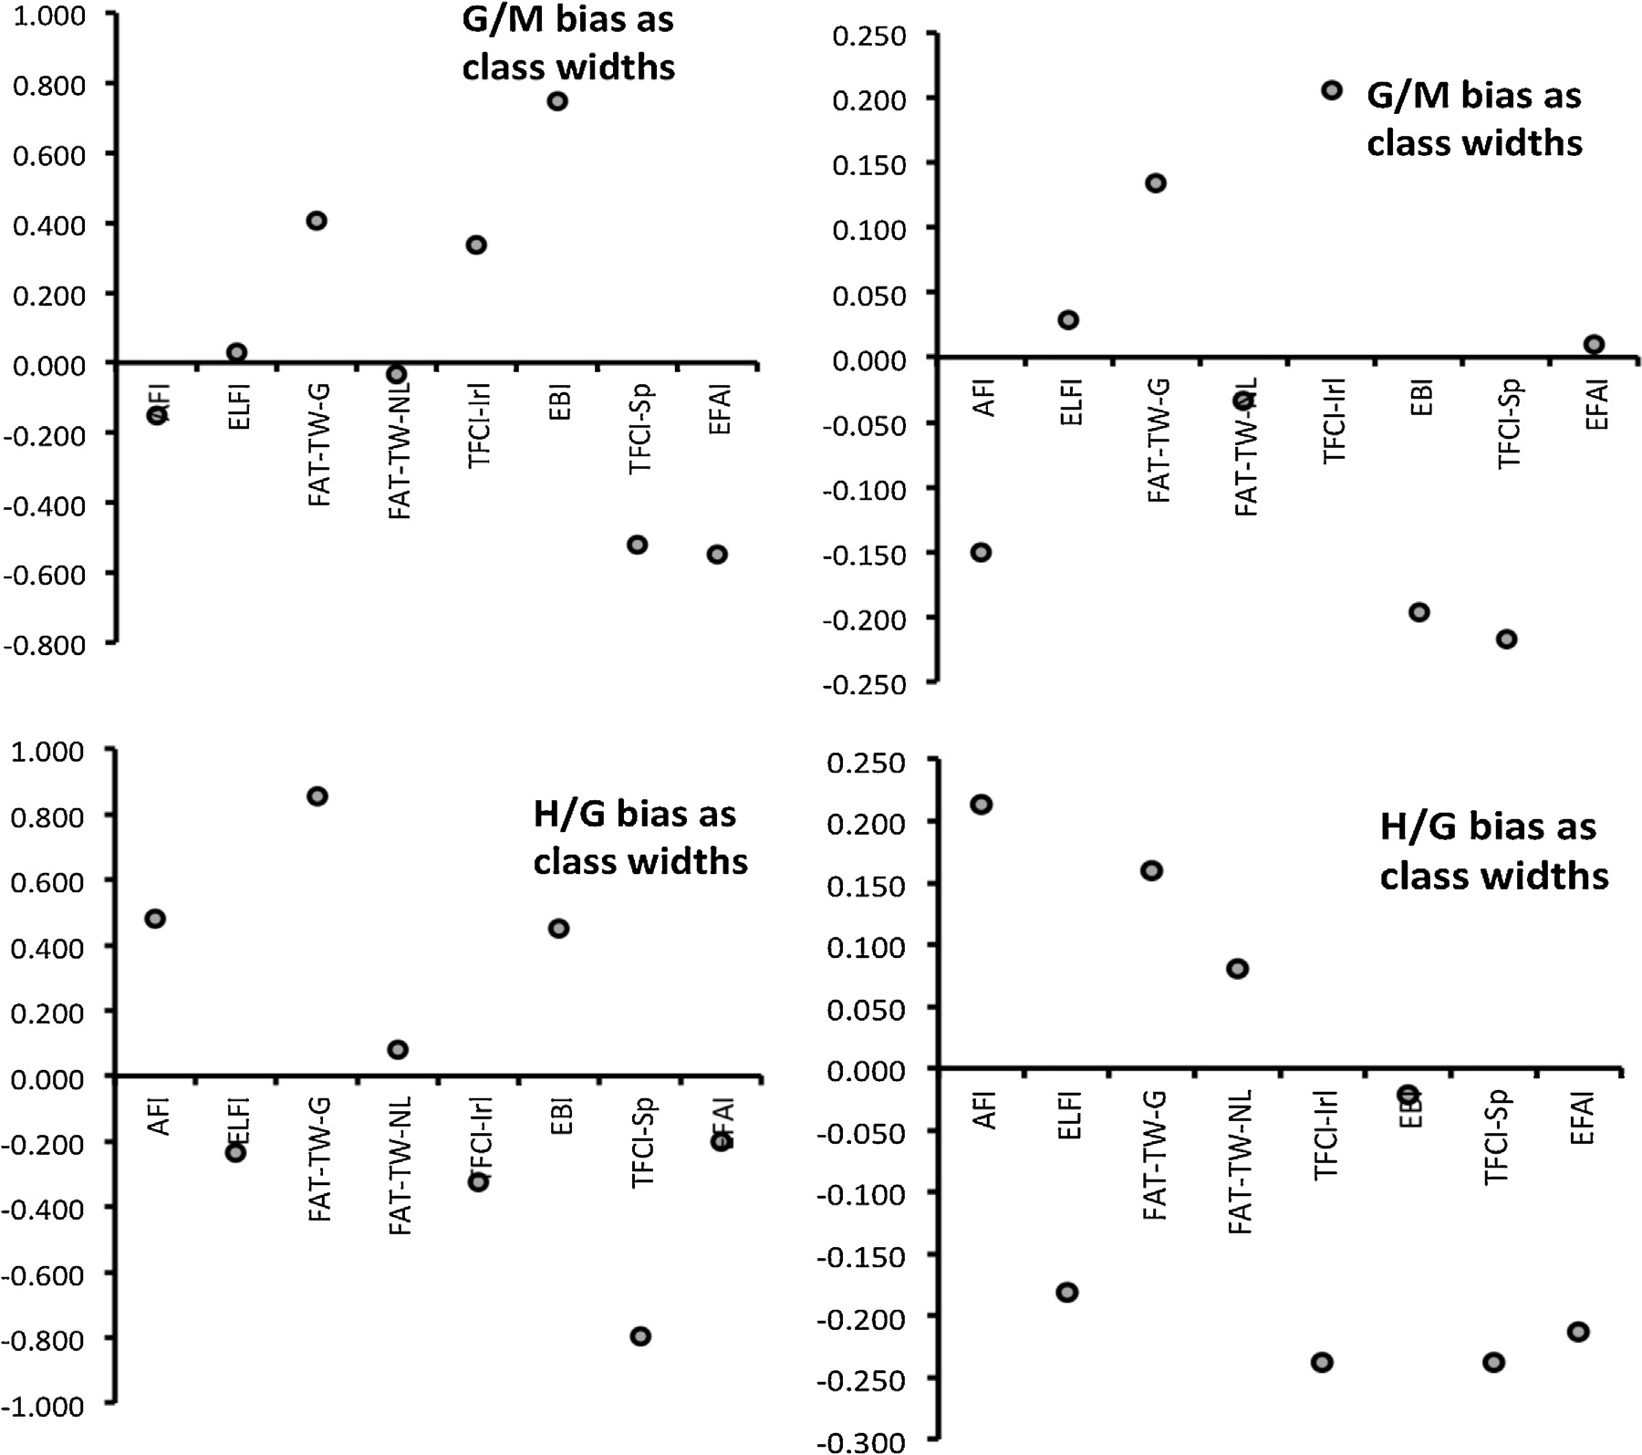

Fig. 3. Boundary bias before (a) and after (b) harmonisation expressed as class width equivalents for each ﬁsh classiﬁcation method for ‘good-moderate’ (G/M) and ‘high-good’ (H/G) boundaries; the boundary bias should not exceed −0.250 class otherwise the method is considered too relaxed. If the boundary bias exceeds +0.250 it is accepted, as the method is considered more stringent.

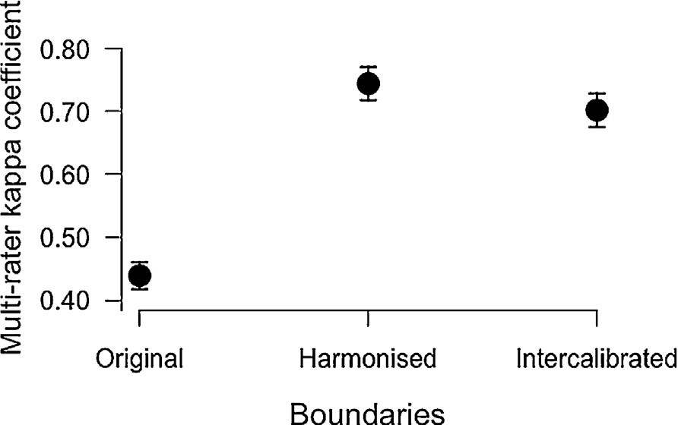Table 7
Ecological Quality Ratios class boundary values for the EMFI based on original boundary values, harmonised (global mean) boundary values, and intercalibrated boundary values.

Boundary | Original | Harmonised | Intercalibrated
High/good | 0.71 | 0.99 | 0.92
Good/moderate | 0.62 | 0.67 | 0.65
Moderate/poor | 0.52 | 0.37 | 0.35
Poor/bad | 0.43 | 0.08 | 0.10

same as, or within one class of each other (average absolute class difference <1.0). In our case, percentage of class agreement between all methods exceeded 70%, with absolute average class differences below 0.3 (Table 8).
The regression of the EMFI-EQR values of the old method (EMFIOLD) and the EMFI-EQR values of the new method (EMFINEW) produced a very strong (r2 = 0.99) relationship. The EMFIOLD bound- aries when converted into the EMFINEW scale produced values that
were similar to or lower than those used for the revised index (EMFINEW). The EMFIOLD ‘high-good’ boundary produced a value of 0.91 on the EMFINEW scale while the ‘good-moderate’ boundary translated into a value of 0.65.

Fig. 4. Classiﬁcation agreement (±95% conﬁdence limit) between ﬁsh classiﬁca- tion methods using original class boundaries, harmonised boundary values, and intercalibrated boundary values.

- Discussion

A key component of intercalibration is to ensure that classiﬁca- tions from each national classiﬁcation method are comparable and reﬂects similar states of ecological condition (Poikane et al., 2014). This ensures that although methods are different, each country’s assessment of ecological status stay within an acceptable range

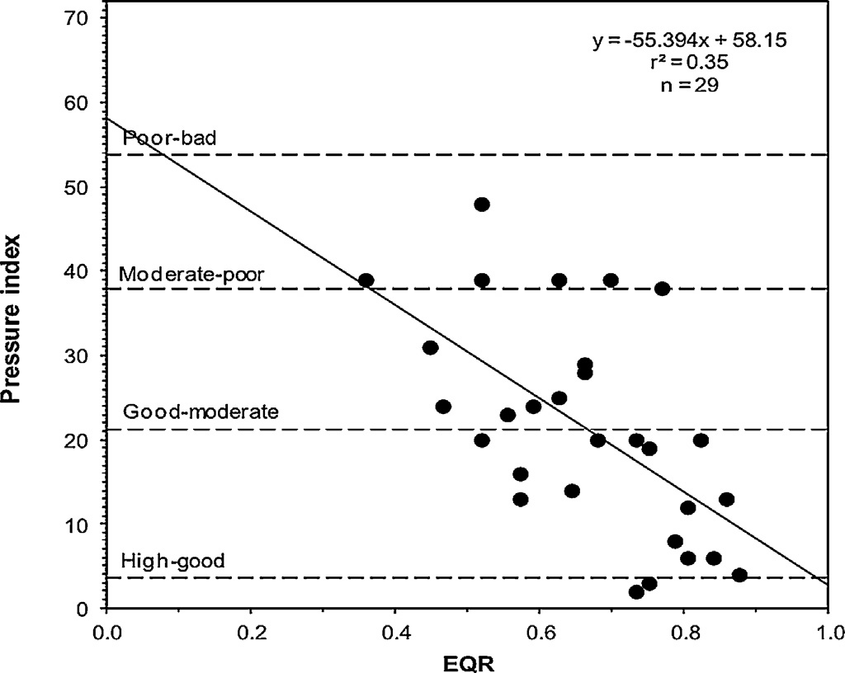

Fig. 5. Regression between the EMFI-EQR and the pressure index; horizontal lines represent the harmonised (global mean) class boundaries (on the pressure index scale).

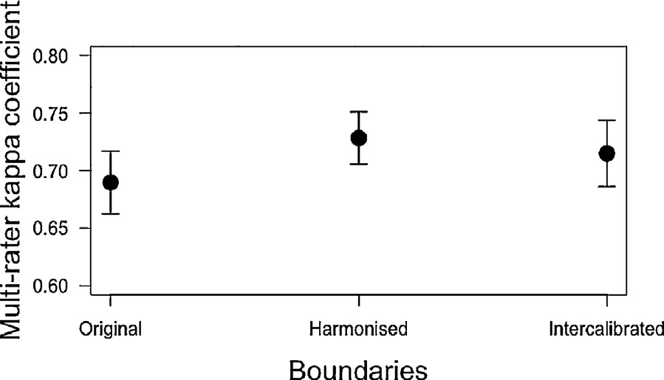

Fig. 6. Classiﬁcation agreement (±95% conﬁdence limit) between the EMFI and intercalibrated ﬁsh classiﬁcation methods using original EMFI class boundaries, harmonised EMFI boundary values, and intercalibrated EMFI boundary values.

Table 8
Absolute average class difference and percentage of class agreement between the EMFI and other ﬁsh classiﬁcation methods.
country to another (Birk et al., 2010). This has a strong effect on the calculation of metrics and prevents the use of a common biological metric. However, inter-comparison assessments are possible (and valid) using a common pressure index. The main purpose of the ﬁsh indices developed for the WFD is to assess if the disturbance created by human pressures degrades the ﬁsh communities qual- ity and, in ﬁne, the ecological status of the water bodies. Then, the use of a common pressure index as a common yardstick appears to be a good solution for the intercalibration of several assessment tools. Nevertheless, it raises some questions about the effects of each pressure taken individually rather than in addition. Teichert et al. (2016) showed that there is a hierarchical effect between pres- sure categories and demonstrated that one pressure is not equal to another. These authors also pinpoint the additive, synergetic or antagonistic effect of the combined pressures compared to their individual effects. Therefore the use of a global pressure index rep- resenting the simple sum of scores obtained by intensity classes is not well representing the underlying pressure-impact relationship but should only be considered as a proxy of the real level of pressure effects on ﬁsh assemblage.
In addition, because some countries only have few estuaries, it is also very difﬁcult to get the full range of pressures from 0 to
72. Then adjusting a linear regression to a restricted part of the gradient of pressures could also lead to differences in the slope of the regression curves (Fig. 2) and modify slightly the global mean obtained for the boundary harmonisation.
Nonetheless, all ﬁsh classiﬁcation methods showed a signiﬁ- cant relationship with the pressure index (Fig. 2). The regressions also met the requirements set out in the intercalibration guidance i.e.: the relationship should be signiﬁcant (p ≤ 0.05) and sufﬁciently
strong (r ≥ 0.5) (European Commission, 2011).
Intercalibration of a new method revealed that the EMFI exhib- ited a sufﬁcient and signiﬁcant relationship with the pressure index and met the intercalibration guidance requirements (European Commission, 2011). Although Harrison and Kelly (2013) originally established class boundary values for the EMFI according to the pressure index, the pressure index values used to set the class boundaries were somewhat arbitrarily derived, through a simple division of the pressure index range. This had the effect of com- pressing the EMFI boundary values towards the middle of the EQR range (Harrison and Kelly, 2013). The intercalibration process has enabled pressure index values that represent boundaries between ecological classes to be established and agreed at the North East

Absolute average class difference
Percentage of class agreement
Atlantic GIG level. Fleiss’ kappa multi-rater analysis indicated that the introduction of the new method led to a very good level of

AFI 0.25 75.67
EBI 0.25 75.67
EFAI 0.21 79.33
ELFI 0.27 73.33
FAT-TW-Ge 0.21 79.00
FAT-TW-Ne 0.24 76.00
TFCI-Irl 0.29 72.67
TFCI-Sp 0.26 74.00
of response. A variety of ﬁsh classiﬁcation tools were developed to assess European transitional waters (Pérez-Domínguez et al., 2012a,b). In the North East Atlantic region each method was formu- lated based on speciﬁc sampling methods and data requirements. Pérez-Domínguez et al. (2012b) found that, due to the variety of transitional ﬁsh classiﬁcation methods currently used across Europe, it is unlikely that ﬁsh methodologies can be harmonised using common (biological) metrics, either by adapting current methods or by creating new ﬁsh metrics. Contrarily to phytoplank- ton and most of benthic invertebrate surveys that respectively share sampling methods and strategies across Europe, the sampling strategies for ﬁsh in transitional waters are very different from one
agreement even increasing from 0.70 to 0.73 the previous agree- ment obtained with the ﬁrst eight assessment methods (Fig. 6). The absolute average class difference between the EMFI and the other methods (<0.30) was also below the acceptable threshold (Birk et al., 2013) with percentage of class agreements exceeding 72% (Table 8).
According to the procedure to intercalibrate new or updated methods, if the boundary values of the new method are higher than or equal to the old method, then the revised method is considered intercalibrated (Willby et al., 2014).
The approach described in this study represents a simpli- ﬁed method where boundary values are set and harmonised directly according to the level of anthropogenic pressure using regression analyses. A similar approach was adopted by Sandin and Hering (2004) to intercalibrate stream macroinvertebrate assessment methods where an organic pollution gradient was used to deﬁne ‘high-good’ and ‘good-moderate’ class boundaries. Ritterbusch et al. (2015) developed a common pressure index (TAPI index) for the intercalibration of ﬁsh indices of the central Baltic lakes. Their pressure index assessed eutrophication, hydro- morphological alteration, and biological inﬂuences as commercial

ﬁshing, stocking activities, and presence of non-native ﬁsh. Birk and Hering (2006) recommend that an understanding of the relation- ships between biological assessment methods and abiotic pressure gradients should be integral to the process of boundary comparison. The use of pressure data has comprised a key component of many intercalibration exercises, particularly in the establishment of ref- erence or benchmark sites and the establishment of class boundary values (e.g. Bennett et al., 2011; Birk et al., 2013; Birk and Hering, 2006, 2009; Buffagni et al., 2006, 2007; Ebra et al., 2009; Lopez y Royo et al., 2011). The application of marine benthic inverte- brate classiﬁcation methods in the United Kingdom determined EQR boundaries in relation to an anthropogenic pressure gradi- ent and these values were used to intercalibrate the boundaries of the other member states (Borja et al., 2007). Pressure data has also been used to compare classiﬁcations based on different biological components. Lyche-Solheim et al. (2013) used total phosphorous as a measure of eutrophication pressure to compare various phyto- plankton, macrophyte, benthic invertebrate and ﬁsh classiﬁcation methods in European lakes.
The use of a pressure index to establish boundary values pro- vides a practical method of deﬁning the quality classes associated with human pressures, as required by the WFD (Uriarte and Borja, 2009). In addition, the designation of thresholds requires distinct pressure-impact relationships between environmental parameters and intercalibrated biological metrics (Birk and Hering, 2009).
All ﬁsh classiﬁcation methods in this study exhibited a signif- icant relationship with pressures. This relationship enabled the harmonisation of all ecological classes according to pressure index thresholds through linear regression. This approach, however, assumes a linear relationship between the pressure index and each ﬁsh classiﬁcation method. Even if in our case, this assumption ﬁts, the relationship is probably more complicated to explain. Uriarte and Borja (2009) suggested that the relationship between transi- tional water ﬁsh communities and (multiple) pressure may not be linear and that the initial response to increasing pressure is a rapid degradation in biological quality. Teichert et al. (2016) demon- strated that some pressures like water quality have a threshold effect on the EQR. In addition the response of each ﬁsh classiﬁcation method to the various pressure indicators may vary as indicated by the regression statistics. Furthermore, the pressure index does not cover the full range of factors that impact on ﬁsh communities in transitional waters. Nonetheless, the selected parameters used in the pressure index offer a practical solution to issues of data avail- ability that are often encountered in the development and intercali- bration of biological classiﬁcation methods (Birk and Hering, 2009; Buffagni et al., 2007). The data required to compute the pressure index is relatively easy to compile, most parameters either form part of existing monitoring programmes (e.g. water quality) or can be estimated remotely using for instance, aerial photography.
As conclusion, the intercalibration method described here is a simple and powerful tool that can be used for other biological elements and/or in other geographical areas. The development of a relatively simple pressure index provides a consistent and comparable measure of anthropogenic stress in transitional waters from all countries. It also enables distinct pressure-impact rela- tionships between environmental parameters and biological (ﬁsh) classiﬁcation methods to be established. Finally, the approach also allows further intercalibration of modiﬁed and new classiﬁcation methods.

Acknowledgements

The authors would like to thank all those who participated in and contributed towards the intercalibration of transitional ﬁsh
methods within the North East Atlantic GIG. We would also like to thank the FP7 WISER project that helped in this intercalibra- tion exercise. We also like to thank the two reviewers for providing constructive feedback on the manuscript.

References

Aubry, A., Elliott, M., 2006. The use of environmental integrative indicators to assess seabed disturbance in estuaries and coasts: application to the Humber Estuary, UK. Mar. Pollut. Bull. 53, 175–185.
Bennett, C., Owen, R., Birk, S., Buffagni, A., Ebra, S., Mengin, N., Murray-Bligh, J., Ofenböck, G., Pardo, I., van de Bund, W., Wagner, F., Wasson, J-G., 2011. Bringing European river quality into line: an exercise to intercalibrate macro-invertebrate classiﬁcation methods. Hydrobiologia 667, 31–48.
Birk, S., Hering, D., 2006. Direct comparison of assessment methods using ben- thic macroinvertebrates: a contribution to the EU Water Framework Directive intercalibration exercise. Hydrobiologia 566, 401–415.
Birk, S., Hering, D., 2009. A new procedure for comparing class boundaries of bio- logical assessment methods: a case study from the Danube Basin. Ecol. Indic. 9, 528–539.
Birk, S., Strackbein, J., Hering, D., 2010. WISER methods database, Version: May 2010.
Available at http://www.wiser.eu/results/method-database/.
Birk, S., Bonne, W., Borja, A., Brucet, S., Courrat, A., Poikane, S., Solimini, A., van de Bund, W., Zampoukas, N., Hering, D., 2012. Three hundred ways to assess Europe’s surface waters: an almost complete overview of biological methods to implement the Water Framework Directive. Ecol. Indic. 18, 31–41.
Birk, S., Willby, N.J., Kelly, M.G., Bonne, W., Borje, A., Poikane, S., van de Bund, W., 2013. Intercalibrating classiﬁcations of ecological status: Europe’s quest for common management objectives for aquatic ecosystems. Sci. Total Environ. 454-455, 490–499.
Borja, A., Franco, J., Valencia, V., Bald, J., Muxika, I., Belzunce, M.J., Solaun, O., 2004. Implementation of the European water framework directive from the Basque country (northern Spain): a methodological approach. Mar. Pollut. Bull. 48, 209–218.
Borja, A., Josefson, A.B., Miles, A., Muxika, I., Olsgard, F., Phillips, G., Rodríguez, J.G., Rygg, B., 2007. An approach to the intercalibration of benthic ecological status assessment in the North Atlantic ecoregion, according to the European Water Framework Directive. Mar. Pollut. Bull. 55, 42–52.
Borja, A., Miles, A., Occhipinti-Ambrogi, A., Berg, T., 2009. Current status of macroin- vertebrate methods used for assessing the quality of European marine waters: implementing the Water Framework Directive. Hydrobiologia 633, 181–196.
Borja, Á., Dauer, D.M., Grémare, A., 2012. The importance of setting targets and reference conditions in assessing marine ecosystem quality. Ecol. Indic. 12, 1–7. Breine, J.J., Maes, J., Quataert, P., Van den Bergh, E., Simoens, I., Van Thuyne, G.,
Belpaire, C., 2007. A ﬁsh-based assessment tool for the ecological quality of the brackish Schelde estuary in Flanders (Belgium). Hydrobiologia 575, 141–159.
Buffagni, A., Furse, M., 2006. Intercalibration and comparison – major results and conclusions from the STAR project. Hydrobiologia 566, 357–364.
Buffagni, A., Ebra, S., Cazzola, M., Murray-Bligh, J., Soszka, H., Genoni, P., 2006. The STAR common metrics approach to the WFD intercalibration process: full appli- cation for small, lowland rivers in three European countries. Hydrobiologia 566, 379–399.
Buffagni, A., Ebra, S., Furse, M., 2007. A simple procedure to harmonize class bound- aries of assessment systems at the pan-European scale. Environ. Sci. Policy 10, 709–724.
Cabral, H.N., Fonseca, V.F., Gamito, R., Gonc¸ alves, C.I., Costa, J.L., Erzini, K., Gonc¸ alves, J., Martins, J., Leite, L., Andrade, J.P., Ramos, S., Bordalo, A., Amorim, E., Neto,
J.M., Marques, J.C., Rebelo, J.E., Silva, C., Castro, N., Almeida, P.R., Domingos, I., Gordo, L.S., Costa, M.J., 2012. Ecological quality assessment of transitional waters based on ﬁsh assemblages in Portuguese estuaries: the Estuarine Fish Assessment Index (EFAI). Ecol. Indic. 19, 144–153.
Coates, S., Waugh, A., Anwar, A., Robson, M., 2007. Efﬁcacy of a multi-metric ﬁsh index as an analysis tool for the transitional ﬁsh component of the water frame- work directive. Mar. Pollut. Bull. 55, 225–240.
Cohen, J., 1960. A coefﬁcient of agreement for nominal scales. Educ. Psychol. Meas.
20 (1), 37–46.
Delpech, C., Courrat, A., Pasquaud, S., Lobry, J., Le Pape, O., Nicolas, D., Boet, P., Girardin, M., Lepage, M., 2010. Development of a ﬁsh-based index to assess the ecological quality of transitional waters: the case of French estuaries. Mar. Pollut. Bull. 60, 908–918.
Ebra, S., Furse, M., Balestrini, R., Christodoulides, A., Ofenböck, T., van de Bund, W., Wasson, J-G., Buffagni, A., 2009. The validation of common European class boundaries for river benthic macroinvertebrates to facilitate the intercalibration process of the Water Framework Directive. Hydrobiologia 633, 17–31.
European Commission, 2011. Guidance document on the intercalibration pro- cess 2008-2011. Common Implementation Strategy for the Water Framework

Directive (200/60/EC) Guidance Document No. 14. Technical Report-2011-045. European Communities, 101 pp.
Fleiss, J.L., 1981. Statistical Methods for Rates and Proportions, 3rd ed. John Wiley, New York, pp. 38–46.
Harrison, T.D., Kelly, F.L., 2013. Development of an estuarine multi-metric ﬁsh index and its application to Irish transitional waters. Ecol. Indic. 34, 494–506.
Hering, D., Borja, A., Carstensen, J., Carvalho, L., Elliott, M., Feld, C.K., Heiskanen, A.-S., Johnson, R.K., Moe, J., Pont, D., Solheim, A.L., de Bund, W.v., 2010. The European Water Framework Directive at the age of 10: a critical review of the achievements with recommendations for the future. Sci. Total Environ. 408, 4007–4019.
Landis, J.R., Koch, G.G., 1977. The measurement of observer agreement for categorical data. Biometrics 33, 159–174.
Lopez y Royo, C., Pergent, G., Alcoverro, T., Buia, M.C., Casazza, G., Martínez-Crego, B., Pérez, M., Silvestre, F., Romero, J., 2011. The seagrass Posidonia oceanica as indicator of coastal water quality: experimental intercalibration of classiﬁcation systems. Ecol. Indic. 11, 557–563.
Lyche-Solheim, A., Feld, C.K., Birk, S., Phillips, G., Carvalho, L., Morabito, G., Mischke, U., Willby, N., Søndergaard, M., Hellsten, S., Kolada, A., Mjelde, M., Böhmer, J., Miler, O., Pusch, M.T., Argillier, C., Jeppesen, E., Lauridsen, T.L., Poikane, S., 2013. Ecological status assessment of European lakes: a comparison of metrics for phytoplankton, macrophytes, benthic invertebrates and ﬁsh. Hydrobiologia 704, 57–74.
Pérez-Domínguez, R., Maci, S., Courrat, A., Lepage, M., Borja, A., Uriarte, A., Neto, J.M., Cabral, H., StRaykov, V., Franco, A., Alvarez, M.C., Elliott, M., 2012a. Cur- rent developments on ﬁsh-based indices to assess ecological-quality status of estuaries and lagoons. Ecol. Indic. 23, 34–45.
Pérez-Domínguez, R., Alvarez, M.C., Borja, A., Cabral, H., Courrat, A., Elliott, M., Fon- seca, V., Franco, A., Gamito, R., Garmendia, J.M., Lepage, M., Muxika, I., Neto, J.M., Pasquad, S., Raykov, V., Uriarte, A., 2012b. Precision and behaviour of ﬁsh-based ecological quality metrics in relation to natural and anthropogenic pressure gra- dients in European estuaries and lagoons. Water bodies in Europe: Integrative systems to assess ecological status and recovery (WISER) Deliverable D4. 4–5, 71 pp.
Poikane, S., Zampoukas, N., Borja, A., Davies, S.P., van de Bund, W., Birk, S., 2014. Intercalibration of aquatic ecological assessment methods in the Euro- pean Union: lessons learned and way forward. Environ. Sci. Policy 44, 237–246.
R Core Team, 2014. R: a language and environment for statistical computing. R Foun- dation for Statistical Computing; 2012, Vienna, Austria, Open access available at: http://cran.r-project.org.
Ritterbusch, D., Argillier, C., Arle, J., Białokoz, W., Birzaks, J., Blabolil, P., Breine, J., Draszkiewicz-Mioduszewska, H., Jaarsma, N., Karottki, I., Krasucka, S., Krause, T., Kubecˇka, J., Lauridsen, T., Logez, M., Maire, A., Palm, A., Peirson, G., Poikane, S., Rˇ íha, M., Szlakowski, J., Virbickas, T., 2015. Central Baltic lake ﬁsh intercalibration group: results of the intercalibration process 2013–2015, 173 pp.
Sandin, L., Hering, D., 2004. Comparing macroinvertebrate indices to detect organic pollution across Europe: contribution to the EC Water Framework Directive intercalibration. Hydrobiologia 516, 55–68.
Scholle, J., Schuchardt, B., 2012. A ﬁsh-based index of biotic integrity – FAT-TW an assessment tool for transitional waters of the northern German tidal estuaries. Coastline Rep. 18, 1–73.
Teichert, N., Borja, A., Chust, G., Uriarte, A., Lepage, M., 2016. Restoring ﬁsh ecological quality in estuaries: implication of interactive and cumulative effects among anthropogenic stressors. Sci. Total Environ. 542 (Part A), 383–393.
Uriarte, A., Borja, A., 2009. Assessing ﬁsh quality status in transitional waters, within the European Water Framework Directive: setting boundary classes and responding to anthropogenic pressures. Est. Coast. Shelf Sci. 82, 214–224.
Willby, N., Birk, S., 2010. Comparability criteria for intercalibration phase 2. Outline of the procedure to compare and harmonise the national classiﬁcations of eco- logical status according to the WFD intercalibration exercise. Stirling and Essen, 25 pp.
Willby, N., Birk, S., Poikane, S., van de Bund, W., 2014. Water Framework Direc- tive Intercalibration Manual: Procedure to ﬁt new or updated classiﬁcation methods to the results of a completed intercalibration. European Commis- sion Joint Research Centre (JRC) Technical Report EUR 26568 EN, Ispra, Italy, 28 pp.

