Accumulation of neurotoxic organochlorines and trace elements in brain of female European eel (Anguilla anguilla)
C. Bonnineaua, D. Scaiona, B. Lemairea, C. Belpaireb, J.-P. Thoméc, M. Thononc,
M. Leermakerd, Y. Gaod, C. Debiera, F. Silvestree, P. Kestemonte, J.-F. Reesa,∗
a Université catholique de Louvain, Institut des Sciences de la Vie, Croix du Sud, 2/L7.05.08, B-1348 Louvain-la-Neuve, Belgium
b Research Institute for Nature and Forest (INBO), Duboislaan 14, 1560 Hoeilaart, Belgium
c Laboratoire d’Ecologie animale et d’Ecotoxicologie, Institut de Zoologie, Université de Liège, Quai Van Beneden 22, 4020 Liège, Belgium
d Analytical and Environmental Chemistry, Department of Chemistry, Faculty of Science, Vrije Universiteit Brussel, Pleinlaan 2, 1050 Elsene, Belgium
e Unité de Recherche en Biologie Environnementale et Evolutive (URBE), Université de Namur, Rue de Bruxelles 61, B-5000, Namur, Belgium

a b s t r a c t

Keywords: Toxicology PCBs
Organochlorine pesticides Mercury
Metals Brain Eel
Xenobiotics such as organochlorine compounds (OCs) and metals have been suggested to play a signif- icant role in the collapse of European eel stocks in the last decades. Several of these pollutants could affect functioning of the nervous system. Still, no information is so far available on levels of potentially neurotoxic pollutants in eel brain. In present study, carried out on female eels caught in Belgian rivers and canals, we analyzed brain levels of potentially-neurotoxic trace elements (Ag, Al, As, Cd, Co, Cr, Cu, Fe, Hg, MeHg, Mn, Ni, Pb, Sn, Sb, Zn) and OCs (Polychlorinated biphenyls, PCBs; Hexachlorocyclohexanes, HCHs; Dichlorodiphenyltrichloroethane and its metabolites, DDTs). Data were compared to levels in liver and muscle tissues. Eel brain contained very high amounts of OCs, superior to those found in the two other tis- sues. Interestingly, the relative abundance of PCB congeners markedly differed between tissues. In brain, a predominance of low chlorinated PCBs was noted, whereas highly chlorinated congeners prevailed in muscle and liver. HCHs were particularly abundant in brain, which contains the highest amounts of 1- HCH and ϒ-HCH. p,p’-DDTs concentration was similar between brain and muscle (i.e., about twice that of liver). A higher proportion of p,p’-DDT was noticed in brain. Except for Cr and inorganic Hg, all potentially neurotoxic metals accumulated in brain to levels equal to or lower than hepatic levels. Altogether, results indicate that eel brain is an important target for organic and, to a lesser extent, for inorganic neurotoxic pollutants.

- Introduction

European eel (Anguilla anguilla L.) population has dramatically declined since the 1980s (Dekker, 2003). Changes in ocean cur- rents, climate shifts, habitat loss, overﬁshing, barriers to migration, increased predation, introduction of parasites and exposure to chemicals have all been postulated as plausible causative factors that could act in a synergistic manner (Miller et al., 2016). Regarding chemical exposure, several authors have pointed to the abun- dance of organochlorine compounds (OCs) (i.e., polychlorinated biphenyls or PCBs, and organochlorine pesticides or OCPs) in eel tissues, and to the possible impact that this intoxication could have on energy stores and reproduction (Belpaire and Goemans, 2007;

∗ Corresponding author.
E-mail address: jf.rees@uclouvain.be (J.-F. Rees).
Geeraerts and Belpaire, 2010; Van Ginneken et al., 2009). As in most ﬁsh species, pollutant analyses in eel usually focus on liver and muscle. This is because of the relative importance of these two organs for detoxiﬁcation processes and human health, respec- tively (Harrad, 1999; Hoff et al., 2005). Despite the importance of the central nervous system for animal ﬁtness, and the clear neu- rotoxic properties of many environmental contaminants, chemical analyses in ﬁsh rarely focus on the brain. Neurotoxicity has how- ever been associated with exposure to both organic and inorganic contaminants in this fauna. PCBs and pesticides such as lindane (')'-Hexachlorocyclohexane, ')'-HCH) and DDT (Dichlorodiphenyl- trichloroethane) are abundant in eel liver (e.g. Maes et al., 2008). These persistent chemicals also are proven neurotoxicants (Slotkin et al., 2006). High levels of neurotoxic trace elements, such as Pb, Cd, Hg, and As have been detected in eel liver and muscle as well (Nunes et al., 2014; Tabouret et al., 2011). If present also in brain, all these contaminants may induce injuries and behavioral deﬁcits

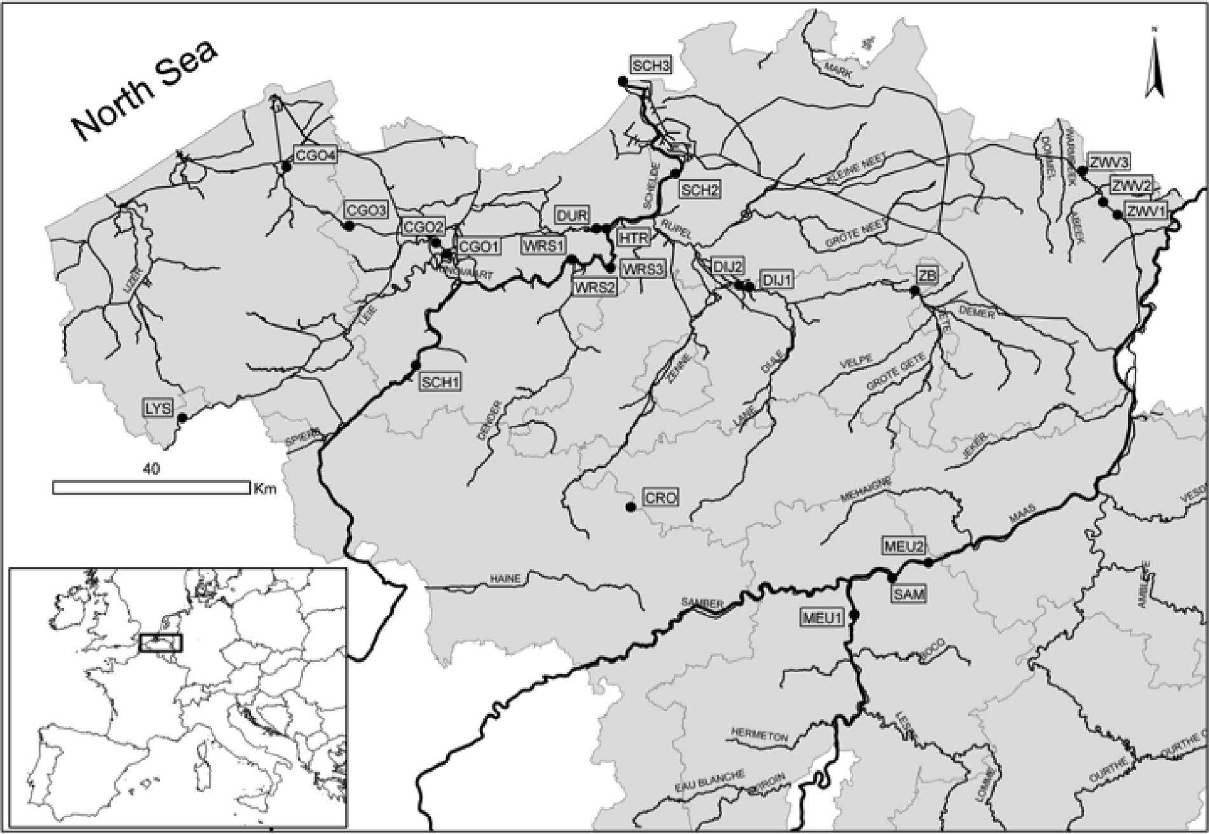

Fig. 1. Map of Belgium with the 23 sampling sites. Black dots indicate yellow eel sampling locations.

affecting individual ﬁtness. Recent studies suggest that cognitive performances are crucial to the successful migration of young eels, especially when facing obstacles such as dams (Podgorniak et al., 2016; Podgorniak et al., 2015a,b). It appears that reduced cogni- tive performances, together with pollutant-mediated depletion of energy stores (Van Ginneken et al., 2009), could well detrimen- tally affect silver eels carrying out their 6000-km migration towards their reproduction sites.
To determine whether or not eel brain accumulates neurotoxic organic and inorganic pollutants to levels comparable to those of liver and muscle, we investigated the contamination load in the three organs of female European eels sampled from Belgian rivers and canals.

- Materials and methods

  - Sample collection

Sixty-ﬁve female European eels of the yellow stage, with an average length of 70.3 ± 10.8 cm and weight of 714.4 ± 47.1 g (mean ± S.E.M.), were collected from 23 locations in Belgian rivers and canals between May and October 2010 (Fig. 1). Most of them were captured by fyke ﬁshing and a minority by electro-ﬁshing. Eels were transported back to the laboratory in oxygenated freshwater tanks where they were housed for up to 3 days in tanks equipped with a freshwater recirculation system. Eels were euthanized with MS 222 or clove oil, and their total length and weight recorded prior to dissection. Brain (0.22 ± 0.01 g), liver (9.85 ± 0.58 g) and dorsal muscle samples (151.0 ± 10.01 g) were obtained. The brain of each
individual was divided into two symmetric equivalent parts, for OC and metal analyses. All tissues were stored at −24 ◦C prior to
lyophilisation and grinding. Samples were weighed before and after lyophilisation as to determine their water content.

  - Chemical analyses

The general structures of the OCs quantiﬁed in eel tissues are presented in Fig. 2.

    - PCBs and OCPs
PCB congeners (IUPAC numbers: CB-28, -52, -101, -105, -118,
-138, -153 and -180), HCHs (a-HCH, 1-HCH + ')'-HCH) and DDTs
(p,p’-DDD, p,p’-DDE and p,p’-DDT) were analyzed. The method of extraction, modiﬁed from Debier et al. (2003) and Schnitzler et al. (2008), was similar for OCPs and PCBs. Brieﬂy, samples were crushed with a Grindomix GM20 (Retsh, Haan, Germany) then freeze-dried with a Benchtop 3L Sentry Lyophilisator (VirTis, New- York, USA). Lipid extraction was performed with n-hexane using an Accelerated Solvent Extractor (Dionex 200, Sunnyvale, USA). Cells
were heated during 6 min before performing two 5-min cycles of extraction at 1500 psi pressure and 125 ◦C. All extracts were used for lipid content determination: solvent was evaporated using a
Turbovap LV (Zymarck, Hopkinton, Mass., USA). Samples were then diluted in 3 ml of n-hexane and an internal standard (CB 112 with a ﬁnal concentration of 50 pg µl−1) was added in order to quantify
possible loss of PCBs during the procedure of sample preparation described hereafter.
To remove organic matter, extracts were subjected to clean- up with sulphuric acid. For this, 2 ml of a mixture of concentrate (95%) and fuming (30%) sulphuric acid (3:1; v:v) were added to
each extract. The mixture was shaken and centrifuged for 3 min at 1750g (10 ◦C). The supernatant was removed and 3 ml of n-hexane were added to the decanted acid. The shaking-centrifugation-

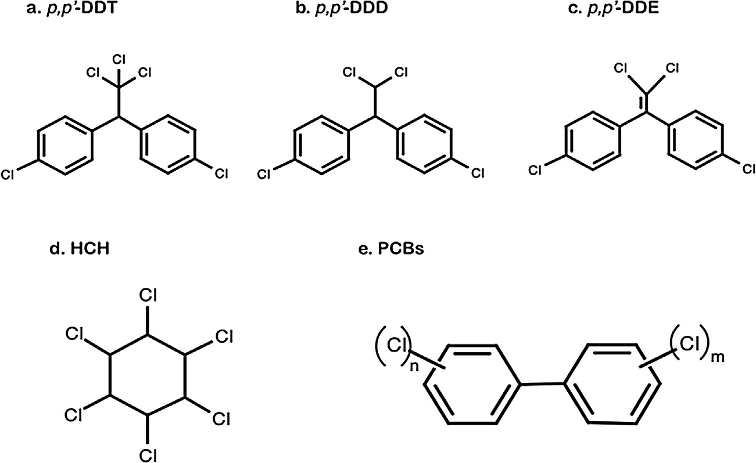

Fig. 2. General structure of the organochlorine compounds assayed in eel tissues.

supernatant removal procedure was repeated prior to solvent evaporation. A Florisil clean-up (SupercleanTM ENVI Florisil SPE tubes 6 ml, SUPELCO, Bellefonte, USA) was used to remove polar substances. Columns were conditioned with 5 ml acetone, 5 ml acetone-hexane (1:1; v:v) and 12 ml hexane. Extracts were eluted with 6 ml hexane-diethyl ether (85:15; V:V). Hexane was evapo- rated using a Visidry evaporator (Supelco, Bellefonte, PA., USA). After addition of 75 µl of n-hexane and 75 µl of an internal standard (Mirex, 100 pg µl−1 diluted in n-hexane), extracts were analyzed using a high-resolution gas chromatograph (Thermoquest, Trace 2000, Milano, Italy). The apparatus was equipped with a 63Ni electron capture detector (ECD-63Ni). PCBs and organochlorines pesticides were separated by progressive increases of tempera- ture: 2 min at 60 ◦C followed by an increase of 20 ◦C per min until 140 ◦C; 140 ◦C during 3 min; increase of 2.5 ◦C per min until 270 ◦C; and 270 ◦C during 12 min. Congeners and pesticides were identi- ﬁed and individually quantiﬁed according to their relative retention times to the internal standard used for quantiﬁcation (i.e. Mirex). Quantiﬁcation was performed using the internal standard method. Calibration curves in the linear response interval of the detector were created for each of the eight pure PCB congeners (IUPAC CB- 28, -52, -101, -105, -118, -138, -153, -180; Ultra Scientiﬁc) and for pesticides. The concentrations used for the linear calibration curves ranged from 1 to 75 pg µl−1 of each analyte and good correlation (r > 0.995) was achieved. CB-105 congener was not analyzed in the liver as this congener co-eluted with CB-138 in this organ.
The quality control was performed by regular analyses of pro- cedural blanks, standards and n-hexane blanks. Standard reference materials SRM 1946 (PCBs and OCPs in ﬁsh tissue; National Insti- tute of Standards and Technology, NIST, USA) and BCR RM 349 (cod liver) were used to test the accuracy of the whole procedure. The quality control scheme is also assessed through regular participa- tion to comparison exercises organized by the IAEA-MEL Marine Environment Laboratory (Monaco, France).
Procedural blanks and laboratory-made quality controls were run with each series of 10 samples (i.e., to control for the extraction and clean-up procedures). The limit of detection (LOD) was set at
a level of 3 times the background noise of the chromatograms. The LOD for PCB congeners was therefore 1 pg µl−1, which corresponds to 0.03 ng g−1 (ppb) of ﬁsh muscle and liver in our analytical con-
ditions. To determine the limit of quantiﬁcation (LOQ), cod muscle samples were spiked at different concentrations before the chem- ical extraction. The lowest concentration that showed a recovery range between 70% and 130% was determined as the LOQ of the
chemical (Debier et al., 2003). This concentration also corresponded to at least 10 times the background noise of the chromatograms. In these conditions, the LOQ was 0.4 ng g−1 (ppb) wet weight and
12.4 ng g−1 (ppb) of lipid of cod muscle for PCB congeners. For each PCB congener, recovery efﬁciency was calculated on the basis of the concentration of the surrogate marker CB-112 (50 µg µl−1), and results corrected accordingly. �PCBs corresponds to the sum of all 8 PCB congeners.

    - Trace elements analysis
Ag, Al, As, Cd, Co, Cr, Cu, Fe, HgTOT (Total Hg, including organic and inorganic Hg), Mn, Ni, Pb, Sn, Sb, Zn were analyzed by induc- tively coupled plasma mass spectrometry (ICP-MS). Samples were digested with HNO3 and H2O2 in a microwave oven (CEM Mars 5), using a controlled temperature procedure. Approximately 100 mg (muscle, liver) or 5–20 mg (brain) of lyophilized samples were accu- rately weighed and transferred into digestion vessels. Five ml of concentrated HNO3 (Merck, distilled pro-analysis) were added to 1 ml of H202 (30% V/V; Merck, suprapure). Digestion was performed using a temperature and pressure-controlled procedure: the tem- perature gradually increased from room temperature to 180 ◦C during 15 min and was then held at 180 ◦C for 15 min. After cool- ing, samples were diluted to 50 ml and stored in PE bottles. Each digestion set (14 positions) contained two blanks and two reference materials (DORM-3, DOLT-3).
ICP-MS analysis was performed using a double focusing sec- tor ﬁeld instrument (Thermo Finnigan Element II). Samples were further diluted ten times before analysis. Indium, added at a con- centration of 1 µg L−1, was used as an internal standard throughout the procedure. Calibration was performed using single element standards (Alpha) as well as multi-element standards (Merck Multi-element standard XIII).
Methylmercury (MeHg) was analyzed by ethylation headspace gas chromatography with atomic ﬂuorescence detection (HGC- AFS). MeHg was extracted with a mixture of H2SO4/KBr and CuSO4, extracted in dichloromethane (CH2Cl2) and back-extracted into water. Lyophilized samples were weighed and transferred to Teﬂon vials. Five ml of 5% H2SO4 and 18% KBr solutions were added together with 1 ml of 5% CuSO4. Samples were shaken for 20 min before addition of 9 ml of CH2Cl2 and subsequent shaking for 1 h. Samples were centrifuged for 15 min at 3000 rpm and the aque- ous layer was then removed. Five ml of the CH2Cl2 layer were then transferred to 20 ml deionized water for back-extraction in a water bath (60 ◦C) under constant N2 ﬂow. After evaporation of the CH2Cl2

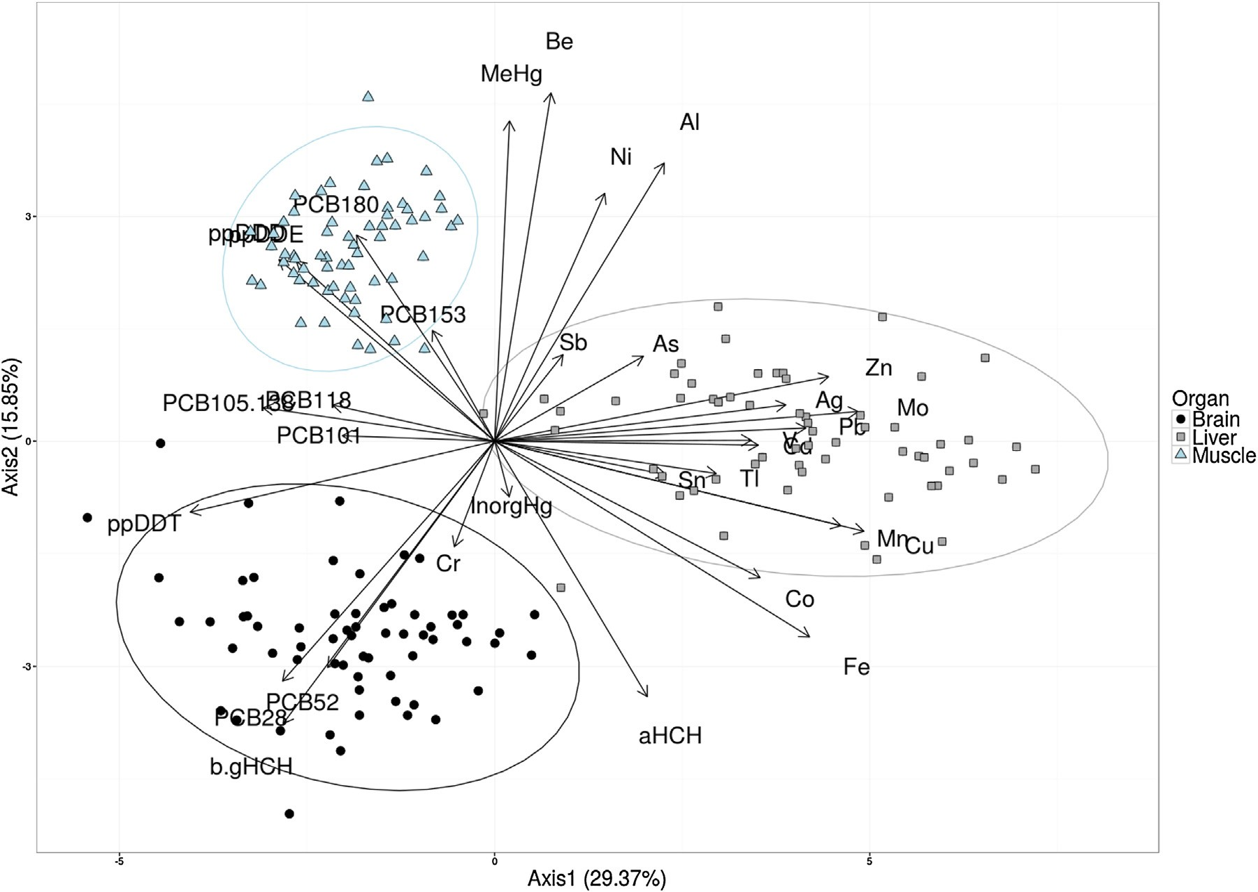

Fig. 3. Biplot of the PCA. Samples are represented by dots and variables by arrows. p,p1 -DDD and p,p1 -DDE are overlapping. For each organ, 95% conﬁdence ellipse is shown.

phase, the aqueous samples were stored overnight at 4 ◦C prior to analysis. The aqueous phase was then ethylated with NaBEt4 and the ethylated compounds were separated by gas chromatography (GC). For analysis, aliquots (0.2–5 ml) were transferred to 20 ml chromatographic headspace vials and diluted to 10 ml. 60 µl of acetate buffer and 100 µl of NaBEt4 1% were added and left to react for 1 h. Samples were then transferred to the headspace GC. After 10 min equilibration (60 ◦C), the headspace was transferred to a GC column for separation of ethylated compounds. A temperature- programmed GC method was applied. Compounds leaving the GC column pass a pyrolytic column held at 700 ◦C to decompose the ethylated compounds to elemental Hg. Detection of elemental Hg was performed by atomic ﬂuorescence spectrometry (AFS). Each batch of samples contained a blank and two reference materials (DORM-3 or DOLT-3). Calibration standards (0–40 ng Hg l−1) were made from a MeHg stock solution (Alfa). Inorganic Hg (Hg2+) was calculated from the difference between HgTOT and MeHg.

  - Statistical methods

Results are expressed as mean ± standard error of the mean (S.E.M.). The normality of data distributions was tested by Lilliefors test. In order to stabilize the variance within the data, pollutant levels were log-transformed. Data were compared between brain, liver and muscle tissues using a General Linear Model ANOVA (SAS Institute Inc.). A post-hoc Tukey’s test was used to identify signif- icant (p < 0.05) differences between means. Pearson’s correlation coefﬁcients between variables were calculated with the R software (www.R-project.org).
- Results

  - Lipid content

The lipid content was similar in female eel brain (4.7 ± 0.2%) and liver (4.1 ± 0.2%) while it reached 15.5 ± 0.7% in the muscle.

  - Contaminants repartition in eel organs

Contamination within the 3 organs differed in quantity and quality as shown by the PCA (Fig. 3) while differences between sites were not highlighted by the PCA (data not shown). Thus, the ﬁrst two axes of the PCA clearly separated the samples from the differ- ent organs and explained 45.2% of the variance (PC1: 29.4%, PC2: 15.8%). Samples from brain and muscle were clearly separated from liver samples along PC1 while PC2 clearly separated muscle from brain samples. Roughly, axis 1 separated samples enriched in met- als (such as liver) from samples rich in OCs (such as muscle and brain) while axis 2 was mainly driven by the content in MeHg, Be, Ni, and Al. Thus, liver samples were associated with high concen- trations of metals (especially Cu, Mo, Mn, Zn, Fe, Pb, Ag, Co, Cd, V) and low concentrations of DDTs and PCBs (especially PCB 118, 105, 138). Muscle samples were associated with high concentrations in p,p’-DDD, p,p’-DDE, PCB 153 and 180 as well as higher concentra- tions in MeHg and Be. Brain samples were associated with high concentrations of PCB 28, 52, and of 1 and ')' HCH.

  - PCBs and OCPs

Mean concentrations of organic contaminants in female eel brain, liver and muscle are shown in Table 1. The brain was signiﬁcantly (p < 0.0002) more contaminated with PCBs (224.7 ng g−1 ww) than liver (132.3 ng g−1 ww) or muscle

Table 1
Concentrations of organochlorines and trace elements in European eel tissues collected from rivers in Belgium. Mean and S.E.M., n.d.: not determined. The p-values resulting from the Welch ANOVA are ranked with stars: p <0.05: *, p < 0.01: **; p < 0.001: ***. n.s.: non-signiﬁcant. Letters refer to signiﬁcant differences in concentrations between organs as indicated by the Games-Howell post-hoc test.

 | Brain | Liver | Muscle | p
Organics
PCBs (ng g−1 ww) | n = 63 | n = 62 | n = 63
PCB28 PCB52 PCB101 PCB105 PCB118 PCB138 PCB105 + 138 PCB153 PCB180  �PCBs  Pesticides (ng g−1 ww) | 34.4 ± 5.0a  35.2 ± 6.2a  25.5 ± 3.7ab 6.7 ± 0.6a 26.2 ± 5.2 40.9 ± 5.2 47.6 ± 5.6a 38.9 ± 4.8 16.9 ± 3.5a 224.7 ± 22.5a n = 63 | 2.2 ± 0.3b  3.8 ± 0.5b  14.3 ± 1.4a  n.d.  17.5 ± 1.8  n.d.  23.0 ± 2.8b  55.6 ± 8.0  15.8 ± 1.8a  132.3 ± 14.8b  n = 62 | 4.2 ± 0.6c  3.6 ± 0.4b  18.5 ± 1.5b  3.6 ± 0.4b  19.4 ± 1.3  31.1 ± 1.8  34.8 ± 2.0a  41.8 ± 2.6  25.4 ± 1.7b  147.7 ± 9.0ab  n = 63 | ***  ***  *  *** n.s.  n.s.  *** n.s.  ***  **
aHCH 1HCH ')'HCH  1 + ')'HCH  �HCH p,p1 -DDE p,p1 -DDD p,p1 -DDT  �DDD  Trace elements | 5.1 ± 0.9a  n.d.  n.d.  31.3 ± 5.2a  35.8 ± 5.3a  16.2 ± 3.8a  6.3 ± 1.0a  4.7 ± 0.7a  27.2 ± 4.5a  n = 65 | 10.1 ± 2.4a  0.0 ± 0.0  1.4 ± 0.2a  1.5 ± 0.2b  11.4 ± 2.4b  6.7 ± 0.6a  3.8 ± 0.4a  0.2 ± 0.0b  10.7 ± 1.0b  n = 65 | 0.1 ± 0.0b  0.1 ± 0.0  2.2 ± 0.2b  2.2 ± 0.2c  2.3 ± 0.2c  18.0 ± 1.0b  10.6 ± 0.8b  2.5 ± 0.3c  31.0 ± 1.8c  n = 65 | *** n.s.  **  ***  ***  ***  ***  ***  ***
Non-essential (ng g−1 ww)
Ag Al As Be Cd Co Cr  Inorganic Hg Methyl-Hg Mo  Ni Pb Sb Sn Tl V | 6.5 ± 1.1a  360.7 ± 31.4a  30.2 ± 4.4a  3.0 ± 0.2a  30.4 ± 5.3a  37.6 ± 2.9a  91.2 ± 15.3a  27.0 ± 1.3a  6.1 ± 0.7a  16.0 ± 0.9a  30.4 ± 7.5a  57.2 ± 7.0a  0.8 ± 0.2a  22.0 ± 2.8a  12.7 ± 1.5a  20.8 ± 1.8a | 106.7 ± 12.6b  3214.9 ± 364.5b  138.3 ± 23.7b  18.7 ± 0.9b  546.9 ± 88.9b  65.3 ± 4.5b  33.7 ± 4.9b  23.2 ± 3.8ab 76.1 ± 6.6b 245.9 ± 11.1b  155.0 ± 6.6b 187.1 ± 14.3b 3.5 ± 0.5b 45.6 ± 5.5b 64.6 ± 9.9b 224.1 ± 37.4b | 18.3 ± 0.9c  3056.6 ± 216.7b  75.7 ± 13.1c  30.0 ± 1.1c  4.3 ± 0.2c  9.7 ± 1.1c  44.7 ± 9.7b  18.8 ± 2.9b  131.2 ± 8.7c 32.1 ± 4.2c 178.5 ± 14.7b 62.3 ± 1.4a 3.1 ± 1.1ab 9.8 ± 1.2c  4.4 ± 0.6c  5.0 ± 0.5c | ***  ***  ***  ***  ***  ***  ***  *  ***  ***  ***  ***  ***  ***  ***  ***
Essential (µg g−1 ww)
Cu Fe Mn Zn  �trace elements (µg g−1 ww) | 1.4 ± 0.1a  34.6 ± 2.2a  0.5 ± 0.0a  14.8 ± 1.2a  52.0 ± 2.5a | 17.9 ± 1.2b  314.9 ± 21.5b  1.6 ± 0.1b  42.4 ± 2.1b  382.0 ± 22.6b | 0.1 ± 0.0c  2.1 ± 0.3c  0.2 ± 0.0c  16.5 ± 0.5c  22.8 ± 0.7c | ***  ***  ***  ***  ***

(147.7 ng g−1 ww). Brain PCB proﬁle differed from that of liver or muscle (Fig. 4) in having a higher proportion of low chlorinated congeners (i.e., ≤4 chlorine atoms; CB-28, CB-52). These accounted for 38% of the total PCB burden in brain, against less than 5% in liver and muscle (p < 0.0001). The sum of CB-138 and CB-153 levels accounted for 60% of the total of PCBs in liver, 50% in muscle and 30% in brain. Signiﬁcant correlations were observed for congeners CB-118, CB-138, CB-153 and CB-180 levels between brain and liver, whereas only CB-101 levels correlated between brain and muscle (Table 2). As shown in Fig. 5, positive correlations between octanol:water partition coefﬁcient (Log KOW; from Hansen et al., 1999) and the abundance of PCB congeners were found in muscle (r = 0.58) and liver (r = 0.36), whereas none was observed in brain (r = 0.05). Levels of a-HCH were signiﬁcantly higher (p < 0.0001)
in brain (5.10 ± 0.90 ng g−1 ww) and liver (10.10 ± 2.40 ng g−1 ww) than in muscle (0.10 ± 0.01 ng g−1 ww), while 1- and ')'- HCH concentrations were much higher (p < 0.0001) in brain (31.25 ± 5.19 ng g−1 ww) than in liver (1.42 ± 0.16 ng g−1 ww) and muscle (2.21 ± 0.20 ng g−1 ww).
The total content in p,p’-DDT and its metabolites p,p’-DDD and p,p’-DDE (DDTs) was higher in brain and muscle than in liver of female eels (p < 0.0001; Table 1). Marked differences existed in the relative tissue abundance of the three chemical forms (p < 0.02). DDT/DDE ratio was 1.17 in brain, 0.04 in liver, and 0.15 in muscle. Only for liver did DDTs concentration positively correlate with tis- sue lipid content (r = 0.45). In muscle, positive relationships with the fat content were observed for DDD and DDE (r = 0.46), whereas it was only signiﬁcant for DDT in liver (r = 0.28). The only signiﬁcant correlation between OC levels in brain and the two other organs was observed for DDE in liver (r = 0.29). The signiﬁcant correlations detected between levels of OCs in brain are shown in Table 2.

  - Trace elements

All metals and metalloids were detected in the three tissues of female eels. Essential elements (i.e., Fe, Cu, Mn and Zn) were found at relatively high concentrations in all tissues, with mean concentrations higher in liver than in muscle and brain (Table 1).

Table 2
Spearman correlations between concentrations of contaminants and lipid content (in%) in each organ, between concentrations of each contaminant in the different organs. Correlations have been calculated with organics concentrations in ng g−1 ww (ww) or in ng g−1 lipid (lipid). The different p-values are ranked with stars: p < 0.05: *, p < 0.01:
**; p < 0.001: ***. n.s.: non-signiﬁcant, n.d.: not determined.

Correlations between [contaminants] and%lipid Correlations between [contaminants] in the different organs

Brain Muscle Liver Brain-Liver Brain-Muscle Liver-Muscle

 | ww | lipid |  | ww | lipid |  | ww | lipid |  | ww | lipid |  | ww | lipid |  | ww | lipid
Organics ng g−1
PCB28 | n.s. | −0.40*** |  | 0.34** | n.s. |  | n.s. | n.s. |  | n.s. | −0.26* |  | n.s. | n.s. |  | n.s. | 0.28*
PCB52 | n.s. | −0.46*** |  | 0.28* | n.s. |  | n.s. | n.s. |  | n.s. | n.s. |  | n.s. | 0.26* |  | n.s. | 0.40***
PCB101 | n.s. | −0.32* |  | n.s. | −0.34** |  | n.s. | −0.34** |  | 0.26* | 0.35** |  | 0.30* | 0.52*** |  | n.s. | 0.59***
PCB105 | n.s. | n.s. |  | n.s. | 0.26* |  | n.d. | n.d. |  | n.d. | n.d. |  | n.s. | n.s. |  | n.d. | n.d.
PCB118 | 0.36** | n.s. |  | n.s. | −0.44*** |  | n.s. | n.s. |  | 0.39** | 0.37** |  | 0.31* | 0.44*** |  | n.s. | 0.59***
PCB138 | n.s. | n.s. |  | n.s. | −0.58*** |  | n.d. | n.d. |  | n.d. | n.d. |  | n.s. | 0.42*** |  | n.d. | n.d.
PCB105 + 138 | 0.25* | n.s. |  | n.s. | −0.59*** |  | n.s. | n.s. |  | 0.45*** | 0.48*** |  | 0.28* | 0.33** |  | 0.28* | 0.63***
PCB153 | 0.27* | n.s. |  | n.s. | −0.50*** |  | 0.33** | n.s. |  | 0.42*** | 0.49*** |  | 0.28* | 0.47*** |  | 0.31* | 0.6***
PCB180 | n.s. | n.s. |  | n.s. | −0.52*** |  | 0.31* | n.s. |  | 0.57*** | 0.54*** |  | n.s. | 0.52*** |  | 0.43*** | 0.68***
�PCBs | n.s. | −0.35* |  | n.s. | −0.52*** |  | 0.27* | n.s. |  | 0.30* | 0.32* |  | n.s. | 0.42*** |  | n.s. | 0.68***
aHCH | n.s. | n.s. |  | n.s. | n.s. |  | n.s. | n.s. |  | n.s. | n.s. |  | n.s. | n.s. |  | n.s. | n.s.
1HCH | n.d. | n.d. |  | n.s. | 0.25* |  | n.s. | n.s. |  | n.d. | n.d. |  | n.d. | n.d. |  | n.s. | n.s.
')'HCH | n.d. | n.d. |  | n.s. | n.s. |  | n.s. | n.s. |  | n.d. | n.d. |  | n.d. | n.d. |  | 0.33** | 0.45***
1+')'HCH | n.s. | −0.26* |  | n.s. | n.s. |  | n.s. | n.s. |  | n.s. | n.s. |  | n.s. | 0.39** |  | 0.30* | 0.35**
�HCHs | n.s. | −0.25* |  | n.s. | n.s. |  | 0.30* | n.s. |  | n.s. | n.s. |  | n.s. | 0.40*** |  | n.s. | n.s.
p,p,’-DDE | n.s. | n.s. |  | 0.48*** | −0.37** |  | n.s. | −0.33** |  | 0.32* | n.s. |  | n.s. | n.s. |  | n.s. | 0.60***
p,p,’-DDD | n.s. | n.s. |  | 0.48*** | n.s. |  | n.s. | n.s. |  | n.s. | n.s. |  | n.s. | n.s. |  | 0.37** | 0.63***
p,p,’-DDT | n.s. | n.s. |  | n.s. | −0.47*** |  | 0.28* | n.s. |  | n.s. | n.s. |  | n.s. | n.s. |  | n.s. | n.s.
�DDTs | n.s. | −0.30* |  | 0.51*** | −0.30* |  | n.s. | −0.30* |  | 0.26* | n.s. |  | n.s. | n.s. |  | 0.29* | 0.62***
Trace elements µg g−1 ww
Ag | 0.41*** |  |  | n.s. |  |  | n.s. |  |  | 0.47*** |  |  | 0.26* |  |  | n.s.
Al | n.s. |  |  | n.s. |  |  | n.s. |  |  | n.s. |  |  | n.s. |  |  | n.s.
As | n.s. |  |  | n.s. |  |  | n.s. |  |  | 0.72*** |  |  | 0.71*** |  |  | 0.85***
Be | n.s. |  |  | n.s. |  |  | n.s. |  |  | −0.27* |  |  | n.s. |  |  | 0.29*
Cd | n.s. |  |  | n.s. |  |  | n.s. |  |  | 0.81*** |  |  | 0.57*** |  |  | 0.59***
Co | n.s. |  |  | n.s. |  |  | n.s. |  |  | 0.73*** |  |  | 0.50*** |  |  | 0.51***
Cr | n.s. |  |  | n.s. |  |  | n.s. |  |  | n.s. |  |  | n.s. |  |  | n.s.
Inorganic Hg | n.s. |  |  | n.s. |  |  | n.s. |  |  | n.s. |  |  | 0.28* |  |  | 0.36**
MeHg | n.s. |  |  | n.s. |  |  | n.s. |  |  | 0.41*** |  |  | 0.39*** |  |  | 0.73***
Mo | n.s. |  |  | n.s. |  |  | n.s. |  |  | 0.32** |  |  | 0.29* |  |  | n.s.
Ni | n.s. |  |  | 0.36** |  |  | n.s. |  |  | 0.27* |  |  | 0.33** |  |  | n.s.
Pb | n.s. |  |  | n.s. |  |  | n.s. |  |  | 0.31* |  |  | n.s. |  |  | n.s.
Sb | n.s. |  |  | n.s. |  |  | n.s. |  |  | 0.57*** |  |  | n.s. |  |  | n.s.
Sn | n.s. |  |  | n.s. |  |  | n.s. |  |  | 0.68*** |  |  | 0.57*** |  |  | 0.52***
Tl | n.s. |  |  | n.s. |  |  | −0.41*** |  |  | 0.93*** |  |  | 0.92*** |  |  | 0.90***
V | 0.27* |  |  | n.s. |  |  | n.s. |  |  | 0.53*** |  |  | 0.33** |  |  | 0.38**
Cu | 0.40*** |  |  | n.s. |  |  | n.s. |  |  | 0.25* |  |  | n.s. |  |  | n.s.
Fe | n.s. |  |  | n.s. |  |  | n.s. |  |  | n.s. |  |  | n.s. |  |  | n.s.
Mn | n.s. |  |  | n.s. |  |  | n.s. |  |  | n.s. |  |  | n.s. |  |  | n.s.
Zn | 0.31* |  |  | n.s. |  |  | n.s. |  |  | n.s. |  |  | n.s. |  |  | 0.35**
�non-essentials | 0.30* |  |  | n.s. |  |  | n.s. |  |  | n.s. |  |  | n.s. |  |  | n.s.
�essentials | n.s. |  |  | n.s. |  |  | n.s. |  |  | n.s. |  |  | n.s. |  |  | n.s.
�trace elements | n.s. |  |  | n.s. |  |  | n.s. |  |  | n.s. |  |  | n.s. |  |  | n.s.

Among all analyzed non-essential element (Ag, Al, As, Be, Cd, Co, Cr, Hg, MeHg, Mo, Ni, Pb, Sb, Sn, Ti), only Sb was not detected in the brain.
Although HgTot was higher in liver and muscle, the rela- tive abundance of Hg2+ was far superior in brain. Indeed, MeHg was the dominant Hg form in liver (mean 81.84%) and muscle
(mean 93.53%), but accounted for only 18.36% in brain. Corre- lations performed on concentrations of MeHg, HgTot and Hg2+ in the three organs indicate that Hg2+ forms correlated pos- itively with MeHg and HgTot in eel brain (R = 0.33 and 0.88, respectively) and muscle (R = 0.27 and 0.51, respectively). Con- trastingly, Hg2+ correlated negatively to MeHg and HgTOT in liver
(R = −0.83 and −0.96, respectively). Among non-essential trace
elements, Al always showed the highest tissue concentration. Brain Al levels correlated positively with those of HgTOT, Cr and Mn.
- Discussion

  - Contamination of the brain with organochlorines

These ﬁrst data on European eel brain contamination reveal a rather high OC content in female samples. Quite surprisingly, this content accounts for twice that of the liver, and almost 6 times that of muscle. There is very little data on OC levels in ﬁsh brain to which present data could be compared, but limited information with aquatic vertebrates suggests that brain OC levels are gener- ally lower than in muscle and liver of aquatic vertebrates. Brázová et al. (2012) reported brain PCB levels of 8 ﬁsh species from a heavily contaminated Slovakian watershed to be 4–6 times lower than cor- responding levels in liver and muscle. In mammals, such as seal and otter, brain also accumulates OCs to much lower levels than liver and muscle (Jenssen et al., 1996; Nakata et al., 1998; Wang et al., 2010). For example, the levels of PCBs and DDTs in fur seals brain correspond to 15% and 30% the hepatic levels (Wang et al., 2010). An interspeciﬁc comparison of PCB relative abundance in brain, muscle

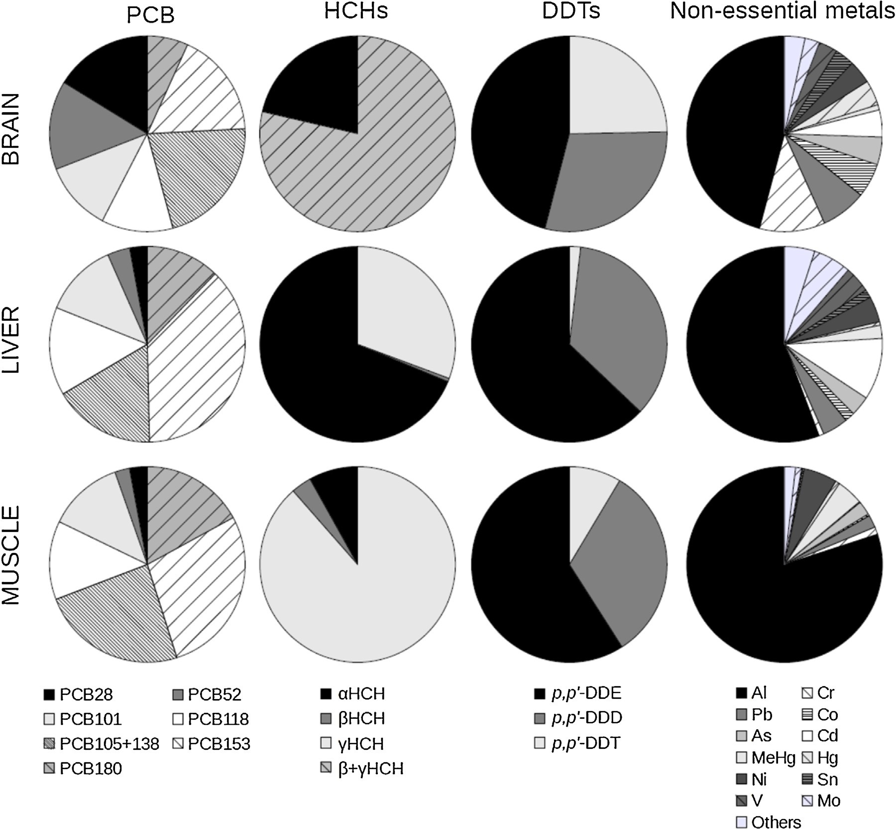

Fig. 4. Relative abundance (% of the sum for each chemical group) of the PCBs congeners, the different forms of HCHs or of DDTs and the non-essential metals in brain, liver and muscle of eels sampled in Belgian rivers.

and liver suggested that the low accessibility of OCs to mammalian brain reﬂects a higher efﬁciency of the blood-brain-barrier (BBB) compared to that of ﬁsh (Bachour et al., 1998).
Brinkmann et al. (2015) recently showed that model lipophilic compounds accumulate in eel organs according to their lipid con- tent and the speciﬁc hydrophobicity of each chemical (as measured by log KOW). Accordingly, one would expect that inter-organ dif- ferences in OCs content reﬂect variations in the non-polar lipid content of the three tissues analyzed. This was not the case in present study, as OCs levels in eel brain and liver were higher than in lipid-rich muscle. This suggests that the quantity of lipids does not dictate inter-organ OCs variations. Still, our method of lipid extraction with n-hexane mainly extracted non-polar lipids, such as triglycerides, that are prevalent in muscle and liver but not brain (De Boer et al., 2010). In the latter organ, lipids are mainly polar con- sisting in phospholipids, sphingolipids and cholesterol (Bratberg et al., 2013; Jenssen et al., 1996). It could therefore be that the actual lipid content of eel brain was higher than what our mea- surements suggest, however values obtained for all three organs are very similar to those recorded by Brinkmann et al. (2015) with another lipid extraction method. We conclude that the absence of correlation between the abundance of lipids and OC content in eel brain might well reﬂect some peculiarities of brain biochemistry.

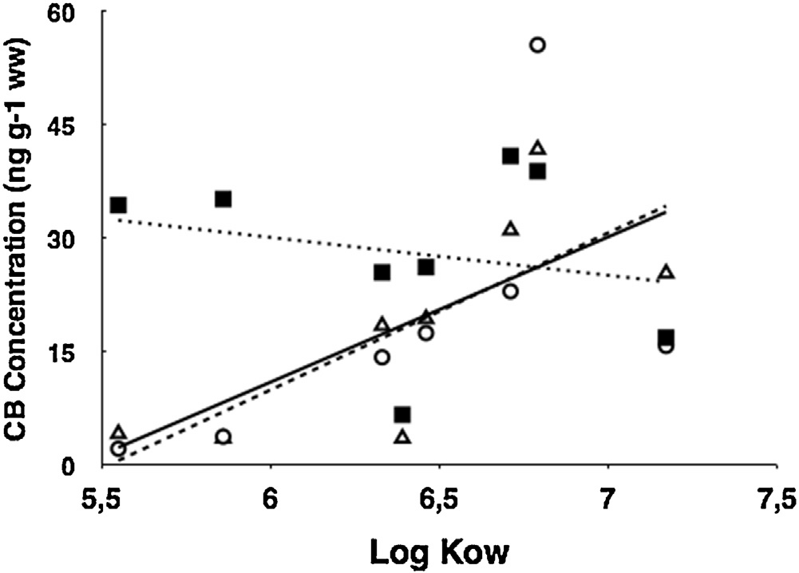

Fig. 5. Correlations between Octanol:water partition coefﬁcients (KOW) of PCB con- geners and their concentration in brain (ﬁlled squares; doted line), liver (empty circles; plain line) and muscle (empty triangles; dashed line).

Not only did female eel brain show high OC levels, but also pat- terns of PCB contamination differed markedly from those of liver

and muscle. Thus, low chlorinated congeners dominated in brain and highly chlorinated ones were more abundant in muscle and liver. The prevalence of low chlorinated congeners in nervous tis- sues could reﬂect their higher afﬁnity for polar lipids. Nakata et al. (1998) indeed linked differences in lipid-normalized concentra- tions of OCs in sea otter tissues to their lipid composition. However, the PCB proﬁle of fur seals brain were not reported as being markedly different from those of liver and muscle (Wang et al., 2010). As for ﬁsh, low chlorinated congeners were found to prefer- entially partition into ﬂatﬁsh tissues containing high levels of polar lipids, whilst highly chlorinated congeners preferentially accumu- lated in tissues with high amounts of neutral lipids (Kammann et al., 1990). The absence of positive correlations between log KOW and the abundance of each PCB congener in female eel brain, as opposed to the situation in muscle and liver, further suggests a selective accessibility of ﬁsh brain to organic pollutants. It would be par- ticularly interesting to investigate eel brain levels of hydroxylated PCBs, as these polar metabolites can impair brain functioning in vertebrates (e.g. Kimura-Kuroda et al., 2007)
Remarkably, the total HCH content in brain was 3–10 times higher than in the two other tissues. This suggests that HCH might also have a higher afﬁnity for polar lipids. A similar observation was made with fur seals (Wang et al., 2010). Such tissue-speciﬁc accumulation of HCH could result from the lower lipophilicity of HCHs (log KOW ∼ 3.8). Interestingly, while a-HCH tended to domi- nate in the brain of sea mammals (Metcalfe et al., 1999; Mössner et al., 1992), 1 + ')'-isomers constituted the major part of HCHs in eel brain.
Levels of DDTs were quite high in eel brain, compared to the liver. The former organ was characterized by a higher content of DDT, accounting for about 25% of DDTs contamination. The dis- tribution and storage of DDTs have been extensively studied in vertebrates (Turusov et al., 2002). Once absorbed from the diet, DDT and its metabolites are distributed via the blood to all organs in pro- portion to their tissue lipid contents (Morgan and Roan, 1971). DDT uptake varies with organ perfusion, lipid composition and chemi- cal partition coefﬁcient between blood and tissue lipids. DDE and DDD are most abundant in aquatic ecosystems (Yang et al., 2007). The high proportion of DDE we measured in eel liver is consistent with a long period without recent inﬂux of DDT. Our data indicate that levels of DDTs increased with tissue lipid content in eel mus- cle and liver. This is similar to observations made with the blueﬁsh Pomatomus saltatrix from heavily polluted sites (Deshpande et al., 2013). Contrastingly, lipid content did not appear to be a major factor inﬂuencing DDTs abundance in eel brain.
Some studies reported signiﬁcant relationships in vertebrates between chemical hydrophobicity and abundance of HCHs and DDTs in muscle and brain (e.g., Covaci et al., 2004). Attempts to link HCHs and DDTs concentrations in eel tissues with log KOW values failed to reveal any signiﬁcant relationship. This obser- vation strongly suggests that other factors (e.g. active transport, metabolism, depuration) inﬂuence accumulation of both HCH and DDT congeners in eel tissues (Van der Oost et al., 2003).
The relative abundance of DDT (as compared to DDE and DDD) in female eel brain could therefore reﬂect a low metabolic capac- ity, a high accessibility and/or a limited excretion capacity of DDT. Comparisons with data reported in brain of other ﬁsh species indi- cate that the relative abundance of DDT forms in eel brain is rather uncommon. In a study analyzing brain DDTs in Carassius carassius, Cyprinus carpio, Esox lucius and Leucaspius delineatus, the range of DDT level was far lower than in present study (0–1.13% of DDTs) while they reached 5.25% of DDTs and 7.81% of DDTs in liver and muscle, respectively (Kiziewicz and Czeczuga, 2003). Still, a higher relative abundance of DDT in brain was also observed in blue- ﬁsh Pomatomus saltatrix (Deshpande et al., 2013) and in mammals
(Covaci et al., 2004; Metcalfe et al., 1999). This suggests that similar factors could be at work in brain of other vertebrates.

  - Contamination of brain with neurotoxic metals

The above results indicate that the contamination of eel brain with neurotoxic metals was similar to or lower than those of muscle and liver. The hepatic tissue contained the highest amounts of Ag, Cd, Pb, Mn, Fe, Co, Cu and Zn. Only Cr was slightly more abundant in female eel brain. This indicates that the BBB, reported as less efﬁcient in ﬁsh than mammals (Bachour et al., 1998), has a rather limited ability to prevent metal uptake in brain.
The only marked difference in metal contents between eel brain and the other organs was found in the speciation of Hg. Thus, eel muscle and liver showed a marked prevalence of MeHg (i.e., over 80% of total Hg load), while this organometallic form represented only 18% of total Hg burden in the brain. MeHg readily crosses bio- logical membranes and is able to accumulate in muscle and liver (Mason et al., 2000). Demethylation of MeHg into Hg2+ was shown to take place in various tissues, particularly liver (Gonzalez et al., 2005). In this organ, abundance of inorganic mercury markedly var- ied between individuals, ranging from 0 to 73.05% (median 12.9%) of total Hg load. Such a high variability in liver Hg2+content, pre- viously reported for birds and mammals (e.g. Evans et al., 2000; Kim et al., 1996), has been ascribed to the occurrence of hep- atic demethylation mechanisms. Note that the prevalence of MeHg in muscle (56.20–100%; median 94%) suggests low demethylation capacities for this tissue.
Inorganic mercury occurring in muscle could either result from intramuscular demethylation of MeHg or transport from other tissues where demethylation occurs. The posi- tive link between Hg2+ concentrations in liver and muscle (Hg2+Muscle = 0.002 + 1.15 × Hg2+Liver; r = 0.41) could therefore
reﬂect transfer of Hg2+ from eel liver to skeletal muscle. However,
the ability of Hg2+ to transit through biological membranes is very low (Carocci et al., 2014). Therefore, it remains plausible that the relationship between Hg2+ in muscle and liver would therefore simply reﬂect correlated contents of MeHg in two organs with speciﬁc demethylation rates. Noteworthy, both liver and muscle have been considered as reservoirs for cysteine-bound MeHg, and this complexation may limit MeHg intake in brain and neurotoxicity (Wiener and Spry, 1996).
The abundance of inorganic mercury was far higher in eel brain than in muscle or liver. Since we found no correlation for inor- ganic Hg2+ concentrations between liver and brain, it is plausible that Hg2+ produced by demethylation of MeHg did not diffuse from the liver to the central nervous system. Since a strong relationship linked eel brain Hg2+ concentration to total Hg con-
tent (Hg2+brain = 0.0005 + 0.80 × Total HgBrain; r = 0.78), abundance of inorganic Hg2+ most probably resulted from intense demethy-
lation processes in the brain. Demethylation in brain has been suggested to occur in mammals (Shapiro and Chan, 2008) and ﬁsh (Branco et al., 2011). Our data could indicate that demethylation is most active in eel brain. Alternatively, it could mean that brain Hg2+ production cannot be compensated for by excretion mechanisms, as is the case in eel liver. Brain demethylation could involve sele- nium and seleno-aminoacids, which are particularly abundant in brain of vertebrates (Khan and Wang, 2010). Future studies should investigate Se content in eel tissues as this element is known to protect against MeHg neurotoxicity in ﬁsh, by formation of Se-Hg complexes (Scheuhammer et al., 1998). The absence of a link for Hg2+ concentrations in liver and brain as well as between muscle and brain suggests that Hg2+ localized to the central nervous sys- tem has a fairly limited ability to reach the general blood circulation in eel.

- Conclusion

Present study indicates that the brain of female European eel is an important target for both organic and inorganic pollutants. Brain levels of OCs were superior to those found in liver and mus- cle, whose contamination was already considered as preoccupying (i.e., probably affecting eel physiology and ﬁtness). Whereas muscle and liver showed rather similar contamination patterns with OCs and metals, the brain exhibited a distinct OCs and Hg contamina- tion proﬁle. This might reﬂect the peculiar lipid composition of the nervous tissue and, to a lesser extent, the presence of the BBB. PCB levels in European eel brain are far higher than those reported in other ﬁsh species from highly contaminated reservoirs, indicating that this matrix is a prime target for neurotoxic OCs. The possible impact of these neurotoxicants and their metabolites remains to be investigated, and focus should ﬁrst be put on analyzing biomarkers of effects (Van der Oost et al., 2003). Exposure of eel brain to persis- tent neurotoxicants appears to be of great concern due to possible detrimental effects on the migration and reproduction capacities of this endangered species.

Acknowledgements

The authors are grateful to the ﬁshing teams of INBO Groe- nendaal for sampling and especially Isabel Lambeens, Linde Galle, Adinda De Bruyn and Yves Maes for cartography and technical support. This work was supported by the Fonds de la Recherche Fondamentale Collective (FRFC) convention 2.4569.10F.

References

Bachour, G., Failing, K., Georgii, S., Elmadfa, I., Brunn, H., 1998. Species and organ dependence of PCB contamination in ﬁsh, foxes, roe deer, and humans. Arch. Environ. Contam. Toxicol. 35, 666–673.
Belpaire, C., Goemans, G., 2007. Eels: contaminant cocktails pinpointing environmental contamination. ICES J. Mar. Sci. 64, 1423–1436.
Brázová, T., Hanzelová, V., Miklisová, D., 2012. Bioaccumulation of six PCB indicator congeners in a heavily polluted water reservoir in Eastern Slovakia: tissue-speciﬁc distribution in ﬁsh and their parasites. Parasitol. Res. 111, 779–786.
Branco, V., Canário, J., Holmgren, A., Carvalho, C., 2011. Inhibition of the thioredoxin system in the brain and liver of zebra-seabreams exposed to waterborne methylmercury. Toxicol. Appl. Pharmacol. 251, 95–103.
Bratberg, M., Olsvik, P.A., Edvardsen, R.B., Brekken, H.K., Vadla, R., Meier, S., 2013.
Effects of oil pollution and persistent organic pollutants (POPs) on glycerophospholipids in liver and brain of male Atlantic cod (Gadus morhua). Chemosphere 90, 2157–2171.
Brinkmann, M., Freese, M., Pohlmann, J.-D., Kammann, U., Preuss, T.G., Buchinger, S., Reifferscheid, G., Beiermeister, A., Hanel, R., Hollert, H., 2015. A physiologically based toxicokinetic (PBTK) model for moderately hydrophobic organic chemicals in the European eel (Anguilla anguilla). Sci. Total Environ. 536, 279–287.
Carocci, A., Rovito, N., Sinicropi, M.S., Genchi, G., 2014. Mercury toxicity and neurodegenerative effects. Rev. Environ. Contam. Toxicol. 229, 1–18.
Covaci, A., Gheorghe, A., Schepens, P., 2004. Distribution of organochlorine pesticides, polychlorinated biphenyls and alpha-HCH enantiomers in pork tissues. Chemosphere 56, 757–766.
De Boer, J., Dao, Q.T., van Leeuwen, S.P.J., Kotterman, M.J.J., Schobben, J.H.M., 2010.
Thirty year monitoring of PCBs, organochlorine pesticides and tetrabromodiphenylether in eel from The Netherlands. Environ. Pollut. 158, 1228–1236.
Debier, C., Pomeroy, P.P., Dupont, C., Joiris, C., Comblin, V., Le Boulengé, E., Larondelle, Y., Thomé, J.P., 2003. Quantitative dynamics of PCB transfer from mother to pup during lactation in UK grey seals Halichoerus grypus. Mar. Ecol. Prog. Ser. 247, 237–248.
Dekker, W., 2003. Status of the European eel stock and ﬁsheries. In: Aida, K., Tsukamoto, K., Yamauchi, K. (Eds.), Eel Biology. Springer, Japan, pp. 237–254.
Deshpande, A.D., Dockum, B.W., Cleary, T., Farrington, C., Wieczorek, D., 2013.
Bioaccumulation of polychlorinated biphenyls and organochlorine pesticides in young-of-the-year blueﬁsh (Pomatomus saltatrix) in the vicinity of a

Superfund Site in New Bedford Harbor Massachusetts, and in the adjacent waters. Mar. Pollut. Bull. 72, 146–164.
Evans, R.D., Addison, E.M., Villeneuve, J.Y., MacDonald, K.S., Joachim, D.G., 2000. Distribution of inorganic and methylmercury among tissues in mink (Mustela vison) and otter (Lutra canadensis). Environ. Res. 84, 133–139.
Geeraerts, C., Belpaire, C., 2010. The effects of contaminants in European eel: a review. Ecotoxicology 19, 239–266.
Gonzalez, P., Dominique, Y., Massabuau, J.C., Boudou, A., Bourdineaud, J.P., 2005. Comparative effects of dietary methylmercury on gene expression in liver, skeletal muscle, and brain of the zebraﬁsh (Danio rerio). Environ. Sci. Technol. 39, 3972–3980.
Hansen, B.G., Paya-Perez, A.B., Rahman, M., Larsen, B.R., 1999. QSARs for KOW and KOC of PCB congeners: a critical examination of data, assumptions and statistical approaches. Chemosphere 39, 2209–2228.
Harrad, S., 1999. Eel consumption as a pathway of human exposure to PCBs. Int. J. Environ. Health Res. 9, 31–37.
Hoff, P.T., Van Campenhout, K., Van De Vijver, K., Covaci, A., Bervoets, L., Moens, L., Huyskens, G., Goemans, G., Belpaire, C., Blust, R., De Coen, W., 2005.
Perﬂuorooctane sulfonic acid and organohalogen pollutants in liver of three freshwater ﬁsh species in Flanders (Belgium): relationships with biochemical and organismal effects. Environ. Pollut. 137, 324–333.
Jenssen, B.M., Skaare, J.U., Ekker, M., Vongraven, D., Lorentsen, S.-H., 1996.
Organochlorine compounds in blubber, liver and brain in neonatal grey seal pups. Chemosphere 32, 2115–2125.
Kammann, U., Knickmeyer, R., Steinhart, H., 1990. Distribution of polychlorobiphenyls and hexachlorobenzene in different tissues of the dab (Limanda limanda L.) in relation to lipid polarity. Bull. Environ. Contam. Toxicol. 45, 552–559.
Khan, M.A.K., Wang, F., 2010. Chemical demethylation of methylmercury by selenoamino acids. Chem. Res. Toxicol. 23, 1202–1206.
Kim, E.Y., Murakami, T., Saeki, K., Tatsukawa, R., 1996. Mercury levels and its chemical form in tissues and organs of seabirds. Arch. Environ. Contam. Toxicol. 30, 259–266.
Kimura-Kuroda, J., Nagata, I., Kuroda, Y., 2007. Disrupting effects of
hydroxy-polychlorinated biphenyl (PCB) congeners on neuronal development of cerebellar Purkinje cells: a possible causal factor for developmental brain disorders? Chemosphere 67, S412–20.
Kiziewicz, B., Czeczuga, B., 2003. DDT and its metabolites in the tissues of certain ﬁsh species from Podlasie Province. Pol. J. Environ. Stud. 12, 123–127.
Mössner, S., Spraker, T.R., Becker, P.R., Ballschmiter, K., 1992. Ratios of enantiomers of alpha-HCH and determination of alpha-, beta-, and gamma-HCH isomers in brain and other tissues of neonatal Northern fur seals (Callorhinus ursinus).
Chemosphere 24, 1171–1180.
Maes, J., Belpaire, C., Goemans, G., 2008. Spatial variations and temporal trends between 1994 and 2005 in polychlorinated biphenyls organochlorine pesticides and heavy metals in European eel (Anguilla anguilla L.) in Flanders, Belgium. Environ. Pollut. 153, 223–237.
Mason, R.P., Laporte, J.M., Andres, S., 2000. Factors controlling the bioaccumulation of mercury, methylmercury, arsenic, selenium, and cadmium by freshwater invertebrates and ﬁsh. Arch. Environ. Contam. Toxicol. 38, 283–297.
Metcalfe, C., Metcalfe, T., Ray, S., Paterson, G., Koenig, B., 1999. Polychlorinated biphenyls and organochlorine compounds in brain: liver and muscle of beluga whales (Delphinapterus leucas) from the Arctic and St. Lawrence estuary. Mar. Environ. Res. 47, 1–15.
Morgan, D.P., Roan, C.C., 1971. Absorption, storage, and metabolic conversion of ingested DDT and DDT metabolites in man. Arch. Environ. Health 22, 301–308.
Miller, M.J., Feunteun, E., Tsukamoto, K., 2016. Did a perfect storm of oceanic changes and continental anthropogenic impacts cause northern hemisphere anguillid recruitment reductions? ICES J. Mar. Sci. J. Cons. 73, 43–56.
Nakata, H., Kannan, K., Jing, L., Thomas, N., Tanabe, S., Giesy, J.P., 1998.
Accumulation pattern of organochlorine pesticides and polychlorinated biphenyls in southern sea otters (Enhydra lutris nereis) found stranded along coastal California, USA. Environ. Pollut. 103, 45–53.
Nunes, B., Capela, R.C., Sérgio, T., Caldeira, C., Gonc¸ alves, F., Correia, A.T., 2014.
Effects of chronic exposure to lead, copper, zinc, and cadmium on biomarkers of the European eel, Anguilla anguilla. Environ. Sci. Pollut. Res. Int. 21, 5689–5700.
Podgorniak, T., Angelini, A., Blanchet, S., de Oliveira, E., Pierron, F., Daverat, F., 2015a. Climbing experience in glass eels: a cognitive task or a matter of physical capacities? Physiol. Behav. 151, 448–455.
Podgorniak, T., Milan, M., Pujolar, J.M., Maes, G.E., Bargelloni, L., De Oliveira, E., Pierron, F., Daverat, F., 2015b. Differences in brain gene transcription proﬁles advocate for an important role of cognitive function in upstream migration and water obstacles crossing in European eel. BMC Genom. 16, 378.
Podgorniak, T., Blanchet, S., De Oliveira, E., Daverat, F., Pierron, F., 2016. To boldly climb: behavioural and cognitive differences in migrating European glass eels.
R. Soc. Open Sci. 3, 150665.
Scheuhammer, A.M., Wong, A.H.K., Bond, D., 1998. Mercury and selenium accumulation in common loons (Gavia immer) and common mergansers (Mergus merganser) from eastern Canada. Environ. Toxicol. Chem. 17, 197–201.
Schnitzler, J.G., Koutrakis, E., Siebert, U., Thomé, J.P., Das, K., 2008. Effects of persistent organic pollutants on the thyroid function of the European sea bass (Dicentrarchus labrax) from the Aegean sea, is it an endocrine disruption? Mar. Pollut. Bull. 56, 1755–1764.
Shapiro, A.M., Chan, H.M., 2008. Characterization of demethylation of methylmercury in cultured astrocytes. Chemosphere 74, 112–118.

Slotkin, T.A., Levin, E.D., Seidler, F.J., 2006. Comparative developmental neurotoxicity of organophosphate insecticides: effects on brain development are separable from systemic toxicity. Environ. Health Perspect. 114, 746–751.
Tabouret, H., Bareille, G., Mestrot, A., Caill-Milly, N., Budzinski, H., Peluhet, L., Prouzet, P., Donard, O.F.X., 2011. Heavy metals and organochlorinated compounds in the European eel (Anguilla anguilla) from the Adour estuary and associated wetlands (France). J. Environ. Monit. 13, 1446–1456.
Turusov, V., Rakitsky, V., Tomatis, L., 2002. Dichlorodiphenyltrichloroethane (DDT): Ubiquity, persistence, and risks. Environ. Health Perspect. 2, 125–128.
Van der Oost, R., Beyer, J., Vermeulen, N.P.E., 2003. Fish bioaccumulation and biomarkers in environmental risk assessment: A review. Environ. Toxicol. Pharmacol. 13, 57–149.
Van Ginneken, V., Palstra, A., Leonards, P., Nieveen, M., van den Berg, H., Flik, G., Spanings, T., Niemantsverdriet, P., van den Thillart, G., Murk, A., 2009. PCBs and the energy cost of migration in the European eel (Anguilla anguilla L.). Aquat. Toxicol. 92, 213–220.
Wang, D., Shelver, W.L., Atkinson, S., Mellish, J.-A., Li, Q.X., 2010. Tissue distribution of polychlorinated biphenyls and organochlorine pesticides and potential toxicity to Alaskan northern fur seals assessed using PCBs congener speciﬁc mode of action schemes. Arch. Environ. Contam. Toxicol. 58, 478–488.
Wiener, J.G., Spry, D.J., 1996. Environmental Contaminants in Wildlife: Interpreting Tissue Concentrations. CRC Press.
Yang, R., Yao, T., Xu, B., Jiang, G., Xin, X., 2007. Accumulation features of organochlorine pesticides and heavy metals in ﬁsh from high mountain lakes and Lhasa River in the Tibetan Plateau. Environ. Int. 33, 151–156.

