The occurrence and ecological requirements of the horse-lies (Tabanidae) of brackish marshes in Belgium

Frank Van de Meutter1 · Ralf Gyselings1 · Erika Van den Bergh1

Abstract The deteriorated state and shrunken area of brackish marshes in Western-Europe has taken a toll of its typical inhabitants. Careful management of the remain- ing area is required to conserve the vulnerable biodiver- sity, yet with respect to the large group of invertebrates we have very poor knowledge on how to achieve this. In this study we investigated the occurrence of horse-lies (Dip- tera: Tabanidae) in Belgian brackish marshes in relation to habitat properties. We found three strictly halophile tabanid species occurring in Belgium: Atylotus latistriatus, Hae- matopota bigoti and Hybomitra expollicata. These halo- phile tabanids are rare insects as their habitat is now rare. Our data indicated that a prime critical condition may be a stable, high groundwater table. In addition, soil salinity probably needs to exceed some threshold, but more data are needed to substantiate this claim. Soil salinity measure- ments in brackish marshes indicated that soil salinity was signiicantly higher throughout the year in open, sparsely vegetated patches, compared to fully vegetated marshland. Such conditions could be beneicial to horse-lies or con- sorts, but have become rare because there is little impetus for maintaining a spectrum of brackish marshland types and associated species. However, maintaining this spec- trum is required in order to conserve existing biodiversity in Western-European brackish marshlands.

Keywords Groundwater amplitude · Soil salinity · Saltmarsh · Hybomitra · Atylotus · Haematopota

* Frank Van de Meutter Frank.VandeMeutter@inbo.be

1 Research Institute for Nature and Forest, Kliniekstraat 25, B-1070, Brussels, Belgium

Introduction

For many decades brackish marshes in Western-Europe have been in strong decline (Wolters et al. 2005; Van Brae- ckel et al. 2012) because of a variety of factors, such as land reclamation, sea level rise and river channel deepening for tidal brackish marshland, and drainage, desalinization, land illing and agricultural intensiication for inland brack- ish marshes (De Saeger et al. 2013). The current, remain- ing, area of inland brackish marshes in Belgium is esti- mated at a mere 140 ha (Feys et al. 2015), whereas double the amount of tidal marshland remains (Vriens et al. 2011). It is evident that this decline to the presently small area of habitat has taken its toll on the brackish marshland biotic community, yet besides birds (Vermeersch and Anselin 2009), plants (Van Landuyt et al. 2006), and ground beetles (Desender et al. 1998, 2007, 2008; Desender and Maelfait 1999), very little is known or documented for this commu- nity (Zwaenepoel et al. 2002). This lack of knowledge of the majority of the biotic community, and of its ecologi- cal requirements, compromises adequate management and conservation of the remaining biodiversity in Western- European brackish marshland and, in particular, in the few remaining marshes in Belgium.
Currently, we know relatively little about the rela- tionship between management (e.g. grazing, regulation of hydrology), the resulting habitat characteristics (e.g. salinity, hydrology, presence of microhabitats) and ento- mofauna in brackish marshlands. Hitherto, management of brackish marshland has primarily focused on favouring plants and birds. Whether the same regime is benign to entomofauna is largely unknown. Previous research has shown that grazing, the currently prevailing management regime to sustain brackish marshland vegetation, has an adverse efect that is much stronger on invertebrate

diversity than on plant diversity (Rickert et al. 2012; Van Klink et al. 2013; van Klink 2014; van Klink et al. 2015). Three main factors have been identiied determining the efects of large herbivores on arthropod diversity: unin- tentional predation and increased disturbance, decreases in total resource abundance for arthropods and changes in plant diversity, vegetation structure and abiotic condi- tions (van Klink et al. 2015). Whilst our understanding of grazing management has increased, we understand little of how the regulation of hydrology and related changes in salinity afect invertebrates. Brackish marshlands are typically rich in environmental gradients, of which hydrology is the prime driver. Many species that are most dependent on physiochemical gradients are considered to be endangered, and information on their response to hydrology and salinity would greatly advance our under- standing of how they are organized along these gradi- ents (Zeegers and Van Haren 2000; Stubbs 2003; Buglife 2015).
Horse-lies (Tabanidae) are some of the largest and best- known dipterans that occur in Western-European brackish marshland. All halobiont horse-lies in Western-Europe have larvae that live in the moist soil or at the edge of water and are considered rare or threatened, where such data are available (Zeegers and Van Haren 2000; Sandström 2007; Buglife 2015). As they are relatively easily found, yet may have specialist habitat requirements, as suggested by their there rarity, they make excellent representatives of the group of insects that are soil-associated during part of their lives. Studying their occurrence in relation to habitat char- acteristics may yield information that is relevant to a larger group of invertebrates with similar life history or habitat requirements. Therefore, the aim of this study was to: (1) get a comprehensive view on the occurrence of halophile horse-lies in Belgium with a particular focus on the inland brackish marshes, (2) drainage and desalinization have drastically changed many Flemish brackish marshland hab- itats and many of its inhabitants, including tabanids, have become rare. We therefore hypothesize that the occurrence of multiple brackish marshland tabanid species may be
restricted to areas with low groundwater amplitude (little drainage) and comparatively higher salinity.

Materials and methods

Study sites and collection of recent data

Inland brackish marshland in Belgium occurs mostly as small, disturbed fragments in depressions in cultivated land. Larger marshland habitats are conined to a handful of areas. We set-up a large, standardized sampling campaign in four of the largest remaining inland brackish marshes in Belgium. These are the “Uitkerkse polder” at Blanken- berge (UIT), the military domain “het Pompje” at Ouden- burg (OUD), “Monnikenwerve” at Lissewege (MON) and “Putten Weiden” at Beveren-Waas (PUWE) (Fig. 1). The irst area is a large, heterogeneous complex of polder grass- lands intermixed with some larger brackish marshes that cover 39 ha of the area. Because rather distant and isolated fragments of brackish marshlands occur, we considered three diferent subareas (Uitkerke I, II, III). Monniken- werve is a well-developed brackish marshland of 4.94 ha. Het Pompje is a mosaic of agricultural land and graz- ing marsh with some small, localized historical brackish marshes. Twelve hectares of brackish marshland is present in various successional stages on former arable land. Putten Weiden is a grazed grassland area of which approximately 25 ha is brackish marshland. Together, these areas consti- tute more than half the total area of inland brackish marsh in Flanders. With the exception of the Dudzeelse polder (see further) all other inland brackish marshlands in Bel- gium are very small, have been heavily disturbed or are the result of recent nature development (Feys et al. 2015), and therefore are less likely to house a diverse entomofauna. In addition to these inland brackish marshes, we also set-up two sampling stations in a tidal brackish marsh: the “Schor Oude Doel” at Beveren-Waas (SODO). This tidal marsh- land covers 51 ha between the Dutch border and the nuclear power plant of Doel along the river Scheldt. Over the past

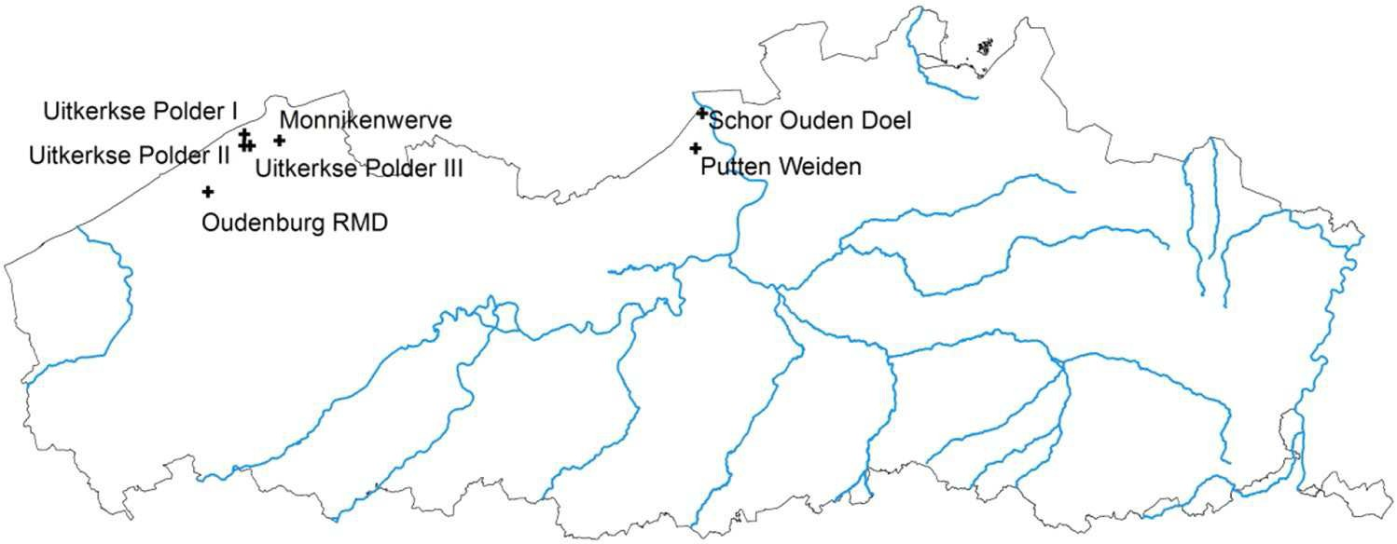Fig. 1 Map of Flanders with the sampling sites of the inver- tebrate sampling campaign

few decades it has become increasingly dominated by reed (Phragmites australis) and currently no more than 5 ha of open brackish marshland remains (Teijsen 2007), yet this is the largest remaining brackish marsh habitat in Belgium. In each of the above brackish marshlands we installed two Malaise traps, except for Uitkerkse polder where we installed one in each subarea, to sample lying insects, including tabanids. Malaise traps are among the best avail- able trapping devices for lying insects, and work especially well for female tabanids (Horváth et al. 2014a), even with- out the use of speciic attractants (Roberts 1978). Because tabanids are attracted to large, dark objects (Zeegers and Van Haren 2000; Krcmar et al. 2014) relecting strongly linearly polarized light (Egri et al. 2012; Horváth et al. 2014b), the use of Malaise traps with black netting is most efective. All traps were serviced between the beginning of April and 15 October. The marshlands of Putten Weiden, Monnikenwerve and het Pompje were sampled in 2012; the three sites within the Uitkerkse polder were sampled in 2013. In 2014 we sampled the Schor Oude Doel. An overview of the details for all trapping stations is presented in Table 1. The Malaise traps were installed on the tran- sition from rather low-growing marshland vegetation to tall vegetation (Phragmites australis, Scirpus maritima), because most invertebrates are known to follow vertical structures in the landscape. As all brackish marshes were grazed with cattle, individual Malaise traps were fenced with barbed wire. Samples were collected every 2–3 weeks, sorted in the lab and preserved in 70 % alcohol. In addition to the Malaise traps, we visited each of the studied brack- ish marshlands at least ive times during June- August to sample tabanids with a sweep net. Additional data (N = 8) of Tabanidae from brackish marshland in Belgium were received from amateur dipterists in Belgium and the Neth- erlands. Records were supported by photographs or pinned specimens that were seen by the irst author. Additionally, the irst author searched for tabanids with a sweep net in the “Dudzeelse polder” (DUN, 15+ visits) and the “Zwin”
(3 visits); an extensive inland brackish marsh and tidal salt- marsh, respectively. If we combine all data from the stand- ardized survey, the additional surveys by the authors, and data from amateur entomologists, more than 95 % of the area of non-tidal brackish marshland and more than half the area of tidal brackish marshland currently present in Belgium has been searched for Tabanidae at least once at the right time of year during the past 30 years. As a result, we believe the occurrence maps shown in this paper should yield a fairly complete view on the distribution of the spe- cies in the Flemish region.

Collection of historical data

We compiled historical records of tabanids from published literature and specimens within the national entomological collection of the RBINS in Brussels. Identiications of tab- anids were based on Zeegers and Van Haren (2000).

Abiotic measurements of study sites

The life cycle of tabanids consists of a relatively long juvenile phase in the soil. The larval stage lasts for a few months to 3 years followed by a short (several weeks) pupal stage after which the adult lies emerge. We measured two aspects of soil conditions hypothesized to be critical for the presence of tabanids, including salinity and level of drought stress. First, at each of the study sites, we measured average soil salinity for each consecutive period of 2 months during March–Octo- ber. For each combination of site (N = 9) and period (N = 4), we performed measurements at three randomly chosen places in each of two microhabitat types with possibly diferent soil salinity: brackish marsh dominated by Juncus gerardii and mudlats with typical brackish marshland annuals (mainly Aster tripolium, Salicornia procumbens, Spergularia salina). Measurements were taken using rhizons (Rhizosphere©). Rhizons consist of a 8.5 cm hydrophilic, porous polymer tube and were inserted at −3 to −13 cm below ground level.

Table 1 Descriptive parameters
Station code X (lat) Y (long) Site name Municipality Year Grazing efect

of the sampling locations.
“Grazing efect” indicates whether patches of standing vegetation remain after grazing (low), or whether it is fully grazed and lattened (high)
SODO | 51.3428 | 4.2409 | Schor Ouden Doel | Kieldrecht | 2014 | Low
SODOZ | 51.3386 | 4.2466 | Schor Ouden Doel | Kieldrecht | 2014 | Low
UIT1 | 51.2858 | 3.1333 | Uitkerkse Polder I | Blankenberge | 2013 | High
UIT2 | 51.3007 | 3.1219 | Uitkerkse Polder II | Blankenberge | 2013 | High
UIT3 | 51.2874 | 3.1188 | Uitkerkse Polder III | Blankenberge | 2013 | High
MON1 | 51.2894 | 3.2044 | Monnikenwerve | Lissewege | 2012 | Low
MON2 | 51.2890 | 3.2049 | Monnikenwerve | Lissewege | 2012 | Low
OUD1 | 51.2093 | 3.0351 | Oudenburg RMD | Oudenburg | 2012 | Low
OUD2 | 51.2107 | 3.0358 | Oudenburg RMD | Oudenburg | 2012 | Low
PUWE1 | 51.2887 | 4.2196 | Putten Weiden | Kieldrecht | 2012 | Low
PUWE2 | 51.2887 | 4.2195 | Putten Weiden | Kieldrecht | 2012 | Low

Negative suction pressure is created by vacuum tubes to col- lect soil moisture. An electrical conductivity probe (WTW
Nr. species
3
3
7
6
4
2
1
© Multiline P3) was used to measure conductivity of the extracted luid. Water conductivity is then recalculated to chlorinity using an equation derived from previous ield stud- ies on Belgian brackish marshlands (Van de Meutter et al. 2016). Second, long spells of drought may cause the soil to dry and harden to the disadvantage of soil inhabiting spe- cies, such as Tabanids and their prey. We obtained the annual groundwater amplitude from 1 to 3 piezometers installed at the studied marshlands, as a proxy for annual drought stress. Groundwater amplitude is the diference between the highest and the lowest groundwater level measured in 1 hydrologi- cal year. Because groundwater amplitude may difer strongly between years, observations over a longer period are required. For each individual piezometer, we obtained groundwater amplitude values for 3–8 years, within a time window from 2001–2014. For six brackish marshes we had piezometer data available. The median spring groundwater level (Dutch: GVG) based on the selected piezometers was in a narrow range, between −4 and −15 cm below ground level.
Table 2 Results of the Malaise trap sampling in Flemish inland brackish marshes and one tidal brackish marsh (Schor Ouden Doel)
Heptatoma pellucens
Hybomitra ciureai
H. expollicata*
Tabanus autumnalis
T. bromius
10
10
2
1
1
5
1
1
1
1
2
1
Halophile species are indicated with “*”. If a halophile species was not caught at a site by the Malaise traps, but was observed otherwise, this is indicated with “x”

Data analyses
H.
subcylindrica

Of seven surveyed marshes, only two had multiple brackish marshland species present. We applied bootstrapping to test our hypotheses whether these marshes displayed a higher salinity or a lower groundwater amplitude as expected by chance. We randomly sampled 10,000 pairs of values from the measured parameters and compared the observed mean for the valuable brackish marshland with the means of the sampled pairs. Following our directional hypotheses, we calculated the one-sided p-values. For the analyses of the efect of groundwater amplitude, data were lacking for the tidal marsh (SODO and adjacent SODOZ). As this marshland is looded twice daily, and because groundwater amplitude is used in this study as a proxy of constant soil moisture levels, we assigned SODO the smallest ground- water amplitude value present in our data (0.378 m).
Haema- topota bigoti*
H. crassicornis
H. italica
H. pluvialis
26
10
20
35
49
29
1
1
1
1
We tested for a diference in average soil salinity (meas- ured as conductivity) between the microhabitats in brack- ish marsh with ANOVA in R 2.13.0 (R Development Core Team 2011) making use of the package CAR (Fox and Weisberg 2011). Microhabitat was used as the categorical variable; site as a covariable.
Atylotus latistriatus*
Chrys- ops relictus
x x 4
3
1

Results
Monnikenwerve Het Pompje Putten Weiden Schor Ouden Doel Uitkerkse Polder I
Uitkerkse Polder II
Uitkerkse Polder III
1

The occurrence of horse-lies in Belgium

The Malaise trap sampling yielded 12 species of horse- ly (Table 2). The number of horse-lies found at one site
Site

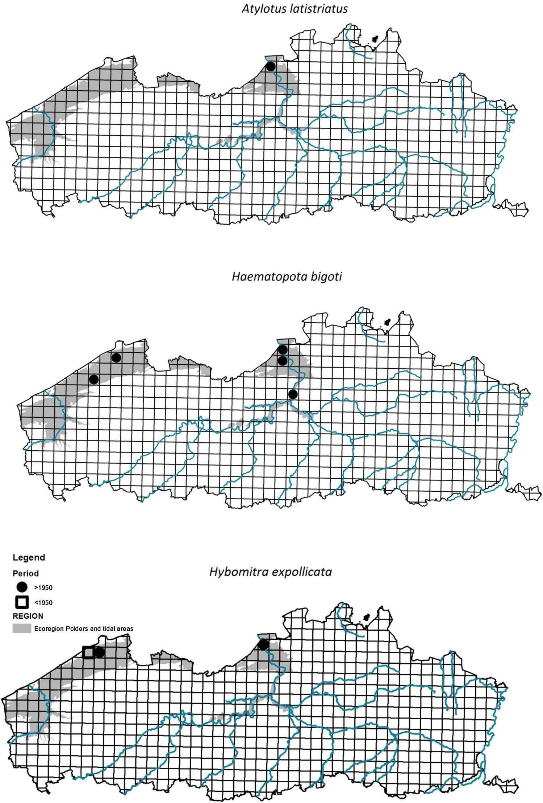Fig. 2 The occurrence of three halophile horse-lies in Flan- ders: Atylotus latistriatus (upper panel), Haematopota bigoti (middle panel) and Hybomitra expollicata (lower panel). The grey coloured zone indicates the polder ecoregion

ranged from one (Uitkerke III) to seven (Putten Weiden). One species Haematopota pluvialis dominated the Taba- nidae community both numerically and in occupancy. Tabanus autumnalis was also widely distributed. We caught three halophile horse-lies species: Atylotus latistri- atus, Haematopota bigoti and Hybomitra expollicata. Hal- ophile horse lies were restricted to three marshes: Monni- kenwerve, Putten Weiden and Schor Oude Doel.

Additional catches with a sweep net, and data obtained from fellow dipterists, revealed extra popula- tions of Haematopota bigoti at Dudzeelse polder, Mon- nikenwerve and het Pompje. Atylotus latistriatus had been observed by other observers at Doelpolder Noord, which is the inland side of the Schor Oude Doel, adja- cent to our own catches at the latter location (Mortel- mans et al. 2012).

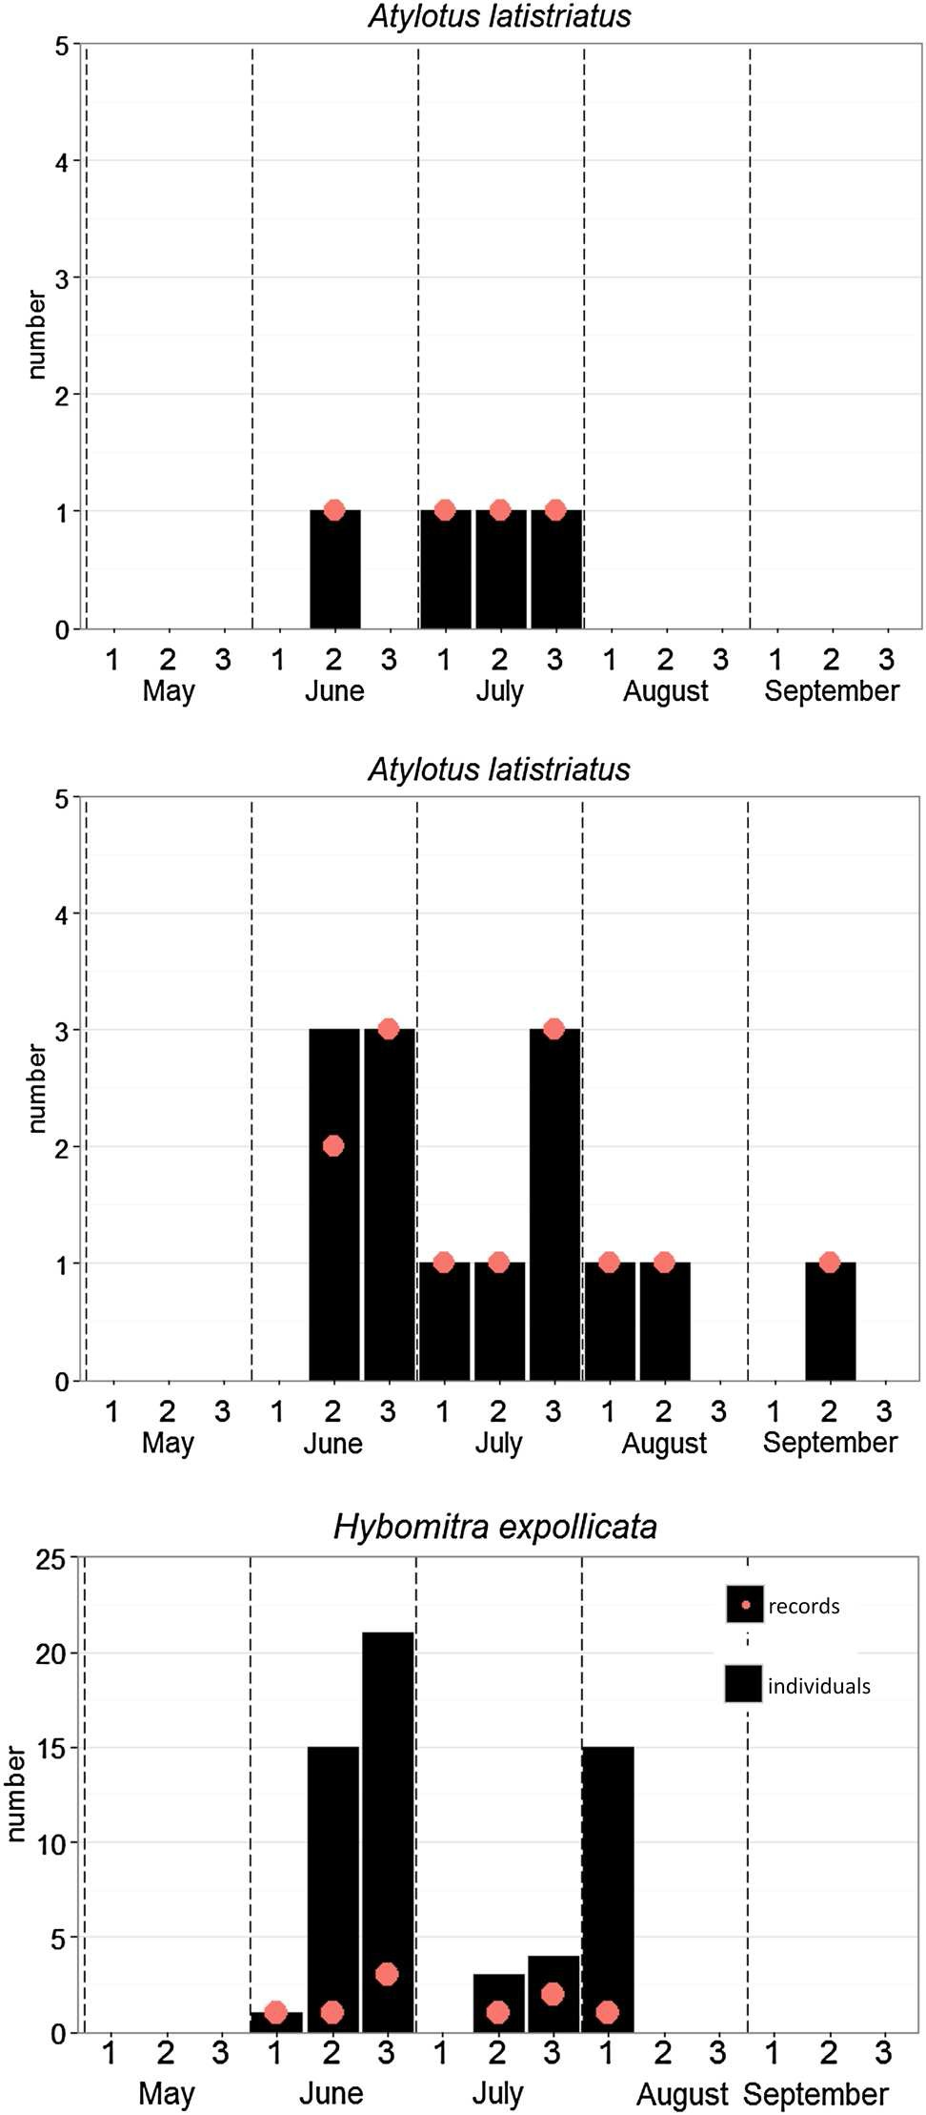

Fig. 3 Phenology graphs per ten-day period from May to September for the three halophile horse-lies [Atylotus latistriatus (upper panel), Haematopota bigoti (middle panel) and Hybomitra expollicata (lower panel)]. Dots indicate the number of observations, the black bars the number of observed individuals

Historical data

From the literature, we retrieved one historical record of Hybomitra expollicata (1922 at Blankeberge; cited in

Zeegers and Van Haren 2000), which is close to the current location at Monnikenwerve. For Haematopota bigoti, one historical record was communicated to us (1989 at Bazel, Van de Weyer Guido), which is also reported in Zeegers and Van Haren (2000). Our research of the historical col- lection of the RBINS revealed one specimen of Hybomi- tra expollicata (1922 at Blankenberge, Anonymous) which likely is the same as reported in Zeegers and Van Haren (2000). No other halophile horselies were present.
The occurrence of halophile tabanids in Flanders based on all available data is presented in Fig. 2. The phenology of these three species, combining all available data in Bel- gium, is presented in Fig. 3.

Soil physiochemical measurements

In Fig. 4, the soil salinity values are presented. Soil salin- ity varied considerably among our study sites and ranged from 12,000 [Cl−] (mg/l) at the Monnikenwerve to ~3,100 [Cl−] (mg/l) at Oudenburg. Soil salinity of pioneer vegeta- tion was on average 19 % higher than that of Juncus gerar- dii dominated vegetation (F1,53 = 10.88, p = 0.002).
In Fig. 5, boxplots of groundwater amplitude for each
site are presented ordered from low to high median values. Sites difered greatly in median groundwater amplitude, from 0.325 m at Putten Weiden to 0.905 m at Oudenburg het Pompje.
Mean salinity of the brackish marshes with multiple brackish marshland tabanids (Monnikenwerve and Schor Oude Doel) was not signiicantly higher than expected under H0 (p = 0.095). Mean groundwater amplitude, how-
ever, was signiicantly lower in marshes with several brack-
ish marshland tabanids present (p = 0.047).

Discussion

Brackish marshland is a rare and threatened habitat in Flanders (Van Braeckel et al. 2012), yet little is known of its unique entomofauna. In the absence of knowledge of this major component of the biodiversity, the signiicance of current conservation actions in this habitat is at stake. This study focuses on horse-lies strictly associated with brackish marshland. Three species were found to occur in Belgium, yet they are conined to one or a few locations. One species is strictly tidal (Atylotus latistriatus), but the other two species occurred in both inland and tidal brack- ish marshland. Our data suggest that the rarest of the spe- cies occurring in inland brackish marsh (Hybomitra expol- licata) is conined to sites with a quite elevated (brackish) soil salinity and especially a permanently high groundwater table. The occurrence of such particular, yet crucial, condi- tions is beyond the focus of current management or habitat

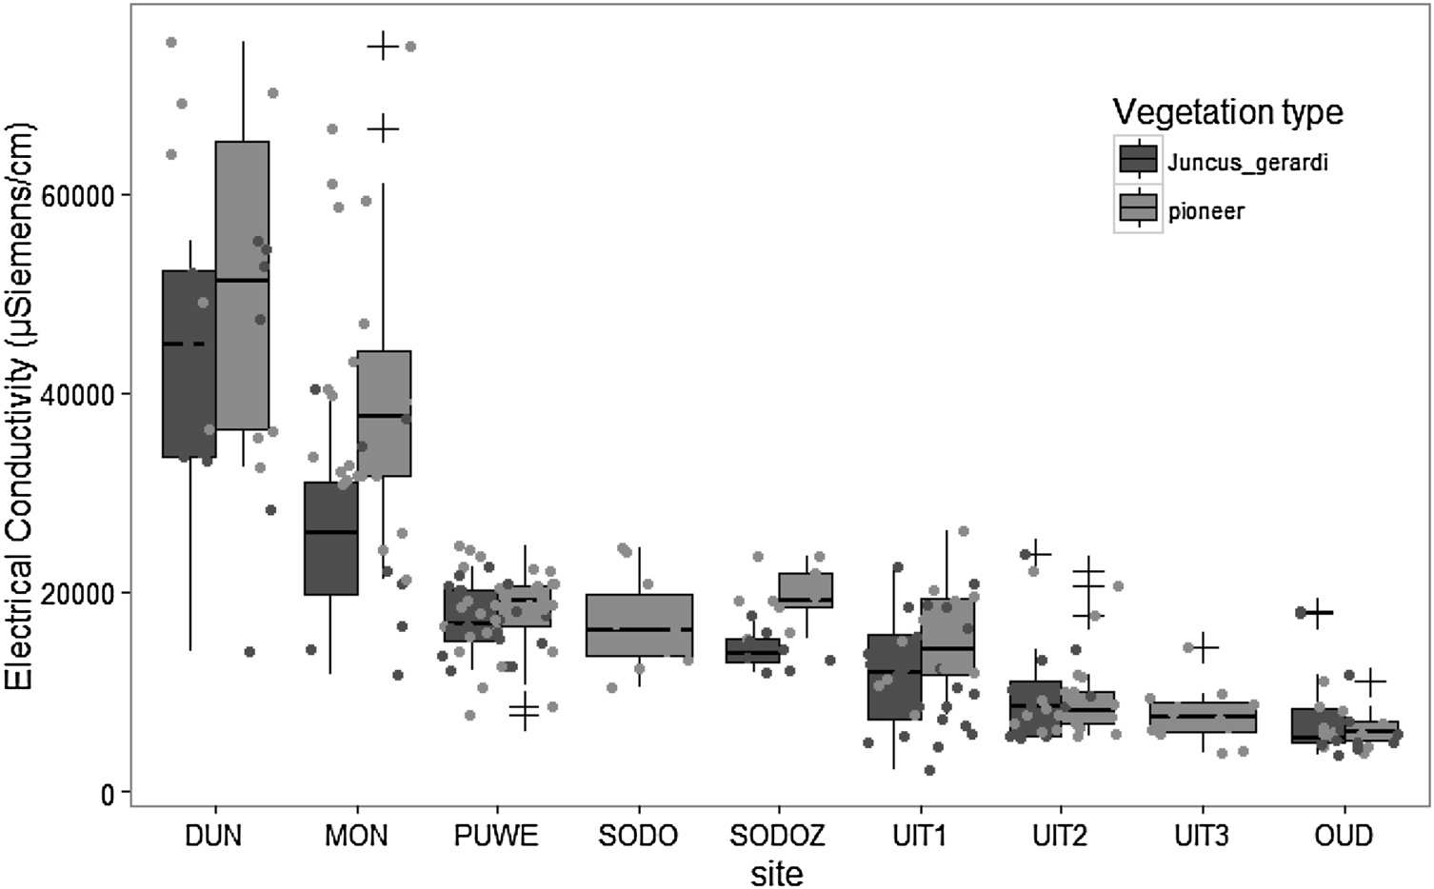Fig. 4 Boxplots of electrical conductivity (EC) of topsoil moisture extracted with rhizons in the study areas. Data are from 6 stations in each area divided over two habitat types: Juncus gerardi dominated saltmarsh and mudlats with pioneer vegetation. For each station, measurements were available for each 2 month period from March to October. Boxes represent the interquartile range (IQR), the central black horizontal bar is the median, whiskers extend to the highest value within 1.5 IQR of the hinges of the boxes, “+” are outliers outside the whiskers’ range, dots are raw data points

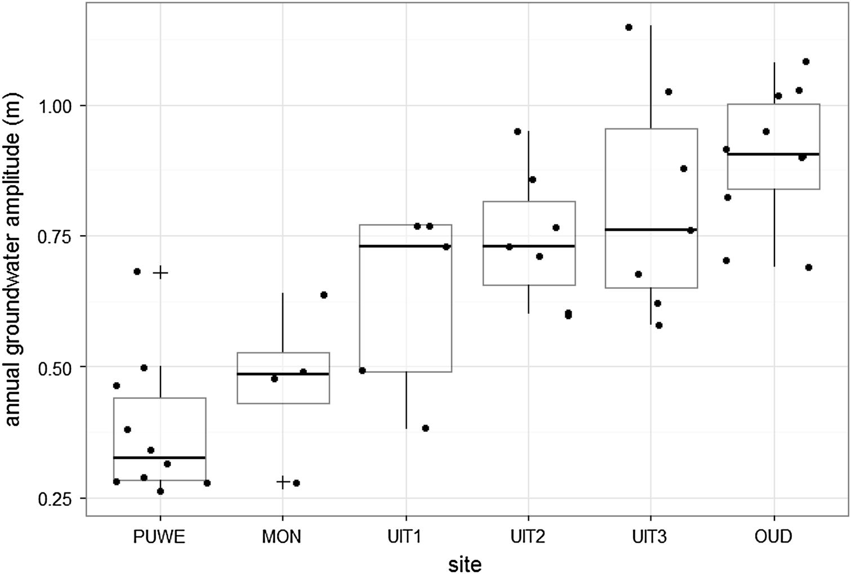Fig. 5 Boxplots of annual groundwater amplitude for piezometers in six of the study areas, ordered from low to high median values. For boxplots legends, see Fig. 4

design. Consequently, these conditions have often become very rare in Belgian brackish marshlands. This may not be problematic to Tabanidae only: a larger community of below-ground living invertebrates unique to brackish marshlands exists with possibly similar ecological require- ments including for example, members of the Dolichopo- didae, Ephydridae and Syrphidae. Given the critical status of several insects unique to brackish marshes, a refreshed view on how to conserve biodiversity in brackish marshes, especially inland brackish marshland, is urgently needed.
Appropriate ecosystem management is fostered by ecological knowledge of the ecosystem and its inhabit- ants. Our data indicate that a small groundwater ampli- tude may be important to support brackish marshland tabanids. This is not surprising given that the larvae are predators in moist soil (Falk 1991; Zeegers and Van Haren 2000). High groundwater amplitudes are mostly related to long spells of drought that can make the soil uninhabitable for tabanid larvae or their prey. Our ind- ings are in line with earlier hypotheses on the ecology of

these species: Falk (1991) suggested that H. expollicata may require a high, stable groundwater table. Atylotus latistriatus has not been found outside tidal marshland, to our knowledge; it is found along the seaward end of estu- aries in extended, gradient-rich tidal marshlands. Haema- topota bigoti was the commonest of the species studied and is probably less sensitive to changes in groundwater amplitude: it was found both at the sites with the highest and lowest groundwater amplitude. Other members of the genus Haematopota are found to live in pastures in damp soil, yet not in marshy or wet soil, suggesting a good tol- erance to drier conditions (Zeegers and Van Haren 2000). Soil salinity evidently plays a critical role in the occur- rence of brackish marsh tabanids, yet from the limited data in this study it is not conclusive whether the high end of the salinity range observed in Flemish brackish marshlands is preferred as we predicted, although trends are clearly in this direction. Indeed, both H. expollicata and A. latistriatus are restricted to highly brackish sec- tions of estuaries in the Netherlands and the UK, suggest- ing a preference for such conditions. The third species H. bigoti appears less sensitive to this environmental gradi- ent: it was found both higher upstream the Scheldt estu- ary near Bazel at a salinity of 111 [Cl−] (mg/l) and at the Monnikenwerve at 9,000 [Cl−] (mg/l).
Tabanidae are relatively easy to monitor as they are large insects and may be easily caught. With respect to future surveys for tabanids, it is noteworthy that the activ- ity period of all halophile tabanids in Belgium was consist- ently earlier compared to adjacent areas (UK, the Nether- lands) (Fig. 3).
Appropriate entomofauna management in brack- ish marshes requires diversiication (e.g. van Klink et al. 2015), yet, with respect to brackish marshland tabanids, some general rules emerge. A high, stable, groundwater table was a prerequisite for the presence of multiple tabanid species. Unfortunately, this is a rare condition in present- day brackish marshes in Belgium. Although evidence for the importance of high salinity was not decisive, the most critical tabanid species were never found at the low end of the salinity range observed in Belgian brackish marshes nor have they to our knowledge been found in such envi- ronments in adjacent countries. We demonstrated that soil salinity in our studied brackish marshes was approximately 20 % higher in pioneer vegetation compared to vegeta- tion dominated by Juncus gerardi. If this diference is due to the vegetation itself, variation in vegetation types may help to create appropriate conditions for tabanids or other invertebrates with similar needs. Overall, halophile taban- ids are rare in the whole of Western-Europe and conined to a decreasing number of locations. The irst manage- ment guidelines that are ‘friendly’ towards above-ground invertebrates in brackish marshes have only recently been
formulated (Rickert et al. 2012; Ford et al. 2013; van Klink et al. 2013, 2015). The study reported here adds knowledge that allows us to expand this management toolbox to the below-ground invertebrate community. Recently, tidal and inland brackish marshlands have been restored or created as part of integrated water management or NATURA 2000 policies in estuaries and coastal areas in Western Europe, but they have not always been successful for lora (Wolters et al. 2005) and the success for invertebrates is hardly reported on (but see Pétillon and Garbutt 2008; Pétillon et al. 2014). Clearly, more attention needs to be devoted to invertebrates to ensure integrated conservation of brackish marshland ecosystems.

Acknowledgments We like to thank Wouter Dekoninck and Pol Limbourg for kindly hosting our visits at the RBINS museum. All amateur entomologists that provided additional data on Belgian taba- nids are thanked for their kind cooperation: Jonas Mortelmans, Elias de Bree, Jef Hendrix, Chantal Martens, Guy Van de Weyer and Theo Zeegers. This research beneited from a grant from the Waterways and Maritime Afairs Administration (project Zilte Graslanden).

References

Buglife (2015) Coastal saltmarsh. Notable invertebrates associated with coastal saltmarsh. https://www.buglife.org.uk/advice-and- publications/advice-on-managing-bap-habitats/coastal-salt- marsh. Accessed 5 oct 2016
De Saeger S, Louette G, Oosterlynck P, Paelinckx D, Hofmann M (2013) Historisch permanent grasland in de landbouwstreek ‘polders’ anno 2013. Technisch rapport campagne 2013 Rap- porten van het Instituut voor Natuur–en Bosonderzoek 2013 (896909), Brussel
Desender K, Maelfait JP (1999) Diversity and conservation of ter- restrial arthropods in tidal marshes along the River Schelde: a gradient analysis. Biol Conserv 87:221–229
Desender K, Backeljau T, Delahaye K, De Meester L (1998) Age and size of European saltmarshes and the population genetic conse- quences for ground beetles. Oecologia 114:503–513
Desender K, Maelfait JP, Baert L (2007) Ground beetles as ‘early warning-indicators’ in restored salt marshes and dune slacks. In: Isermann M, Kiehl K (eds) Restoration of coastal ecosys- tems. coastline reports 7, EUCC—The Coastal Union, Leiden, pp 25–39
Desender K, Dekoninck W, Maes D (2008) An updated Red List of the ground and tiger beetles (Coleoptera, Carabidae) in Flanders (Belgium). Bull SRBE/KBVE 78:113–131
Egri A, Blahó M, Sándor A, Kriska G, Gyurkovszky M, Farkas R, Horváth G (2012) New kind of polarotaxis governed by degree of polarization: attraction of tabanid lies to diferently polar- izing host animals and water surfaces. Naturwissenschaften 99:407–416
Falk S (1991) A review of the scarce and threatened lies of Great- Britain (part 1). Research and survey in nature conservation no 39, Peterborough
Feys S, Jacobs I, De Saeger S (2015) Lokalisering van de zilte habi- tattypes in de regio polders in West-Vlaanderen en het Meetje- sland. Rapporten van het Instituut voor Natuur- en Bosonder- zoek 2015 Instituut voor Natuur- en Bosonderzoek, Brussel

Ford H, Garbutt A, Jones L, Jones DL (2013) Grazing management in saltmarsh ecosystems drives invertebrate diversity, abun- dance and functional group structure. Insect Conserv Diversity 6:189–200
Fox J, Weisberg S (2011) An {R} companion to applied regression, 2nd edn. Sage, Thousand Oaks
Horváth G, Blahó M, Egri A, Lerner A (2014a) Chapter 23: Apply- ing polarization-based traps to insect control. In: Horváth G (ed) Polarized light and polarization vision in animal sciences. Springer, Heidelberg, pp 561–584
Horváth G, Egri A, Blahó M (2014b) Chapter 22: Linearly polarized light as a guiding cue for water detection and host inding in tabanid lies. In: Horváth G (ed) Polarized light and polarization vision in animal sciences. Springer, Heidelberg, pp 525–559
Krcmar S, Radolic V, Lajos P, Lukacevic I (2014) Eiciency of colored modiied box traps for sampling of tabanids. Parasite 21:67 doi:10.1051/parasite/2014068
Mortelmans J, De Bree E, Hendrix J (2012) Four new additions to the Belgian fauna. (Diptera: Conopidae, Tabanidae, Sciomyzidae, Ulidiidae). Bull SRBE/KBVE 148:193–196
Pétillon J, Garbutt A (2008) Success of managed realignment for the restoration of salt-marsh biodiversity: preliminary results on ground-active spiders. J Arachnol 36:388–393
Pétillon J, Potier S, Carpentier A, Garbutt A (2014) Evaluating the success of managed realignment for the restoration of salt marshes: Lessons from invertebrate communities. Ecol Eng 69:70–75
R Development Core Team (2011) R: A language and environment for statistical computing. R Foundation for Statistical Comput- ing, Vienna
Rickert C, Fichtner A, van Klink R, Bakker JP (2012) a- and b-diver- sity in moth communities in salt marshes is driven by grazing management. Biol Conserv 146:24–31
Roberts RH (1978) Efect of Malaise trap modiications on collec- tions of Tabanidae. Mosq news 38:382–385
Sandström J (2007) Hybomitra expollicata, Saltfäbroms. SLU. http:// www.artfakta.se. Accessed 3 Oct 2016
Stubbs A (2003) Tipulidae and Allies—Cranelies. Managing priority habitats for invertebrates, Buglife, the Invertebrate Conservation Trust, Peterborough
Teijsen K (2007) De invloed van begrazing door runderen en grauwe ganzen in het brakwaterschor ‘Schor Oude Doel’. Masters thesis, Universiteit Antwerpen
Timmer J (1980) De Dazen (Diptera Tabanidae) van de Benelux- landen. Wetenschappelijke Mededeling KNNV, 138, Hoogwoud
van Klink R (2014) Of Dwarves and Giants: How large herbivores shape arthropod communities on salt marshes. PhD thesis, Uni- versity of Groningen
Van Landuyt W, Hoste I, Vanhecke L, Van den Bremt P, Vercruysse W, De Beer D (2006) Atlas van de Flora van Vlaanderen en het Brussels gewest., Nationale Plantentuin en het Instituut voor Natuur- en Bosonderzoek i.s.m. Flo. Wer vzw., Brussel
Van Braeckel A, Coen L, Peeters P, Plancke Y, Mikkelsen J, Van den Bergh E (2012) Historische evolutie van Zeescheldehabitats. Kwantitatieve en kwalitatieve analyse van invloedsfactoren. Rap- porten van het Instittuut voor Natuur- en Bosonderzoek 22012 (59), Brussel
van Klink R, Rickert C, Vermeulen R, Vorst O, WallisDeVries MF, Bakker JP (2013) Grazed vegetation mosaics do not maximize arthropod diversity: evidence from salt marshes. Biol Conserv 164:150–157
van Klink R, van der Plas F, van Noordwijk CGE, WallisDeVries MF, Olf H (2015) Efects of large herbivores on grassland arthropod diversity. Biol Rev 90:347–366
Van de Meutter F, Gyselings R, Van den Bergh E (2016) Onder- zoek naar de inrichting van binnendijkse zilte graslanden. Rap- porten van het Instituut voor Natuur- en Bosonderzoek 2016 (INBOR201611491582), Instituut voor Natuur- en Bosonder- zoek, Brussel
Vermeersch G, Anselin A (2009) Broedvogels in Vlaanderen in 2006–2007. Recente status en trends van Bijzondere Broedvo- gels en soorten van de Vlaamse Rode Lijst en/of Bijlage I van de Europese Vogelrichtlijn. Mededeling van het Instituut voor Natuur- en Bosonderzoek nr 3, Brussel
Vriens L, Bosch H, De Knijf G, De Saeger S, Guelinckx R, Oost- erlynck P, Van Hove M, Paelinckx D (2011) De Biologische Waarderingskaart. Biotopen en hun verspreiding in Vlaanderen en het Brussels Hoofdstedelijk Gewest. Mededelingen van het Instituut voor Natuur- en Bosonderzoek vol INBO.M.2011.1, Brussel
Wolters M, Garbutt A, Bakker JP (2005) Salt-marsh restoration: evaluating the success of de-embankments in north-west Europe. Biol Conserv 123:249–268. doi:10.1016/j.biocon.2004.11.013
Zeegers T, Van Haren T (2000) Dazen en dazenlarven vol 225, Uit- geverij van de Koninklijke Nederlandse Natuurhistorische Vereniging, Utrecht
Zwaenepoel A, T’Jollyn F, Vandenbussche V, Hofmann M (2002) Systematiek van natuurtypen voor Vlaanderen: 6.1 Graslanden, Zilte en storingsgraslanden Onderzoeksopdracht AMINAL afd Natuur, Brugge, Gent, Brussel

