A spatially explicit empirical model on actual and potential ancient forest plant diversity in a fragmented landscape
Luc De Keersmaekera,∗, Thierry Onkelinxa, Kris Vandekerkhovea, Arno Thomaesa,
Martin Hermyb, Kris Verheyenc
a Research Institute for Nature and Forest, Gaverstraat 4, B-9500 Geraardsbergen, Belgium
b Department of Earth & Environmental Sciences, Katholieke Universiteit Leuven, Celestijnenlaan 200E, B-3001 Leuven, Belgium
c Forest & Nature Lab, Ghent University, Geraardsbergsesteenweg 267, B-9090 Melle, Belgium

h i g h l i g h t s

- Habitat continuity and suitability explain AFS richness in sample plots.
- AFS richness is predicted for present-day forest and currently open landscapes.
- The predictive map can serve for conservation and restoration purposes.

a b s t r a c t

Keywords:
Connectivity
Generalized additive model (GAM) Multi-temporal GIS
Historical ecology Land-use change
Environmental planning
Spatio-temporal forest cover changes often cause a change of forest plant species diversity. Slow colo- nizing ancient forest plant species (AFS) can be negatively affected, as they depend to a certain degree on the continuity of the forest cover in space and time. The implementation of conservation and restora- tion strategies for AFS can be supported by a map that represents the actual AFS diversity of the current forest, as well as the potential AFS diversity that open land can achieve when converted to forest. To create such a map for Flanders (northern Belgium), an empirical model was constructed using spatially explicit data on habitat suitability and continuity. The model calculated a high AFS diversity for suitable mesophilous sites covered by forest in 1775 and in the early 20th century. Sites near a concave edge of a forest patch in 2000, either inside or outside forest, were also rated high. This is the ﬁrst operational landscape model on AFS diversity that can be used to select hotspots of AFS diversity in the present-day forest and sites with a high restoration potential in the open landscapes. Application of the AFS diversity map on a local scale should include additional information on linear landscape elements, soil conditions and forest management, as we assume that these factors account for a high proportion of the unexplained deviance.

- Introduction

Many forest organisms are slowly colonizing habitat specialists and the most studied species in this respect are vascular plants called ancient forest plant species (AFS) (Hermy, Honnay, Firbank, Grashof-Bokdam, & Lawesson, 1999). AFS are, by deﬁnition, found more frequently in ancient forest – sites as far as we know

∗ Corresponding author. Tel.: +32 54436154; fax: +32 54436160.
E-mail addresses: luc.dekeersmaeker@inbo.be (L. De Keersmaeker), thierry.onkelinx@inbo.be (T. Onkelinx), kris.vandekerkhove@inbo.be (K. Vandekerkhove), arno.thomaes@inbo.be (A. Thomaes),
martin.hermy@ees.kuleuven.be (M. Hermy), Kris.verheyen@ugent.be (K. Verheyen).

continuously covered by forest – than in recent forest that was converted to other land-use for some time (Rackham, 1980). AFS depend on a long and continuous forest land-use and they suffer from habitat loss and fragmentation at a rate that exceeds the slow colonization capacities of AFS (Vellend, 2003; Verheyen, Vellend, Van Calster, Peterken, & Hermy, 2004). Spatio-temporal disruptions can result into a highly fragmented forest cover with a vari- able recovery level of forest vegetation (Verheyen, Fastenaekels, Vellend, De Keersmaeker, & Hermy, 2006).
The recovery of forest vegetation at former agricultural sites is a slow process and largely depends on the connectivity with source populations of AFS (Baeten, Hermy & Verheyen, 2009; Baeten, Jacquemyn, et al., 2009; Brunet, 2007; Brunet et al., 2011). For this reason conservation of remaining ancient forest is seen as a

priority (Peterken, 1977; Vellend, 2003; Wulf, 2003). The AFS num- ber in recent forest is positively inﬂuenced by physical contact with ancient forest (Honnay, Hermy, & Coppin, 1999; Peterken & Game, 1984). However, the quality of the landscape matrix can be impor- tant as well. Relic populations of AFS can survive forest clearance in fringe relics, hedges or tree rows, that support vegetation recovery following reforestation (Honnay, Hermy, & Coppin, 1999). Further- more, hedgerows and tree rows can function to some extent as habitat corridors for AFS (Corbit, Marks, & Gardescu, 1999; Endels, Adriaens, Verheyen, & Hermy, 2004; Wehling & Diekmann, 2009). AFS diversity is not only explained by habitat continuity and connectivity, but also by habitat suitability, that can be inﬂuenced by natural and by anthropogenic factors. The number of AFS is dependent of habitat type (De Keersmaeker et al., 2013; Hermy et al., 1999). The highest diversity of AFS in NW Europe is found in forest habitat on mesophilous sites (Hermy et al., 1999). How- ever, more than other forest habitat types, mesophilous forest was cleared and converted to agricultural land during the past cen- turies (De Keersmaeker, 2013; Wulf, Sommer, & Schmidt, 2010). AFS diversity of the remaining mesophilous forest habitat can also decline by anthropogenic habitat degradation (Baeten, Bauwens, et al., 2009; Baeten, Hermy, Van Daele, & Verheyen, 2010; Decocq et al., 2004; Van Calster et al., 2008). As a result of habitat loss and degradation, the recovery of recent forest can be inhibited as well
(Baeten et al., 2010; Vellend, 2003).
As spatio-temporal forest cover changes and habitat degrada- tion put a high pressure on AFS diversity, there is a need for tools that can support conservation and restoration projects. Strate- gies for conservation of forest plant species diversity have been explored several times, e.g. in the framework of the SLOSS (a sin- gle large or several small) discussion (Game & Peterken, 1984; Hokkanen, Kouki, & Komonen, 2009; Honnay et al., 1999a). The operationalization of conservation strategies requires thorough species inventories (Hokkanen et al., 2009), that are mostly only available for a selected, relatively small number of forest patches.
The aim of this study was to build a model using spatially explicit explanatory variables that can predict AFS richness on a scale and resolution that are beyond the limits of what is possible by means of ﬁeld surveys. As argued above, such a model requires maps on habitat suitability and on forest continuity, both of which are avail- able for our study area. However, we also aimed to create a map that can be used to forecast the recovery potential of open land, when converted to forest. As the historical landscape structure can explain the recovery rate of post-agricultural forest, we wanted to include connectivity measures calculated on separate historical and present-day forest maps instead of measures only calculated on the remaining ancient forest (AF). We aimed to create a spa- tially explicit model and for this reason explanatory connectivity measures had to be quantiﬁed for the whole study area, not only for forests. As far as we know, an operational landscape model of this kind has not been constructed before.

- Methods

  - Study area

This study covered most of Flanders (northern Belgium, 13,500 km2). The climate is mild with little regional variation. Average monthly minimum and maximum temperatures equal
2.5 ◦C and 17.0 ◦C, respectively, and mean annual precipitation amounts to 852 mm according to the Royal Meteorological Insti- tute (www.meteo.be). The altitude increases from sea level in the West to ca. 290 m in the East. The north of Flanders is ﬂat or undu- lating and relic hills up to 150 m are present in the southwest and the center. Topsoils mainly consist of pleistocene aeolian sand and
loess deposits that result in soils with a high silt loam content. The silt loam content gradually increases from the north to the south. Flanders has been densely populated for a long time and it is assumed that forest cover was already low in medieval times and in many cases even in the Roman era (Tack, van den Bremt, & Hermy, 1993). At the end of the 18th century, forest cover equalled 10.8% of the total area. Absolute changes were low since that time and the forest cover occupied 10.6% of the total area of Flanders in 2000. However, after 1775 many forests on soils with a high silt loam content were converted to farmland, which resulted into a decline by approximately 50% of the area covered by forest on these sites. This area loss was counterbalanced by the conversion of heathland and waterlogged soils to forest in the 19th and 20th century. As a result of these spatio-temporal forest cover changes, only approx- imately 16% of the forest cover in 2000 is called ancient forest in Flanders, i.e. forest continuously present since 1775 when the ﬁrst maps for the whole area were drawn (De Keersmaeker, 2013).

  - Response data

We intended to explain AFS number for a relative large area, counted in grid-based sample plots that are representative for the total forest cover in our study area. These data were provided by the Flemish forest inventory, a systematic sampling of forests con- taining an inventory of vegetation at the nodes of a 1 km × 1 km grid (Waterinckx & Roelandt, 2001). Grid nodes that were covered by forest, were visited between 1997 and 1999 for this purpose. Vegetation at these grid nodes was inventoried in 16 m × 16 m (256 m2) sample plots, using the Braun–Blanquet sampling scale (Waterinckx & Roelandt, 2001). Sample plots at a distance of less than 200 m from the border of the study area were omitted, as not all explanatory variables could be calculated at closer distance (explained below).
We calculated from this vegetation samples (n = 1121) the num- ber of species that are considered AFS according to a European compilation list (Hermy et al., 1999). The number of AFS in for- est vegetation is not only determined by forest history, but is also highly dependent of natural site conditions (see above). To reduce zero-inﬂation of the dataset, we removed samples located on sites that are unsuitable for mesophilous forest habitat accord- ing to the potential natural vegetation (PNV) map of Flanders (De Keersmaeker et al., 2013). PNV is the most mature forest vegetation that can be expected and the map depicts the suitability of a site for ﬁve PNV types (Table 1). The two selected PNV types (AP and FC in Table 1) are mesophilous forest habitat with a high number of AFS, including several habitat specialists that are frequent in one PNV type but scarce in others. AFS, in particular habitat specialists, are scarce in other PNV types that were not selected (Table 1). As a result of this selection, 737 sample plots were removed, most of which counted less than four AFS (Appendix A). Seven sample plots with extreme values of explanatory variables were also removed, so 377 samples on sites with a potential for mesophilous forest were used for modeling.

  - Explanatory data

The explanatory variables were derived from ﬁve types of source data (Table 2): eight connectivity measures were calculated on maps with forest cover at four time slices, four connectivity measures were calculated on a cadastral map, two habitat suitabil- ity indices were extracted from the PNV map, slope was derived from a digital terrain model (DTM), and three variables were the result of an interpretation of land use on eight maps that cover the time period between 1775 and 2000. Names of explanatory variables are indicated by capitals hereafter (Table 2). Contrary to the 15 other variables that are spatially explicit, the three

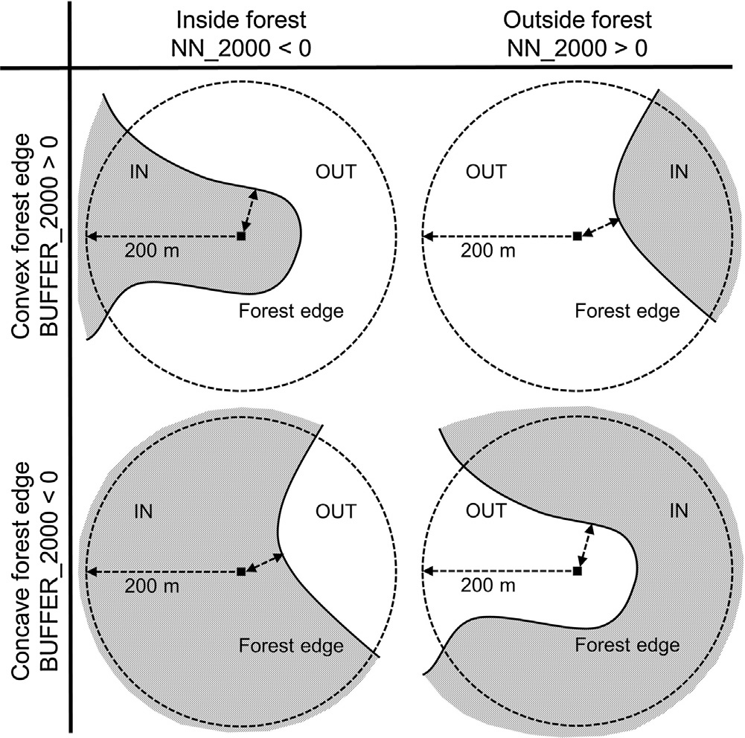Table 1
The median, upper and lower quartiles of the ancient forest species (AFS) count per plot and the number of habitat specialist AFS, in ﬁve forest types that are potential natural vegetation (PNV) in Flanders (De Keersmaeker et al., 2013). Habitat spe- cialist AFS occur much more frequently in one type than in other types. PNV types with an abbreviation between brackets are mesophilous forest habitat, selected for modeling.

Forest vegetation types Median AFS count (1st–3rd quartiles)

Specialist AFS

Alnion forest with Carex elongata and Scutellaria galericulata
Alno-Padion forest with Adoxa mosschatellina and Primula elatior
Fagion or Carpinion forest with Luzula pilosa and Oxalis acetosella
Quercion forest with Athyrium ﬁlix-femina and Pteridium aquilinum
Quercion forest with Molinia caerulea and Vaccinium myrtillus
2 (1–3) 0
(AP) 8 (5–10) 15
(FC) 5 (3–7) 6
2 (1–4) 0
1 (1–2) 1

land-use history variables (FOREST AGE, FIELD, GRASSLAND) were assessed on forest inventory sample plots only (Table 2). These three variables were included to compare with a model that only used spatially explicit variables.
The connectivity measures calculated on forest cover maps and on maps with cadastral parcel borders can be classiﬁed as near- est neighborhood variables (NN hereafter) and buffer variables (Moilanen & Hanski, 2006). The forest cover represented by maps drawn in approximately 1775, 1850, 1917, and in 2000 was dig- itized for most of Flanders (De Keersmaeker, 2013). We derived from these four polygon maps with historical forest cover, raster maps with a resolution of 10 m that contain the Euclidean distance
(m) of a grid cell to the edge of the nearest forest patch. These variables were named in chronological order: NN 1775, NN 1850, NN 1917, NN 2000 (Table 2). Grid cells within forest were given negative values, cells outside forest had positive values (Fig. 1), and

Table 2
Names, units, and description of 18 explanatory variables included into modeling of AFS count. Three variables marked with * have no spatial dimensions, whereas 15 others are spatially explicit variables, available as digital maps.

Fig. 1. Connectivity measures calculated for raster pixels (black squares) on the for- est cover (e.g. in 2000). The NN 2000 measure is indicated by the double arrow and calculated as the nearest distance to the forest edge (solid line), with negative and positive values inside (IN) and outside (OUT) forest, respectively. The BUFFER 2000 measure is calculated as the mean value of the NN 2000 measures within in a radius of 200 m (single arrow) around the focal pixel (black squares), minus the NN 2000 value of the focal pixel itself.

grid cells on the forest edge were equal to zero. In a similar way, but with only zeros and positive values, the Euclidean distance was determined to cadastral parcel borders represented by the Cadmap layer (AGIV, 2013). We discerned parcel borders that were already present when the ﬁrst cadastral maps were drawn (1810–1825), from borders that were created after that time. It was assumed that the former had a higher potential to contain AFS, e.g. in linear landscape elements, than the latter.
The raster maps with NN variables served to calculate raster maps that contained BUFFER variables (Table 2 and Fig. 1). For this purpose the Focalmean200 value of a grid cell was ﬁrst calculated, being the mean value of the NN values in a circular area with a

radius of 200 m around the focal grid cell (Fig. 1). We assumed that
Variable name | Unit | Description
NN 1775 | Meters | Nearest distance to a forest edge in 1775
NN 1850 | Meters | Nearest distance to a forest edge in 1850
NN 1917 | Meters | Nearest distance to a forest edge in 1917
NN 2000 | Meters | Nearest distance to a forest edge in 2000
BUFFER 1775 | Meters | Shape of the nearest forest edge in 1775
BUFFER 1850 | Meters | Shape of the nearest forest edge in 1850
BUFFER 1917 | Meters | Shape of the nearest forest edge in 1917
BUFFER 2000 | Meters | Shape of the nearest forest edge in 2000
NN CADORI | Meters | Nearest distance to a parcel border created
 |  | before 1825
NN CADALT | Meters | Nearest distance to a parcel border created
 |  | after 1825
BUFFER CADORI | Meters | Shape of the nearest parcel border created
 |  | before1825
BUFFER CADALT | Meters | Shape of the nearest parcel border created
 |  | after 1825
SI AP | No unit | Suitability for Alno-Padion forest vegetation
SI FC | No unit | Suitability for Fagion or Carpinion forest
 |  | vegetation
SLOPE | Degrees | Slope derived from a digital terrain model
 |  | (DTM)
*FOREST AGE | Years | Time of continuous cover by forest up to 2000
*FIELD | Years | Time used as a ﬁeld between 1775 and 2000
*GRASSLAND | Years | Time used as a grassland between 1775 and
 |  | 2000

AFS migration since 1775 was mostly restricted to this distance, as many AFS have colonization rates below 1 m yr−1 (e.g. Brunet,
De Frenne, Holmström, & Lajos Mayr, 2012; Hermy & Verheyen, 2007). The Focalmean200 values were highly correlated with the NN values and therefore a linear combination of both correlated variables was calculated (Dormann et al., 2013), e.g. on forest cover in 2000: BUFFER 2000 = Focalmean200[NN 2000] − NN 2000.
The BUFFER variables that are the result of this equation were
not correlated with the NN variables (Appendix B) and there- fore used for modeling instead of the Focalmean200 variables. The BUFFER variables are continuous, with negative values indicating that the nearest forest edge to a grid cell is concave, and positive values indicating that the nearest forest edge is convex (Fig. 1).
We included two indices (SI AP and SI FC) extracted from the fuzzy PNV map of Flanders (De Keersmaeker et al., 2013) that quan- tify the suitability of a site for the two selected mesophilous forest types (AP and FC in Table 1). The suitability indices range between 0 (not suitable) and 1 (highly suitable for only one type) and the sum of indices of all ﬁve PNV types that can occur on a site is always equal to 1. We only selected 377 samples on sites that have a potential for at least one of both mesophilous types, covering 41% of Flan- ders, and for this reason the sum of SI AP and SI FC was always

greater than 0 but below or equal to 1. As the values of both selected site indices are not independent, it is appropriate to include also the interaction term into modeling (Zuur, Ieno, Walker, Saveliev, & Smith, 2009).
It was hypothesized that an undulating topography could result into microhabitats for AFS, not explained by the site indices extracted from the PNV map. For this reason the variable SLOPE was included, that indicated the slope (degrees) derived from a DTM grid with 5 m × 5 m resolution (Digital terrain model of Flanders,
2001–2004). This grid was resampled to a 10 m × 10 m grid with
a similar extent as the other spatially explicit variables. All afore- mentioned spatial analyses and grid calculations to obtain spatially explicit explanatory variables were performed in Arc/Info 10.
Three variables on land-use history were assessed on the for- est inventory sample plots only, but were not available as digital raster maps: forest age (FOREST AGE), total time used as grassland since 1775 (GRASSLAND), and total time used as ﬁeld since 1775 (FIELD) (Table 2). For this purpose, land-use was interpreted on eight historical maps, approximately drawn in: 1775, 1850, 1867,
1883, 1917, 1959, 1979, and 2000. FOREST AGE is a quantiﬁcation of forest continuity and was determined as the time (years) up to 2000, a sample plot was continuously covered by forest, since ﬁnal conversion from open land to forest. This value was calculated using the mean of the interval between the two successive maps, that precede and follow on this ﬁnal land-use change. FOREST AGE of sample plots continuously covered by forest, equalled 225 years. The mean values of interval times were also used to calculate the total number of years between 1775 and 2000, sample plots were occupied by grassland (GRASSLAND) and ﬁeld (FIELD). Other land- use, e.g. heathland, was only marginally present on mesophilous soils and was therefore not quantiﬁed.

  - Model construction

Relationships of AFS counts with potential explanatory vari- ables were analyzed in R version 2.15.2 (R Development Core Team, 2011), with generalized additive models (GAMs), using reduced rank versions of the thin plate splines with shrinkage (Wood, 2003). The dimension of the basis of the smoothers was set to four in order to avoid oversmoothing. Absolute values of correlations among variables included in the full models are not above 0.62 (Appendix B). Except for SI AP and SI FC, interaction was not taken into account and variables were included as univariate smoothers. SI AP and SI FC were included together as one bivariate smoother to deal with the interaction between both site indices. The number of AFS are overdispersed count data that were modeled with a quasi-Poisson
distribution using the mgcv package in R (Wood, 2011). Backwards model selection was manually applied, removing the least signif- icant smoother. The smaller model was retained when either the smaller model did not signiﬁcantly (P ≥ 0.05) differed from the full model using an F-test (Zuur et al., 2009) or the difference in esti- mated degrees of freedom was negligible (Df < 0.0006).
We compared a model that only included spatially explicit data as explanatory variables (model A), with a model that also included additional, more detailed information of land-use history only available on forest inventory sample plots (model B). Both models followed the same procedure for the selection of explana- tory variables. The upper models in both cases included 15 and 18 variables, respectively. Partial effects were illustrated by response shapes of smoothed predictor variables.
We examined the deviance residuals of both models for signs of spatial autocorrelation by calculation of an experimental vari- ogram. We ﬁtted a spherical variogram model to the experimental variogram, using the gstat package (Pebesma, 2004) in R. The bin- width was set at 1 km to match the spatial resolution of the dataset. The geoTIFF raster maps were imported in R using the rgdal package (Bivand, Keitt, & Rowlingson, 2013). The model was applied on the individual raster cells and the calculated values were written to geoTIFF rasters, that were visualized in Arc/Info 10. All
scripts used for modeling are available in Appendix C.

- Results

The modeling procedure resulted into a spatially explicit model that included four explanatory variables and explained 18% deviance (model A in Table 3). When explanatory variables, only available for sample plots, were also tested, seven variables were included and 25% deviance was explained (model B in Table 3). Both models shared the same four spatially explicit variables and the relationships with the response variable were similar, but weaker, in model B as compared to model A (compare Figs. 2 and 3). The species number was negatively affected by the included NN vari- ables, meaning that the species number increased toward the forest interior. The smoothers on the BUFFER variables indicated that a concave forest border (negative values) resulted into more AFS than a convex forest border (see Figs. 1–3).
The selection procedure included connectivity measures calcu- lated on the forest cover at three time slices (1775, 1917, 2000) in model A. When additional information on land-use of sample plots was used for modeling, the ﬁnal model B also included a connectiv- ity measure on the forest cover in 1850. Spatially explicit variables

Table 3
Parametric coefﬁcients and approximate signiﬁcance of the smooth terms of two GAMs (A and B) on AFS count. The construction of model A only included spatially explicit data as explanatory variables whereas for the construction of model B explanatory variables without spatial dimensions were tested as well. The models are expressed by the formulas: AFS ∼ s(SI AP, SI FC) + s(NN 1917) + s(NN 1775) + s(BUFFER 2000) + s(BUFFER 1850)* + s(FIELD)* + s(FOREST AGE)*. Variables names are explained in Table 2 and variables marked with * are only included in model B. Edf: estimated degrees of freedom for the model terms; Ref.df: estimated residual degrees of freedom. The GCV scores equaled 2.451 (model A) and 2.3425 (model B), the explained deviance equaled 18.3% (model A) and 24.9% (model B), on 377 observations.

 | Estimate |  |  | Std. error |  |  | t-value |  |  | Pr(>|t|)
 | A | B |  | A | B |  | A | B |  | A | B
Intercept | 1.00989 | 0.97468 |  | 0.04969 | 0.04988 |  | 20.32 | 19.54 |  | <0.001 | <0.001
Smooth term | Edf |  |  | Ref.df |  |  | F-value |  |  | P
 | A | B |  | A | B |  | A | B |  | A | B
s(SI AP, SI FC) | 2.3832 | 2.5469 |  | 3 | 3 |  | 2.931 | 4.374 |  | 0.013 | 0.002
s(NN 1917) | 0.9258 | 0.8374 |  | 3 | 3 |  | 4.573 | 2.310 |  | <0.001 | 0.003
s(NN 1775) | 0.9013 | 0.7405 |  | 3 | 3 |  | 3.188 | 1.350 |  | <0.001 | 0.015
s(BUFFER 2000) | 0.7336 | 0.7023 |  | 3 | 3 |  | 1.060 | 0.963 |  | 0.034 | 0.039
s(BUFFER 1850) |  | 2.4158 |  |  | 3 |  |  | 1.976 |  |  | 0.065
s(FIELD) |  | 2.8403 |  |  | 3 |  |  | 4.111 |  |  | 0.005
s(FOREST AGE) |  | 2.0106 |  |  | 3 |  |  | 3.926 |  |  | 0.001

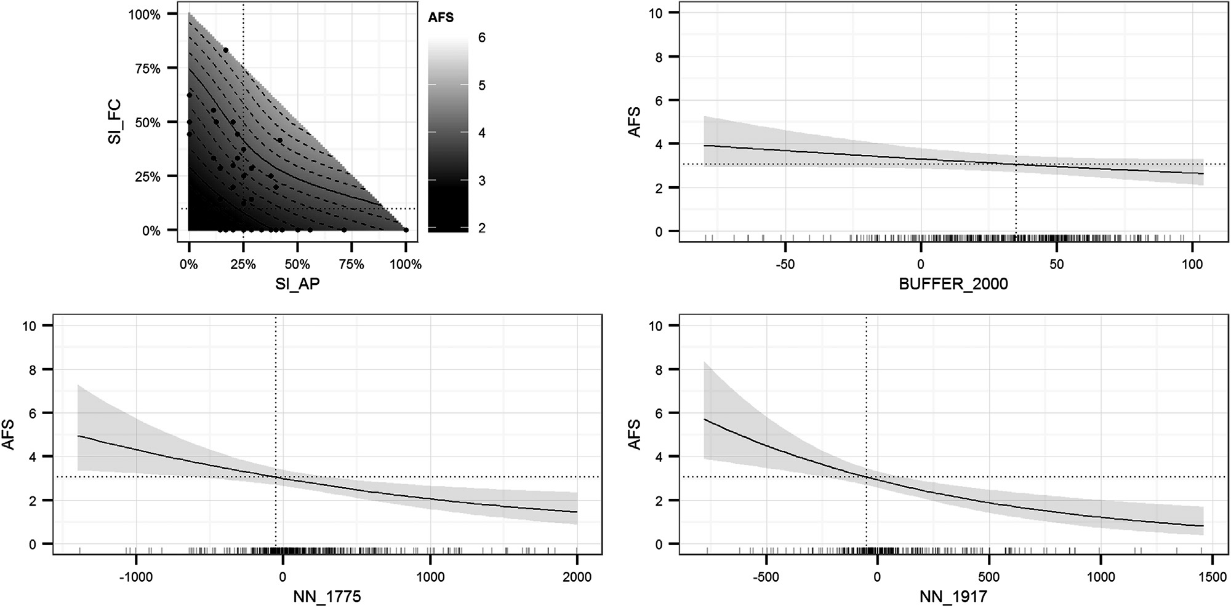

Fig. 2. Estimated partial effects of four spatially explicit variables, included into the GAM of the ancient forest species (AFS) count (Model A). The 95% conﬁdence interval is indicated by the gray area in the 2D plots. Dotted lines represent reference values of the model. Tick marks on the x-axis (2D plots) and dots (3D plot) show the location of observations. Variable names are explained in Table 2.

calculated on the DTM and on the cadastral maps were not retained by both models.
Spatial autocorrelation might be present in the spatially explicit data, with a range of 2.2 km and 1.7 km, a sill of 2.4 and 2.1 and a nugget of 0.8 and 0 for models A and B, respectively (Fig. 4). Note that the spatial resolution of the dataset does not allow to prop- erly estimate the spatial autocorrelation at distances below 1 km. Hence, the values of the nugget should be interpreted with caution. In order to safeguard the users of the resulting maps (Figs. 5 and 6g) from misinterpretation, we preferred to present the lower limit (LCL) of the 95% conﬁdence interval of the predictions instead of the predicted values. Predicted values do not take the model uncer- tainty into account, whereas the LCL gives a conservative estimate of the AFS count. Thus high LCL values indicate areas with a strong potential of AFS at a 95% conﬁdence level.
The map of Flanders with the modeled AFS count illustrates that a high AFS count is forecasted in the south of Flanders (Fig. 5). This area is characterized by a high proportion of mesophilous soils and, although forest cover was low in 2000 (between 5% and 15%), many forests are ancient forest. By contrast, suitable mesophilous sites are scarce in NE Flanders (Fig. 5), where forest cover in 2000 is high (>20%). In this area locations with a high potential AFS count are mostly located on alluvial soil along watercourses. The spatial pat- terns generated by the explanatory variables and by the outcome of model A are illustrated for a selected area in the south of Flanders (Fig. 6), where a forest patch on silt loam soil covered approxi- mately 600 ha in 1775 but was reduced to approximately 180 ha in 2000 (Fig. 6c–e). The north of this forest, located on the most suit- able sites where the modeled AFS count is high, was cleared in the 19th century. North of the remaining ancient forest several small forest patches emerged in the 20th century on alluvial soils. These patches are located on more or less suitable sites for AFS (Fig. 6a and b), but the model predicted a low AFS count due to spatio- temporal isolation (Fig. 6c and d). Extrapolation of the model to the open landscape not covered by forest in 2000 resulted into high values for areas that were covered by forest in 1775, on suitable sites (compare Fig. 6a–d and f). Also open land next to a concave
ancient forest edge or within an ancient forest patch, is rated high (compare Fig. 6e and f).

- Discussions

  - Model construction

The connectivity of forest patches has been used before to explain occurrence or diversity of AFS (Jacquemyn, Butaye, & Hermy, 2003; Verheyen et al., 2004). As opposed to our empir- ical model, these studies applied mechanistic models based on the metapopulation concept, explaining the fundamental processes of species extinction and colonization in habitat patches (Levins, 1969). Such a process-oriented approach makes it necessary to sim- plify the description of the landscape matrix for modeling. Species characteristics, the permeability of the landscape, and the quality of the available data determine what kind of simpliﬁcations that are necessary for modeling, are most helpful (Fagan & Calabrese, 2006). A drawback of an empirical model is that indirect variables or vari- ables without causation, can be included (Guisan & Zimmerman, 2000). The FIELD measure in our model could be an example of such a variable.
Landscape indices can be subdivided into three categories: near- est neighborhood (NN) values, buffer values, and the incidence function model (IFM) connectivity measure (Moilanen & Hanski, 2006). We used NN and buffer measures derived from spatially explicit data to explain AFS counts on a set of forest vegetation sample plots that is representative for the whole present-day for- est cover. Such an approach can be successful for matrix-sensitive species, i.e. species that do not tend to wander out of the pre- ferred habitat type (Fagan & Calabrese, 2006). For two forest cover maps, NN measures were signiﬁcant but not the variables that included additional information calculated for a buffer area. This is in disagreement with the conclusion that NN measures mostly are inferior to buffer and IFM measures (Moilanen & Hanski, 2006). Based on the species traits, it can be assumed that most AFS show remnant dynamics instead of metapopulation dynamics (Eriksson,

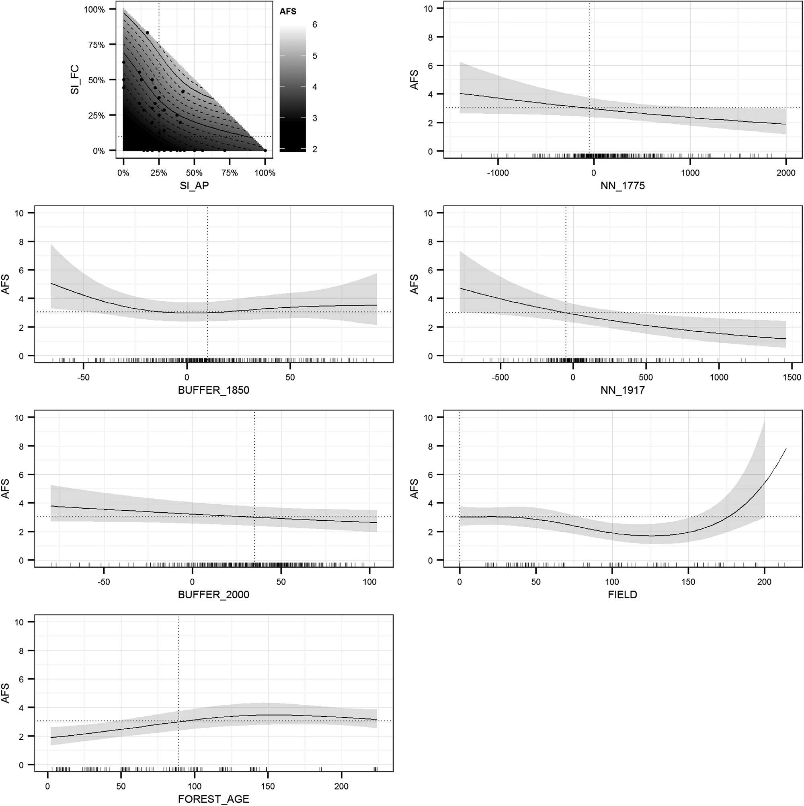

Fig. 3. Estimated partial effects of ﬁve spatially explicit variables and two variables without spatial dimensions, included into the GAM of the ancient forest species (AFS) count (Model B). The 95% conﬁdence interval is indicated by the gray area in the 2D plots. Dotted lines represent reference values of the model. Tick marks on the x-axis (2D plots) and dots (3D plot) show the location of observations. Variable names are explained in Table 2.

1996). This could explain the effectiveness of NN measures in our study.
As we wanted to calculate a value for the open land too, the use of the extended IFM measure, for which the area of the focal patch is required, was not possible. It can be relevant to calculate a value for the open land, as AFS can also occur in linear landscape elements,
e.g. hedgerows (Honnay et al., 1999b; Endels et al., 2004). These linear landscape elements are not represented by the applied for- est cover maps. Calculation of NN values for the open landscape is supported by the ﬁndings that physical contact of hedgerows with forest patches resulted into an increased species richness (Corbit et al., 1999; Roy & de Blois, 2008) and that richness of forest species in attached hedgerows declined with increasing distance to the for- est patches they were attached to (Wehling & Diekmann, 2009). Another advantage of our approach could be that the applied NN
measures, calculated as the distance to the forest perimeter, can have either positive or negative values. The variable positional error of the historical maps can be handled this way.

  - Factors that determine AFS diversity

The slight autocorrelation, assessed for sample plots at distances between 1 km and 2.2 km can have several causes, e.g. environ- mental gradients, similar forest management, but also dispersal effects (Bjørnstad, Ims, & Lambin, 1999). The absence of autocor- relation beyond 2.2 km could indicate that long-distance dispersal events are not highly explanatory for the AFS richness in present- day forests of Flanders. The high level of forest fragmentation for more than 200 years in our study area and AFS traits support this hypothesis. AFS in general are long-lived forest interior species

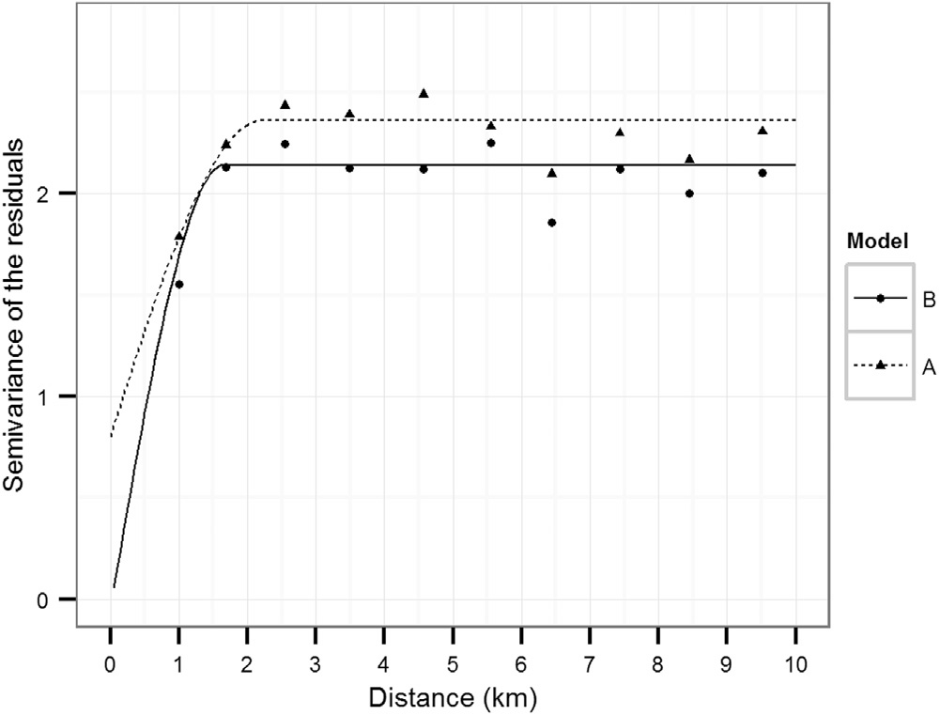

Fig. 4. Semivariogram with the semivariance of the residuals of the models on ancient forest species (AFS) count in forest inventory sample plots, as a function of the distance between the plots. Model A is constructed using spatially explicit data only (see Table 3 and Fig. 2), whereas model B resulted from the procedure that also included data without spatial dimensions (see Table 3 and Fig. 3).

that have poor colonization capacities (Hermy et al., 1999). Col- onization of new habitat by AFS is mostly a slow process, although recent studies (e.g. Brunet et al., 2012) indicated that the migra- tion rate may vary considerably among AFS. The high proportion of unexplained deviance could be caused by the heterogeneous behavior among AFS colonizing RF. A further homogenization of the response variable, e.g. by deﬁning subgroups based on species traits, could further improve modeling. A drawback could be that the zero inﬂation of the response variable could further increase by a subdivision.
The age of a recent forest was found to be highly explanatory for its forest plant richness (Jacquemyn, Butaye, & Hermy, 2001). Forest age can be derived from land use identiﬁed on successive historical maps. When applied to sample plots, such an analysis is relatively simple and accurate as compared to the spatially explicit approach (De Keersmaeker, 2013). The positional error of old maps can generate false land use changes in an overlay map (Clercq, Clement, & De Wulf, 2009). By using only four forest cover maps
instead of eight that were available for the interpretation of land- use of sample plots, some land use changes remained undetected (De Keersmaeker, 2013). The positional root mean squared error of the three included historical maps was higher than the raster resolution (10 m) and speciﬁc for each time slice (De Keersmaeker, 2013). Calculation of NN measures for separate time slices is more appropriate to handle the variable positional error of the forest cover maps, than calculating similar measures on an overlay map containing false land use change classes. Including more detailed and accurate information on historical land use, but without spatial dimensions, improved the model only slightly. Still a high propor- tion of deviance remained unexplained and the explanatory power of both models was low.
The NN measures calculated on two historical maps (1775 and 1917) indicated that the AFS count increased from the for- est edge to the forest interior, up to a distance of more than 500 m. Although abiotic and biotic conditions of forest edges dif- fer from the forest interior, several studies did not register such effects beyond 80 m of the forest edge (Gehlhausen, Schwartz, & Augspurger, 2000; Matlack, 1994; Wuyts et al., 2008). However, our results are in agreement with recent studies that found long periphery-to-interior gradients of species frequencies in forests (Bergès, Pellissier, Avon, Verheyen, & Dupouey, 2013; Pellissier et al., 2013). These patterns could be explained by repeated dis- placements of the forest edge, that successively created recent forest at the periphery (Pellissier et al., 2013). Such displacements not only generate species colonization patterns but also create long-range environmental gradients from the forest edge to the forest interior (Bergès, Pellissier, et al., 2013). As a result, landown- ership can be a comprehensive, highly explanatory variable for forest species composition (Bergès, Avon, Verheyen, & Dupouey, 2013).
This explanation is further supported by our study as we found that, when more detailed information was included on historical land use of sample plots, the relationship between the NN meas- ures and AFS count was weaker. The remaining gradient in AFS richness could be explained by land use conversions before 1775 for which no information was available. The models also indicated that a concave or interior forest edge, resulted into a higher count of AFS than an external, convex forest edge. We can assume that edges of the present-day forest, protruding into farmland, suffer more from increased N and S depositions (e.g. Wuyts et al., 2008),

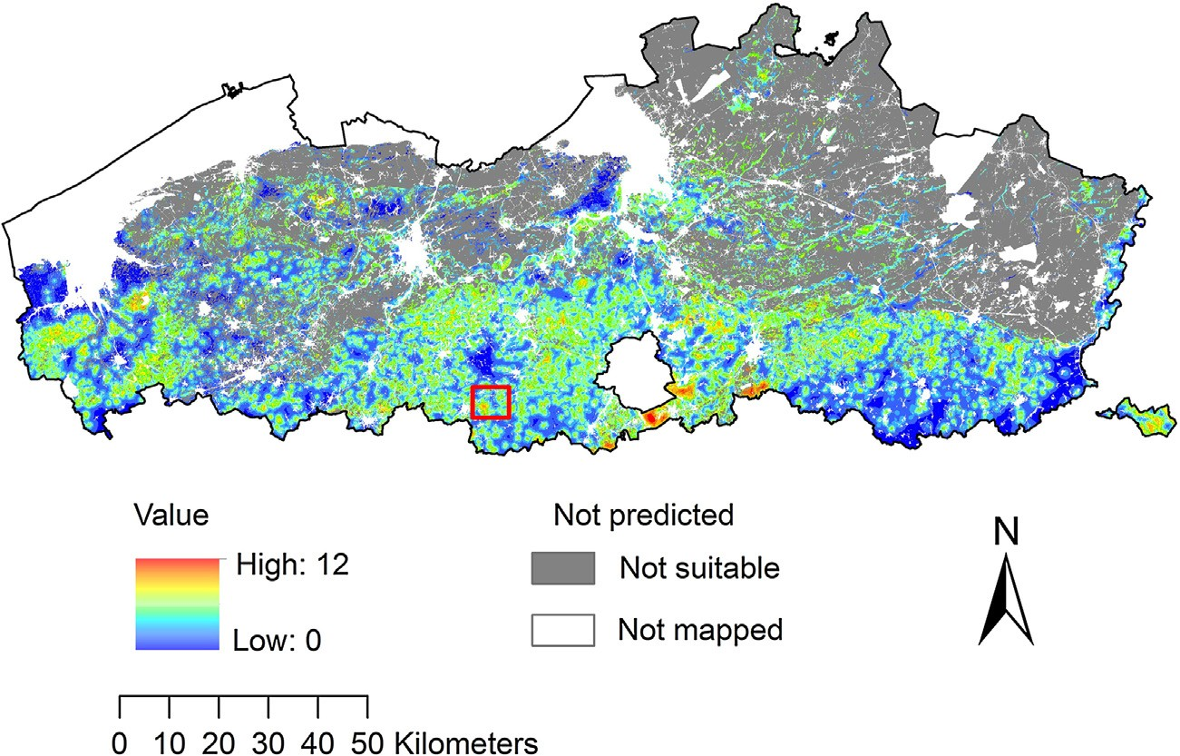

Fig. 5. Lower conﬁdence limit of the predicted count of AFS in Flanders. White areas are not mapped as no habitat suitability index was available (e.g. polders, dunes, military areas, disturbed soils), or as areas were not mapped in 1775. Gray areas are sites that are not suitable for mesophilous forest habitat. The area of the red rectangle is illustrated by Fig. 6.

166

165
  - Suitability index for AP (2000)
  - Suitability index for FC (2000)

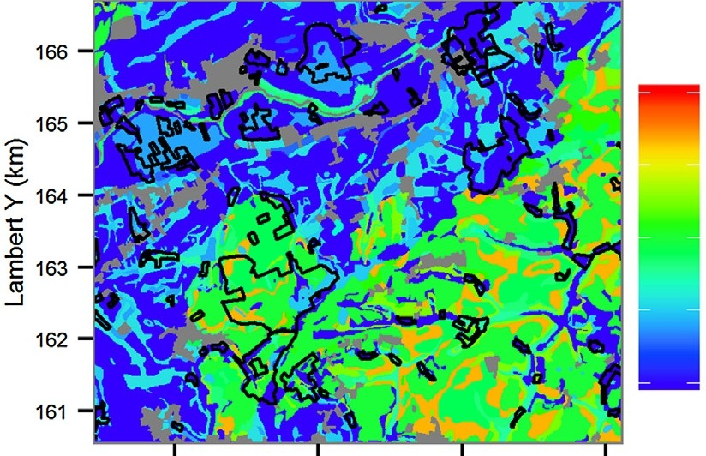1.00 1.00

Ê
-"'
;::- 164
t::
Q)
..c
E 163
_"J'
162

161

118 120 122
Lambert X (km)

(c) NN_1775 (1775)

124
0.75

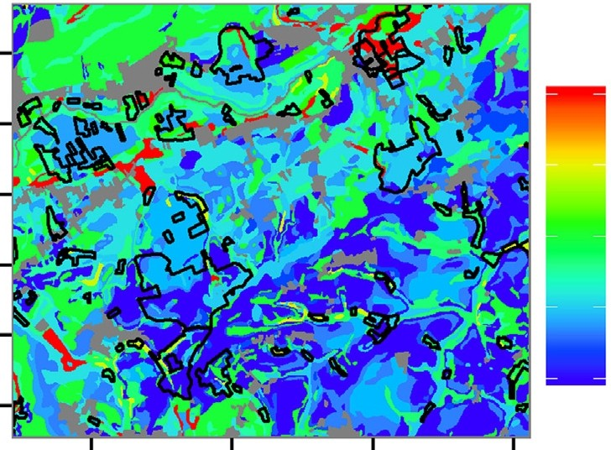0.50

0.25

0.00

118 120 122 124
Lambert X (km)

(d) NN_1917 (1917)
0.75

0.50

0.25

0.00

166

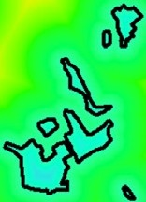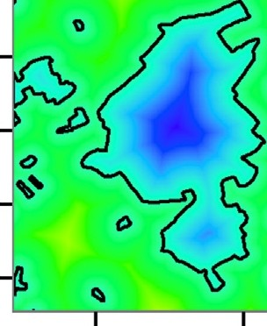1500
/
'
0
"

1000

-"'

166 Il
g-f3

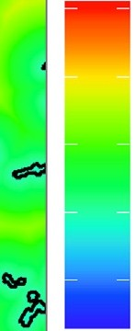'.I'
.
rt}S
Q••

1500

165
Ê
500
165 ()
Ê
, 1000

-"'
;::- 164
t::
Q)
;::-
t::
Q)
E
164 0
<>
...
500

..c
E 163
j
162

161
0

-500
..c 163 0-
_"J'
162

161

.,_
"'•
0

-500

118 120 122
Lambert X {km)
124
118 120 122
Lambert X (km)
124

(e) BUFFER_2000 (2000)

Ê
-"'
166

165

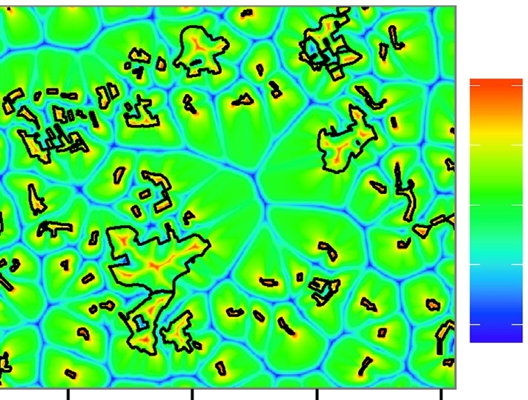100

50

;::- 164
t::
Q)
..c
E 163
j
162

161

0

-50

-100

166
118 120 122
Lambert X (km)

- Lower confidence limit of predicted AFS (2000)
124

- Relative width of
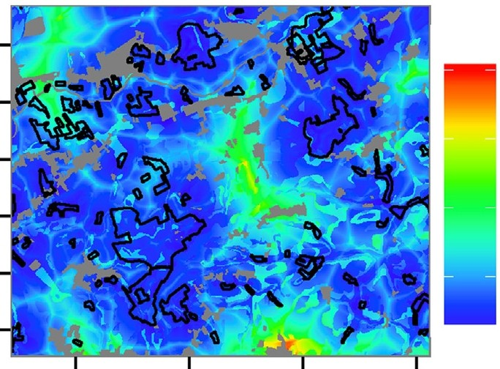95% confidence interval predictions (2000)

166

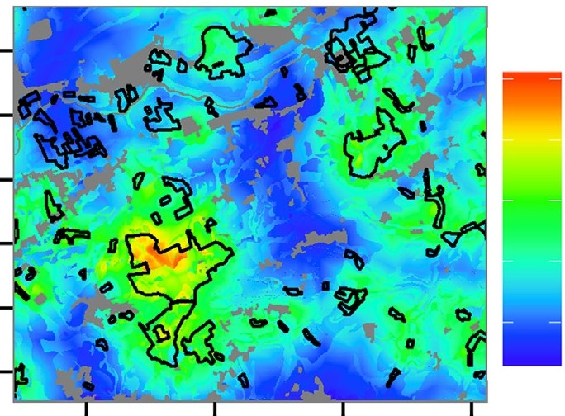165
cE 4
165
cE 4

>- 164
t::
Q)
163
_"J'
162

161

118 120 122
Lambert X (km)

2

124
>- 164
t::
Q)
163
_"J'
162

161

118 120 122
Lambert X (km)

2

124

Fig. 6. Patterns of explanatory variables (a-e) (names: see Table 2), lower confidence limit of the predicted ancient forest species (AFS) count (f), and width of 95% confidence interval (g). Black outlines depict forest perimeter at time slices mentioned between brackets. Coordinates are in the Belgian Lambert 72 project ion.

misplacement of fertilizer, and increased competition by light and nutrient demanding species (Honnay, Verheyen, & Hermy, 2002) than concave or interior forest edges. The model that also included forest age, calculated on sample plots only, included a similar but weaker effect of the shape of the nearest forest edge in 1850. This effect of the historical forest edge could indicate that recent forest located near a concave edge of the forest still present in 1850, recov- ered faster than recent forest near a convex edge of the remaining forest. We can assume that connectivity with source populations in a forest is more favorable near a concave forest edge than near a concave forest edge (see Fig. 1).
The shape of the forest edge in 1850 had a weak effect in the model that included forest age, and no connectivity measure cal- culated on the 1850 forest cover was included into the model that only used spatially explicit data. This is a remarkable ﬁnding, as forest age and forest continuity are regarded to be essential for pre- serving AFS richness (see, e.g. Wulf, 2003). This could indicate that vegetation of forest, cleared between 1775 and 1850, but reforested before 1917, had mostly recovered to the level of ancient forest veg- etation. This may be explained by the fact that many of these forests were converted to farmland for a very short time, during a famine (Tack et al., 1993). Low soil P levels indicated that these clearings probably were not fertilized, as opposed to sites converted from farmland to forest in the 20th century (De Keersmaeker et al., 2004). P eutrophication can slow down recovery of forest vegetation, as competitive exclusion of AFS by species with a higher plasticity is promoted (Baeten, Hermy, et al., 2009). Another explanation for the recovery of AFS richness since 1850 could be that AFS survived forest clearing in linear landscape elements (Honnay et al., 1999b). Linear landscape elements, also newly created ones, can be suit- able habitat for AFS and can function as a colonization source when incorporated in recent forest (Endels et al., 2004). We tested con- nectivity measures on cadastral parcel borders as a substitute for linear landscape elements, but none of these measures explained AFS richness in forest patches. Perhaps the density of linear land- scape elements with AFS was too low to detect an effect on the recovery of recent forest at the scale of our study. Moreover, fringe relics of the mid-19th century forest clearing, that enabled recov- ery of AFS after reforestation, did not necessarily coincide with the border of cadastral parcels (Honnay et al., 1999b).

  - Application of the AFS diversity map

The spatially explicit model offered the advantage that it gen- erated information on AFS count for a very high number of forest patches (19,000) that covered a large total forest area (144,000 ha). Research that compared conservation strategies based on the inventory of forest patches, comprised a smaller total forest area and much less forest patches, selected from study areas that also contained patches that were not inventoried (Hokkanen et al., 2009; Honnay et al., 1999a; Peterken & Game, 1984). When using the prediction map it should be kept in mind that a high propor- tion of the deviance was not explained. The GIS map can thus be used for prospection of potential diversity hotspots, guiding addi- tional ﬁeld surveys that can provide a more accurate assessment of species diversity.
When using the map for local conservation projects, it is recom- mended to collect additional information on explanatory variables. The unknown connectivity of forest patches through linear land- scape elements, discussed above, could attribute to some of the unexplained deviance, particularly in recent forest. The habitat suitability index is derived from a morphogenetic soil map, that does not represent certain soil characteristics that can explain AFS diversity, e.g. the level of eutrophication with P (explained above), and soil pH. Soils of the silt loam plateau are sensitive to acidiﬁca- tion that can cause a decline of sensitive species, including many
AFS (Baeten, Hermy, et al., 2009; Baeten, Jacquemyn, et al., 2009). The rate of this process can be inﬂuenced by tree species (Thomaes et al., 2011, 2012). Current or historical forest management prac- tices, not included into our models, also can have an important impact on AFS diversity. A shift from a coppice with standards management, to a selective cutting management can result into an increase of the disturbance frequency. Such a shift can promote competitive species, e.g. Rubus fruticosus, and can negatively affect the diversity of typical forest species (Decocq et al., 2004). The litter quality and shade casting ability of the tree species, promoted by a forest management form, can also inﬂuence the composition and species richness of herbaceous forest vegetation (Van Calster et al., 2008).
The map generated by the empirical landscape model can also be used for restoration projects, as an estimated value is calculated for the open land. Suitable sites covered by forest on historical maps, but not anymore in 2000, were also rated high. In such areas, relic populations of AFS could be present in hedgerows and tree lines and the map can be used for the prospection of such linear land- scape elements. However, linear landscape elements have severely declined in the past decades (Barr & Parr, 1994), and for this rea- son colonization of reforested open land by AFS is probably mostly dependent of source populations in forest. In this case the map can be used to select open sites with a suitable habitat quality, adjacent to a forest with a high predicted AFS diversity. The shape of the for- est edge can inﬂuence the restoration potential as well, as more AFS were found in a concave forest edge than in a convex forest edge. Moreover, a parcel surrounded by forest with a high AFS diversity can be colonized from more than one side.

- Conclusions

Spatially explicit data on habitat suitability, historical and present-day forest cover can be used to explain AFS diversity when spatio-temporal forest cover changes have resulted into a variable recovery level of forest cover. The applied model generated values for the present-day forest, but extrapolation to sites at present not covered by forest can be relevant. Areas that were recently defor- ested and that have a high potential AFS count according to the prediction map, can contain relic populations of AFS, e.g. in lin- ear landscape elements that are not represented by digitized forest cover maps. In most cases however, recovery of reforested open land will rely on physical contact with present-day forest that still contains AFS. The map of AFS count can be applied for landscape planning at a regional scale, e.g. for selecting biodiversity hotspots in present-day forest or for selection of open locations with a high recovery potential. However, the map should be combined with additional information on historical land-use, landscape structure, soil characteristics, and forest management history when used for the operationalization of conservation, defragmentation or restora- tion projects.

Acknowledgements

We would like to thank Johnny Cornelis, Bart Roelandt, and Mar- tine Waterinckx of the Nature and Forest Agency who put the forest inventory sample points to our disposal.

References

AGIV. (2013). Cadmap metadata (digital plan of cadastral parcels). Retrieved from: http://www.agiv.be/gis/projecten/?artid=532 (in Dutch)
Baeten, L., Bauwens, B., De Schrijver, A., De Keersmaeker, L., Van Calster, H., Vandek- erkhove, K., et al. (2009). Compositional changes 1954–2000 in the forest herb layer following the cessation of coppice-with-standards management and soil acidiﬁcation. Applied Vegetation Science, 12, 187–197.
Baeten, L., Hermy, M., Van Daele, S., & Verheyen, K. (2010). Unexpected understorey community development after 30 years in ancient and post-agricultural forests. Journal of Ecology, 98, 1447–1453.
Baeten, L., Hermy, M., & Verheyen, K. (2009). Environmental limitation contributes to the differential colonization capacity of two forest herbs. Journal of Vegetation Science, 20, 209–223.
Baeten, L., Jacquemyn, H., Van Calster, H., Van Beek, E., Devlaeminck, R., Verheyen, K., et al. (2009). Low recruitment across life stages partly accounts for the slow colonization of forest herbs. Journal of Ecology, 97, 109–117.
Barr, C. J., & Parr, T. W. (1994). Hedgerows: linking ecological research and coun- tryside policy. In T. A. Watt, & G. P. Buckley (Eds.), Hedgerow Management and Nature Conservation (pp. 119–134). Ashford: Wye College Press.
Bergès, L., Avon, C., Verheyen, K., & Dupouey, J.-L. (2013). Landownership is an unex- plored determinant of forest understory plant composition in Northern France. Forest Ecology and Management, 306, 281–291.
Bergès, L., Pellissier, V., Avon, C., Verheyen, K., & Dupouey, J.-L. (2013). Unexpected long-range edge-to-forest interior environmental gradients. Landscape Ecology, 28, 439–453.
Bivand, R., Keitt, T., & Rowlingson, B. (2013). rgdal: Bindings for the Geospa- tial Data Abstraction Library. R package version 0.8-14. http://CRAN. R-project.org/package=rgdal
Bjørnstad, O. N., Ims, R. A., & Lambin, X. (1999). Spatial population dynamics: Ana- lyzing patterns and processes of population synchrony. Trends in Ecology & Evolution, 14, 427–432.
Brunet, J. (2007). Plant colonization in heterogeneous landscapes: An 80-year per- spective on restoration of broadleaved forest vegetation. Journal of Applied Ecology, 44, 563–572.
Brunet, J., Valtinat, K., Lajos Mayr, M., Felton, A., Lindbladh, M., & Bruun, H. H. (2011). Understory succession in post-agricultural oak forests: Habitat fragmentation affects forest specialists and generalists differently. Forest Ecology and Manage- ment, 262, 1863–1871.
Brunet, J., De Frenne, P., Holmström, E., & Lajos Mayr, M. (2012). Life-history traits explain rapid colonization of young post-agricultural forests by understory herbs. Forest Ecology and Management, 278, 55–62.
Corbit, M., Marks, P. L., & Gardescu, S. (1999). Hedgerows as habitat corridors for forest herbs in central New York, USA. Journal of Ecology, 87, 220–232.
De Clercq, E. M., Clement, L., & De Wulf, R. R. (2009). Monte Carlo simulation of false change in the overlay of misregistered forest vector maps. Landscape and Urban Planning, 91, 36–45.
Decocq, G., Aubert, M., Dupont, F., Alard, D., Saguez, R., Wattez-Franger, A., et al. (2004). Plant diversity in a managed temperate deciduous forest: Under- storey response to two silvicultural systems. Journal of Applied Ecology, 41, 1065–1079.
De Keersmaeker, L., Martens, L., Verheyen, K., Hermy, M., De Schrijver, A., & Lust, N. (2004). Impact of soil fertility and insolation on diversity of herbaceous wood- land species colonizing afforestations in Muizen Forest (Belgium). Forest Ecology and Management, 188, 291–304.
De Keersmaeker, L. (2013). Spatio-temporal patterns of vegetation recovery in post- agricultural forests in Flanders (PhD thesis). Ghent: Ghent University.
De Keersmaeker, L., Rogiers, N., Vandekerkhove, K., De Vos, B., Roelandt, B., Cornelis, J., et al. (2013). Application of the ancient forest concept to potential natural veg- etation mapping in Flanders: A strongly altered landscape in Northern Belgium. Folia Geobotanica, 48, 137–162.
Digital terrain model of Flanders. (2001–2004). MVG-LIN-AMINAL – section Water and MVG-LIN-AWZ – section Flanders Hydraulics Research. Flemish Geographical Information Agency (AGIV).
Dormann, C. F., Elith, J., Bacher, S., Buchmann, C., Carl, G., Carre, G., et al. (2013). Collinearity: A review of methods to deal with it and a simulation study evalu- ating their performance. Ecography, 36, 27–46.
Endels, P., Adriaens, D., Verheyen, K., & Hermy, M. (2004). Population structure and adult plant performance of forest herbs in three contrasting habitats. Ecography, 27, 225–241.
Eriksson, O. (1996). Regional dynamics of plants: A review of evidence for remnant, source-sink and metapopulations. Oikos, 77, 248–258.
Fagan, W. F., & Calabrese, J. M. (2006). Quantifying connectivity: Balancing metric performance with data requirements. In K. R. Crooks, & M. Sanjayan (Eds.), Con- nectivity conservation (pp. 297–317). Cambridge: Cambridge University Press.
Game, M., & Peterken, G. F. (1984). Nature reserve selection strategies in the woodlands of Central Lincolnshire, England. Biological Conservation, 29, 157–181.
Gehlhausen, S. M., Schwartz, M. W., & Augspurger, C. K. (2000). Vegetation and microclimatic edge effects in two mixed-mesophytic forest fragments. Plant Ecology, 147, 21–35.
Guisan, A., & Zimmerman, N. E. (2000). Predictive habitat distribution models in ecology. Ecological Modelling, 135, 147–186.
Hermy, M., Honnay, O., Firbank, L., Grashof-Bokdam, C., & Lawesson, J. E. (1999). An ecological comparison between ancient and other forest plant species of Europe, and the implications for forest conservation. Biological Conservation, 91, 9–22.

Hermy, M., & Verheyen, K. (2007). Legacies of the past in the present-day forest bio- diversity: A review of past land-use effects on forest plant species composition and diversity. Ecological Research, 22, 361–371.
Hokkanen, P., Kouki, J., & Komonen, A. (2009). Nestedness, SLOSS and conservation network of boreal herb-rich forests. Applied Vegetation Science, 12, 295–303.
Honnay, O., Hermy, M., & Coppin, P. (1999a). Effects of area, age and diversity of forest patches in Belgium on plant species richness, and implications for conservation and reforestation. Biological Conservation, 87, 73–84.
Honnay, O., Hermy, M., & Coppin, P. (1999b). Impact of habitat quality on forest plant species colonization. Forest Ecology and Management, 115, 157–170.
Honnay, O., Verheyen, K., & Hermy, M. (2002). Permeability of ancient forest edges for weedy plant species invasion. Forest Ecology and Management, 161, 109–122. Jacquemyn, H., Butaye, J., & Hermy, M. (2001). Forest plant species richness in small, fragmented mixed deciduous forest patches: The role of area, time and dispersal
limitation. Journal of Biogeography, 28, 801–812.
Jacquemyn, H., Butaye, J., & Hermy, M. (2003). Inﬂuence of environmental and spatial variables on regional distribution of forest plant species in a fragmented and changing landscape. Ecography, 26, 768–776.
Levins, R. (1969). Some demographic and genetic consequences of environmen- tal heterogeneity for biological control. Bulletin of the Entomological Society of America, 15, 237–240.
Matlack, G. R. (1994). Vegetation dynamics of the forest edge – Trends in space and successional time. Journal of Ecology, 82, 113–123.
Moilanen, A., & Hanski, I. (2006). Connectivity and metapopulation dynamics in highly fragmented landscapes. In K. R. Crooks, & M. Sanjayan (Eds.), Connectivity conservation (pp. 44–71). Cambridge: Cambridge University Press.
Pebesma, E. J. (2004). Multivariable geostatistics in S: The gstat package. Computers
& Geosciences, 30, 683–691.
Pellissier, V., Bergès, L., Nedeltcheva, T., Schmitt, M.-C., Avon, C., Cluzeau, C., et al. (2013). Understorey plant species show long-range spatial patterns in forest patches according to distance-to-edge. Journal of Vegetation Science, 24, 9–24.
Peterken, G. F. (1977). Habitat conservation priorities in British and European wood- lands. Biological Conservation, 11, 223–236.
Peterken, G. F., & Game, M. (1984). Historical factors affecting the number and distri- bution of vascular plant species in the woodlands of central Lincolnshire. Journal of Ecology, 72, 155–182.
Rackham, O. (1980). Ancient woodland: Its history, vegetation and uses in England.
London: Edward Arnold.
R Development Core Team. (2011). R: A language and environment for statistical computing. Vienna, Austria: R Foundation for Statistical Computing. ISBN 3- 900051-07-0, Retrieved from: http://www.R-project.org/
Roy, V., & de Blois, S. (2008). Evaluating hedgerow corridors for the conservation of native forest herb diversity. Biological Conservation, 141, 298–307.
Tack, G., van den Bremt, P., & Hermy, M. (1993). (Forests of Flanders, a historical ecolog- ical study) Bossen van Vlaanderen: Een historische ecologie. Leuven: Davidsfonds (in Dutch).
Thomaes, A., De Keersmaeker, L., De Schrijver, A., Vandekerkhove, K., Verschelde, P.,
& Verheyen, K. (2011). Can tree species choice inﬂuence recruitment of ancient forest species in post-agricultural forest? Plant Ecology, 212, 573–584.
Thomaes, A., De Keersmaeker, L., Van Calster, H., De Schrijver, A., Vandekerkhove, K., Verstraeten, G., et al. (2012). Diverging effects of two contrasting tree species on soil and herb layer development in a chronosequence of post-agricultural forest. Forest Ecology and Management, 278, 90–100.
Van Calster, H., Baeten, L., Verheyen, K., De Keersmaeker, L., Dekeyser, S., Rogister,
J. E., et al. (2008). Diverging effects of different overstorey conversion scenarios on the understorey vegetation in a former coppice-with-standards forest. Forest Ecology and Management, 256, 519–528.
Vellend, M. (2003). Habitat loss inhibits recovery of plant diversity as forests regrow.
Ecology, 84, 1158–1164.
Verheyen, K., Vellend, M., Van Calster, H., Peterken, G., & Hermy, M. (2004). Metapop- ulation dynamics in changing landscapes: A new spatially realistic model for forest plants. Ecology, 85, 3302–3312.
Verheyen, K., Fastenaekels, I., Vellend, M., De Keersmaeker, L., & Hermy, M. (2006). Landscape factors and regional differences in recovery rates of herb layer rich- ness in Flanders (Belgium). Landscape Ecology, 21, 1109–1118.
Waterinckx, M., & Roelandt, B. (2001). De bosinventaris van het Vlaamse Gewest (the Flemish forest inventory). Brussel: Ministerie van de Vlaamse Gemeenschap, afdeling Bos and Groen (in Dutch).
Wehling, S., & Diekmann, M. (2009). Importance of hedgerows as habitat corri- dors for forest plants in agricultural landscapes. Biological Conservation, 142, 2522–2530.
Wood, S. N. (2003). Thin plate regression splines. Journal of the Royal Statistical Society B, 65, 95–114.
Wood, S. N. (2011). Fast stable restricted maximum likelihood and marginal like- lihood estimation of semiparametric generalized linear models. Journal of the Royal Statistical Society B, 73, 3–36.
Wulf, M. (2003). Forest policy in the EU and its inﬂuence on the plant diversity of woodlands. Journal of Environmental Management, 67, 15–25.
Wulf, M., Sommer, M., & Schmidt, R. (2010). Forest cover changes in the Prignitz region (NE Germany) between 1790 and 1960 in relation to soils and other driving forces. Landscape Ecology, 25, 299–313.
Wuyts, K., De Schrijver, A., Staelens, J., Gielis, L., Vandenbruwane, J., & Verheyen, K. (2008). Comparison of forest edge effects on throughfall deposition in different forest types. Environmental Pollution, 156, 854–861.
Zuur, A., Ieno, E. N., Walker, N., Saveliev, A. A., & Smith, G. M. (2009). Mixed effects models and extensions in ecology with R. New York: Springer.

