The distribution of amphibians and reptiles on Samos island (Greece)
(Amphibia: reptilia)

Die Verbreitung der Amphibien und reptilien auf der insel Samos (Griechenland) (Amphibia: reptilia)

Jeroen SPeyBroeCK & DAniel BoHle & eDoArDo rAZZeTTi & MAriA DiMAKi & MArlene KATHArinA KirCHner & WouTer BeuKeMA

KurZFASSunG

Die Arbeit faßt 1580 Funddaten von reptilien und Amphibien auf der insel Samos (Griechenland) aus den letzten Jahren (1993-2012) zusammen. Alle Funde wurden auf einem 1 km x 1 km raster verortet, wobei 40 % der Zellen (261 von insgesamt 648) zumindest eine Beobachtung einer Art aufwiesen. Auf dieser Datengrundlage wurden Verbreitungsmuster und ökologische Beobachtungen mit Vorkommen auf anderen inseln der Ägäis ver- glichen. Das in der Arbeit erstmals publizierte Vorkommen der Münzennatter Hemorrhois nummifer (reuSS, 1834) auf dieser insel hebt die Anzahl der bekannten Arten für Samos auf 28 (4 Amphibien- und 24 reptilienarten).
ABSTrACT

A collection of 1580 recent data records (1993-2012) of amphibians and reptiles from the Greek island of Samos was compiled. All records were mapped onto a grid of 1 km by 1 km, with 261 of the total 648 cells (40
%) of the island holding at least one observation. Subsequently, the distribution patterns and ecological observa- tions were compared with data from other islands in the Aegean Basin. The discovery of the Coin-marked Snake Hemorrhois nummifer (reuSS, 1834), published herein after, constitutes a new island record, setting the herpeto- fauna list to 28 confirmed species (4 amphibians, 24 reptiles).
KeyWorDS
Amphibia, reptilia, amphibians, reptiles, distribution, mapping, large contemporary dataset, Samos,
Greece, Aegean, island herpetofauna, new island record, Hemorrhois nummifer

inTroDuCTion

Samos is a Greek island in the eastern Aegean Sea, separated from Asia Minor by the 1.3 km wide Mycale Strait (Figs. 1A, 1B). The island has a surface of 476 km², roughly 44 km from west to east by 19 km from north to south (STAMATelAToS & VAMVA-STAMATelATou 2006). Built up by largely mountainous and hilly terrain with a maximal elevation of 1,434 m (Mt. Kerkis), pine forest dominates considerable sections of the inland. Additionally, the island hosts relatively large flatlands, especially in the southeast. These areas are characterized by non-intensively managed olive orchards with rich herbaceous undergrowth bordered by dry-stone walls, providing refuge for wildlife. As sustainable amphibian popula- tions rely on water for reproduction, a num-
ber of perennial and intermittent streams, coastal marshes as well as man-made water reservoirs are of particular importance to the anuran species of Samos, as well as a num- ber of reptile species dependent on water habitats (namely, Grass Snake and terra- pins). The island’s climate is of mild Medi- terranean type, with monthly average tem- peratures ranging from 10.3 (January) to
28.4 °C (July) and monthly rainfall ranging from 0.5 (July) to 164 mm (December) (Hel- leniC nATionAl MeTeoroloGiCAl SerViCe 2013). its heterogeneous landscape, mild climate and close proximity to the Anatolian mainland has resulted in a distinct and high biodiversity.
The herpetofauna of Samos is one of the most diverse of all Greek islands, likely

to be only surpassed by that of Corfu (Kerkyra) (TóTH et al. 2002; rAZZeTTi et al. 2006). oskar BoeTTGer (1888) set the basis of herpetological studies on Samos, describ- ing specimens collected by eberhard Von oerTZen in 1887, thus presenting more or less the first reference to a list of Samos amphibian and reptile species (listed here by their current names): Bufo bufo, Pelophylax bedriagae, Chamaeleo chamaeleon, Lau- dakia stellio, Ophisops elegans, Anatolola- certa anatolica, Typhlops vermicularis and Eirenis modestus. Subsequently, enrica CAlABreSi (1923) published a list of speci- mens collected on the island in 1893 by Forsyth MAJor, adding Mediodactylus kotschyi, Hemidactylus turcicus and Able- pharus kitaibelii. unfortunately, the speci- mens collected by F.S.C. MAJor, until today present in the Museo di Storia naturale “la Specola” of Firenze, cannot be assigned un- ambiguously to Samos, as the locality re- ported on the labels is “Samos e isole vicine” (= Samos and nearby islands) (Annamaria niSTri, in litt. 2013). CAlABreSi’s first mention of the presence of Mediodactylus kotschyi (cited as Gymnodactylus oertzeni) was later also listed by Franz Werner (1930, 1933), and with indication of doubt adopted by BeuTler & GruBer (1977) and CHonDroPouloS (1986). However, since the exact origin of the data is unclear and more recent records of M. kotschyi are lack- ing from the available literature, there seems to be no convincing evidence that this species is present on Samos. in contrast to CAlABreSi’s citation of M. kotschyi, subse- quent records confirmed the presence on Samos of Hemidactylus turcicus (Werner 1935) and Ablepharus kitaibelii (Werner 1930). A third major addition to the list of herpetofauna species of Samos was made by a number of papers by Werner (1930, 1933, 1935, 1938), adding Bufo viridis, Mauremys rivulata, Testudo graeca, Pseu- dopus apodus, Dolichophis caspius, Zame- nis situla and Natrix natrix to the faunal inventory. From the second half of the last century onwards, the majority of the species seemed to have been discovered and report- ed, and new discoveries became less numer- ous. DAAn (1967) added Lacerta trilineata, Platyceps najadum and Telescopus fallax, while BeuTler (1979) mentioned Trachy-
lepis aurata for the first time. The first explicit reports of Montivipera xanthina were published in the same year within three different publications: VAn WinGerDe (1986), nilSon & AnDrén (1986) and TieDeMAnn & GrilliTSCH (1986). The presence of the species on Samos was, how- ever, (indirectly) noted much earlier. in 1857, the italian explorer and zoologist orazio AnTinori was bitten in his right hand and suffered partial paralysis of the arm and discomfort for nearly two years (AMBroGi 1992; MAZZoTTi 2011). Natrix tessellata was listed as occurring on Samos by CHonDroPouloS (1989), by authority of an observation made by S. VAlAKoS in 1984, but has been revoked by the latter (S. VAlAKoS in verbis). BuTTle (1990) men- tioned Blanus strauchi for Samos by author- ity of a personal communication of Achilles DiMiTroPouloS, which was subsequently indicated as erroneous by the latter (A. DiMiTroPouloS in verbis). Bol (1992) was the first to mention Eryx jaculus for Samos from a 1989 find, although an earlier obser- vation (1988) was reported two years later (ioAnniDeS et al. 1994). ioAnniDeS et al. (1994) also published the presence of Hyla arborea (see also ioAnniDeS & DiMAKi 1996, 1997) and Malpolon insignitus for the first time. The last addition to the herpeto- fauna list of the island was Emys orbicu- laris, published by Meyer & FriTZ (1996). leaving sea turtles aside, and exclud-
ing three unconfirmed species (Mediodacty- lus kotschyi, Blanus strauchi and Natrix tes- sellata), prior to this paper, twenty-six species have been found, confirmed, pub- lished and repeatedly recorded on Samos, which includes four species of amphibians and twenty-two species of reptiles. As some of these species occur within Greece only on Samos and other islands off the Turkish western coast, the herpetofauna of the island has been identified as holding an ‘Asian’ character, in contrast to islands west of the Mid-Aegean Trench, with a more ‘euro- pean’ fauna composition (PAFiliS 2010).
The aim of this paper is to collect, dis- cuss and map recent distribution records, most of which have never been published before, in order to enhance knowledge about presence, abundance, seasonality and distribution of the herpetofauna of Samos.

MATeriAlS AnD MeTHoDS Data
total 224
412
155
197
155
160
167
46
4
60
1580
% 14
26
10
12
10
10
11
3
0
4
100
Data was collected opportunistically from 1993 to 2012 (Table 1) by the authors as well as from numerous contributors (see acknowledgements). Table 1 summarizes the temporal spread of the collected data, with spring (April-May) and a number of years with dedicated field trips taking up large portions of the total data.
‘10
12
5
2
33
59
75
1
‘11
5
78
1
17
22
11
4
‘12
?
3
10
1
17
42
1
139
57
58
187
72
The degree of accuracy differs within the data, ranging from exact GPS coordi- nates, estimated sites of location in Google earth and other available detailed mapping tools, to only the indication of the grid cell (see below) of observation. Such data was of sufficient quality for the present mapping purposes, while less precise observations were omitted.
Table 1: number of herpetological records available for the present analysis, tabulated by year and month. Tab. 1: Die Anzahl der für die Analyse verfügbaren Funddaten, geordnet nach Jahr und Monat.
‘06
‘07
‘08
24
48
8
20
13
28
3
‘09
4
2
12
33
3
1
105
73
11
1
85
144
160
repeated sightings of the same spe- cies at the same site were not lumped, in order to maintain an image of sampling bias and observational preferences. Densities (number of observed individuals per obser- vation and/or site) could unfortunately not be taken into account, as this information was frequently unavailable. A certain con- tributor-specific bias that may exist (e.g., some contributors focus on one or a number of species rather than collecting data for all, some do not search at night or under objects, etc.), was assumed to be largely levelled out by the large number of available records. Thus, the authors consider the relative num- ber of records for each species to reflect its detectability and/or abundance. one nota- ble exception is given by the data of Cha- maeleo chamaeleon, for which one of the authors (MD) conducted intensive species- specific sampling.
year / Jahr
‘97
14
‘98
‘99
‘00
‘01
4
2
‘02
1
‘03
‘04
124
52
‘05
59
1
44
28
9
14
89
24
18
3
29
1
1
1
28
4
7
8
47
24
18
155
13
9
3
176
30
90
Mapping
‘96
22
4
1
27
The distribution database was inter- sected in ArcGiS10 with a 1 km x 1 km grid (coordinate system WGS84, uTM zone 35) comprising 648 individual cells, encom- passing Samos and the small satellite island of Samiopoula (Fig. 1C). An overall sam- pling density map and grid maps per species were created to visualize the distribution (Figs. 5 - 8) and calculate the portion of occupied grid cells within the total grid.
Month / Monat
‘93
‘94
14
Apr May Jun Jul Aug Sep oct nov Dec
?
total
38
59
28
4
38
105

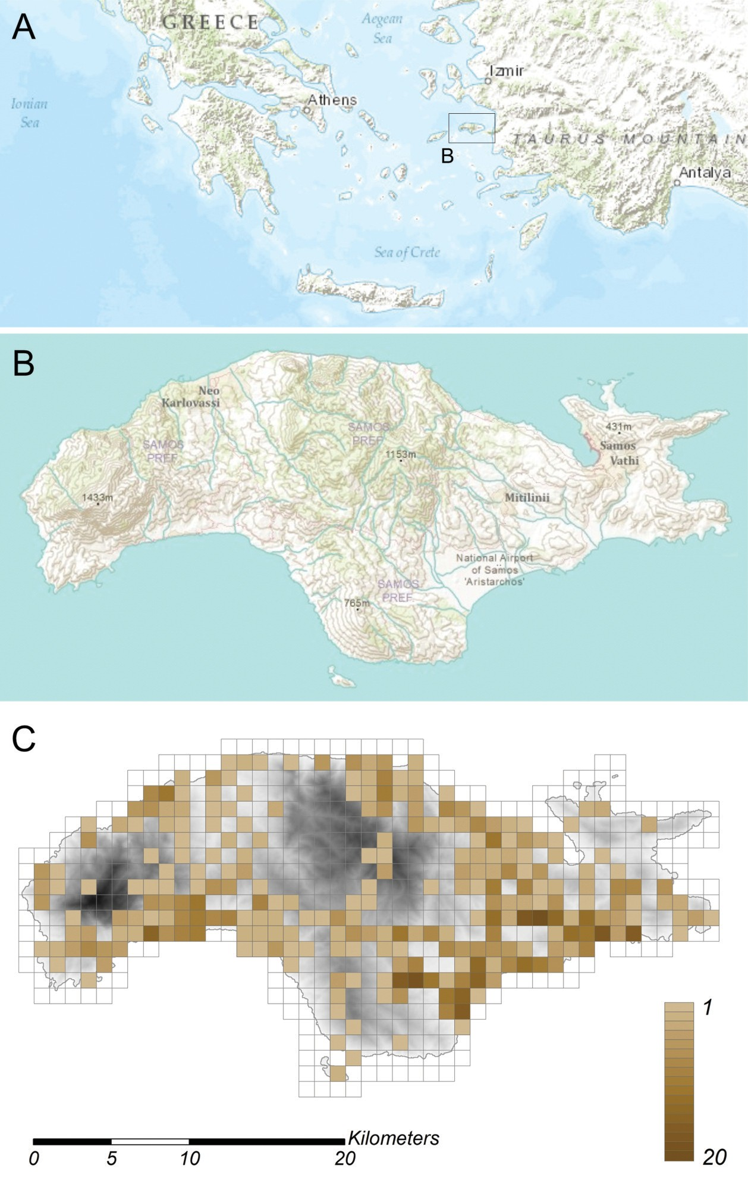

Fig. 1: A & B - Geographic location of the island of Samos (east Aegean, Greece) and basic topography and hydrology of the island; C - Density distribution of collected herpetological data, represented
by different shades of brown. The legend shows the number of species within each grid cell.
Abb. 1: A. & B - Die geographische lage von Samos, sowie eine vereinfachte Darstellung der Topographie und Hydrologie; C - Dichte der gesammelten herpetologischen Daten, verdeutlicht durch unterschiedliche Braun-Schattierungen. Die legende zeigt die Anzahl der Arten innerhalb jeder Zelle.

Altitudinal information was not avail- able for the records. This is why for each species, the occupied grid cells were com- bined with altitude descriptors, viz. average altitude ± SD (HiJMAnS et al. 2013) to dis- play the species’ vertical distribution. Mean altitude ± SD of the entire island, based on the averages of all its 648 grid cells is
304.25 ± 263.59 m, and of the territory cov- ered by occupied grid cells, based on the averages of the 261 occupied grid cells is 116 ± 150.37 m.
Bibliographic data and references to museum specimens were included in each species account. To reflect true data accu- mulation, it was attempted to only list papers providing new distributional data, excluding secondary sources like reviews such as CHonDroPouloS (1986, 1989). Specimen information was requested from numerous museum collections, while some were ob-
tained from online catalogues. unfortunate- ly, some of these queries remained unan- swered. Concerning the use of museum acronyms, standard symbolic codes for insti- tutional resource collections as listed in SABAJ PéreZ (2013) were adopted: AMnH - American Museum of natural History, new york; GnHM - Goulandris natural History Museum, Athinai; MCZ - Museo Civico di Zoologia, roma; MHnG - Muséum d’Histoire naturelle, Genève; MnHn - Mu- séum national d’Histoire naturelle, Paris; MSnF - Museum of natural Sciences, Firenze; nHMAS - natural History Museum of the Aegean, Mitilini; nHMC - natural History Museum of Crete, iraklió; nHMW - naturhistorisches Museum, Wien; nrM - Swedish Museum of natural History, Stockholm; yPM - yale university Peabody Museum, new Haven.

reSulTS AnD DiSCuSSion

A total number of 1,580 records (spe- cies observation at a given site and date), belonging to 28 species, were collected (Table 2). Merging multiple observations of the same species within the same grid cell, resulted in 1,019 species-cell observations remaining.
Species frequently represented by numerous records per grid cell showed higher values in the percentage of observa- tions in comparison to the percentage of occupied grid cells (e.g., Pelophylax bedria- gae and especially Mauremys rivulata), or vice versa, occupied less grid cells than the general overall trend would predict, judging their number of observations. This is likely to be due to both habitat specificity as well as relatively high ease of observation; other types of biased sampling (seasonal and behavioral effects) may add to this imbal- ance. Figure 2 illustrates the relation be- tween the tabulated percentages. The graph indicates that the more frequently observed species tended to be observed more often in the same grid cell than seemingly rarer species.
As shown in Fig. 1C, coverage is in- complete at the chosen grid resolution: 261 grid cells of a total of 648 cells (40%) hold
one or more observations. important (in most cases mountainous) parts of the center and central south of the island are readily visible as gaps in the mapping effort, with available data partially concentrated around commonly used tourist accommodation facilities, serving as the working base of most of the field trips, which contributed to this data compilation.
The frequency distribution of specific grid occupancy rates (number of grid cells by number of herpetological species) is given in Fig. 3. The highest number of species within a single cell was 20.
The altitudinal distribution of each species is illustrated in Fig. 4 and will be discussed in the species accounts below. As more observations and surveying activities were done in lower, coastal and more acces- sible areas, sampling is unbalanced with re- gard to medium and higher elevations.
in the following section, the species are discussed in detail. Available references to bibliography and museum specimens are given.
Mean altitudes of the sites of observa- tion are represented by the mean altitudes of the corresponding grids ± 1 Standard Devia- tion given in m a.s.l..

Table 2: Amphibians and reptiles of Samos island (Greece). overview of available records per species, including number of records, proportion of records in total dataset (n = 1,580), number of occupied grid cells (1 km x 1 km), and proportion of occupied grid cells in total number of grid cells (n = 648).
Tab. 2: Amphibien und reptilien von Samos (Griechenland). Überblick der vorhandenen nachweise. Angegeben werden für jede Art: Anzahl der nachweise, Prozentsatz der nachweise bezogen auf den Gesamt- datensatz (n = 1580), Anzahl der belegten rasterfelder (1 km x 1 km), Prozentsatz der belegten rasterfelder bezo- gen auf die Gesamtanzahl der rasterfelder (n = 648).

Species  -  -  - | number of records / Anzahl der nachweise | Proportion relative to all records (%) / Anteil an allen Beobachtungen (%) | number of grid cells / Anzahl der rasterfelder | Proportion relative to all grid cells (%) / Anteil an allen rasterfeldern (%)
Bufo bufo | 34 | 2.2 | 26 | 4.0
Bufo viridis | 22 | 1.4 | 17 | 2.6
Hyla arborea | 13 | 0.8 | 10 | 1.5
Pelophylax bedriagae | 117 | 7.4 | 57 | 8.8
Testudo graeca | 26 | 1.6 | 24 | 3.7
Mauremys rivulata | 68 | 4.3 | 23 | 3.5
Emys orbicularis | 7 | 0.4 | 4 | 0.6
Trachemys scripta | 3 | 0.2 | 1 | 0.2
Laudakia stellio | 182 | 11.5 | 93 | 14.4
Chamaeleo chamaeleon | 162 | 10.3 | 86 | 13.3
Hemidactylus turcicus | 48 | 3.0 | 31 | 4.8
Anatololacerta anatolica | 45 | 2.8 | 30 | 4.6
Lacerta trilineata | 100 | 6.3 | 60 | 9.3
Ophisops elegans | 154 | 9.7 | 98 | 15.1
Ablepharus kitaibelii | 47 | 3.0 | 40 | 6.2
Trachylepis aurata | 23 | 1.5 | 20 | 3.1
Pseudopus apodus | 66 | 4.2 | 46 | 7.1
Typhlops vermicularis | 44 | 2.8 | 35 | 5.4
Eryx jaculus | 24 | 1.5 | 23 | 3.5
Malpolon insignitus | 18 | 1.1 | 17 | 2.6
Natrix natrix | 30 | 1.9 | 18 | 2.8
Dolichophis caspius | 106 | 6.7 | 67 | 10.3
Eirenis modestus | 82 | 5.2 | 65 | 10.0
Hemorrhois nummifer | 9 | 0.6 | 7 | 1.1
Platyceps najadum | 54 | 3.4 | 47 | 7.3
Telescopus fallax | 32 | 2.0 | 28 | 4.3
Zamenis situla | 13 | 0.8 | 11 | 1.7
Montivipera xanthina | 51 | 3.2 | 35 | 5.4
Total | Σ = 1580 | ξ = 3.56 | Σ = 1019 | ξ = 5.61

A M P H i B i A n S

Bufo bufo
(linnAeuS, 1758) (Fig. 5)

even though it was one of the first species recorded (BoeTTGer 1888), subse- quent sightings remained fairly scarce. only 34 records were collected, correspon- ding to 2.2 % of the data. These fall within 26 grid cells (4.0 % of entire grid). The present records are scattered across different parts of Samos. Possibly, a certain bias is caused by most of the data originating from months of suboptimal conditions for this species to be active (after reproductive peri-

od), in combination with lack of interest for nocturnal searches during rain, and tadpoles as helpful means of detection. Being a spe- cies of typically temperate humid climates, this toad is absent from most Greek islands (VAlAKoS et al. 2008). The relatively high mean altitude of the sites of observation (160 ± 27 m) coincides with a more inland distribution and could also be related to the species’ occurrence in more temperate habi- tats such as woodland. As inland records are relatively scarce, this species’ distribu- tion is likely insufficiently sampled. no obvious seasonal pattern seems to emerge from the data; the percentage of observa- tions per month does not strongly differ from that of the entire dataset.

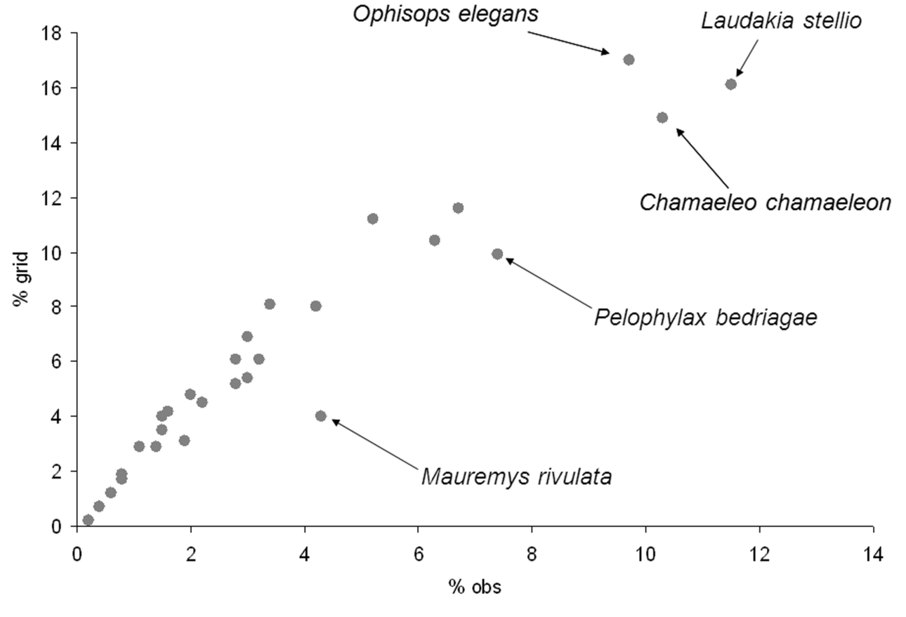

Fig. 2: relation between percentages of observations (% obs) and occupied grid cells (% grid) for 28 herpetological species on the island of Samos.
Abb. 2: Die Beziehung zwischen prozentualer Anzahl der Beobachtungen (% obs) und prozentualer Anzahl der besetzten rasterfelder (% grid) für 28 herpetologische Arten auf der insel Samos.

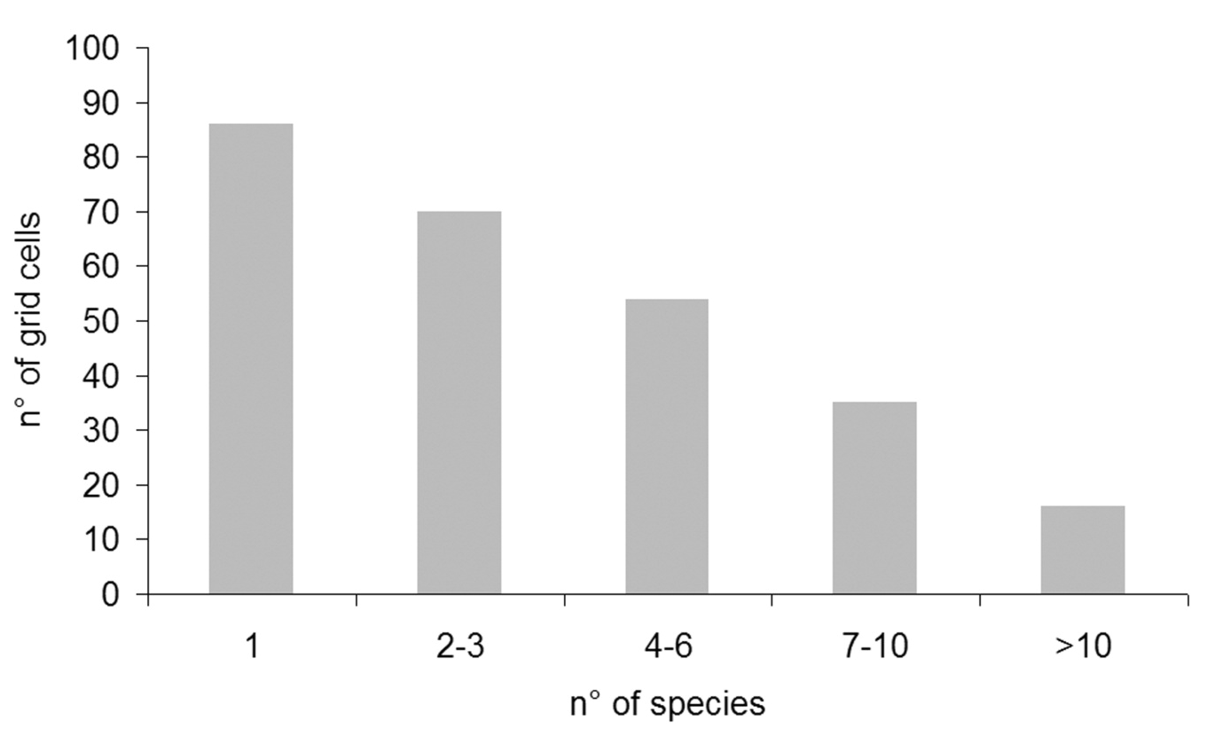

Fig. 3: Frequency distribution of specific grid occupancy rates (number of grid cells by number of herpetological species).
Abb. 3: Häufigkeitsverteilung der Belegungsdichten der rasterzellen mit unterschiedlichen Artenzahlen (Anzahl von rasterzellen bezogen auf die Anzahl der herpetologischen Arten).

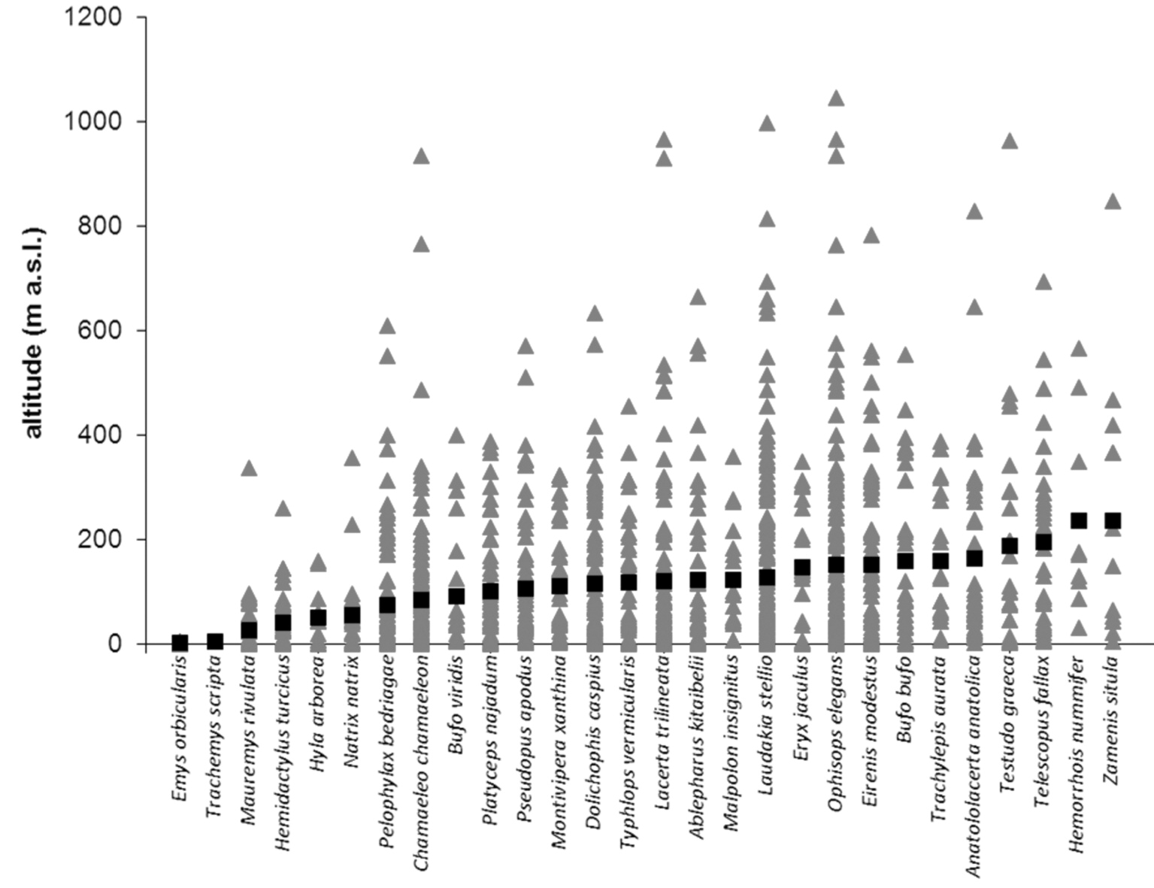

Fig. 4: Altitudinal distribution of the amphibian and reptile species records (n = 1019 grid cells) on the island of Samos. Triangles indicate individual data points, squares are species means.
Abb. 4: Höhenverteilung der Amphibien- und reptiliennachweise (n = 1019 rasterfelder) auf der insel Samos.
Dreiecke kennzeichnen einzelne Fundpunkte, Quadrate zeigen den Durchschnittswert pro Spezies an.

Museum specimens: nHMAS 27-28, 4103, nHMW 27904, 27905, 30980:1-65.
Bibliographic data: BoeTTGer (1888), Werner (1938), ioAnniDeS et al. (1994),
ioAnniDeS & DiMAKi (1996), ClArK (2000),
CATTAneo (2003).
Bufo viridis
(lAurenTi, 1768) (Fig. 5)

only 22 records, or 1.4 % of the data, relate to this species. These fall within 17 grid cells (2.6 % of entire grid). While this rather xerophilic species is adapted to more temporal, shallow and even brackish waters as breeding grounds than the previous species, and consequentially occurs on many of the bigger Greek islands (VAlAKoS et al. 2008), other above raised hypotheses might
apply here as well. Sightings are relatively uncommon and seem to display some bias to the more intensively sampled south-eastern parts of Samos, coinciding with a mean alti- tude of observation (92 ± 25 m) which is lower than in B. bufo. Although the rather small number of observations for this species may be misleading, its detectability may be higher in spring – while only 14 % of all available data was collected in April, 32 % of the records of this species were col- lected during that same month. The species may be recorded more efficiently earlier in the year.
remarks: STöCK et al. (2006) pro- posed to split Bufo viridis into a number of different species, of which Bufo variabilis (PAllAS, 1769) would be the taxon inhabit- ing Samos. However, as at present this

arrangement is not generally accepted, the authors follow SPeyBroeCK et al. (2010), awaiting further support for the species rank of B. variabilis and maintaining the use of the genus name Bufo.
Museum specimens: MCZ A-19372, nHMAS 4106, nHMW 30818, 30991.
Bibliographic data: Werner (1933), ioAnniDeS et al. (1994), ioAnniDeS & Di- MAKi (1996), CATTAneo (2003).
Hyla arborea
BeDriAGA, 1890 (Fig. 5)

only the larger, more humid Greek islands are inhabited by this species (VAlA- KoS et al. 2008). recorded for the first time as late as the first half of the 1990s (ioAn- niDeS et al. 1994; ioAnniDeS & DiMAKi 1996 1997), Hyla arborea seems localized and rare on Samos (13 records (0.8 %) relate to the species), in contrast to its widespread and abundant nature in many other parts of the range. As these 13 observations fall within 10 different grid squares (1.5 % of total grid), a possibly relatively large yet localized range of H. arborea seems to be the case, at relatively low altitude: 53 ± 15 m, maximum of 161 m. records appear to be clearly restricted to the south-eastern parts of the island. While this area does indeed provide suitable wetland areas as habitat, it cannot be ruled out that other parts of Samos have been surveyed incom- pletely for this species.
remarks: STöCK et al. (2008, 2011 and 2012) assigned the tree frogs of the area in which Samos is located (including sam- ples from the Anatolian mainland as well as lesbos island) to Hyla orientalis BeDriAGA, 1890. As taxonomical discussion is clearly not in the scope of the present paper, the Samos populations were conservatively as- signed to H. arborea.
Bibliographic data: ioAnniDeS et al. (1994), ioAnniDeS & DiMAKi (1996, 1997).
Pelophylax bedriagae
(CAMerAno, 1882) (Fig. 5)

While generally restricted to the water sources of the island, this species was easily spotted, and thus commonly encountered, with 117 records (7.4 % of collected data)
belonging to it. These fall within 57 grid cells (8.8 % of the entire grid), indicating a rather high number of observations per grid cell. in contrast to the other amphibians of Samos, this species displayed a fairly regu- lar presence and abundance. Most records are from sites at relatively low altitude (76 ± 10 m, maximum of 610 m).
remarks: The validity of this species is under debate. HoTZ et al. (2013) suggest- ed Pelophylax bedriagae possibly should be treated as a synonym of Pelophylax ridibun- dus while other authors like BÜlBÜl et al. (2011) confirmed the validity of the species based on analyses of mtDnA sequences.
Museum specimens: AMnH 37088, nHMW 30817:1-4, 30990:1-7.
Bibliographic data: BoeTTGer (1888), CAlABreSi (1923), Werner (1938), Bol
(1992), ioAnniDeS et al. (1994), ioAnniDeS
& DiMAKi (1996), ClArK (2000), CATTAneo
(2003).

r e P T i l e S
Testudo graeca
linnAeuS, 1758 (Fig. 5)

From the authors’ experience in other parts of Greece and Turkey in similar habi- tat and comparable seasonal conditions, numbers of this species seem relatively low on Samos: 26 sightings (1.6 % of collected data) were made. These fall within 24 grid cells, corresponding to 3.7 % of the entire grid. A possibly biased image appears, as sightings seem absent from the northwest of Samos. The altitudinal range of this species is rather wide (188 ± 43 m).
Museum specimens: nHMAS 8102. Bibliographic data: Werner (1935),
onDriAS (1968), ioAnniDeS et al. (1994), MÜller (1995), ioAnniDeS & DiMAKi (1996), BroGGi (1997), ClArK (2000), CAT-
TAneo (2003).
Mauremys rivulata
(VAlenCienneS, 1833) (Fig. 5)

This species seems largely restricted to the south-eastern wetland areas of the island. interesting in this regard, is a single record from the north-western coast near

Karlovasi. A relatively high tolerance for elevated levels of salinity and eutrophica- tion make this species fairly abundant with- in suitable habitats. While local populations appear to be safe, the number of records remains limited (68 records, 4.3 % of col- lected data). Furthermore, these fall within 23 grid cells (3.5 % of the entire grid), thus indicating large numbers of observations per grid cell. From the collected data, this is a lowland species (27 ± 6 m).
Museum specimens: nHMC 80.3.15.
101-104, nHMW 33342:1, nrM 6707.
Bibliographic data: Werner (1935, 1938), Bol (1992), ioAnniDeS et al. (1994),
ioAnniDeS & DiMAKi (1996), ClArK (2000),
CATTAneo (2003).
Emys orbicularis
(linnAeuS, 1758) (Fig. 5)

This species is extremely rare on Samos. Seven records were available (0.4
% of collected data), including the first sighting on the island (Meyer & FriTZ 1996), which is the only previously pub- lished record. The other records refer to two additional coastal sites (4 ± 1 m). The ob- servations fall within 4 grid cells, corre- sponding to 0.6 % of the entire grid. Since numbers of this species are reported by our observers as well as ClArK (2000) to be ex- tremely low, the conservation of the species on Samos deserves attention. occurrence of the species in the adjacent part of Turkey is also restriced (eiSelT & SPiTZenBerGer 1967).
Museum specimens: GnHM 4104, nHMAS 4104.
Bibliographic data: Meyer & FriTZ (1996), ClArK (2000).
Trachemys scripta
(SCHoePFF, 1792) (Fig. 5)

Three records of this alien species, subspecies elegans (WieD, 1838), at a sin- gle site are available to the authors. As this site is also inhabited by Mauremys rivulata and close to one of the very few sites of Emys orbicularis, eradication of this poten- tially harmful species (e.g., CADi & Joly 2004; Polo-CAViA et al. 2011) may be con- sidered.
Laudakia stellio
(linnAeuS, 1758) (Fig. 6)

This most commonly recorded lizard, accounting for 11.5 % of all collected data (182 records) and inhabiting the ample exposed, rocky habitats on the island, was indeed one of the most conspicuous, wide- spread and abundant species. observations fell within 93 grid cells (14.4 % of entire grid), which indicates a rather high number of observations per grid cell. Altitudinal distribution was concentrated at 128 ±13 m, with the maximum altitude recorded as high as at 999 m.
remarks: in the collection of the Muséum national d’Histoire naturelle (Paris) there is a stuffed specimen (MnHn 7494) of Stellio vulgaris collected by Admiral Jules DuMonT D’urVille (1790- 1842) (ivan ineiCH in litteris, 2013). it was probably collected during the hydrographi- cal survey (1819-1820) of the Aegean Sea by the ship Chevrette (GoePP & CorDier 1877), thus this specimen represents the oldest museum sample from Samos, appar- ently predating the oldest available pub- lished record (BoeTTGer 1888).
BAiG et al. (2012) proposed the assign- ment of this species to the genus Stell- agama. As evidence of the alleged para- phyly of the genus Laudakia sensu lato is limited (MACey et al. 2000), the authors refrain from the use of the new name.
Museum specimens: GnHM 5092, 7081, MCZ r-37019, MnHn 7494, MSnF
727, 13691-92, nHMAS 23-24, 4107,
70011, nHMW 7297, 27584, 30820:1-2,
30989:4, 33040:2, 35403:12-14, yPM
Herr 005835.
Bibliographic data: BoeTTGer (1888), CAlABreSi (1923), Werner (1933), onDri- AS (1968), Bol (1992), ioAnniDeS et al. (1994), ioAnniDeS & DiMAKi (1996), ClArK
(2000), CATTAneo (2003).
Chamaeleo chamaeleon
(linnAeuS, 1758) (Fig. 6)

As its current status on the islands of Chios and Crete needs further investigation, Samos currently holds the only stable and confirmed population of this species in Greece (DiMiTroPouloS 1987; VAlAKoS et

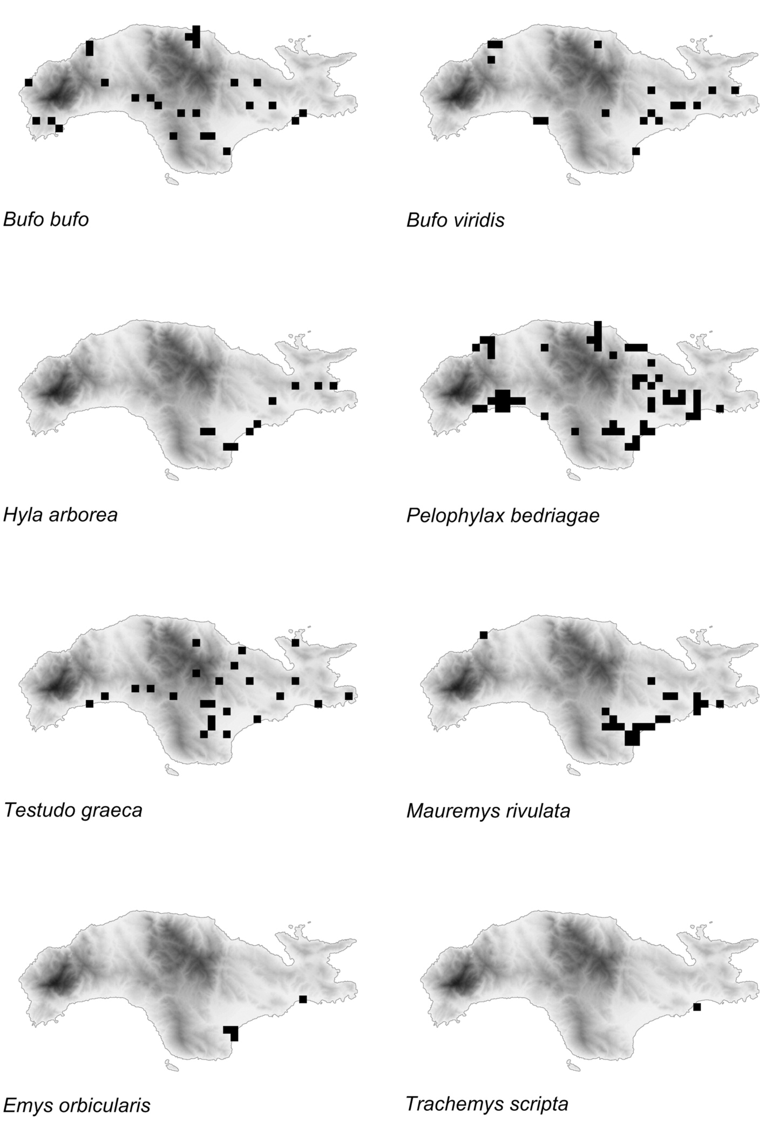

Fig. 5: island of Samos, distribution maps – amphibians, tortoises and terrapins.
Abb. 5: insel Samos, artspezifische Verbreitungskarten – Amphibien, land- und Sumpfschildkröten.

al. 2008). Chameleons are cryptic and easi- ly overlooked, thus often recorded as single individuals only. yet, as part of the present data originated from specific research effort (DiMAKi 2008; DiMAKi et al. 2010), the species takes up 10.3 % of the data (162 observations). These fall within 86 grid cells, corresponding to 13.3 % of the entire grid. While also recorded in many places in the interior of the island, most sightings were made in or near wetlands fairly close to the coast, in concordance with the pres- ence of water, soft substrate (for nesting) and warmer habitats. its altitudinal range is accordingly (84 m ± 10 m). While only 10
% of the entire dataset stemmed from August, 47 % of the observations of this species were made in that month. Although a certain bias originated from the nature of species-specific data collection, this seems to indicate that this species is one of the few more readily encountered during warmer months. This is related to mating and breed- ing activities making adults (especially males but also ground-dwelling, nesting females in autumn) more conspicuous, while in September, hatchlings add to the population density (e.g., BonS & BonS 1960; DíAZ-PAniAGuA et al. 2002; DiMAKi
2008).
Museum specimens: GnHM 1-3, 19-
23, 78-83, 183-200, 268, 358-367, 369-411,
538-539, 541, 4097, 7083, 7094, 8082-8083,
8085, 8087, 8091-8092, 8121, MHnG
2679.95-96, nHMAS 14-17, 7103, 8001,
8003-8009, 9001, 71012, 80010-80012,
80014-80016, 81011, 81014-81015, nHMC
80.3.91.5, 80.3.91.16-18, nHMW 7398,
30987.
Bibliographic data: BoeTTGer (1888), Werner (1930), WeTTSTein (1953), onDri- AS (1968), ioAnniDeS et al. (1994), ioAnni- DeS & DiMAKi (1996), DiMAKi et al. (2000), DiMAKi (2001, 2008), DiMAKi et al. (2010).
Hemidactylus turcicus
(linnAeuS, 1758) (Fig. 6)

Forty-eight observations (3.0 % of the total) were available in the collected data. These fall within 31 grid cells (4.8 % of the entire grid).
Seemingly restricted to coastal loca- tions (41 ± 8 m) in limited parts of the
island, this species’ distribution seems to indicate sampling bias, related to its noctur- nal activity pattern and its presence in human environments (among other places). its actual presence might in reality take up a much more significant portion of the coastal lowlands, including less developed areas.
Museum specimens: nHMAS 8103, nHMW 30995:4-6, MSnF 703.
Bibliographic data: CAlABreSi (1923), Werner (1935), ioAnniDeS et al. (1994), ioAnniDeS & DiMAKi (1996), CATTAneo (2003).
Anatololacerta anatolica
(Werner, 1902) (Fig. 6)

While from the authors’ experience, seemingly less abundant than the related Anatololacerta oertzeni (Werner, 1904) on other Greek islands like Symi or rhodes, 45 the records (2.8 %) display a fairly wide- spread distribution across the island, in a wide range of rocky, often vegetated habi- tats. The observations fall within 30 grid cells, corresponding to 4.6 % of the entire grid. Samos holds the only Greek popula- tion of this species (VAlAKoS et al. 2008). Vertical distribution seems mainly, but not exclusively, related to medium and lower altitudes (164 ± 27 m).
remarks: BoeTTGer (1888) recorded Lacerta danfordi (GÜnTHer, 1876) among the specimens he studied from Samos. CAlABreSi (1923) omitted to take the for- mer paper into account, and assigned the 14 specimens collected by J. C. F. MAJor to Lacerta muralis lAur. var. erhardi BeDr., a taxon at the time known from Seriphos island (e.g., SCHreiBer 1912).
Museum specimens: nHMW 30981: 1-6, MSnF 745 e 18021-32.
Bibliographic data: BoeTTGer (1888), CAlABreSi (1923), Bol (1992), ioAnniDeS et al. (1994), ioAnniDeS & DiMAKi (1996), CATTAneo (2003).
Lacerta trilineata
BeDriAGA, 1886 (Fig. 6)

With 100 records (6.3 %) and 60 occu- pied grid cells (9.3 %), this species is fairly frequently sighted and widespread. While 36 % of all data was collected in May and

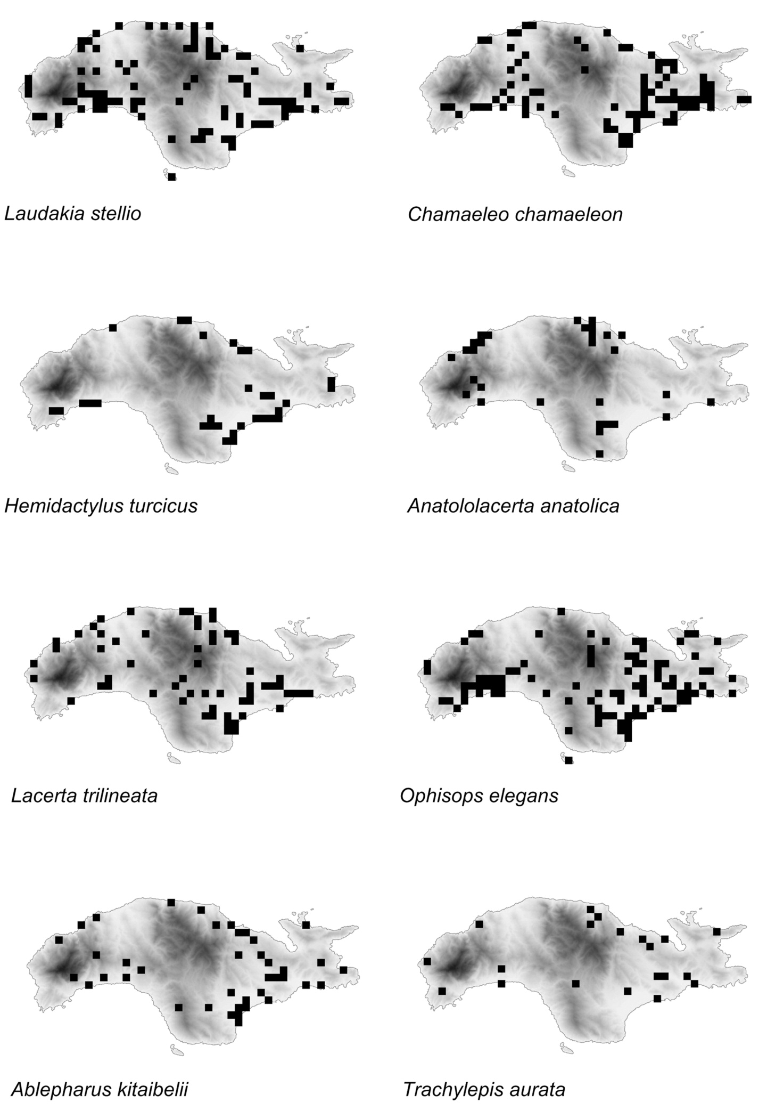

Fig. 6: island of Samos, distribution maps – lizards except Pseudopus apodus.
Abb. 6: insel Samos, artspezifische Verbreitungskarten – echsen außer Pseudopus apodus.

June, as much as 54 % of the observations of this species were made in these months, indicating a spring activity peak. Alti- tudinal range is fairly wide (122 ± 18 m, from 2 to 968 m).
Museum specimens: nHMAS 18, 7104,
nHMC 80.3.60.286, nHMW 30816:1-4,
30988:1-3, nrM 6703.
Bibliographic data: DAAn (1967), Bol (1992), ioAnniDeS et al. (1994), ioAnniDeS
& DiMAKi (1996), ClArK (2000), CATTAneo
(2003).
Ophisops elegans
MénéTrieS, 1832 (Fig. 6)

only Laudakia stellio and (the specif- ically intensively sampled) Chamaeleo chamaeleon were sighted more often than this species (154 site records, 9.7 % of col- lected data). The observations fall within 98 grid cells, corresponding to 15.1 % of the entire grid. As in L. stellio, observational bias of sighting the same species more than once in limited surveyed areas seems to be the case. Laudakia stellio and O. elegans often co-occur in dry and hot environments, the latter being the most common small lac- ertid, and clearly more ground-dwelling than Anatololacerta anatolica. The map for this species shows a broad occurrence throughout the island, albeit with significant gaps, most likely due to lack of sampling. records are most numerous from lower lo- cations (152 ± 15 m), but range as wide as from 0 to 1,047 m a.s.l., the latter represent- ing the highest record throughout the dataset.
Museum specimens: MCZ r-37052, 38505, nHMAS 19, nHMC 80.3.70.120,
80.3.70.350, 80.3.70.351, 80.3.70.352,
80.3.70.421, nHMW 11921:1-2, 30819:1-5,
30967:4, 30985:4-5, yPM Herr 005801.
Bibliographic data: BoeTTGer (1888), Werner (1902, 1933), Cyrén (1941), Bol
(1992), ioAnniDeS et al. (1994), ioAnniDeS
& DiMAKi (1996), ClArK (2000), CATTAneo
(2003).

Ablepharus kitaibelii BiBron & Bory De SAinT-VinCenT, 1833 (Fig. 6)

This species, while observed less fre- quently (47 records, 3.0 %), showed a dis-
tribution pattern similar to that of the most widespread taxa Ophisops elegans and Laudakia stellio. This rather indicates sam- pling bias than actual presence and is most likely due to its inconspicuous and rather secretive nature. The observations fall with- in 40 grid cells, corresponding to 6.2 % of the entire grid (altitudinal range: 123 ± 24 m). remarkably, 40 % of the records were collected in April, whereas only 14 % of the entire dataset originated from that month.
Museum specimens: MSnF 864, 12763-77, nHMC 80.3.82.54, nHMW
30993:1-2.
Bibliographic data: CAlABreSi (1923), Werner (1930, 1935, 1938), ioAnniDeS et
al. (1994), ioAnniDeS & DiMAKi (1996),
ClArK (2000), CATTAneo (2003).
Trachylepis aurata
(linnAeuS, 1758) (Fig. 6)

While records of this species are scat- tered, it is recorded infrequently (23 rec- ords, 1.5 %; 20 grid cells, 3.1 %; altitudinal range: 160 ± 27 m) and is unclear to which extent this is due to its secretive habits, actu- al rareness or other factors. While 26 % of all data was collected in May, 35 % of observations of this species were made in that month, possibly suggesting a spring activity peak.
Museum specimens: GnHM 7096, nHMAS 80017.
Bibliographic data: BeuTler (1979), Bol (1992), ioAnniDeS et al. (1994), ioAn- niDeS & DiMAKi (1996), CATTAneo (2003).
Pseudopus apodus
(PAllAS, 1775) (Fig. 7)
Commonly recorded (66 records, 4.2
%; 46 grid cells, 7.1 %; altitudinal range: 107 ± 16 m), the map of this species high- lights most likely sampling intensity rather than actual presence. Personal experience suggests abundance values similar as in places outside Samos. While 26 % of all data was collected in May, as much as 48 % of observations of this species were made in that month, indicating a spring activity peak. Museum specimens: GnHM 5091, nHMAS 29, 5004, nHMW 30962:1-2,
30998.

Bibliographic data: Werner (1933), Bol (1992), ioAnniDeS et al. (1994), ioAn- niDeS & DiMAKi (1996), CATTAneo (2003).
Typhlops vermicularis
MerreM, 1820 (Fig. 7)

While bias may exist due to the fact that finding this species requires turning stones and other cover objects, this is a com- monly recorded snake species (44 records,
2.8 % of data; 35 grid cells, 5.4 % of entire grid; altitudinal range: 119 ± 18 m), occur- ring throughout the island. While its fosso- rial habits and apparent seasonal behavior (including aestivation or deeper under- ground activity) make this species hard to encounter during summer or autumn, spring sightings are rather common. As much as 89 % of records relate to observations in April or May, while these months together hold only 40 % of the entire dataset.
remarks: local folklore seemed to incorrectly attribute a venomous character to this species, as Franz Werner (1932), fifty years before the first scientific record about the presence of a viperid snake on Samos wrote: “Das angebliche Vorkommen von Giftschlangen auf Samos bezieht sich nicht auf Vipern, sondern auf den allgemein sehr ge- fürchteten Typhlops vermicularis” [The al- leged occurrence of venomous snakes on Sa- mos does not relate to vipers, but to the in gen- eral greatly feared Typhlops vermicularis].
Museum specimens: GnHM 7992, nHMW 15419:4 (collected 1901), 30972:1-
7, 30997:3-7.
Bibliographic data: BoeTTGer (1888), Werner (1902, 1930), BureSCH & ZonKoV
(1934), Werner (1938), ioAnniDeS et al.
(1994), ioAnniDeS & DiMAKi (1996),
CATTAneo (2003).
Eryx jaculus
(linnAeuS, 1758) (Fig. 7)

With first records as recent as 1988 and 1989 (Bol 1992; ioAnniDeS et al. 1994), this was one of the more infrequent- ly recorded species on Samos (24 records,
1.5 % of data; altitudinal range: 148 ± 25 m). interestingly, nearly all records fell in different grid cells, 23 of which are occu- pied (3.5 %). Being a secretive burrowing
snake, the rather limited data availability was not in contrast to what is known for other Greek islands (e.g., TóTH et al. 2002; rAZZeTTi et al. 2006). The data did not allow clear identification of patterns. Most of the individuals have been observed on the inner side of coastal lagoons or at the border of cultivated areas, as loose soils are usual- ly preferred by this species.
Museum specimens: GnHM 6, nHMAS 7106, 7109, 50013.
Bibliographic data: Bol (1992), ioAn- niDeS et al. (1994), ioAnniDeS & DiMAKi (1996), ClArK (2000), CATTAneo (2003).
Malpolon insignitus
(GeoFFroy SAinT-HilAire, 1827)
(Fig. 7)

eighteen records (1.1 %) were avail- able to this study, which fall in 17 different grid cells (2.6 % of entire grid), suggesting widespread occurrence, albeit concentrated in the eastern parts of the island. The few records mainly originated from low-lying areas (altitudinal range: 125 ± 24 m). As the species of this genus are known as oppor- tunistic and often abundant snakes, being able to thrive in anthropogenic environ- ments (e.g., PleGueZueloS 2003), its appar- ent absence from much of the island could be related to competition with sympatric Dolichophis caspius (GMelin, 1789), as both species are large diurnal, mostly terres- trial snakes (ArnolD & oVenDen 2002). Since island ecological networks are simpli- fied, with species broadening their niche, competition can be particularly strong (e.g., liSTer 1976; CASe & BolGer 1991; Bo- BACK 2003). Published sightings are limit- ed: ioAnniDeS et al. (1994) found a dead specimen near Karlovasi and an additional specimen near Mytilini, while CATTAneo (2003) found two specimens near Maratho- kampos. From the latter locality, one ani- mal was also collected in 1979 by H. MAliCKy and donated to the nHMW (27588). The 18 presently evaluated data add strongly to the available records. note- worthy is that 14 of these relate to animals found as traffic victims.
Museum specimens: GnHM 36-38, 10971, nHMAS 4109, 5009, 7009, 50010,
nHMW 27588.

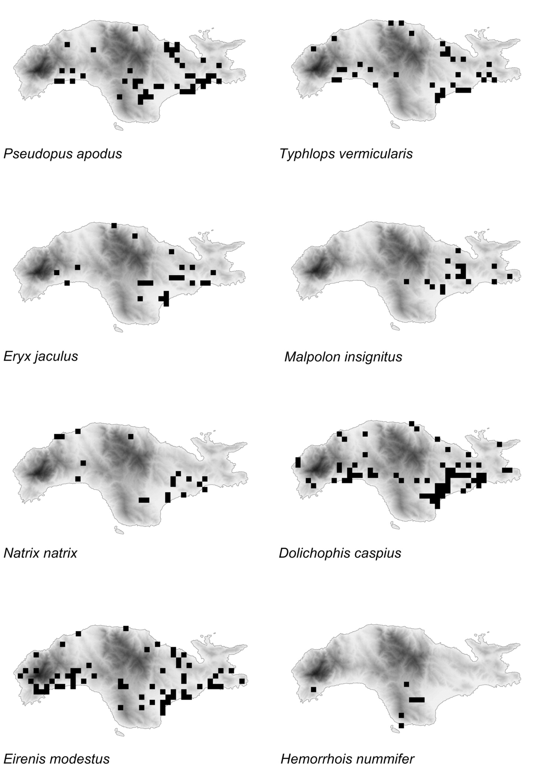

Fig. 7: island of Samos, distribution maps – snakes part 1 and Pseudopus apodus.
Abb. 7: insel Samos, artspezifische Verbreitungskarten – Schlangen Teil 1 und Pseudopus apodus.

Bibliographic data: ioAnniDeS et al. (1994), ioAnniDeS & DiMAKi (1996), CATTA-
neo (2003).
Natrix natrix
(linnAeuS, 1758) (Fig. 7)

As amphibians often build up a signif- icant portion of its diet, this snake is usually (but not always) recorded near water. Natrix natrix is among the most readily recorded species in other parts of Greece and Turkey (e.g., VAlAKoS et al. 2004), yet on other islands the species appears to be rare and localized (e.g., Cyprus - BAier et al. 2009). records for Samos seem rather infrequent from the data processed (30 records, 1.9 %; 18 grid cells, 2.8 %). observation sites are mainly located in the southeast of the island, which might be related to a relatively higher sampling effort in that area, as well as a locally higher avail- ability of suitable habitat. As to be expect- ed from multiple records near low-lying wetlands and other water sources, the col- lected data for this species is mainly restrict- ed to low elevations (55 ± 13 m).
Museum specimens: GnHM 7082, 7084, nHMAS 5003, 7005, nHMC
80.3.34.7.
Bibliographic data: Werner (1933), ClArK (1968), Bol (1992), ioAnniDeS et al. (1994), ioAnniDeS & DiMAKi (1996), ClArK
(2000), CATTAneo (2003).
Dolichophis caspius
(GMelin, 1789) (Fig. 7)

This is the most often recorded snake species in the dataset analyzed (106 records,
6.7 %; 67 grid cells, 10.3 %), in concor- dance with the authors’ experience from other parts of southeast europe, including Greece, Bulgaria, Montenegro and romania (SPeyBroeCK, unpublished data). it occurs throughout the island. This species is fre- quently recorded as a traffic victim, with 62 records relating to such findings. Altitud- inal data points towards low elevations (117
± 13 m).
Museum specimens: GnHM 7, 33-34,
39, 4943, 5002, 6941, 6984-6985, 7001,
7095, 7994, 8084, 70014, MCZ r-37003,
nHMAS 22, 5001, 5006, 5008, 5101, 6001,
7007, 7107, 8101, 41010-41011, 41013,
50011, 50018, 50020, 70014, 71011, nHMC
80.3.117.25, nrM 6702.
Bibliographic data: Werner (1933), BureSCH & ZonKoV (1934), ClArK (1968,
2000), SCHÄTTi (1988), Bol (1992), ioAnni-
DeS et al. (1994), ioAnniDeS & DiMAKi (1996), CATTAneo (2003).
Eirenis modestus
(MArTin, 1838) (Fig. 7)

This was, from the data analyzed, the second most recorded and widespread snake species (82 records, 5.2 %; 65 grid cells,
10.0 %), mirroring its mainland abundance (e.g. FrAnZen et al. 2008). The species seems to display a rather wide altitudinal range (153 ± 18 m).
remarks: From the “Samos region”, WeTTSTein (1937) described Contia modes- ta werneri from Alazonisi on Fourni island. This taxon was later considered invalid by BArAn (1976).
Museum specimens: GnHM 8, 4942,
6942, 7993, MCZ r-37005-37006,
nHMAS 21, 25, 5102, 7002, 7101-7102,
7108, 8002, 50015, 50019, 70010, 70013,
80013, nHMW 30971:1-4, 31000:1-4,
nrM 6705, 6706, 6708, yPM Herr
005751.
Bibliographic data: BoeTTGer (1888), CAlABreSi (1923), Werner (1902, 1933),
ClArK (1968), Bol (1992), ioAnniDeS et al. (1994), ioAnniDeS & DiMAKi (1996),
CATTAneo (2003).
Hemorrhois nummifer
(reuSS, 1834) (Figs. 7, 8)

The present data includes what is most likely the first record of this species on the island, made available by Andreas Meyer and dating back to 1996. Also for the east Aegean islands of lesbos (HoFSTrA 2008), Samothraki and Chios (STrACHiniS & lyM- BerAKiS 2013), this species represents a recent addition to the known fauna.
on some islands, this species could be difficult to detect, as according to SCHÄTTi
& SiGG (1989), from Cypriot data, H. num- mifer has reclusive habits, even though it can be locally abundant.
observers suggested that this species might be easier to record in autumn than in

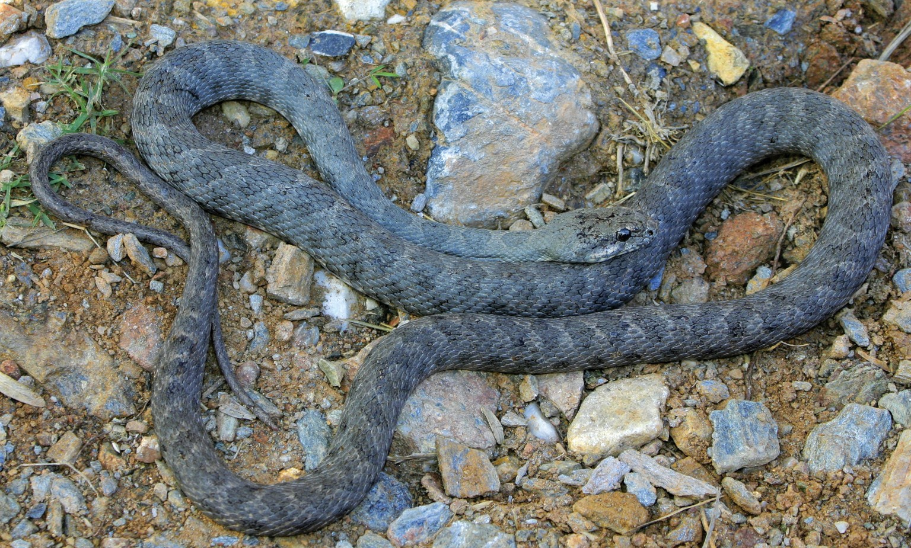

Fig. 8: Hemorrhois nummifer (reuSS, 1834), from Samos, found and photographed by first author (JS), autumn 2009.
Abb. 8: Hemorrhois nummifer (reuSS, 1834) von Samos, gefunden und fotografiert vom erstautor (JS), Herbst 2009.

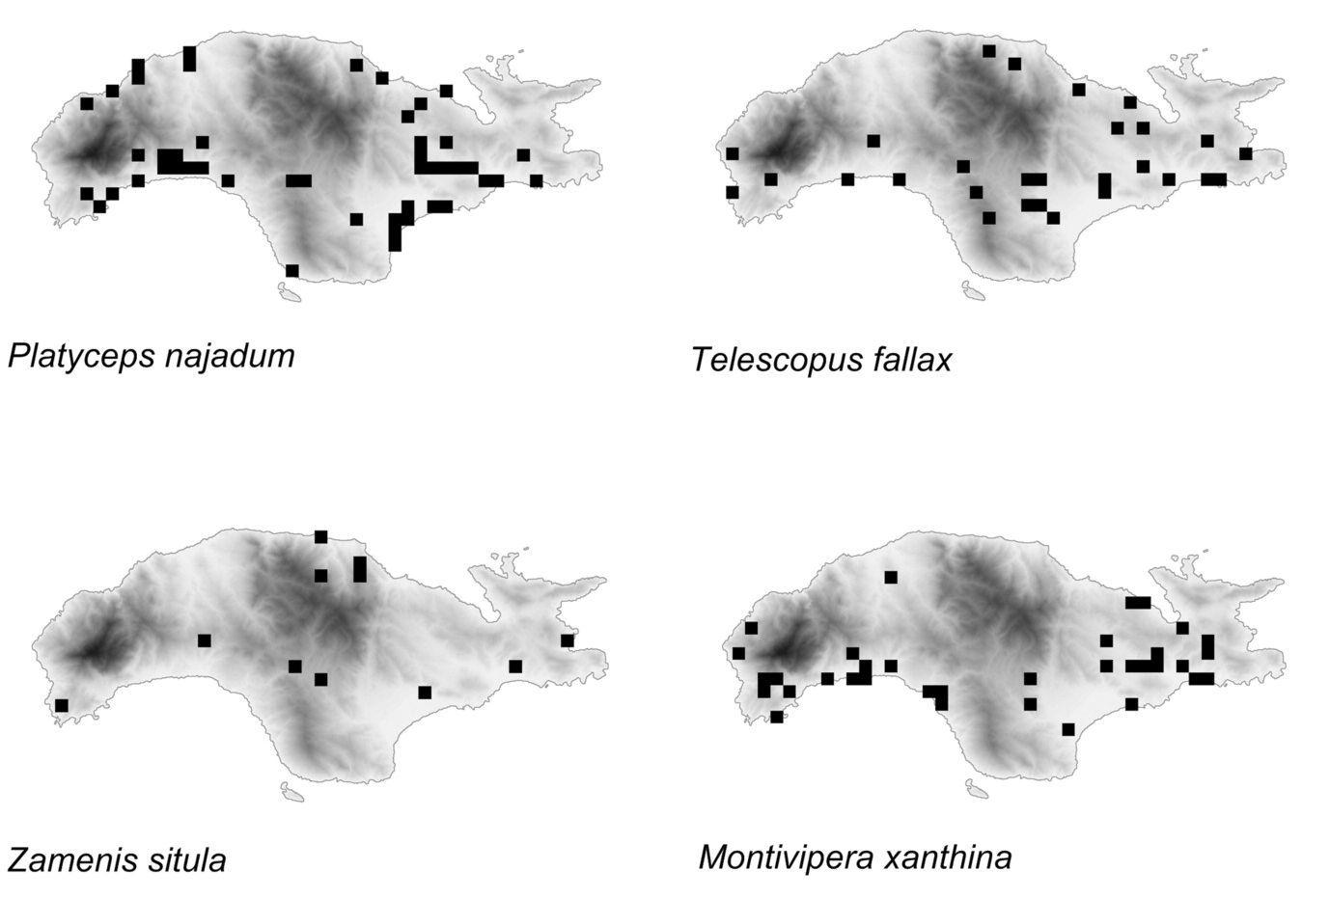

Fig. 9: island of Samos, distribution maps – snakes part 2.
Abb. 9: insel Samos, artspezifische Verbreitungskarten – Schlangen Teil 2.

spring, whereas herpetofauna searches often focus on the spring months April and May. in this regard, it deserves mentioning that five (55 %) of the available records (9 records, 0.6 %; 7 grid cells, 1.1 %) stem from autumn observations. This could be related to the dispersion of juveniles. As eight out of nine records originate from the central southern part of the island, a 2011 western observation from near Agia Kiriaki stands out. The limited available data show an average altitude which is, together with that of Zamenis situla (linnAeuS, 1758), the highest among all Samos herpetofauna species (237 ± 63 m).
Platyceps najadum
(eiCHWAlD, 1831) (Fig. 9)

This species is ffrequently encoun- tered (54 records, 3.4 %; 47 grid cells, 7.3
%), displaying a wide distribution in warm, rocky habitats across the island. While 40
% of all data analyzed was collected in April and May, 56 % of observations of this species were made in those months, sug- gesting a spring activity peak. The limited available data point to a relatively low (to medium) altitudinal distribution (103 ± 15 m).
Museum specimens: GnHM 9118, nHMAS 26, 5007, 7105, 50014, nHMW
30968, 30999:3.
Bibliographic data: DAAn (1967), Bol (1992), ioAnniDeS et al. (1994), ioAnniDeS
& DiMAKi (1996), ClArK (2000), CATTAneo
(2003).
Telescopus fallax
(FleiSCHMAnn, 1831) (Fig. 9)

Since this species is nocturnal and secretive, the number of 32 records (2.0 %; 28 grid cells, 4.3 %) is in fact relatively high, in relation to species which are usual- ly encountered much more frequently else- where, like N. natrix and M. insignitus. Available records occur across most of the island. As such, this species is possibly not particularly rare on Samos. The fact that it is often recorded as traffic victim, with 21 records relating to such findings, is also exemplified by its recent first time discov- ery for Chios by one of the authors
(KirCHner 2009). Altitudinal distribution seems relatively wide (195 ± 31 m, from 8 to 695 m a.s.l).
Museum specimens: GnHM 40, 4941, 9091, nHMAS 5002, 41012, 50016-
50017, 81012, nHMC 80.3.38.36, nHMW
30969.
Bibliographic data: DAAn (1967), ioAnniDeS et al. (1994), ioAnniDeS & Di- MAKi (1996).
Zamenis situla
(linnAeuS, 1758) (Fig. 9)

This species, known as secretive, is generally observed in relatively low abun- dances (VAlAKoS et al. 2008). Thus, the number of 13 records (0.8 %; 11 grid cells,
1.7 %) was not particularly low in relation to those of other snake species. Available records occur across most of the island. As such, Z. situla is possibly not particularly rare on Samos. While 14 % of all processed records originated from April, 31 % of the
Z. situla records fell in that same month, suggesting some seasonality in the chance to observe this species. This species was, together with Hemorrhois nummifer, found at the highest mean elevation (237 ± 69 m). Museum specimens: GnHM 6983,
nHMAS 20, 7001, nHMC 80.3.30.39.
Bibliographic data: Werner (1933), BureSCH & ZonKoV (1934), ioAnniDeS et al. (1994), ioAnniDeS & DiMAKi (1996),
CATTAneo (2003).
Montivipera xanthina
(GrAy, 1849) (Fig. 9)

Directed searching by one of the authors (MD) may have added some bias to the dataset processed (51 records, 3.2 %; 35 grid cells, 5.4 %), as, from the rest of the data, this species appeared infrequently sighted. This might, in part, explain its rather recent first reference (nilSon & AnDrén 1986; TieDeMAnn & GrilliTSCH 1986; VAn WinGerDe 1986; yet, ClArK 1989 refers to a 1984 sighting of the species near Marathokampos). Montivipera xanthi- na is frequently recorded as traffic victim, with 34 records relating to such findings. Despite geographically biased sampling, the species seems to be more frequently

encountered in the southern half of the island, mainly at relatively low elevation (111 ± 14 m).
Museum specimens: GnHM 4096, 6986, 8081, 9942, nHMAS 7003-7004,
7006, 7008, 8104, nHMW 27587, 30963.
Bibliographic data: VAn WinGerDe (1986), nilSon & AnDrén (1986), TieDe-
MAnn & GrilliTSCH (1986), ClArK (1989),
ioAnniDeS et al. (1994), ioAnniDeS & DiMA-
Ki (1996), ClArK (2000), CATTAneo (2003).

The high herpetofauna diversity ob- served on Samos is largely the result of the complex paleogeography and geological history of the island, and the Aegean region in general, especially during the glaciations (PAniTSA et al. 2010). The sea level changes during late Pleistocene and Holocene are particularly relevant as they exposed a large part of the continental shelf, thus connecting Samos and adjacent islands, including ikaria, Fourni, Patmos, lipsi, Arkoi and Agathonisi, to the Anatolian coast (AKSu et al. 1995; lAMBeCK 1995; FouFoPouloS & iVeS 1999). Since Samos is separated from the Turkish coast by the shallow Mycale Strait (with a maximum depth of less than 20 m) it was probably still connected to the mainland 9,000 years B.P. when the sea level was about 35 m lower than now (AKSu et al. 1995). The herpetofauna of western Turkey and of the entire Anatolian Peninsula is par- ticularly rich because of its geographical location functioning as a bridge or barrier for species dispersal between Asia and europe (SinDACo et al. 2000). Moreover, western Anatolia acted as a refugium during the ice Ages and later allowed the re-colo- nization of northern areas during the inter- glacial periods (HeWiTT 1996). According- ly, these connections promoted the crossing of species from the Anatolian mainland onto Samos, giving the island its ‘Asian charac- ter’ (PAFiliS 2010). The obvious absence of several species to be expected, including Blanus strauchi (BeDriAGA, 1884), Medio- dactylus kotschyi (STeinDACHner, 1870) and Natrix tessellata (lAurenTi, 1768) on Samos, is not self-evident and asks for ex- planation. it may be the result of secondary stochastic events of extinction, as these species occur abundantly on the Anatolian mainland (FrAnZen et al. 2008) and were
easily observed by one of the authors (er) during a short survey. As noted before, the apparent rarity of some species on Samos could be explained by interspecific compe- tition on this island, however, these hypo- theses remain to be verified.
From the three species listed above,
M. kotschyi deserves some additional atten- tion. As described in the introduction, uncertainty with the initial citation of this species from Samos (CAlABreSi 1923), as well as the lack of any subsequent published records, makes its presence in need of con- firmation, if not doubtful. However, three specimens are listed in the catalog of the natural History Museum of Crete (nHMC 80.3.85.1193, 80.3.85.1236, 80.3.85.1237). The animals were collected in 2007 at Psili Ammos in pitfall traps used by Dimitris KAlTSAS in his PhD research on the beetle fauna of Juniperus phoenicea ecosystems in the Aegean region. Both D. KAlTSAS and Petros lyMBerAKiS (who provided the authors with photos of the severely desic- cated specimens) see no logical reason to assume any error in this record. Thus, this might represent the first record in over 80 years of the presence of this species on Samos, if not ever. establishing the absence of a species in a given area is difficult, if not logically impossible, as a lack of observa- tions for a species (even with large series of field data) does not necessarily imply its absence (rAZZeTTi & SinDACo 2006). in any case, M. kotschyi is at best rare and localized on the island, although suitable habitat seems amply available. yet, local- ized and poorly recorded populations of M. kotschyi also exist on the large and variably- structured island of Crete (Petros lyMBe- rAKiS, in litt.). Conclusively, the authors consider the presence of Mediodactylus kotschyi on Samos in continued need of confirmation.
The species cited by BoeTTGer (1888) include those that were most common in the authors’ dataset. While this data is certain- ly imperfect for scientific evaluation of abundance, several species appear to be scarcer and less widespread on Samos than in many other parts of their range. regard- ing conservation issues it should be stressed that frequent and widespread fires affected large parts of the island during the last

decades. in 1983, 2,000 ha of forest (ca. 4.2
% of the island’s surface) were burned, the 2000 fire burned about one third of the island (eDenFelD et al. 2000; KAlABoKiDiS et al. 2008; Dimaki 2008), and an addition- al major fire hit the island in 2010. ob- viously, these frequent and repeated fires are of particular, and potentially damaging effect to less mobile elements of the fauna including various amphibians and reptiles (Fig. 10) (SAnToS & PoQueT 2010). Tourist industry development seems to represent another threat. As tourism is an important economic factor in Greece, it seems not in- frequently considered prevalent over nature preservation. This is consistently evident in coastal areas. Several coastal and lowland habitats (e.g., wetlands such as marshes and lagoons) are particularly vulnerable. While their flat topography makes them suitable sites for construction of e.g., houses and touristic facilities, their unique natural re- sources often are unrecognized and neglect- ed. This is in line with the conclusions of BroGGi (1994), who highlighted the impor- tance of threatened Greek island biotopes such as mouths of creeks, cisterns and pits and mountain creeks.
As these and other threats impact the herpetofauna of Samos, it is important to stress that many of the island’s amphibian and reptile species are protected under the european Habitat Directive (92/43/Cee). The list of protected species was updated on november 20, 2006, after the accession of romania and Bulgaria to the european union (Council Directive 2006/ 105/eC). Four Samos reptile species are listed in the Annex ii “animal and plant species of com- munity interest whose conservation requires the designation of special areas of conserva- tion”: T. graeca, E. orbicularis, M. rivulata (as Mauremys caspica) and Z. situla (as Elaphe situla). in addition, 20 of the 28 amphibian and reptile species of Samos are listed in Annex iV “animal and plant species of community interest in need of strict pro- tection”: Testudo graeca, Emys orbicularis,
Mauremys rivulata (as Mauremys caspica), Anatololacerta anatolica (as Lacerta dan- fordi), Lacerta trilineata, Ophisops elegans, Ablepharus kitaibelii, Laudakia stellio (as Stellio stellio), Chamaeleo chamaeleon, Pseudopus apodus (as Ophisaurus apodus), Dolichophis caspius (as Coluber caspius), Platyceps najadum (as Coluber najadum), Hemorrhois nummifer (as Coluber num- mifer), Eirenis modestus (as Eirenis modes- ta), Zamenis situla (as Elaphe situla), Telescopus fallax (as Telescopus falax), Macrovipera xanthina (as Vipera xanthina), Eryx jaculus, Bufo viridis and Hyla arborea. Hence, since a large portion of the Samos herpetofauna is listed in one or both Habitat Directive annexes, a clear legal obligation exists to balance human activities against protection and conservation of the diverse herpetofauna of Samos. in particular, this refers to two listed species which appear very rare on the island – Emys orbicularis and Hemorrhois nummifer. eradication of exogenous species like Trachemys scripta should be considered.
Perspectives

This paper is not considered an end- point in data acquisition, therefore, potential contributors to the herpetofauna of Samos are kindly invited to get in touch with Daniel BoHle at < danielbohle@gmx.de >. The authors of this paper are also open to disseminate the collected data (at grid cell level resolution) to any Greek or interna- tional scientific initiative upon simple request.
in summary, the currently known her- petofauna of Samos comprises 28 species, including one that has not been published before (Hemorrhois nummifer). Three addi- tional species (Blanus strauchi, Mediodac- tylus kotschyi and Natrix tessellata), listed elsewhere for the island, require confirma- tion of their presence, until which time they are disregarded as contemporary parts of the herpetofauna of Samos.

ACKnoWleDGMenTS

in order of decreasing number of contributed data records, we are grateful for their contributions to
Stefan Dummermuth, Maarten Gilbert, David Buttle, Arjan van der lugt, Markus Grimm, Thomas reich,

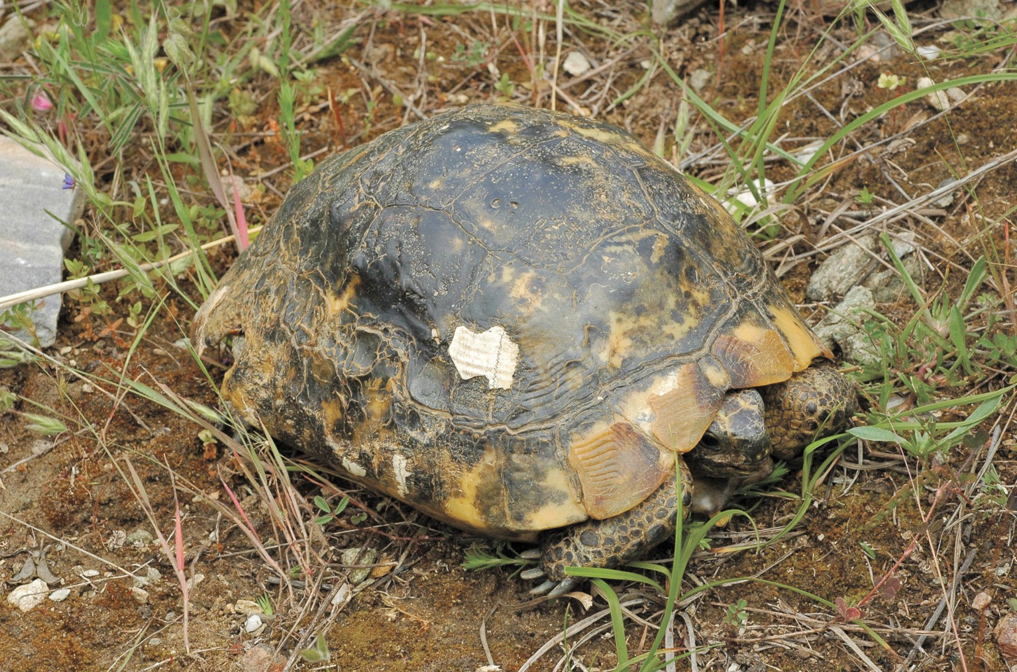

Fig. 10: Testudo graeca linnAeuS, 1758, from Samos with obvious burn marks, photographed by third author (er).
Abb. 10: Testudo graeca linnAeuS, 1758 von Samos mit offensichtlichen Brandverletzungen, fotografiert vom Drittautor (er).

Andreas Meyer, Miloslav Homolka, Peter oefinger, Bobby Bok, nikolai Babiniuk, rainer Kastl, Jon Webster, Melina Baurecht, ronald laan, Michael Glaß, Thomas Athineou, Kristian Munkholm, Ben Verboom, Hero Moorlag, Aaron lutziger, Dieter Fritsch, Peter Molz, Georg Wiesinger, Michael Zeder, Christian Koerner, Johan F. Storm and a limited number of unnamed data providers, as well as to those who joined the authors during their field work activities (to DB: Marita Wenzel; to er: Francesca Baccalini, Massimo Delfino, Anna rita Di Cerbo, roberto Sacchi; to JS and DB: Anniek Aerden, Tekla Boersma, Bobby Bok, Gijs Damen, Gerd Dossche, Peter engelen, Jos lycops, liam russell, ilias Strachinis, lea Sylva, Jan Van Der Voort, leonard Zammit; to MKK: the Grimm family, nicolá lutzmann, Michael Barej, Karin Kirchner and Michael
Havlicek). David Bird, Sergé Bogaerts, Francesca Cat- taneo and Mario Schweiger provided literature.
Curators of several natural History museums provided data about reptile and amphibian specimens in the collections, for which we are particularly grateful to Massimo Capula (MCZ), Andreas Schmitz (MHnG), ivan ineich (MnHn), Annamaria nistri (MSnF), Giu- liano Doria (MSnG), Stefano Scali (MSnM), Franco Andreone (MrSn), Petros lymberakis (nHMC) and Heinz Grillitsch, Silke Schweiger and richard Gemel (nHMW).
Special thanks go to Andreas Meyer for allowing the authors to publish his discovery of Hemorrhois num- mifer in this paper, as well as to Christoph riegler for allowing reference to his discovery of the same species on Chios.

reFerenCeS

AMBroGi, S. (1992): un arabo perugino. Vita e viaggi di orazio Antinori in egitto e nell’etiopia di Menelik; Torino (edizioni rai), pp. 85.
ArnolD, e. n. & oVenDen D. (2002): A field guide to the reptiles and amphibians of Britain and europe; london (Harper Collins Publ. ltd.), pp. 272.
BAier, F. & SPArroW, D. J. & WieDl, H.-J. (2009): The amphibians and reptiles of Cyprus. Frank- furt am Main (edition Chimaira), pp. 364.
BAiG, K. J. & WAGner, P. & AnAnJeVA, n. B.
& BöHMe, W. (2012): A morphology-based taxonom- ic revision of Laudakia GrAy, 1845 (Squamata:

Agamidae).- Vertebrate Zoology, Dresden; 62 (2):
213-260.
BArAn, i. (1976): Türkiye yilanlarinin taksono- mik revizyonu ve coğrafi dağilişlari.- Tübitak yayınları, Ankara; 309 (9): 1-177.
BeuTler, A. (1979): General principles in the distribution of reptiles and amphibians in the Aegean.- Biologia Gallo-Hellenica, Athinai; 8: 337-344.
BeuTler, A. & GruBer, u. (1977): intraspe- zifische untersuchungen an Cyrtodactylus kotschyi (STeinDACHner, 1870): reptilia: Gekkonidae. Beitrag zu einer mathematischen Definition des Begriffs unter- art.- Spixiana, München; 1: 165-202.
BoBACK, S. M. (2003): Body size evolution in snakes: evidence from island populations.- Copeia, Washington; 2003 (1): 81–94.
BoeTTGer, o. (1888): Verzeichniss der von Hrn.
e. von oerTZen aus Griechenland und aus Kleinasien mitgebrachten Batrachier und reptilien.- Sitzungsbe- richte der Königlich Preuβischen Akademie der Wis- senschaften zu Berlin, Berlin; 1888 (1): 139-186.
Bol, S. (1992): De reptielen en amfibieën op Samos.- lacerta, utrecht; 50 (4): 134-139; 50 (5): 162. BonS, J. & BonS, n. (1960): notes sur la repro- duction et le développement de Chamaeleo chamae- leon (l.).- Bulletin de la Société des sciences naturel-
les et physiques du Maroc, rabat, Paris; 40: 323-335. BroGGi, M. (1994): Feldherpetologische Beob-
achtungen und Bemerkungen zu schützenswerten Bio- topen auf griechischen inseln.- Herpetozoa, Wien; 7 (1/2): 29-34.
BroGGi, M. (1997): Zur Verbreitung von Testu- do graeca ibera PAllAS, 1814 auf den inseln der nord- ostägäis und der Dodekanes (Griechenland).- Herpeto- zoa, Wien; 10 (3/4): 153-155.
BÜlBÜl, u. & MATSui M. & KuTruP B. & eTo
K. (2011): Taxonomic relationships among Turkish Water Frogs as revealed by phylogenetic analyses using mtDnA gene sequences.- Zoological Science, Tokyo; 28: 930-936.
BuTTle, D. (1990): The herpetofauna of leros (Dodecanese, S.e. Aegean).- The British Herpeto- logical Bulletin, london; 34: 34-38.
CADi, A. & Joly, P. (2004): impact of the intro- duction of the red-eared slider (Trachemys scripta ele- gans) on survival rates of the european pond turtle (Emys orbicularis).- Biodiversity and Conservation, london; 13 (13): 2511-2518.
CAlABreSi, e. (1923): Anfibi e rettili dell’isola di Samos.- Monitore Zoologico italiano, Siena; 34: 75- 78.
CASe, T. J. & BolGer, D. T. (1991): The role of interspecific competition in the biogeography of island lizards.- Trends in ecology & evolution, Cambridge; 6 (4): 135-139.
CATTAneo, A. (2003): note erpetologiche sulle isole egee di lesvos, Chios e Samos.- Bollettino del Museo Civico di Storia naturale di Venezia, Venezia; 54: 95-116.
CHonDroPouloS, A. (1986): A checklist of the Greek reptiles. i. The lizards.- Amphibia-reptilia, leiden; 7: 217-235.
CHonDroPouloS, A. (1989): A checklist of the Greek reptiles. ii. The snakes.- Herpetozoa, Wien; 2 (1/2): 3-36.
ClArK, r. (1968): A collection of snakes from Greece.- British Journal of Herpetology, london; 4: 45-48.
ClArK, r. (1989): A report on a herpetological trip to n.e. Aegean.- The Herptile, Walsall; 14 (2): 68- 82.
ClArK, r. (2000): The herpetology of Samos island, eastern Aegean Sea, Greece.- The Herptile, Walsall; 25 (4): 172-175.
Cyrén, o. (1941): Beiträge zur Herpetologie der Balkanhalbinsel.- Mitteilungen aus den Königli- chen naturwissenschaftlichen instituten in Sofia, Sofia; 14: 36-146.
DAAn, S. (1967): new record localities of Aegean amphibians and reptiles.- British Journal of Herpetology, london; 3: 312-313.
DíAZ-PAniAGuA, C. & CuADrADo, M. & BláZ- QueZ, M. C. & MATeo, J. A. (2002): reproduction of Chamaeleo chamaeleon under different environmental conditions.- Herpetological Journal, londen; 12: 99-
104.
DiMAKi, M. (2001): The european Chamele- ons.- Chameleon information network, San Diego; 41: 11-13.
DiMAKi, M. (2008): ecology and physiology of the chameleon (Chamaeleo spp.) in Greece. PhD thesis university of Athens, pp. 202.
DiMAKi, M., lyMBerAKiS, P. & MArAGou, P. (2010): reptiles of Greece, threats, the Common Chameleon, the African Chameleon; pp. 180-189 +
193. in: leGAKiS, A. & MArAGou, P. (eds.): red Book of Threatened Animals of Greece; Athens (Greek Zoological Society).
DiMAKi, M. & VAlAKoS, e. D. & leGAKiS, A. (2000): Variation in body temperatures of the African Chameleon Chamaeleo africanus lAurenTi, 1768 and the Common Chameleon Chamaeleo chamaeleon (linnAeuS, 1758).- Belgian Journal of Zoology, Bruxelles; 130 (Supplement 1): 87-91.
DiMiTroPouloS, A. (1987): The distribution and status of the Mediterranean Chameleon – Chamaeleo chamaeleon chamaeleon (linnAeuS, 1758) in Greece.- The Herptile, Walsall; 12 (3): 101-104.
eDenFelD, J. & KATSAroS, G. & reMMerT, M. (2000): Vorstudie zur naturraumgenese nach Wald- bränden. eine anwendungsorientierte Fallstudie für die ägäische insel Samos (Griechenland) – Schaden, Folgen, Maβnamen. institut für Geographie der WWu, Münster, pp. 59.
eiSelT, J. & SPiTZenBerGer, F. (1967): ergeb- nisse zoologischer Sammelreisen in der Türkei: Testu- dines.- Annalen des naturhistorischen Museums in Wien, Wien; 70: 357-378.
FrAnZen, M. & BuSSMAnn, M. & KorDGeS, T.
& THieSMeier, B. (2008): Die Amphibien und repti- lien der Südwest-Türkei; Bielefeld, laurenti, pp. 328.
GoePP, é. & CorDier, e. l. (1877): les grands hommes de la France: navigateurs. 3e edition; Paris (P.
Ducrocq), pp. 385.
HelleniC nATionAl MeTeoroloGiCAl SerViCe (2013): Samos. Document available at < http://www. hnms.gr/hnms/english/climatology/climatology_region
_diagrams_html?dr_city=Samos > [last accessed: oc- tober 22, 2013].
HeWiTT, G. M. (1996): Some genetic conse- quences of ice ages and their role in divergence and speciation.- Biological Journal of the linnean Society, london; 58: 247-276.
HiJMAnS, r. J. & CAMeron, S. & PArrA, J. (2013): WorldClim - Global climate data. Free climate data for ecological modeling and GiS. Data available at

< http://worldclim.org/current > [last accessed: octo- ber 22, 2013].
HoFSTrA, J. (2008): An addition to the herpeto- fauna of the Greek island lesbos.- Pod@rcis, leiden; 9 (1): 2-10.
HoTZ, H. & Beerli, P. & uZZell, T. & Guex, G.-D. & PruVoST, n. B. M. & SCHreiBer, r. & PlöT- ner, J. (2013): Balancing a cline by influx of migrants: a genetic transition in water frogs of eastern Greece.- Journal of Heredity, oxford; 104 (1): 57-71.
ioAnniDeS, y. & DiMAKi, M. & DiMiTroPouloS,
A. (1994): The herpetofauna of Samos (eastern Aegean, Greece).- Annales Musei Goulandris, Athinai; 9: 445-456.
ioAnniDeS, y. & DiMAKi, Μ. (1996): Systematic observations of reptiles of Samos (in Greek).- Samiakes Meletes, Athinai; 2: 443-463.
ioAnniDeS, y. & DiMAKi, M. (1997): A new locality record for Hyla arborea (l., 1758) (Amphibia, Hylidae) on Samos island.- newsletter of the Hellenic Zoological Society, Athinai; 30: 10.
KAlABoKiDiS, K. & ioSiFiDeS, T. & HenDerSon,
M. & MoreHouSe, B. (2008): Wildfire policy and use of science in the context of a socio-ecological system on the Aegean Archipelago.- environmental Science and Policy, exeter; 11: 408-421.
KirCHner, M. (2009): Telescopus fallax (FleiSCHMAnn, 1831) found in the Aegean island of Chios, Greece.- Herpetozoa, Wien; 21 (3/4): 189-190.
liSTer, B. C. (1976): The nature of niche ex- pansion in West indian Anolis lizards i: ecological consequences of reduced competition.- evolution, lawrence; 30 (4): 659-676.
MACey, r. J. & SCHulTe, J. A. & lArSon, A. & AnAnJeVA, n. B. & WAnG, y. & rASTeGAr-PouyAni,
n. & PeTHiyAGoDA, r. & PAPenFuSS, T. J. (2000): evaluating trans-Tethis migration: an example using acrodont lizard phylogenetics.- Systematic Biology, oxford; 49: 233-256.
MAZZoTTi, S. (2011): esploratori perduti: storie dimenticate di naturalisti italiani di fine ottocento; Torine (Codice edizioni), pp. xxxiii + 239.
Meyer, A. & FriTZ, u. (1996): Die europäische Sumpfschildkröte (Emys orbicularis hellenica) auf Samos.- Herpetofauna, Weinstadt; 18 (103): 27.
nilSon, G. & AnDrén, C. (1986): The mountain vipers of the Middle east: The Vipera xanthina com- plex.- Bonner Zoologische Monographien, Bonn; 20: 1-90.
PAFiliS, P. (2010): A brief history of Greek her- petology.- Bonn Zoological Bulletin, Bonn; 57 (2): 329-345.
PleGueZueloS, J. M. (2003): Culebra bastarda
– Malpolon monspessulanus. in: CArrASCAl, l. M. & SAlVADor, A. (eds.): enciclopedia Virtual de los Verte- brados españoles. Museo nacional de Ciencias natura- les, Madrid. Document available at < http:// www. vertebradosibericos.org/ > [last accessed: 22 January 2013].
Polo-CAViA, n. & loPeZ, P. & MArTin, J. (2011): Aggressive interactions during feeding between native and invasive freshwater turtles.- Biological invasions, london; 13 (6): 1387-1396.
rAZZeTTi, e. & BADer, T. & BileK, K. & DelFino, M. & Di CerBo, A. r. & DuDA, M. & Hill,
J. & rATHBAuer, F. & rieGler, C. & SACCHi, r. (2006): A contribution to the knowledge of the her-
petofauna of the Greek island of Corfu; pp. 207-216. in: Societas Herpetologica italica: Atti del V congresso nazionale, Calci (Pisa), 29 settembre-3 ottobre 2004. Firenze (university Press, Firenze).
rAZZeTTi, e. & SinDACo, r. (2006): 8. uncon- firmed taxa or in need of confirmation; pp. 644-653. in: SinDACo, r. & DoriA G. & rAZZeTTi e. & Bernini F. (eds.): Atlante degli anfibi e dei rettili d’italia / Atlas of italian amphibians and reptiles. Firenze (Societas Her- petologica italica, edizioni Polistampa), pp. 792.
SABAJ PéreZ, M. H. (2013): Standard symbolic codes for institutional resource collections in herpetol- ogy and ichthyology: an online reference provided by the American Society of ichthyologists and Herpetolo- gists, Washington, DC. Document available at < http:// www.asih.org/sites/default/files/documents/resources/ symbolic_codes_for_collections_v4.0_sabajperez_ 2013.pdf > [last accessed: 22 January 2013].
SAnToS, x. & PoQueT, J. M. (2010): ecological succession and habitat attributes affect the postfire response of a Mediterranean reptile community.- european Journal of Wildlife research, Berlin; 56 (6): 895-905.
SCHÄTTi, B. (1988): Systematik und evolution der Schlangengattung Hierophis FiTZinGer, 1843 (reptilia, Serpentes). Doctoral thesis, universität Zürich, pp. 50.
SCHÄTTi, B. & SiGG, H. (1989): Die Herpetofau- na der insel Zypern. Teil 2: Schildkröten, echsen und Schlangen.- Herpetofauna, Weindstadt; 11 (62): 17-25. SCHreiBer e., (1912). Herpetologia europaea,
eine systematische Bearbeitung der Amphibien und reptilien welche bisher in europa aufgefunden sind; Jena (Gustav Fischer), pp. x + 960.
SPeyBroeCK, J. & BeuKeMA, W. & CroCHeT, P.-
A. (2010): A tentative species list of the european her- petofauna (Amphibia and reptilia) - an update.- Zoo- taxa, Auckland; 2492: 1-27.
STAMATelAToS, M. & VAMVA-STAMATelATou, F.
(2006): Geographical dictionary of Greece [Γεωγρα- φικό λεξικό της Ελλάδας].- To Vima, Athinai; 5: 27-28. STöCK, M. & DuBey, S. & KlÜTSCH, C. &
liTVinCHuK, S. n. & SCHeiDT, u. & Perrin, n. (2008): Mitochondrial and nuclear phylogeny of circum- Mediterranean tree frogs from the Hyla arborea group.- Molecular Phylogenetics and evolution, San Diego; 49: 1019-1024.
STöCK, M. & DuFreSneS, C. & liTVinCHuK, S.
n. & lyMBerAKiS, P. & BiollAy, S. & BerroneAu, M.
& BorZée, A. & GHAli, K. & oGielSKA, M. & Perrin,
n. (2012): Cryptic diversity among Western Palearctic tree frogs: Postglacial range expansion, range limits, and secondary contacts of three european tree frog lin- eages (Hyla arborea group).- Molecular Phylogenetics and evolution, San Diego; 65: 1-9.
STöCK, M. & Horn, A. & GroSSen, C. & linDTKe, D. & SerMier, r. & BeTTo-ColliArD, C. & DuFreSneS, C. & BonJour, e. & DuMAS, Z. & luQueT,
e. & MADDAlenA, T. & ClAVero SouSA, H. & MAr- TineZ-SolAno, i. & Perrin, n. (2011): ever-young sex chromosomes in european Tree Frogs.- PloS Biology, lawrence; 9: e1001062.
STöCK, M. & MoriTZ, C. & HiCKerSon, M. & FrynTA, D. & DuJSeBAyeVA, T. & ereMCHenKo, V. & MACey, J. r. & PAPenFuSS, T. J. & WAKe, D. B. (2006):
evolution of mitochondrial relationships and bio- geography of Palearctic green toads (Bufo viridis sub-

group) with insights in their genomic plasticity.- Molecular Phylogenetics and evolution, San Diego; 41: 663-689.
TieDeMAnn, F. & GrilliTSCH, H. (1986): Zur Verbreitung von Vipera xanthina (GrAy, 1849) in Grie- chenland.- Salamandra, rheinbach; 22: 272-275.
TóTH, T. & KreCSáK, l. & MADSen, T. & ÚJVári, B. (2002): Herpetofaunal locality records on the Greek islands of Corfu (Amphibia, reptilia).- Herpetozoa, Wien; 15 (3/4): 149-169.
VAlAKoS, S. D. & DiMAKi, M. & PAFiliS, P.
(2004): natural history of lesvos: 1. reptiles and am- phibians; Mytilene (aei-editions for the natural History Collection of Vrissas of the national and Kapodistrian university of Athens), pp. 128.
VAlAKoS, e. D. & PAFiliS, P. & SoTiroPouloS,
K. & lyMBerAKiS, P. & MArAGou, P. & FouFoPouloS,
J. (2008): The amphibians and reptiles of Greece; Frankfurt am Main (edition Chimaira)[Frankfurt Contributions to natural History, Vol. 32], pp. 463.
VAn WinGerDe, J. (1986): The distribution of Vipera xanthina (GrAy, 1849) on the east Aegean islands and in Thrace.- litteratura Serpentium, Asten; 6: 131-139.
Werner, F. (1902): Die reptilien- und Amphi- bienfauna von Kleinasien.- Sitzungsberichte der kai-
serlichen Akademie der Wissenschaften (mathema- tisch-naturwissenschaftliche Klasse, Abt. 1), Wien; 111: 1057-1120.
Werner, F. (1930): Contribution to the knowl- edge of the reptiles and amphibians of Greece, espe- cially the Aegean islands.- occasional Papers of the Museum of Zoology, university of Michigan, Ann Arbor; 211: 1-46.
Werner, F. (1933): ergebnisse einer zoologi- schen Studien- und Sammelreise nach den inseln des Ägäischen Meeres. i. reptilien und Amphibien.- Sitzungsberichte der kaiserlichen Akademie der Wissenschaften (mathematisch-naturwissenschaftliche Klasse, Abt. 1), Wien; 142: 103-133.
Werner, F. (1935): reptilien der Agäischen inseln.- Sitzungsberichte der kaiserlichen Akademie der Wissenschaften (mathematisch-naturwissenschaft- liche Klasse, Abt. 1), Wien; 144 (l-2): 81-117.
Werner, F. (1938). Die Amphibien und rep- tilien Griechenlands.- Zoologica, Stuttgart; 35: 1-117.
WeTTSTein, o. v. (1937): Vierzehn neue repti- lienrassen von den südlichen Ägäischen inseln.- Zoo- logische Anzeiger, leipzig; 118 (3/4): 79-90.
WeTTSTein, o. v. (1953): Herpetologia aegaea.- Sitzungsberichte der österreichischen Akademie der Wissenschaften, Wien; 162: 651-833.

