Limited mitochondrial DNA diversity is indicative of a small number of founders of the German raccoon (Procyon lotor) population

A. C. Frantz & M. Heddergott & J. Lang & C. Schulze & H. Ansorge &
M. Runge & S. Braune & F.-U. Michler & U. Wittstatt & L. Hoffmann &
U. Hohmann & B. A. Michler & K. Van Den Berge & G. J. Horsburgh

Abstract The raccoon (Procyon lotor) has successfully invad- ed central Europe, despite the population apparently having been founded by a small number of individuals in two distinct populations in Germany. The ecological success of the invasion has been explained by raccoons being an adaptable, truly omnivorous species. However, the German raccoon population might have a larger number of founders and be more geneti- cally diverse than assumed, as accidental or deliberate releases of household pets or individuals from zoos are relatively
common. In the present study, we sequenced a 550-base-pair long fragment of the mitochondrial control region in 193 rac- coons from Germany and neighbouring countries. We only identified six different haplotypes; of which, five were limited to Germany. Our results support the notions that the population was founded by a small number of females and that the German raccoons originate from two separate release events in central and eastern Germany. Additionally, however, we provide evidence for the presence of a distinct

Communicated by C. Gortázar
A. C. Frantz
University of Greifswald, Zoological Institute, J.-S. Bach Straße 11-12, 17489 Greifswald, Germany

M. Heddergott
Göttinger Straße 28, 37308 Heilbad Heiligenstadt, Thuringia, Germany

J. Lang
Institut für Tierökologie und Naturbildung, Haupstraße 30, 35321 Gonterskirchen, Germany
C. Schulze : U. Wittstatt
Landeslabor Berlin-Brandenburg, Gerhard-Neumann-Str. 2-3, 15236 Franfurt (Oder) und Invalidenstr. 60,
10557 Berlin, Germany

H. Ansorge
Senckenberg Museum of Natural History Görlitz, PF 300154, 02806 Görlitz, Germany
M. Runge : S. Braune
LAVES, Food and Veterinary Institute Braunschweig/Hannover, Eintrachtweg 17, 30173 Hannover, Germany
F.-U. Michler : B. A. Michler
Technische Universität Dresden, Institut für Forstzoologie, Pienner Str. 7, 01737 Tharandt, Germany

L. Hoffmann
Thüringer Landesamt für Lebensmittelsicherheit und Verbraucherschutz, Tennstedter Str.8/9, 99947
Bad Langensalza, Germany

U. Hohmann
Department of Wildlife Ecology, Research Institute for Forest Ecology and Forestry Rhineland-Palatinate, Schloss,
67705 Trippstadt, Germany

K. Van Den Berge
Research Institute for Nature and Forest, Gaverstraat 4, 9500 Geraardsbergen, Belgium

G. J. Horsburgh
NERC Biomolecular Analysis Facility, Department of Animal and Plant Sciences, University of Sheffield, Western Bank,
Sheffield S10 2TN, UK

A. C. Frantz (*)
Musée National D’histoire Naturelle, 24, rue,
Münster 2160, Luxembourg
e-mail: alainfrantz@yahoo.co.uk

population in Saxony, eastern Germany. Further studies using different genetic markers are necessary to gain additional infor- mation on genetic diversity and population genetic structure.

Keywords Alien species . Founder effect . Genetic diversity . Invasive species . Wildlife management

Introduction

Conservation genetic theory predicts that high genetic diver- sity is important for introduced species becoming invasive, as it reduces rates of inbreeding and allows adaptation to new environments (Frankham et al. 2009). However, as a result of founder effects and genetic bottlenecks, invasive populations frequently have a reduced genetic diversity compared to their source populations, especially if they result from an introduc- tion event from a single source population (Puillandre et al. 2008). While it can be considered paradoxical (e.g. Kolbe et al. 2004; Grapputo et al. 2005), there are many examples of successful invasions of genetically depauperate colonisers (Puillandre et al. 2008). For example, the muskrat (Ondata zibethicus) has invaded large parts of Europe, despite the population originating from a small number of founders, showing that genetic diversity is not necessarily a prerequisite for ecological success (Zachos et al. 2007).
Conversely, high propagule pressure, multiple sources of introduction and hybridisation of alien and native species can help to overcome genetic founder effects in introduced populations (Ellstrand and Schierenbeck 2000). The introduc- tion of a large number of individuals and/or a large number of introduction events will ensure a more representative sampling of the original source of diversity in the newly-established population (Simberloff 2009). Introductions of individuals from multiple source populations can even lead to a greater genetic diversity in a newly established population than in any individual native population (Kolbe et al. 2004; Genton et al. 2005; Gillis et al. 2009). Quantifying genetic diversity of an invasive population may be important for management and control (Allendorf and Lundquist 2003), but may also allow inference of the demographic history of the invaders (Zachos et al. 2007; Puillandre et al. 2008; Keller et al. 2012).
The raccoon (Procyon lotor) is a medium-sized Central- and North American carnivore (Kaufmann 1982) that has established invasive populations in different parts of the world, following deliberate or accidental releases (Stubbe 1975; Suzuki et al. 2003; Helgen et al. 2008; Beltran-Beck et al. 2012; Alda et al. 2012). The species is particularly widespread and abundant in Germany (Vos et al. 2012; Fig. 1), where it was first introduced to Europe around 80 years ago (Müller-Using 1959). Starting in the 1950s, raccoons have gradually extended their range beyond their core distribution areas in Germany, reaching neighbouring European countries by the 1970s (Lutz
1984). Over the past two decades, the species has dramatically increased in abundance in Germany. While the hunting bag consisted of around 2,000 individuals in 1992/1993 (Lutz 1995), this number increased to more than 50,000 in 2008/2009 (Vos et al. 2012). While the German law now considers the raccoon to be a native species, it is classified as game in almost all federal states (Michler and Michler 2012). So far, there is very little evidence of a negative ecological and epidemiological impact of the procyonid in its introduced range (Michler and Michler 2012), although it has been suggested that raccoons might seriously threaten native fauna (Frantz et al. 2005; Kauhala 1996) and might transmit pathogens to other species (Beltran-Beck et al. 2012).
The German invasion of the raccoon succeeded despite the population apparently having been founded by a small number of individuals. The first self-sustained population established itself after two raccoons of each sex (one of the females was pregnant), were released near lake Edersee in Hesse, central Germany, in 1934 (Lutz 1984). There are reports of one further introduction and of three to five fur farm escapees during the 1940s in the same area (Müller-Using 1959; Lutz 1984). Furthermore, in 1945, a stable raccoon population became established east of Berlin, after 25 individuals escaped from captivity in Wolfshagen (Stubbe 1975). It has also been reported that a population become established in the Harz region in the western part of the former German Democratic Republic after 60 raccoons escaped from a fur farm in 1945 (Stubbe 1975, 1990). However, it is normally assumed that the whole German raccoon population descends from the founders of the Edersee and Wolfshagen populations (Lutz 1984, 1995; Frantz et al. 2005).
The raccoon in central Europe is thus possibly another example of a genetically depauperate invader. Lutz (1995) observed dental anomalies in around a third of 93 skulls analysed from Hesse and explained this result by the small size of the founder population. Recent results by Alda et al. (2012) suggest that introduced raccoons can become invasive despite reduced genetic diversity. The authors used mitochon- drial DNA (mtDNA) and microsatellite markers to show that at least two introduction events occurred in central Spain over the last decade, with between two and four founders per population. Both newly founded populations are expanding despite the initial genetic bottleneck.
The species’ ecological success has been explained by rac- coons’ ability adapt to new environments (including urban habitat), their omnivorous nature and their capacity to accumu- late fat reserves for improved overwinter survival (Kauhala 1996; Rosatte 2000). However, accidental or deliberate releases of household pets or individuals from zoos are fairly common (Stubbe 1975; Corbet and Harris 1991; Léger 1999; Garcia et al. 2012; Alda et al. 2012) and it has been suggested that some small, isolated feral populations were integrated into the larger population during expansion (Lutz 1984; Hohmann and

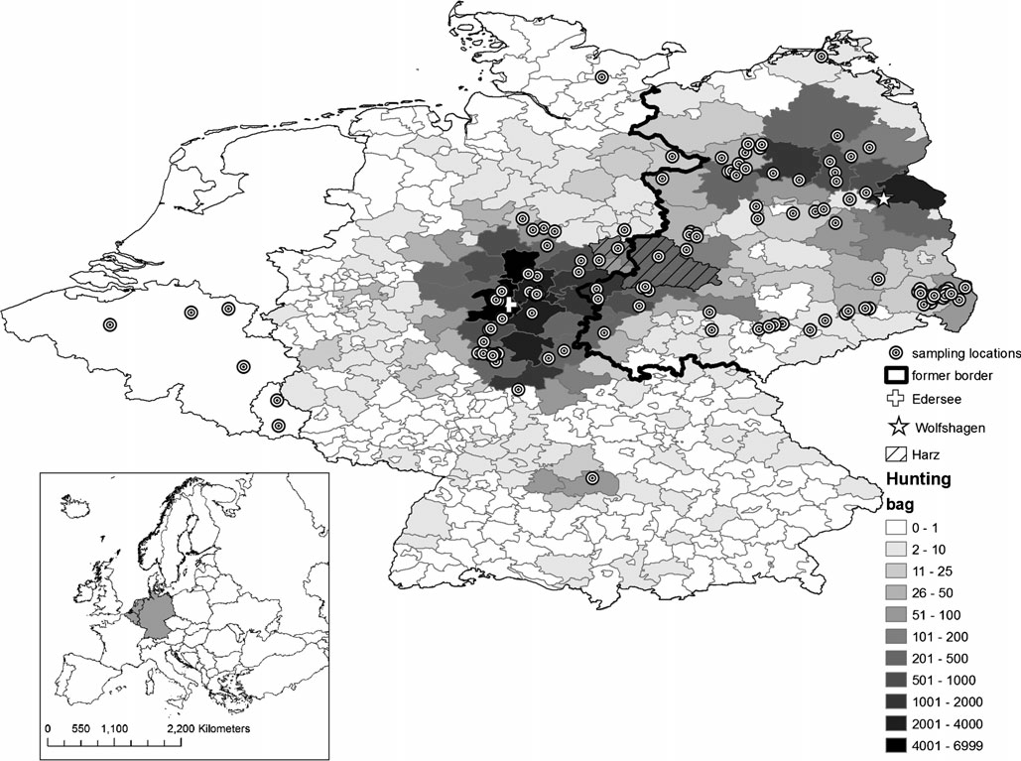Fig. 1 Sampling locations of the 193 raccoons analysed in this study. One point can represent multiple samples. Hunting bag: number of individuals harvested between 2000 and 2003 in different German administrative districts (grey lines Landkreise). Wolfshagen and Edersee indicate the geographic locations of the two introduced

populations that are supposed to be at the origin of the whole raccoon population. The hashed area indicated the approximate location of the Harz mountains. The picture inset illustrates the location of the study area in a European context

Bartussek 2005). The number of founders of the German population might therefore have been greater than commonly assumed, resulting in a more genetically diverse population capable of adapting to a new environment.
In a previous study, Cullingham et al. (2008) analysed mtDNA diversity of raccoons in the eastern USA in order to evaluate the phylogenetic distinctiveness of four subspecies previously identified based on morphology. These authors identified 76 different control region haplotypes in a total of 311 samples. The presence of three concordant lineages was inferred, which, however, did only partially correspond to the geographic ranges of the presumed sub-species. In the present study, and similarly to Alda et al. (2012), we aimed to sequence the same region to test the commonly-held assumption that the raccoon population in Germany originated from a small num- ber of (female) founders in only two distinct populations (Edersee, Wolfshagen) and to identify the control region line- ages present in Germany.
Materials and methods

A total of 193 raccoon tissue samples were obtained from across Germany, with an emphasis on the core distribution areas in central and eastern Germany, as illustrated by the hunting bag statistics from 2000 to 2003 (Fig. 1). In addition, four and two samples were obtained from Belgium and Luxembourg, respectively. Tissues samples from legally hunted or road-killed individuals were stored in absolute eth- anol until extraction.
Cullingham et al. (2008) amplified a control region frag- ment (expected size, 610 base pairs), using the universal mammalian control region forward primer L15997 (Ward et al. 1991), as well as the raccoon-specific reverse primer PLO- CRL1 (5′-CGCTTAAACTTATGTCCTGTAACC-3′). Using
sequence information from Pons et al. (1999; Genbank accession nos. AF080174 to AF080182), as well as from Helgen et al. (2008; Genbank accession nos. EU021073 to

EU021081), we generated the forward primer (PLO-L15997; 5′-CCATCAGCACCCAAAGCT-3′) that annealed to the same region as the universal primer, but was raccoon- specific. While the expected product size was 608 base pairs (bp), sequencing of the fragment resulted in 550 bp of clean sequence. Cullingham et al. (2008) report results for 467 bp of clean sequence.
DNA was extracted using an ammonium acetate-based salting-out procedure (Miller et al. 1988). We amplified fragments using 10-μl polymerase chain reactions (PCR) that contained approximately 10 ng of DNA and 0.5 units of Hot FirePol Taq (Solis Biodyne) in the manufacturer’s buffer with a concentration of 0.25 μM of each primer,
2.0 mM MgCl2 and 0.1 mM of each dNTP. PCRs were performed in a Veriti thermal cycler (Applied Biosystems) using the following programme: one cycle of 3 min at 95 °C, followed by 28 cycles of 94 °C for 30s, 56 °C for 45 s, 72 °C for 30s, and a final extension at 72 °C for
10 min. PCR products were purified using ExoSAP-IT enzyme (Amersham). Both the forward and reverse strands were sequenced using a BigDye terminator (Perkin Elmer) sequencing kit and the product was run on an ABI 3730 capillary DNA automated sequencer (Applied Biosystems).
Sequence alignment was performed using the MUSCLE procedure (Edgar 2004) imbedded in MEGA v.5 (Tamura et al. 2011). Sequences were collapsed to haplotypes using software COLLAPSE V1.2 (D. Posada; unpublished software). In order to test whether the genetic structure of the mtDNA haplotypes supported the hypothesised founding populations, sampling units were created by grouping in- dividuals based on their federal state of origin (Fig. 2). Ignoring states from which only one sample had been col- lected, haplotype and nucleotide diversity statistics for each federal state were calculated using programme DnaSP v5 (Librado and Rozas 2009). Genetic differentiation between federal states (ΦST) was calculated using the software ARLEQUIN 2.0 (Schneider et al. 2000), using Kimura’s two- parameter genetic distances (Kimura 1980). We tested for significance by performing 10,000 permutations. Programme ARCGIS 9.2 (Esri) was used for geographic representation of the haplotypes. The software NETWORK v4.640 (www.fluxus-engineering.com; unpublished soft- ware) was used to construct a phylogenetic network of raccoon sequences using the median-joining option (Bandelt et al. 1999) followed by MP construction (Polzin and Daneschmand 2003). The network included the sequences generated by Cullingham et al. (2008; GenBank accession nos. EF30343–EF30362, EF30364– EF30419), the frequencies of which were obtained from Cullingham (2007), as well as those from the present study, but reduced in length to cover exactly the same region as the older sequences.
Results

Sequencing a 550-bp fragment of the mtDNA control region in 193 West European raccoons gave rise to only six haplotypes (Table 1), differing at a total of 17 variable sites. The sequences of five of the haplotypes matched a 467-bp fragment spanning the same region (covering variable sites 118–489) that had previously been used to investigate raccoon phylogeography (Table 1). Because haplotypes PLO2a and PLO2b only differed at nucleotide position 577, they both matched the previous haplotype PLO2. Haplotype PLO16 also matched a mtDNA sequence (with 99 % coverage) of a raccoon from Japan (Genbank accession no AB462046), where the species was introduced as well. Haplotype 110 did not match any existing sequence. Together with haplotypes PLO13, PLO16 and PLO75, it clustered with lineage 2 in the phylogenetic net- work (Fig. 3), while haplotypes PLO2a and PLO2b were part of lineage 3. The overall haplotype diversity was Hd=0.764±
0.012 and the overall nucleotide diversity was π=0.011.
Haplotype PLO75 was observed only once. It originated from a raccoon captured in a suburb of the city of Luxembourg (Fig. 2). The 20 raccoons (10.4 % of all sampled individuals) with haplotype PLO16 all were sampled in a relatively small geographic area (two administrative districts) from the eastern- most part of Germany in the federal state of Saxony, where few other haplotypes were observed. Consequently, the raccoon population of the federal state of Saxony had a reduced hap- lotype diversity (Table 2) and was significantly differentiated from all the other federal states (Table 3), suggesting an inde- pendent origin of this population.
The spatial distribution of the other haplotypes was characterised neither by a clearly distinct geographical cluster- ing, nor by a completely random distribution. In the majority of cases, the haplotypes PLO2b (carried by 31.6 % of all sampled individuals) and PLO110 (8.8 %) were found in the territory of the former Eastern Germany, even though their distribution did overlap relatively little, with the PLO2b haplotype mostly occurring in the north, and the PLO110 haplotype in the centre of the region. Conversely, haplotype PLO13 (28.0 %) was observed mostly on the territory of former Western Germany. Haplotype PL02a occurred frequently in the city of Kassel (in the federal state of Hesse) and its surrounding area (20.7 % of all samples individuals carried this haplotype). The ΦST values support an independent origin of the central Hessian and eastern German raccoons (Table 3): the populations in the federal states of Berlin, Brandenburg and Mecklenburg-Western Pomerania were not significantly differentiated from each other, but they were significantly differentiated from both the populations in Hesse and Thuringia, which in turn were not differentiated from each other.
The raccoons in Lower Saxony and Saxony Anhalt had the highest haplotype diversity (Table 2) and were not genetically differentiated from either Brandenburg or

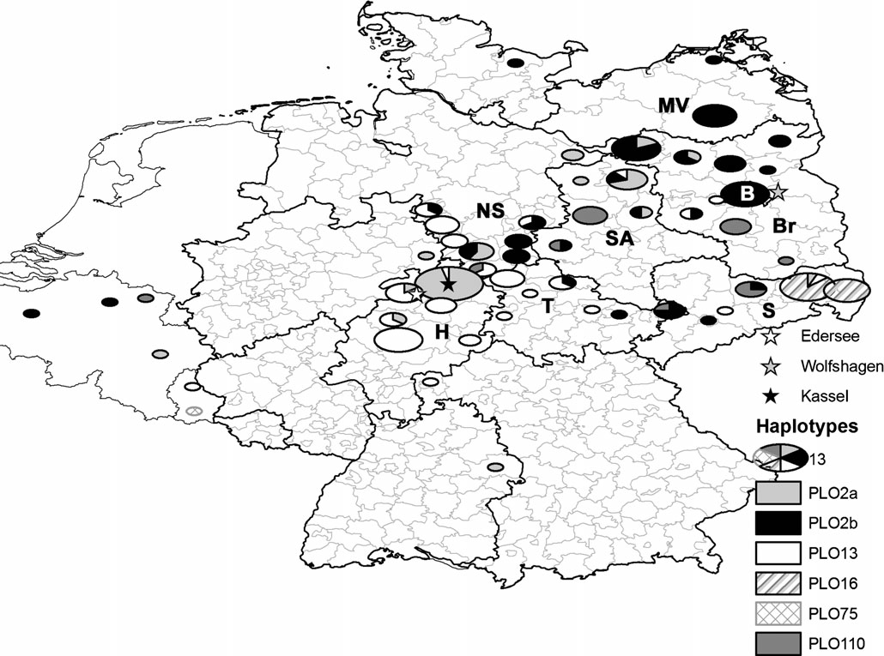Fig. 2 Geographic distribution of the haplotypes observed in the present study. The pie charts represent individuals sampled in different German administrative districts (grey lines Landkreise). The former inner-German border is now shown in Fig. 1. Wolfshagen and Edersee indicate the geographic locations of the two introduced populations from are supposed to be at the origin of the whole raccoon population,

while Kassel indicates the location of the largest urban raccoon popu- lation in Germany. Bold lines represent the location of the German federal states: B Berlin, Br Brandenburg, H Hesse, MV Mecklenburg– Western Pomerania, NS Lower Saxony, S Saxony, SA Saxony Anhalt, T Thuringia

Hesse (Table 3), suggesting that the populations in these two federal states contained individuals from both main source populations. Finally, every haplotype observed in this study (with the exception of PLO16) was found in the six raccoons from Belgium and Luxembourg. The eight analysed raccoons collected in central Berlin had haplotype PLO2b, suggesting a natural colonisation from rural into urban areas.

Discussion

There are many examples of successful invasions of geneti- cally depauperate colonisers. While mitochondrial DNA only provides a limited picture of the overall genetic diversity of a species, our results suggest that the raccoon in Germany and
neighbouring countries is another such example. One raccoon captured in a suburb of Luxembourg City had a haplotype (PLO75) that was observed only once. It is therefore likely that it escaped captivity and can be discounted from the interpretation of the observed genetic patterns. We observed only five further haplotypes in the remaining 192 individuals (or an average of 38.4 individuals per haplotype). Please note that it was important to sequence 550 bp of the control region, rather than the shorter fragment used by Cullingham et al. (2008), as only this allowed the important distinction between haplotypes PLO2a and PLO2b to be made. The limited num- ber of haplotype observed in the present study is likely to be the result of a founder effect, since the species is not characterised by low mtDNA diversity in its native range. Cullingham et al. (2008) identified 76 different haplotypes in 311 samples from the Eastern USA, or 4.1 individuals per

Table 1 Variable sites in a 550-bp-long fragment of the raccoon mtDNA control region among the six haplotypes (Genbank accession nos. KC846064–KC846069) observed in this study (N=193). Nucleo- tide positions are numbered following Pons et al. (1999). Nucleotide
position highlighted in italic are included in the 467-bp sequence used by Cullingham et al. (2008) to investigate raccoon phylogeography in the eastern US. Haplotype names follow Cullingham et al. (2008)

Nucleotide position

Haplotypes | 0 | 1 | 1 | 1 | 1 | 1 | 1 | 2 | 2 | 2 | 2 | 2 | 3 | 4 | 5 | 5 | 5 | N
 | 6 | 0 | 1 | 5 | 8 | 8 | 9 | 0 | 0 | 0 | 6 | 9 | 2 | 8 | 7 | 8 | 9
 | 4 | 3 | 8 | 3 | 2 | 3 | 1 | 2 | 3 | 9 | 3 | 5 | 6 | 9 | 7 | 3 | 2
PLO2aa | G | C | C | G | G | T | T | G | A | T | G | G | T | A | T | C | A | 40
PLO2ba | . | . | . | . | . | . | . | . | . | . | . | . | . | . | C | . | . | 61
PLO13 | A | . | . | . | A | . | C | . | G | C | . | A | C | G | C | T | G | 54
PLO16 | . | . | . | . | A | . | C | A | G | . | . | A | C | G | C | T | G | 20
PLO75 | A | T | . | A | A | . | C | . | G | C | A | A | C | G | C | T | G | 1
PLO110b | A | . | T | . | A | C | C | A | G | C | . | A | C | G | C | . | G | 17
N number of observations, dots indicate matches with the master sequence
a Both sequences match the shorter haplotype PLO2 from Cullingham et al. (2008)
b Haplotype not previously identified

haplotype on average. The overall haplotype diversity in Germany of Hd=0.764 was relatively high (haplotype diversity
in different populations in the eastern United States: Hd ≥0.841;
Cullingham et al. 2008), reflecting the fact that, with the

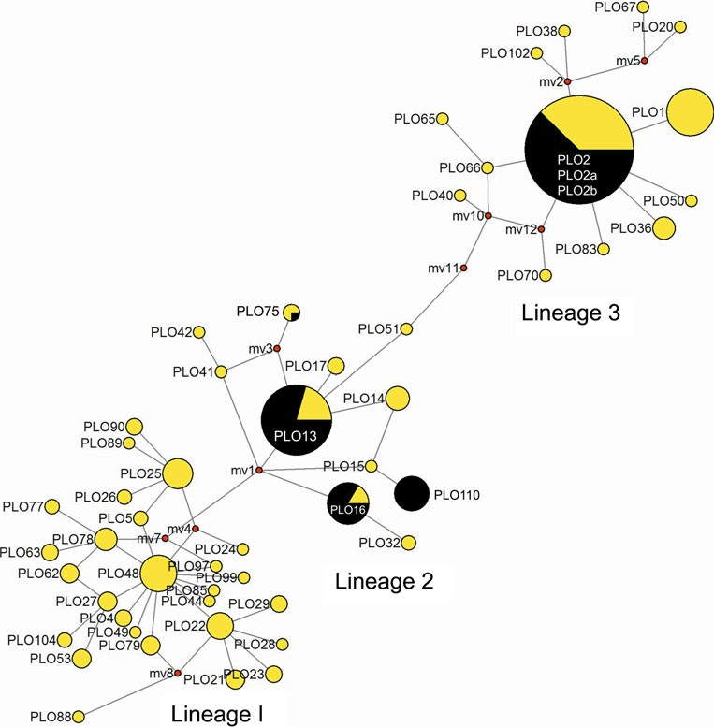Fig. 3 Median-joining network for 77 raccoon mitochondrial control region haplotypes. The yellow haplotypes (light grey in printed version) were identified in a previous study by Cullingham et al. (2008). The black colour indicates the haplotypes identified in the present study. Missing haplotypes are indicated by small red (dark grey in printed version) dots. The size of the symbol is representative of haplotype frequency.
Haplotypes that occurred only once are not shown for clarity

Table 2 Diversity statistics of the raccoon population in eight federal states of Germany

Federal state N Hd SD π

Berlin 10 0.00 0.00 0.00
Brandenburg 28 0.56 0.01 0.009
Hesse 45 0.55 0.02 0.010
Lower Saxony 30 0.67 0.05 0.010
Meck.-West. Pom. 9 0.00 0.00 0.00
Saxony 28 0.48 0.11 0.006
Saxony Anhalt 17 0.71 0.06 0.012
Thuringia 16 0.54 0.10 0.009

N sample size, Hd haplotype diversity, SD standard deviation of the haplotype diversity, π nucleotide diversity, Meck.-West. Pom. Meck- lenburg Western Pomerania

exception of PLO75, all haplotypes occurred at a high frequency.
The number of haplotypes observed in our data set sug- gests that there could have been as few as five founder females of the German raccoon population. Using microsat- ellite markers, Alda et al. (2012) estimated that two recently established (last decade), geographically adjacent raccoon populations in Central Spain were founded by between two and four individuals each. The authors only identified two
mtDNA haplotypes in 58 samples, each of which was nearly fixed in one population (haplotype diversity Hd≤0.095). In
this example, comparison of the results from both marker types did suggest that the reduced mtDNA control region diversity observed was an accurate reflection of the number of female founders. Both populations are in the process of expansion, despite having reduced genetic diversity as the result of a founder effect.
On the other hand, there are reasons to believe that the analysis of mtDNA diversity will underestimate the number

of female founders of a population. Founders can have widely differing contributions to the gene pool and mito- chondrial haplotypes might be lost due to genetic drift (Tokarska et al. 2011). Furthermore, rarer haplotypes still present in the population might not have been detected. For example, Wojcik et al. (2009) detected one of the three haplotypes of the three female founders of a population of European bison in only one of 195 analysed individuals. It is also possible that different founder females had identical haplotypes, especially if they came from the same captive population (e.g. Frantz et al. 2012). Despite some uncertain- ty as to the precise number of females that have founded the German populations, the raccoons exhibit less mtDNA di- versity than other invasive mammals, such as the American mink (Zalewski et al. 2011) or the raccoon dog (Korablev et al. 2011,) and are therefore likely to originate from a smaller number of founding females and to have a different demo- graphic history than these more diverse species.
Results from a prior microsatellite study suggest, however, that raccoons in Germany are less genetically impoverished than our results suggest. In the context of a parentage study, Gramlich et al. (2011) used 10 microsatellites to genotype 141 raccoons from a study area in northeastern Germany. While we only identified one haplotype (PLO2b) in eight individuals from the same study area, Gramlich et al. (2011) reported an average of 6.2 alleles per locus, with one locus having 11 alleles. While using different microsatellite markers, results by Alda et al. (2012), obtained by genotyping 58 individuals at 14 microsatellite loci, suggest a lower genetic diversity of two newly established Spanish populations. The authors report an average of 4.1 alleles per locus and they did not observe more than six alleles at any locus across both populations. While the estimate of the overall observed heterozygosity (the German study does not report expected heterozygosities) was compa- rable in both studies (Germany, Ho=0.623; Spain, Ho=0.629), allelic diversity is lost faster than heterozygosity during a

Table 3 Pairwise ΦST values (lower diagonal) among raccoon populations in different federal states of Germany. Information of significance level of p value above diagonal

 | Berlin | Brandenburg | Hesse | Lower Saxony | Meck.-West. Pom | Saxony | Saxony Anhalt | Thuringia
Berlin |  | n.s. | –* | –* | n.s. | –** | –* | –**
Brandenburg | 0.11 |  | –* | n.s. | n.s. | –** | n.s. | –**
Hesse | 0.35 | 0.14 |  | n.s. | –* | –** | n.s. | n.s.
Lower Saxony | 0.31 | 0.08 | 0.00 |  | –* | –** | n.s. | n.s.
Meck.-West. Pom. | 0.00 | 0.10 | 0.35 | 0.30 |  | –** | –*** | –*
Saxony | 0.74 | 0.48 | 0.31 | 0.32 | 0.74 |  | –** | –*
Saxony Anhalt | 0.29 | 0.03 | 0.07 | 0.04 | 0.27 | 0.36 |  | –***
Thuringia | 0.59 | 0.28 | 0.05 | 0.04 | 0.57 | 0.24 | 0.15
Meck.-West. Pom. Mecklenburg Western Pomerania
*p=0.05, **p= 0.01, ***p=0.001 significance level

bottleneck (Nei et al. 1975; Cornuet and Luikart 1996). In comparison, Alda et al. (2012) also genotyped 77 raccoons from the central USA and found up to 16 alleles per locus, an average of 9.9 alleles per locus, and an observed heterozygos- ity of Ho=0.800. Other studies, although based on differ- ent microsatellite makers, report similarly high diversity values for other North American raccoon populations (e.g. Cullingham et al. 2009; Root et al. 2009; Côté et al. 2012; Santonastaso et al. 2012).
Our results clearly show that the commonly held belief that the raccoon population in Germany originated from only two distinct release events is not correct. Haplotype PLO16 was restricted to the eastern-most tip of Saxony (and Germany), and is the most common haplotype in this area. Accordingly, the raccoons in Saxony were genetically differentiated from all others populations and had a reduced diversity. The only meaningful explanation for this result is that these individuals descend from an independent source population. Indeed, until the mid-1990s, the species was in essence absent from this area (Stubbe 1990; Hertweck 2009). The geographical distribu- tion of the remaining four haplotypes was generally in line with the Edersee and Wolfshagen individuals as founders of the populations in the west and east of the country, respectively (high frequencies of PLO2a and PLO13 in central Germany and of PLO2b and PLO110 in eastern Germany). Importantly, ΦST values showed the raccoons in northeastern Germany to be genetically differentiated from the population in central Germany (Hesse and Thuringia), supporting the notion of two independent source populations (outside Saxony).
All four haplotypes (excluding PLO16 from Saxony) had a relatively broad distribution. It is more likely that this pattern resulted from raccoon dispersal, rather than the pres- ence of all haplotypes in the two founding populations. The analysis of genetic differentiation suggested the populations in Lower Saxony and Saxony Anhalt contained descendants from both main source populations. A microsatellite-based analysis is needed to test for admixture between raccoons from the different populations. Finally, the relatively small number of haplotypes suggests that it is unlikely that further small, independently founded populations contributed to the genetic make-up of German raccoons. While haplotype PLO110 was distributed fairly widely in central eastern Germany, it was not possible to ascertain as to whether a fourth population established itself in the Harz region. A microsatellite study is also needed to further clarify the number of founding populations.
Our results generally support the notion that the raccoon population in Germany and neighbouring countries was founded by a small number of individuals in a limited number of locations. The results by Alda et al. (2012) confirm that newly-established raccoon populations can expand despite reduced genetic diversity. The raccoon, as an adaptable, truly
omnivorous species (Kauhala 1996; Rosatte 2000), might thus represent an example of a species being pre-adapted for suc- cessful invasion (Ellstrand and Schierenbeck 2000). On the other hand, the microsatellite study by Gramlich et al. (2011) suggest that raccoons in Germany retained more genetically diversity than suggested by the analysis of mtDNA and there- fore likely to still possess the ability to respond to natural selection in their new environment (Novak and Mack 2005; Wares et al. 2005). The raccoon only started to signifi- cantly expand its range some 20 years after the first feral populations were established (Müller-Using 1959; Lutz 1984), and the dramatic increase in abundance only occurred over the past 20 years (Vos et al. 2012). We cannot exclude the possibility that individuals that escaped zoos, fur farm or private households contributed to the gene pool of the wild population and thereby facilitated the recent increase. Again, a microsatellite-based analysis might help to clarify these issues.
Information on genetic diversity and population ge- netic structure can be important for the management and control of invasive species. Using genetic tools for under- standing inter-population connectivity might help to delimit effective eradication units (Abdelkrim et al. 2005) and predict spread of diseases transmitted by the invader (Bataille et al. 2009). Information on genetic diversity may help to predict an invader’s potential to evolve in defences against a control agent (Allendorf and Lundquist 2003) and to defend itself against infectious disease (Spielman et al. 2004; Radwan et al. 2010). Raccoons are now very abundant in many parts of central Europe and complete eradication of the species, other than at a local scale, is not feasible (Winter 2006). Conversely, in North America, raccoons are known to harbour a variety of pathogens that can be transmitted to wildlife, to domestic animals and to humans (Beltran-Beck et al. 2012). Further studies are thus necessary to gain a more precise understanding of the genetic make-up of European raccoons and the management implications that this may have.

Acknowledgments We would like to thank the following people for their invaluable help in providing samples for this study: H. Baczynski,
A. Baumgärtel, M. Beiermeier, M. Bensch, H. Bodenstein, P. Borkenhagen, K. Börner, F. Busse, M. Dietrich, H. Heim, L. Hopfer,
K. Hoppe, L. Höser, N. Kann, M. Ködel, R. Köppel, H. Langerzig, B. Lorenz, D. Müller, B. Pietsch, H. Rathaj, K.-F. Reckling, W. Rohrmann, K.-H. Schaper, L. Schley, A. Schliephake, K. Schlüter, K. Schuchhardt, D. Smyrek, S. Stry, A. Stubbe, M. Stubbe, E. Veile, H. Wilhelmi and T. zur Löwen. The laboratory work was performed at the NERC Biomolecular Analysis Facility, supported by the UK Natural Environment Research Council and at the University of Greifswald. We would like to thank T. Burke, NERC and G. Kerth for financially supporting this work. We would like to thank T. Burke for his enthu- siastic support of the project. We would like to thank Frank Zachos, Paulo Alves and three anonymous referees for their comments that helped to improve earlier versions of the manuscript.

References

Abdelkrim J, Pascal M, Calmet C, Samadi S (2005) Importance of assessing population genetic structure before eradication of inva- sive species: examples from insular Norway rat populations. Conserv Biol 19:1509–1518
Alda F, Ruiz-López MJ, García FJ, Gompper ME, Eggert LS, García JT (2012) Genetic evidence for multiple introduction events of raccoons (Procyon lotor) in Spain. Biol Invasions. doi:10.1007/ s10530-012-0318-6
Allendorf FW, Lundquist LL (2003) Introduction: population biology, evolution, and control of invasive species. Conserv Biol 17:24–30 Bandelt HJ, Forster P, Röhl A (1999) Median-joining networks for
inferring intraspecific phylogenies. Mol Biol Evol 16:37–48
Bataille A, Cunningham AA, Cedeno V, Cruz M, Eastwood G, Fonseca DM, Causton CE, Azuero R, Loayza J, Cruz Martinez JD, Goodman SJ (2009) Evidence for regular ongoing introduc- tions of mosquito disease vectors into the Galapagos Islands. Proc R Soc B-Biol Sci 276:3769–3775
Beltran-Beck B, Garcia FJ, Gortazar C (2012) Raccoons in Europe: disease hazards due to the establishment of an invasive species. Eur J Wildl Res 58:5–15
Corbet GB, Harris S (1991) The handbook of British mammals.
Blackwell, Oxford
Cornuet JM, Luikart G (1996) Description and power analysis of two tests for detecting recent population bottlenecks from allele fre- quency data. Genetics 144:2001–2014
Côté H, Garant D, Robert K, Mainguy J, Pelletier F (2012) Genetic structure and rabies spread potential in raccoons: the role of landscape barriers and sex-biased dispersal. Evol Appl 5:393–404 Cullingham CI (2007) Analysis of the genetic structure of raccoons (Procyon lotor) across eastern North America: applications for wild-
life disease management. Dissertation, Trent University, Canada Cullingham CI, Kyle CJ, Pond BA, White BN (2008) Genetic structure
of raccoons in Eastern North America based on mtDNA: impli- cations for subspecies designation and rabies disease dynamics. Can J Zool-Rev Can Zool 86:947–958
Cullingham C, Kyle C, Pond B, Rees E, White BN (2009) Differential permeability of rivers to tacoon gene flow corresponds to rabies incidence on Ontario, Canada. Mol Ecol 18:43–53
Edgar RC (2004) MUSCLE: multiple sequence alignment with high accuracy and high throughput. Nucleic Acids Res 32:1792–1797 Ellstrand NC, Schierenbeck KA (2000) Hybridization as a stimulus for the evolution of invasiveness in plants? Proc Natl Acad Sci USA
97:7043–7050
Frankham R, Ballou JD, Briscoe DA (2009) Introduction to conserva- tion genetics. Cambridge University Press, Cambridge
Frantz AC, Cyriacks P, Schley L (2005) Spatial behaviour of a female raccoon (Procyon lotor) at the edge of the species’ European distribution range. Eur J Wildl Res 51:126–130
Frantz AC, Massei G, Burke T (2012) Genetic evidence for past hybridisation between domestic pigs and English wild boar. Conserv Genet 13:1355–1364
Garcia JT, Garcia FJ, Alda F, Gonzalez JL, Aramburu MJ, Cortes Y, Prieto B, Pliego B, Perez M, Herrera J, Garcia-Roman L (2012) Recent invasion and status of the raccoon (Procyon lotor) in Spain. Biol Invasions 14:1305–1310
Genton BJ, Shykoff JA, Giraud T (2005) High genetic diversity in French invasive populations of common ragweed, Ambrosia artemisiifolia, as a result of multiple sources of introduction. Mol Ecol 14:4275–4285
Gillis NK, Walters LJ, Fernandes FC, Hoffman EA (2009) Higher genetic diversity in introduced than in native populations of the mussel Mytella charruana: evidence of population admixture at introduction sites. Diversity And Distributions 15:784–795

Gramlich S, Schulz H, Köhnemann BA, Michler F-U (2011) Mater semper certa? Molekular-biologische Analyse einer Waschbärenpopulation (Procyon lotor Linné, 1758) im Müritz Nationalpark. Beitr Jagd- Wildforsch 36:521–530
Grapputo A, Boman S, Lindstrom L, Lyytinen A, Mappes J (2005) The voyage of an invasive species across continents: genetic diversity of North American and European Colorado potato beetle populations. Mol Ecol 14:4207–4219
Hertweck K (2009) Waschbär Procyon lotor (Linnaeus, 1758). In: Hauer S, Ansorge H, Zöphel U (eds) Atlas der Säugetiere Sachsens. LfULG, Dresden, pp 281–283
Helgen KM, Maldonado JE, Wilson DE, Buckner SD (2008) Molecular confirmation of the origin and invasive status of West Indian rac- coons. J Mammal 89:282–291
Hohmann U, Bartussek I (2005) Der Waschbär. Oertel & Spörer, Reutlingen Kaufmann JH (1982) Raccoon and allies. In: Chapman JA, Feldhamer GA (eds) Wild mammals of North America. John Hopkins
University Press, Baltimore, pp 567–585
Kauhala K (1996) Introduced carnivores in Europe with special refer- ence to central and northern Europe. Wildlife Biol 2:197–204
Keller SR, Gilbert KJ, Fields PD, Taylor DR (2012) Bayesian infer- ence of a complex invasion history revealed by nuclear and chloroplast genetic diversity in the colonizing plant, Silene latifolia. Mol Ecol. doi:10.1111/j.1365-294X.2012.05751.x
Kolbe JJ, Glor RE, Schettino LRG, Lara AC, Larson A, Losos JB (2004) Genetic variation increases during biological invasion by a Cuban lizard. Nature 431:177–181
Kimura M (1980) A simple method for estimating evolutionary rate of base substitution through comparative studies of nucleotide se- quences. J Mol Evol 16:111–120
Korablev NP, Korablev MP, Rozhnov VV, Korablev PN (2011) Polymorphism of the mitochondrial DNA control region in the population of raccoon dog (Nyctereutes procyonoides Gray, 1834) introduced into the Upper Volga Basin. Russ J Genet 47:1227–1233 Léger F (1999) Le raton-laveur en France. Bull Mens ONC 241:16–37 Librado P, Rozas J (2009) DnaSP v5: a software for comprehensive analysis of DNA polymorphism data. Bioinformatics 25:1451–1452
Lutz W (1984) Die Verbreitung des Waschbären (Procyon lotor, Linné 1758) im mitteleuropäischen Raum. Z Jagdwiss 30:218–228
Lutz W (1995) Occurrence and morphometrics of the raccoon Procyon lotor L. in Germany. Ann Zool Fennici 32:15–20
Michler FUF, Michler BA (2012) Ökologische, ökonomische und epidemiologische Bedeutung des Waschbären (Procyon lotor) in Deutschland - eine aktuelle Übersicht. Beitr Jagd u Wildforsch 37:389–397
Miller SA, Dykes DD, Polesky HF (1988) A simple salting-out proce- dure for extracting DNA from human nucleated cells. Nucleic Acids Res 16:1215
Müller-Using D (1959) Die Ausbreitung des Waschbären (Procyon lotor [L.]) in Westdeutschland. Z Jagdwiss 5:108–109
Nei M, Maruyama T, Chakraborty R (1975) The bottleneck effect and genetic variability in populations. Evolution 29:1–10
Novak SJ, Mack RN (2005) Genetic bottlenecks in alien plant species: influences of mating systems and introduction dynamics. In: Sax DF, Stachowicz JJ, Gaines SD (eds) Species invasions: insights into ecol- ogy, evolution, and biogeography. Sinauer, Sunderland, pp 201–228
Polzin T, Daneschmand SV (2003) On Steiner trees and minimum spanning trees in hypergraphs. Oper Res Lett 31:12–20
Pons JM, Volobouev V, Ducroz JF, Tillier A, Reudet D (1999) Is the Guadeloupean racoon (Procyon minor) really an endemic spe- cies? New insights from molecular and chromosomal analyses. J Zool Syst Evol Research 37:101–108
Puillandre N, Dupas S, Dangles O, Zeddam JL, Capdevielle-Dulac C, Barbin K, Torres-Leguizamon M, Silvain JF (2008) Genetic bot- tleneck in invasive species: the potato tuber moth adds to the list. Biol Invasions 10:319–333

Radwan J, Biedrzycka A, Babik W (2010) Does reduced MHC diversity decrease viability of vertebrate populations? Biol Conserv 143:537–544
Root JJ, Puskas RB, Fischer JW, Swope CB, Neubaum MA, Reeder SA, Piaggio AJ (2009) Landscape genetics of raccoons (Procyon lotor) associated with ridges and valleys of Pennsylvania: implications for oral rabies vaccination programs. Vector-Borne Zoonot 9:583–588
Rosatte RC (2000) Management of raccoons (Procyon lotor) in Ontario, Canada: do human intervention and disease have signif- icant impact on raccoon populations? Mammalia 64:369–390
Santonastaso TT, Dubach J, Hauver SA, Graser WH, Gehrt SD (2012) Microsatellite analysis of raccoon (Procyon lotor) population structure across an extensive metropolitan landscape. J Mammal 93:447–455
Schneider S, Roessli D, Excoffier L (2000) Arlequin ver. 2.000: a software for population genetics data analysis. Genetics and Biometry Laboratory, University of Geneva, Switzerland
Simberloff D (2009) The role of propagule pressure in biological invasions. Annu Rev Ecol Evol Syst 40:81–102
Spielman D, Brook BW, Briscoe DA, Frankham R (2004) Does in- breeding and loss of genetic diversity decrease disease resistance? Conserv Genet 5:439–448
Stubbe M (1975) Der Waschbär Procyon lotor (L., 1758) in der DDR. Hercynia N.F. 12: 80–91
Stubbe M (1990) Der Status des Waschbären Procyon lotor (L.) in der DDR (1975 bis 1984). Beitr Jagd- Wildforsch 17:180–192
Suzuki T, Aoi T, Maekawa K (2003) Spacing pattern of introduced female raccoons (Procyon lotor) in Hokkaido, Japan. Mamm Study 28:121–128
Tamura K, Peterson D, Peterson N, Stecher G, Nei M, Kumar S (2011) MEGA5: molecular evolutionary genetics analysis using maxi- mum likelihood, evolutionary distance, and maximum parsimony methods. Mol Biol Evol 28:2731–2739
Tokarska M, Pertoldi C, Kowalczyk R, Perzanowski K (2011) Genetic status of the European bison Bison bonasus after extinction in the wild and subsequent recovery. Mammal Rev 41:151–162
Vos A, Ortmann S, Kretzschmar AS, Köhnemann B, Michler F (2012) The raccoon (Procyon lotor) as potential rabies reservoir species in Germany: a risk assessment. Berl Munch Tierarztl 125:228–235
Ward RH, Frazier BL, Dewjager K, Paabo S (1991) Extensive mito- chondrial diversity within a single Amerindian tribe. Proc Natl Acad Sci USA 88:8720–8724
Wares JP, Hughes AR, Grosberg RK (2005) Mechanisms that drive evolutionary change: insights from species introductions and in- vasions. In: Sax DF, Stachowicz JJ, Gaines SD (eds) Species invasions: insights into ecology, evolution, and biogeography. Sinauer, Sunderland, pp 229–257
Winter M (2006) Procyon lotor. Delivering Alien Invasive Species Inventories for Europe factsheet. http://www.europe-aliens.org. Accessed 18 Sep 2012
Wojcik JM, Kawalko A, Tokarska M, Jaarola M, Vallenback P, Pertoldi C (2009) Post-bottleneck mtDNA diversity in a free-living popu- lation of European bison: implications for conservation. J Zool 277:81–87
Zachos FE, Cirovic D, Rottgardt I, Seiffert B, Oeking S, Eckert I, Hartl GB (2007) Geographically large-scate genetic mono- morphism in a highly successful introduced species: the case of the muskrat (Ondatra zibethicus) in Europe. Mamm Biol 72:123–126
Zalewski A, Michalska-Parda A, Ratkiewicz M, Kozakiewicz M, Bartoszewicz M, Brzezinski M (2011) High mitochondrial DNA diversity of an introduced alien carnivore: comparison of feral and ranch American mink Neovison vison in Poland. Diversity Distrib 17:757–768

