Heathland conservation status mapping through integration of hyperspectral mixture analysis and decision tree classiﬁers
- Delalieux a,⁎, B. Somers a, B. Haest a, T. Spanhove b, J. Vanden Borre b, C.A. Mücher c
a Centre of Expertise in Remote Sensing and Atmospheric Processes (TAP), the Flemish Institute for Technological Research (VITO), Boeretang 200, 2400 Mol, Belgium
b Research Institute for Nature and Forest (INBO), Kliniekstraat 25, 1070 Brussels, Belgium
c Alterra, Wageningen University and Research Centre, PO Box 47, 6700 AA Wageningen, The Netherlands

Keywords: Natura 2000 Unmixing MESMA
AHS hyperspectral data Habitat status
Calluna vulgaris
Age classes
a b s t r a c t

Monitoring the conservation status of natural habitats is an essential aspect of effective conservation man- agement. Not only data on habitat occurrence are needed, but also detailed information on the structural and functional characteristics of the habitat patches is crucial for an adequate conservation status assessment. Classiﬁcation of hyperspectral remote sensing images performs well in discriminating dominant land cover and vegetation classes, but the accuracy drops signiﬁcantly for the classiﬁcation of more subtle differences in conservation status that are related to structural characteristics. This study proposes a method to facilitate ecological conservation status assessment based on decision tree modeling of subpixel fraction estimates steered by ecological expert knowledge. In particular, it contributes to the spatially explicit assessment of an important structural aspect of dry heathland vegetation, namely the heather age structure, using Airborne Hyperspectral line-Scanner radiometer (AHS-160) data of the Kalmthoutse Heide in northern Belgium. We implemented a subpixel unmixing approach to identify the percentage of heather, sand and shadow in each heather pixel, and subsequently applied a decision tree classiﬁcation to allocate each pixel to a certain age class. As such, our method provides a tool that contributes to the information required for an appropriate management and successful conservation of natural heathlands.

  - Introduction

Knowledge on the conservation status of natural areas is essential to guide site managers in their management decisions. Speciﬁc man- agement actions may be needed to counteract observed effects of en- vironmental pressures, while zones in excellent condition may beneﬁt from a continuation of the existing management. Since spe- cies richness is closely linked to habitat structure, variation in the structure of the vegetation is needed to maintain high levels of biodi- versity. This is especially true for heathland, which is a dwarf shrub dominated vegetation type predominantly growing on nutrient poor soils in coastal climates. In Western Europe, heathland occurrence is almost always caused by historical anthropogenic land use. In the past, European heathlands extended over several millions of hectares, but due to the cessation of traditional agricultural practices and changes in land use, the total heathland area has decreased signiﬁ- cantly over the last 150 years (Odé et al., 2001; Webb, 1998). As a re- sult, the remaining “islands” of heathland have become even more vulnerable to isolation, increased grass and tree encroachment, high levels of atmospheric deposition of pollutants, and occasional uncontrolled wildﬁres (Anderson, 1995; Webb, 1990). The loss and

* Corresponding author.
E-mail address: Stephanie.Delalieux@vito.be (S. Delalieux).
degradation of heathland has caused many fauna and ﬂora species, closely associated with the habitat, to become rare and isolated (Desender et al., 2010; Piessens & Hermy, 2006). In order to preserve the historical, ecological and aesthetic conservation value of heath- lands, European environmental policies have introduced a formal protection of heathland habitats under the Habitats Directive. Many heathland remnants were designated as Special Areas of Conservation (SAC), contributing to the coherent European ecological network of SACs, referred to as the Natura 2000 network (Anon, 1992). This EU-wide network, comprising all SACs designated by Member States under the Habitats Directive, aims at assuring the long-term survival of Europe's most valuable and threatened species and habitats. With- in this framework, European Member States are obliged to report every 6 years on the conservation status of, amongst others, the heathland habitats on their national territory. As a result, an impor- tant challenge with the implementation of the Habitats Directive and the Natura 2000 network, lies in the design of accurate, simple and repeatable methods for habitat and species monitoring as a basis for reporting.
In areas with a favorable conservation status, heathlands show a complex structural variation, which is a prerequisite to provide a hab- itat for many rare and specialized plant and animal species. Important indicators of heathland quality are the amount of grass and tree en- croachment, optimally being less than 10% (T'jollyn et al., 2009), the

age structure of heather (Calluna vulgaris) which is preferably mixed, and the presence of typical species. To date, most conservation status assessments are based on ﬁeld observations and/or aerial photo inter- pretation (Vanden Borre et al., 2011). This survey driven approach is however very labor-intensive and time-consuming, and hence not suit- able to be repeated frequently. For example, for the Flemish region of Belgium (Flanders), one of the smaller sub-national administrative units in Europe, covering an area of approximately 13 500 km2, it took more than 10 years of intensive ﬁeldwork to realize the Biological Valuation Map (BVM), a uniform ﬁeld-driven land cover and vegetation map at a scale of 1/10.000 (Vriens et al., 2011). Relying entirely on this map to comply with the European Natura 2000 legislation, would mean that it should be updated every 6 years, which is simply not possible with the current ﬁeld methods. Next to labor-intensity, survey-driven approaches are further complicated by the limited accessibility of many protected areas (i.e., because of remoteness, difﬁcult terrain, mil- itary use). Moreover, despite efforts to apply strict rules for ﬁeld map- ping, inter-observer errors remain an issue (e.g. Hearn et al., 2011). Remote sensing, in contrast, is considered as a valuable, accurate and re- peatable tool to aid in the mapping and monitoring of habitat types and their conservation status assessment (Alexandridis et al., 2009; Bock et al., 2005; Cantarello & Newton, 2008; Förster et al., 2008; Frick et al., 2005; Gross et al., 2009; Mehner et al., 2004; Newton et al., 2009; Ramsey & Jensen, 1996; Roughgarden et al., 1991; Zomer et al., 2009). Researchers have already successfully used remote sensing for broad heathland mapping for more than 20 years (e.g., Wardley et al., 1987). More recently, Hooftman and Bullock (2012) presented a way to quantify the scale and pattern of habitat loss in heathlands by analyz- ing patterns of habitat changes over a large scale with remote sensing data. They thereby introduced the ﬁrst step towards a more quantita- tive framework to support conservation planning decisions on a broad scale. While pixel-based remote sensing techniques have been used to map heathland cover successfully, they are at present sub-optimal or in- appropriate for accurate, and complete conservation status assessment and monitoring of natural heathland habitats at a local scale, such as re- quired in the European Natura 2000 context (Spanhove et al., 2012). This also explains why these in-depth conservation status assessment studies still are rarely exploited (Vanden Borre et al., 2011) and some- times even questioned by ecologists. Or as McDermid et al. (2005) for- mulated: “The resource manager requires a variety of information products at a wide range of scales but is unsure of the capabilities of re- mote sensing and GIS”.
Conventional satellite and airborne hyperspectral optical remote sensing classiﬁcation methods indeed suffer from important limita- tions for detailed habitat conservation status mapping (Spanhove et al., 2012). A major drawback is the limited degree of detail that can be monitored. Lucas et al. (2007) were able to map most homogeneous habitats with an accuracy of over 80% using rule-based classiﬁcation, but the accuracy dropped with increasing complexity and for less well-deﬁned habitats. Similarly, a more detailed study on heathland habitats performed by Haest et al. (2010) illustrated that conservation status indicators related to dominant vegetation species (e.g. Molinia encroachment) can be mapped successfully using pixel-based classiﬁ- cation methods on hyperspectral AHS imagery. However, for more spe- ciﬁc indicators associated to species related vegetation structures (such as Calluna heath age classes), difﬁculties arise and classiﬁcation accura- cies drop. The key issue relates to the procedure itself, in which it is as- sumed that each pixel is exclusively occupied by just one feature (Fisher, 1997). Because of the speciﬁc age-related vertical and horizon- tal spatial characteristics of heath (see Section 2.2), the incorporation of subpixel classiﬁcation or unmixing in the remote sensing analysis may therefore be the right tool to move beyond the pixel-based limitations for habitat conservation status assessment, thereby exploiting these in- herent characteristics.
The current study, which is an extension of the work performed by Haest et al. (2010), aims at improving the assessment of the conservation
status of dry heathland habitats by clarifying the relation between Calluna age classes and subpixel fraction estimates for sand, shadow and Calluna. To this end, a three-step algorithm was developed. First, a conventional supervised classiﬁcation of the whole study area was performed, allowing the selection of heather-dominated pixels. Second, for each heather pixel, the subpixel composition of sand, shadow and Calluna was calculated using a Multiple Endmember Spectral Mixture Analysis (MESMA) (Roberts et al., 1998). Finally, a decision tree classiﬁca- tion of the unmixing results was performed to reveal details about the structural characteristics of different heather age classes and hence allowing to turn it into a map product for conservation management planning.

  - Materials and methods

    - Study area

The Kalmthoutse Heide (51° 24′ 0″ N, 4° 25′ 0″ E) is situated 25 km north of Antwerp (Flanders, Belgium), next to the Dutch border. The central heath part of almost 1000 ha is one of the largest remaining heathlands in Flanders containing a mixture of wet and dry heath, in- land sand dunes and water bodies (De Blust & Slootmaekers, 1997). It is the core of the 2000 ha protected complex heath and forest landscape of the Kalmthoutse Heide nature reserve and the 6000 ha Dutch-Flemish cross-border nature park ‘De Zoom–Kalmthoutse Heide’.
De Kalmthoutse Heide is recognized as a heathland of international importance under the Ramsar convention, and is, together with the neighbouring heath, pools and forests in The Netherlands, designated as a special Bird and Habitat Protection Site under the European Na- ture Directives (De Blust, 2007). Natura 2000 habitat types that are well represented are: dry sand heaths with Calluna and Genista (Habitats Directive Annex I code: 2310), inland dunes with open Corynephorus and Agrostis grasslands (2330), northern Atlantic wet heaths with Erica tetralix (4010), European dry heaths (4030), depressions on peat sub- strates of the Rhynchosporion (7150), natural dystrophic lakes and ponds (3160), and old acidophilous oak woods with Quercus robur on sandy plains (9190).
Appropriate management of this heathland area is needed to coun- teract the impacts of acidiﬁcation, eutrophication and dessication (Diemont & Oude Voshaar, 1994). Due to the cessation of traditional land use and the substantial increase of atmospheric deposition, nutri- ents accumulate in the heath (Terry et al., 2004). As a consequence, pur- ple moorgrass (Molinia caerulea (L.) Moench) has spread rapidly and has become dominant in the dwarf shrub vegetation (Aerts & Heil, 1993), resulting in a loss of suitable habitat for a large number of animals.

    - Heather life cycle

In western Europe, heather (Calluna vulgaris (L.) Hull) is a dominant species in dry heathlands. Its life cycle (Fig. 1) can be divided into four more or less distinctive stages: a (i) pioneer, (ii) building, (iii) mature and (iv) degeneration phase (Barclay-Estrup & Gimingham, 1969; Watt, 1955). The pioneer phase consists of low plants, recently established or in their early growth. Through the building and the ma- ture phase, the plants grow higher and branches become densely foliat- ed. Depending on the nutrient availability, heights of about 60 cm, rarely up to 1 m, can be attained (Watt, 1955). In the degeneration phase (from 15 years of age onwards in the Low Countries; Weeda et al., 1988), the branches start to defoliate, the stems spread apart and the plant ﬁnally dies off. As a result of the opening of the bush, light reaches the bare soil and litter underneath, stimulating the growth of mosses and lichens and eventually the colonization by new seedlings of heather. So, heather morphology strongly differs between develop- ment stages, with each phase creating different microclimatic condi- tions and microhabitats which provide shelter or food to different

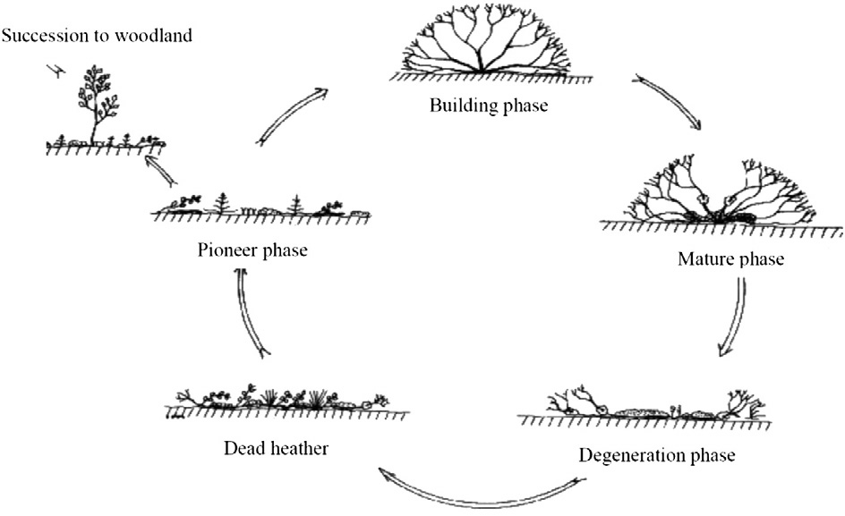

Fig. 1. Different life stages of Calluna vulgaris according to Watt (1955).

organisms. Variations in the structure of thevegetation is thus needed to maintain high niche diversity and accompanying species richness. In- appropriate management or other external inﬂuences such as ﬁre or beetle infestations may result in large patches of evenly aged heather, which are usually considered of lower conservation value. Conservation ecologists advocate to maintain a mosaic of heather in different phases of growth, in order to sustain a maximum of biodiversity associated with each of the phases (De Blust, 2007). Therefore, the presence and cover of the different heather age classes have been included as a con- servation status indicator of the dry heathland habitats 2310 and 4030 (see Section 2.1) in the habitat monitoring and assessment schemes of

several EU member states (e.g. Søgaard et al., 2007; T'jollyn et al., 2009; Verbücheln et al., 2002).

    - Ground reference data

Ground reference data were recorded in the study area in the summer of 2006 and 2007. The ﬁeldwork was performed by trained ecologists who are also in charge of the habitat status reporting for Natura 2000. For each of the targeted vegetation types (Table 1 clas- siﬁcation scheme), circular plots of homogeneous vegetation, at least 10 m in diameter, were identiﬁed. This plot size guaranteed

Table 1
Four-level hierarchical classiﬁcation scheme for heathland areas.

Level 1 Level 2 Level 3 Level 4

H Heathland Hd Dry heathland Hdc Calluna-dominated heathland Hdcy Calluna-stand of predominantly young age
Hdca Calluna-stand of predominantly adult age Hdco Calluna-stand of predominantly old age Hdcm Calluna-stand of mixed age classes
Hw Wet heathland Hwe Erica-dominated heathland Hwe- Erica-dominated heathland Hg Grass encroached heathland Hgm Molinia-dominated heathland Hgmd Molinia-stand on dry soil
Hgmw Molinia-stand on moist soil
Hgd Deschampsia ﬂexuosa-dominated heathland Hgd- Deschampsia ﬂexuosa-dominated heathland Hs Shrub/Tree-encroached heathland Hsr Rubus-encroached heathland Hsr- Rubus-encroached heathland
Hst Tree-encroached heathland Hst- Tree-encroached heathland G Grassland Gt Temporary grassland Gt- Temporary grassland Gt- Temporary grassland

Gp Permanent grassland Gpa Permanent grassland in intensive
agricultural use
Gpn Permanent grassland with semi-natural vegetation
Gpap Species-poor permanent agricultural grassland Gpar Species-rich permanent agricultural grassland Gpnd Dry semi-natural permanent grassland

Gpj Juncus effusus-dominated grassland Gpj- Juncus effusus-dominated grassland F Forest Fc Coniferous forest Fcp Pine forest Fcpc Corsican pine
Fcps Scots pine
Fd Deciduous forest Fdb Birch forest Fdb- Birch forest
Fdq Oak forest Fdqz Pedunculate oak S Sand dune Sb Bare sand Sb- Bare sand Sb- Bare sand
Sf Fixated sand dune Sfg Sand dune with grasses as important ﬁxators Sfgm Sand dune ﬁxated by grasses and mosses

Sfm Sand dune with mosses as dominating
ﬁxators
Sfmc Fixed sand dune with predominantly Campylopus introﬂexus
Sfmp Fixed sand dune with predominantly Polytrichum piliferum

W Water body Wo Oligotrophic water body Wov Shallow, vegetated oligotrophic water body Wov- Shallow, vegetated oligotrophic water body
Wou Unvegetated oligotrophic water Wou- Unvegetated oligotrophic water A Arable ﬁelds Ac Arable ﬁeld with crop Acm Arable ﬁeld — maize Acm- Arable ﬁeld — maize
Aco Arable ﬁeld — other crops Aco- Arable ﬁeld — other crops

that, irrespective of the pixel grid orientation in the hyperspectral image (AHS, pixel size 2.4 by 2.4 m), each plot yielded between 4 and 9 training pixels for classiﬁcation. For each plot the habitat type and its conservation status were deﬁned based on visual estimates of the coverage (%) of the occurring plant life forms (grassy species, forbs, woody species of several height categories, aquatic species) and the dominant species within each life form (Bunce et al., 2005). For plots with heather present, its prevailing age class was recorded as young (‘Y’, corresponding to pioneer and early building phase up to a height of 30 cm), adult (‘A’, older building+ mature phase) or old (‘O’, degeneration phase). Building and mature phases were grouped into ‘A’, because their distinction was not always possible in the ﬁeld. Also, a mixed-age class (‘M’) was added for plots with heather of different phases in more or less equal quantities. Finally, each plot record was completed with some additional information, such as GPS-location, pictures, Natura 2000 habitat type (if applica- ble), soil moisture class, management regime, and mean vegetation height. In total, 146 plots in summer 2006 and 694 plots in summer 2007 were recorded (Fig. 2), representing all major vegetations from dry and wet heathlands, inland sand dunes, forests and ecolog- ically valuable grasslands present in the study site.
To reﬁne the heather age classiﬁcation, two subsets of pixels were derived from this ﬁeld dataset, one to be used for endmember spec- trum extraction and the other for sub-pixel fraction estimation and subsequent decision tree building. Pure endmember spectra of sand and heather were extracted from 35 pixels of 100% sand and 35 pixels of 100% dense, young Calluna heather (see Section 2.6). For the subpixel fraction estimation, only plots with cover percentages of over 95% of heather were used, such that the training dataset for

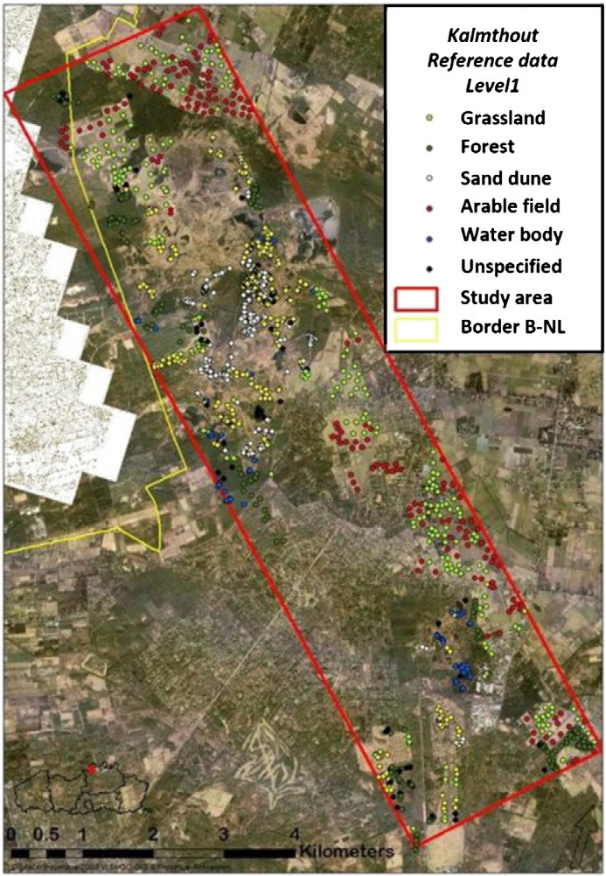

Fig. 2. Study area and ground sampling locations.
decision tree building (see Section 2.7) was not inﬂuenced by other species contributions. This subset resulted in a total of 89 pixels of the airborne data consisting of young heather plants (Y), 97 pixels Calluna of predominantly adult age (A) and 80 pixels with mixed aged (M) Calluna plants. A degeneration (‘O’, old) stage was not retained for this study, due to the very limited number of ﬁeld refer- ence plots of this class that were found in the study site.

    - Remote sensing data

Airborne Hyperspectral line-Scanner radiometer (AHS-160) im- ages of the study area were acquired in June 2007 on a clear sky day around 9.30 am local solar time (9.10 am UTC, solar zenith: 39°, solar azimuth: 122°). The AHS sensor, equipped with 63 spectral bands in the reﬂective part of the electromagnetic spectrum, was mounted on a CASA C-212 airplane operated by the National Institute for Aerospace Technology (INTA). The AHS sensor design has very distinct performances depending on the spectral range considered. In the visible and near-infrared (VIS/NIR) range, bands are relatively broad (28–30 nm) and the spectral coverage is continuous from 430 up to 1000 nm. In the shortwave infrared (SWIR) range, there is an isolated band at 1600 nm. Next, there is a set of continuous, fairly narrow bands (13 nm) between 2000 and 2500 nm. The sensor has an instantaneous ﬁeld of view of 2.5 mrad (1.25 mrad optional) and a ground sampling distance (GSD) of 2.1 mrad (0.12 degrees) (Fernández-Renau et al., 2005).
Images with a spatial resolution of 2.4 by 2.4 m were radiometri- cally calibrated and accurately geo-referenced (sub-pixel accuracy) by direct georeferencing. A LIDAR Digital Elevation Model (DEM) of Flanders, with a spatial resolution of 5 m and a vertical accuracy of 7 cm, was used in support of the orthorectiﬁcation.
Atmospheric correction was performed using the CDPC (Central Data Processing Chain; Biesemans et al., 2007) with implementations equivalent to ATCOR4 (Atmospheric and Topographic Correction for Airborne Scanner Data) (Richter, 2004). Aerosol type, visibility and water vapor are crucial inputs in the atmospheric correction. Visibili- ty and water vapor were estimated from the image itself, the aerosol type was derived from sunphotometer readings. For the visibility, the methodology of Richter et al. (2006) was integrated in the CDPC. It uses only a red and near infrared band and is based on the dark veg- etation pixels in the image. An average visibility value of the dark veg- etation mask is used in the atmospheric correction procedure. The automatic determination of the water vapor is based on the algorithm of Rodger and Lynch (2001). It is calculated (and used) on a per-pixel basis because water vapor is highly variable in space and time.
The geometrically and atmospherically corrected AHS images were subsequently mosaicked into a seamless data product by using the data from the ﬂight line with the smallest View Zenith Angle (VZA) in overlapping areas. The shortwave infrared spectral region (i.e., from band 21 (1585.8 nm) onwards) was excluded from further analysis due to noise (water absorption) hampering a good classiﬁcation.

    - Pixel-based classiﬁcation

As a ﬁrst step in the heathland conservation status mapping, su- pervised classiﬁcation of the AHS imagery was performed, using a hi- erarchically organized classiﬁcation legend with four levels (Table 1). To do so, Linear Discriminant Analysis (Fischer, 1936) in combination with a sequential ﬂoating forward selection (Pudil et al., 1994) of the most informative bands (LDA-SFFS) was implemented in C++ code. LDA minimizes the ratio of the within-class over the between-class scatter matrices. Once the ﬁrst variable is selected, a second variable is added for which the combination of both gives the best score for the criterion, and so on. After each forward step, one or more back- ward steps are taken, i.e., removing a previously selected variable to see if the separability measure can be increased at that level. This

feature extraction algorithm is generic, in a sense that it performs well, re- gardless of the nature and complexity of the application and sensor char- acteristics (i.e., number and width of spectral bands) (Kempeneers et al., 2005). Compared to other algorithms, the LDA-SFFS performed very well in classifying broad habitat classes (level 1 up to 3, Table 1) (Haest et al., 2010). However, when detailed, local conservation status (level 4) had to be assessed, some limitations were faced, especially in the distinction be- tween the different Calluna age classes.
As this study focuses on the detailed, local conservation status (level 4), an additional LDA-SFFS classiﬁcation was performed on only the pixels which were earlier classiﬁed at level 3 as “Calluna vulgaris dominated heathland”, which is characteristic for 4030 Euro- pean dry heaths and 2310 dry sand heaths with Calluna and Genista. All ﬁeld reference data of the three most dominant age classes were used for training (young, mixed and adult). Due to the main interest in heather age classes, classiﬁcation results from the other classes were omitted in this manuscript. For a complete overview of the four-level hierarchical classiﬁcation of the Kalmthoutse Heide study area, the reader is referred to Haest et al. (2010).

    - Spectral mixture analysis

As stated above (in Section 2.5), the traditional pixel-based classi- ﬁcation approach did not fulﬁl our needs with respect to local conser- vation status mapping (level 4). This was especially true for the Calluna vulgaris dominated heathland areas in which the different Calluna age classes could not be identiﬁed appropriately. In an at- tempt to address this issue we implemented a subpixel classiﬁcation. To do so, we ﬁrst selected the dry heathland cover class with Calluna vulgaris dominated heathland and performed a MESMA (Multiple Endmember Spectral Mixture Analysis). By doing so, some structural features from within the pixel are also incorporated into the decision on the age class of the heather plants. The aim of the subpixel classi- ﬁcation technique is thus to allow a more detailed classiﬁcation of level 3 classiﬁed Calluna vulgaris pixels in different age classes on the basis of which an even better estimation can be made of the con- servation status of the habitat.
The basic linear Spectral Mixture Analysis (SMA) model describes a mixed spectrum (r) as a linear combination of pure spectral signa- tures of its constituent components (i.e., endmembers), weighted by their subpixel fractional cover, and can be formulated as (Somers et al., 2009):

m
r ¼ Mf þ ε with X f j ¼ 1 and 0≤f j≤1 ð1Þ
j¼1

In Eq. (1) M is a matrix wherein each column corresponds to the spectral signal of a speciﬁc endmember. f is a column vector [f1,…, fm]T denoting the cover fractions occupied by each of the m endmembers in the pixel. ε is the error term. In this study the estima- tion of fractions was based on least squares error (LSE) regression analysis (Barducci & Mecocci, 2005):
Based on the inherent structural differences between the different heather age classes (see Section 2.2), sand, shadow and Calluna heather were selected as suitable endmembers. For this, only a subset of the ﬁeld reference dataset was used: 35 pixels with 100% sand cover and 35 pixels with 100% cover of young Calluna plants. Reﬂec- tance signatures of these pixels were extracted from the AHS imagery to be used as endmember spectra in the spectral mixture analysis. The shadow endmember was simulated as a spectrum with zero to 5% re- ﬂectance over the whole spectral region (Somers et al., 2010). The resulting endmember spectra and their corresponding 95% conﬁ- dence intervals are presented in Fig. 3.
Once the pure endmember spectra were set, the MESMA model was applied to 266 reference pixels with over 95% of heather cover- age (89 pixels of young heather plants (Y), 97 pixels of adult plants
(A) and 80 pixels with mixed aged plants (M)). The sub-pixel fraction estimates of sand, shadow and Calluna were subsequently used as input training data to build the decision tree classiﬁcation model.

    - Decision tree classiﬁer

Classiﬁcation trees recursively partition categorical response vari- ables (in this case: heather age class, being one of three categories: adult (A), young (Y), and mixed (M)) into subsets based on their re- lationship to the predictor variables (fractions of sand, Calluna and shadow in this study; Breiman et al., 1984). Resulting trees present a series of splits based on ﬁnding the one predictor variable and a threshold that results in the greatest change in explained deviance. There is no implicit assumption on the underlying relationships be- tween the predictor variables and the dependent variable. Classiﬁca- tion trees are particularly well suited when little knowledge, on which and how variables are related, is available. In this study, we wanted to clarify the relation between Calluna age classes and the subpixel fraction estimates (for sand, shadow and Calluna) obtained by MESMA, and as such, assess the numerical trade-offs in endmember cover fractions between the different age classes. Tree-based classiﬁca- tion was performed via the Rpart library (Maindonald & Braun, 2003;

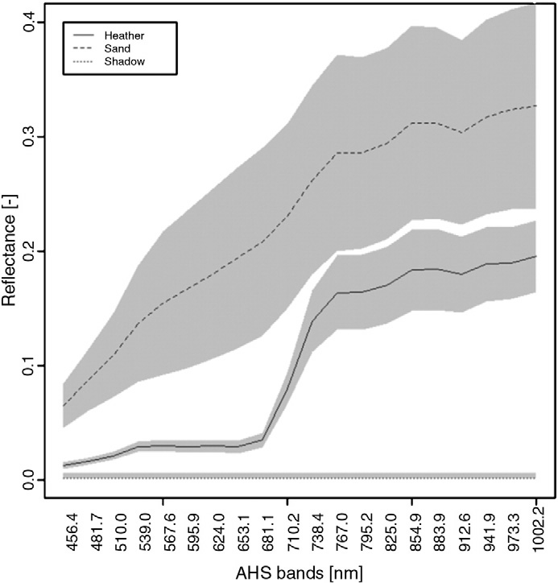n n 0 m 12
( \

X εi2 ¼ X X
@
Mi;j x f j
−riA
ð2Þ

i¼1
i¼1
j¼1

In Eq. (2) n is the number of available spectral bands.
Traditional SMA has been repeatedly shown to fall short in fully accounting for the spectral variability associated with spatial and temporal changes in the endmembers. Several methods have been proposed to overcome these limitations, of which MESMA is by far the most widely used (Somers et al., 2011). Roberts et al. (1998) pro- posed this algorithm to decompose spectral mixtures by using nu- merous endmember combinations in an iterative procedure. In this study, MESMA was iterated 10 times.

Fig. 3. Reﬂectance spectra and 95% conﬁdence interval of ‘Sand’, ‘Heather’ and ‘Shadow’
endmembers used in MESMA.

Thernau & Atkinson, 1997) of the computational language R using the same set of reference pixels referred to in Section 2.6.

    - Accuracy assessment and map agreement

Classiﬁcation accuracy assessment was obtained through analyz- ing the error or confusion matrices for both the LDA and decision tree classiﬁcation method, using the subset of plots with 95% or higher heather coverage (as estimated in the ﬁeld) as a reference. Producer Accuracy (PA), User Accuracy (UA), Overall accuracy (OA), and Kappa coefﬁcient (κ) were calculated as described in literature (Congalton, 1991; Congalton et al., 1983; Kalkhan et al., 1997; Smits et al., 1999).
Also the conﬁdence interval for each of these accuracies was calcu- lated. Given an unbiased sample of size n, with nt successes, the pro- portional accuracy (p) and its standard deviation (s) are estimated as (Rossiter, 2004):

nt
  - Results and discussion

    - Pixel-based classiﬁcation

Haest et al. (2010) already showed that broad land cover classes (i.e. heathland, grassland, forest, sand dunes, water and arable land) were almost perfectly classiﬁed with the SFFS-LDA classiﬁcation method (OA= 0.93 and κ= 0.92). Even for a more detailed classiﬁca- tion (level 4 in the classiﬁcation scheme), the results were satisfying, with overall accuracies up to 0.74. In this study, the overall accuracy of the SFFS-LDA classiﬁcation even increased to 0.81 ± 0.047 (95% conﬁdence interval) when only Calluna vulgaris dominated heathland pixels were used (Fig. 4; other classes were masked from the image). However, careful examination of the confusion matrix shown in Table 3 revealed that most of the level 4 classiﬁcation errors could be attributed to a failure in discriminating adult age classes from mixed (i.e., young and adult; PA= 0.74 ± 0.096 and UA= 0.72 ± 0.097) age classes.
Since revealing the presence and extent of different developmen-

p
n
rpﬃﬃﬃ⋅ﬃﬃﬃﬃ1ﬃﬃﬃ−ﬃﬃﬃﬃpﬃﬃﬃﬃﬃ
s ¼ ð Þ
n
ð3Þ

ð4Þ
tal stages of Calluna (i.e., mixed class) is essential information in the light of the conservation status assessment of heathland ecosystems, the conventional LDA classiﬁcation technique reached limited accura- cy for detailed conservation status mapping.

If the sample size is large enough, the conﬁdence interval of the estimate may be approximated as:

p ± ½s⋅Z1−α ð5Þ
where Z1 −α is the two-tailed normal score for the probability of Type I error α. For a 5% probability of a Type I error, the corresponding area under the normal curve is Pr = 0.95, which is obtained for the two-tailed test with Z = 1.96.
Subsequently, the relative accuracies of both maps were compared by calculating which of them had a lower error frequency over the whole map.

jp1 −p2 j
    - Spectral mixture analysis and decision tree classiﬁcation

In order to enable a more detailed insight into heather age struc- ture, sub-pixel unmixing analysis followed by a decision tree classiﬁ- cation was applied on a level 3 classiﬁed Calluna vulgaris dominated heathland image. This level 3 image was obtained by pixel based clas- siﬁcation (LDA-SFFS) of the AHS image in 20 classes (see Table 1). Results of the tree based classiﬁcation of MESMA cover fractions are given in Table 3. An overall accuracy of 0.86 ± 0.042 was hereby obtained. Comparison of the relative accuracies of both the LDA and MESMA classiﬁcation, resulted in a Z-score of 0.793 with a two- sided P-value of 0.43. Therefore, the two-tailed probability that the MESMA map is more accurate than the LDA map is 57%. A similar cal- culation for the producers accuracy resulted in a better estimation of

Z ¼ qﬃﬃﬃﬃﬃﬃﬃﬃﬃﬃﬃﬃﬃﬃﬃ
ð6Þ
adult pixels by the MESMA‐decision tree classiﬁcation with a proba-

s2 2

1 þ s2

Although this is a commonly used approach in remote sensing, it does assume that the samples under comparison are independent, which is not the case when aiming to evaluate the relative accuracy of different image classiﬁers (Foody, 2004). Although the error arising from this situation may be small, we opted to additionally express the accuracy as the proportion correct allocation according to Agresti (1996) and Foody (2004). For related samples, the statistical signiﬁ- cance of the difference between two proportions is thereby based on the evaluation upon a chisquare distribution. The test equation may be expressed as:

ðf 12−f 21Þ
2
bility of 86%, and for mixed class with a probability of 76%. However,
the LDA classiﬁcation proved better for estimating the young heather classes with a probability of 93%.
Using the method of Foody (2004), the comparison of both maps was based on Eq. (7). The χ2 test results are shown in Table 3. As can be deducted from these values, both methods differ signiﬁcantly for all age classes. Although performance differences cannot be made sim- ply by comparing conﬁdence intervals of accuracies for the mixed clas- ses (88%± 7.1 PA and 80% ± 8.4 UA for M, Table 3), the decision tree based method performed signiﬁcantly better (p = 0.041) in estimating the mixed class pixels compared to the supervised LDA classiﬁcation (Table 3). However, it is clear that the accuracies of the young heather class were signiﬁcantly lower for the MESMA tree based classiﬁcation method. Possible reasons for this are described in the discussion section
(see Section 3.4).

χ2 ¼

ðf 12 þ f 21 Þ
ð7Þ

The resulting classiﬁcation tree has three splits and four terminal nodes. The endmembers sand and shadow are selected by the deci-

with the derived value compared against tabulated χ2 values to indi-
cate its statistical signiﬁcance (α= 0.05). Both rows and columns of the new confusion matrix represent mapped data. The reader is re- ferred to Table 2 for the deﬁnition of the matrix elements used in Eq. (7).
To see how well the two maps agreed, the map produced using the conventional pixel-based classiﬁcation was compared to the map generated using the subpixel decision tree. The degree of agreement and disagreement was calculated. Finally, the maps were also evalu- ated by ecological experts.
sion tree model to make a distinction between young, adult and mixed heather classes. The top decision node splits the 266 pixels in

Table 2
The deﬁnition of the matrix elements used in Eq. (7).
Allocation | Correct | Incorrect
Classiﬁcation 1
Correct Incorrect | f11 f21 | f12 f22

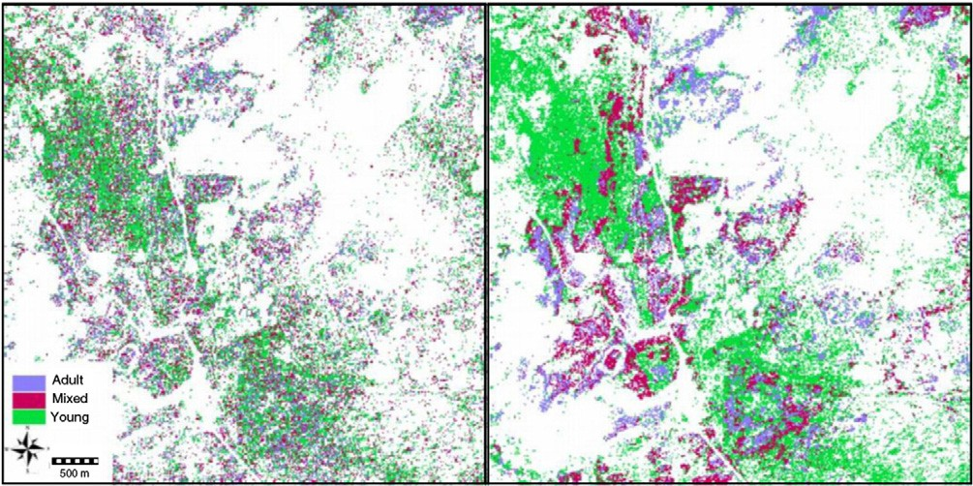

Fig. 4. Left: Pixel-based classiﬁcation of the heathland area in the Kalmthoutse Heide study area. Right: sub-pixel classiﬁcation of the heathland area in the Kalmthoutse Heide with different age classes according to the decision model of the unmixing-based tree classiﬁcation.

‘mixed or adult classes’ and ‘mixed or young classes’ based on the percentage bare sand in each pixel. When the results of MESMA indi- cate the presence of more than 7% sand in a pixel, the pixel will be assigned to a mixed or young heather class depending on the amount of shadow (more than 16% shadow is ‘mixed’, else ‘young’ heather plants). In the other case (less than 7% sand), the pixel is assigned to either adult (if more than 1% shadow) or mixed (if less than 1% shadow).
The ﬁrst decision rule based on the amount of sand in a pixel can ecologically be justiﬁed. It is indeed expected that heather at the adult stage is dense and well-established covering most of the soil surface. According to a study by Barclay-Estrup and Gimingham (1969), Calluna cover approaches 100% in the building phase and 80% in the mature phase. There are instances when the canopy of Calluna is so dense that no other plants co-exist. Young heather plants are small and therefore a substantial part of the sandy topsoil may be exposed in the pixel.
The distinction between young and mixed habitats is made by the degree of shadow. Young, small heather plants are likely to cast less shadow than mixed pixels and are indeed classiﬁed as having ‘less than 16% shadow’. Pixels containing more than 7% sand and more than 16% shadow are classiﬁed as mixed heather. The same is the

Table 3
Error matrices and comparison of the supervised LDA-SFFS and MESMA classiﬁcations on Calluna vulgaris.
 | Field class
 | A | M | Y | User Acc. + err
LDA-SFFS
A | 71 | 21 | 3 | 75%± 8.7
M | 23 | 59 | 0 | 72%± 9.7
Y | 3 | 0 | 86 | 97%± 3.5
Prod. Acc+ err | 73%± 8.8 | 74%± 9.6 | 97%± 3.5
MESMA
A | 86 | 8 | 7 | 85%± 6.9
M | 7 | 70 | 10 | 80%± 8.4
Y | 4 | 2 | 72 | 92%± 6.0

Prod. Acc 89%± 6.2 88%± 7.1 81%± 8.1
Comparison – proportion

correct
Chi sq 6.82 4.17 14.20
P-value (df =1) p = 0.009 p = 0.041 p = 0.0001
case for pixels with less than 7% sand, and less than 1% shadow. A pixel with less than 7% sand and more than 1% shadow is classiﬁed as adult heather. The adult heather plant is indeed expected to pro- duce more shadow than a young plant and has a quite dense canopy cover.
Overall, the results obtained from this classiﬁcation exercise were explained by natural heather structure. The decision rules obtained from the decision regression tree analysis were used to divide all level 3 Calluna pixels in three main heather age classes. This resulted in 22% adult pixels, 17% mixed pixels and 61% young pixels, as shown in Fig. 4.

    - Map evaluation

The results of the subpixel decision tree classiﬁcation were subse- quently compared to those of the conventional pixel-based classiﬁca- tion. The degree of agreement and disagreement is shown in Fig. 5. Only 47% of the pixels were identically classiﬁed by both classiﬁcation methods. In 10% of the pixels, confusion exists between young and adult age classes. For 24% of the pixels, the classiﬁcation techniques differ in classifying adult and mixed heather classes. Finally in 19% of the pixels both methods differ in assigning a young or mixed age class to the pixel.
The heather age class maps of both methods were also taken into the ﬁeld in 2012 for evaluation by trained ecologists. Overall, experts felt that the MESMA-result provided a more realistic, intuitive and useful result in delineating patches of similar (or mixed) heather age classes, compared to the salt-and-pepper effect on the LDA-map. Unfortunately, an evaluation at pixel-level was not possi- ble, not in the least due to the occurrence of mixed pixels and the in- herent difﬁculties of recognizing heather age classes in the ﬁeld. In reality, many transitions exist, making it difﬁcult to clearly attribute an age class to every single heather plant. However, even the MESMA-result suffered from obvious ﬂaws, in that it tended to place several non-heather dominated patches into the ‘young heath- er’ class. In most cases where purple moorgrass (Molinia caerulea) was observed to encroach upon Calluna, the area was classiﬁed as young heather, irrespective of the age class of the Calluna plants. The resulting confusion between Molinia and Calluna likely accounts for the overestimate of the young class, which was mapped at 61%, higher than expected according to ecological expert knowledge of the study region. A more thorough distinction of Calluna-dominated pixels from other categories during LDA classiﬁcation, and hence be- fore the application of MESMA, could alleviate this problem.

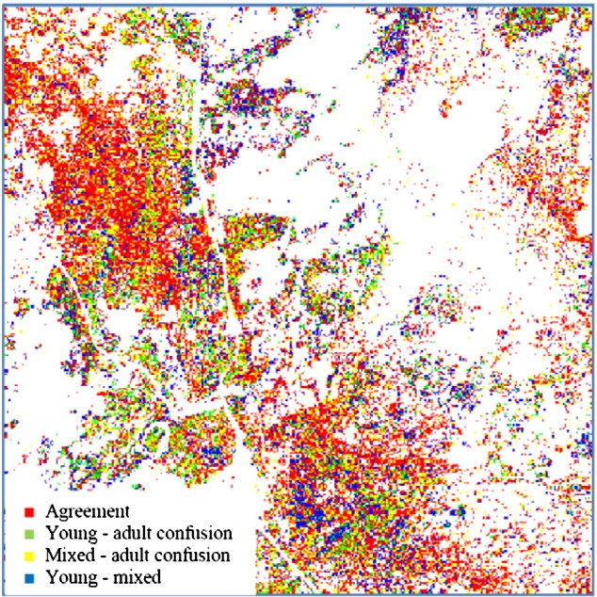

Fig. 5. Level of agreement and disagreement between the pixel-based LDA and the sub-pixel based decision tree heather age class classiﬁcations. (For interpretation of the references to color in this ﬁgure legend, the reader is referred to the web version of this article.)

    - Discussion

Earlier research showed that pixel- and object-based classiﬁcation techniques are well-suited for broad habitat mapping, but the accura- cy decreases with increasing level of detail and complexity and for ill-deﬁned classes (e.g., Haest et al., 2010; Lucas et al., 2007). Often, the devil lies in the detail which is the heterogeneity within a pixel. A better insight in the sub-pixel composition could therefore be expected to be beneﬁcial when aiming for a highly detailed classiﬁca- tion, analogous to the beneﬁts of applying unmixing procedures for the classiﬁcation of broad habitat classes (e.g. Lucas et al., 2002; Peddle et al., 1999; Shanmugam et al., 2006). Moreover the use of de- cision tree classiﬁers has been reported to outperform other nonpara- metric classiﬁers for vegetation classiﬁcation mapping (Borak & Strahler, 1999; Rogan et al., 2002), with overall accuracies typically higher by 10%.
Indeed, compared to a traditional pixel-based classiﬁcations, the sub-pixel oriented analysis of a hyperspectral image showed some clear advantages for the ﬁne-scale conservation status assessment of heathland. In the ﬁrst place, the heathland map based on the sub-pixel unmixture analysis seems to be much more realistic, with the occurrence of larger patches of the same age classes and showing less salt-and-pepper effect as observed in the pixel-based classiﬁca- tion. Furthermore, the accuracy increased when the subpixel compo- sition was included in the image analysis. The discrimination of mixed and adult classes was signiﬁcantly better for the unmixing model. For young heather, however, both user and producer accuracy were signiﬁcantly lower when subpixel information was included in the classiﬁcation. As already mentioned in the previous paragraph, the LDA classiﬁcation result from which we extracted the Calluna map encompassed Molinia encroached heathland, which was not taken into account in the unmixing step. Since no Molinia endmembers were selected in the unmixing process, one can expect that Molinia will most resemble the heather endmember, which is the only ‘vegeta- tion’ endmember in the MESMA. If this is the case, the occurrence of Molinia would lead to an overestimation of the Calluna fractions, and subsequently lead to a classiﬁcation as of mixed age, which — according to the classiﬁcation tree — has the highest portions of Calluna, However,
the structure and signature of Molinia is more complex: it typically con- sists of freshly grown green sprouts embedded in a bunch of accumulat- ed old, dry leaves that often appear light brown, or even slightly sand-coloured. In the range of 400–1000 nm, the spectra of dry leaves more strongly resemble the sand spectra than the Calluna vegetation spectra. As a result, Molinia encroachment is therefore expected to in- crease the estimated sand fractions, thus increasing the chance that a pixel is classiﬁed as young Calluna. Consequently, these pixels are most often classiﬁed as young Calluna, in the unmixing step irrespective of the real age class.
It is well known and crucial for MESMA classiﬁcation that all rele- vant endmembers should be included in the analysis, and failure to do so may lead to inaccurate results, especially for the pixels where an important endmember is missing. To account for Molinia encroach- ment, at least two endmembers should be added to the model: one for the accumulated leaf litter and one for the green sprouts of the current growing season. Alternatively, one could strive for a better classiﬁcation of the heathland at a higher level, so that MESMA can be restricted to the pixels without any indication of grass encroach- ment. By doing so, only a fraction of the heather will be assessed, but this does not mean that ecological relevance is lost: grass en- croachment is considered to be a much more severe conservation problem than the lack of varied age classes and thus structural diver- sity. When heather vegetations are (heavily) encroached by Molinia, they can be considered as being in a poor conservation status, irrespective of the age structure of the heather. Knowledge on the age classes is thus most relevant for the pure heather pixels, hence ﬁrst focussing on grass encroachment and in a second step consider- ing the age structure for only the purest heather vegetations is in this view a valid option.
A major advantage of the unmixing method is its transparency. The combination of unmixing and decision tree classiﬁcation tech- niques approaches rule-based classiﬁcation, which often employ sim- ple rules that are understandable for potential users (e.g. Lucas et al., 2007; Thoonen et al., 2010). These approaches for the classiﬁcation of semi-natural habitats are more transparent to the users and attempt to bridge the gap between ecological understanding and remote sens- ing classiﬁcation by including ecological knowledge in the classiﬁca- tion rules. In this study, fractional abundances of sand, shadow and heather were estimated for each heather pixel as a basis to conclude on the age class of the heather plants. From an ecological point of view, these endmembers are comparable to the endmembers select- ed by Lucas et al. (2007) (soil, water, shade and vegetation) to classify upland and marginal vegetation. Although these authors were focus- ing on a broader scale, they provided a promising framework for a more detailed mapping of habitat structure by simply adapting or re- ﬁning the rules. Although surveyors do not always consider or mea- sure these endmembers during their ﬁeldwork, there is no doubt on the relation between the selected endmembers and ecologically rele- vant structures or classes. As these attributes can be estimated from remote sensing data or fraction estimates thereof, they can be very useful to help in a very detailed classiﬁcation of local conservation status as presented here.
Ecological knowledge may further provide empirically underpinned ranges for pixel composition to enhance the ecological interpretation of the decision tree results. These fraction images may also be very useful to link with the natural incidence of, for example, ﬁre in an ecosystem and its ecological effects. The proposed technique provides a new way of analyzing and deriving insights into the horizontal structural proper- ties of heather vegetation in order to monitor its ecological functioning in the ecosystem. By doing so, an important step can be made toward a more quantitative approach to monitor different heather age classes in a reliable and repeatable way. The heather age maps created in this au- tomated way will then prove useful to ecologists to report on habitat status for e.g. Natura 2000 and for a more efﬁcient steering of the heath- land management system.

In further research, it would be interesting to test the presented approach on other ecosystems with a high heterogeneity and high mixture of vegetal formations, e.g., savannas, tundra, and on other habitat types in which the composition/structure within a pixel is of signiﬁcant importance to deﬁne the habitat status.

  - Conclusions

This study showed that the difﬁculties in mapping detailed habitat characteristics with optical remote sensing, i.e. high heterogeneity and high mixture of vegetal formations, can be overcome by using a combi- nation of ecological characteristics and suitable image data and analysis. Using hyperspectral imaging, the most widely used supervised classiﬁ- cation techniques enable an accurate mapping of vegetation classes up to a certain detail, but the spatial resolution of even the most advanced airborne hyperspectral sensors limits the differentiation of certain ﬁne- scale vegetation characteristics, needed to assess the local conservation status of habitats in a spatially explicit manner. In this study, we success- fully introduceda new approach to dealing with this problem by using subpixel spectral unmixing techniques that extract pixel compositions of ecologically relevant classes (i.e. endmembers). The speciﬁc structural characteristics of heather age classes were thereby used to guide the analysis and enhance the ecological value of information derived from remote sensing data.

Acknowledgements

We thankfully acknowledge that the research leading to these results received funding from the Belgian Science Policy Ofﬁce in the frame of the Stereo II programme (Habistat project — contract SR/00/103, Hypermix project — SR/00/141 and Vegemix project — SR/67/146) and the European Community's Seventh Framework Programme (FP7/2007-2013) under grant agreement no 263479. Also many thanks to all Habistat project partners including, INBO, VUB, UA, and Alterra.

References

Aerts, R., & Heil, G. W. (1993). Heathlands: Patterns and processes in a changing environ- ment. Dordrecht, The Netherlands: Kluwer Academic Press.
Agresti, A. (1996). An introduction to categorical data analysis. New York, N.Y.: Wiley 312 pp.
Alexandridis, T. K., Lazaridou, E., Tsirika, A., & Zalidis, G. C. (2009). Using Earth Obser- vation to update a Natura 2000 habitat. Journal of Environmental Management, 90, 2243–2251.
Anderson, P. (1995). Ecological restoration and creation: A review. Biological Journal of the Linnean Society, 56, 187–211.
Anon (1992). Habitats directive: Council directive 92:43/EEC of 21 May. .
Barclay-Estrup, P., & Gimingham, C. H. (1969). The description and interpretation of cy- clical processes in a heath community: I. Vegetational change in relation to the calluna cycle. Journal of Ecology, 57, 737–758.
Barducci, A., & Mecocci, A. (2005). Theoretical and experimental assessment of noise effects on least-squares spectral unmixing of hyperspectral images. Optical Engi- neering, 44, 087008.
Biesemans, J., Sterckx, S., Knaeps, E., Vreys, K., Adriaensen, S., Hooyberghs, J., et al. (2007). Image processing workﬂows for airborne remote sensing. Proceedings of the 5th EARSel Workshop on Imaging Spectroscopy, Bruges, Belgium, April 23-25.
Bock, M., Xoﬁs, P., Rossner, G., Wissen, M., & Mitchley, J. (2005). Object oriented methods for habitat mapping in multiple scales: Case studies from Northern Germany and North Downs GB. Journal for Nature Conservation, 13, 75–89.
Borak, J. S., & Strahler, A. H. (1999). Feature selection and landcover classiﬁcation of a MODIS-like data set for a semiarid environment. International Journal of Remote Sensing, 20, 919–938.
Breiman, L., Freidman, J. H., Olshen, R. A., & Stone, C. J. (1984). Classiﬁcation and regression trees. : Wadsworth.
Bunce, R. G. H., Groom, G. B., Jongman, R. H. G., & Padoa-Schioppa, E. (2005). Handbook for surveillance and monitoring of European habitats (1st edition), pp. 86. Wageningen: Alterra Report nr 1219.
Cantarello, E., & Newton, A. C. (2008). Identifying cost-effective indicators to assess the conservation status of forested habitats in Natura 2000 sites. Forest Ecology and Management, 256, 815–826.
Congalton, R. G. (1991). A review of assessing the accuracy of classiﬁcations of remotely sensed data. Remote Sensing of Environment, 37, 35–46.
Congalton, R. G., Oderwald, R. G., & Mead, R. A. (1983). Assessing Landsat classiﬁcation accuracy using discrete multivariate analysis statistical techniques. Photogrammetric Engineering and Remote Sensing, 49, 1671–1678.
De Blust, G. (2007). Chapter 11. In B. Pedroli, A. Van Doorn, G. De Blust, M. L. Paracchini,
D. Wascher, & F. Bunce (Eds.), Europe's living landscapes. Essays on exploring our identity in the countryside. : Landscape Europe / KNNV.
De Blust, G., & Slootmaekers, M. (1997). De Kalmthoutse heide. Leuven: Davidsfonds 142 pp.
Desender, K., Dekoninck, W., Dufrêne, M., & Maes, D. (2010). Changes in the distribu- tion of carabid beetles in Belgium revisited: Have we halted the diversity loss? Bi- ological Conservation, 143(6), 1549–1557.
Diemont, W. H., & Oude Voshaar, J. H. (1994). Effects of climate and management on the productivity of Dutch heathlands. Journal of Applied Ecology, 31, 709–716.
Fernández-Renau, A., Gómez, J. A., & De Miguel, E. (2005). The INTA AHS system. Proceedings of SPIE, 5978, 471–478.
Fischer, R. A. (1936). The use of multiple measurements in taxonomic problems. Annals of Eugenics, 7, 179–188.
Fisher, P. (1997). The pixel: a snare and a delusion. International Journal of Remote Sensing, 18(3), 679–685.
Foody, G. M. (2004). Thematic Map Comparison: Evaluating the Statistical Signiﬁcance of Differences in Classiﬁcation Accuracy. Photogrammetric Engineering and Remote Sensing, 70(5), 627–633.
Förster, M., Frick, A., Walentowski, H., & Kleinschmit, B. (2008). Approaches to utilising QuickBird data for the monitoring of NATURA 2000 habitats. Community Ecology, 9(2), 155–168.
Frick, A., Weyer, G., Kenneweg, H., & Kleinschmitt, B. (2005). A Knowledge-based ap- proach to vegetation monitoring with Quickbird imagery. ISPRS Workshop 2005 - High- Resolution Earth Imaging for Geospatial Information, May 17- 20, 2005, Hannover.
Gross, J. E., Goetz, S. J., & Cihlar, J. (2009). Application of remote sensing to parks and protected area monitoring: Introduction to the special issue. Remote Sensing of Environment, 113, 1343–1345.
Haest, B., Thoonen, G., Vanden Borre, J., Spanhove, T., Delalieux, S., Bertels, L., et al. (2010). An object-based approach to quantity and quality assessment of heathland habitats in the framework of NATURA 2000 using hyperspectral airborne AHS images. Proceedings submitted to GEOBIA 2010 – the Geographic Object-Based Image Analysis Conference, 29 June – 2 July 2010, Ghent, Belgium.
Hearn, S. M., Healey, J. R., McDonald, M. A., Turner, A. J., Wong, J. L. G., & Stewart, G. B. (2011). The repeatability of habitat mapping. Journal of Environmental Management, 92, 1174–1184.
Hooftman, D. A. P., & Bullock, J. M. (2012). Mapping to inform conservation: a case study in semi-natural habitats and their connectivity over 70 years. Biological Conservation, 145, 30–38.
Kalkhan, M. A., Reich, R. M., & Czaplewski, R. L. (1997). Variance estimates and conﬁ- dence intervals for the Kappa measure of classiﬁcation accuracy. Canadian Journal of Remote Sensing, 23, 210–216.
Kempeneers, P., De Backer, S., Debruyn, W., Coppin, P., & Scheunders, P. (2005). Generic wavelet-based hyperspectral classiﬁcation applied to vegetation stress detection. IEEE Transactions on Geoscience and Remote Sensing, 43, 610–614.
Lucas, R., Rowlands, A., Brown, A., Keyworth, S., & Bunting, P. (2007). Rule-based classiﬁcation of multi-temporal satellite imagery for habitat and agricultural land cover mapping. ISPRS Journal of Photogrammetry and Remote Sensing, 62, 165–185.
Lucas, N. S., Shanmugam, S., & Barnsley, M. (2002). Sub-pixel habitat mapping of a costal dune ecosystem. Applied Geography, 22, 253–270.
Maindonald, J., & Braun, J. (2003). Data analysis and graphics using R: an example based ap- proach. Tree-based Classiﬁcation and Regression (pp. 259–280). Cambridge: Cambridge University Press.
McDermid, G. J., Franklin, S. E., & LeDrew, E. F. (2005). Remote sensing for large-area habitat mapping. Progress in Physical Geography, 29, 449–474.
Mehner, H., Cutler, M., Fairbairn, D., & Thompson, G. (2004). Remote sensing of upland vegetation: The potential of high spatial resolution satellite sensors. Global Ecology and Biogeography, 13, 359–369.
Newton, A., Hill, R. A., Echeverria, C., Golicher, D., Rey Benayas, J. M., Cayuela, L., et al. (2009). Remote sensing and the future of landscape ecology. Progress in Physical Geography, 33, 528–546.
Odé, B., Groen, K., & De Blust, G. (2001). Het Nederlandse en Vlaamse heidelandschap.
De Levende Natuur, 102, 145–149.
Peddle, D. R., Hall, F. G., & LeDrew, E. F. (1999). Spectral Mixture Analysis and Geometric-Optical Reﬂectance Modeling of Boreal Forest Biophysical Structure. Remote Sensing of Environment, 67, 288–297.
Piessens, K., & Hermy, M. (2006). Does the heathland ﬂora in north-western Belgium show an extinction debt? Biological Conservation, 132(3), 382–394.
Pudil, P., Novovievova, J., & Kittler, J. (1994). Floating search methods in feature selection.
Pattern Recognition Letters, 15, 108–119.
Ramsey, E. W., & Jensen, J. R. (1996). Remote sensing of mangrove wetlands: relating canopy spectra to site-speciﬁc data. Photogrammetric Engineering and Remote Sensing, 62(8), 939–948.
Richter, R. (2004). Atmospheric/ Topographic Correction for airborne Imagery. ATCOR-4 user guide version 3.1. Wessling, Germany: DLR.
Richter, R., Schläpfer, D., & Müller, A. (2006). An automatic atmospheric correction al- gorithm for visible/NIR imagery. International Journal of Remote Sensing, 27, 2077–2085.
Roberts, D. A., Gardner, M., Church, R., Ustin, S., Scheer, G., & Green, R. O. (1998). Mapping Chaparral in the Santa Monica Mountains Using Multiple Endmember Spectral Mixture Models. Remote Sensing of Environment, 65, 267–279.

Rodger, A., & Lynch, M. J. (2001). Determining atmospheric column water vapour in the 0.4-2.5 μm spectral region. Proceedings of the AVIRIS Workshop 2001 (Pasadena, California, USA).
Rogan, J., Franklin, J., & Roberts, D. A. (2002). A comparison of methods for monitoring multitemporal vegetation change using Thematic Mapper imagery. Remote Sensing of Environment, 80, 143–156.
Rossiter, D. G. (2004). Statistical methods for accuracy assessment of classiﬁed thematic maps. Technical Note 46 pp.
Roughgarden, J., Running, S. W., & Matson, P. A. (1991). What does remote sensing do for ecology? Ecology, 72, 1918–1922.
Shanmugam, P., Ahn, Y. H., & Sanjeevi, S. (2006). A comparison of the classiﬁcation of wetland characteristics by linear spectral mixture modelling and traditional hard classiﬁers on multispectral remotely sensed imagery in southern India. Ecological Modelling, 194, 379–394.
Smits, P. C., Dellepiane, S. G., & Schowengerdt, R. A. (1999). Quality assessment of image classiﬁcation algorithms for land-cover mapping: a review and a proposal for a cost-based approach. International Journal of Remote Sensing, 20, 1461–1486.
Søgaard, B., Skov, F., Ejrnæs, R., Pihl, S., Fredshavn, J., Nielsen, K. E., et al. (2007). Criteria for favourable conservation status in Denmark. Natural Habitat Types and Species Covered by the EEC Habitats Directive and Birds Covered by the EEC Birds Directive. Aarhus: National Environmental Research Institute (NERI).
Somers, B., Asner, G. P., Tits, L., & Coppin, P. (2011). Endmember Variability in Spectral Mixture Analysis: a review. Remote Sensing of Environment, 115, 1603–1616.
Somers, B., Delalieux, S., Verstraeten, W. W., van Aardt, J. A. N., Albrigo, G. L., & Coppin, P. (2010). An automated wavelength selection technique for optimized hyperspectral mixture analysis. International Journal of Remote Sensing, 31, 5549–5568.
Somers, B., Delalieux, S., Verstraeten, W. W., Verbesselt, J., Lhermitte, S., & Coppin, P. (2009). Magnitude- and Shape-Related Feature Integration in Hyperspectral Mixture Analysis to Monitor Weeds in Citrus Orchards. IEEE Transactions on Geoscience and Remote Sensing, 47, 3630–3642.
Spanhove, T., Vanden Borre, J., Delalieux, S., Haest, B., & Paelinck, D. (2012). Can remote sensing estimate ﬁne-scale quality indicators of natural habitats? Ecological Indicators, 18, 403–412.
T'jollyn, F., Bosch, H., Demolder, H., De Saeger, S., Leyssen, A., Thomaes, A., et al. (2009).
Criteria voor de beoordeling van de lokale staat van instandhouding van de Natura
2000-habitattypen. Versie 2.0. Brussels: Research Institute for Nature and Forest (INBO).
Terry, A. C., Ashmore, M. R., Power, S. A., Alchin, E. A., & Heil, G. W. (2004). Modelling the impacts of atmospheric nitrogen deposition on Calluna-dominated ecosystems in the UK. Journal of Applied Ecology, 41, 897–909.
Thernau, T. M., & Atkinson, E. J. (1997). An introduction to recursive partitioning using the rpart routines. Technical report series, 61, Rochester.
Thoonen, G., Spanhove, T., Haest, B., Vanden Borre, J., & Scheunders, P. (2010). Habitat mapping and quality assessment of heathlands using a modiﬁed kernel-based reclassiﬁcation technique, 2707-2710. 2010 IEEE International Geoscience and Remote Sensing Symposium (pp. 2707–2710).
Vanden Borre, J., Paelinckx, D., Mücher, C. A., Kooistra, L., Haest, B., De Blust, G., et al. (2011). Integrating remote sensing in Natura 2000 habitat monitoring: Prospects on the way forward. Journal for Nature Conservation, 19, 116–125.
Verbücheln, G., Börth, M., Hinterlang, D., Hübner, Th., Michels, C., Neitzke, A., et al. (2002). Anleitung zur Bewertung des Erhaltungszustandes von FFH-Lebensraumtypen. Reck- linghausen: Landesanstalt für Ökologie, Bodenordnung und Forsten Nordrhein Westfalen.
Vriens, L., Bosch, H., De Knijf, G., De Saeger, S., Guelinckx, R., Oosterlynck, P., et al. (2011). De Biologische Waarderingskaart. Biotopen en hun verspreiding in Vlaanderen en het Brussels Hoofdstedelijk GewestMededelingen van het Instituut voor Natuur- en Bosonderzoek. INBO.M.2011.1, Brussel9789040303142.
Wardley, N. W., Milton, E. J., & Hill, C. T. (1987). Remote sensing of structurally complex semi-natural vegetation — an example from heathland. International Journal of Re- mote Sensing, 8, 31–42.
Watt, A. S. (1955). Bracken versus Heather, A study in plant sociology. Journal of Ecology, 43, 490–506.
Webb, N. R. (1990). Changes on the Heathlands of Dorset, England between 1978 and 1987. Biological Conservation, 51, 273–286.
Webb, N. R. (1998). The traditional management of European heathlands. Journal of Applied Ecology, 35, 987–990.
Weeda, E. J., Westra, R., Westra, C., & Westra, T. (1988). Nederlandse ecologische ﬂora.
Wilde planten en hun relaties, 3, Amsterdam: IVN.
Zomer, R. J., Trabucco, A., & Ustin, S. L. (2009). Building spectral libraries for wetlands land cover classiﬁcation and hyperspectral remote sensing. Journal of Environmental Management, 90, 2170–2177.

