High genetic diversity but limited gene flow in Flemish populations of the crested newt, Triturus cristatus

Schön I.1*, Raepsaet A.1,2, Goddeeris B.1, Bauwens D.3, Mergeay J.4,5, Vanoverbeke J.5 & Martens K.1
1 Royal Belgian Institute of Natural Sciences, Freshwater Biology, Vautierstraat 29, B-1000 Brussels, Belgium
2 University of Gent, Zoology, K.L. Ledeganckstraat 35, B-9000 Gent, Belgium
3 Research Institute for Nature and Forest, Kliniekstraat 25, B-1070 Brussels, Belgium
4 Research Institute for Nature and Forest, Gaverstraat 4, B-9500 Geraardsbergen, Belgium
5 Laboratory of Aquatic Ecology and Evolutionary Biology, Catholic University of Leuven, Charles Deberiotstraat, 32, B-3000 Leuven, Belgium
* Corresponding author: isa.schoen@naturalsciences.be

ABSTRACT. Habitat destruction and fragmentation are among the major causes of amphibian decline. We investigated to what extent geographic distance and barriers affect the genetic composition of the crested newt, Triturus cristatus in Flanders (North Belgium), causing inbreeding or loss of genetic diversity. Data from seven microsatellite loci and 170 individuals from seven meta- populations up to 180km apart revealed heterozygosities of 0.53 to 0.67 within populations and moderate levels of genetic diver- gence between populations (FST values from 0.074 to 0.141, harmonic means of Dest between 0.070 and 0.189). In all Flemish
meta-populations, more than 90% of the individuals from a given geographic region were assigned to the same genetic cluster indi-
cating little genetic exchange, even in De Panne where the two populations Oosthoek and Westhoek are only a few kilometres apart. Such sub-structuring on a micro-scale has also been described in other amphibians. Unique alleles in most populations fur- ther support the probability that genetic drift has already led to some isolation. With the exception of the Oosthoek population, however, we found no significant evidence for bottlenecks. Connectivity within pool clusters seems essential to the maintenance of genetic diversity in crested newts as is indicated by our findings from Tommelen, the population with the largest number of pools in close proximity, which also shows the highest levels of heterozygosity (He and Ho) and the second highest number and richness of
alleles.
In conclusion, our study indicates that dispersal and migration rates between the Flemish populations of Triturus cristatus are limited at the geographic scale studied here but that habitat fragmentation has not yet led to a significant loss of genetic diversity of the studied Flemish populations, possibly because crested newts are relatively long-lived, fragmentation of their habitat is relatively recent in Flanders, and most investigated pools are still connected at the local scale.

KEY WORDS: Triturus cristatus, genetic variability, conservation, microsatellite, population genetics, crested newt.

INTRODUCTION

Worldwide, many populations of amphibians are rap- idly declining (HOULAHAN et al., 2000), which means that as a group, they are more threatened than many birds or mammals (STUART et al., 2004, VENCES & KÖHLER, 2008).
Although diseases have also been put forward as an explanation (JAMES et al., 2009), in industrial countries the decline is mainly attributed to habitat fragmentation and the loss of suitable breeding habitats (SODHI et al., 2008). Especially in many parts of Western Europe, the number of ponds has declined severely in recent decades (MCLEE & SCAIFE, 1993; THIESMEIER & KUPFER, 2000; NÖLLERT & NÖLLERT, 2001, DECLERCK et al., 2006).
Because these small water bodies are essential for many amphibian species, several pond conservation projects have been instigated (e.g. European Pond Conservation Network; http://campus.hesge.ch/epcn/). They have con- tributed to a growing sense of awareness and understand- ing of the necessity to conserve ponds in a rapidly chang- ing European landscape in order to protect their fauna and flora (e.g. FROGLIFE, 2001). However, little is known about the genetic constitution of typical pond species, although such knowledge is a prerequisite for effective
and efficient conservation practices (JEHLE & ARNTZEN, 2002).
The crested newt, Triturus cristatus (Laurenti 1768) has a wide distribution in central and northern Europe (NÖLLERT & NÖLLERT, 2001). Nowadays, it is mostly found inhabiting deep and vegetated pools in extensive agricultural landscapes and is thus readily influenced by human activities (GRIFFITHS, 1996; THIESMEIER & KUP- FER, 2000). The crested newt, with a typical amphibian dual lifestyle, spends more of its time in the aquatic phase than other western European newts (THIESMEIER & KUP- FER, 2000). Adults often linger in ponds until autumn, while larvae sometimes hibernate during their first year on the bottom of pools. In contrast to many other newts, young, non-reproducing individuals return to the pool in spring to exploit the abundance of food that is found there (GRIFFITHS, 1996; NÖLLERT & NÖLLERT, 2001). Triturus
cristatus is thus more dependent on suitable ponds than most other newts of the genus Triturus in Western Europe.
In Flanders (Northern Belgium), Triturus cristatus has a wide but very fragmented distribution (http:// www.hylawerkgroep.be/images/website/hi_kamsalamander/ kaart.jpg), making the species particularly vulnerable to

habitat disturbance and destruction. For example, in the Flemish region Haspengouw, the species declined by 20% from 1980-89 to 1992 and many pools held only few indi- viduals (BAUWENS & CLAUS, 1996). To develop suitable conservation plans, genetic data are required (BEEBEE, 2005). The crested newt may be even more endangered through inbreeding than most other amphibians, because homomorphism for chromosome 1 leads to 50% mortality in eggs (WALLACE, 1987).
Population genetic theory states that in small, isolated populations, inbreeding may reduce average fitness, and loss of genetic variability from random genetic drift may further reduce future adaptability (LANDE, 1988). Small and isolated populations are therefore expected to show lower levels of genetic variability than large populations that belong to a highly connected meta-population. ALTENTOFT & O’ BRIEN (2010) recently showed that genetic variation in 17 amphibian species is linked to fit- ness, emphasizing the necessity of genetic variability for evolutionary potential (FRANKHAM et al., 1999). A high degree of genetic diversity may be required for popula- tions to respond adequately to changing selective pres- sures, especially in highly dynamic anthropogenic envi- ronments. Due to negative effects of inbreeding and genetic drift, small isolated populations are more likely to disappear over time (e.g., SACCHERI et al., 1998). Assess-
ing the genetic diversity of threatened amphibian species can, therefore, provide clues for the long-term viability of their populations.

Here, we investigated the genetic variation of the crested newt, Triturus cristatus in Flanders (Northern Belgium) as an initial indication of the conservation genetic status of this species in Flanders and to facilitate further studies on smaller geographic scales. Genetic var- iability among populations was estimated using microsat- ellite markers. The studied populations are distributed over Flanders to give an overall assessment of regional genetic diversity and population genetic structure. We specifically tested predictions from population genetics theory. First, we would expect that areas with fragmenta- tion (large distances between individual pools and/or man-made barriers) show indications for population dif- ferentiation, substructuring and low levels of genetic diversity. Areas with well-connected pools, on the other hand, would be expected to harbor higher levels of genetic diversity and facilitate genetic exchange between pools. Second, we would expect the loss of suitable habi- tats in the last few decades and the fragmented distribu- tion of this species in Flanders to have induced bottle- necks and hence, have led to a loss of genetic diversity in Flemish populations of T. cristatus.

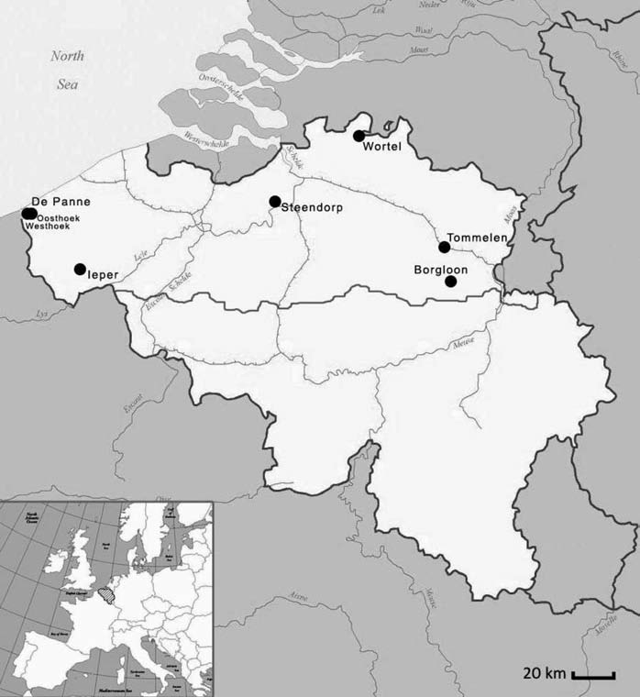
Fig. 1. – Distribution of sample localities in Flanders.

TABLE 1
Overview of sampling localities, numbers and connectivity of sampled ponds, and individuals sampled for two consecutive years.
#=number of ponds; D=maximal geographic distance between individual pools with Triturus cristatus in km (in Ieper, pools closer to each other did not contain any T. cristatus during our sampling periods); C=connec- tivity estimated as average number of pools within 1.5km, the dispersal distance of T. cristatus (GRIFFITHS, 1996) subtracting 0.1 for every barrier (roads, agricultural areas or human settlements) between pools; N=sam- pled individuals. The population from De Panne is split into Westhoek and Oosthoek in all subsequent analy- ses.
Geographic location
# ponds
Year
D
C
N

Tommelen | 15 | 2006 | 0.267 | 1.00 | 30
Ieper | 7 | 2006 | 10.500 | 0.30 | 12
 | 7 | 2007 |  |  | 35
Steendorp | 5 | 2006 | 0.931 | 0.70 | 10
 | 5 | 2007 |  |  | 20
De Panne | 8 | 2006 | 3.300 | 0.35 | 16
 | 8 | 2007 |  |  | 40
De Panne/Oosthoek | 6 | 2006 | 0.412 | 1.00 | 12
 | 2 | 2007 |  |  | 10
De Panne/Westhoek | 2 | 2006 | 0.618 | 1.00 | 4
 | 6 | 2007 |  |  | 30
Borgloon | 3 | 2006 | 0.580 | 0.80 | 5
Wortel | 1 | 2006 | 0.098 | 1.00 | 2

MATERIALS AND METHODS

We studied newts from seven localities over Flanders, up to 180km apart (Fig. 1). Triturus cristatus is protected by Belgian law; permission to capture specimens and col- lect tissue samples is administered by the Agency for Nature and Forest of the Flemish Community. In 2006, we were only permitted to sample two larvae per pool. To acquire sufficient individuals for statistically meaningful analyses, we therefore reverted to sampling clusters of breeding ponds, focusing on those pools with the highest numbers of individuals. With the exceptions of Ieper and De Panne, distances between pools with T. cristatus within a certain cluster were less than 1km (see Table 1 for the maximal distances between individual pools and Fig. 1S in the supplementary material for maps of the sampled regions). In Ieper, pools in close proximity to each other (less than 1km) did not contain any crested newts during our sampling campaigns. T. cristatus is known to migrate up to 1.5km and often wanders among different pools within a cluster during the breeding season (GRIFFITHS, 1996; THIESMEIER & KUPFER, 2000; KUPFER,
1998; but see also GRIFFITHS et al., 2010). We also calcu- lated relative connectivity of pools by dividing the number of pools within dispersal distance of T. cristatus by the overall number of sampled pools with T. cristatus and by subtracting 0.1 for every barrier between pools (roads, fields, houses etc.; see Table 1 for the sampled regions). In 2007, we obtained permission to sample five larvae per pond. In that year, we re-sampled the popula- tions from the regions De Panne, Ieper and Steendorp. At these localities, we revisited the same ponds as in 2006 and additional ponds in close vicinity. All sampled pools in 2007 were within the same maximal distance to each
other as in 2006 and also with the same relative connec- tivity. In the analyses, we pooled the data obtained in 2006 and 2007. One could wonder whether our sampling regime, which differed in the two years with respect to the number of samples per individual pond, could have biased our results. Preliminary analyses of the 2006 data (RAPSAET, 2007) revealed similar results to those with the combined samples from both years. The fact that we noticed migration between breeding pools in some clus- ters further supports our sampling design of including several individual pools per cluster rather than sampling high numbers of newts from individual pools.
Tissue from a total of 170 crested newt larvae was collected; Table 1 provides an overview of the number of ponds and specimens. Tissue samples were taken by clip- ping the tip of the tail of larval Triturus cristatus; subse- quently, larvae were released at their capture site. This procedure has no long-term effect on the development and survival of newt larvae as clipped tails are readily re- grown (ARNTZEN et al., 1999). Tail clips were stored in 95% ethanol at 4°C until further use. DNA was extracted following the standard DNeasy® Blood & Tissue Kit pro- cedure (QIAGEN).
A polymerase chain reaction (PCR) was used to amplify seven microsatellite loci, Tcri13, Tcri27, Tcri29, Tcri32, Tcri35, Tcri36 and Tcri46, following the PCR- protocols of KRUPA et al. (2002). Each forward primer was labeled with a fluorescent dye allowing automatic detection of the amplified microsatellites on an ABI 3130 Genetic Analyzer (Applied Biosystems). Following standard procedures, a 500-Liz size standard (Applied Biosystems) was used to estimate the size of the ampli- fied microsatellites, excluding both the 35bp and 250bp peak.

One μL of PCR-product and 0.5μL of the 500-Liz size standard were diluted in formamide to a total volume of 18μL. Samples were denatured and then loaded onto the automatic genetic analyzer. Data collection and sizing
analysis were performed using Genemapper® v4.0 soft- ware. Allele sizes were also checked manually. Results of all analyzed microsatellite loci from each individual are given in Table 1S (supplementary material).

TABLE 2
Summary of population genetic parameters for the five investigated populations in Flanders with sufficient numbers of individuals.
N=number of individuals for which microsats were analysed; NAL=number of alleles; AR=average allelic richness; HE=expected heterozygosity; HO:observed heterozygosity; p (HW) average probability for devia- tions from Hardy Weinberg equilibrium; if significant, this is indicated by *, individual p values and number of microsatellites in brackets with significant p values is provided; FIS=F coefficient; if significant, this is indi- cated by * and number of microsatellites in brackets with significant values for FIS is provided; AUA=average number of private alleles; AUAR=average unique allelic richness. Averages and standard deviations were cal- culated from all microsatellites per (meta)population.

Popula- tion | N | NAL | AR | HE | HO | p (HW) | FIS | AUA | AUAR
Tommelen | 29.14± | 5.86± | 3.17± | 0.65± | 0.67± | 0.56± | (0) | 0.10 | 0.42
 | 1.86 | 1.57 | 0.43 | 0.08 | 0.12 | 0.23
Ieper | 46.43± | 6.57± | 3.85± | 0.64± | 0.61± | 0.006* | 0.098* | 0.085 | 0.70
 | 0.79 | 2.07 | 1.85 | 0.18 | 0.16 | 0.026* | 0.190*
 |  |  |  |  |  | 0.0008* | 0.171*
 |  |  |  |  |  | (3) | (3)
Steendorp | 28.86± | 5.14± | 3.01± | 0.57± | 0.59± | 0.61± | (0) | 0.07 | 0.55
 | 1.86 | 2.27 | 1.02 | 0.25 | 0.26 | 0.33
Oosthoek | 21.86± | 3.86± | 2.61± | 0.53± | 0.54± | 0.67± | (0) | 0 | 0
 | 0.38 | 1.07 | 0.54 | 0.11 | 0.10 | 0.34
Westhoek | 33.14± | 5.57± | 3.07± | 0.62± | 0.66± | 0.43± | (0) | 0.03 | 0.42
 | 1.86 | 1.27 | 0.51 | 0.13 | 0.12 | 0.34

Data analysis

The possible presence of null alleles, stuttering or large allele dropouts was checked with MICROCHECKER (VAN OOSTERHOUT et al., 2004).
GENEPOP v4.0 (ROUSSSET, 2008) was used to test for linkage disequilibrium and to calculate allelic frequencies of microsatellites across populations. For multiple com- parisons with a significant result, the Bonferroni correc- tion was applied (http://www.quantitativeskills.com/sisa/ calculations/bonfer.htm). GENEPOP was also used to calculate the observed and expected number of heterozy- gotes (Ho & He) for each population. The implemented
Markov Chain method was applied to obtain unbiased
estimates of Fisher’s exact tests for the calculations of Ho, He and departures from Hardy-Weinberg equilibrium (HWE; following GUO & THOMPSON, 1992; and others).
To distinguish between several possible explanations for deviations from HWE (see below), additional analyses were conducted for those meta-populations with signifi- cant deviations from HWE. These meta-populations were subdivided into smaller subunits to determine whether these subunits themselves were in HWE. If so, deviations from HWE were probably due to population sub-structur- ing. FIS values were calculated for all meta-populations
(Table 2). These values can fluctuate between -1 and 1
(WEIR & COCKERHAM, 1984), where a positive value indi- cates a surplus of homozygotes, a negative value an excess of heterozygotes. Allelic richness and private
allelic richness were estimated with HP-Rare (KALINOWSKI, 2005).
Microsatellite data were analysed with the programme STRUCTURE (PRITCHARD et al., 2000), which infers population structures by implementing model-based clus- tering methods. It does so by assigning individual multi- locus genotypes to the user-defined number of clusters with certain probabilities. We applied it to estimate the number of genetic clusters (K) in the seven studied popu- lations, assigned individuals to those clusters and esti- mated the number of individuals with mixed ancestry. With test runs, we checked that all necessary parameters reached equilibrium before the end of the burn-in. For the actual runs, 100,000 burn-in iterations were used, fol- lowed by another 900,000 generations and cluster num- bers varied from 1 to 10. Independent chains were con- ducted with and without a model of admixture (mixed ancestry), a constant value for individual admixtures in all clusters and independent allele frequencies between clus- ters. We conducted eight independent chains of iterations for the five simulations with the highest likelihood values. STRUCTURE was also used to discover hidden genetic structures among individuals and pools in the meta-popu- lations of De Panne and Ieper (see below).
To test whether populations showed signs of a signifi- cant recent bottleneck, all data were analysed with the BOTTLENECK software (CORNUET & LUIKART, 1996).
When populations undergo a size reduction, an excess of heterozygotes develops, which persists for a number of

generations until a new equilibrium is reached between mutation-migration and genetic drift (CORNUET & LUIKART, 1996). BOTTLENECK statistically tests for shifts in heterozygosity, which may indicate past demo- graphic expansions (heterozygote deficiency) or reduc- tions (heterozygote excess). We used the infinite allele mutation model as we explicitly assume in further tests for population differentiation (F- and D-statistics) that identical alleles among populations are identical by descent, not by chance of having identical mutations. It also relaxes the assumption that no migration among pop- ulations takes place, as a new allele in a population may originate through mutation as well as through occasional migration. A one-phased model of mutation (100% IAM (GRIFFITHS, 1979) was used. Mean heterozygosities were calculated across all loci for each population. Levels of significance were determined with a one-tailed Wilcoxon sign-rank test (LUIKART et al., 1998), with 104 iterations.
Genetic differentiation was assessed with two esti- mates: First, calculating FST values for pairwise popula- tion comparisons according to WEIR & COCKERHAM
(1984) using GENETIX v.4.05 (BELKHIR et al., 2004) and
estimating levels of significance by using an exact test in GENEPOP for population differentiation to be able to compare our results with published data from other amphibia. Second, estimating Dest (JOST, 2008), using the
unbiased estimators of NEI & CHESSER (1983) of the over-
all gene diversity Ht and subpopulation gene diversity Hs. Calculations of Dest were performed using the online soft- ware tool SMOGD (CRAWFORD, 2010). Just like Gst or related measures (FST, Theta), Dest ranges from zero (no differentiation) to 1 (complete genetic differentiation), but
it is not dependent on gene diversity (JOST, 2008), provid- ing a much more accurate measure of genetic differentia- tion when using highly variable markers such as micros- atellites.
A Mantel test (MANTEL, 1967), as implemented in GENEPOP, was used to check for a significant correlation between geographical and genetic distances. FST and Dest
statistics were logarithmically converted and fitted with
geographic distances in km.

RESULTS

Sample size and sampling sites
In two localities, Wortel and Borgloon, only two and five larvae, respectively, could be sampled (Table 1). These sample sizes were too small for reliable statistical analyses with classical population genetic methods, which is why these populations were omitted from the analyses with GENEPOP, BOTTLENECK and the calcu- lations of Fst and Dest. They were, however, included in
the analyses with STRUCTURE, which is less sensitive
to the effects of sample size.
From the two sampling campaigns in 2006 and 2007, it was obvious that the area of De Panne showed a shifted occupation of pools by larvae. In some pools with ample larvae in 2006, we found no larvae in 2007, whereas other pools from that cluster, where larvae were absent in 2006, contained larvae in 2007. No other sampling area showed comparable shifts.

Genetic diversity
within and between populations
We did not find evidence for null alleles, stuttering or large allele dropouts in any population using MICRO- CHECKER. There was also no evidence for linkage dise- quilibrium between any pair of loci across all populations except for the locus pair Tcri29 & Tcri46 (Fisher exact test P=0.035, df=12), which was no longer significant after the Bonferroni correction. Genotypes from different loci are thus independent from each other. The total number of alleles per locus ranged from 3 to 10 (Table 1S, supplementary material) and the average between 3.86 (Oosthoek) and 6.57 (Ieper) alleles (Table 2) while allelic richness varied between 2.61 (Oosthoek) and 3.85 (Ieper; see Table 2). Locus Tcri36 showed the lowest, locus Tcri27 the highest variability (Table 1S, supplementary material). All loci were in accordance with HWE, with two exceptions for the meta-populations in Ieper and De Panne with significant heterozygosity deficiencies for three and two microsatellites, respectively (Table 1S, sup- plementary material).
To test whether the Wahlund effect could have caused these deviations, the De Panne meta-population was split into two subpopulations for additional analyses according to geographic location. No more deviation from HWE was detected (Table 2). Henceforth, the population from De Panne was divided into two subpopulations based on their geographical origin, Oosthoek and Westhoek, for all subsequent analyses (see the maps in the supplementary material for their positions). Unraveling sub-structuring of the Ieper meta-population was less straightforward. This meta-population was either divided into two or three subunits comprising several ponds each or into seven sub- units with a single pond each. Deviations from HWE dis- appeared when we split the meta-population into seven subunits according to the individual pools (data not shown but available from the first author on request). Because these subunits only contained five to seven indi- viduals each, it was not possible to conduct subsequent analyses (e.g. estimates of allele number, private alleles, BOTTLENECK etc.) with the subdivided data sets.
When the average number of alleles per population was calculated for all loci (see Table 2), the number was high- est in Ieper (6.57), followed by the populations in Tom- melen (5.86) and Westhoek (5.57) (see Table 1). Omitting the two populations with limited sample size (Wortel and Borgloon), newts from Oosthoek displayed, with 3.86, the lowest average number of alleles. We found the same pat- terns for the average allelic richness (Table 2). The fre- quency of unique alleles in a single population (Table 2) fluctuated between zero for the Oosthoek population to
0.10 for Tommelen and 0.085 for Ieper. Considering the average of unique allelic richness, the population from Oosthoek showed the lowest (0) and the Ieper meta-popu- lation the highest value (0.70; Table 2). Tommelen, with 0.42, was less rich in average unique alleles than the pop- ulation from Steendorp with 0.55.
Values of expected heterozygosity, He, ranged from
0.53 for the population in Oosthoek to 0.64 for the popu-
lation in Tommelen (see Table 2). Bottleneck tests showed a significant heterozygote deficiency in the Oost- hoek population as well as a mode-shift in the distribution

of alleles (Table 3) but provided no statistically signifi- cant evidence for genetic bottlenecks in the other investi- gated Triturus popuations from Flanders.
Simulations with STRUCTURE showed that the data fitted best a model with five genetic clusters (K=5) with- out admixture (max. Ln P(D)= –3081.7 without admix- ture at K=5; max. Ln P(D)= –3194.2 with admixture at K=5;), meaning that each individual is derived purely from one of the five clusters. These clusters correspond to the meta-populations of Tommelen, Oosthoek, Westhoek, Ieper and Steendorp (Fig. 2). Average posterior probabili- ties reached 90% (or more) if the individuals from these populations were assigned to the same cluster according to geographic origin (Fig. 2) except for Wortel for which
only two individuals could be analysed. On the whole, standard deviations were low (see Fig. 2) with the excep- tion of Westhoek where two individuals were assigned to other genetic clusters – one to Oosthoek, and the second to Steendorp. If six genetic clusters (K=6) were defined, the maximal Ln P (D) was with -3087.2 only slightly smaller than the Ln with five genetic clusters. Also with six clusters, more than 90% of newts from the meta-popu- lations Ieper, Tommelen, Oosthoek, Westhoek and Steen- dorp were assigned according to their geographic origin, again with little standard deviation, while the posterior probabilities for assigning individuals from the two popu- lations with limited sample sizes, Wortel and Borgloon, increased (not shown).

Results of analyses for population bottlenecks.

TABLE 3

MHE=Probabilities of mean heterozygosity excess; MHD=Probabilities of mean heterozygosity deficiency. MHDE=Probabilities of mean heterozygosity excess or deficiency. Distribution shape describes the shape of allele frequencies. Bold numbers indicate 5% significance.

 | MHE | MHD | MHDE | distribution shape
Tommelen | 0.234 | 0.813 | 0.469 | normal
Ieper | 0.188 | 0.852 | 0.375 | normal
Steendorp | 0.234 | 0.813 | 0.469 | normal
Oosthoek | 0.039 | 0.973 | 0.078 | shifted
Westhoek | 0.188 | 0.852 | 0.375 | normal
 |  | TABLE 4
Pairwise estimates of FST and Dest.
Upper half: pairwise estimates of FST. Lower half: pairwise estimates of the arithmetic mean of Dest and the harmonic mean of Dest (in italics).

 | Tommelen | Ieper | Westhoek | Oosthoek | Steendorp
Tommelen | – | 0.079 | 0.074 | 0.110 | 0.079
Ieper | 0.172; 0.070 | – | 0.141 | 0.107 | 0.077
Westhoek | 0.157; 0.104 | 0.274; 0.189 | – | 0.114 | 0.145
Oosthoek | 0.207; 0.103 | 0.207; 0.149 | 0.184; 0.092 | – | 0.107
Steendorp | 0.169; 0.087 | 0.165; 0.070 | 0.270; 0.152 | 0.198; 0.102 | –

Genetic divergence between populations

Pairwise genetic differentiations between populations are represented in Table 4 showing that all pairwise com- parisons were different from zero. When estimating FST ,
mates of Dest were primarily influenced by Tcri35 and Tcri 36 (Table 4). The populations from Tommelen and Westhoek had the lowest pairwise FST values (0.074) (Table 4) although these two populations were geographi- cally the furthest away from each other. Estimates of the

the allelic distribution of all microsatellite loci was signif-
arithmetic mean of D
show the same pattern while har-

icantly different amongst all investigated populations
monic means of D
est
lowest between Tommelen and

(P<0.0001 for each locus separately; P<0.0001, df=14 in the combined test with Fisher’s method). FST values ranged from 0.074 to 0.141 when estimated with
GENETIX (see Table 4) and from 0.0647 to 0.2055 when estimated with STRUCTURE. Overall genetic differenti-
ation Dest was estimated to be 0.139 (harmonic mean over all loci) and 0.179 (arithmetic mean over all loci; Table 4). Overall differences between populations estimated
with FST were primarily influenced by the allelic variation at loci Tcri35 and Tcri27, and to a lesser extent by locus Tcri46 (see Table 2S, supplementary material) while esti-
est were
Ieper (Table 4). Seven alleles of microsatellites Tcri27,
Tcri35 and Tcri46, are exclusively found in either Tom- melen or Westhoek, respectively, and are not shared between these two populations (see Table 2S, supplemen- tary material).

No significant correlation between geographical and genetic distances was detected with the Mantel test with either FST or the arithmetic and harmonic means of Dest (P=0.82, 0.47, and 0.77, respectively).

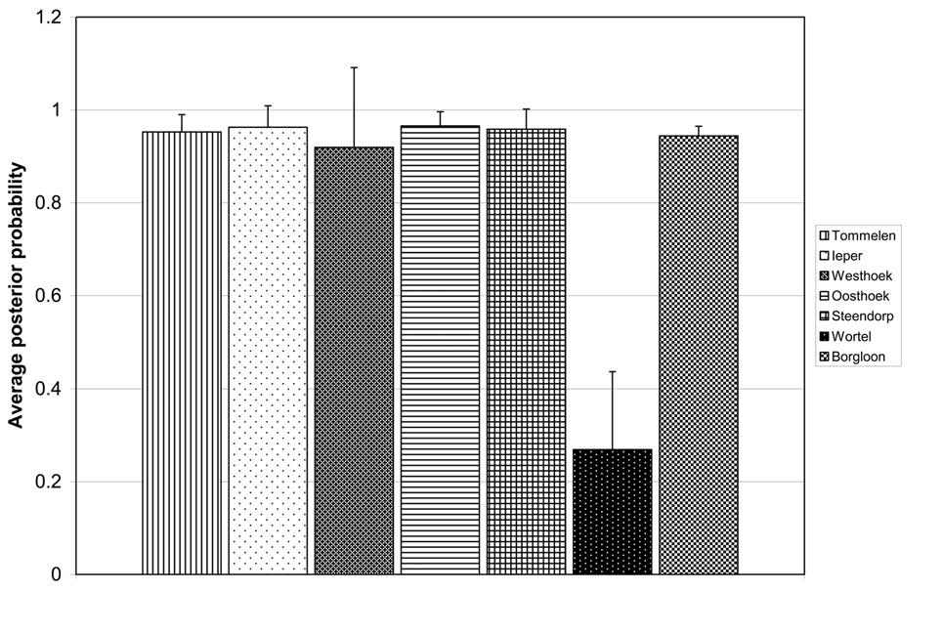Fig. 2. – Assignment of individual newts to the seven clusters of geographic origin defined by STRUCTURE. The y axis repre- sents the average posterior probability and its standard deviation for all individuals of a certain geographically-defined popula- tion to be assigned to this particular genetic cluster. Different black and white patterns indicate the seven genetic clusters. Aver- age and standard deviation were calculated per geographic origin and all eight runs of STRUCTURE.

DISCUSSION

Contrary to what we expected, we did not find evi- dence for the significant loss of genetic diversity in the screened Flemish populations. There is one exception, however, the population from Oosthoek that is genetically very diverse from the nearby Westhoek population and shows some indications for a genetic bottleneck. It is also the population with the lowest number of alleles, the low- est estimates for allele richness, observed and expected heterozygosity and has no private alleles (Table 2).
The lack of evidence for bottlenecks in the other Flem- ish populations could have several explanations. We ana- lysed seven microsatellite loci, whereas more loci are generally advised (CORNUET & LUIKART, 1996). Moreo- ver, the statistical power of a bottleneck test from a single sample is lower than for a test that includes historical samples pre-dating the bottleneck event. This implies that only really severe bottlenecks will be detected (LUIKART et al., 1998). In the case of the tree frog, Hyla arborea, from Denmark (ANDERSEN et al., 2004), however, bottle- necks could be demonstrated; these populations had not only lost genetic diversity but also showed signs of low fitness. Recent bottlenecks can furthermore be masked by an increasing number of rare alleles (BURNS et al., 2004). It is also possible that demographic changes are of too recent origin in the T. cristatus populations in Flanders to allow their statistical detection. Given that habitat loss and fragmentation of crested newt habitats have mostly

taken place during the past decades (BAUWENS, pers. comm.), that the life span of T. cristatus is 13 to 18 years (BLITTERSWIJK et al., 2005), and that the severity of a bot- tleneck depends not only on the minimum population size but also on the duration of the reduction in generations (FRANKHAM et al., 2002), the loss of genetic diversity through drift may still be moderate. Overall, our results are encouraging because they indicate that the loss of neutral genetic diversity, local and regional, is not yet worrisome in most of the studied populations and that res- toration measures leading to population expansion may be sufficient for the long-term conservation and viability of crested newt populations in Flanders.

Genetic variability within and between Flemish populations
We proposed that higher connectivity and shorter dis- tances between individual pools within a pool cluster would facilitate genetic exchange and hence, prevent the loss of genetic diversity. Contrary to this hypothesis, newts from the region with the largest distances between individual pools and the least relative connectivity, Ieper, also displayed the highest numbers of alleles and allelic richness in all analysed populations (Table 2). However, at the same time, this meta-population showed significant deviations from HWE and significant heterozygote defi-
ciency (positive FIS; Table 2). Such deviations may be owing to a variety of causes such as selection, the pres- ence of null alleles (due to failure of PCR) or inbreeding.

In the present study, we can probably eliminate selection as a possible explanation for deviations from HWE, because microsatellites are supposed to be neutral mark- ers (GOLDSTEIN & SCHLÖTTERER, 1999). Also, no null alleles were identified in the dataset by MICRO- CHECKER. These deviations can also be caused by the Wahlund-effect, the mixing of genetically distinct (sub) populations (WAHLUND, 1928), which mostly results from sampling artefacts. This is in our opinion the most likely explanation for our results from Ieper because as described above, we had a second region, namely De Panne (see above), with significant deviations from HWE and significant heterozygote deficiency, which were no longer observed when we split the newts from De Panne into Oosthoek and Westhoek.
A similar subdivision to that in De Panne was unfortu- nately not possible for the Ieper meta-population – split- ting it into two or three subunits did not remove the sig- nificant heterozygote deficiencies. Distributing newts according to the seven different pools would not have left sufficient sample numbers per pool for meaningful statis- tical analyses. STRUCTURE did not provide any indica- tion for more than one genetic cluster in the Ieper area because no individuals were assigned to other clusters and also the standard deviation was not higher than in the other meta-populations (Fig. 2). It seems that additional sampling will be required to conclusively test for popula- tion substructuring in the Ieper area.
If we exclude the results from Ieper for testing our hypothesis mentioned above, the second most diverse crested newt population in Flanders is Tommelen with the largest He and Ho, the highest number of alleles and
unique alleles and allelic richness. In Tommelen, dis-
tances between pools in the cluster are shortest (see Table 1), individual pools are surrounded by the highest number of other pools (Table 1) and barriers are absent (see Fig. 1S, supplementary material). The population size there was estimated between 575 and 1037 individuals (males=369-521; females=206–516; DESCAMPS & BAERT, 2003) although the effective (genetic) population size is not known. For the other regions, data on popula- tion size are not yet available. The data from Tommelen thus support our hypothesis on the importance of connec- tivity for maintaining genetic diversity in crested newts.
This is further corroborated by the clustering analyses with STRUCTURE, which showed that newts from West- hoek and Oosthoek formed two distinct genetic clusters with only one shared individual, despite their geographic proximity of 3.3km. However, the two areas are separated by roads, agricultural areas and human settlements (see Fig. 1S in the supplementary material). We believe that most of the roads were built at the latest in the 1950’s together with the adventure park of De Panne. This would mean that within 50 years, habitat fragmentation might effectively have blocked genetic exchange between crested newt populations close to each other. Road infra- structure, even when there is little or no traffic seems to negatively affect the migration abilities of newts between ponds (THIESMEIER & KUPFER, 2000). Triturus cristatus has been known to occur for decades in the Oost- and Westhoek region but we cannot exclude the possibility that the introduction of newts from elsewhere into this
region by tourists, for example for gardens of holiday houses (VERSCHOORE, pers. comm.) might have further contributed to the genetic differentiation between the Oost- and Westhoek populations. Additional research on population histories will be required to unravel this strong genetic differentiation.
Such differentiation at the micro-geographical scale (less than 10km) has also been observed in other amphib- ians such as frogs (Geocrinia – DRISCOLL, 1998; MONSEN
& BLOUIN, 2003), the tiger salamander, Ambystoma tigri- num (ROUTMAN, 1993) and toads (Bufo canorus – SHAF- FER et al., 2000; Bufo calmita – ROWE et al., 2000). In the spotted salamander, Ambystoma maculatum, (ZAMUDIO & WIECZOREK, 2007), significant correlations between genetic and geographic distances were only found for populations that were separated by 4.8km or less. This could explain why we failed to detect a significant corre- lation between geographic and genetic distances in Flem- ish populations of Triturus cristatus. However, other amphibian species seem to depart from this pattern of strong population sub-structuring (Bufo bufo – SEPPA & LAURILA, 1999; Ambystoma macrodactylum – TALLMON et al., 2000; Rana sylvatica – NEWMAN & SQUIRE, 2001; Litoria aurea – BURNS et al., 2004).
Genetic differentiation between Flemish populations was considerable, irrespective of the measure used (see Table 4). There was no significant correlation between geographic distance and genetic differentiation from the Mantel test, probably because comparisons between the close populations Oost- and Westhoek showed similar Fst
and Dest estimates as did comparisons with the distant
meta-populations Tommelen, Ieper and Steendorp, which
are separated by major rivers (IJzer, Scheldt).
The marked pairwise genetic differentiation between all study areas (except those with very few sampled indi- viduals) is supported by the results from STRUCTURE (see above) showing that all populations formed effective genetic clusters with little (Westhoek/Oosthoek and West- hoek/Steendorp) or no exchange of genotypes among populations. Individual newts were always clearly assigned (>90%) to one of the five genetic clusters with asymmetrically assigned proportions and small standard deviations (Fig. 2), strongly indicating that the observed population structure with five clusters is real. The STRUCTURE results also support our sampling scheme of considering clusters of pools as one meta-population, with the exceptions of De Panne and Ieper as discussed above. STRUCTURE assignments were less obvious for the two populations Borgloon and Wortel but the limited sample numbers (2 and 5, respectively) from these areas probably provide sufficient explanation for this pattern.
Four out of seven microsatellite loci shared common alleles in all analyzed Flemish Triturus cristatus popula- tions (Table 2S, supplementary material). This genetic conformity indicates that the Flemish populations once shared common ancestors and this is further supported by our relatively low Fst and Dest values (Table 4) when com-
pared to the study by MALETZKY et al. (2010) on T. crista-
tus from Germany and Austria from a much smaller geo- graphic area.
From our sampling campaign, we cannot conclude if the Flemish Triturus cristatus populations are in migra-

tion-drift equilibrium. Therefore, we can also not infer whether the observed genetic differentiation is a remnant of persistent founder effects after postglacial recoloniza- tions or whether it reflects the balance between gene flow/mutation and genetic drift in the investigated popu- lations. The observed population genetic differentiation nevertheless indicates that either sufficient numbers of individuals colonized the pools during postglacial expan- sion such that founder effects are not too prevalent and/or that gene flow in the past has been sufficiently high to maintain these relatively low levels of genetic differentia- tion among populations.

Genetic variability of Triturus cristatus

at a larger scale
One major aim of this study was to assess the genetic variability of Triturus cristatus within and among Flem- ish populations. If estimates of genetic diversity are expressed as expected heterozygosity, He, to allow com-
parisons with other studies, we would expect lower values
for the Flemish populations, because most of them are small, fragmented and isolated owing to anthropogenic influences (BAUWENS, pers. commun.; http:// www.inbo.be/content/page.asp?pid=FAU_AMF_VER_ kamsalamander). Values of He in our study varied from
0.53 to 0.64 (Table 2) and were thus close to estimates
from another investigation on T. cristatus from France (0.49 and 0.65- JEHLE et al., 2005). However, our esti- mated He were clearly larger than those of MALETZKY et
al. (2010) from Austria and Germany (0.34-0.59) but
lower than the data by MEYER (2005) on German and by MIKULICEK (2005) on Czech and Slovakian crested newts, who estimated He of 0.53-0.81 and 0.50-0.84, respec-
tively. Also allelic richness of Flemish T. cristatus, with
2.61 to 3.86, was higher than that observed by MALETZKY et al. (2010; 2.0 to 3.75). The number of alleles for each analyzed microsatellite locus in Flemish populations var- ied from 3 to 10 (Table 1S, supplementary material) while French populations exhibited 4 (Tcri13 and Tcri36) to 9 (Tcri43) alleles per locus with the same microsats (JEHLE et al., 2001). German populations showed a slightly ele- vated allelic variation, ranging from 7 (Tcri29) to 13 (Tcri43) alleles per locus and up to 29 alleles in the study by MALETZKY et al. (2010). Thus, we can conclude that genetic diversity of T. cristatus populations from Flanders is similar to that of French populations, slightly lower than that of German, Czech and Slovakian and higher than that of Austrian/German populations despite the fact that Belgium has a much more fragmented landscape with extensive urbanized areas intersected by agriculture (MAES & VAN DYCK, 2001).
In comparison to other European amphibians, Flemish Triturus cristatus showed higher He values (0.5 to 0.81). Triturus marmoratus, a close relative to T. cristatus,
exhibited He values ranging from 0.20 to 0.55 (JEHLE et al., 2005) whereas He values of Bufo calamita varied from
0.24 to 0.39 (ROWE et al., 2000). ANDERSEN et al. (2004)
found He between 0.35 and 0.53 for Hyla arborea popula- tions in Denmark and VOS et al. (2001) reported He of 0.2 to 0.6 for Rana arvalis. Alytes muletensis showed lower
minimal values than T. cristatus ranging between 0.38 and 0.71 (KRAAIJVELD-SMIT et al., 2005).
While MALETZKY et al. (2010) have detected decreas- ing genetic diversity of crested newts in their study area including a river valley and hills, none of the studies of T. cristatus in Flanders, France, Germany, Czech Republic and Slovakia showed any strong evidence for loss of genetic diversity. However, we studied only those Flem- ish populations with the highest densities. Our data illus- trate that in two sites where large numbers were expected, namely Wortel and Borgloon, only few larvae could be found. Thus, pools with lower numbers of T. cristatutus might already have lost genetic diversity but this will be difficult to demonstrate because limited sample numbers will hamper meaningful, statistical analyses.

CONCLUSIONS AND PROSPECTS

We have found evidence that connectivity (proximity of suitable pools and the absence of barriers at a local scale) is crucial for preventing loss of genetic diversity in crested newts. However, at the larger scale, Flemish pop- ulations of Triturus cristatus are already genetically iso- lated to a large extent as is illustrated by our results from the genetic clustering and the finding of unique alleles in most populations. The expectation in the long term is that genetic differentiation between populations will increase, mainly because of drift and a continued lack of genetic exchange at small geographic scales. Most of all, how- ever, we expect that genetic signs of population bottle- necks will manifest themselves, also in the other popula- tions if no suitable conservation measures are taken. Because the persistence of populations depends on their evolutionary abilities to adapt to changing environments, genetic variation is required (FRANKEL & SOULÉ, 1981). If small subpopulations become endangered because of genetic isolation, then this will also have negative effects on the persistence of meta-populations. Such effects are well-documented (FAHRIG, 2002; FAHRIG & MERRIAM, 1985; WILCOX & MURPHY, 1985). Further monitoring of the genetic diversity will be necessary, especially at local geographic scales, to provide reliable data on the genetic exchange and migration rates among sub-populations of
T. cristatus.
It furthermore seems advisable to take additional action to protect Triturus cristatus in Flanders. Firstly, appropri- ate geographical units for conservation management should be identified, which will in the case of T. cristatus sometimes consist of (sub) populations at a very local scale (as in De Panne and Ieper) or include closely con- nected clusters of pools as in Tommelen. Habitat frag- mentation has a negative effect on genetic diversity of amphibian populations (HITCHINGS & BEEBEE, 1998; VOS
& CHARDON, 1998; ANDERSEN et al., 2004; CUSHMAN,
2006), mainly because of the limited dispersal and gene flow (VOS et al., 2001; BURNS et al., 2004). Also our results illustrate that gene flow and dispersal can be sig- nificantly reduced, even between neighboring sites. Although the crested newt is rapidly diminishing in number, for the time being, it still contains relatively large genetic variability at the Flemish scale, at least in the studied populations. This genetic variability might have persisted up to now, because population fragmentation has only taken place recently. However, genetic variabil-

ity could vanish fast if isolation is further increased and no measures to promote migration and genetic exchange are put into place, for example by creating and maintain- ing suitable pools. The connectivity between habitats seems to be one of the key factors to enable the survival of T. cristatus in Flanders and elsewhere in Europe.

ACKNOWLEDGEMENTS

We would like to thank Pierre Dumont and Delphine Vanhae- cke (RBINS), Koen Verschoore (Natuurpunt Westkust), Peter Engelen (Likona), Iwan Lewylle (Natuurpunt Studie), Jos Coteur and Rik Jacobs (Natuurpunt Hasselt-Zonhoven) for their help during field sampling and Agentschap Natuur & Bos (ANB, Brussel) for providing the sampling permits. We acknowledge the Belgian OSTC for funding through the MAN- SCAPE and PONDSCAPE projects. AR also acknowledges financial support from the VUB, Brussels. This research was part of the honours thesis of AR at the University of Ghent.

REFERENCES

ALTENTOFT ME & O’ BRIEN J (2010). Global amphibian declines, loss of genetic diversity and fitness: a review. Diversity, 2:47-71.
ANDERSEN LW, FOG K & DAMGAARD C (2004). Habitat frag-
mentation causes bottlenecks and inbreeding in the Euro- pean tree frog (Hyla arborea). Proceedings of the Royal Society of London, Biological Sciences, 271:1293-1302.
ARNTZEN JW, SMITHSON A & OLDHAM RS (1999). Marking and
tissue sampling effects on body condition and survival in the newt Triturus cristatus. Journal of Herpetology, 33:567-576. BAUWENS D & CLAUS K (1996). Verspreiding van amfibieën en reptielen in Vlaanderen. De Wielewaal Natuurvereniging
v.z.w., Turnhout.
BEEBEE TJC (2005). Short review: Conservation genetics of amphibians. Heredity, 95:423-427.
BELKHIR K, BORSA P, CHIKHI L, RAUFASTE N & BONHOMME F
(2004). GENETIX 4.05, logiciel sous Windows TM pour la génétique des populations. Laboratoire Génome, Popula- tions, Interactions, CNRS UMR 5171, Université de Montpellier II, Montpellier.
BLITTERSWIJK VAN H, STUMPEL AHP, ARENS PFP & OTTBURG
FGWA (2005). Adders onder het gras. Beschikbaarheid en bruikbaarheid van ecologische en genetische kennis over amfibieën en reptielen en de knelpunten voor beleid en beheer. Alterra-report, 1149, Altera, Wageningen, The Neth- erlands: 37-40.
BURNS EL, ELRIDGE BMD & HOULDEN BA (2004). Microsatel-
lite variation and population structure in a declining Austral- ian Hylid Litoria aurea. Molecular Ecology, 13:1745-1757.
CORNUET JM & LUIKART G (1996). Description and power anal- ysis of two tests for detecting recent population bottlenecks from allele frequency data. Genetics, 144:2001-2014.
CRAWFORD NG (2010). SMOGD: Software for the measurement of genetic diversity. Molecular Ecology Resources, 10:556- 557.
CUSHMAN SA (2006). Effects of habitat loss and fragmentation on amphibians: a review and prospectus. Biological Conser- vation, 128:231-240.
DECLERCK S, DE BIE T, ERCKEN D, HAMPEL H, SCHRIJVERS S, VAN WICHELEN J, GILLARD V, MANDIKI R, LOSSON B, BAU- WENS D, KEIJERS S, VYVERMAN W, GODDEERIS B, DE MEESTER L, BRENDONCK L & MARTENS K (2006). Ecological
characteristics of small farm land ponds: associations with
land-use practices at multiple spatial scales. Biological Con- servation, 131:523-532.
DESCAMPS S & BAERT P (2003). De kamsalamander in Tommelen; een unieke waterdraak. In: STEVENS J & CRÉVE- COEUR L (eds) Likona-jaarboek 2003, Likona, Hasselt, Bel- gium.
DRISCOLL D (1998). Genetic structure of the frogs Geocrinia lutea and Geocrinia rosea reflects extreme population diver- gence and range changes, not dispersal barriers. Evolution, 52:1147-1157.
FAHRIG L (2002). Effects of habitat fragmentation on the extinc- tion treshold: a synthesis. Ecological Applications, 12:346- 353.
FAHRIG L & MERRIAM G (1985). Habitat patch connectivity and population survival. Ecology, 66:1762-1768.
FRANKEL OH & SOULÉ ME (1981). Conservation and evolution.
Cambridge University Press, Cambridge.
FRANKHAM R, BALLOU DJ & BRISCOE DA (2002) Introduction to
conservation genetics. Cambridge University Press.
FRANKHAM R, LEES K, MONTGOMERY ME, ENGLAND PR, LOWE
E & BRISCOE DA (1999). Do population size bottlenecks reduce evolutionary potential? Animal Conservation 2:255- 260.
FROGLIFE (2001). The Great Crested Newt Conservation Hand- book. (Internet address: http://www.froglife.org/GCNCH/ GCNCH.htm).
GOLDSTEIN DB & SCHLÖTTERER C (1999). Microsatellites – Evolution and applications. Oxford University Press.
GRIFFITHS RA (1996). Newts and salamanders of Europe. Poyser Natural history, London.
GRIFFITHS RC (1979). A Transition Density Expansion for a Multi-Allele Diffusion Model. Advances in Applied Proba- bility, 11:310-325.
GRIFFITHS RC, SEWELL D & MCREA RS (2010). Dynamics of a
declining amphibian metapopulation: Survival, dispersal and the impact of climate. Biological Conservation, 143:485- 491.
GUO SW & THOMPSON EA (1992). Performing the exact test of Hardy-Weinberg proportion for multiple alleles. Biometrics, 48:361-372.
HITCHINGS SP & BEEBEE TJC (1998). Loss of genetic diversity and fitness in Common toad (Bufo bufo) populations isolated by inimical habitats. Journal of Evolutionary Biology, 11:269-283.
HOULAHAN JE, FINDLAY CS, SCHMIDT BR, MEYER AH & KUZ-
MIN SL (2000). Quantitative evidence for global amphibian population declines. Nature, 404:752-755.
JAMES TY, LITVINTSEVA AP, VILGALYS R, MORGAN JAT, TAYLOR JW, FISHER MC, BERGER L, WELDON C, DU PREEZ L &
LONGCORE JE (2009). Rapid global expansion of the fungal disease cytridiomycosis into declining and healthy amphib- ian populations. PLoS Pathogens, 5:e10000458.
JEHLE R & ARNTZEN JW (2002). Review: Microsatellite markers in amphibian conservation genetics. Herpetological Journal, 12:1-9.
JEHLE R, ARNTZEN JW, BURKE T, KRUPA A & HÖDL W (2001).
The annual number of breeding adults and the effective pop- ulation size of syntopic newts (Triturus cristatus, T. mar- moratus). Molecular Ecology, 10:839-850.
JEHLE R, WILSON GA, ARNTZEN JW & BURKE T (2005). Con-
temporary gene flow and the spatio-temporal genetic struc- ture of subdivided newt populations (Triturus cristatus, T. marmoratus). Journal of Evolutionary Biology, 18:619-628. JOST L (2008). GST and its relatives do not measure differentia-
tion. Molecular Ecology, 17:4015-4026.
KALINOWSKI ST (2005). HP-Rare: a computer program for per- forming rarefaction on measures of allelic diversity. Molecu- lar Ecology Notes, 5:187-189.

KRAAIJVELD-SMIT FJL, BEEBEE TJC, GRIFFITHS RA, MOORE RD
& SCHLEY L (2005). Low gene flow but high genetic diver- sity in the threatened Mallorcan midwife toad Alytes muletensis. Molecular Ecology, 14:3307-3315.
KRUPA AP, JEHLE R, DAWSON DA, GENTLE LK, GIBBS M, ARN-
TZEN JW & BURKE T (2002). Microsatellite loci in the crested newt (Triturus cristatus) and their utility in other newt taxa. Conservation Genetics, 3:87-89.
KUPFER A (1998). Migration distances of some crested newts (Triturus cristatus) within an agricultural landscape. Zeitschrift für Feldherpetologie, 5:238-242.
LANDE R (1988). Genetics and demography in biological con- servation. Science 241:1455-1460.
LUIKART G, SHERWIN WB, STEELE BM & ALLENDORF FW
(1998). Usefulness of molecular markers for detecting popu- lation bottlenecks via monitoring genetic change. Molecular Ecology, 7:963-974.
MAES D & VAN DYCK H (2001). Butterfly diversity loss in Flan- ders (north Belgium): Europe’s worst case scenario? Biolog- ical Conservation, 99:263-276.
MALETZKY A, KAISER R & MIKULICEK P (2010) Conservation
genetics of crested newt species Triturus cristatus and T. carnifex within a contact zone in a central Europe: impact of interspecific introgression and gene flow. Diversity, 2:28-46. MANTEL N (1967). The detection of disease clustering and a generalized regression approach. Cancer Research, 27:209-
220.
MCLEE AG & SCAIFE RW (1993). The colonisation by great crested newt (Triturus cristatus) of a water body following treatment with a piscicide to remove a large population of sticklebacks (Gasterosteus aculeatus). British Herpetologi- cal Society Bulletin, 42:6-9.
MEYER S (2005). Untersuchung zur Überlebensstrategie der Kammmolchpopulationen (Triturus cristatus, Laurenti 1768) in der Kulturlandschaft Sachsen-Anhalts. Dissertation Universität Halle-Wittenberg, Germany.
MIKULICEK P (2005). Hybridization and genetic differentiation of the crested newts (Triturus cristatus superspecies) in Cen- tral Europe – analysis of nuclear markers. PhD thesis, Uni- versity of Prague, Czech Republic.
MONSEN KJ & BLOUIN MS (2003). Genetic structure in a mon- tane ranid frog: restricted gene flow and nuclear-mitochon- drial discordance. Molecular Ecology, 12:3275-3286.
NEI M & CHESSER RK (1983). Estimation of fixation indices and gene diversities. Annals of Human Genetics, 47:253-259.
NEWMAN RA & SQUIRE T (2001). Microsatellite variation and fine-scale population structure in the wood frog (Rana syl- vatica). Molecular Ecology, 10:1087-1100.
NÖLLERT A & NÖLLERT C (2001). Amfibieëngids van Europa, Tirion, Baarn.
PRITCHARD JK, STEPHENS M & DONNELLY P (2000). Inference of
population structure using multilocus genotype data. Genet- ics, 155:945-959.
RAPSAET A (2007). Population genetics of Triturus cristatus
from Flanderen. Honour’s Thesis, University Ghent.
ROUSSET F (2008). Genepop’007: a complete reimplementation of the Genepop software for Windows and Linux. Molecular Ecology Resources, 8:103-106.
ROUTMAN E (1993). Population structure and genetic diversity of metamorphic and paedomorphic populations of the tiger
salamander, Ambystoma tigrinum. Journal of Evolutionary Biology, 6:329-357.
ROWE G, BEEBEE TJC & BURKE T (2000). A microsatellite anal- ysis of natterjack toad, Bufo calamita, metapopulations. Oikos, 88:641-651.
SACCHERI I, KUUSSAARI M, KANKARE M, VIKMAN P, FORTELIUS
W & HANSKI I (1998). Inbreeding and extinction in a butter- fly metapopulation. Nature, 392:491-494.
SEPPA P & LAURILA A (1999). Genetic structure of island popu- lations of the anurans Rana temporaria and Bufo bufo. Heredity, 82:309-317.
SHAFFER HB, FELLERS GM, MAGEE A & VOSS SR (2000). The
genetics of amphibian declines: population substructure and molecular differentiation in the Yosemite toad, Bufo canorus (Anura, Bufonidae) based on single-strand conformation polymporphism analysis (SSCP) and mitochondrial DNA sequence data. Molecular Ecology, 9:245-257.
SODHI NS, BICKFORD D, DIESMOST AC, LEE TM, KOH LP, BROOK BW, SEKERCIOGLU CH & BRADSHAW CJ (2008).
Measuring the meltdown: drivers of global amphibian extinction and decline. PloS ONE, 3:e1636.
STUART SN, CHANSON JS, COX NA, YOUNG BE, RODRIGUES ASL, FISCHMANN DL & WALLER RW (2004). Status and
trends of amphibian declines and extinctions worldwide. Science, 306:1783-1786.
TALLMON DA, FUNK WC, DUNLAP WW & ALLENDORF FW
(2000). Genetic differentiation among long-toed salamander (Ambystoma macrodactylum) populations. Copeia, 1:27-35.
THIESMEIER B & KUPFER A (2000). Der Kammmolch: ein Wasserdrache in Gefahr, Laurenti-Verlag, Bochum.
VAN OOSTERHOUT C, HUTCHINSON WF, WILLS DPM & SHIPLEY P
(2004). Micro-checker: software for identifying and correct- ing genotyping errors in microsatellite data. Molecular Ecol- ogy Notes, 4:535-538.
VENCES M & KÖHLER J (2008). Global diversity of amphibians (Amphibia) in freshwater. Hydrobiologia, 595:569-580.
VOS CC, ANTONISSE-DE JONG AG, GOEDHART PW & SMULDERS
MJM (2001). Genetic similarity as a measure for connectiv- ity between fragmented populations of the moor frog (Rana arvalis). Heredity, 86:598-608.
VOS CC & CHARDON JP (1998). Effects of habitat fragmentation and road density on the distribution pattern of the moor frog Rana arvalis. Journal of Applied Ecology, 35:44-56.
WAHLUND S (1928). Zusammensetzung von Population und Korrelationserscheinung vom Standpunkt der Vererbungsle- hre aus betrachtet. Hereditas, 11:65-106.
WALLACE H (1987). Abortive development in the crested newt
Triturus cristatus. Development, 100:65-72.
WEIR BS & COCKERHAM CC (1984). Estimating F-statistics for the analysis of population structure. Evolution, 38:1358- 1370.
WILCOX B & MURPHY DD (1985). Conservation strategy: the effects of fragmentation on extinction. American Naturalist, 125:879-887.
ZAMUDIO KR & WIECZOREK AM (2007). Fine-scale spatial genetic structure and dispersal among spotted salamander (Ambystoma maculatum) breeding populations. Molecular Ecology, 16:257-274.

Fig. 1S. – Details of pools sampled in the 6 study areas.
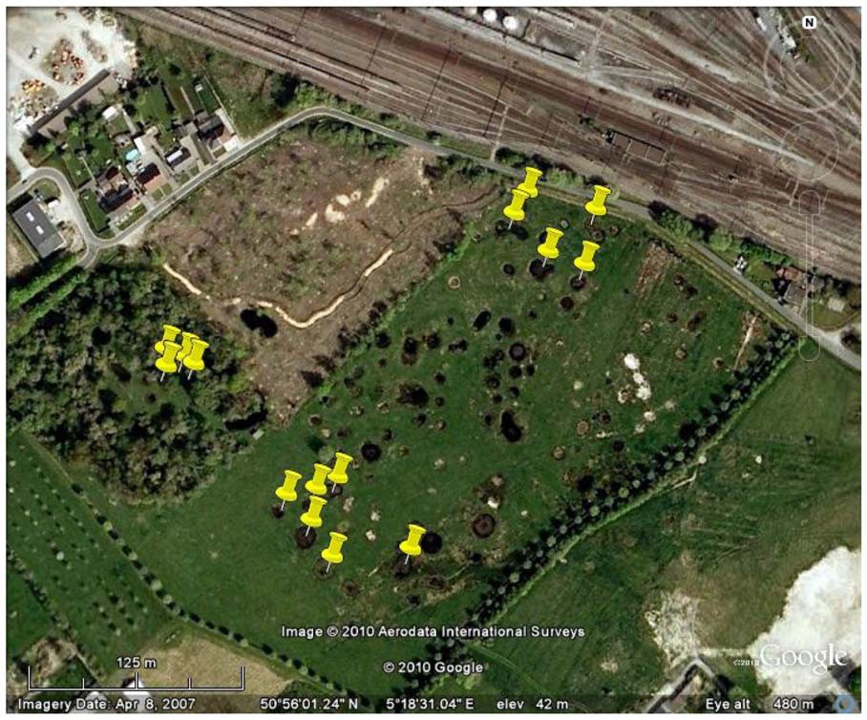
Details of pool cluster Tommelen.

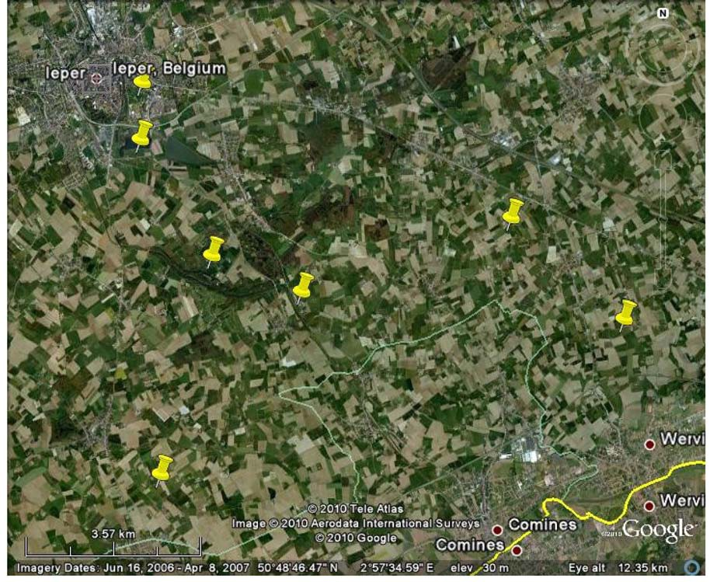
Details from pool cluster Ieper.

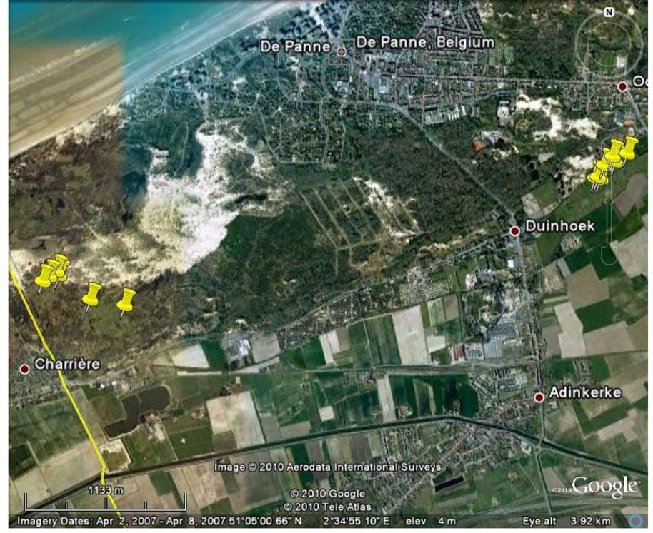
Details from pool cluster De Panne – Westhoek (left hand side) and Oosthoek (right hand side).

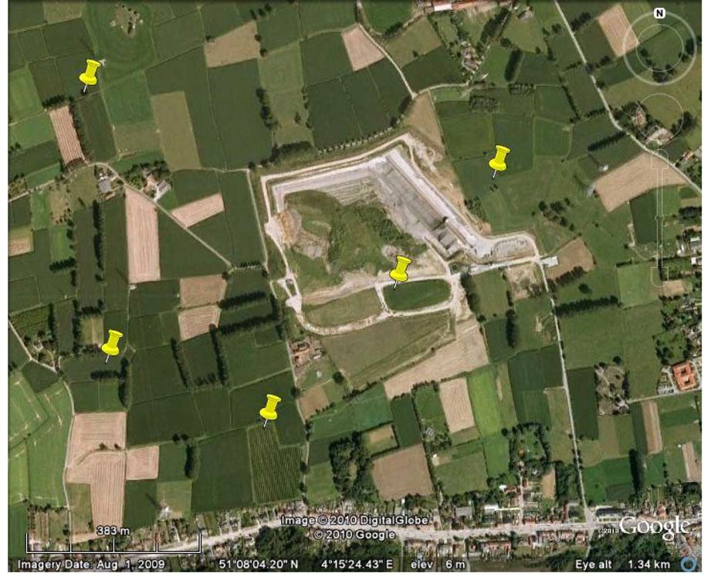
Details of pool cluster Steendorp.

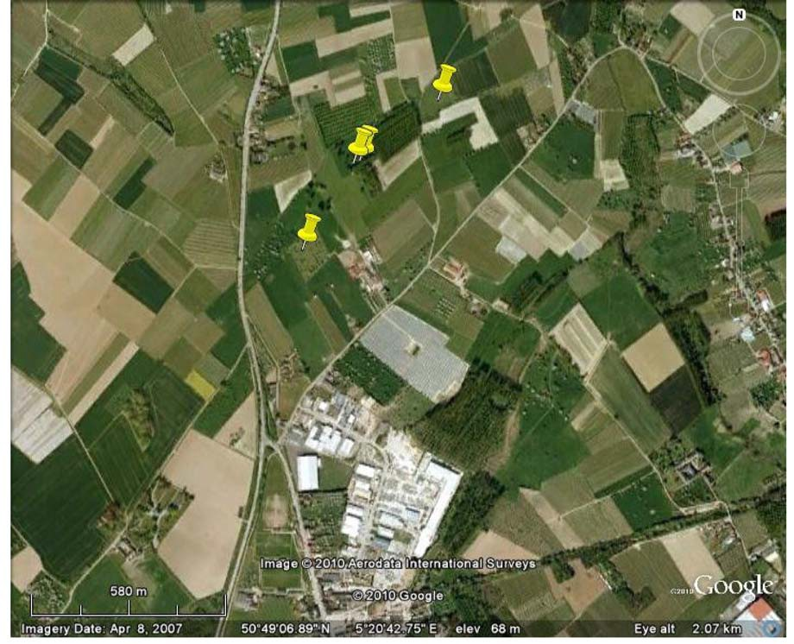
Details of pool cluster Borgloon.

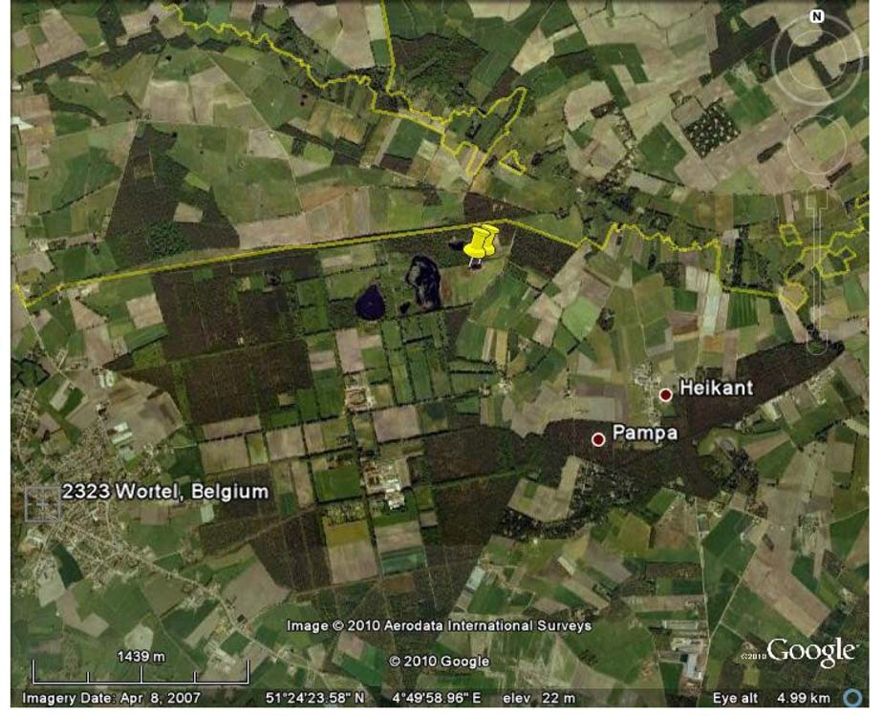
Details of pool cluster Wortel.

TABLE 1S
Population statistics for the Crested newt, Triturus cristatus, screened with seven microsatellite loci. Microsatellite names are as in KRUPA et al. (2002). N=number of genotyped individuals for each locus. NAL=number of alleles per locus. AR=allelic richness. HE=unbiased expected heterozygosity; HO=unbiased observed heterozygosity; P (HW)=probability for observing deviations from Hardy-Weinberg equilibrium. Fis=F coefficient. Bold numbers indicate 5% significance.

 | N | NAL | AR | HE | HO | P (HW) | FIS
Ieper
Tcri13 | 47 | 7 | 2.61 | 0.4715 | 0.4225 | 0.0064 | + 0.098
Tcri27 | 47 | 10 | 4.30 | 0.8161 | 0.7872 | 0.2456 | +0.036
Tcri29 | 47 | 7 | 3.76 | 0.7605 | 0.6170 | 0.0263 | +0.190
Tcri32 | 45 | 6 | 7.65 | 0.7221 | 0.6000 | 0.0008 | +0.171
Tcri35 | 47 | 6 | 3.33 | 0.6914 | 0.7021 | 0.0577 | -0.016
Tcri36 | 46 | 3 | 1.91 | 0.3146 | 0.3696 | 0.7545 | -0.177
Tcri46 | 46 | 7 | 3.40 | 0.6935 | 0.7391 | 0.1786 | -0.067
Tommelen
Tcri13 | 30 | 7 | 2.90 | 0.6345 | 0.6000 | 0.6278 | +0.055
Tcri27 | 30 | 8 | 3.53 | 0.7124 | 0.7667 | 0.4884 | -0.078
Tcri29 | 30 | 4 | 2.84 | 0.6034 | 0.5333 | 0.6762 | +0.118
Tcri32 | 25 | 7 | 2.89 | 0.5233 | 0.6000 | 0.9164 | -0.150
Tcri35 | 30 | 6 | 3.94 | 0.7667 | 0.8000 | 0.6391 | -0.044
Tcri36 | 30 | 4 | 2.80 | 0.6062 | 0.5667 | 0.2310 | +0.066
Tcri46 | 29 | 5 | 3.28 | 0.6927 | 0.8276 | 0.3078 | -0.199
Steendorp
Tcri13 | 30 | 7 | 2.85 | 0.5169 | 0.4667 | 0.1466 | +0.099
Tcri27 | 30 | 8 | 4.38 | 0.8316 | 0.8667 | 0.5819 | -0.043
Tcri29 | 30 | 5 | 3.23 | 0.6994 | 0.8333 | 0.4176 | -0.195
Tcri32 | 25 | 2 | 1.62 | 0.2155 | 0.2400 | 1.0000 | -0.116
Tcri35 | 28 | 7 | 3.90 | 0.7753 | 0.7143 | 0.7975 | +0.080
Tcri36 | 29 | 3 | 1.78 | 0.2492 | 0.2759 | 1.0000 | -0.109
Tcri46 | 30 | 4 | 3.34 | 0.7232 | 0.7000 | 0.3377 | +0.033
De Panne/ Westhoek
Tcri13 | 34 | 7 | 3.29 | 0.6354 | 0.7353 | 0.7437 | -0.143
Tcri27 | 34 | 7 | 3.74 | 0.7556 | 0.7647 | 0.4651 | +0.003
Tcri29 | 33 | 6 | 2.56 | 0.5005 | 0.6364 | 0.3558 | -0.257
Tcri32 | 29 | 5 | 2.45 | 0.4084 | 0.4828 | 1.0000 | -0.165
Tcri35 | 34 | 6 | 3.62 | 0.7366 | 0.5882 | 0.2021 | +0.216
Tcri36 | 34 | 4 | 2.77 | 0.6047 | 0.5882 | 0.1273 | +0.042
Tcri46 | 34 | 4 | 3.11 | 0.6838 | 0.8235 | 0.0978 | -0.190
De Panne/ Oosthoek
Tcri13 | 22 | 5 | 2.53 | 0.5176 | 0.4545 | 0.3144 | +0.145
Tcri27 | 22 | 5 | 3.03 | 0.5790 | 0.5455 | 0.4326 | +0.080
Tcri29 | 22 | 4 | 3.32 | 0.7014 | 0.6364 | 0.2163 | +0.116
Tcri32 | 21 | 4 | 2.28 | 0.4161 | 0.4286 | 1.0000 | -0.006
Tcri35 | 22 | 4 | 3.08 | 0.6384 | 0.6818 | 0.9806 | -0.045
Tcri36 | 22 | 3 | 2.09 | 0.4473 | 0.5455 | 0.7305 | -0.197
Tcri46 | 22 | 2 | 1.91 | 0.3967 | 0.4545 | 1.0000 | -0.123

TABLE 2S
Overview of allele distributions over all populations and microsatellite loci. Names are according to KRUPA et al. (2002). Numbers are lengths of microsatellites in bp. The alleles for each microsatellite are indicated by three digits; the two alleles for each individual by showing twice three digits after each other.

Population | Tcri13 | Tcri27 | Tcri29 | Tcri32 | Tcri35 | Tcri36 | Tcri46
Tommelen | 118118 | 256276 | 331331 | 460476 | 216228 | 262262 | 299303
 | 118124 | 256288 | 331335 | 460464 | 216228 | 262262 | 295303
 | 124126 | 276284 | 327331 | 0 | 220224 | 262262 | 295299
 | 126126 | 276276 | 327327 | 460468 | 228232 | 262262 | 295299
 | 118118 | 256276 | 327327 | 460472 | 212228 | 262266 | 295299
 | 118124 | 256276 | 327327 | 460464 | 228228 | 262266 | 295299
 | 126126 | 256276 | 327331 | 460464 | 224228 | 262266 | 299303
 | 118126 | 276276 | 327327 | 460472 | 220232 | 262266 | 0
 | 120126 | 280284 | 327331 | 460460 | 220228 | 262266 | 287295
 | 126128 | 276280 | 327331 | 460460 | 216220 | 266266 | 287295
 | 126126 | 256276 | 327335 | 0 | 220224 | 262266 | 299303
 | 126126 | 256276 | 327335 | 460460 | 216228 | 262262 | 295307
 | 126126 | 276280 | 327331 | 0 | 228232 | 262262 | 295303
 | 126126 | 256276 | 327327 | 460460 | 224228 | 262266 | 295299
 | 122126 | 256276 | 327335 | 460460 | 224232 | 266266 | 295303
 | 118126 | 260276 | 327331 | 460468 | 224228 | 266266 | 295295
 | 118126 | 256260 | 315327 | 460464 | 212224 | 262266 | 303303
 | 118126 | 276284 | 335335 | 460460 | 228228 | 258262 | 299307
 | 126126 | 256256 | 327331 | 460464 | 216228 | 262270 | 295299
 | 118126 | 276276 | 327327 | 0 | 220232 | 262262 | 295299
 | 118124 | 272280 | 331331 | 460460 | 224228 | 262262 | 295295
 | 118124 | 276288 | 327331 | 456464 | 228228 | 262270 | 287295
 | 118126 | 276276 | 327327 | 460468 | 228228 | 258266 | 295295
 | 118126 | 256280 | 315327 | 460460 | 212216 | 262266 | 295295
 | 118126 | 256276 | 327327 | 460460 | 228228 | 262266 | 295303
 | 118118 | 256256 | 315331 | 460468 | 212228 | 258258 | 295299
 | 118126 | 276276 | 327327 | 460460 | 212224 | 262270 | 295299
 | 118130 | 276280 | 331331 | 456460 | 220224 | 262262 | 299303
 | 118118 | 252260 | 327327 | 0 | 228228 | 262270 | 295299
 | 126126 | 256276 | 315327 | 452460 | 212220 | 258266 | 287295
Ieper | 126126 | 260280 | 289327 | 456464 | 204224 | 262266 | 295303
 | 126126 | 248256 | 327331 | 460464 | 212220 | 0 | 295299
 | 126128 | 248276 | 319327 | 452456 | 212220 | 262262 | 291303
 | 120126 | 264264 | 331331 | 460460 | 204220 | 262266 | 295303
 | 126126 | 256256 | 323327 | 452456 | 216220 | 262266 | 295295
 | 118126 | 252256 | 319319 | 456460 | 212216 | 258262 | 295299
 | 126126 | 248280 | 289327 | 460460 | 220224 | 262266 | 295295
 | 126126 | 272276 | 319331 | 464464 | 220220 | 262266 | 295299
 | 126126 | 256268 | 323327 | 456464 | 212220 | 262262 | 299303
 | 118124 | 260276 | 323327 | 460460 | 212220 | 262262 | 295299
 | 118124 | 256280 | 327335 | 460460 | 220220 | 262262 | 295299
 | 126130 | 256276 | 327331 | 460460 | 220224 | 262262 | 295299
 | 126126 | 280280 | 327327 | 448460 | 220224 | 262262 | 271295
 | 126126 | 276280 | 319335 | 460468 | 220220 | 262266 | 271295
 | 126126 | 256256 | 323327 | 452460 | 220224 | 262266 | 295295
 | 126126 | 256280 | 323323 | 464468 | 220220 | 258262 | 291295
 | 118126 | 248280 | 323327 | 460460 | 216220 | 262262 | 295303
 | 126126 | 272276 | 323323 | 448460 | 212212 | 262262 | 295295
 | 118126 | 276276 | 323327 | 448460 | 216220 | 262262 | 295299
 | 126126 | 256256 | 327327 | 448456 | 212220 | 262262 | 295295

TABLE 2S
Overview of allele distributions over all populations and microsatellite loci. Names are according to KRUPA et al. (2002). Numbers are lengths of microsatellites in bp. The alleles for each microsatellite are indicated by three digits; the two alleles for each individual by showing twice three digits after each other.

Population | Tcri13 | Tcri27 | Tcri29 | Tcri32 | Tcri35 | Tcri36 | Tcri46
 | 118126 | 248280 | 327327 | 448448 | 216216 | 262262 | 295299
 | 116126 | 260276 | 323327 | 460460 | 212220 | 262262 | 295303
 | 126126 | 260276 | 315327 | 460460 | 216220 | 262262 | 295295
 | 118124 | 260276 | 323323 | 456464 | 212220 | 262262 | 295299
 | 126126 | 256276 | 315323 | 460468 | 212212 | 262262 | 291295
 | 118126 | 276276 | 323327 | 460460 | 212220 | 262262 | 287295
 | 126126 | 256276 | 323327 | 448460 | 220220 | 262262 | 291295
 | 126126 | 256276 | 323323 | 456464 | 212212 | 262262 | 295299
 | 126126 | 256276 | 323331 | 460468 | 212220 | 262266 | 295303
 | 126126 | 252268 | 331331 | 460460 | 212220 | 262262 | 299299
 | 118124 | 260276 | 319319 | 460460 | 220224 | 262262 | 299299
 | 118124 | 256256 | 315315 | 452456 | 212220 | 258262 | 295299
 | 126126 | 248280 | 319323 | 456464 | 212220 | 262262 | 295299
 | 126126 | 260280 | 319319 | 460464 | 212220 | 262262 | 299299
 | 126126 | 256280 | 319323 | 464464 | 212220 | 262262 | 295299
 | 126126 | 280284 | 315323 | 456464 | 216220 | 262262 | 291299
 | 126128 | 264280 | 319323 | 460460 | 212220 | 262266 | 295299
 | 126126 | 276280 | 323327 | 448456 | 216220 | 262262 | 295303
 | 118126 | 276280 | 323323 | 448448 | 212216 | 262262 | 295299
 | 118126 | 248276 | 323327 | 460460 | 212220 | 262262 | 295299
 | 118126 | 248276 | 323327 | 0 | 208216 | 262262 | 295295
 | 116126 | 276280 | 323323 | 460460 | 216216 | 262262 | 299299
 | 128128 | 276284 | 319319 | 460464 | 220220 | 262266 | 283295
 | 126128 | 256276 | 319327 | 460468 | 220220 | 262266 | 283287
 | 126126 | 276276 | 327327 | 0 | 220220 | 262266 | 0
 | 126126 | 256256 | 327327 | 464468 | 204212 | 262266 | 283291
 | 126126 | 264276 | 327335 | 460464 | 204204 | 262266 | 283283
Westhoek | 118130 | 272276 | 327327 | 460460 | 216216 | 266266 | 295307
 | 126128 | 248256 | 327335 | 460460 | 212220 | 262262 | 295299
 | 126126 | 260276 | 327335 | 460460 | 216216 | 262266 | 299307
 | 118126 | 260276 | 327335 | 460460 | 212216 | 262270 | 303307
 | 118126 | 276280 | 327327 | 460460 | 204216 | 266270 | 299307
 | 122126 | 256256 | 327327 | 456460 | 212216 | 262270 | 299307
 | 126126 | 256276 | 327327 | 0 | 216228 | 266266 | 299307
 | 122126 | 260276 | 327335 | 460460 | 220220 | 262270 | 295299
 | 118126 | 260260 | 327331 | 0 | 216216 | 258262 | 295307
 | 126126 | 256260 | 327327 | 452460 | 212220 | 266270 | 303307
 | 122126 | 260276 | 327343 | 448460 | 216224 | 266270 | 295299
 | 118126 | 276280 | 327343 | 460460 | 212216 | 266270 | 307307
 | 126126 | 260260 | 327343 | 0 | 224228 | 266270 | 307307
 | 118122 | 276276 | 327327 | 460460 | 224228 | 266266 | 299307
 | 126126 | 256276 | 327335 | 456460 | 216216 | 266266 | 295299
 | 122126 | 260264 | 327335 | 456460 | 216228 | 266270 | 295307
 | 126126 | 260260 | 327335 | 460464 | 216216 | 266266 | 299307
 | 122126 | 256260 | 327335 | 452460 | 212212 | 266270 | 299307
 | 116126 | 260276 | 323327 | 460460 | 228228 | 262270 | 303307
 | 120126 | 256256 | 327327 | 460460 | 216228 | 270270 | 299307
 | 122128 | 260276 | 327327 | 460460 | 220228 | 262266 | 295299
 | 120126 | 256256 | 327327 | 452460 | 220228 | 266270 | 299299
 | 118126 | 256276 | 327335 | 460460 | 216220 | 266266 | 299307

TABLE 2S
Overview of allele distributions over all populations and microsatellite loci. Names are according to KRUPA et al. (2002). Numbers are lengths of microsatellites in bp. The alleles for each microsatellite are indicated by three digits; the two alleles for each individual by showing twice three digits after each other.

Population | Tcri13 | Tcri27 | Tcri29 | Tcri32 | Tcri35 | Tcri36 | Tcri46
 | 122126 | 260280 | 327335 | 0 | 216228 | 262266 | 299299
 | 126130 | 264272 | 0 | 448460 | 216228 | 266266 | 295299
 | 126126 | 256260 | 315335 | 456460 | 220220 | 262270 | 295299
 | 118130 | 256280 | 327335 | 456460 | 220220 | 266270 | 303307
 | 118126 | 276280 | 327335 | 460460 | 216216 | 266266 | 299307
 | 126126 | 260276 | 327335 | 460464 | 216216 | 266266 | 307307
 | 118126 | 260276 | 327327 | 460460 | 228228 | 262266 | 295307
 | 118130 | 256264 | 327327 | 460460 | 220228 | 266266 | 299299
 | 126130 | 256256 | 327327 | 460464 | 216228 | 266266 | 295299
 | 126126 | 256260 | 327335 | 452460 | 212228 | 266266 | 295299
 | 118126 | 256260 | 327331 | 0 | 228228 | 262270 | 295307
Oosthoek | 126126 | 256280 | 331335 | 460460 | 212216 | 262262 | 295299
 | 126126 | 256260 | 327331 | 452460 | 216216 | 262266 | 295299
 | 118126 | 276280 | 327327 | 452460 | 220220 | 262270 | 295299
 | 118118 | 276280 | 327335 | 460460 | 216224 | 262270 | 295299
 | 126126 | 256256 | 327335 | 460460 | 212220 | 262270 | 299299
 | 118126 | 256256 | 335335 | 460460 | 216220 | 262262 | 299299
 | 118124 | 256260 | 327335 | 452460 | 212220 | 262270 | 295295
 | 118126 | 256256 | 315327 | 460460 | 216220 | 262270 | 299299
 | 116126 | 256256 | 315327 | 0 | 216216 | 262270 | 299299
 | 126126 | 256276 | 315327 | 460460 | 212216 | 270270 | 295299
 | 126126 | 256256 | 335335 | 452460 | 216216 | 262270 | 299299
 | 126126 | 256280 | 327331 | 460460 | 216220 | 262262 | 295299
 | 118126 | 260260 | 327327 | 460464 | 216224 | 262262 | 295299
 | 126126 | 256276 | 331331 | 460460 | 216216 | 262262 | 295299
 | 118124 | 256256 | 315315 | 460460 | 212216 | 262262 | 295299
 | 118126 | 256256 | 315327 | 460460 | 216216 | 262262 | 299299
 | 126126 | 252256 | 327327 | 452460 | 216220 | 262270 | 299299
 | 126126 | 260280 | 315327 | 452452 | 216224 | 262270 | 299299
 | 126126 | 256256 | 331335 | 456460 | 220224 | 262262 | 299299
 | 118126 | 256276 | 335335 | 460464 | 216220 | 262270 | 299299
 | 126128 | 256276 | 327335 | 452460 | 220224 | 262262 | 299299
 | 118118 | 256256 | 327335 | 460460 | 216216 | 262270 | 295299
Steendorp | 126126 | 276284 | 323327 | 460460 | 208216 | 262262 | 287299
 | 126126 | 256260 | 327327 | 460460 | 212212 | 262266 | 295299
 | 126126 | 256260 | 293327 | 0 | 212224 | 262262 | 291299
 | 126128 | 256256 | 331331 | 0 | 200212 | 262262 | 291299
 | 126126 | 256260 | 327331 | 460460 | 216224 | 262262 | 291299
 | 126128 | 260276 | 293327 | 460460 | 224228 | 262262 | 291299
 | 126126 | 256276 | 293327 | 460460 | 208208 | 262262 | 295299
 | 118124 | 276280 | 331331 | 460460 | 212212 | 262262 | 287295
 | 126126 | 248252 | 327331 | 460460 | 212212 | 262266 | 291295
 | 126126 | 280280 | 327331 | 460460 | 212224 | 262262 | 299299
 | 126126 | 272276 | 293327 | 460460 | 212216 | 262270 | 291295
 | 126126 | 272276 | 327331 | 460460 | 216224 | 262266 | 295299
 | 120126 | 280280 | 327331 | 460460 | 208208 | 262262 | 287299
 | 126126 | 276280 | 331335 | 460464 | 0 | 262262 | 299299
 | 124126 | 260280 | 293331 | 460460 | 200224 | 262262 | 295299
 | 126130 | 276280 | 293331 | 460460 | 224228 | 262266 | 295299
 | 128128 | 260280 | 331331 | 0 | 208224 | 262262 | 287287

TABLE 2S
Overview of allele distributions over all populations and microsatellite loci. Names are according to KRUPA et al. (2002). Numbers are lengths of microsatellites in bp. The alleles for each microsatellite are indicated by three digits; the two alleles for each individual by showing twice three digits after each other.

Population | Tcri13 | Tcri27 | Tcri29 | Tcri32 | Tcri35 | Tcri36 | Tcri46
 | 126126 | 256280 | 327331 | 460464 | 212216 | 262262 | 295295
 | 126128 | 248280 | 331335 | 460460 | 208212 | 262262 | 287287
 | 126128 | 248276 | 331335 | 460460 | 208224 | 262262 | 295299
 | 126128 | 280280 | 327335 | 460464 | 208212 | 262262 | 287291
 | 126126 | 256284 | 293327 | 460460 | 212212 | 262262 | 299299
 | 118124 | 260276 | 327331 | 460460 | 212224 | 262262 | 287299
 | 118126 | 260280 | 327331 | 460464 | 212224 | 262262 | 287287
 | 118122 | 256276 | 327331 | 0 | 212212 | 262262 | 295299
 | 126126 | 248276 | 327331 | 460460 | 224224 | 262262 | 295295
 | 126126 | 252256 | 327335 | 460460 | 0 | 262266 | 295299
 | 118126 | 276280 | 293327 | 460464 | 212220 | 262270 | 287291
 | 126130 | 260276 | 327327 | 460464 | 220224 | 262266 | 295299
 | 126126 | 256272 | 293327 | 0 | 200224 | 0 | 299299
Borgloon | 118126 | 256260 | 327327 | 460464 | 208220 | 262266 | 295299
 | 126126 | 256256 | 315327 | 460464 | 212220 | 270270 | 291299
 | 118126 | 256276 | 327331 | 464468 | 208208 | 262266 | 287295
 | 118126 | 248284 | 331335 | 460460 | 224228 | 262262 | 295299
 | 118126 | 260280 | 327327 | 460464 | 208228 | 270270 | 299299
Wortel | 126126 | 256276 | 327331 | 464472 | 224224 | 266270 | 295299
 | 132132 | 256276 | 327335 | 460460 | 224228 | 262262 | 295295

