Scat analysis reveals a wide set of plant species to be potentially dispersed by foxes
Bram D’hondt1,4,*, Lies Vansteenbrugge1,4, Koen Van Den Berge2, Jan Bastiaens3 & Maurice Hoffmann1,2

1Terrestrial Ecology Unit, Biology Department, Ghent University, K.L. Ledeganckstraat 35, BE-9000 Ghent, Belgium
2Research Institute for Nature and Forest, Kliniekstraat 25, BE-1070 Brussels, Belgium 3Flemish Heritage Institute, Koning Albert II-laan 19, bus 5, BE-1210 Brussels, Belgium 4The first two authors contributed equally to this work
*Author for correspondence: b.dhondt@ugent.be

Background and aims – A good understanding of the ways in which seeds are dispersed within landscapes is essential to plant ecology and conservation. Carnivorous mammals can act as vectors in dispersal through ingestion and subsequent excretion of seeds (endozoochory). The red fox (Vulpes vulpes L.) is a predatory species that is markedly opportunistic both in habitat and feeding habits, and occurs widespread in many rural and urbanized regions. Due to their high mobility within and among territories, they could contribute to long-distance seed dispersal on a regular basis. To identify the set of species that are potentially dispersed by foxes, we have analyzed scats from the region of Flanders (Belgium) for seeds.
Methods – 303 scats were collected throughout the region during two field campaigns. All seeds were isolated from the scats and identified.
Key results – Seeds were present in 57% of the scats. If present, the seed number was mostly low (< 10), yet amounted to 1135 in one sample. 77 taxa were identified. 82% of the seeds belonged to woody plant species with fleshy propagules (drupes or berries), Rubus being the most abundant taxon (64%). In addition, numerous dry-fruited woody, herbaceous, and graminoid taxa were found. Autumn samples contained more, and more often, seeds than spring samples.
Conclusions – The diversity of plant types and species encountered in scats clearly reflects the opportunistic habits of foxes, with many species consumed from anthropogenic sources such as cultivated plants or waste material. We suspect an inadvertent intake for most of the dry-fruited species, for instance, through the manipulation of prey. Although wild foxes thus appear to excrete a diverse set of species, their role as effective seed dispersers needs further investigation, primarily concerning the fate of these scat-borne seeds.
Key words – Fox, Vulpes, frugivory, seed dispersal, zoochory, endozoochory.

INTRODUCTION
The dispersal of seeds is a crucial stage in the life of plants (Cousens et al. 2008). In recent years, seed dispersal, and long-distance dispersal in particular, has seen an upsurge in research interest. Among other reasons, it is involved in phenomena that are of great conservation concern, such as the spread of invasive species and plant persistence in frag- mented landscapes (Trakhtenbrot et al. 2005).
Animals play an indispensable role as vectors in seed dis- persal (van der Pijl 1969). Larger-sized, relatively mobile an- imals are posited to be efficient vectors in covering distances that are relevant for dispersal at the landscape level (distances
of about hundred to thousand metres; Nathan et al. 2008). The role of birds in this respect is well known, together with mammals that feed principally on plants, such as frugivores (e.g. monkeys; Russo et al. 2006) or herbivores (e.g. cattle, horses; Cosyns et al. 2005). Less obvious, however, is that carnivorous mammals, too, can contribute to seed dispersal. Indeed, many ‘carnivore’ mammals show a flexible, om- nivorous diet that frequently contains fleshy fruits (Willson 1993). Seeds from plant species with drupes or berries have consequently been recorded in droppings of various carni- vores, including badgers, martens, bears and raccoon dogs (Herrera 1989, Schaumann & Heinken 2002, Koike et al. 2008). Carnivorous mammals are generally wide-ranging and

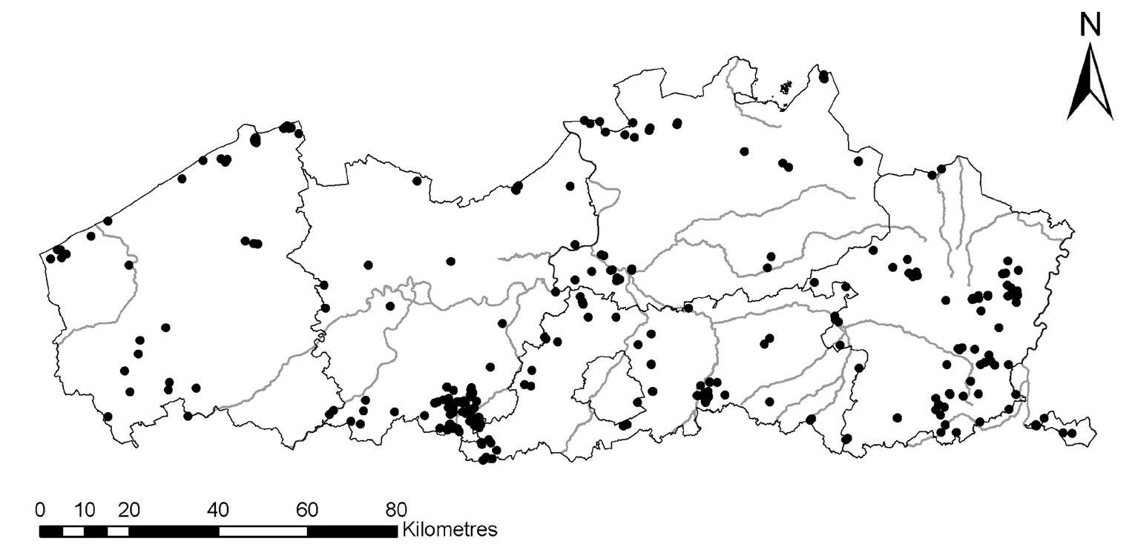

Figure 1 – Spatial distribution of the collected scats (Flanders, Belgium).

highly mobile, with large home-ranges in comparison to non- carnivorous species with similar body sizes. Therefore, they are considered to disperse significant quantities of seeds over relatively large areas (Willson 1993, Jordano et al. 2007).
In Flanders (Belgium), the most common wild predatory mammal is the red fox (Vulpes vulpes L.). Foxes are marked- ly opportunistic feeders, consuming animal, plant and waste material (Lloyd 1980), and they occupy various biotopes, including (semi-)natural (woodlands, heathlands, marshes, etc.), agricultural and urban landscapes. In small-scaled rural areas in Flanders, fox densities reach about one (spring) or two (fall) adults per km² (Van Den Berge & De Pauw 2003). Territories in these areas usually are about 2 to 5 km² large, sometimes over 10 km², and are intensively used by the resi- dent animal. Linear movements of several kilometres can thus be realized within territories on a daily basis. Moreover, first-year foxes disperse over large distances in search of new territories from late September on. In Flanders, movements of about 20 to 40 kilometres have been reported for these individuals (K. Van Den Berge, Research Institute for Na- ture and Forest, Brussels, unpubl. res.). As these relatively inexperienced hunters traverse terrain coincidently with the fruiting season of many plant species, they could show an increased intake of seeds in this stage of life.
Due to their widespread occurrence, opportunistic feeding habits, and high mobility, red foxes might serve as significant long-distance seed dispersers for a wide set of plants. For the highly urbanized region of Flanders, we have therefore per- formed a descriptive study on the occurrence of seeds in scats from foxes (Vansteenbrugge 2009).

MATERIALS AND METHODS
The scats used for analysis originated from two collection campaigns. The first was conducted in 2004–2005 for an ex- plorative study on the incidence of Echinococcus multilocu- laris Leuckart in Flanders, an endoparasitic cestode in foxes (Breyne et al. 2006). Herefore, co-workers of the governmen-
tal Agency for Nature and Forest were called on to collect fox scats in their work areas. From this campaign 246 samples were used in the present study. In 2008–2009 and for this study exclusively, we organized a second call, among volun- teers. Their collections resulted in an additional 57 samples.
Fox scats are easily distinguishable from those of other carnivores (van Diepenbeek 1999). Functioning as an impor- tant means of olfactory communication, they are often de- posited on raised structures (e.g. grass tussocks, tree-stumps) at boundaries within the landscape (e.g. near paths, ditches). Because of potential cestode infection, strict hygienic meas- ures were respected throughout the procedure. After collec- tion, the samples were placed in a freezer at -80°C for at least seven days to kill potentially present cestodes, and subse- quently stored at -20°C.
The resulting 303 samples originated from all over Flan- ders (fig. 1). The collection campaigns were launched with- out any spatial preoccupation, and the few clusters seen in fig. 1 therefore represent ‘observer effects’. The collection campaign of 2004–2005 focused on early spring as fox popu- lations are spatially most stable at this time of year. The cam- paign of 2008–2009 aimed at complementing this as much as possible. Nevertheless, the number of analyzed scats was unevenly distributed over the year (fig. 2).
Before analysis, the samples were soaked in water and sieved (355 µm mesh). If present, seeds (defined here as any propagule of generative origin, such as true seeds, fruits or mericarps) were isolated, air-dried, and identified with a stereomicroscope (main references: Cappers et al. 2006, Ghent University seed collection).

RESULTS
In total, we encountered 5207 seeds distributed among 172 scats. If present, the number of seeds per scat was generally low (fig. 3). However, one scat contained no less than 1135 seeds.

Table 1 – Taxa from which seeds were found in the collected red fox scats.
The data given are frequency (number of scats in which the taxon was found, 303 samples were investigated), and total number of seeds found (#).

taxon | freq. | # | taxon | freq. | #
woody species with fleshy propagules |  |  | herbs and graminoids (continued)
Rubus fruticosus L. | 19 | 2478 | Brassicaceae | 3 | 3
Crataegus L. | 18 | 495 | Juncus L. | 2 | 20
Prunus serotina Ehrh. | 10 | 225 | Elymus L. | 2 | 4
Malus Mill. | 9 | 12 | Trifolium L. | 2 | 4
Rubus L. | 7 | 281 | Agrostis capillaris L. | 2 | 2
Prunus domestica L. | 5 | 8 | Atriplex L. | 2 | 2
Rosa L. | 4 | 65 | Carex L. | 2 | 2
Sambucus nigra L. | 4 | 14 | Festuca L. | 2 | 2
Prunus avium (L.) L. | 3 | 32 | Persicaria maculosa Gray | 2 | 2
Sorbus L. | 3 | 25 | Panicum miliaceum L. | 1 | 124
Prunus laurocerasus L. | 3 | 22 | Calamagrostis Adans. | 1 | 15
Rubus caesius L. | 2 | 554 | Setaria italica (L.) P.Beauv. | 1 | 12
Prunus spinosa L. | 2 | 12 | Bromus hordeaceus L. | 1 | 8
Viburnum lantana L. | 2 | 12 | Asteraceae | 1 | 6
Pyrus L. | 2 | 4 | Avena sativa L. | 1 | 6
Taxus baccata L. | 2 | 2 | Lolium L. | 1 | 6
Prunus cerasus L. | 1 | 19 | Linum usitatissimum L. | 1 | 5
Cornus mas L. | 1 | 8 | Helianthus annuus L. | 1 | 2
Vitis vinifera L. | 1 | 2 | Medicago lupulina L. | 1 | 2
Cotoneaster Ehrh. | 1 | 1 | Phaseolus vulgaris L. | 1 | 2
woody species without fleshy propagules |  |  | Sesamum indicum L. | 1 | 2
Betula pendula Roth | 69 | 356 | Sinapis arvensis L. | 1 | 2
Alnus glutinosa (L.) Gaertn. | 16 | 153 | Thalictrum minus L. | 1 | 2
Betula pubescens Ehrh. | 16 | 25 | Alopecurus L. | 1 | 1
Alnus incana (L.) Moench | 5 | 5 | Brassica L. | 1 | 1
Chamaecyparis lawsoniana (A.Murray) Parl. | 3 | 27 | Cerastium L. | 1 | 1
Coniferales | 2 | 2 | Cucurbita L. | 1 | 1
Larix L. | 2 | 2 | Deschampsia P.Beauv. | 1 | 1
Salix L. | 2 | 2 | Fabaceae | 1 | 1
Fraxinus excelsior L. | 1 | 1 | Fallopia convolvulus (L.) A.Löve | 1 | 1
Pinus L. | 1 | 1 | Fallopia dumetorum (L.) Holub | 1 | 1
herbs and graminoids |  |  | Hordeum L. | 1 | 1
Triticum L. | 8 | 43 | Persicaria hydropiper (L.) Spach | 1 | 1
Chenopodium L. | 7 | 19 | Phragmites australis (Cav.) Steud. | 1 | 1
Polygonum L. | 6 | 7 | Poa L. | 1 | 1
Holcus lanatus L. | 5 | 5 | Ranunculus L. | 1 | 1
Phalaris canariensis L. | 4 | 10 | Rumex L. | 1 | 1
Stellaria media L. | 4 | 8 | Stellaria L. | 1 | 1
Galium aparine L. | 3 | 4 | Veronica hederifolia L. | 1 | 1
Urtica dioica L. | 3 | 4

Except for eleven seeds (representing four visibly distin- guishable morphotypes), all seeds were identified, mostly at species or genus level (table 1). 64% of all seeds belonged to Rubus species (the abovementioned seed-dense sample alone accounted for 993 seeds). 18% of the seeds belonged
to other woody species with fleshy propagules, totalling 82% of the seeds. Yet, woody species with dry propagules were also encountered; Betula even proved to be by far the most frequently present taxon (23% of the scats), albeit in rather low densities (0–37 per scat). Remarkably, we found numer-

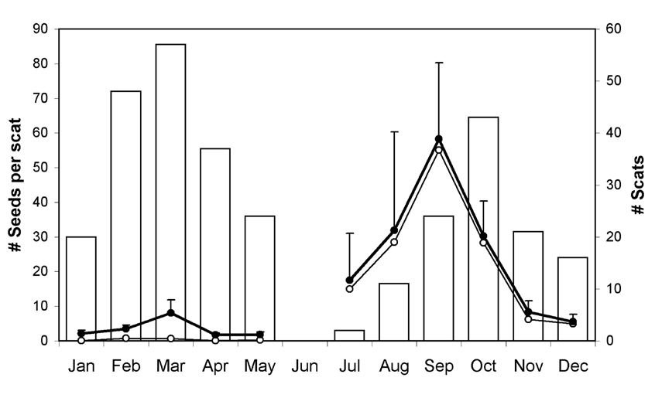

Figure 2 – Temporal distribution of the collected scats (bars). The monthly means of the seed numbers per scat are given by closed dots (± standard error). The number of seeds that are due to woody plant species with fleshy propagules are given by open dots. The sample with 1135 seeds is not included (a September sample).

ous herbaceous plants and graminoids in the scats as well (table 1).
The autumn samples more frequently held seeds, and more seeds, than spring samples did. On average, the highest numbers were found in September samples (fig. 2).

DISCUSSION
This study contributes to the various observations of seeds borne in scats of red foxes, and thus, of plant species that are potentially dispersed by these animals (Willson 1993, Koike et al. 2008, Matías et al. 2010).
The set of species we found in the scats was particularly diverse, which reflects the animals’ opportunistic diet. The majority of seeds were found in autumn scats and belonged to woody plant species with drupes or berries, i.e. species that are (rightly) characterized by an ‘endozoochorous’ seed syn- drome. Indeed, fleshy fruits are known to be appreciated by foxes mainly as a source of sugars and lipids (Willson 1993). Rubus is a very common taxon in Flanders (Van Landuyt et al. 2006), and its low-growing habit undoubtedly facilitates high levels of direct infructescence consumption from the plant. For higher shrubs or trees, consumption is considered to have occurred from fallen fruits (cf. Hernández 2008, Guitián & Munilla 2010), although direct consumption from low-hanging branches cannot be excluded. Several of these woody species are widespread in the wild (e.g. Rosa, Sam- bucus, Crataegus; Van Landuyt et al. 2006), but the seeds from others undoubtedly originated from cultivated plants, escapees, or waste material (e.g. Vitis, from a March sample). From Prunus, for instance, both cultivated (P. laurocerasus) and natural species (indigenous and alien, e.g. P. spinosa and
P. serotina) were recorded in the scats.
No less than 18% of the seeds belonged to plant species whose seeds are not embedded in fleshy tissues. For some of these species, seeds might nonetheless have been actively consumed. Sargeant et al. (1986), for instance, noted Helian- thus fruits to be the single most important winter feed of fox- es in a region where this was a principal crop. Yet, we suspect
an inadvertent intake for most of these species. Foxes some- times consume fresh leaves of grasses to promote digestion, and seeds could thus have been accidently ingested along. Also, the prey itself might have borne seeds, either externally or internally. For Panicum, Phalaris, Setaria, Triticum (one sample contained all of these species), and to a lesser degree Helianthus, this was almost certainly the route of ingestion, since these species are frequently used in feeding mixtures for caged birds or poultry (on which foxes occasionally pre- date). Although these particular observations of ‘double en- dozoochory’ (Nogales et al. 2007) are strongly related to an anthropogenic context, it is probable to apply to wild prey as well. Finally, as for the fleshy fruits, seeds might have been inadvertently ingested through consumption of waste (e.g. Sesamum, a regular constituent of bread rolls).
For foxes to be effective seed dispersers, seeds firstly need to have maintained viability, of course. Our study did not al- low for assessing this since we could impossibly tease apart the effects of ultrafreezing, storage and fox ingestion on seed mortality. High levels of germinability after passage through the intestinal tract of canids have nevertheless been con- firmed several times for fleshy-fruited species (Bustamante et al. 1992, Silva et al. 2005, Varela & Bucher 2006, Fedriani
& Delibes 2009, Matías et al. 2010). On the other hand, such accounts are lacking for dry-fruited herbs and grasses, leav- ing our observations from these species open to suggestion. Second, viably excreted seeds need to establish from scats. Seedling emergence from fox scats has been recorded for Ru- bus and Corema in the field experiment of Fedriani & Delibes (2009), but further observations are lacking. The non-random sites at which fox droppings are deposited in the field will likely influence establishment differently for species.
Due to their widespread occurrence and high mobility, red foxes could be effective vectors in seed dispersal at local and regional scales throughout the species’ range. Our results

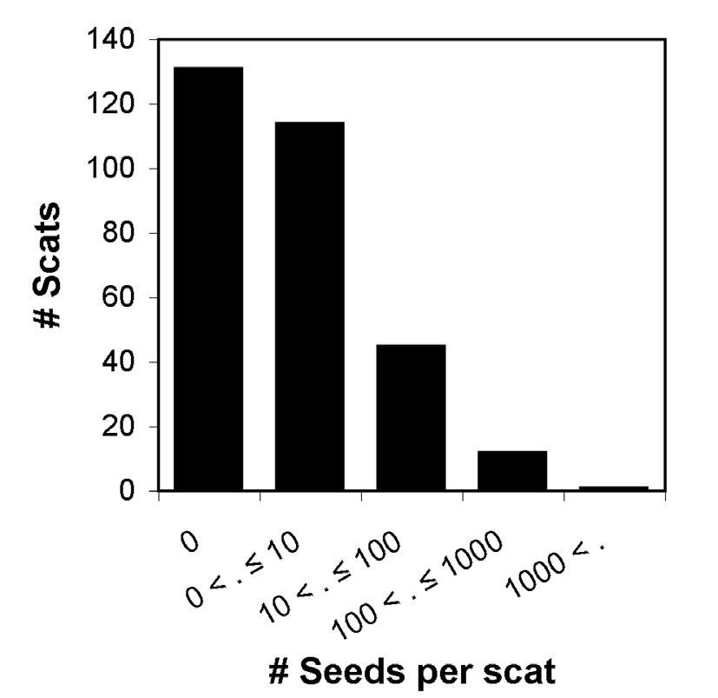
Figure 3 – Frequency distribution of the number of seeds found per scat.

clearly show that a diverse set of plant species, both natural and cultivated, become ingested and excreted by these carni- vores. However, details on effective establishment need to be further assessed.

ACKNOWLEDGEMENTS
We sincerely wish to thank the many people that contributed to the collection of scats (Agency for Nature and Forest of the Flemish Government, Natuurpunt V.Z.W. and others). Also, we are indebted to Dr Leander De Pypere for assistance in the identification of Prunus endocarps. Bram D’hondt is a fellow at the Research Foundation – Flanders (FWO).

REFERENCES
Breyne P., De Pauw W., Halfmaerten D., Van Den Berge K. (2006) Oriënterend onderzoek naar het voorkomen van de vossenlint- worm in Vlaanderen met behulp van moleculair-genetische technieken. Brussels, Research Institute for Nature and Forest.
Bustamante R.O., Simonetti J.A., Mella J.E. (1992) Are foxes le- gitimate and efficient seed dispersers? A field test. Acta Oeco- logica 13: 203–208.

Cappers R.T.J., Bekker R.M., Jans J.E.A. (2006) Digital seed atlas of the Netherlands. Eelde, Barkhuis Publishing.
Cosyns E., Claerbout S., Lamoot I., Hoffmann M. (2005) Endo- zoochorous seed dispersal by cattle and horse in a spatially heterogeneous landscape. Plant Ecology 178: 149–162. DOI: 10.1007/s11258-004-2846-3

Cousens R., Dytham C., Law R. (2008) Dispersal in plants. A popu- lation perspective. New York, Oxford University Press.
Fedriani J.M., Delibes M. (2009) Functional diversity in fruit- frugivore interactions: a field experiment with Mediterranean mammals. Ecography 32: 983–992. DOI: 10.1111/j.1600- 0587.2009.05925.x
Guitián J., Munilla I. (2010) Responses of mammal dispersers to fruit availability: Rowan (Sorbus aucuparia) and carnivores in mountain habitats of northern Spain. Acta Oecologica 36: 242– 247. DOI: 10.1016/j.actao.2010.01.005

Hernández A. (2008) Cherry removal by seed-dispersing mammals: mutualism through commensal association with frugivorous birds. Polish Journal of Ecology 56: 127–138. [available at http://www.pol.j.ecol.cbe-pan.pl/article/ar56_1_11.pdf]

Herrera C.M. (1989) Frugivory and seed dispersal by carnivo- rous mammals, and associated fruit characteristics, in un- disturbed Mediterranean habitats. Oikos 55: 250–262. DOI: 10.2307/3565429
Jordano P., Garcia C., Godoy J.A., Garcia-Castano J.L. (2007) Dif- ferential contribution of frugivores to complex seed dispersal patterns. Proceedings of the National Academy of Sciences of the USA 104: 3278–3282. DOI: 10.1073/pnas.0606793104

Koike S., Morimoto H., Goto Y., Kozakai C., Yamazaki K. (2008) Frugivory of carnivores and seed dispersal of fleshy fruits in cool-temperate deciduous forests. Journal of Forest Research 13: 215–222. DOI: 10.1007/s10310-008-0069-5

Lloyd H.G. (1980) The red fox. London, Batsford Ltd.
Matías L., Zamora R., Mendoza I., Hódar J.A. (2010) Seed dis- persal patterns by large frugivorous mammals in a degraded mosaic landscape. Restoration Ecology 18: 619–627. DOI: 10.1111/j.1526-100X.2008.00475.x
Nathan R., Schurr F.M., Spiegel O., Steinitz O., Trakhtenbrot A., Tsoar A. (2008) Mechanisms of long-distance seed dispersal. Trends in Ecology & Evolution 23: 638–647. DOI: 10.1016/j. tree.2008.08.003
Nogales M., Padilla D.P., Nieves C., Illera J.C., Traveset A. (2007) Secondary seed dispersal systems, frugivorous lizards and pred- atory birds in insular volcanic badlands. Journal of Ecology 95: 1394–1403. DOI: 10.1111/j.1365-2745.2007.01305.x

Russo S.E., Portnoy S., Augspurger C.K. (2006) Incorporat- ing animal behavior into seed dispersal models: implica- tions for seed shadows. Ecology 87: 3160–3174. DOI: 10.1890/0012-9658(2006)87[3160:IABISD]2.0.CO;2
Sargeant A.B., Allen S.H., Fleskes J.P. (1986) Commercial sunflow- ers: food for red foxes in North Dakota. The Prairie Naturalist 18: 91–94.
Schaumann F., Heinken T. (2002) Endozoochorous seed dispersal by martens (Martes foina, M. martes) in two woodland habitats. Flora 197: 370–378. DOI: 10.1078/0367-2530-00053

Silva S.I., Bozinovic F., Jaksic F.M. (2005) Frugivory and seed dispersal by foxes in relation to mammalian prey abundance in a semiarid thornscrub. Austral Ecology 30: 739–746. DOI: 10.1111/j.1442-9993.2005.01449.x

Trakhtenbrot A., Nathan R., Perry G., Richardson D.M. (2005) The importance of long-distance dispersal in biodiversity conservation. Diversity and Distributions 11: 173–181. DOI: 10.1111/j.1366-9516.2005.00156.x

Van Den Berge K., De Pauw W. (2003) Vos. In: Verkem S., De Maeseneer J., Vandendriessche B., Verbeylen G., Yskout S. (eds) Zoogdieren in Vlaanderen. Ecologie en verspreiding van 1987 tot 2002: 363–369. Mechelen & Ghent, Natuurpunt Studie
& JNM-Zoogdierenwerkgroep.
van der Pijl L. (1969) Principles of dispersal in higher plants. Hei- delberg/Berlin, Springer-Verlag.
van Diepenbeek A. (1999) Veldgids diersporen. Utrecht, KNNV Uitgeverij.
Van Landuyt W., Hoste I., Vanhecke L., Van den Bremt P., Vercruys- se E., De Beer D. (2006) Atlas van de flora van Vlaanderen en het Brussels Gewest. Brussels & Meise, Research Institute for Nature and Forest & National Botanic Garden of Belgium.
Vansteenbrugge L. (2009) Potentiële endozoöchore zaadverbrei- ding door de vos (Vulpes vulpes L.) in Vlaanderen. MSc thesis. Ghent University, Ghent, Belgium.
Varela O., Bucher E.H. (2006) Passage time, viability, and germina- tion of seeds ingested by foxes. Journal of Arid Environments 67: 566–578. DOI: 10.1016/j.jaridenv.2006.03.013

Willson M.F. (1993) Mammals as seed-dispersal mutualists in North-America. Oikos 67: 159–176. DOI: 10.2307/3545106

