Distribution and ecology of the Belgian Campodea species (Diplura: Campodeidae)
Koen Lock a,*, Tim Adriaens b, Maarten Stevens b
a Laboratory of Environmental Toxicology and Aquatic Ecology, Ghent University, J. Plateaustraat 22, 9000 Gent, Belgium
b Research Institute for Nature and Forest, Kliniekstraat 25, 1070 Brussel, Belgium

Keywords:
Belgium Community analysis Niche segregation Soil invertebrates

a b s t r a c t

From 2004 till 2008, Diplura were sampled at 96 localities in Belgium. Nine different species of Campodea were collected: Campodea fragilis Meinert 1865, Campodea lankesteri Silvestri 1912, Campodea lubbocki Silvestri 1912, Campodea meinerti Bagnall 1918, Campodea plusiochaeta Silvestri 1912, Campodea remyi Denis 1930, Campodea rhopalota Denis 1930, Campodea staphylinus Westwood 1842 and Campodea wal- lacei Bagnall 1918. The ordination technique non-metric multidimensional scaling indicated that pH and temperature/humidity were probably the most important variables determining species composition. However, it was remarkable that almost all combinations of species were encountered in the ﬁeld, often even under the same stone. As no temporal segregations seem to take place, it remains unknown how these very similar species can occur together.

- Introduction

Diplura are an order of wingless, blind arthropods belonging to the class of the Entognatha. Typically, Campodeidae are inhabitants of damp, stable environments [2]. They can be found under stones on humid soil, in degrading lodges, in forest litter and in humid soils [10]. Eisenbeis [6] indicated that Campodea species require a relative humidity of close to 100%. Campodeidae are generalists that are herbivorous, carnivorous, detrivorous as well as fungivorous [2]. All studied species in Western Europe breed in summer and autumn. However, as they live in the ﬁeld for about two years [1,10], they can be found throughout the year. As Campodeidae are seldom found in large numbers [7], their economical importance is minimal. Due to their small size (usually smaller than 5 mm), their subterranean lifestyle and the difﬁculty of their identiﬁcation, they did not receive much attention until present and therefore, little information is available on their biodiversity, ecology and distribution.
Recently, Lock [8] made a checklist reporting 13 species of Diplura for the Belgian fauna. Of these 13 species, nine belong to the genus Campodea, which is by far the most common genus in Belgium. The aim of the present study was to get a better insight in the distribution and the ecology of the Campodea species occurring in Belgium.

* Corresponding author. Tel.: þ32 9 2643996; fax: þ32 9 2643766.
E-mail address: Koen.Lock@UGent.be (K. Lock).
- Materials and methods

  - Sampling

Diplura of the genus Campodea were searched from 2004 till 2008 during random ﬁeld trips distributed over all ecoregions in Belgium (Fig. 1). As it was one of the goals to get an idea of the diversity in Belgium, all kinds of habitat were sampled. Campodea species can be found throughout the year, however, because they crawl deeper into the soil during dry and cold conditions, catches during spring and autumn were most successful. Animals were sampled by turning stones and subsequently catching them with an aspirator. To increase the change of being able to identify the encountered Campodea species, on average four animals were caught on each locality. Before the preparation of microscopic slides using Hoyer solution, specimens were preserved in 70% alcohol. Species were identiﬁed using the identiﬁcation key recently developed by Lock [8]. Besides Campodea species, also one spec- imen of Dipljapyx humberti (GRASSI, 1886) of the family Japygidae was encountered during the present study, however, as this family has a completely different lifestyle, this record was not further discussed. Metajapyx leruthi SILVESTRI 1948 and two cave-dwelling species, Litocampa hubarti hubarti BARETH 1999 and L. humilis (CONDE´ , 1948), which also occur in Belgium [8], were not observed during the present study.

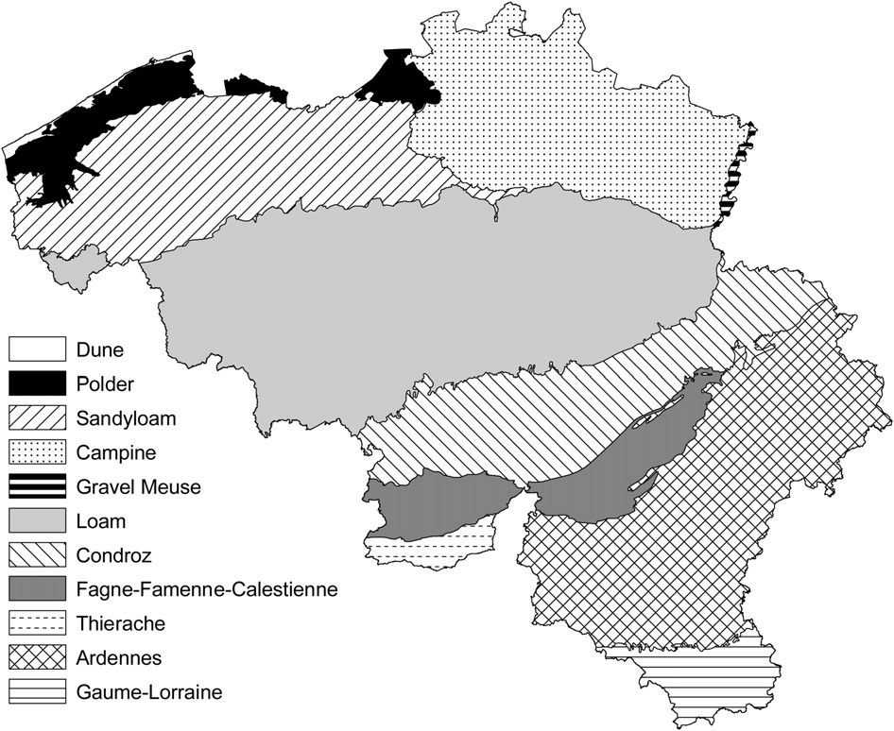

Fig. 1. Map of Belgium with indication of the different ecoregions.

  - Statistics

Dissimilarity matrices were calculated from log transformed abundance data using Bray–Curtis distances. The non-metric multi- dimensional scaling (NMDS) ordination was created using random starting conﬁgurations and iterated until solutions converged. Analysis was performed using the vegan package in R 2.6.2 [9]. Similarities among sites were calculated on the basis of species composition and species were plotted as an overlay on the plot. Using this technique, species with similar habitat requirements are plotted closely together, whereas species with very different requirements are plotted far apart.

- Results

From 2004 till 2008, 387 specimens of Diplura were sampled at 96 localities. Nine different species of Campodea, all belonging to the subgenus Campodea, were captured in Belgium: Campodea fragilis Meinert 1865, Campodea lankesteri Silvestri 1912, Campodea lubbocki Silvestri 1912, Campodea meinerti Bagnall 1918, Campodea plu- siochaeta Silvestri 1912, Campodea remyi Denis 1930, Campodea
rhopalota Denis 1930, Campodea staphylinus Westwood 1842 and Campodea wallacei Bagnall 1918. The most common species in Belgium was C. lubbocki (Table 1, Fig. 2). Also most other species were quite common, however, C. meinerti and C. remyi were only found on four and seven occasions, respectively (Table 1, Fig. 2).
Despite the fact that at each locality only a few square meters were sampled and that on average only about four specimens were captured, different species were often found together. In fact, most species combinations were encountered in the ﬁeld (Table 1). However, C. remyi was exceptional as it only co-occurred once with
C. staphylinus.
NMDS was able to give a fairly good representation of the underlying resemblance matrix, as indicated by a stress factor of
15.7 for the ﬁrst two axis. Adding a third axis did not reveal any additional information. In the NMDS biplot, the ﬁrst axis seemed to be related with pH (Fig. 3). C. remyi, which is restricted to the Ardennes and the Thierache regions (Table 2, Fig. 2) with their acidic soils, was plotted on the right. The only other species that were found in the Ardennes, were C. staphylinus and C. plusiochaeta (Table 2, Fig. 2). On the left side of the ﬁrst axis, C. rhopalota was

Table 1
Co-occurrence of the different Campodea species in Belgium, with the number of localities where each species was found between brackets. The values indicate the percent of the localities where the species in the row was found together with the species in the column.

 | fragilis | lankesteri | lubbocki | meinerti | plusiochaeta | remyi | rhopalota | staphylinus | wallacei
Campodea fragilis (22) | 100 | 5 | 23 | 5 | 18 | 0 | 14 | 5 | 14
Campodea lankesteri (17) | 6 | 100 | 47 | 12 | 12 | 0 | 24 | 6 | 6
Campodea lubbocki (32) | 16 | 25 | 100 | 3 | 13 | 0 | 22 | 6 | 9
Campodea meinerti (4) | 25 | 50 | 25 | 100 | 25 | 0 | 0 | 25 | 25
Campodea plusiochaeta (15) | 27 | 13 | 27 | 7 | 100 | 0 | 7 | 27 | 7
Campodea remyi (7) | 0 | 0 | 0 | 0 | 0 | 100 | 0 | 14 | 0
Campodea rhopalota (19) | 16 | 21 | 37 | 0 | 5 | 0 | 100 | 0 | 11
Campodea staphylinus (16) | 6 | 6 | 13 | 6 | 25 | 6 | 0 | 100 | 0
Campodea wallacei (13) | 23 | 8 | 23 | 8 | 8 | 0 | 15 | 0 | 100

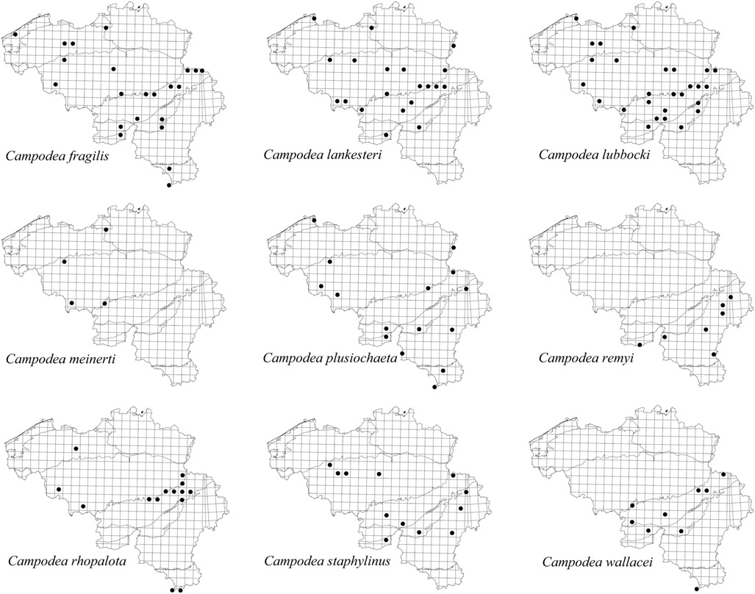

Fig. 2. Distribution of the Campodea species in Belgium (10*10 km UTM grid), with indication of the different ecoregions.

plotted, which preferred the calcareous soils of the Condroz and the Lorraine (Table 2, Fig. 2). The second axis was probably related to temperature or humidity (Fig. 3): C. wallacei and C. fragilis were often found in thermophilous habitats such as south exposed forest, whereas C. lankesteri was especially found in valleys.

- Discussion

The identiﬁcation of Campodea species is a difﬁcult task and in addition, collected specimens are frequently damaged because antennae, cerci and setae easily break off. Therefore, several spec- imens were collected at each site. However, after identiﬁcation, it was discovered that these specimens often belonged to different species and by sampling more individuals, probably even a higher number of species would have been sampled per site. Campodea species could be easily found by turning stones and therefore other techniques such as soils extractions, ﬂoatation and hand sorting were not used. Possibly some species might have been overlooked
this species was conﬁned to ruins, mine dumps and quarries.
C. fragilis was reported from relatively warm and dry conditions [4,5,10], which is in agreement with our records from thermophi- lous habitats such as south exposed forests. In the present study,

2
stress: 15.7
C. wallacei C. fragilis
C. plusiochaeta
C. staphylinus
C. remyi
C. rhopalota

1.5

1

0.5

0
nMDS 2

by using only this technique, however, all species that had been | -0.5 |  |  | C. lubbocki
reported for Belgium were encountered during the present study |  |  |  | C. meinerti
and even some additional species were encountered [8].  Only a few studies are available about the habitat requirements | -1 |  |  | C. lankesteri
of the West European Campodeidae, however, the situation is even
worse in the rest of the world. Here, we give an overview of the | -1.5
literature about the habitat of the species that were encountered in
the present study. C. remyi, which we only found in forests of the | -2
acidic Ardennes and Thierache regions, was found under similar |  | -2 | -1 | 0 | 1 | 2 | 3 | 4
conditions in coniferous forests of the Vosges in France [1] and also |  |  |  |  | nMDS 1

Conde´ [4] and von Orelli [10] reported this species from forests.
C. rhopalota has only been mentioned from synanthropous habitats such as graveyards [3] and gardens [4,5]. However, in the present
Thierache Sandyloam Polder
Loam
Gravel Meuse Gaume-Lorraine
Fagne-Famenne-Calestienne Condroz
Ardennes

study, this species was also found in forests, but only on calcareous soils of the Condroz and the Lorraine regions; outside these regions,
Fig. 3. Non-metric multidimensional scaling (NMDS) biplot of the sample scores and the Campodea species scores.

Table 2
Relative occurrence of the different Campodea species in Belgium per ecoregion, with the number of 5*5 km squares per ecoregion where Campodea species were found between brackets. The values indicate the percentage of squares with Campodea species where the respective species were found in each ecoregion.
 | fragilis | lankesteri | lubbocki | meinerti | plusiochaeta | remyi | rhopalota | staphylinus | wallacei
Ardennes (9) |  |  |  |  | 33 | 67 |  | 33
Condroz (26) | 27 | 23 | 54 | 4 | 8 |  | 35 | 15 | 27
Fagne-Famenne-Calestienne (8) | 62 | 25 | 50 |  | 38 |  |  | 25 | 25
Gaume-Lorraine (4) | 50 |  |  |  | 50 |  | 50 |  | 25
Gravel Meuse (1) |  | 100 |  |  | 100
Loam (14) | 21 | 43 | 57 | 14 | 21 |  | 29 | 29
Polder (4) | 50 | 50 | 50 | 25 | 25
Sandyloam (3) | 67 |  | 67 |  |  |  | 33
Thierache (1) |  |  |  |  |  | 100

also C. wallacei was especially found in south exposed forests, however, no literature was found about the habitat of this species. On the other hand, C. lankesteri was more commonly found in valleys with more cool and humid conditions during the present study, while this species was also commonly reported from Belgian caves [8]. The most common species in Belgium, C. lubbocki, has often been reported from gardens [3–5] and shrubs [10]. C. plu- siochaeta and C. staphylinus, which were found in all kinds of habitat during the present study, were also reported in literature as eurytopic species [2–5]. No literature was available about the habitat of C. meinerti and because this species was only found four times under differing conditions during the present study, its habitat requirements remain unknown.
Our results indicated that pH and temperature/humidity are probably the most important environmental parameters affecting species composition. However, the different species encountered during the present study were commonly found together, often even under the same stone. As all species seem to reproduce during summer and autumn and live for about two years [1,10], no temporal segregation seems to take place. Therefore, it is remains unknown how it is possible that different Campodea species are able to live together. Further research is therefore required to investigate how niche segregation takes place.

Acknowledgements

Koen Lock is currently supported by a post-doctoral fellowship from the Fund for Scientiﬁc Research (FWO-Vlaanderen, Belgium).

References

[1] C. Bareth, Biologie sexuelle et formations endocrines de Campodea remyi Denis (Diploures Campode´ ide´ s). Rev. Ecol. Biol. Sol. 3 (1968) 303–426.
[2] A. Carpenter, The biology of Campodea staphylinus (Campodeidae: Diplura) in a grassland soil. Pedobiologia 32 (1988) 31–38.
[3] E. Christian, Urban distribution and habitat preference of Diplura in the city of Vienna (Campodeidae, Japygidae). Entomol. Gen. 17 (1992) 195–205.
[4] B. Conde´ , Quelques Campode´ ide´ s du Nord-Est de la France. Bull. Soc. Sc. Nancy (N.S.) 6 (1947) 85–92.
[5] B. Conde´ , Mate´ riaux pour une monographie des diploures campode´ ide´ s. Me´ m.
Mus. Nat. Hist. Nat. (A) 12 (1956) 1–202.
[6] G. Eisenbeis, Kinetics of water exchange in soil arthropods. in: P. Lebrun,
H.M. Andre´ (Eds.), New Trends in Soil Biology. Dieu Brichart, Ottignies- Louvain-la-Neuve, 1983, pp. 417–425.
[7] J. Lagerlo¨ f, O. Andre´ n, Abundance and activity of Collembola, Protura and Diplura (Insecta, Apterygota) in four cropping systems. Pedobiologia 35 (1981) 337–350.
[8] K. Lock, Diplura of Belgium. Bull. Soc. R. Belg. Entomol. 145 (2009).
[9] J. Oksanen, R. Kindt, P. Legendre, R.B. O’Hara, M. Henry, H. Stevens, Vegan: community ecology package R package version 1.8-7. http://cran.r-project.org (2006).
[10] M. von Orelli, Untersuchungen zur postembryonalen Entwicklung von Campo- dea (Insecta; Apterygota). Verh. Naturforsch. Ges. Basel 67 (1956) 501–574.

