Effects of flood events on the genetic structure of riparian populations of the grassland plant Origanum vulgare
Kris Van Looya,*, Hans Jacquemynb, Peter Breynea, Olivier Honnayb
aResearch Institute for Nature and Forest, Kliniekstraat 25, 1070 Brussels, Belgium
bDivision of Plant Ecology and Systematics, University of Leuven, Arenbergpark 31, B-3001 Heverlee, Belgium

Keywords:
Assignment test
Long distance seed dispersal River regulation Colonisation
Fragmentation
A B S T R A C T

River regulation results in the disconnection and increased fragmentation of habitats in the river corridor. In this study, we investigated the within-population genetic variability and among-population genetic differentiation of 21 populations of Origanum vulgare along the River Meuse, using dominant AFLP markers, in order to asses the restoration potential of this species in the context of current river restoration efforts. The average observed within-population genetic diversity was high and suggests that river regulation and asso- ciated fragmentation of the populations have not strongly affected genetic diversity. The genetic differentiation between populations was high (UST = 0.24) and can be explained by founder effects, rather than by genetic drift in isolated populations. We also detected a pronounced hierarchic spatio-temporal structure in genetic variation. This structure can be related to the irregular patterns in the flow regime of the River Meuse. Large floods are the major vector of genetic structure, but geographic upstream proximity, probably mediated by small floods, also has an important effect on genetic structure. Three distinct groups of populations were observed, two of which could be related to the extreme flood events of the mid-nineties of last century. Assignment tests revealed occasional long-dis- tance seed dispersal with extreme flood events and local colonisation with more regular floods. Our study species optimally took benefit of the opportunities offered by the river restoration programme, with a strong colonisation after floods, and illustrates the need for maintaining river dynamics to conserve and restore genetic diversity.

Introduction

Natural river landscapes of the temperate regions harbour an exceptionally high biodiversity due to their high spatio-tem- poral habitat heterogeneity and high landscape connectivity (Naiman et al., 1993; Mouw and Alaback, 2003). Nearly all large rivers in Europe and the USA, however, are affected by dams, dykes and other channel containments that reduce variation in water levels and peak flows and that disrupt both lateral and longitudinal river connectivity (Giller, 2005). Be-
cause the maintenance of plant diversity in the riparian land- scape is tightly linked to disturbance regimes and longitudinal and lateral exchanges between river regions and forelands (Ward, 1998; Van Looy et al., 2006), river regula- tion disconnects these vital contacts for the exchange of spe- cies and the recolonisation after local extinction, with a general loss of diversity as result (Zwick, 1992).
Dry river grasslands in particular have been shown to be important hot spots of biodiversity along river networks in North-west Europe (Jongman, 1992; Stroh et al., 2005). How-

ever, due to an increasing regulation of natural river dynamics and the intensification of agricultural practices in the river forelands, many river grasslands of the large North-western European rivers have become extremely fragmented and many characteristic species have become severely threatened (Burkart, 2001; Donath et al., 2005; Wolfert et al., 2002). The disconnection of river grasslands from the river dynamics may result in decreased gene flow between grassland plant populations, strong genetic differentiation and a lower genet- ic diversity of the present species (Young et al., 1996), poten- tially affecting long-term persistence of species at both the local and regional scale. It is indeed known that genetic ero- sion may both affect the evolutionary adaptation potential of a species through the loss of alleles, and its short-term fit- ness through inbreeding (Young et al., 1996; Keller and Waller, 2002).
In dynamic landscapes, populations can be favoured by stochastic processes or disturbances at the landscape scale to maintain their genetic diversity. Floods form a source of environmental stochasticity that is likely to be important for the dynamics of riparian species (Menges, 1990; Lytle and Poff, 2004). Still, for the case of perennial plants with seed banks, Freckleton and Watkinson (2002, 2003) argued that the short-term persistence of species depends to a great- er extent on local rather than regional dynamics. Ehrle´ n and Eriksson (2003) nevertheless considered the relative impor- tance of regional dynamics as high in the perspective of lar- ger spatial and temporal scales. Short- and long-distance seed dispersal in dynamic rivers is mentioned as a potentially determining aspect of long-term persistence of populations of riparian species (Menges, 1990; Ouborg, 1993; Ja¨ ka¨ la¨ niemi et al., 2005). Yet, no data to proof this assumption existed up to now.
At present, the role of river dynamics in determining the spatial distribution of genetic diversity of plant species con- fined to dynamic riparian landscapes is still poorly under- stood. Several conceptual models have been outlined to understand the spatio-temporal dynamics of genetic diversity of riparian plant species (e.g. Tero et al., 2003; DeWoody et al., 2004). In dynamic river systems, continuous extinction and colonization of habitats may result in relatively high levels of genetic differentiation due to genetic bottlenecks and foun- der events (Tero et al., 2003). If in this case gene flow is most effective at shorter distances, a relationship between genetic and geographic distances may emerge (Hutchison and Tem- pleton, 1999; Koizumi et al., 2006), whereas no relationship between geographic and genetic distances is expected when long-distance seed dispersal occurs frequently within the sys- tem (Bohrer et al., 2005; Jacquemyn et al., 2006). With increas- ing river regulation, however, populations may become too fragmented to allow gene flow among populations, resulting in a patchwork of virtually unconnected remnant popula- tions. In this case, high genetic differentiation and a complete lack of a relationship between geographic and genetic dis- tances can be expected due to random genetic drift and the absence of gene flow replenishing lost alleles (Koizumi et al., 2006). Extreme flood events, however, can mediate long-distance dispersal and colonisation events that may mitigate this genetic erosion. This may even result in an age structure, leading to spatio-temporal patterns in genetic

heterogeneity that can be closely linked to the historical dynamics of the river (Jacquemyn et al., 2006).
In this study, we investigated the spatio-temporal struc- ture of genetic variation among- and within-populations of the perennial grassland plant species Origanum vulgare L. using dominant amplified fragment length polymorphism (AFLP) markers. Populations of this species became seriously fragmented in the riparian landscape of the River Meuse when grasslands were disconnected from the river by the establishment of dykes throughout the last century. Current river restoration projects, initiated after the extreme floods of 1993 and 1995, aim at restoring the connectivity between the river and the river grasslands by locally removing the dykes. The general aim of this study was to assess the within- and among-population genetic diversity of O. vulgare, in order to assess the restoration potential of this species in the con- text of further river restoration efforts. Because detailed infor- mation on the flood regime and the establishment and expansion of the extant populations was available, there was a unique opportunity to link this information with the AFLP-derived genetic structure of the populations. More spe- cific, the following questions were addressed:

  - What is the genetic diversity of the O. vulgare
populations?
  - How have two, relatively recent, extreme flooding events (1993 and 1995) affected the genetic structure of the populations?
  - Is there a genetic differentiation resulting in genetic erosion, due to isolation of populations?
  - Can among-population gene flow be detected and does it affect within- and among-population genetic diversity?

Materials and methods

Study species

Origanum vulgare L. is a tufted, aromatic herb, growing to 20–80 cm tall, flowering in late Spring and Summer. It is a perennial grassland species of relatively dry and infertile, cal- careous soils (Grime et al., 1988). The flowers are self-incom- patible and insect-pollinated. It regenerates by means of seeds and produces numerous small seeds (1.0 · 0.7 mm, mean weight 0.1 mg), which germinate in vegetation gaps during Spring (Cresswel, 1982). O. vulgare also forms very large buried seed banks that allow the species to respond to distur- bances, observed in habitats subjected to intermittent dam- age by fire (Grime, 1978).
In our study area, O. vulgare is a typical river corridor spe- cies of the calcareous floodplain soils (Fig. 1). With the inten- sification of agricultural practices it became a threatened species of grassland borders and the more extensively man- aged floodplain meadows. A restoration programme was ini- tiated for the river and its valley in 1995, starting with the installation of a natural grazing management on several loca- tions. O. vulgare was one of the species to benefit from this development and at present it is expanding across the re- cently established nature reserves in the valley.

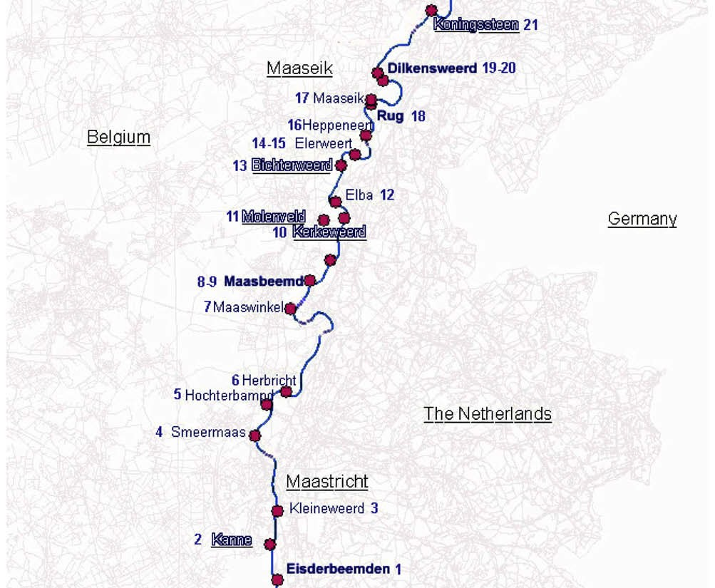

Fig. 1 – Map of all sampled Origanum vulgare populations within the River Meuse valley. Populations in bold have been founded after the 1993 flood, whereas underlined populations colonized the area after the 1995 flood.

Study area

The Common Meuse between Belgium and The Netherlands is the non-impounded, non-navigable reach of the River Meuse between the towns of Maastricht and Maaseik, where the river descends from the Ardennes and enters the low- lands. The high slope is responsible for its fast flowing grav- el-bed river character. The rain fed discharge regime shows high peak flows and extreme low flows in dryer periods with a base flow of less than 10 m3/s and the extreme peak dis- charges being thousand times bigger. In the mid-nineties, two extreme peak flows occurred in 1993 and 1995 with the
highest ever-recorded discharges of over 3200 m3/s (Fig. 2). These floods further instigated the restoration programme as they revitalised the river’s morphodynamic character with impressive bank retreats, scouring of flood channels and overbank sedimentation of gravel and sand. Together with this morphological revival, an impressive influx and recoloni- sation of species was recorded, enhancing further restoration measures (Pedroli et al., 2002). In contrast to these extreme floods of more than 2000 m3/s, the more frequent intermedi- ate peak events (Fig. 2) only allow contact between the river and the floodplain, without the strong morphological activity of overbank sedimentation and erosion.

3500

3000

2500

2000
Flux (m³/s)

1500

1000

500

0
1910

1920 1930

1940

1950

1960

Year

1970

1980

1990

2000

Fig. 2 – Annual peak fluxes during the last 95 years, showing the pattern of intermediate and extreme peak flows.

Sampling and AFLP analysis

In Spring 2005, leaf materials were collected from 398 individ- uals, from 21 populations located along a 55 km long stretch of the river (Fig. 1 and Table 1). Since the vegetation in the flood- plain and all O. vulgare populations of this river stretch were monitored since 1992, we could exactly determine the age of the sampled populations (Table 1). Individuals were sampled from the entire area occupied by the population in order to avoid the effects of population substructure. Young leaf mate- rial was collected and immediately frozen in liquid nitrogen. Before DNA extraction, leaf material was freeze-dried and homogenized with a mill (Retsch MM 200) to a fine powder. To- tal DNA was extracted from 20 mg of lyophilized leaf material using Dneasy Plant Mini Kit (Qiagen). After extraction, DNA concentrations were estimated on 1.0% (w/v) agarose gels.
AFLP analysis was carried out according to Vos et al. (1995). The enzymes EcoRI and MseI were used for DNA digestion. Four primer combinations were used in selective PCR: Eco- RI-CAT/MseI-GAT, EcoRI-CAT/MseI-GCT, EcoRI-CCA/MseI-GTT
and EcoRI-CCA/MseI-GGA. Amplified fragments were sepa- rated and visualized using 36 cm denaturing acrylamide gels on a Nen IR2 DNA analyzer (Li-Cor, Lincoln, Nebraska, USA). Sizes of fragments were determined by the IRDye size stan- dard (50–700 bp). AFLP profiles were scored for the presence or absence of bands using the SAGAmx software (Li-Cor). Only fragments between 100 and 600 bp were scored. Three repli- cate samples and both a negative control (containing no DNA) and a positive control (DNA sample from a distinct spe- cies) were included on each gel to check for reliability and reproducibility of the AFLP profiles.

Data analysis

Genetic diversity and structure

Three measures of within-population genetic diversity were estimated: the proportion of polymorphic loci (PPL), Nei’s gene diversity (Hj) and band richness (Br). PPL and Hj were esti- mated using AFLPsurv 1.0 (Vekemans et al., 2002). Estimates of allelic frequencies at AFLP loci were calculated using the Bayesian method with a non-uniform prior distribution of al- lele frequencies following Zhivotovsky (1999), assuming either no, or some deviation (FIS = 0.1) from Hardy–Weinberg genotypic proportions according to the outcrossing nature of the species (Knuth, 1906). However, the results for different FIS values did not differ much and only results for FIS = 0 are presented. After estimating allele frequencies, statistics of gene diversity and population genetic structure were com- puted according to Lynch and Milligan (1994). For each popu- lation, we calculated PPL at the 5% level and Hj. Band richness was calculated for a standardized sample size of 5 individuals according to the rarefaction method of Petit et al. (1998). This measure of genetic diversity represents the number of pheno- types expected at each locus (i.e. each scored AFLP fragment) and can be interpreted as an analogue of allelic richness (Coart et al., 2005).
To investigate whether population size affected PPL, Hj and Br, populations were divided in three classes based on their size: small (<50 individuals), medium-sized (50–100 individu- als) and large (>100 individuals) populations and a Kruskal– Wallis test was used to investigate whether measures of ge- netic diversity differed among size classes.

Table 1 – Statistics of gene diversity within 21 populations (numbered from upstream to downstream) of Origanum vulgare for 65 AFLP loci. N = number of individuals in the population, n = number of individuals for which scorable patterns were obtained for the four AFLP primer combinations used, PPL = proportion of polymorphic loci at the 5% level, Hj = expected heterozygosity, Br = band richness.
Population |  | river km | age | N | n | PPL | Hj | Br
1 | Eisderbeemden | 7 | 14 | >100 | 19 | 87.5 | 0.3041 | 1.60
2 | Kanne | 9 | 12 | 25–50 | 17 | 68.8 | 0.2486 | 1.56
3 | Kleine Weerd | 12 | >15 | 50–100 | 20 | 79.7 | 0.2874 | 1.63
4 | Smeermaas | 17 | >15 | 8 | 5 | 60.9 | 0.2605 | 1.61
5 | Hochterbampd | 20.5 | 14 | >1000 | 20 | 62.5 | 0.2314 | 1.47
6 | Herbricht | 22 | >15 | 23 | 17 | 78.1 | 0.3001 | 1.59
7 | Maaswinkel | 32 | >15 | 50–100 | 20 | 82.8 | 0.2878 | 1.63
8 | Maasbeemdoever | 34 | 14 | 25–50 | 19 | 60.9 | 0.2216 | 1.47
9 | Maasbeemdgreend | 35 | 3 | 50–100 | 17 | 75.0 | 0.2663 | 1.56
10 | Kerkeweerd | 40 | 8 | >100 | 19 | 79.7 | 0.2656 | 1.64
11 | Molenveld | 40.5 | 12 | 25–50 | 15 | 71.9 | 0.2594 | 1.64
12 | Elba | 42.5 | >15 | >1000 | 18 | 78.1 | 0.2796 | 1.57
13 | Bichterweerd | 44.5 | 3 | 25–50 | 17 | 79.7 | 0.2844 | 1.68
14 | Elerweert | 46.5 | >15 | 50–100 | 19 | 62.5 | 0.2312 | 1.54
15 | De Krauw | 47 | >15 | >100 | 20 | 76.6 | 0.3018 | 1.64
16 | Heppeneert | 50 | >15 | >100 | 17 | 67.2 | 0.2409 | 1.54
17 | Maaseikbrug | 53 | >15 | 25–50 | 20 | 71.9 | 0.2557 | 1.52
18 | De Rug-Roosteren | 53 | 14 | 24 | 20 | 82.8 | 0.3304 | 1.67
19 | Dilkensweerd dijk | 56 | 14 | 25–50 | 19 | 73.4 | 0.2798 | 1.58
20 | Dilkensweerd | 56.5 | 10 | 22 | 17 | 76.6 | 0.2896 | 1.57
21 | Koningssteen | 61.5 | 12 | 20 | 18 | 68.8 | 0.2367 | 1.56
 |  |  |  |  | Mean: | 73.59 | 0.270 | 1.58

To study the impact of river dynamics on the distribution of genetic variation, total genetic diversity was partitioned among the three groups of populations (i.e. ‘old’ populations from the pre 1993 flooding era, and populations that origi- nated after the large floods of 1993 and 1995, respectively), among-populations within groups, and within-populations by carrying out a hierarchical analysis of molecular variance (amova) on Euclidean pairwise distances between individuals calculated according to (Huff et al., 1993) and using GenAlEx v.
6.1 (Peakall and Smouse, 2005). Significances were determined using a permutation test (n = 9999). The Ust analogue for Gst was also derived from the Euclidean genetic distances and its significance was determined using the Monte Carlo proce- dure available in GenAlEx (9999 simulations). The Ust is an analogue for FST –values, used for the AFLP dominant markers.
Pairwise genetic distances among the 21 investigated pop- ulations and their level of significance were also obtained from the amova. Again 9999 permutations were performed. A principal coordinates (PCoA) analysis was performed on this matrix using GenAlEx and the first two components were plotted graphically. Evidence of isolation by distance among populations was obtained by examining correlations between the matrices of genetic distances and geographical distances (Slatkin, 1993). Significance of the observed relationships was obtained using a Mantel test available in GenAlEx (Mantel, 1967). A total of 9999 random permutations were performed.

Assignment tests

Population assignment tests for individuals based on genetic differentiation among populations were used to estimate con- temporary gene flow. These tests identify for a given genotype and a set of sampled populations, the population to which the genotype most likely belongs (Duchesne and Bernatchez, 2002). Assignment of an individual to a population other than the one it was sampled can in most cases be interpreted as a seed dispersal event (He et al., 2004). We followed the proce- dure of Duchesne and Bernatchez (2002) that was specifically developed for AFLP markers using AFLPOP v.1.1. First, we cal- culated the likelihood that a given individual originating from each of the 21 sampled populations based on their respective dominant AFLP band frequencies. Individual wasthen allo- cated to the population that showed the highest likelihood for thatgenotype. An unambiguous assignment was accepted when the log-likelihood difference between the most likely and the second most likely source population was greater than 1.0 (He et al., 2004). In case log-likelihood differences were smaller than 1.0, individuals remained unassigned. Meanwhile, the probability of each individual’s likelihood
within empirical distributions obtained from simulations was also calculated. An extreme small P-value (i.e. <0.001) indicates that the particular individual could not originate from any of the sampled population, i.e. it is an immigrant from outside the sampling domain (Duchesne and Bernat- chez, 2002).
For individuals that were allocated to a population other than from which they were sampled, simulations were per- formed to assess the probability of an incorrect assignment. 10,000 random specimens were generated from the sample population file and the proportion of occurrences of alloca- tion to the population to which the individual was assigned was calculated. A small proportion (i.e. <0.001) indicates that it is very unlikely that the individual was assigned to a popu- lation other than from which it was sampled solely by chance alone, thus providing strong evidence for a dispersal event.

Results

Genetic diversity and structure

The size of the 21 populations studied ranged from 8 to more than 1000 individuals (Table 1). The four AFLP primer combi- nations resulted in 65 unambiguous polymorphic bands. Each individual displayed a unique banding pattern and the differ- ences among populations were thus attributable to frequency differences in variable markers, rather than to private mark- ers. PPL ranged from 60.9 to 87.5 (mean: 73.59) (Table 1). Hj was 0.270 (range: 0.222–0.330). Both measures of gene diver- sity were not significantly (Kruskal–Wallis v2 = 1.07 and 0.06, P > 0.05) related to population size. Br ranged from 1.47 to
1.68 (mean: 1.58; SD: 0.06) (Table 1) and was also not signifi- cantly (Kruskal–Wallis v2 = 0.02, P > 0.05) related to population size.
The AMOVA indicated significant (P < 0.001) genetic differ- entiation between populations (UST = 0.24). Twelve percent of the genetic variation was attributed to variation between the three groups and 13% to variation between populations with- in groups, suggesting a strong impact of river dynamics on partitioning of the total genetic variation (Table 2). Pairwise genetic distances (UST values) ranged from 0.031 to 0.397 and were all highly significant (P < 0.001).
The first two principal coordinates (Fig. 3), which ex- plained 26 and 18% of the total variance, shows remarkable deviations to a consistent spatial pattern along the river (the populations are numbered from upstream to down- stream) and a clear distinction between two groups of popu- lations that originated from the two extreme flood events. Furthermore, within these three large groups, some cluster- ing of nearby populations is present. A first group represents

Table 2 – Hierarchical analysis of molecular variance (AMOVA) based on 65 AFLP loci in 21 populations. Populations were assigned to three groups based on their date of foundation.
Source of variation | df | Sum of squares | Variance components | % of the total variance | P-value
Between groups | 2 | 416.063 | 1.443 | 12% | <0.001
Among populations within groups | 18 | 654.077 | 1.534 | 13% | <0.001
Among individuals within-populations | 352 | 3239.957 | 9.204 | 76% | <0.001
Total | 372 | 4310.097 | 12.181 | 100%

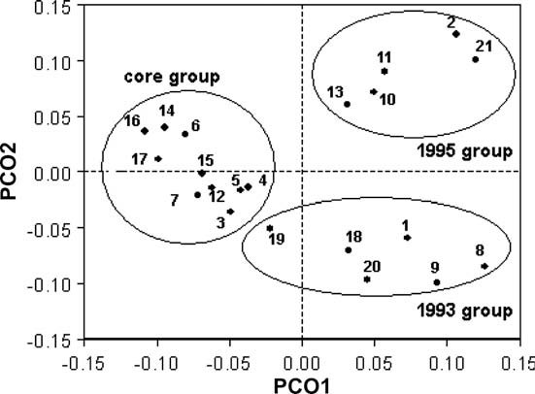

Fig. 3 – Principal coordinates (PCoA) plot of first two principal coordinates calculated based on 65 polymorphic markers and using Nei’s genetic distances (Nei’s D) between populations. Numbers refer to populations described in Table 1. Ellipses indicate the groups that were distinguished by the clustering of genetic distances and the age of the populations.

populations that originated after the 1995 flood, and consists of several populations that are located in the downstream part of the stream. Two populations (10 and 13) belonging to this group were established more recently and were located in the vicinity of populations of this group, for which the ge- netic similarity suggests that these are the ancestors. A sec- ond group consists of populations that were founded after the severe 1993 flood and which are located up to the highest parts of the winter bed at considerable distances from the riv- er. This group also includes two populations that were estab- lished more recently (populations 9 and 19), genetically similar to the nearby populations of this group. The newly established populations in these two groups were likely founded after intermediate floods of the last decade (Fig. 2). Finally, a third group of populations consists of mainly older populations and may be considered as the older core group of populations in the study area. In this group the populations

0.4

0.3
Genetic distance

0.2

0.1

0.0
0 5 10 15 20 25 30 35 40 45

Distance (km)

Fig. 4 – Relationship between pairwise genetic distances (Nei’s genetic distance) and pairwise geographical distances for 21 populations of Origanum vulgare.

are more spatially clustered than in the other groups. One population (5) that established during the 1993 flood is in- cluded in this group, and seems genetically most related to the immediately upstream population 4. There was a weak, but significant relationship between pairwise genetic dis- tances and geographic distances when all 21 populations were considered (rM = 0.184, P = 0.049) (Fig. 4).

Assignment tests

From the 373 individuals analysed in the assignment tests, 311 (83.38%) were allocated to a single of the sampled populations. Three (0.8%) individuals were allocated to outside the sampled populations. From these unambiguously assigned individuals, 300 (95.54%) were assigned to the population from which they were sampled and 11 (3.50%) individuals were allocated to an- other population than the one they were sampled from. A total of 14 (4.46%) individuals were allocated to a population that was different from the one from which they were sampled. Simulation tests in all cases supported the hypothesis that these individuals were the result of dispersal events, as the probabilities that an individual was allocated to other popula- tions by chance alone was very low (<0.001). Most of these iden- tified source populations were located up-stream, indicating downstream seed dispersal. Distances between source popula- tions and sink populations ranged from 0.10 km to more than 31 km (mean: 12.45 km). These 14 individuals were all, but one present in the populations that originated after the floods of 1993 and 1995. No statistically reliable allocation was found for 59 individuals (15.55%).

Discussion

Within-population genetic diversity and genetic differentiation

The average observed within-population genetic diversity (Hj = 0.27) was high and similar to that of other species with an outcrossing breeding system or a long life span (Hj = 0.27 and 0.25, respectively, as mean values derived from >23 stud- ies) (Nybom and Bartish, 2000). The observed values suggest that river regulation and associated fragmentation of the pop- ulations have not strongly affected genetic diversity in Origa- num vulgare. Given the long life span of the species and the rather short fragmentation period, the period of disconnec- tion of large parts of the alluvial plain from river influence by the construction of dykes might have been too short to re- duce population genetic diversity within-populations (Young et al., 1996). The absence of a relationship between population size and genetic diversity within-populations also indicates that small populations have not become genetically impover- ished through genetic drift. These results thus demonstrate that O. vulgare survived a period of strong fragmentation without too much loss of genetic variation.
On the other hand, genetic differentiation among O. vulgare populations was rather high compared to other species along river systems, such as the perennial riparian pioneer species Sisymbrium austriacum (FST = 0.097, Jacquemyn et al., 2006), the wetland macrophyte Hibiscus moscheutos (FST = 0.062, Ku- doh and Whigham, 1997), the threatened floodplain species

Boltonia decurrens (FST = 0.098, DeWoody et al., 2004) and the riparian pioneer tree species Populus nigra (FST = 0.049, Imbert and Lefe` vre, 2002). Tero et al. (2003) observed comparable amounts of genetic differentiation for the perennial riparian species Silene tatarica (FST = 0.287).
Several lines of evidence suggest that the relatively high level of genetic differentiation can be best explained by foun- der effects rather than by genetic drift in isolated populations. Firstly, the lack of a relation between population size and ge- netic diversity suggest that small populations have not lost genetic diversity through drift. Secondly a small number of migrants and long-distance dispersal was observed between the populations, explaining the weak but significant isolation by distance. Third, the observed flood-induced newly colon- ised grasslands always contained a very small number of col- onists, allowing strong genetic founder events.

Spatio-temporal structure of genetic variation and long-distance seed dispersal

Concomitant to the strong genetic differentiation we also de- tected a pronounced hierarchic spatio-temporal pattern in the structure of genetic variation. This pattern can most likely be brought back to the irregular pattern in the flow regime that typically characterizes the River Meuse. The temporal pattern of the decennial extreme flood events and more fre- quent intermediate flood peaks is depicted in Fig. 2. From this picture, it is clear that peak flows of over 2000 m3/s are not unusual, and have a high frequency the last decade. The col- onisation dynamics of the species can be related to this flood regime. The extreme peak flows are able to gain and transport large amounts of seeds to the generated new habitats of over- bank deposits, leading to the founding of new populations (Fig. 5). The downstream long-distance seed dispersal events resulted in two genetically distinct groups of populations founded after the two big floods. These populations are genet- ically rather similar within each group, suggesting a common
upstream source. The fact that O. vulgare produces numerous lightweight seeds and that the plant stays upright winter long, facilitates seed dispersal. In the studied fast flowing riv- er reach (velocities >1.5 m/s on average at peak discharges), seeds with the dimensions of a grain of sand can be expected to be flushed through the entire river reach.
Regarding the observed genetic variation, most remarkable is the fact that groups of populations founded during the large flooding events cluster as genetically similar populations. This suggests that even during a large flood, successful long- distance dispersal and colonisation are very rare events and are probably achieved from one or only a few and near-to- each-other source populations. Individual extreme peak flows might gather seeds from different source populations, as they show clearly distinct flooding patterns. From our observations, the 1993 event was a short, extremely high peak, whereas the 1995 flooding was a more extended but lower flood wave.
This supra-regional gene flow by long-distance seed dis- persal is an ultimate source of genetic variation for the local metapopulation. Long-distance seed dispersal has been iden- tified as an essential feature for the survival of metapopula- tions under conditions of stochastic and asynchronous variation, when the mean conditions for local populations are unfavourable (Levin et al., 2003; Volis et al., 2005). Bohrer et al. (2005) found that at intermediate levels of local extinc- tion, long-distance dispersal clearly increases metapopula- tion survival, especially in spreading populations. Extreme flood events can transport seeds, enhance seed germination rates and seedling survival, and in this way long-distance seed dispersal generates a ‘rescue effect’ (Brown and Kodric- Brown, 1977) at the metapopulation level.

River dynamics and riparian species conservation

River regulation had strongly diminished the flood contact and hence local gene flow in our study species. However, due to the restoration projects that re-established flood

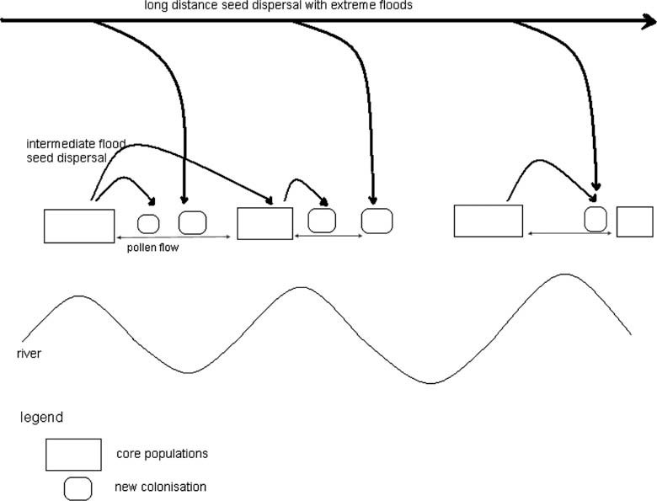

Fig. 5 – Hierarchic pattern of gene flow in large rivers with older core group of populations and recent colonisations.

contacts, and which were initiated by the extreme floods of 1993 and 1995, the species recovered with the establishment of new populations Long-distance seed dispersal induced by peak flow events mediated these new colonisations. Recur- rent intermediate floods further shaped the genetic make up of these populations and were responsible for the estab- lishment of other recent populations. The differential flood regime seems necessary to allow for regular long-distance seed dispersal with extreme floods, as well as local seed dis- persal with intermediate floods (Fig. 5). In riparian landscapes with irregular dynamics, responsible for colonization-extinc- tion, this conclusion can be more general applicable to all species for which a sufficient local gene flow is still present. In absence of this local gene flow, seeds arriving to distant suitable patches are not likely to survive.

Conclusion

River regulation and fragmentation may cause a decrease in population size and number, and a decreased gene flow among-populations, resulting in larger genetic differentiation and lower genetic diversity. For the study species O. vulgare in the highly regulated Common Meuse reach, these threats were present. The extreme peak flows, however, were respon- sible for a number of colonisations and an increased genetic variation. The long-distance seed dispersal in combination with local colonisation with intermediate flood peaks re- sulted in a hierarchy in the spatio-temporal genetic structure. These findings indicate that the recurrent formation and destruction of riverbank habitats following intermediate and extreme flood events and the associated seed-inflow have a large impact on the metapopulation structure and genetic variability, and could affect the survival of the species. In this way the irregular flood regime is a fundamental element for the genetic structure and diversity of riparian species and conservation and restoration efforts need to emphasize and encompass the patterns and characteristics of regular and
irregular floods.

Acknowledgements

We thank the Flemish Fund for Scientific Research (FWO) for financing this project (3E040158) and Leen Verschaeve and Nancy Van Liefferinge for technical and logistic assistance.

R E F E R E N C E S

Bohrer, G., Nathan, R., Volis, S., 2005. Effects of long-distance dispersal for metapopulation survival and genetic structure at ecological time and spatial scales. Journal of Ecology 93, 1029– 1040.
Brown, J.H., Kodric-Brown, A., 1977. Turnover rates in insular biogeography: effect of immigration on extinction. Ecology 58, 445–449.
Burkart, M., 2001. River corridor plants (Stromtalpflanzen) in Central European lowland: a review of a poorly understood plant distribution pattern. Global Ecology and Biogeography 10, 449–468.

Coart, E., Van Glabeke, S., Petit, R.J., Van Bockstaele, E., Rolda´ n- Ruiz, I., 2005. Range wide versus local patterns of genetic diversity in hornbeam (Carpinus betulus L). Conservation Genetics 6, 259–273.
Cresswel, E.G. 1982. The developmental origin and ecological consequences of seed germination responses to light. Ph. D. Thesis, University of Sheffield.
DeWoody, J., Nason, J.D., Smith, M., 2004. Inferring demographic processes from the genetic structure of a metapopulation of Boltonia decurrens (Asteraceae). Conservation Genetics 5, 603– 617.
Donath, T.W., Ho¨ lzel, N., Otte, A., 2005. Influence of competition by sown grass, disturbance and litter on recruitment of rare flood-meadow species. Biological Conservation 130, 315–323.
Duchesne, P., Bernatchez, L., 2002. AFLPOP: a computer program for simulated and real population allocation, based on AFLP data. Molecular Ecology Notes 2, 380–383.
Ehrle´ n, J., Eriksson, O., 2003. Large-scale spatial dynamics of plants: a response to Freckleton & Watkinson. Journal of Ecology 91, 316–320.
Freckleton, R.P., Watkinson, A.R., 2002. Large-scale spatial dynamics of plants: metapopulations, regional ensembles and patchy populations. Journal of Ecology 90, 419–434.
Freckleton, R.P., Watkinson, A.R., 2003. Are all plant populations metapopulations? Journal of Ecology 91, 321–324.
Giller, S., 2005. River restoration: seeking ecological standards. Editor’s introduction. Journal of Applied Ecology 42, 201–207.
Grime, J.P. 1978. Interpretation of small scale patterns in the distribution of plant species in space and time. In: Freysen, A.H.J., Woldendorp, J.W. (Eds), Structure and functioning of plant populations, Amsterdam, North-Holland, pp. 101–201.
Grime, J.P., Hodgson, J.G., Hunt, R., 1988. Comparative plant ecology: a functional approach to common British species. Unwin Hyman, London.
He, T., Krauss, S.L., Lamont, B.B., Miller, B.P., Enright, N.J., 2004. Long-distance seed dispersal in a metapopulation of Banskia hookeriana inferred from a population allocation analysis of amplified fragment length polymorphism data. Molecular Ecology 13, 1099–1109.
Huff, D.R., Smouse, P.E., Peakall, R., 1993. RAPD variation within- and among-populations of outcrossing buffalograss (Buchloe¨ dactyloides (Nutt.) Engelm). Theoretical and Applied Genetics 86, 927–934.
Hutchison, D.W., Templeton, A.R., 1999. Correlation of pairwise genetic and geographic distance measures: inferring the relative influences of gene flow and drift on the distribution of genetic variability. Evolution 53, 1898–1914.
Imbert, E., Lefe` vre, F., 2003. Dispersal and gene flow of Populus nigra (Salicaceae) along a dynamic river system. Journal of Ecology 91, 447–456.
Jacquemyn, H., Honnay, O., Van Looy, K., Breyne, P., 2006. Spatio- temporal structure of genetic variation of a spreading plant metapopulation on dynamic riverbanks along the Meuse River. Heredity 96, 471–478.
Ja¨ ka¨ la¨ niemi, A., Tuomi, J., Siikama¨ ki, P., Kilpia¨ , A., 2005.
Colonization-extinction and patch dynamics of the perennial riparian plant, Silene tatarica. Journal of Ecology 93, 670–680.
Jongman, R.H.G., 1992. Vegetation, river management and land use in the Dutch Rhine floodplains. Regulated Rivers: Research and Management 7, 279–289.
Keller, L.F., Waller, D.M., 2002. Inbreeding effects in wild populations. Trends in Ecology and Evolution 17, 230–241.
Knuth, P., 1906. In: Handbook of flower pollination (English translation), 3 Vols. Clarendon Press, London.
Koizumi, I., Yamamoto, S., Maekawa, K., 2006. Decomposed pairwise regression analysis of genetic and geographic distances reveals a metapopulation structure of stream- dwelling Dolly Varden charr. Molecular Ecology 15, 3175–3189.

Kudoh, H., Whigham, D.F., 1997. Microgeographic genetic structure and gene flow in Hibiscus moscheutos (Malvaceae) populations. American Journal of Botany 84, 1285–1293.
Levin, S.A., Muller-Landau, H.C., Nathan, R., Chave, J., 2003. The ecology and evolution of seed dispersal: a theoretical perspective. Annual Review of Ecology Evolution and Systematics 34, 575–604.
Lynch, M., Milligan, B.G., 1994. Analysis of population genetic structure with RAPD markers. Molecular Ecology 3, 91–99.
Lytle, D.A., Poff, N.L., 2004. Adaptation to natural flow regimes.
Trends in Ecology and Evolution 19, 94–100.
Mantel, N., 1967. The detection of disease clustering and a generalized regression approach. Cancer Research 27, 209–220.
Menges, E.S., 1990. Population viability analysis for an endangered plant. Conservation Biology 4, 52–62.
Mouw, J.E.B., Alaback, P.B., 2003. Putting floodplain hyperdiversity in a regional context: an assessment of terrestrial-floodplain connectivity in a montane environment. Journal of Biogeography 30, 87–103.
Naiman, R.J., De´ camps, H., Pollock, M., 1993. The role of riparian corridors in maintaining regional biodiversity. Ecological Applications 3, 209–212.
Nybom, H., Bartish, I.V., 2000. Effects of life history traits and sampling strategies on genetic diversity estimates obtained with RAPD markers in plants. Perspectives in Plant Ecology, Evolution and Systematics 3, 93–114.
Ouborg, N.J., 1993. Isolation, population size and extinction: the classical and metapopulation approaches applied to vascular plants along the Dutch Rhine-system. Oikos 66, 298–308.
Peakall, R., Smouse, P. E. 2005. GenAlEx V6: Genetic Analysis in Excel. Population genetic software for teaching and research. Australian National University, Canberra, Australia. <http:// www.anu.edu.au/BoZo/GenAlEx/>.
Pedroli, B., De Blust, G., Van Looy, K., van Rooij, S., 2002. Setting targets in strategies for river restoration. Landscape ecology 17, 5–18.
Petit, R.J., El Mousadik, A., Pons, O., 1998. Identifying populations for conservation on the basis of genetic markers. Conservation Biology 12, 844–855.
Slatkin, M., 1993. Isolation by distance in equilibrium and nonequilibrium populations. Evolution 47, 264–279.
Stroh, M., Kratochwil, A., Remy, D., Zimmermann, H., Schwabe, A., 2005. Rehabilitation of alluvial landscapes along the river Hase (Ems river basin, Germany) large rivers. Archiv Fur Hydrobiologie 15 (Suppl. 155/1–4), 243–260.
Tero, N., Aspi, J., Siikama¨ ki, P., Ja¨ ka¨ la¨ niemi, A., Tuomi, J., 2003. Genetic structure and gene flow in a metapopulation of an endangered plant species, Silene tatarica. Molecular Ecology 12, 2073–2085.
Van Looy, K., Honnay, O., Pedroli, B., Muller, S., 2006. Order and disorder in the river continuum Continuity and connectivity contribution to biodiversity in floodplain meadows. Journal of Biogeography 33, 1615–1627.
Vekemans, X., Beauwens, T., Lemaire, M., Rolda´ n-Ruiz, I., 2002. Data from amplified fragment length polymorphism (AFLP) markers show indication of size homoplasy and of a relationship between degree of homoplasy and fragment size. Molecular Ecology 11, 139–151.
Volis, S., Bohrer, G., Oostermeijer, G., Van Tienderen, P., 2005. Regional consequences of local population demography and genetics in relation to habitat management in Gentiana pneumonanthe. Conservation Biology 19, 357–367.
Vos, P., Hogers, R., Bleeker, M., Reijans, M., van de Lee, T., Hornes, M., Frijters, A., Pot, J., Peleman, J., Kuiper, M., Zabeau, M., 1995. AFLP: a new technique for DNA fingerprinting. Nucleic Acids Research 23, 4407–4414.
Ward, J.V., 1998. Riverine landscapes: biodiversity patterns, disturbance regimes, and aquatic conservation. Biological Conservation 83, 269–278.
Wolfert, H.P., Hommel, P.W.F.M., Prins, A.H., Stam, M.H., 2002. The formation of natural levees as a disturbance process significant to the conservation of riverine pastures. Landscape Ecology 17, 47–57.
Young, A., Boyle, T., Brown, T., 1996. The population genetic consequences of habitat fragmentation for plants. Trends in Ecology and Evolution 11, 413–418.
Zhivotovsky, L.A., 1999. Estimating population structure in diploids with multilocus dominant DNA markers. Molecular Ecology 8, 907–913.
Zwick, P., 1992. Stream habitat fragmentation – a threat to biodiversity. Biodiversity and Conservation 1, 80–97.

