New records of Cantharellus species (Basidiomycota, Cantharellaceae) from Malaysian dipterocarp rainforest

Eyssartier, G.1, Stubbe, D.2, Walleyn, R.3 and Verbeken, A.2*
1250, étangs de Béon, F-45120 Bazoches-sur-le-Betz, France
2Ghent University, Department of Biology, Research Group Mycology, K.L. Ledeganckstraat 35, B-9000 Ghent, Belgium
3Research Institute for Nature and Forest, Gaverstraat 4, B-8500 Geraardsbergen, Belgium

Eyssartier, E., Stubbe, D., Walleyn, R. and Verbeken, A. (2009). New records of Cantharellus species (Basidiomycota,
Cantharellaceae) from Malaysian dipterocarp rainforest. Fungal Diversity 36: 57-67.

The authors describe and illustrate five Cantharellus species recently collected in Peninsular Malaysia, associated with Dipterocarpaceae. Among them, Cantharellus cerinoalbus and C. subamethysteus are described as new species and the type-collection of C. cuticulatus is revised. A key for the Malaysian Cantharellus is also provided.

Key words: Malaysia, tropical, ectomycorrhizal fungi, taxonomy.

Introduction
Recent mycological surveys in the lowland dipterocarp rainforests of Peninsular Malaysia revealed a very high diversity of putative ectomycorrhizal macrofungi and other macrofungi (Watling et al., 2002; Lee et al., 2002, 2003; Tan et al., 2007; Stubbe et al., 2008). These forests are dominated by ectomycorrhizal Dipterocarpaceae (such as Shorea spp., Dipterocarpus spp., Anisoptera spp. and Neobalanocarpus heimii). Other ectomycorrhizal trees in these rainforests belong to the Fagaceae, Myrtaceae, Legumino- sae and Euphorbiaceae. Members of Russula- ceae dominate the number of collections and estimated number of species. The next most represented groups are Boletaceae, followed by Amanitaceae and Cantharellaceae (Lee et al., 2003).
Cantharellaceae of Southeast Asia were monographed by Corner (1966, 1970, 1976). Since then, the only published descriptions of Cantharellus species from the area have been brief treatments of C. cuticulatus and C. subcibarius from Brunei (Roberts and Spooner, 2000). Despite Corner’s elaborate monograph,
several species still seem undescribed. In the Pasoh Forest Reserve alone, Lee et al. (2003) could identify only 4 of the 12 Cantharellus species collected.
In this paper we describe collections of 5 Cantharellus species collected during August- September 2006 in the states of Pahang and Negeri Sembilan in Peninsular Malaysia, including 2 new species.

Materials and methods

Microscopic observations have been made in an ammonia-congo red solution, after a short pre-treatment in a 10% potassium hydroxide solution. Spore measurements (length, width and Q = “quotient length/ width”) were taken for 20 spores and are given with arithmetic average. Colour-codes are adopted from the Methuen Handbook of Colour (Kornerup and Wanscher 1978).
The original collections are conserved in the mycological herbarium of Ghent University (GENT), and duplicates are stored in the Forest Research Institute of Malaysia (KEP) and the personal herbarium of G. Eyssartier.

Results

Key to the Malaysian species of Cantharellus

- Fruitbodies with predominant pink tinges; fruitbodies fleshy, with solid stipe ..8. C. pudorinus
- .* Fruitbodies without red or pink tinges; fruitbodies may or may not be fleshy 2
- Cap ochraceous or yellowish, covered with purplish, violaceous, or brownish squamules, at least at centre
................................................................................ 3
- .* Cap without contrasting felt or squamules 6
- Fruitbodies small (cap 12 mm in diam.), reminiscent of Omphalina, with cap and stipe with brown felt and white gill-folds ................. 7. C. omphalinoides
- .* Not with these characters 4
- Hyphae of the suprapellis thick-walled; spores 6- 7.5(8) × 5-6 µm ............................ 3. C. diminutivus
- .* Hyphae of the suprapellis thin-walled 5

5. Spores 8-10.5 × 5.5-7 µm; cap up to 3.5 cm ............
.......................................................... 4. C. ianthinus
- .* Spores smaller, 6-8 × 5-6 µm; cap up to 6.5 cm ......
.................................. 9. C. subamethysteus sp. nov.
- Clamps present or, if absent, then hymenophore smooth; hymenophore smooth, wrinkled, or with gill-folds 7
- .* Clamps absent; hymenophore always with distinct gill-folds 11
- Hymenophore smooth 8
- .* Hymenophore not smooth 9

- Clamp-connections present ............... 5. C. lateritius
- .* Clamp-connections absent................. 6. C. odoratus

- Hymenophore only wrinkled, gill-folds more or less
0.5 mm high; fruitbodies becoming rusty when bruised; spores 7-9.5 × 4.5-6 µm..............................
......................... 11. C. subcibarius var. rugosivenis
- .* Hymenophore with distinct gill-folds, 0.8 mm high
.............................................................................. 10

- Fruitbodies ochraceous or dirty whitish; spores 7.5- 9 × 5.5-7 µm................................10. C. subcibarius
- .* Fruitbodies dirty yellowish; spores 8-11 × 6-8 µm ..
.............................. 12. C. subcibarius var. sordidus

- Suprapellis a hymeniderm; cap deep orange to bright egg-yellow, without olivaceous, greyish tinges ............................................. 2. C. cuticulatus
- .* Suprapellis of repent hyphae; cap yellow, often with olivaceous or greyish tinges .....................................
......................................... 1. C. cerinoalbus sp. nov.
- Cantharellus cerinoalbus Eyssart. & Walleyn, sp. nov.
(Figs 1-3, Pls 1-2)
MycoBank: 512120
Etymology: from the Latin word cerinus, wax- coloured, referring to the colour of the cap, and albus, white, referring to the colour of the stipe.
Pileus 17-63 mm in diam., cereus vel siccus, laevis vel fibrillosus, leviter translucide striatus, juventute pallide viridi-olivaceus, tum ex olivaceo stramineus vel griseoflavidus, cerinus. Plicae distantes, decurrentes, pallide flavae, cremeae vel pallide salmonicolores. Stipes 33-70 mm longus, 5-12 mm crassus, subcylindratus ex griseo albus. Contextus albus, leviter griseus; gustus gratus; odor grata. Sporae ellipsoideae ad leviter reniformes, 7.5-9(10) × 5-5.7(6)
µm, Q = 1.3-1.6. Pileipellis ex hyphis repentibus, cylindratis. Fibulae absentes. TYPUS: Malaysia, Pahang, 60 km north of Kuala Lumpur, Forest Lipur Lentang, on sand along river in disturbed primary forest with Dipterocarps, 21 August 2006, A. Verbeken & R. Walleyn 06-51 (GENT, holotypus; KEP, isotypus).
Cap 17-63 mm diam., broadly conical, convex with depressed centre to almost con- cave and irregularly wavy, smooth, sometimes in older specimens slightly but irregularly grooved towards margin; margin smooth to crenate; surface waxy or dry, smooth or very finely fibrillose, slightly translucently striate towards margin, in young specimens distinctly pale olive green (3BC 3-5), then straw yellow with some dirty olivaceous tinge (4A8 with some 4BC7), or greyish yellow with a faint greenish tinge (4AB4-5) to plain deep yellow (4A6-8). Gill-folds distant (6 per cm) to moderately dense, decurrent with tooth (ending in same height), rather thick, rather narrow, pale yellow (3A3, 4A3, 4A4), pale cream coloured (4A2) or pale salmon orange (4A3); edge entire, concolorous. Hymenium some- times slightly loosening from the top of the stipe. Stipe 33-70 × 5-12 mm, more or less cylindrical, equal or tapering downwards; surface dry, smooth, sometimes slightly waxy, white with a very pale greyish tinge, light cream or very pale orange, faintly longi- tudinally striate, faint reddish spots often present, minutely squamulose at the top. Context very thick in centre of pileus, sordid and firm in stipe, thin near margin, white, slightly glaucous-greyish in young fruitbodies, unchanging; smell sweet, like apricots, taste pleasant (like other chanterelles). Spores 7.5-
9(10) × 5-5.75(6) µm, Q = 1.3-1.6, x 8.4 × 5.5

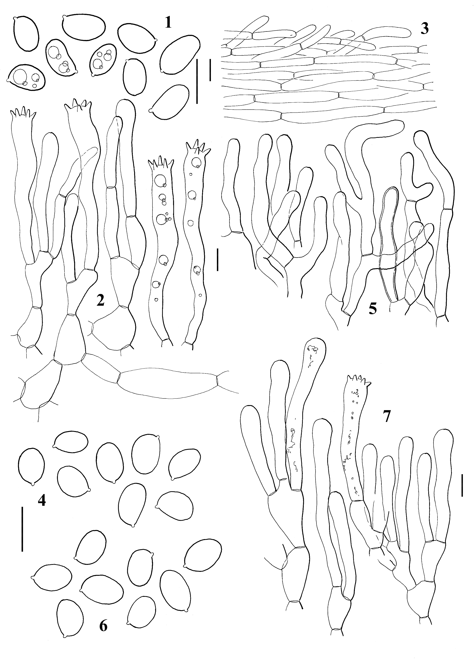

Figs 1, 2, 3. Cantharellus cerinoalbus (from holotype). 1. Spores. 2. Basidia. 3. Suprapellis. Figs 4, 5. Cantharellus cuticulatus (from holotype). 4. Spores. 5. Suprapellis. Figs 6, 7. Cantharellus cuticulatus (A. Verbeken & R. Walleyn 06-74). 6. Spores. 7. Suprapellis. Bars = 10 µm.

µm, Q = 1.5, ellipsoid to sometimes slightly reniform, smooth, very pale yellowish under the microscope. Hymenium distinctly accrescent. Basidia 65-80 × 8-10 µm, 4-5-6- spored, clavate. Subhymenium composed of clearly inflated elements. Lamellar trama of
interwoven and irregular hyphae, x 4-10 µm but sometimes inflated up to 15 µm, sometimes
enlarged as a joint on both sides of the septa, especially on the narrower elements. Suprapellis composed of repent and cylindrical
hyphae, with numerous and often erected free extremities, with opalescent content, 4-6 µm width. Clamp-connections absent.
Habitat: on sand along river in disturbed primary forest with dipterocarps.
Known distribution: Malaysia.
Material examined: MALAYSIA, Pahang, 60 km north of Kuala Lumpur, along highway E8, close to Bukit Tinggi, Forest Lipur Lentang, 184 m alt., N03°23.16'E101°53.25, on sand along river in disturbed primary forest with dipterocarps, 21 August 2006, A. Verbeken & R. Walleyn 06-51 (GENT, holotype; KEP,

isotype); same place, N03°22.82' E101°53.12, on sand along river disturbed primary forest with dipterocarps, 25 August 2006, A. Verbeken & R. Walleyn 06-77 and
A. Verbeken & R. Walleyn 06-78 (GENT; KEP). MALAYSIA, Negeri Sembilan, Pasoh Forest Reserve, Nature Trail, 21 September 2006, D. Stubbe 06-266 (GENT).
Notes: Because of its Hygrophorus-like habit and the absence of clamp-connections, this elegant species fits in Cantharellus subgenus Afrocantharellus (Eyssartier and Buyck, 2001). It is highly variable in colour, one microscopically identical collection was almost whitish (A. Verbeken & R. Walleyn 06- 78). Cantharellus platyphyllus Heinem. is closely related, but its fruit-bodies are more brightly coloured, and its spores consistently wider (Eyssartier and Buyck, 1998). As far as we know, Cantharellus platyphyllus has never been observed outside tropical Africa, where it is associated in mainland with Brachystegia (Caesalpinioideae) and Isoberlinia (Caesal- pinioideae), and in Madagascar with Uapaca (Euphorbiaceae).
The coloured photographs of Cantha- rellus sp. in Lee et al. (2002) and Lee et al. (2006) most probably represent Cantharellus cerinoalbus.

- Cantharellus cuticulatus Corner, Annals of Botany Memoirs 2: 31 (1966).
(Fig. 4-7, Pl. 3)
Cap up to 35(40) mm, orange, 5A7-8, 4A8, slightly hygrophanous and then becoming translucently striate, smooth, greasy. Gill-folds lamellae-like, whitish to pale yellowish, 3A2-3, thick, with lamellulae and sometimes anastomosing. Stipe 30-40 × 7-9 mm, pale yellow (3A2-3, 4A2-3), smooth or with a slightly irregular surface. Context thick in pileus, firm, solid and firm in stipe (one carpophore with fistulose stipe by invertebrate damage), white, slightly orange under the pileipellis, unchanging; taste very pleasant (like other chanterelles), smell of apricots. Spores 7-
9.5 × 5-6.5 µm, Q = 1.2-1.6, x 8.1 × 5.8 µm, Q
= 1.4, ellipsoid to shortly ellipsoid, smooth, very pale yellowish under the microscope. Hymenium distinctly accrescent. Basidia 54-75
× (6.5)7-10 µm, 4-5-6-spored, clavate. Subhymenium composed of clearly inflated elements. Lamellar trama of interwoven and irregular hyphae, (3)5-10(15) µm width, often
enlarged as a joint on both sides of the septa. Suprapellis a hymenoderm composed of short and regularly arranged elements, clavate or more or less lageniform, 5-10 µm width. Clamp-connections absent.

Microscopic description of the holotype
Spores 7-9 × 5-6 µm, Q = 1.2-1.6, x 8 ×
5.7 µm, Q = 1.4, ellipsoid to shortly ellipsoid, smooth, hyaline. Basidia 64-75 × 8-10 µm, slightly clavate; probasidia often slightly capitate. Cystidia absent. Suprapellis a hymenoderm of 5-8(10) µm wide hyphae, subcylindrical or slightly capitate, walls to 0.5
µm thick. Clamp-connections absent.
Habitat: on soil, sand along river in disturbed primary forest with Dipterocarps or Fagaceae.
Known distribution: Malaysia, Brunei.
Material examined: MALAYSIA, Pahang, 60 km north of Kuala Lumpur, along highway E8, close to Bukit Tinggi, Forest Lipur Lentang, 164 m alt., N03°22.82' E101°53.12, on sand along river in disturbed primary forest with dipterocarps, 25 August 2006, A. Verbeken & R. Walleyn 06-74 (GENT). MALAYSIA, Negeri Sembilan, Serting Ulu, Hutan Lipur Serting Ulu, along main trail, at far end of domain, on soil in little disturbed forest with Fagaceae and dipterocarps, 22 September 2006, D. Stubbe 06-283 (GENT). MALAYSIA, North Borneo, Kinabalu, E.J.H. Corner 2995 (holotype, K).
Notes: This enigmatic species is easily recognized by the absence of clamps, well developed gill-folds, bright colours, and a suprapellis composed of short and regularly disposed elements forming a distinct hy- meniderm. The same cap structure is found in Cantharellus splendens Buyck, a very brightly coloured African species (Buyck, 1994), suggesting this microscopical detail could have evolved more than once in the evolutionary path of the genus Cantharellus (convergence). The wide range of variations observed in the described collections of Cantharellus cuticu- latus, with colour of the cap ranging from ochraceous pinkish (Corner, 1966) to orange- yellow or egg-yellow (Corner, 1970), make us think that several species are perhaps mixed under a single name. Nevertheless it should be noted that no microscopic differences have been found between the holotype and the collections here described, in spite of the striking differences in cap colour.

- Cantharellus diminutivus Corner, Nova Hedwigia 18: 786 (1970 “1969”).
(Fig. 8-10, Pl. 4)
Cap up to 27 mm diam., convex and deeply depressed when young, becoming irregularly infundibuliform when mature, margin irregularly wavy and very slightly grooved, edge smooth; surface dry, slightly rugulose, warm deep yellow with a brownish tinge, centre densely covered with blackish to purplish small squamules when young, becoming less dense towards the margin and when maturing. Hymenophore wrinkled and quasi lamellae-like, rather dense, intercom- nected by anastomosing veins, pale warm yellow, dark yellowish cream. Stipe 15-30 × 1- 2 mm, terete but somewhat flattened, surface slightly squamulose, concolorous with cap with darker, adpressed squamules (not dense), completely hollow. Smell strongly apricot-like, pleasant; taste mild. Spores 7-8.5(9) × 4.75-
5.5(6) µm, Q = 1.4-1.7, x 7.7 × 5.1 µm, Q =
1.5, shortly ellipsoid, smooth, very pale yellowish under the microscope. Hymenium distinctly accrescent. Basidia (40)45-60 × 8-9.5
µm, 4-5-6-spored, slightly clavate or subcylindrical. Subhymenium composed of inflated hyphal elements up to 15(20) µm broad. Suprapellis composed of interwoven hyphae, 8-15 µm broad, with numerous free extremities and distinctly thickened and refringent cell wall, coloured with slightly lilaceous greyish intracellular pigment. Clamp- connections present in all parts of fruitbodies.
Habitat: forest with dipterocarps or
Fagaceae.
Known distribution: Malaysia.
Material examined: MALAYSIA, Pahang, Hutan Lipur Lentang, along highway E8, more or less 60 km north of Kuala Lumpur, near Bukit Tinggi, N03°23,157’ E101°53,254’, alt. 184 m, forest with dipterocarps and Fagaceae, 21 August 2006, D. Stubbe 06-019 (GENT); same place, probably same mycelium, on and near dead wood near roots of Dipterocarpus sp., 25 August 2006,
D. Stubbe 06-033 (GENT).
Notes: This is one of the small Cantha- rellus species which can be easily mistaken for a Craterellus species because of the thin flesh and the deeply depressed cap. Among the Cantharellus species with a violaceous or lilac, squamulose cap, it is characterized by the thick-walled hyphae of the suprapellis and relatively small spores.
- Cantharellus ianthinus Corner, Annals of Botany Memoirs 2: 47 (1966).
Notes: We do not possess recent collections of this species, regarded by Corner (1970) as “scarce” and producing “only one or two fruitbodies at a time”.

- Cantharellus lateritius (Berk.) Singer, Lilloa 22: 729 (1951 “1949”).
(Fig. 11-12, Pl. 5)
Cap 9-55 mm diam., planoconvex to somewhat infundibuliform, margin irregularly waving; surface dry, slightly tomentose, deep and bright golden yellow (4A8 but even more intense yellow); extreme margin paler yellow. Hymenophore smooth and without wrinkles, pale yellow (4A4-6 but slightly yellower), forming a continuum with stipe surface. Stipe rather plump and stout, 15-45 × 5-17 mm, more or less cylindrical, slightly tapering down- wards. Context solid to partly hollow (but most probably because of insect larvae), pale yellow (3A3), smell strongly of apricots; taste mild. Spores (6.5)7-7.5(8.75) × 4.5-5(5.5) µm, Q =
1.3-1.5, ellipsoid to shortly ellipsoid, smooth, very pale yellowish under the microscope. Hymenium distinctly accrescent. Basidia 75- 80(90) × 7-9 µm, very long, 4-5-6-spored, slightly clavate, with distinctly thickened wall at the base. Subhymenium undifferentiated. Suprapellis composed of interwoven and irregular hyphae, 5-10(15) µm broad, with numerous free extremities and distinctly thickened and refringent cell wall, coloured with slightly yellowish intracellular pigment. Clamp-connections present in all parts of basidiomata.
Habitat: on soil, in forest, mostly under
Shorea sp.
Known distribution: United States, Africa, Malaysia.
Material examined: MALAYSIA, Negeri Sembilan, Pasoh Forest Reserve, beginning of Main trail, left of trail, secondary lowland rain forest, 7 September 2006, D. Stubbe 06-111 (GENT); same place, mostly under Shorea sp., 10 September 2006, D. Stubbe 06-163 (GENT).
Notes: Under the name Cantharellus lateritius are grouped all the chanterelles with a completely smooth hymenophore, sweet smell, and clamped hyphae. It is very likely that several different species exist with such undifferentiated hymenophore, but the

deviating features between the different collec- tions, originating from different continents, are very few or even absent. Phylogenetic analysis is needed to resolve this species complex.

- Cantharellus odoratus (Schwein.) Fr., Elenchus Fungorum 1: 51 (1828).
Notes: No collection studied. This species, originally described from North Carolina (United States) is reported from Pasoh Forest Reserve by Watling et al., 2002. Petersen (1979b) preferred placement in the genus Craterellus because of the absence of clamp-connections, but this feature is now considered irrelevant in separating the two genera (Eyssartier and Buyck, 2000).

- Cantharellus omphalinoides Corner, Nova Hedwigia 27: 325 (1976).
Notes: No collection studied. This species is also reported from Pasoh Forest Reserve by Watling et al., 2002. Corner (1976) considered it as closely related to Cantharellus diminutivus and C. schmitzii Heinem., but perceived the general habit as reminiscent of the genus Omphalina Quél. It differs from Cantharellus diminutivus in brown vs. purplish colours in cap and stipe, and white gill-folds.

- Cantharellus pudorinus Corner, Annals of Botany Memoirs 2: 54 (1966).
Notes: No collection studied. This species seems to be very rare.

- Cantharellus subamethysteus Eyssart. & Stubbe, sp. nov.
(Figs 13-16, Pl. 6)
MycoBank: 512122
Etymology: from Cantharellus amethysteus, because of the morphological similarities between the two taxa.
Pileus 20-65 mm in diam., vivide flavus, squamellulis purpureo-lilacinis ad purpureobrunneis. Plicae pallide flavae. Stipes 42-57mm longus, 5-11 mm crassus, vivide flavus, fuscans. Odor grata. Sporae breve ellipsoideae, 7-8(8.75) × (4.75)5-6 µm, Q = 1.2-1.5. Pileipellis ex hyphis repentibus, extremitatibus abundantibus, elementis inflatibus usque ad 15 µm. Fibulae presentes. TYPUS: MALAYSIA, Pasoh Forest Reserve, 16 September 2006, D. Stubbe 06-218 (GENT, holotype; KEP, isotype).
Cap 20-65 mm, convex or plano- convex with depressed centre; colour deep and bright yellow (3A4-6), paler towards the
margin sometimes up to 2A4-5, covered with purplish lilac squamules (15BCD3-5); older specimens with scales rather brown to dark brown with a purple tinge instead of clear purple. Hymenium paler yellow than upper surface (3A3-4). Stipe 42-57 × 5-11 mm concolorous with hymenium but darkening when handled (3A4-5). Context solid or slightly hollow (probably because of insect larvae). Smell agreeable, fruity, like apricots. Spores 7-8(8.75) × (4.75)5-6 µm, Q = 1.2-1.5,
x 7.6 × 5.6 µm, Q = 1.4. shortly ellipsoid, smooth. Hymenium distinctly accrescent.
Basidia 44-75 × 9-10 µm, 4-5-6-spored, clavate. Subhymenium not differentiated. Suprapellis composed of repent hyphae with numerous and obtuse free extremities and often short and inflated elements, thin-walled, 8-15
µm width, coloured with yellowish intracellular and parietal pigment, smooth or sometimes incrusting on the slender hyphae, combined with greyish or violaceous intracellular pigment on the squamules. Clamp-connections present.
Habitat: on soil, in forest, under Dipterocarps.
Known distribution: Malaysia.
Material examined: MALAYSIA, Pasoh Forest Reserve, along Main Trail, between beginning of the Nature Trail and the Old Tree Tower, 16 September 2006, D. Stubbe 06-218 (GENT, holotype; KEP, isotype); same place, at very beginning of main trail, 25 September 2006, D. Stubbe 06-303 (GENT).
Notes: These two collections (D. Stubbe 06-218 and D. Stubbe 06-303) and the following one (D. Stubbe 06-52) share numerous characters such as the general colours, the purplish lilac squamules on the cap and the configuration of the hymenophore. D. Stubbe 06-052 differs by the less fleshy fruit- bodies and the slightly smaller spores, and we prefer to provide a separate description below. It may be a minor form of C. subamethysteus, but more material needs to be studied to understand the variation in this taxon. Cantha- rellus ianthinus is obviously closely related but differs in its much smaller fruitbodies and larger spores.
Cantharellus appalachiensis R.H. Petersen and C. tabernensis Feib. & Cibula share some macro- and microscopic features with C. subamethysteus, but the cap of these American taxa is smooth to glabrous, and only

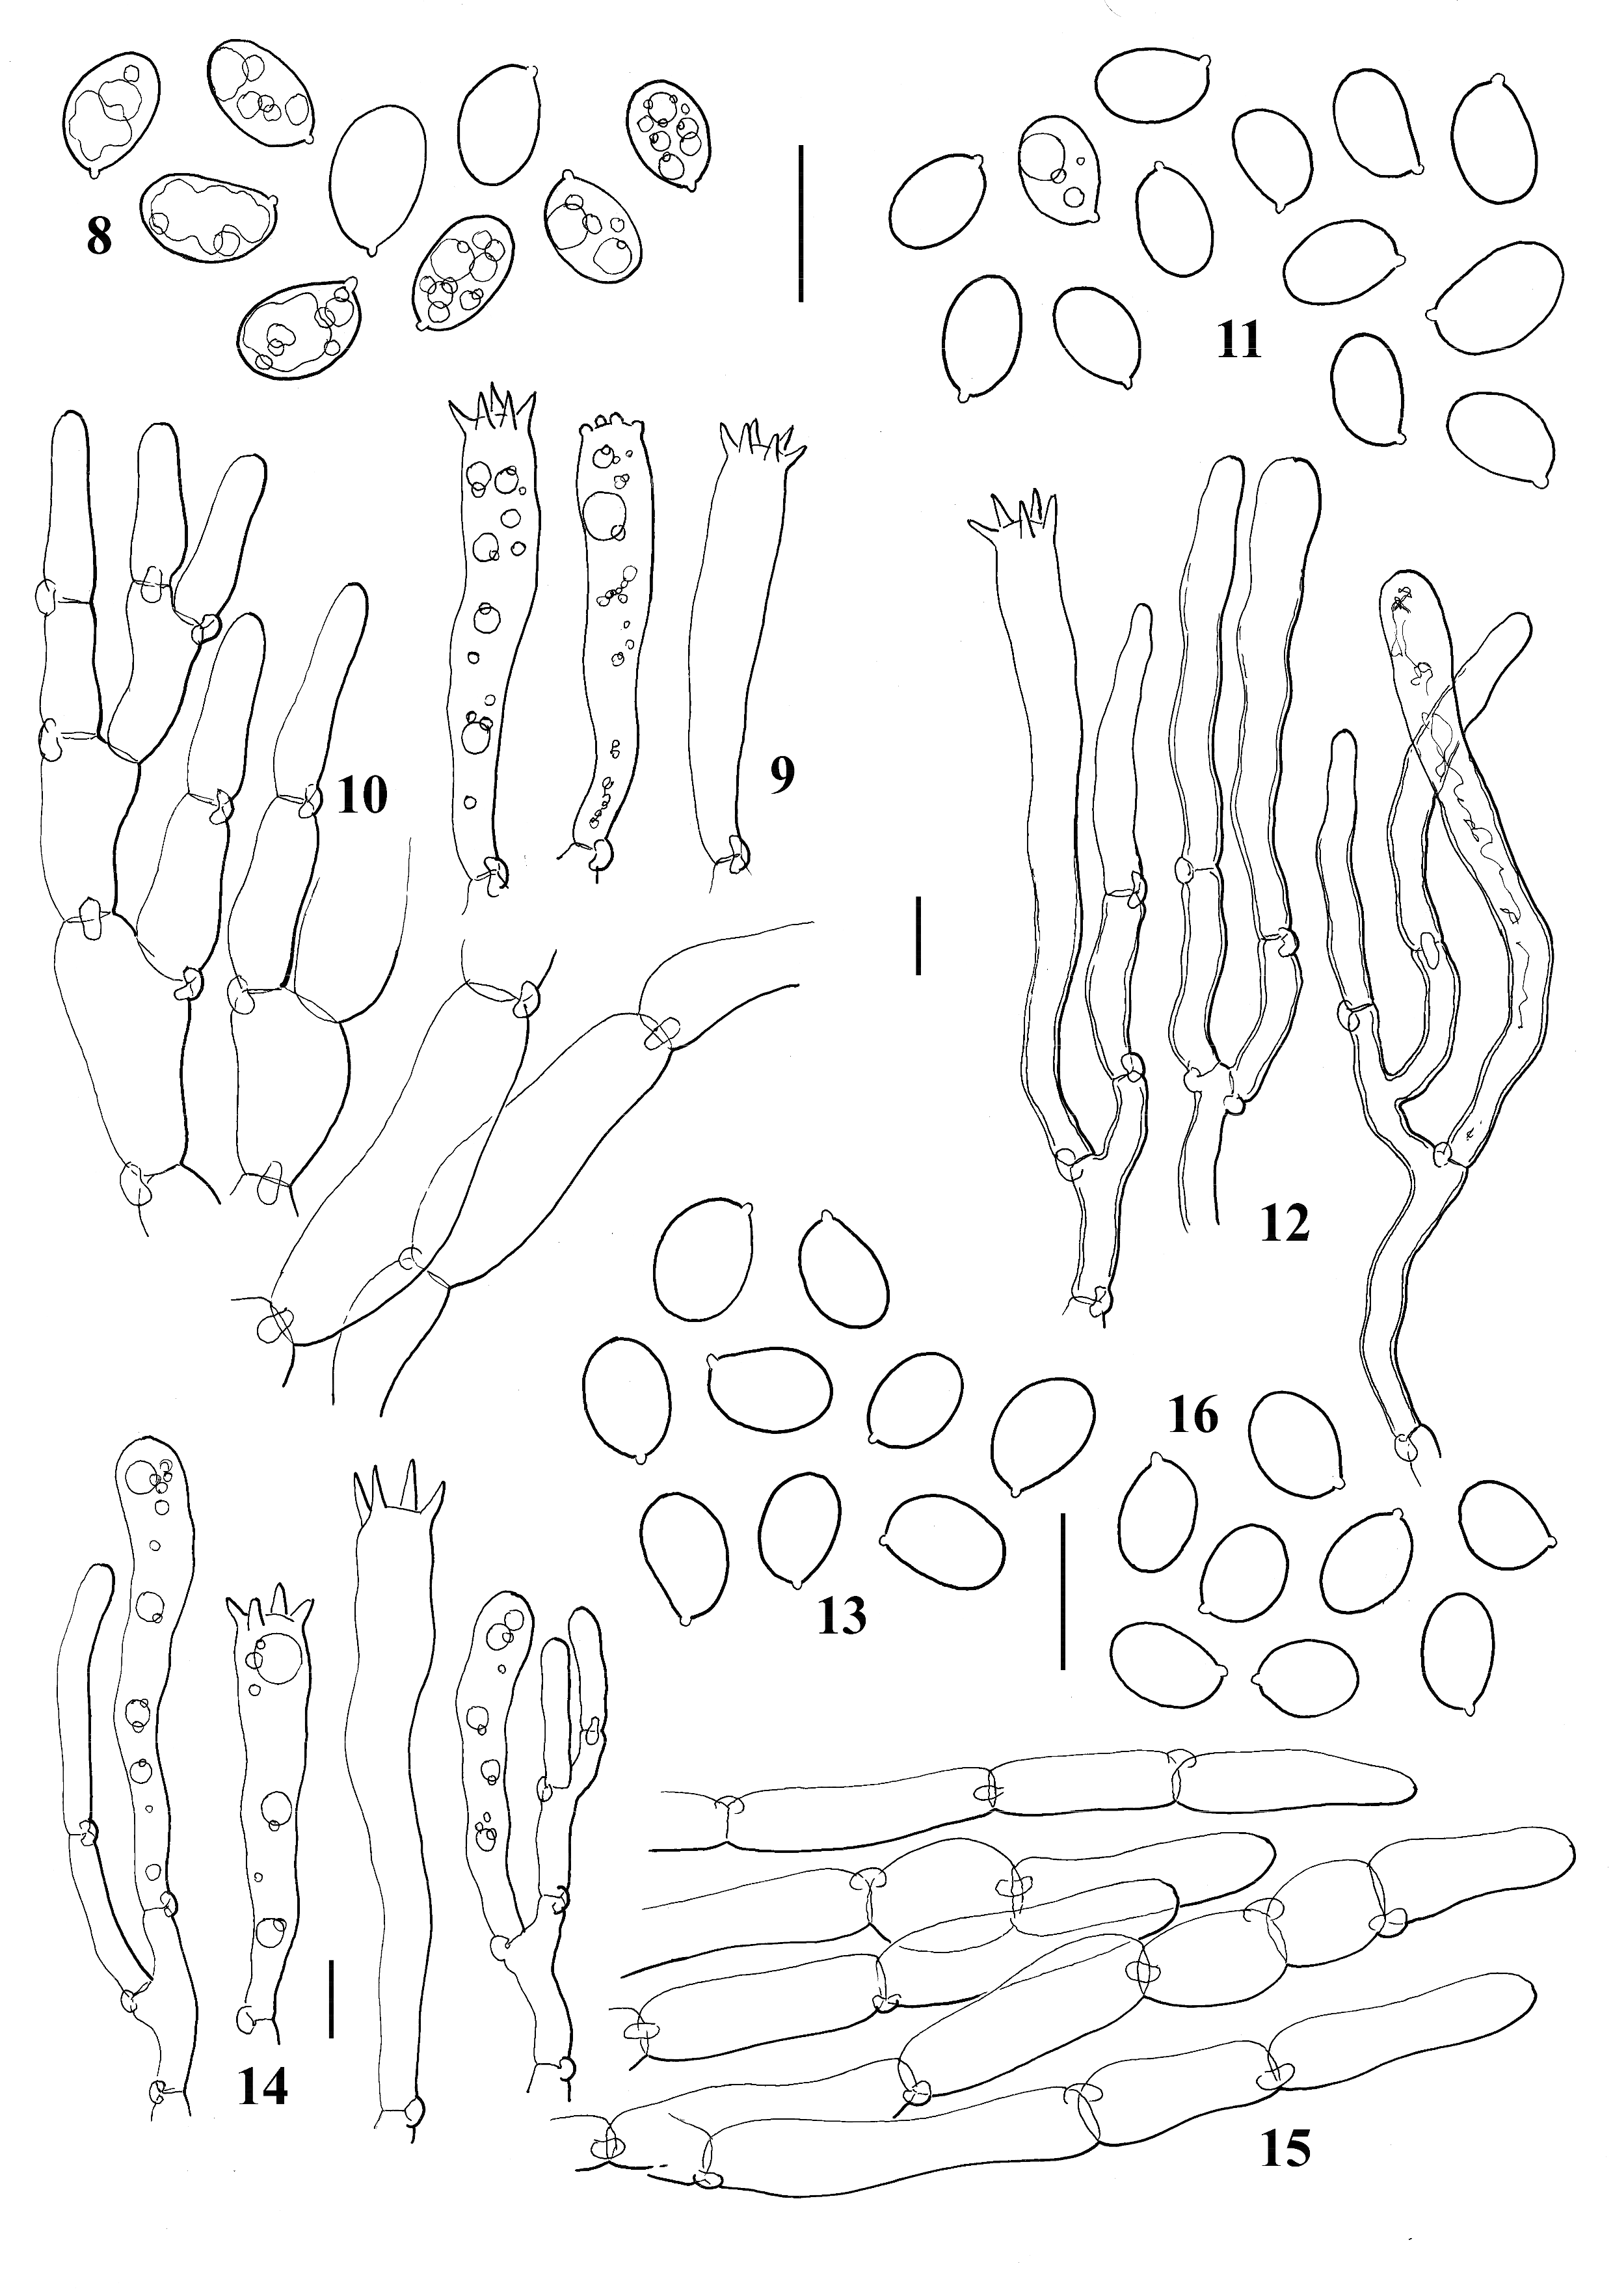

Figs 8, 9, 10. Cantharellus diminutivus (D. Stubbe 06-19). 8. Spores. 9. Basidia. 10. Suprapellis. Figs 11, 12.
Cantharellus lateritius (D. Stubbe 06-111). 11. Spores. 12. Basidia. Figs 13, 14, 15. Cantharellus subamethysteus (D.
Stubbe 06-218). 13. Spores. 14. Basidia. 15. Suprapellis. Fig. 16. Cantharellus subamethysteus (D. Stubbe 06-52). 16. Spores. Bars = 10 µm.

flushed with brown at the disc, never bearing well-delimited purplish lilac squamules (Petersen and Ryvarden, 1971; Petersen, 1979a; Feibelman et al., 1996).
Cantharellus amethysteus (Quél.) Sacc. is a much stouter species, with a cap up to 10 cm. The spores are also larger, measuring 9.5- 11 × 6-7 µm (Eyssartier and Buyck, 2000).

Description of collection D. Stubbe 06-52
Cap 8-50 mm diam., convex or planoconvex with depressed centre, margin irregularly waving and fissured, surface warm yellow (4A4-5) paler towards margin, with purple fibrillose squamules (11EF4-5) more densely in centre or entirely covering the cap surface in young basidiocarps. Gill-folds rather

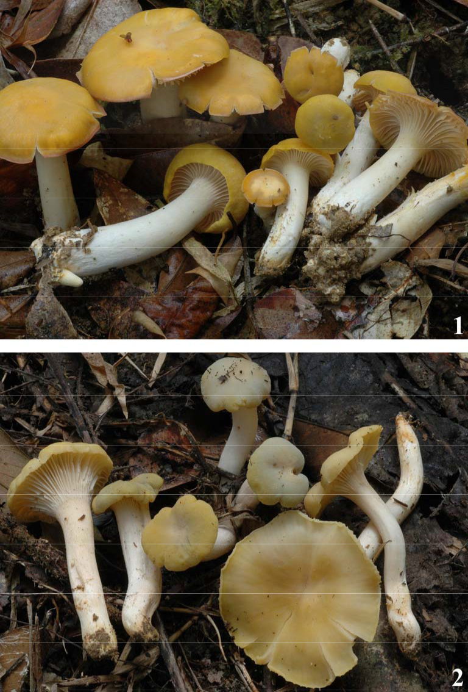

Plate 1. Cantharellus cerinoalbus (holotype, A. Verbeken & R. Walleyn 06-51). Plate 2. C. cerinoalbus (A. Verbeken
& R. Walleyn 06-77).

dense, rather shallow, decurrent, deep-yellow (4A5-6). Stipe 15-25 × 3-7 mm, more or less cylindrical, tapering downwards, surface more or less smooth pale yellow, concolorous with cap margin but darker yellow when handled. Context thin, hollow in entire stipe but stuffed in young specimens; typical Cantharellus smell of apricots but slightly sweeter, taste mild. Spores (6)6.5-7(7.25) × 5-5.5(5.75) µm, Q =
1.2-1.4, x 6.8 × 5.2 µm, Q = 1.3, very shortly
ellipsoid, smooth. Hymenium distinctly accrescent. Basidia 52-63 × 8.5-9.5 µm, 4-5-6- spored, clavate. Subhymenium not differentia- ted. Suprapellis composed of repent and cylindrical hyphae, with numerous and obtuse free extremities and relatively short elements, thin-walled, 5-10(15) µm broad, coloured with yellowish intracellular and parietal pigment, smooth or sometimes incrusting on the slender hyphae, combined with greyish or violaceous

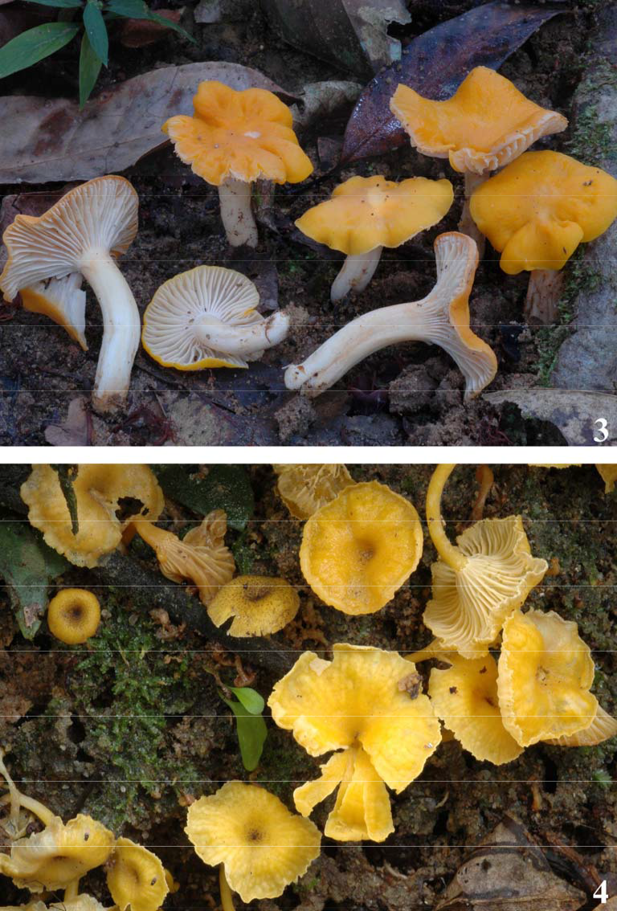

Plate 3. C. cuticulatus (A. Verbeken & R. Walleyn 06-74).Plate 4. C. diminutivus (D. Stubbe 06-33).

intracellular parietal pigment on the squamules.
Clamp-connections present.
Habitat: on soil, in forest, under Dipterocarps.
Known distribution: Malaysia.
Material examined: MALAYSIA, Negeri Sembilan, Serting Ulu, Hutan Lipur Serting Ulu, on soil near Dipterocarpus sp., 31 August 2006, D. Stubbe 06-
52 (GENT).
- Cantharellus subcibarius Corner, Annals of Botany Memoirs 2: 58 (1966).
Notes: No collection studied. According to Corner (1966), this species “appears as a rather slender pallid C. cibarius with rather feebly developed gill-folds”. It has also been reported from New Guinea (Corner, 1970), associated with Castanopsis (Fagaceae), and

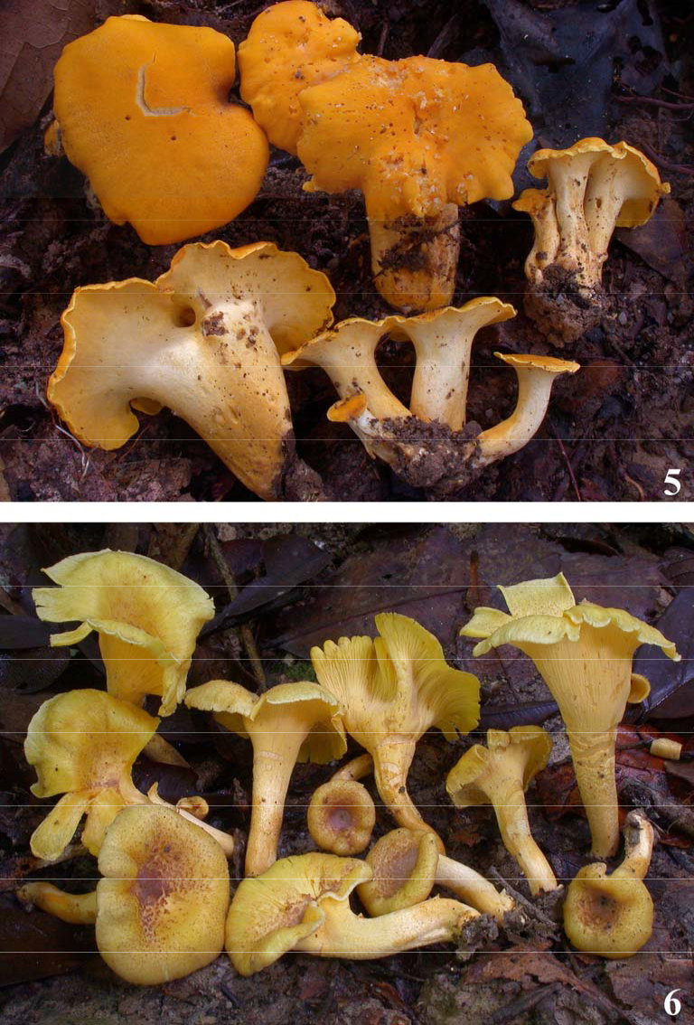

Plate 5. C. lateritius (D. Stubbe 06-111). Plate 6. C. subamethysteus (holotype, D. Stubbe 06-218).

Brunei (Roberts and Spooner, 2000), associa- ted with dipterocarps.

- Cantharellus subcibarius var. rugosivenis Corner, Annals of Botany Memoirs 2: 58 (1966).
Notes: No collection studied.

Cantharellus subcibarius var. sordidus
Corner, Annals of Botany Memoirs 2: 58
(1966).
Notes: No collection studied.

Discussion

All the Cantharellus species collected in Malaysia are found in unmanaged or little disturbed forest. The host trees also occur in the botanical garden of Forest Research Institute of Malaysia, and there we found other

ectomycorrhizal fungi associated with these more or less isolated trees, but so far no Cantharellus species were found there. So it seems that they need the dipterocarp trees in original primary forest and are more fragile when it comes to disturbance than other ectomycorrhizal genera (e.g. Lactarius, Russu- la, certain Boletes, Amanita).
Chanterelles are widely used as edible mushrooms, but little is known about the edibility of the species described here. Chanterelles are not mentioned in a review on utilisations of mushrooms in Malaysia (Chang and Lee, 2004) but recent surveys confirmed that Cantharellus species resembling species of subgenus Afrocantharellus are consumed and appreciated by several communities of local tribes in Peninsular Malaysia (Lee et al., 2006).

Acknowledgements

The authors are grateful for the help and assistance provided by the staff of the Forest Research Institute Malaysia (FRIM) with special thanks to Dr. Lee Su See. Our sincere gratitude also goes out to Dr. Jean Weber and Khadijah Rambe for their generous hospitality and kind support. Annemieke Verbeken and Dirk Stubbe would like to thank the Foundation of Scientific Research-Flanders (FWO-Vlaanderen) for financial support. Dirk Stubbe would like to thank the Institute for the Promotion of Innovation through Science and Technology in Flanders (IWT-Vlaanderen) for enabling his research.

References

Buyck, B. (1994). Ubwoba: Les champignons comestibles de l’Ouest du Burundi. Publication agricole 34: 1-124.
Chang, Y.S. and Lee, S.S. (2004). Utilisation of macrofungi species in Malaysia. Fungal Diversity 15: 15-22.
Corner, E.J.H. (1966). A Monograph of Cantharelloid fungi. Annales of Botany Memoirs 2: 1-255.
Corner, E.J.H. (1970 “1969”). Notes on Cantharelloid fungi. Nova Hedwigia 18: 783-818.
Corner, E.J.H. (1976). Further notes on cantharelloid fungi and Thelephora. Nova Hedwigia 27: 325- 342.
Eyssartier, G. and Buyck, B. (1998). Contribution à la connaissance du genre Cantharellus en Afrique tropicale: étude de quelques espèces rouges. Belgian Journal of Botany 131: 139-149.
Eyssartier, G. and Buyck, B. (2000). Le genre Cantharellus en Europe. Nomenclature et taxinomie. Bulletin de la Société mycologique de France 116: 91-137.
Eyssartier, G. and Buyck, B. (2001). Note nomenclaturale et systématique sur le genre Cantharellus. Documents mycologiques 31: 55-
56.
Feibelman, T.P., Bennett, J.W. and Cibula, W.G. (1996). Cantharellus tabernensis: a new species from the Southeastern United States. Mycologia 88: 295-
301.
Kornerup, A. and Wanscher, J.H. (1978). Methuen handbook of colour, 3rd edn. Eyre Methuen Ltd., London.
Lee, S.S., Chang, Y.S. and Noraswati, M.N.R. (2006). Common edible mushrooms of Orang Asli communities in Peninsular Malaysia. Forestry Research Institute Malaysia, Kepong.
Lee, S.S., Watling, R. and Sikin, Y.N. (2002). Ectomycorrhizal basidiomata fruiting in lowland rain forests of Peninsular Malaysia. Bois et Forêts des Tropiques 274: 33-43.
Lee, S.S., Watling, R. and Turnbull, E. (2003). Diversity of putative ectomycorrhizal fungi in Pasoh Forest Reserve. In: Pasoh. Ecology of a lowland rainforest in Southeast Asia (eds. T. Okuda, N. Manokaran, Y. Matsumoto, K. Niiyama, S.C. Thomas and P.S. Ashton). Springer-Verlag, Tokyo: 149-159.
Petersen, R. (1979a). Notes on cantharelloid fungi. IX. Illustrations of new or poorly understood taxa. Nova Hedwigia, 31: 1-23.
Petersen, R. (1979b). Notes on cantharelloid fungi. X. Cantharellus confluens and C. lateritius, Craterellus odoratus and C. aureus. Sydowia, 32: 198-208.
Petersen, R., and Ryvarden, L. (1971). Notes on cantharelloid fungi. IV. Two new species of Cantharellus. Svensk Botanisk Tidskrift, 65: 399-
405.
Roberts, P.J. and Spooner, B.M. (2000). Cantharelloid, clavarioid and thelephoroid fungi from Brunei Darussalam. Kew Bulletin 55: 843-851.
Stubbe, D., Nuytinck, J. and Verbeken, A. (2008). Lactarius subgenus Plinthogalus of Malaysia. Fungal Diversity 32: 125-156.
Tan, Y.S., Desjardin, D.E., Vikineswary, S. and Abdullah, N. (2007). New species and mating studies of Marasmius from Malaysia. Fungal Diversity 25: 187-217.
Watling, R., Lee, S.S. and Turnbull, E. (2002). The occurrence and distribution of putative ectomycorrhizal basidiomycetes in a regenerating South-east Asian rain forest. In: Tropical mycology, vol. 1: Macromycetes (eds. R. Watling,
J.C. Frankland, A.M. Ainsworth, S. Isaac and
C.H. Robinson). CABI Publishing, Oxon: 25-43.

