THE EUROPEAN EEL anGuilla anGuilla, A RAPPORTEUR OF THE CHEMICAL STATUS FOR THE WATER FRAMEWORK
DIRECTIVE?

C. Belpaire*, G. Goemans
research institute for nature and forest, duboislaan 14, 1560 Groenendaal-Hoeilaart, Belgium
*Corresponding author: claude.belpaire@inbo.be

EUROPEAN EEL
anGuilla anGuilla
WATER FRAMEWORK DIRECTIVE
CHEMICAL STATUS MONITORING BIOACCUMULATION
PCBS PESTICIDES HEAVY METALS
ABSTRACT. – The Water Framework Directive recently (2006) proposed to monitor a selec- tion of priority substances and to report on the chemical status of European water bodies. The final objective is the protection of aquatic life and human health. The majority of these sub- stances are lipophilic, nevertheless it is proposed to monitor them in the water-phase. As there is serious concern about whether measurements of these lipophilic compounds in water will give results that will guarantee the protection of aquatic life, monitoring in biota seems to be more appropriate. The advantages of using the European eel (anguilla anguilla) as a model for evalu- ating the chemical status within the WFD are discussed. A wide range of studies over Europe exists and has pinpointed various types of environmental contamination. Eel contaminant pro- files seem to be a fingerprint of the contamination pressure of a specific site. This is illustrated with results from 12 years of contaminant monitoring in eel in Flanders, where the database comprises at present analyses of 2946 eels from 365 sites. From this database, reference values and quality classes for PCBs, OCPs and heavy metals in eel were deduced and are presented. The establishment of a harmonised, Europe-wide chemical monitoring programme of eels could enable three separate objectives to be addressed: (1) the evaluation of environmental health and chemical status, (2) the sanitary control of fisheries products within human food safety regula- tions, and (3) the monitoring of eel quality within the requirements of the international eel resto- ration plan. Because of high concentration of some contaminants in certain eel subpopulations and the ecotoxicological effects of these substances, achieving good chemical status of EU waters will directly be beneficial for restoration of eels stocks.

IntroductIon

During the last decade, many countries have reported the development of local monitoring programmes for spe- cific contaminants within biotic matrices. Bioindicators belonging to very different classes are used for evaluating pollution in fresh water ecosystems, e.g. microbial assem- blages, algae, Bryozoa, aquatic macrophytes, molluscs, fish parasites, invertebrates, fish, turtle eggs, aquatic birds and mammals.
As described by Belpaire & Goemans (2007), a good chemical status indicator should fulfil a number of requirements. It is essential that the species shows a high bioaccumulation capacity for a wide range of chemicals. Specific ecological traits of the indicator species should allow representative information of the chemical status of the sample site to be gained. Furthermore the species should present analytical advantages. Standard proce- dures for sampling and analysis should be available and a normative framework should be developed. It is an eco- nomic advantage when the data obtained through an indi- cator species can be used for multiple purposes (e.g. other (inter)national monitoring programmes), thus allowing better cost efficiency and effectiveness of the monitoring efforts. It is an additional benefit if monitoring networks are already in place in certain countries and expertise is already available. Evidently the indicator species should
be widely distributed, to allow its use on a large geo- graphical scale.
In recent years, an increasing number of studies have focused on the use of eel to monitor harmful substances. It is known for many years that, due to specific physio- logical and ecological features, eels bioaccumulate many substances in their muscle tissue (e.g. Bruslé 1991, de Boer & Hagel 1994, Maes et al. 2007). Specific charac- teristics of the species (size, long life span, fat content, feeding and habitat ecology, distribution, euryhyalinity, one reproductive cycle) are considered as favourable for the choice of the eel as a chemical sentinel species. The European eel is distributed over a wide geographical area, extending from North Africa in the south to Northern Scandinavia in the north, and from the Azores in the west to the Eastern Mediterranean region in the south-east. The natural distribution of the eel covers most EC countries (Fig. 1). Its distribution in remote places far from the sea where accessibility is hampered by migration barriers is quite often enforced by restocking with glass eel. Eels are thus widespread and can be found in a wide range of aquatic habitats of various typology. They occur in the fresh, brackish and coastal waters of a large part of the EC territory.
In this paper we will assess the indicator value of this species and, specifically, the possibility to use the eel as an indicator for the chemical status within the Water

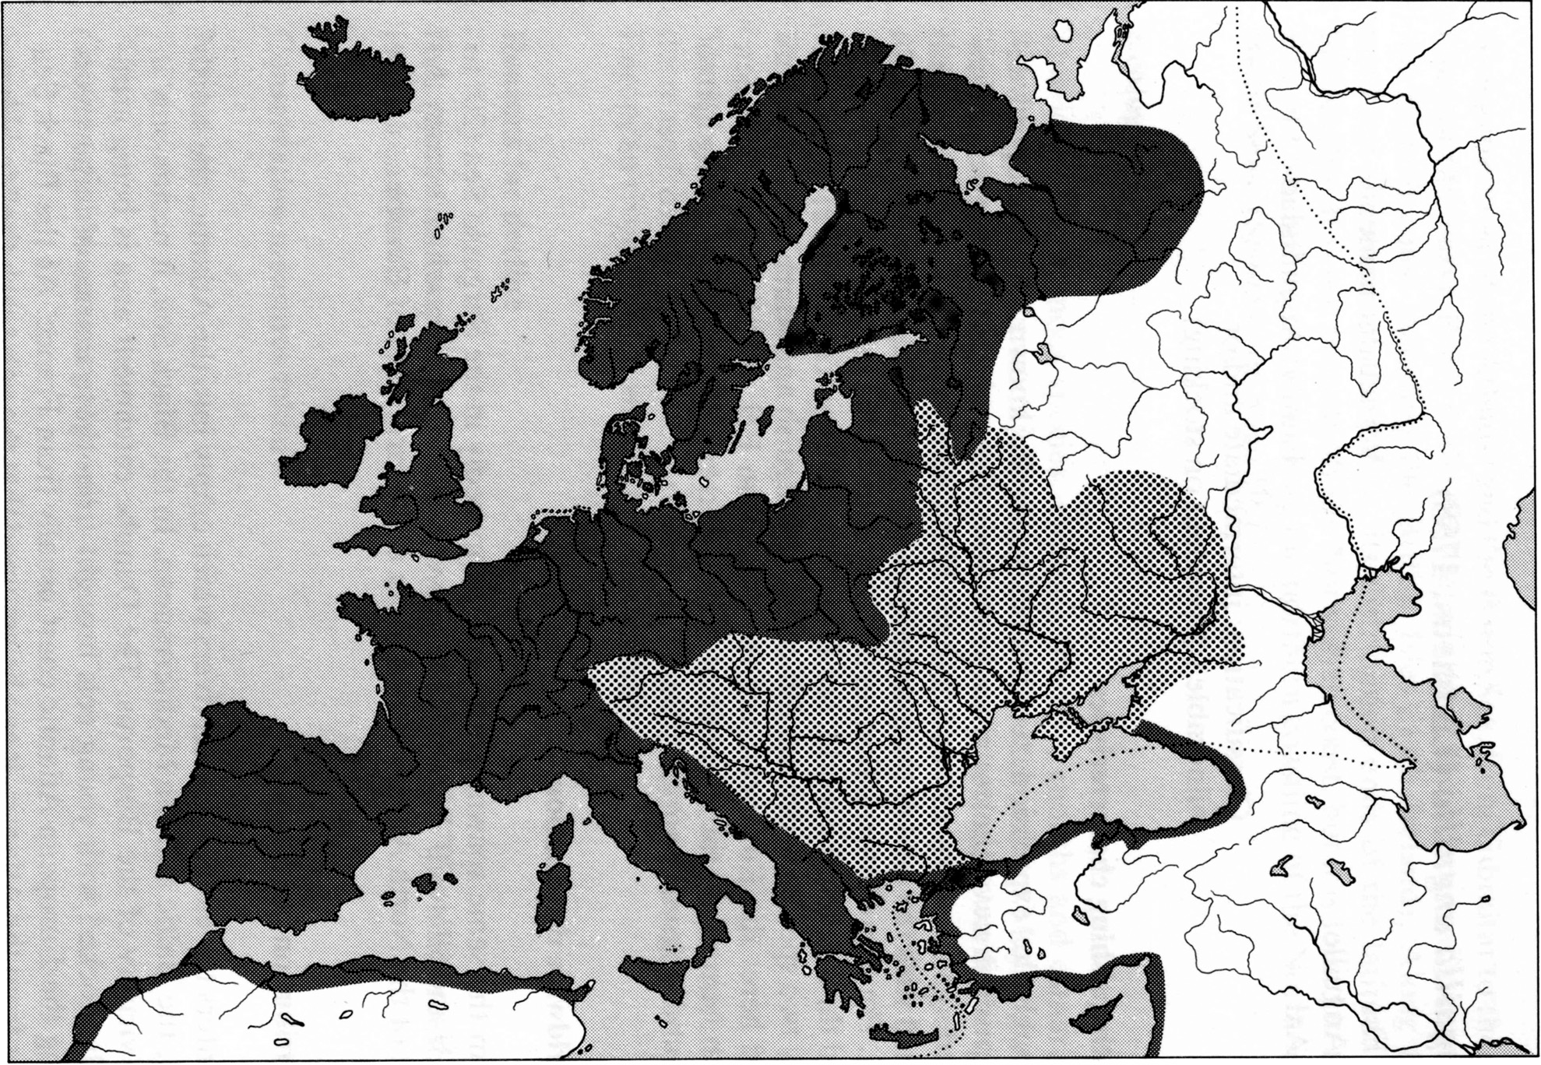
Fig. 1. – Distribution map of the European eel. Dark area: natural distribution area. Dotted area: enlarged distribution by stocking (Lelek 1987).

Framework Directive (WFD), using the results and expe- riences of 12 years of eel monitoring in Flanders. Since 1994 the Research Institute for Nature and Forest (INBO) has developed a pollutant monitoring network for public water bodies in Flanders (Belgium) using eel (anguilla anguilla) as a sentinel species. During this monitoring within the river basins of Yser, Scheldt and Meuse (ca. 13 500 km2), 2 946 eels have been sampled on 365 sites between 1994 and 2005. Muscle tissue of individual eels was routinely analysed for a series of c.30 polychlorine biphenyls (PCBs), organochlorine pesticides (OCPs) and heavy metals (see Goemans et al. (2003) and Maes et al. (2007) for sampling analytical procedures and quality assurance). In addition to this routine analysis, other con- taminants were analysed on a restricted selection of sites. These contaminants included brominated flame retard- ants, volatile organic pollutants (VOCs), endocrine dis- ruptors, dioxins, perfluorooctane sulfonic acids (PFOSs), metallothioneins and polycyclic aromatic compounds. These results are reported in various papers (Belpaire et al. 2001, 2003, Goemans et al. 2003, Roose et al. 2003, Goemans & Belpaire 2003, 2004; 2005, Morris et al. 2004, Versonnen et al. 2004, Hoff et al. 2005, Maes et al. 2005, Belpaire & Goemans 2007, Maes et al. 2007).
The WFD (CEC 2000) and, more specifically amend-

ment CEC (2006a), enforces the monitoring of a selec- tion of harmful substances in the aquatic environment. The monitoring strategy described sets out to measure most of these contaminants in the water-phase. However, the final aim of the Directive is to protect aquatic organ- isms and the aquatic ecosystem health. Belpaire & Goe- mans (2007) have discussed, and to some extent criti- cised, the monitoring strategy mainly on the basis of ana- lytical features of those compounds. Basically, most of the substances selected under CEC (2006a) are highly lipophilic, and consequently are hardly (if ever) traceable in water. On the other hand, they may attain very high concentrations in organisms, as a result of bioconcentra- tion and biomagnification. Belpaire & Goemans (2007) argued that within the WFD, at least for some substances, monitoring in water is inadequate and does not guarantee sufficient protection of the aquatic environment, and con- cluded that, as an alternative, the eel may be a suitable species for monitoring lipophilic chemicals in aquatic biota. From the INBO Eel Pollutant Monitoring Network (EPMN), specific examples of how eels can pinpoint environmental pollution by chemicals have been demon- strated. Belpaire & Goemans (2007) further illustrate the potential of using the eel as a biomonitor over a broader geographical range, meeting the requirements of the WFD

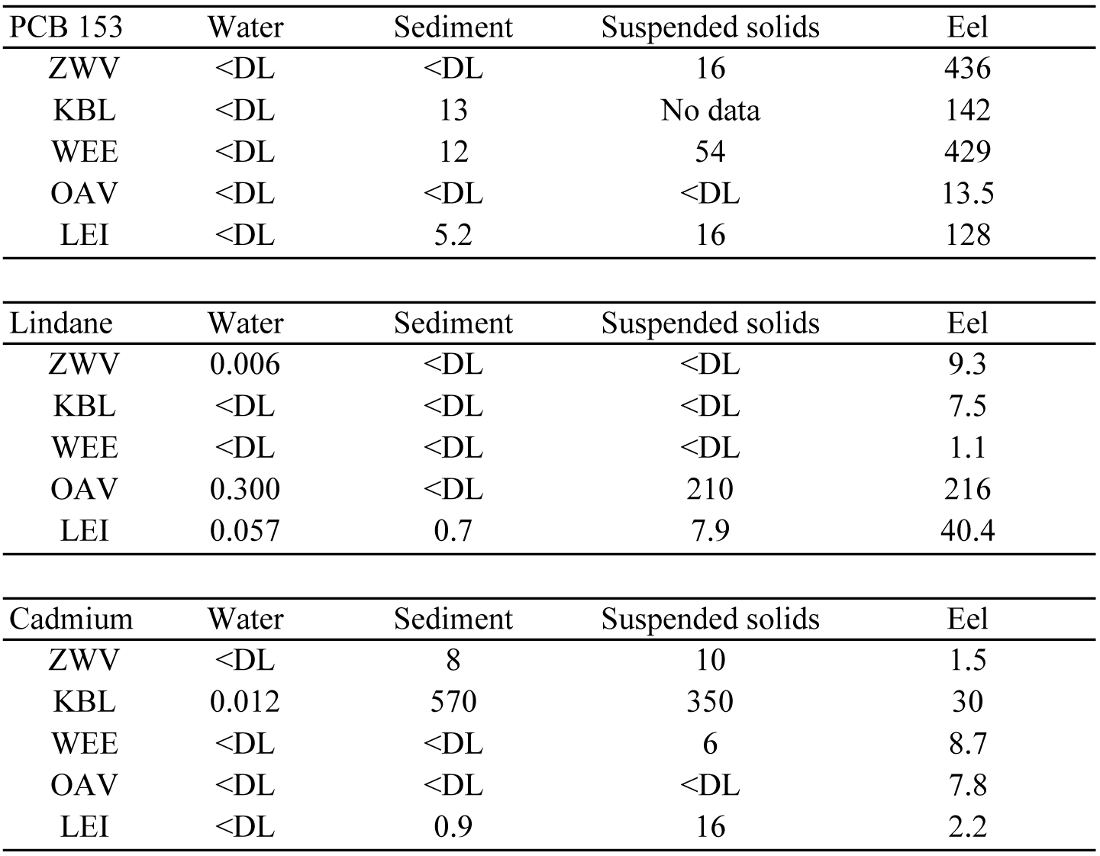Table I. – Concentrations of PCB 153, lindane and cadmium measured simultaneously in water, sediment, suspended sol- ids and eel at 5 stations in Flan- ders (2001). Concentrations are expressed as µg.L-1 (water), in
µg.kg-1 dry matter (sediment and suspended solids) and in
µg.kg-1 wet weight of muscle tissue (eel). Stations are the canals Zuidwillemsvaart (ZWV) and Kanaal van Beverlo ( KBL), a lake at Weerde (WEE), a polder water course Oude Avaart (OAV) and a river Leie (LEI) (after Belpaire & Goemans 2004). DL: detection limit.

for reporting on the chemical status of water bodies at least for some priority substances.
In this paper, we present evidence from results collect- ed through the EPMN to further document and assess the potential advantage of using eel within the WFD chemi- cal status monitoring. An overview of current eel moni- toring work in Europe is given and possibilities for a standardised framework are described. Finally, other environmental constraints related to eel chemical moni- toring will be discussed briefly.

Analytical issues

A number of specific traits of the eel, such as habitat preferences, trophic position, lipid content and size, give specific advantages when considering selecting eel as a chemical bioindicator species. Being benthic and carnivo- rous animals, eels are particularly vulnerable to high con- tamination levels through bioaccumulation and biomag- nification. The lipid content of the eel is high compared to other species and especially the lipophilic contaminants can attain high levels. As a consequence these contami- nants are easily traceable. Eel size is sufficient to provide the required quantity of tissue for the analyses of a series of different contaminants.
From an analytical perspective, biota have the advan- tage of containing much higher concentrations of contam- inants compared with abiotic samples, as a result of proc- esses like bioaccumulation and biomagnification. Organ- isms at higher trophic levels are known to have higher contaminant levels than their preys. During an assessment of the occurrence and partitioning of an extended series of
chemicals in the aquatic environment at 5 polluted sites in waters of different typology in Flanders, suspended sol- ids, sediments and organisms of different trophic levels were analysed (Weltens et al. 2002, 2003, Table I). It is clear that even on sites with high levels of various pollut- ants, a lot of measurements in the abiotic compartments fall below the detection limit (D.L.). In contrast, concen- trations in eel are always measurable and attain higher values (and thus are better detectable) than in the sedi- ment or suspended solids. For heavy metals, e.g. cadmi- um, differences in concentration levels between biotic and abiotic compartments are generally less pronounced. For monitoring heavy metals it could be recommended to measure eel liver concentrations instead of muscle tissue, as concentrations of most metals are higher in liver tissue (Durrieu et al. 2005). However metal measurements in muscle tissue are easily detectable (see below and Fig. 2) and present an added value towards human health risk assessment (see below).
Trophic position is not the only factor determining the degree of contamination of a species. Top-predators like northern pike (esox lucius) and pikeperch (sander lucio- perca) feeding exclusively on fish show 3 to 15 times lower levels of contamination by lipophilic substances than eel (on a muscle wet weight basis) dependent on the specific contaminant, due mainly to their significant lower muscle lipid contents (ca 0.5 %) (Goemans, pers comm). Interspecific differences in contamination load within several field studies have been attributed to differ- ences in lipid content (for an overview see Nowell et al. 1999). Amongst the various biota, eel has particular ana- lytical advantages due to its very high fat content: Maes et

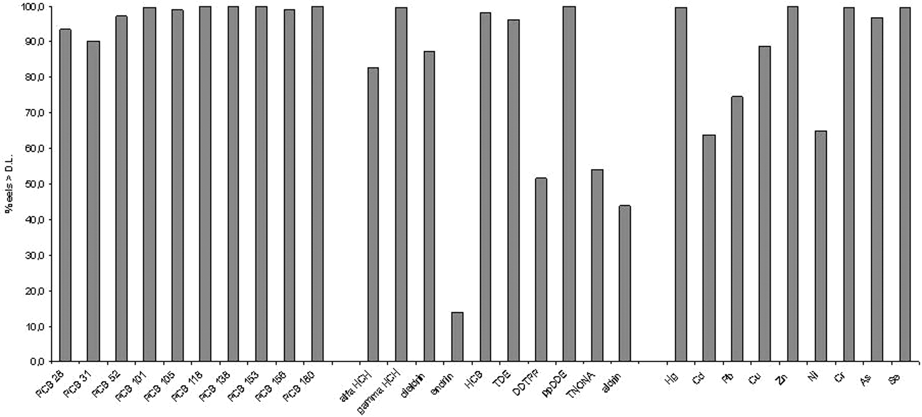
Fig. 2. – Percentage of individual yellow eel measurements above the detection limit for 10 PCB congeners and 10 organochlorine pes- ticides and 9 heavy metals in eels from Flanders collected in the period 1994-2005. N = 2528 for the PCBs, hexachlorocyclohexanes (HCHs), dieldrin, hexachlorobenzene (HCB), DDTs, trans-Nonachlor (TNONA) and endrin, N = 546 for aldrin, N = 2769 for Hg, Cd and Pb, N = 2117 for Cu, Zn, Ni and Cr and N = 1410 for As and Se (data from INBO Eel Pollution Monitoring Network). For an over- view of the mean eel life history statistics (length, weight and lipid content) see Maes et al. (2007).

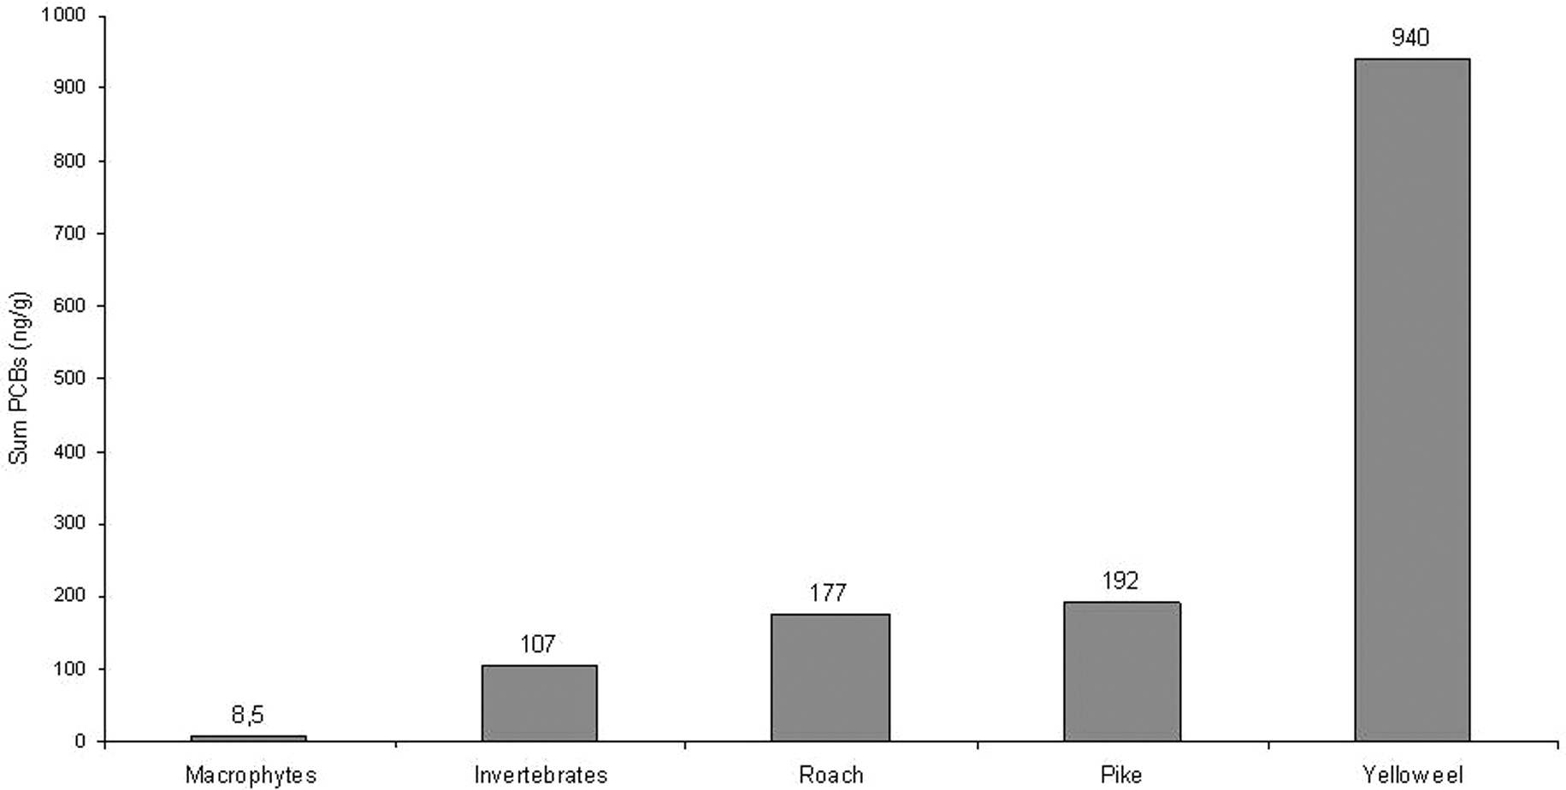
Fig. 3. – Concentration of Sum PCBs over various trophic levels in Lake Weerde (Flanders) in 2001 (spring). Data expressed as ng/g total wet weight for macrophytes and invertebrates and as ng/g wet weight of muscle tissue for fish (from Weltens et al. 2002). Fish analysis was performed on muscle tissue samples (N = 5 for roach and pike, N = 10 for yellow eel).

al. (2007) reported a mean muscle lipid content of 14.92%
± 10.18 (s.d.) in 2528 yellow eels collected over Flanders. High lipid content in eels is partly responsible for the high bioaccumulation of lipophilic contaminants in their tis- sues.
Figure 3 illustrates the concentrations of PCBs meas- ured in various biota. Lipophilic contaminants like PCBs seem to be five times higher in eel than in other fish spe- cies (on a muscle wet weight basis) and ten times higher than in invertebrates (on a total wet weight basis), as can be deduced from measurements in Lake Weerde, a shal-

low contaminated lake in Flanders (Weltens et al. 2002).
Consequently tracing of these chemicals in eel, as an environmental indicator, is particularly meaningful, since only few fall below D.L. From the results of the EPMN including quantitative data of 2946 eels collected from 365 sites between 1994-2005, it is clear that most of the PCBs, OCPs and heavy metals analysed are easily detect- able. Figure 2 represents the proportion of eels above D.L. for the PCBs and OCPs. Of the higher chlorinated PCBs 99.0-100 % are above D.L., while for the lower chlorinat- ed PCBs 28, 31 and 52, the proportion is slightly lower

(90.2-97.3). For the OCPs the situation is more variable. Very high proportions (> 98%) are noticed for the γ iso- mer of hexachlorocyclohexane (gamma-HCH), hexachlo- robenzene (HCB) and p,p’-DDE (1,1’-(2,2-dichlor-ethe- nylidene)- bis[4-chlorobenzene]). Also alfa-HCH, diel- drin and p,p’-DDD (1,1’-(2,2 dichloroethylidene)bis [4-chlorobenzene] ) can be detected in at least 8 out of 10 samples. P,p’-DDT (dichlorodiphenyltrichloroethane) and trans-Nonachlor (TNONA) can be measured in more than 50 % of the eels. The cyclodienes endrin and aldrin are obviously less common in Flanders and can be measured in 13 and 43 % of the cases respectively.
Heavy metals were also measurable for the majority of sites. Mercury, zinc, chromium, arsenic and selenium were detectable in more than 96 % of the samples. Cad- mium, lead, cupper and nickel were measured in 60 to 90 % of the samples.
Similarly, brominated flame retardants and even a number of volatile organic compounds were described as omnipresent in eels (Belpaire & Goemans 2007). Chemi- cals like HBCD (hexabromocyclododecane), PBDEs (polybrominated diphenylethers) and the volatile organic compounds BTEX (benzene, toluene, ethylbenzene and the xylenes) were found in all samples. This is in contrast with measurements in the water phase (as proposed by the WFD): as most of these compounds are lipophilic, meas- urements in water are frequently below the D.L. e.g. PCBs and VOCs are hardly traceable in water. For the VOCs this was documented by Belpaire & Goemans (2007). Even in sediments, the presence of PCBs and VOCs is quite often below the D.L.
Another advantage of using eels as a chemical bioindi- cator is their size. Eels are long-lived and their size ena- bles to obtain enough material for analysis of various con- taminants in individual fish. An individual eel of 40 cm has a back-calculated weight of 110 g, allowing removal of enough muscle tissue for at least six samples (10 g wet w e i g h t e a c h ) t o b e l a b e l l e d a n d f r o z e n a t
-20 °C. In the EPMN two samples (from the mid part of the body) were analysed for heavy metals, OCPs and PCBs. Other samples can be sent to specialised laborato- ries and analysed for BFRs, VOCs, dioxins,… The remaining samples are routinely stored as back up in a tis- sue bank at -20 °C.
From bioaccumulation studies in other fish species, it is known that the concentrations of lipophilic contami- nants are related to length, weight or age, biological fac- tors which are mostly covariant. Furthermore, length and age tend to correlate positively with lipid content. The relation between level of contamination and length or age is not always clearly positive: e.g. Reinert & Bergman (1974) described increasing DDT concentration with length in lake trout and in coho salmon from Lake Michi- gan, whereas in some other studies (e.g. Hubert & Ricci 1981) effects related to size or age were smaller or nonex- istent when contaminant concentrations were expressed

on a lipid weight basis (Nowell et al. 1999). Size and age effects may vary depending on the contaminant. During a recent study assessing the contaminants in muscle of white perch (morone americana) from Hackensack River (New Jersey, USA), Weis & Ashley (2007) found no sig- nificant correlations between PCB concentrations and length or weight. However, for mercury a significant cor- relation for both length and weight was observed. For environmental monitoring purposes it should be recom- mended that the size of the eels sampled be standardised as much as possible. Sample selection within the EPMN focuses on eels between 35 and 45 cm, thereby preclud- ing possible sex-related bias. We are well aware that for other monitoring purposes, like monitoring eel quality within the eel restoration plans or monitoring for human consumption quality (see below), it may be more appro- priate to analyse eels from larger sizes, as these may attain higher contaminant concentrations.

Eels as chemical bioindicators of the contaminant pressure of their habitat

As was described earlier (Belpaire & Goemans 2007) a sentinel species should be fairly sedentary to allow fin- gerprinting of the local pollution load. Yellow eels show explicit homing behaviour and foraging movements are mostly restricted to a few hundred meters. Apparently most eel species share this ecological trait (a. anguilla: Baras et al. 1998, Laffaille et al. 2005, a. rostrata: Olivei- ra 1997, Goodwin 1999, a. australis: Jellyman et al. 1996, a. dieffenbachi: Beentjes & Jellyman 2003,
a. japonica: Aoyama et al. 2002). Although home site fidelity is obvious also within tidal estuaries, the home range may be larger than in freshwater habitats (Parker 1995) and seasonal movements might occur (Hammond 2003). The occurrence of erratic eels (‘nomads’) has also been reported (Feunteun et al. 2003). Due to the migra- tion activities in the silver eel stage, the bioindicator value of the eel is restricted to the yellow eel phase.
The potential of the eel to fingerprint the pollutant pressure at a specific site can be illustrated by several examples from within the EPMN. Belpaire & Goemans (2007) have illustrated with a number of examples (1,2- dichlorobenzene, 1,2-dibromo-3-chloropropane, BTEX, HBCD (hexabromocyclododecane), PBDEs (polybromi- nated diphenylethers), cadmium and lindane) the possi- bility of discovering environmental contamination through eel biomonitoring. They related high levels of specific contaminants in eel with local industrial or agri- cultural activities.
The EPMN covers a dense network of 365 sampling sites; each site is characterized by a series of c.30 chemi- cals for each individually analysed eel. This dataset allowed us to show how local land use at each site charac- terizes the pollution profile within eel muscle tissue. Bel- paire et al. (1999) illustrated the usefulness of using eels

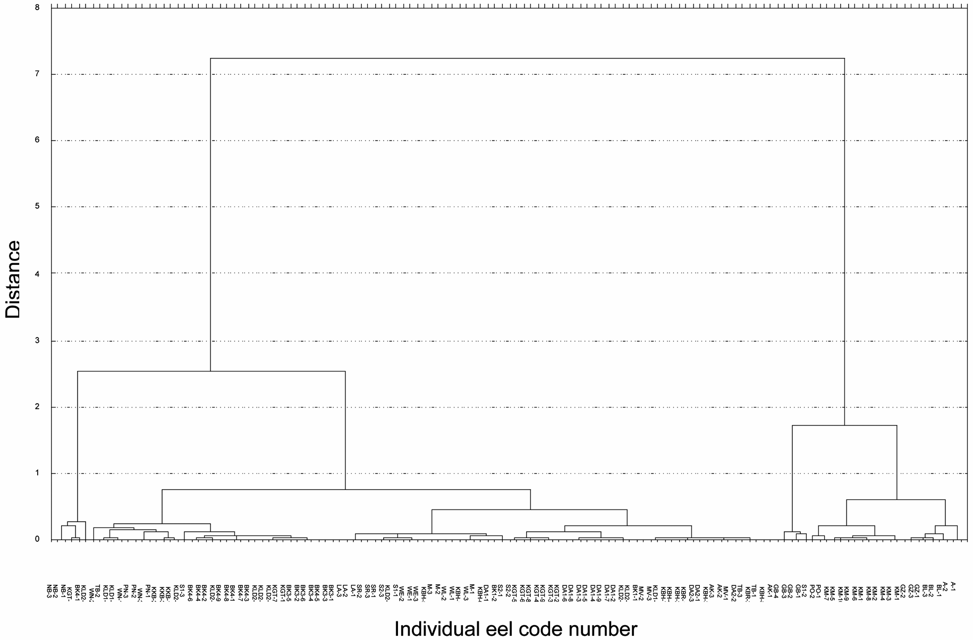
Fig. 4. – Cluster analysis based on the PCB and OCP (lipid weight basis) profiles of 129 yellow eels from 30 sites in Flanders sampled between 1994 and 1998 (Belpaire et al., 1999). Eels from the same site cluster mostly together.

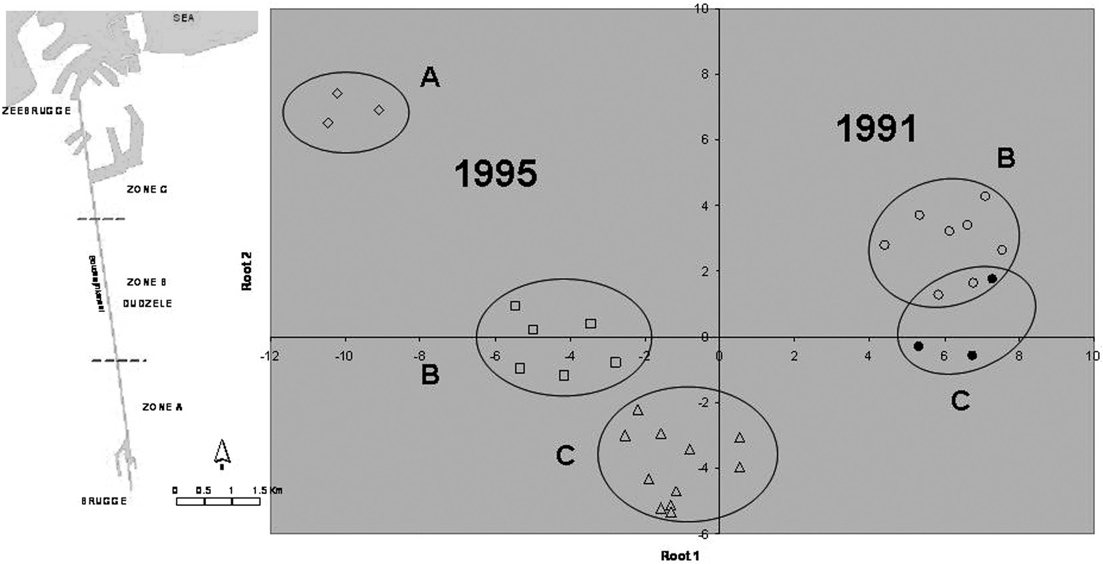
Fig. 5. – Discriminant analysis on the concentrations of 16 PCBs and OCPs (on lipid weight basis) in 31 eels from three zones in the Boudewijnkanaal from 1991 (11 eels) and 1995 (20 eels) (after Belpaire et al. 1999). Left: location of the three zones A, B and C on the Boudewijnkanaal.

as a sentinel species for measuring pollution by persistent pollutants. They presented (Fig. 4) a cluster analysis of the PCB and OCP concentration in 129 yellow eels from 30 sites in Flanders and showed that intra-site variability between eels is generally lower than the inter-site varia- bility. On the basis of their contaminant load, eels from the same location were mostly clustered (Fig. 4). The pol- lution profile of individual yellow eels from one site
seems to be a fingerprint of the local contaminant pres- sure. Even within water bodies and on a small local scale eels may show variations depending on where they lived. A study on the canal Boudewijnkanaal demonstrated dif- ferences in pollution load in eels within the canal (Bel- paire et al. 1999). The Boudewijnkanaal is relatively short (14 km) and situated in the northwest of Flanders, mouth- ing in the North Sea at Zeebrugge harbour. The canal was

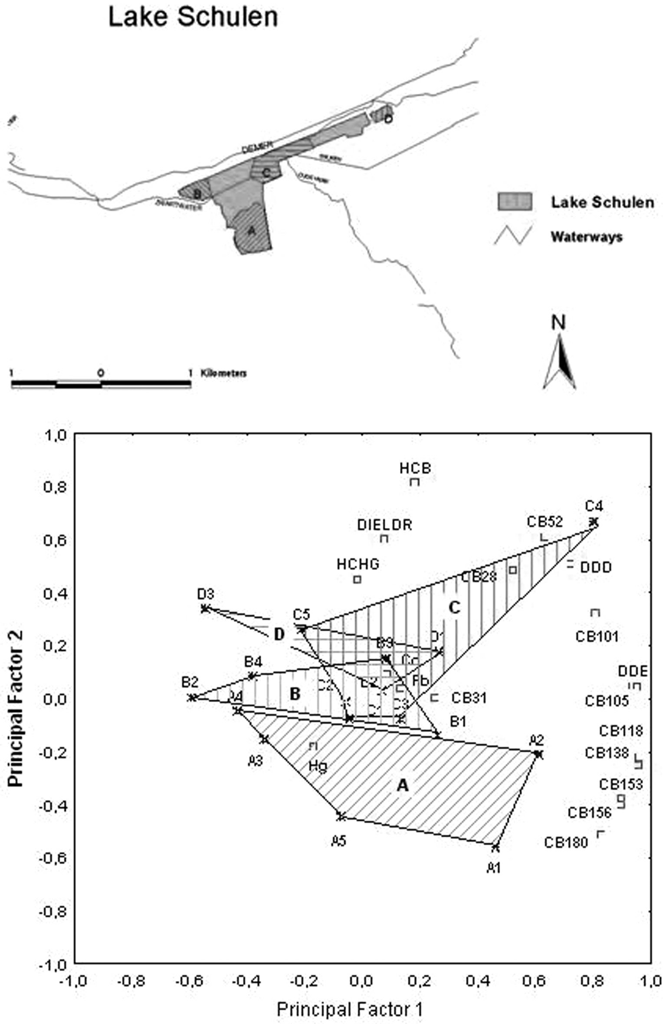
Fig. 6. – Factor analysis of contaminant concentrations (PCBs and OCPs) in 17 yellow eels from the zones A, B, C and D in Lake Schu- len. Eels are numbered per zone (A1, A2,…). HCB: hexachlorobenzene, DIELDR: dieldrin, HCHG: γ-hexachlorocyclohexane (lin- dane), DDD: p,p’-DDD (1,1’-(2,2 dichloroethylidene)bis [4-chlorobenzene] ), DDE: p,p’-DDE (1,1’-(2,2-dichlor-ethenylidene)- bis[4- chlorobenzene]) (Belpaire et al. 2001).

divided into three zones each c.4 km long: zone A which included the southernmost part nearby Brugge, zone B being the intermediate zone nearby Dudzele and zone C the northern part of the canal in front of the sea sluices
(Zeebrugge) (Fig. 5). Eels were analysed for PCBs and OCPs in 1991 (8 eels from zone B and 3 eels from zone
C) and in 1995 (3 eels from zone A, 6 eels from zone B and 11 eels from zone C). Discriminant analysis (Fig. 5)

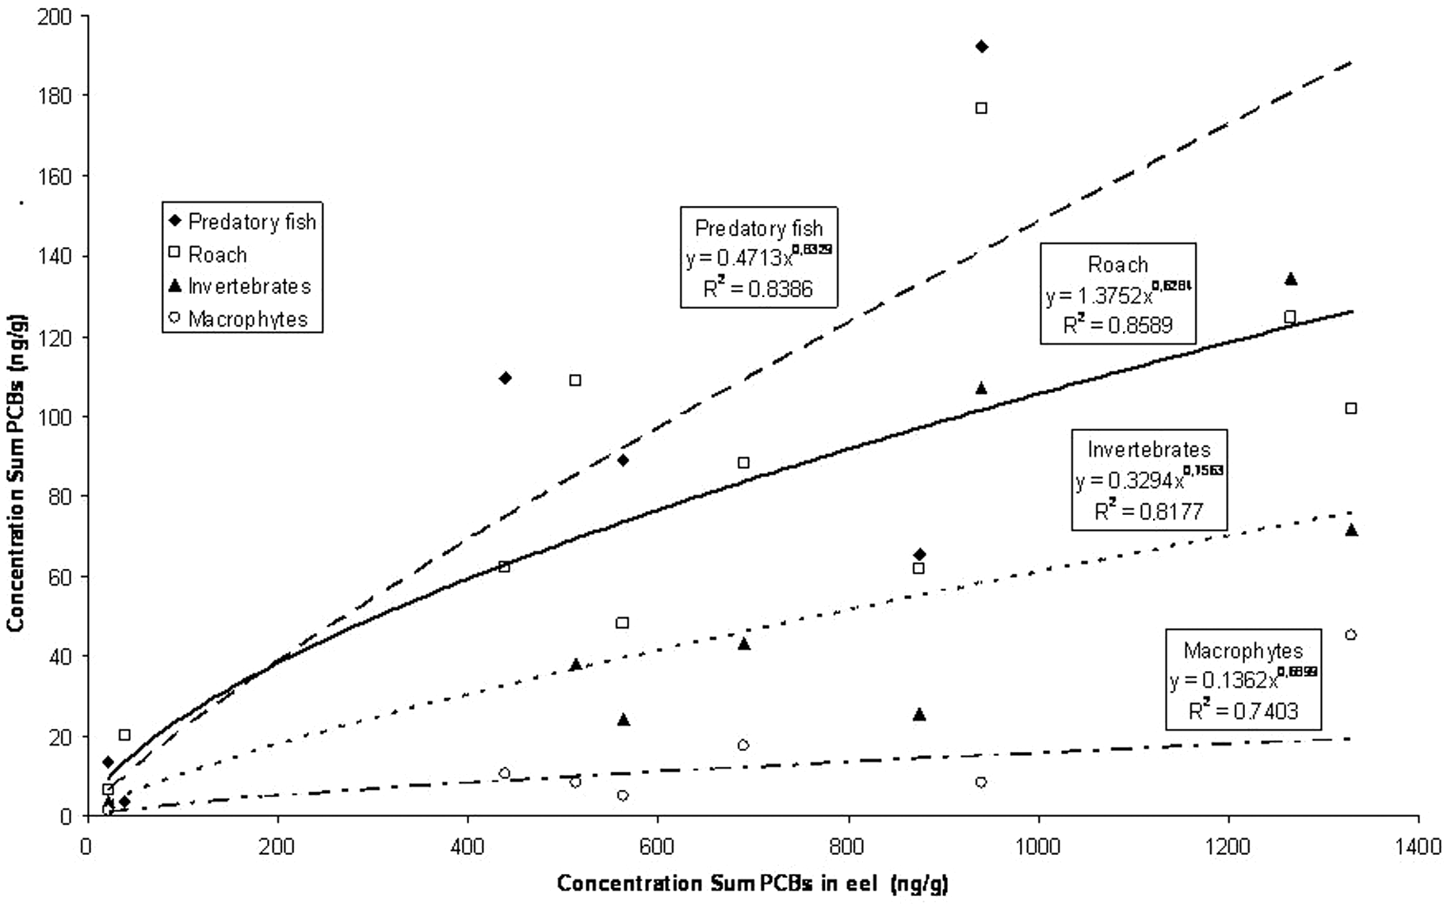
Fig. 7. – Correlation between the concentration of Sum PCBs measured simultaneously in predator fish species, roach, invertebrates and macrophytes, compared to the concentration of Sum PCBs in eel. Data acquired from sampling on five polluted water bodies in Flanders during spring and autumn 2001 (Weltens et al. 2002). Concentrations are expressed in ng/g wet weight of muscle tissue for fish and in ng/g total wet weight for invertebrates and macrophytes.

of the concentrations of 16 PCBs and OCPs (on a lipid weight basis) between these five groups showed differ- ences between the 1991 and 1995 eels. With the exception of lindane, concentrations of most of the contaminants were higher in 1995 compared to the 1991 levels. Moreo- ver, within a year, very distinct regional variations occurred, with eels from zone A being very distinct from the other zones. Also eels from B and C clearly belonged to separate groups, both in 1995 and in 1991. Differences between zones were explained by differences in local pol- lution pressure on the canal (with zone A being the most polluted zone). This gives strong evidence that eels do reflect differences in the pollution load of their habitat, even between locations which are relatively close to each other, as was the case here with the 4 km zones. It also supports the hypothesis that eels are very sedentary.
Other evidence exists for stations within the Meuse river basin, as reported by Goemans & Belpaire (2003), combining data from Flanders and The Netherlands. Goe- mans & Belpaire (2005) also showed that within the group of the PCBs, congener profiles (e.g. ratio of PCB 118 to Sum PCBs) in eels from a specific location are almost constant, but can vary considerably between eels originating from different locations.
An example within a lacustrine environment has been presented by Belpaire et al. (2001). Lake Schulen is a 90 ha eutrophic, oblong lake (length not exceeding 3 km) in central Flanders. 17 eels captured from 4 areas of the

lake were analysed individually for polychlorinated biphenyls, organochlorine pesticides and heavy metals. Although no significant differences were found between eels from the different areas for most of the individual pollutants, there seemed to be a variation in overall pollu- tion pattern, as illustrated in the factor analysis in Fig. 6. The study revealed significant differences in lindane (gamma HCH) concentrations in muscle tissue of eels from different areas. No evidence was found for potential causes of this pollution. This study illustrates the potential of using eel as a monitoring organism for pollution by some persistent substances within lacustrine environ- ments, even within rather small lakes.
Weltens et al. (2002) described the results of a study investigating contamination through the various compart- ments of the aquatic ecosystem. PCBs, heavy metals and pesticides were analysed in water, suspended solids, sedi- ment and biota of different trophic levels on 5 polluted sites in Flanders. Fig. 7 presents the relationships between Sum PCBs in wet weight of muscle tissue of eel with Sum PCBs in wet weight of muscle tissues of predator fish spe- cies and roach and with Sum PCBs on total wet weight basis in invertebrates and macrophytes. Fairly good cor- relations were found.
The contaminant fingerprint value of eels has already been illustrated, to some extent, in the 1980’s for a. ros- trata in the St. Lawrence river. Moreau and Barbeau (1982) distinguished eels of different origins on the basis

Table II. – Overview of recent reports describing bioaccumulation data of various chemicals in anguilla anguilla within EC countries (PCBs: polychlorinated biphenyls, OCPs: organochlorine pesticides, HM: heavy metals, DIO: dioxines, BFRs: brominated flame retardants, PAHs: polyaromatic hydrocarbons, VOCs: volatile organic compounds, PFCs: perfluorinated compounds, MT: metal- lothioneins).

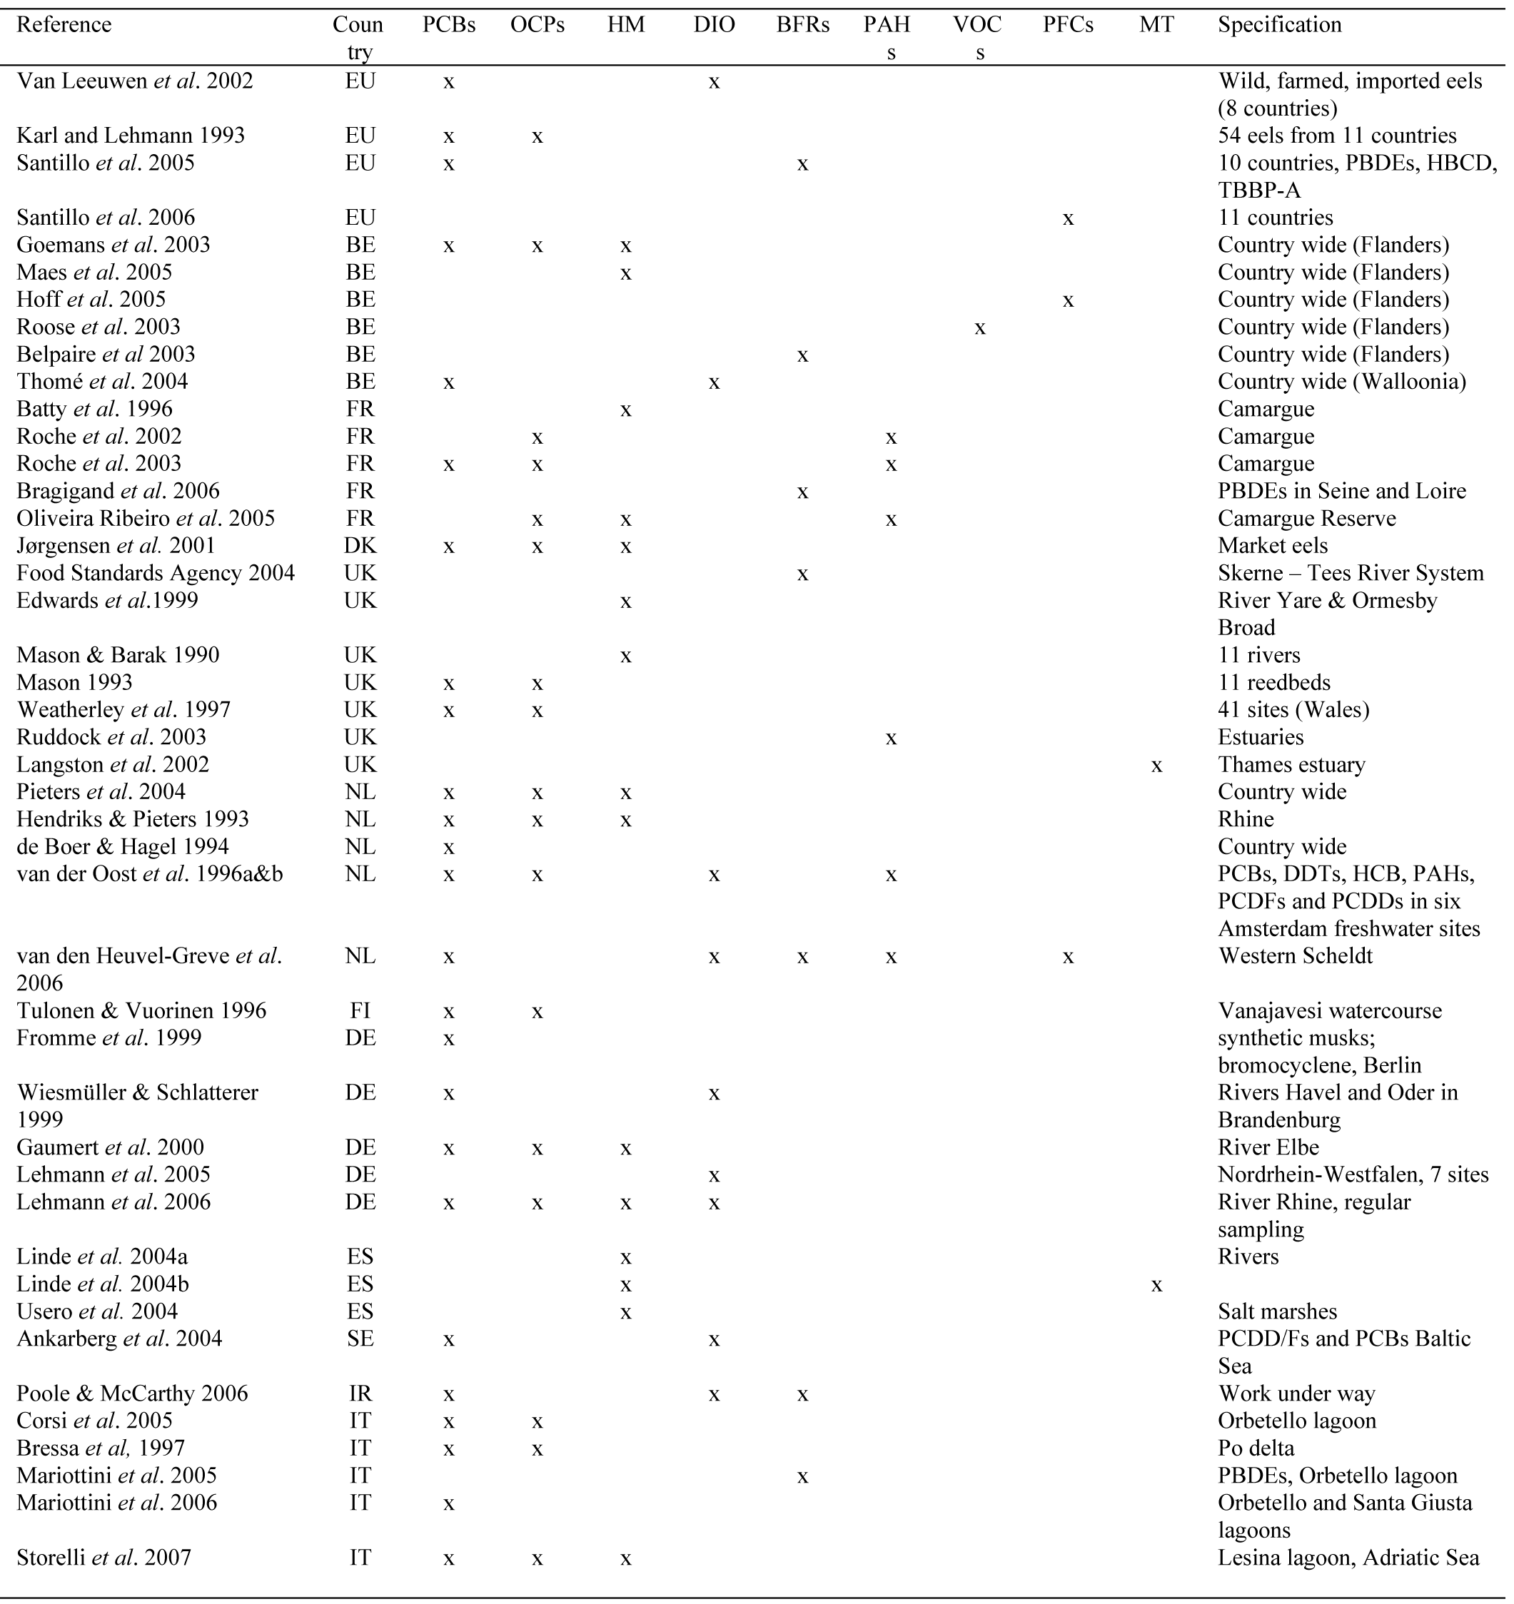

of their heavy metal (Hg) content. Dutil et al. (1985) got similar results on the basis of the presence of mirex. They concluded that organic chemicals could be a better instru- ment for discriminating stocks than heavy metals. In the same region, Castonguay et al. (1989) found a relatively high discrimination among eels from various sampling sites based on their contamination level with organochlo- rines. More recently, many EC countries have reported the use of the European eel to monitor the presence of a

variety of substances. Extensive reviews have been made by Bruslé (1990; 1991) for respectively, heavy metals, and OCPs and PCBs. He assembled reports on the bioac- cumulation of contaminants within several eel species. Since then, for a whole variety of contaminants, reports on eels as bioindicators have been published all over the world. Knights (1997) made a review of available litera- ture on persistent xenobiotic organochlorines in eel spe- cies and Robinet & Feunteun (2002) gave examples of

concentrations of some pollutants in yellow European and American eel. In Table II we summarize reports pub- lished recently for the EC countries. In some countries like The Netherlands and Belgium, a nationwide moni- toring network is operational (respectively since 1977 & 1994). In other countries like Sweden, Finland, Denmark, Germany, United Kingdom and Northern Ireland, France, Spain and Italy, eel biomonitoring studies have been undertaken on a local scale. In Ireland investigations are in progress.
Table II shows that a whole variety of contaminants were analysed. The PCBs, OCPs and heavy metals are the most commonly analysed contaminants. Lately, groups of brominated flame retardants and dioxins are being ana- lysed more frequently, illustrating the increasing concern for these compounds, and following the new EU dioxin regulation in foodstuffs (CEC 2006e). Locally, other con- taminants have been analysed within specific research programs (polycyclic aromatic hydrocarbons, volatile

organic compounds, synthetic musks, perfluorinated com- pounds, metallothioneins,…).
It is remarkable that until now no pan-European com- prehensive reports are available on the chemical status of the eel, considering the increasing number of recent papers that point towards chemicals as being responsible for the decline of the eel. Two studies have compared bio- accumulation data in eels from several countries with allowable values for human consumption: Karl & Leh- mann (1993) reported on OCPs and PCBs in 54 eel sam- ples, both wild and farmed, from 11 different countries, and Van Leeuwen et al. (2002) compared PCBs, dioxins and furans in wild and farmed eels from The Netherlands, and in imported eels from 7 countries. More recently, two Europe-wide studies have been presented by Greenpeace using the eel as a bioindicator of brominated flame retard- ants and PCBs from rivers and lakes in 10 European coun- tries (Santillo et al. 2005) and of perfluorinated chemicals in 11 countries (Santillo et al. 2006). These studies were

Table III. – Reference values and boundary values of the quality classes for a series of heavy metals, PCB congeners and organochlo- rine pesticides as defined in the EPMN. Values are expressed in ng.g-1 wet weight of muscle tissue, unless indicated as * in ng.g-1 lipid weight or ** in µg.g-1 wet weight of muscle tissue.

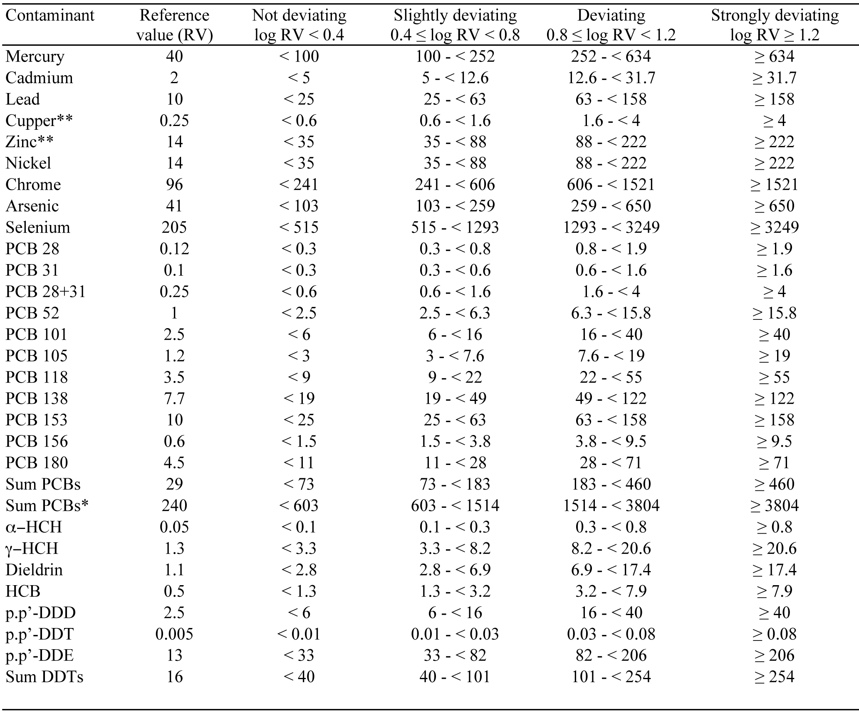

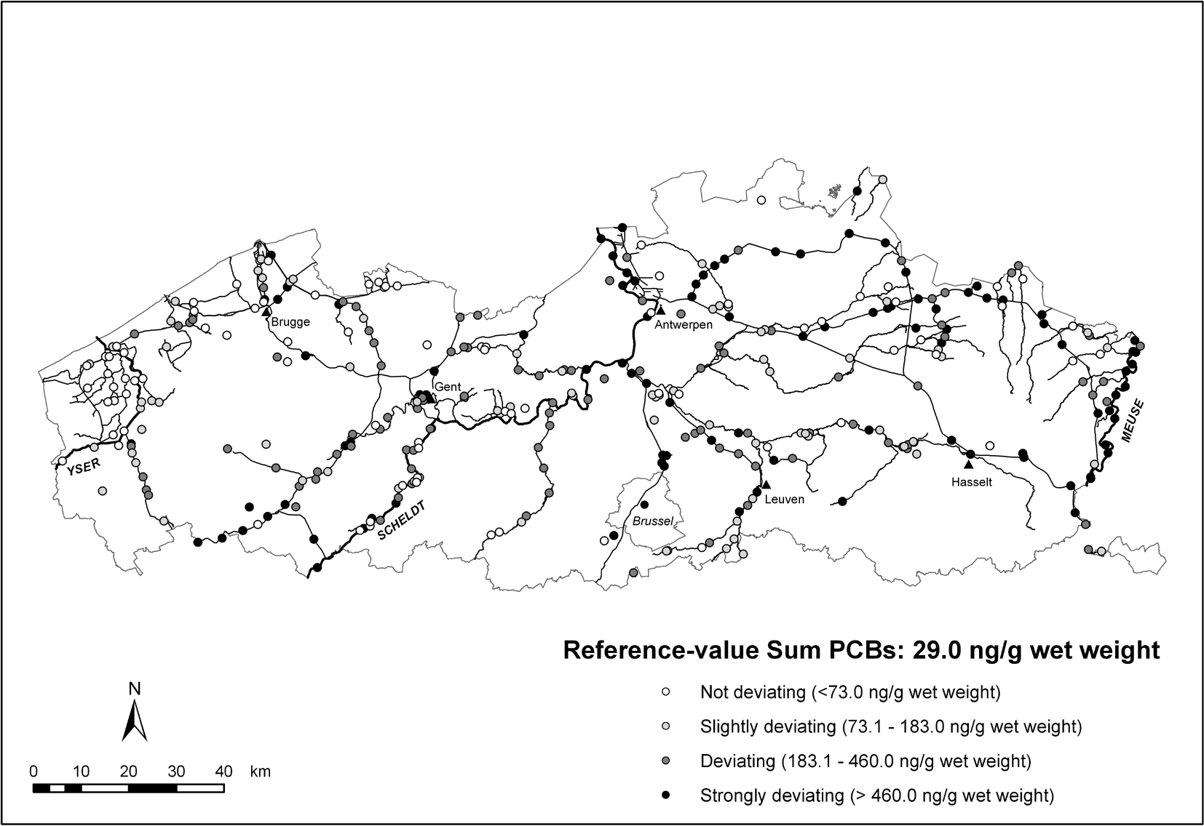
Fig. 8. – Sampling sites of the Eel Pollutants Monitoring Network in Flanders and geographical distribution of quality classes in Flem- ish eels for Sum PCBs (N = 351 sites, 1994-2005). Reference value and quality class boundaries are given. Sum PCBs equals the sum of the 7 indicator congeners (CB 28, 52, 101, 118, 138, 153 and 180).

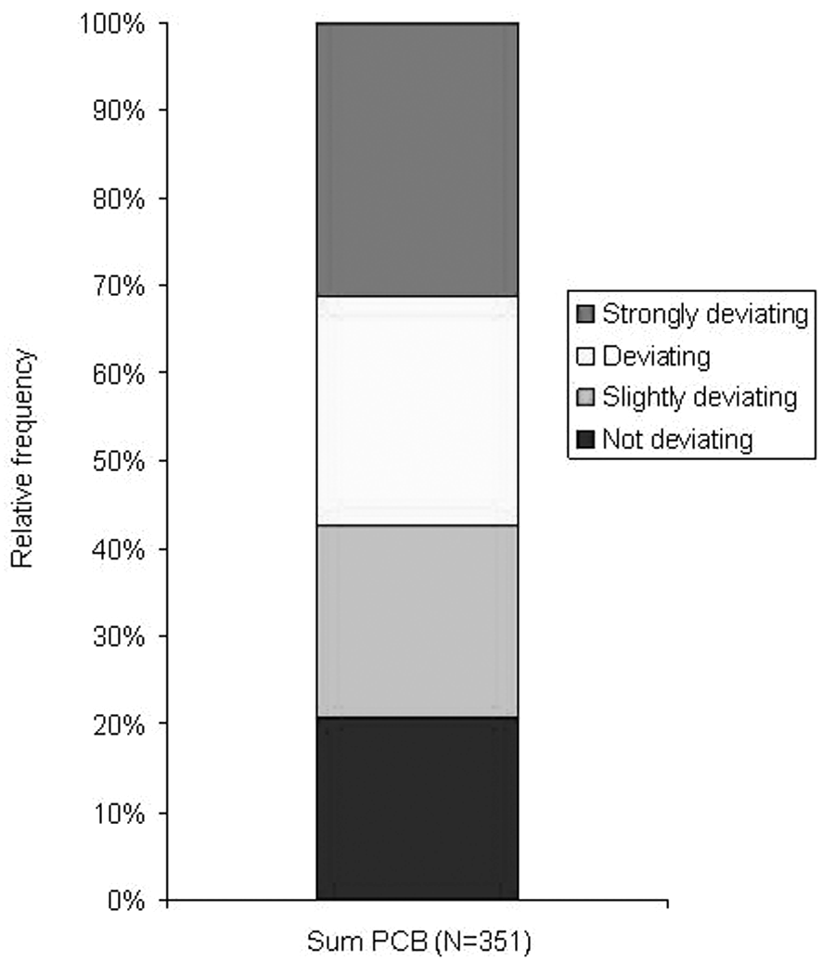Eel contaminant quality classes and standards

Fig. 9. – Distribution of Sum PCB quality classes in Flemish eels (N = 351 sites, 1994-2005). See Table III or Fig. 8 for refer- ence values and boundary values of the quality classes. At
57.2 % of the sites, PCB levels in eels are deviating or strongly deviating from the reference value.

however rather restricted with respect to the number of eels or sites analysed.
Analyses of a series of chemicals generates a database of quantitative data which have to be interpreted. There is a strong need for a normative framework with clear benchmarks to which the data should be compared. This framework can consist of various types of benchmarks. The WFD (CEC 2006a) proposes ‘Environmental quality standards’ (EQS), limit concentrations (e.g. in hexachlo- robenzene, hexachlorobutadiene and methyl-mercury) which can not be exceeded in ‘prey’ tissue of biota. No Observed Effect Concentrations (NOEC) have been described for specific chemicals for certain organisms, including eel (see PAN Pesticides Database, 2007). For some compounds (e.g. Hg, Pb, Cd, dioxins, furans and dioxin-like PCBs (WHO-PCDD/F-PCB-TEQ),….) human health safety standards for fish have been set by the European Commission (CEC 2001; 2006e) or by addi- tional national legislation (e.g. consumption limit for indicator-PCBs for fisheries products in Belgium, Bel- gisch Staatsblad 2002), some with special values for eel. In some countries (e.g. The Netherlands), concentrations of some substances in eel are used as environmental toler- ance values and action thresholds (ecotoxicological val- ues).
In Flanders, quality classes were developed based on quantitative distribution of the data (means per location) for PCBs, OCPs and heavy metals (Goemans et al. 2003). Reference values were fixed for each chemical. These ref-

erence values were defined as the 5 percentile value of the means of all sites. A common procedure was used to dis- tinguish four quality classes as a measure of deviation from the reference value, and class boundary values were set. Class limits and reference values for each contami- nant are listed in Table III. Class boundary calculations were based on the distribution of the relationship between the recorded values and the reference value. Class 1 rep- resents the ‘not deviating’ class (blue colour) with ‘unpol- luted or low polluted’ sites. Sites with a slight to moderate pollution level are classified as class 2 ‘slightly deviating’ (green). The more polluted sites are assigned to class 3 ‘deviating’ (yellow) or 4 ‘strongly deviating’ (red).
On Figs. 8, 9, an example is given of a cartographic and graphic representation of the distribution of Sum PCBs in eel. Fig. 9 indicates that, of a total of 351 sites, only 21 % of the sites are relatively clean, while 57 % of the sites are polluted and assigned to classes 3 or 4 (devi- ating or strongly deviating from the reference value). The map shows that most of the unpolluted or low polluted sites are located in the Yser basin, which is mainly char- acterized by agricultural land use.
In order to allow general status reports, more con- densed reporting can be achieved by representing a com- bination of various chemicals e.g. within a region or as a function of time. This has been done in the annual state of the environment and the nature reports of Flanders. An example is given in Fig. 10 (Peeters et al. 2006). These representations are useful for showing temporal changes or spatial variation in environmental and biotic quality.
For Sum PCBs, possible management objectives and benchmarks have been proposed by Belpaire & Goemans (2004) and are illustrated in Fig. 11. Action and target

threshold values are proposed at 460 and 183 ng/g wet weight respectively. The action threshold can be seen as a limit which never may be exceeded; sites above this limit should be sanitized. The target threshold is the objective to attain within a planned timeframe.

Eel biomonitoring for evaluating chemical status within the Water Framework Directive

The eel has a wide geographical, pan-European distri- bution range. It is exceptional that one bioindicator spe- cies occurs over such a vast diversity of habitats: the whole river trajectory from source to estuary and even in seawater, but also in canals, lakes, ponds and salt water lagoons. Consequently, eels can be used in reporting the chemical status of all categories of water bodies within the river basin approach of the WFD (rivers, lakes, transi- tional water bodies, coastal water bodies, artificial or heavily modified water bodies).
We are aware that some methodological problems still exist. Problems related to sampling procedures, laborato- ry procedures and quality assurance can hamper compari- son and harmonisation. Some analytic procedures for the analysis of certain new chemicals will need further devel- opment. Nevertheless, from our own work presented in this paper and elsewhere, we are confident that the Euro- pean eel is a suitable bioindicator species to use through- out its distribution area for monitoring a variety of priority substances in order to evaluate the chemical status of our waters.
In CEC (2006a), the latest amendment to the WFD (CEC 2000), 33 substances or groups of substances were selected as priority substances, some of them of very high

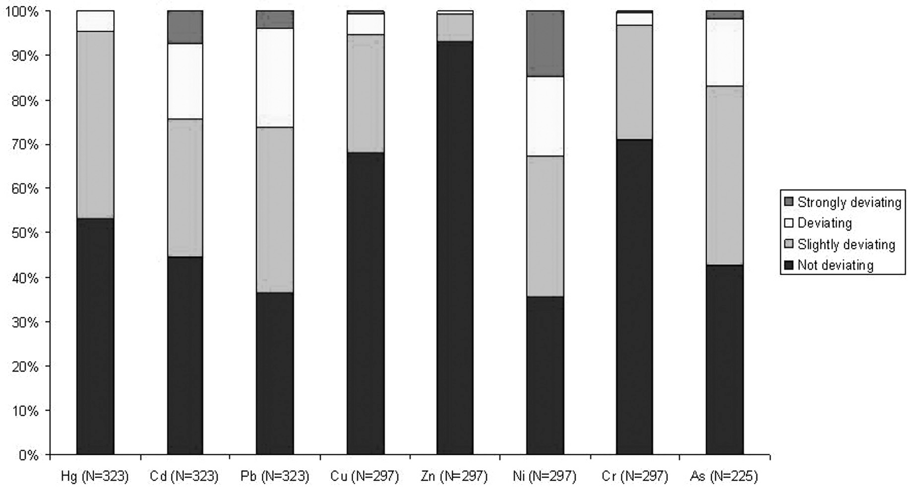
Fig. 10. – Status of heavy metals in eel in Flanders (after Peeters et al. 2006 in Flanders environmental report 2006). Data distribution is based on the means per site sampled between 1994 and 2005; the number of sites is indicated. See Table III for reference values and boundary values of the quality classes of the heavy metals.

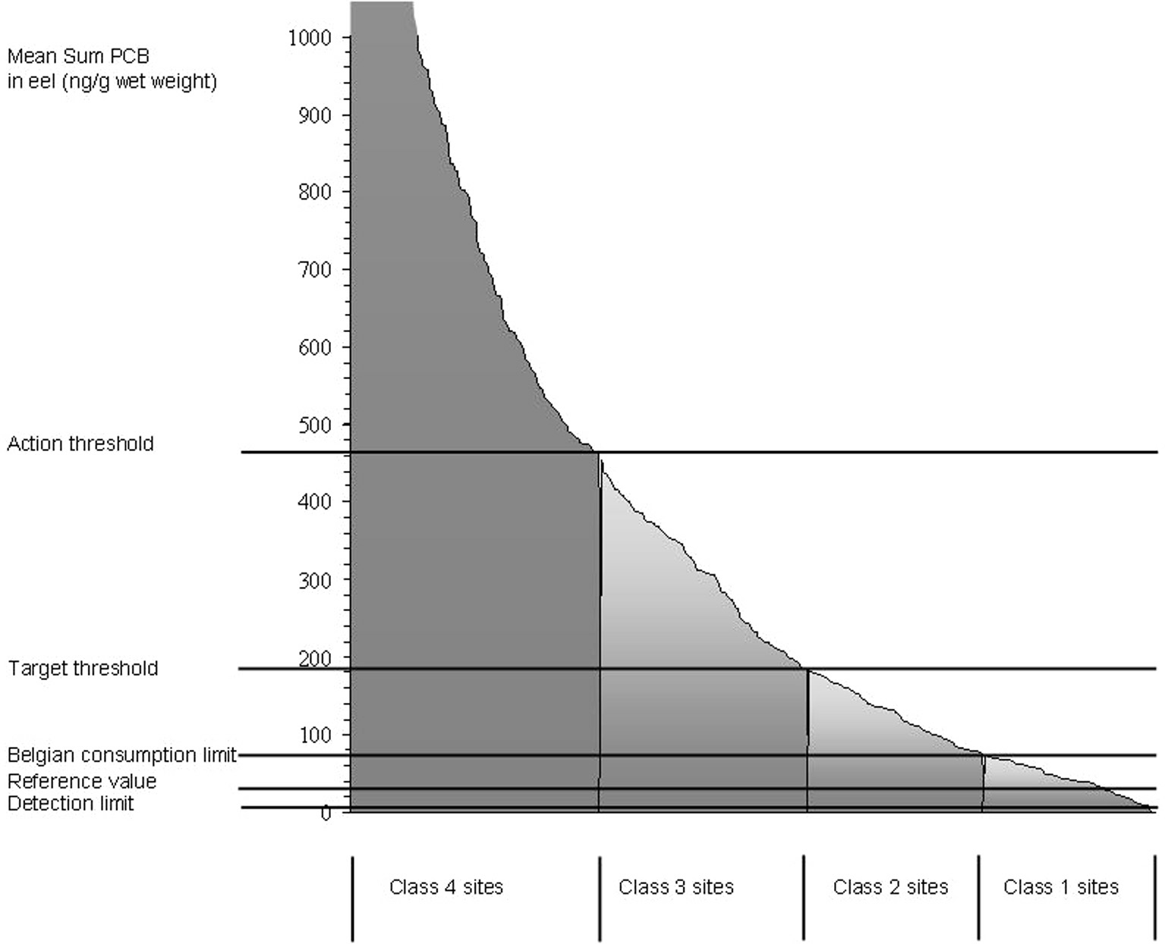
Fig. 11. – Mean Sum PCB values in eel from 351 sites in Flanders (1994-2005): distribution between quality classes and comparison with threshold values for action or target values as proposed by Belpaire & Goemans (2004). Detection limit (2 ng.g-1 wet weight), ref- erence value (29 ng.g-1 wet weight) and the Belgian consumption limit (75 ng.g-1 wet weight) are included in the figure.

concern and identified as ‘priority hazardous substances’. These include some existing chemicals, plant protection products, biocides, metals and other groups like polyaro- matic hydrocarbons (PAH) and some polybrominated biphenylethers (PBDE). Another 8 pollutants are not on the priority list but fall under the scope of older directives. The environmental objectives of the WFD are to ensure the ecological integrity of aquatic ecosystems and the protection of humans (CEC 2006b). In this approach, there is definitely a need to have a harmonised basis for assessment, in particular for international river basins (CEC 2006b). Emphasis is placed on the measurement of these hazardous substances in the water column. It is important to define clear and harmonised standards for priority substances within the most cost-effective and appropriate approach. According to CEC (2006a), there seems to be enough extensive and reliable information on concentrations of priority substances from measurements made in water to provide a sufficient basis to ensure com- prehensive protection and effective pollution control. Based on information concerning the toxicity, persistency and bioaccumulation potential of a substance, together with information on what happens to this chemical in the environment, it is possible to determine threshold concen- trations to protect people, flora and fauna. This assess- ment will be based on ‘environmental quality standards’ (EQS) which are defined as “the concentration of a par-
ticular pollutant or group of pollutants in water, sediment or biota which should not be exceeded in order to protect human health and the environment” (CEC 2006a). It is recognised that sediment and biota remain important matrices for the monitoring of certain substances by mem- ber states in order to assess long term impacts of anthro- pogenic activity and trends. Furthermore, the member states have to ensure, on the basis of monitoring of the water status carried out in accordance with the WFD, that concentrations of substances listed do not increase in sed- iment and biota. It has been decided, however, that no EQS would be proposed for sediments and only three for biota (see above).
We found evidence that current legal chemical quality standards for the water column are wholly insufficient to guarantee the health of our aquatic ecosystems. After comparing the levels of contamination in all compart- ments of several polluted environments, Weltens et al. (2003) concluded that legal chemical criteria for the water column are not suitable to protect the health of the aquatic organisms. Simple partition models did not adequately predict the field concentrations in the different compart- ments nor in biota. We demonstrated that in particular lipohilic substances are hard to trace in water and the majority of measurements fall under the D.L., even on sites where these contaminants attain (very) high levels in fish. Therefore we strongly support the idea that monitor-

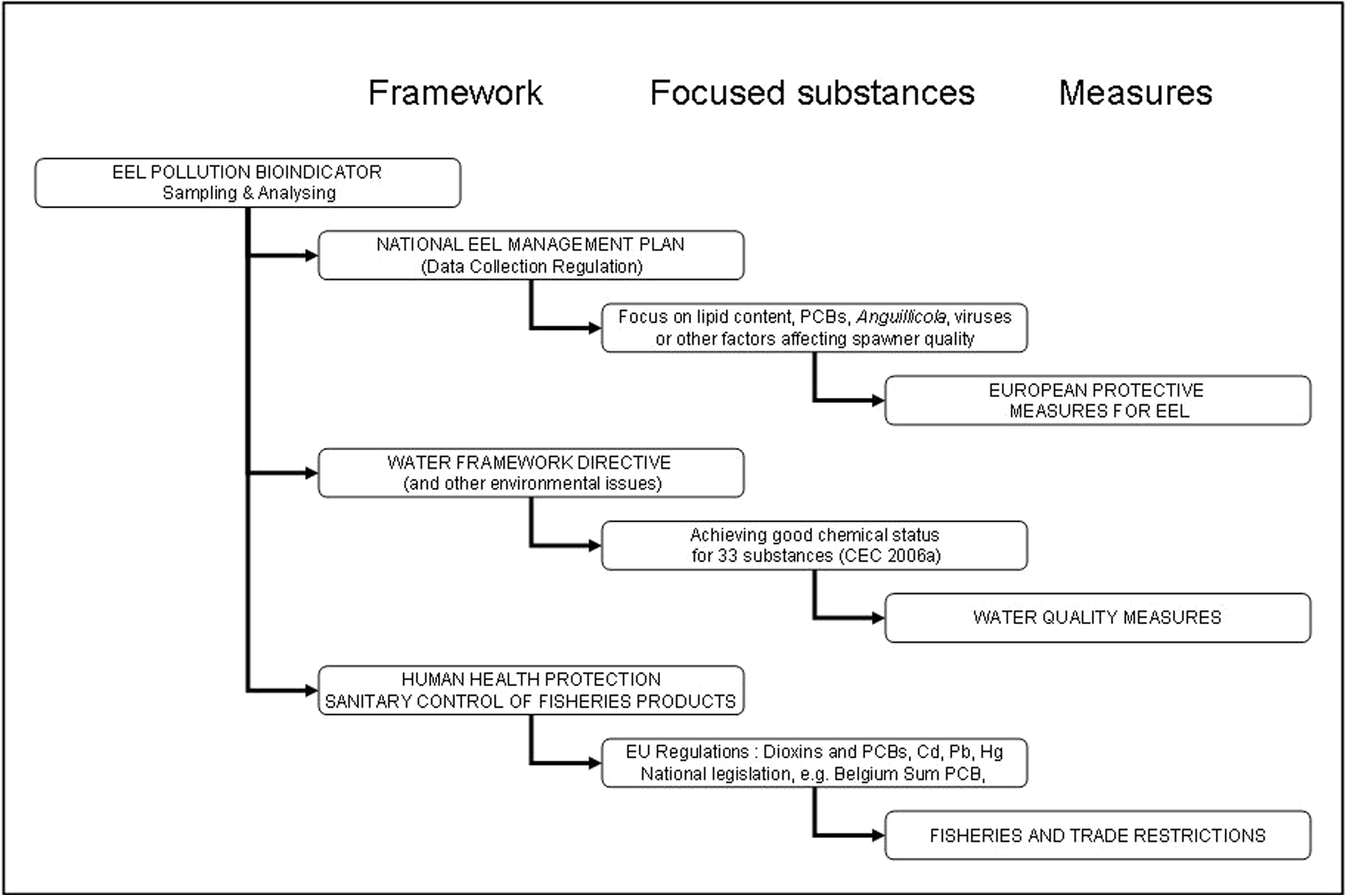
Fig. 12. – Possibilities of combined use of monitoring contaminants in the eel.

ing programmes for lipophilic substances should be focused on biota.
It was admitted by CEC (2006d) that some of the sub- stances are difficult to determine due to the low concen- trations and that EQSs based on waterborne exposures are not protective of aquatic invertebrates and fish in all cases. It is stated by CEC (2006d) that monitoring pro- grammes for lipophilic substances should be focused on biota (and possibly sediment). Following CEC (2006c), the biggest obstacle to develop EQS for sediment and biota was the considerable lack of data. Apparently, on the basis of the given information, it was not possible to derive systematically such EQS for all those priority sub- stances. It was however strongly recommended to pro- duce the required ecotoxicological information for sup- porting sound EQS at least for these substances. In gener- al CEC (2006d) believes that specific quality standards can and should be developed for sediment and biota. These should be based on direct assessment and monitor- ing of sediments and biota. Given the biological relevance of sediment and biota standards and the fact that many persistent substances accumulate in these media, CEC (2006c) underlined the priority need to develop the meth- odologies and gather further data in order to ensure that such EQS can be set in the near future.
We documented the availability of bioaccumulation data for various hazardous substances in one common aquatic organism within EC countries. Countrywide mon- itoring networks for eel are already in place in some mem- ber states and there is additionally a large amount of data available from short term local studies. The data within

member states however are widely scattered over research institutes and universities, and not always available to national agencies committed in the WFD reporting.
We may conclude that, at the time being, the WFD urges the monitoring of toxic substances in the aquatic environment to protect aquatic organisms, but fails to present an appropriate model efficient enough to guaran- tee this protection.
However, monitoring of contaminants in biota and the development of biota based EQS is essential to preserve or restore the ecological integrity of the aquatic environ- ment and the aquatic organisms themselves. Belpaire & Goemans (2007) recommended using eel for monitoring the chemical status of waters within the requirements of the Water Framework Directive. They give details about monitoring WFD substances in eels and the percentage of measurements above D.L. In this paper we further dis- cussed the analytical advantages of using eel among other aquatic biota and documented the suitability of this spe- cies for tracing local and specific chemical pressures. We provided a normative framework on the basis of the EPMN bioaccumulation data for a number of PCBs, OCPs and heavy metals. We compiled an overview of current monitoring work over the EC. As the eel seems to be a suitable model when monitoring chemical status in aquatic biota, we propose to further compile existing data on a European scale, as a basis to set up eel-based EQS and for further work. We recommend that a comprehen- sive research and monitoring project should be started and coordinated on a European level. A first initiative has been taken recently by the Working Group on eel (WG

Eel 2007) starting to compile data on contaminants and diseases in eel within an European Eel Quality Database. Twelve countries submitted data on contaminants in eel for inclusion into this database. Monitoring of the quality of eel received increased attention. Countries like The Netherlands and Belgium continue their monitoring pro- grammes on contaminants, whilst other countries have initiated eel quality studies. Preliminary interrogation of the database illustrates the wide variability of contami- nants and the presence of ‘black spots’ over the distribu- tion area of the eel. Such examples highlight the benefits of an eel quality database, and the need for a harmonised eel quality monitoring network across Europe to feed such a database (WG Eel 2007).
Using eel as an indicator for the chemical status within the WFD forms the basis for other required monitoring programmes, i.e. the required monitoring of the quality of human foodstuffs (fisheries products) (e.g. CEC 2001, 2006e) and the sampling for eel quality within the Euro- pean efforts for the restoration of the species (Data Col- lection Regulation) as proposed by the Working Group on Eel (WG Eel 2006) and the Scientific, Technical and Eco- nomic Committee for Fisheries of the EC (STECF 2006) (see Fig. 12). Of course, by combining sampling proce- dures and analytic efforts, these monitoring programmes become more cost-efficient and -effective. The set up of a harmonised, Europe-wide chemical monitoring pro- gramme of eels could stand for triple usage: the evalua- tion of environmental health and chemical status (national level and WFD level), the sanitary control of fisheries products within human food safety regulations, and the monitoring of eel (spawner) quality within the require- ments of the international eel restoration plan and the national Eel Management Plans (STECF 2006). To this end, it might be envisaged to extend the contaminant monitoring in yellow eel with analysis in silver eel popu- lations from specific locations, to trace the quality of the spawners (e.g. in European basins with high production of spawners), and to measure against food safety stand- ards (e.g. within exploited silver eel stocks).
Up-scaling the European monitoring strategy of chem- icals in the European eel to a worldwide scale seems to be possible. Other eel species occur in other parts of the world, and at least some of them share similar ecological and physiological traits (migration and homing behaviour, trophic position, fat content,…). In the U.S. and Canada (Hodson et al. 1994, Castonguay et al. 1994) and in New Zealand (Buckland et al. 1998) there is already a long his- tory in using anguillids as sentinel species for selected chemicals.
Taking into account the high concentration of some contaminants in certain eel subpopulations (Maes et al. 2007, WG Eel 2007), and the ecotoxicological and repro- toxic effects of these substances (e.g. Maes et al. 2005, Palstra et al. 2006), the authors believe that achieving good chemical status of EU waters will directly benefit

eel restoration efforts. How better to assess the status of its environment, than using the eel itself?
Acknowledgements.- We would like to thank all Groenen- daal collaborators for technical support in sampling and treat- ment of eels and Y Maes & T De Boeck for preparing maps and datasets. We very much acknowledge K McCarthy, T Higgins, H Verreycken & two anonymous referees for their critical com- ments on the manuscript.

rEFErEncES

Ankarberg E, Bjerselius R, Aune M, Darnerud PO, Larsson L, Andersson A, Tysklind M, Bergek S, Lundstedt-Enkel K, Karlsson L, Törnkvist A, Glynn A 2004. Study of dioxin and dioxin-like PCB levels in fatty fish from Sweden 2000-2002. organohal Comp 66: 2061-65.
Aoyama J, Sasai S, Miller MJ, Shinoda A, Nakamura A, Kawa- zu K, Tsukamoto K 2002. A preliminary study of the move- ments of yellow and silver eels, anguilla japonica, in the estuary of the Fukui River, Japan, as revealed by acoustic tracking. Hydrobiologia 470: 31-36.
Baras E, Jeandrain D, Serouge B, Philippart JC 1998. Seasonal variations in time and space utilization by radiotagged yel- low eels anguilla anguilla (L.) in a small stream. Hydrobio- logia 371/372: 187-198.
Batty J, Pain D, Caurant F 1996. Metal concentrations in eels anguilla anguilla from the Camargue region of France. Biol Conserv 76: 17-23.
Beentjes MP, Jellyman DJ 2003. Enhanced growth of longfin eels, anguilla dieffenbachii, transplanted into Lake Hawea, a high country lake in South Island, New Zealand. n Z J mar freshw res 37: 1-11.
Belgisch Staatsblad 2002. Koninklijk besluit tot wijziging van het koninklijk besluit van 19 mei 2000 tot vaststelling van maximale gehaltes aan dioxines en polygechloreerde bife- nylen in sommige voedingsmiddelen. Brussel, 6 march 2002. Publication 2002-04-16.
Belpaire C, Van Thuyne G, Callaars S, Roose P, Cooreman K, Bossier P 1999. Spatial and temporal variation in organo- chlorine pesticide and polychlorinated biphenyl pollution in fresh water aquatic ecosystems in Flanders using the Euro- pean eel (anguilla anguilla L.) as an indicator. EIFAC/ICES, Working Group on Eel, Silkeborg (DK), 20-25 Septembre 1999.
Belpaire C, Derwich A, Goemans G, Van Thuyne G, Cooreman K, Guns M, Ollevier F 2001. Intra lake spatial variations in pollution patterns of eel a. anguilla. in Aida K et al., eds, Proceedings of the International Symposium ‘Advances in Eel Biology’, Univ Tokyo, 28-30 September 2001: 170-174.
Belpaire C, Goemans G, de Boer J, Van Hooste, H. 2003.Ver- spreiding van gebromeerde vlamvertragers. in Van Steerteg- em M ed, Mira T 2003, Milieu- en Natuurrapport Vlaander- en, LannooCampus, Leuven : 387-395.
Belpaire C, Goemans G 2004. Monitoring en normering van milieugevaarlijke stoffen in paling: bruikbaarheid en rele- vantie voor het milieubeleid. Water 2004: 1-16.
Belpaire C, Goemans G 2007. Eels: contaminant cocktails pin- pointing environmental pollution. iCes J mar sci doi:10.1093/icesjms/fsm121
Bligh EG, Dyer WJ 1959. A rapid method of total lipid extrac- tion and purification for organic compounds. Can J Biochem physiol 37: 911-917.

Bragigand V, Amiard-Triquet C, Parlier E, Boury P, Marchand P, El Hourch M 2006. Influence of biological and ecological factors on the bioaccumulation of polybrominated diphenyl ethers in aquatic food webs from French estuaries. sci total environ 368: 615-626.
Bressa G, Sisti E, Cima F 1997. PCBs and organochlorinated pesticides in eel (anguilla anguilla L.) from the Po Delta. mar Chem 58: 261-266.
Bruslé J 1990. The effect of heavy metals on eels (anguilla sp).
aquat living res 3: 131-141.
Bruslé J 1991. The eel (anguilla sp) and organic chemical pol- lutants. sci total environ 102: 1-19.
Buckland SJ, Jones PD, Ellis HK, Salter RT, 1998. Organochlo- rines in New Zealand: Ambient concentrations of selected organochlorines in rivers. Ministry for the Environment, Wellington (New Zealand), 72 p.
Castonguay M, Dutil JD, Desjardins C 1989. Distinction between American eels (anguilla rostrata) of different geo- graphic origins on the basis of their organochlorine contami- nant levels. Can J fish aquat sci 46: 836-843.
Castonguay M, Hodson PV, Moriarty C, Drinkwater KF, Jessop, BM 1994. Is there a role of ocean environment in American and European eel decline? fish oceanogr. 3: 197-203.
Corsi I, Mariottini M, Badesso A, Caruso T, Borghesi N, Bonac- ci S, Iacocca A, Focardi S 2005. Contaminants and sub-lethal toxicological effects of persistent organic pollutants in the European eel (anguilla anguilla) in the Orbetello lagoon (Tuscany, Italy). Hydrobiologia 550: 237-249.
CEC 2000. Directive of the European parliament and of the council 2000/60/EC establishing a framework for communi- ty action in the field of water policy. off J eur Comm 22.12.2000, L 327/1.
CEC 2001. Commission Regulation (EC) 466/2001 of 8 March 2001 setting maximum levels for certain contaminants in foodstuffs. off J eur Comm, 16 March 2001, L77/1.
CEC 2006a. Proposal for a Directive of the European parliament and of the Council on environmental quality standards in the field of water policy and amending Directive 2000/60/EC (presented by the Commission) {COM(2006) 398 final}
{SEC(2006) 947} Commission of the European Communi- ties, Brussels, 17.7.2006 COM(2006) 397 final 2006/0129 (COD).
CEC 2006b. Communication from the Commission to the Coun- cil and the European Parliament. Integrated prevention and control of chemical pollution of surface waters in the Euro- pean Union {SEC(2006) 947} {COM(2006) 397 final} Com- mission of the European Communities Brussels, 17.7.2006 COM(2006) 398 final.
CEC 2006c. Commission Staff Working Document Impact Assessment Proposal for a Directive of the European Parlia- ment and of the Council on environmental quality standards in the field of water policy and amending Directive 2000/60/ EC {COM(2006) 397 final} {COM(2006) 398 final} Com-
mission of the European Communities, Brussels, 17.7.2006 SEC(2006) 947.
CEC 2006d. Opinion of the Scientific Committee on Toxicolo- gy, Ecotoxicology and the Environment (CSTEE) on “The Setting of Environmental Quality Standards for the Priority Substances included in Annex X of Directive 2000/60/EC in Accordance with Article 16 thereof ” Adopted by the CSTEE during the 43rd plenary meeting of 28 May 2004. European Commisssion, Health & Consumer Protection Directorate- General, Directorate C – Public Health and Risk Assessment C7 – Risk Assessment Brussels, C7/GF/csteeop/WFD/ 280504 D(04).

CEC 2006e. Commission Regulation (EC) 199/2006 of 3 Febru- ary 2006 amending Regulation (EC) No 466/2001 setting maximum levels for certain contaminants in foodstuffs as regards dioxins and dioxin-like PCBs. off J eur Comm 04.02.2006, L 32/34.
De Boer J, Hagel P 1994. Spatial differences and temporal trends of chlorobiphenyls in yellow eel (anguilla anguilla) from inland waters of the Netherlands. sci total environ 141: 155-174.
Durrieu G, Maury-Brachet R, Girardin M, Rochard E, Boudou A 2005. Contamination by heavy metals (Cd, Zn, Cu, and Hg) of eight fish species in the Gironde estuary (France). estuaries 28 (4): 581-591
Dutil JD, Legare B, Desjardins C 1985. Discrimination d’un stock de poisson, l’Anguille (anguilla rostrata), basée sur la présence d’un produit chimique de synthèse, le mirex (Dis- crimination of a fish stock, anguilla rostrata, on the basis of the presence of synthetic chemical product, the mirex). Can J fish aquat sci 42 (3): 455-458.
Edwards SC, MacLeod CL, Lester JN Mercury 1999. Contami- nation of the eel (anguilla anguilla) and roach (rutilus rutilus) in East Anglia, UK. environ monitor assess 55: 371- 387
Feunteun E, Lafaille P, Robinet T, Briand C, Baisez A, Olivier JM, Acou A 2003. A review of upstream migration and move- ments in inland waters by anguillid eels: towards a general theory. in Aida K, Tsukamoto K, Yamauchi K eds, Eel biolo- gy, Springer Verlag, Tokyo: 191-213.
Food Standards Agency 2004. Brominated flame retardants in trout and eels from the Skerne-Tees river system and total diet study samples. Food Surveillance Information Sheet No. 52/04, April 2004, FSA, London, available at http://www. food.gov.uk/science/surveillance/fsis2004branch/fsis5204.
Fromme H, Otto T, Pilz K, Neugebauer F 1999. Levels of syn- thetic musks: bromocyclene and PCBs in eel (anguilla anguilla) and PCBs in sediment samples from some waters of Berlin/Germany. Chemosphere 39: 1723–1735.
Gaumert T, Löffler J, Bergemann M, Reincke H. 2000. Schadst- offe in Elbefischen. Belastung und Vermarktungsfähigkeit. Arbeitsgemeinschaft für die Reinhaltung de Elbe, 103 p.
Goemans G, Belpaire C 2003. The Flemish eel monitoring net- work: PCB-concentrations in eel from the Meuse catchment area. Proceedings of the First International Scientific Sym- posium on the River Meuse, November 27-28, 2002, Maas- tricht, Netherlands: 58-62.
Goemans G, Belpaire C, Raemaekers M, Guns M 2003. Het Vlaamse palingpolluentenmeetnet, 1994-2001 : gehalten aan polychloorbifenylen, organochloorpesticiden en zware met- alen in paling. [The Flemish eel pollution monitoring net- work 1994-2001: polychlorine biphenyls, organochlorine pesticides and heavy metals in eel]. Report of the Institute for Forestry and Game Management, IBW. Wb.V.R.2003.99,169 p.
Goemans G, Belpaire C 2004. The eel pollutant monitoring net- work in Flanders, Belgium. Results of 10 years monitoring. organohal Comp 66: 1834-1840.
Goemans G, Belpaire C 2005. Congener profiles in European eel (anguilla anguilla L.) as a method of tracing the origin of PCB contamination. organohal Comp 67: 1304-1307.
Goodwin KR 1999. American Eel subpopulation characteristics in the Potomac river drainage, Virginia. Thesis Faculty of Virginia Polytechnic Institute and State Univ Blacksburg, Virginia, 116 p.

Hammond SD 2003. Seasonal movements of yellow-phase American eels (anguilla rostrata) in the Shenandoah River, West Virginia. Thesis. Davis College of Agriculture, Forest- ry, and Consumer Sciences at West Virginia Univ, Morgan- town WV, 32 p.
Hendriks AJ, Pieters H 1993. Monitoring concentrations of microcontaminants in aquatic organisms in the Rhine delta: a comparison with reference values. Chemosphere 26: 817- 836.
Hodson PV, Castonguay M, Couillard CM, Desjardins C, Pelle- tier E, McLeod R 1994. Spatial and temporal variations in chemical contamination of American eels, anguilla rostrata, captured in the estuary of the St. Lawrence river. Can J fish aquat sci 51 (2): 464-478.
Hoff PT, Van Campenhout K, de Vijver K, Covaci A, Bervoets L, Moens L, Huyskens G, Goemans G, Belpaire C, Blust R, De Coen W 2005. Perfluorooctane sulfonic acid and organo- halogen pollutants in liver of three freshwater fish species in Flanders (Belgium): relationships with biochemical and organismal effects. environ poll 137: 324-333.
Hubert W, Ricci ED 1981. Factors influencing dieldrin and DDT residues from Des Moines Rivers, Iowa, 1977-1980. pest monit J 15 (3): 111-116.
Jellyman DJ, Glova GJ, Todd PR 1996. Movements of short- finned eels, anguilla australis, in Lake Ellesmere, New Zea- land: results from mark-recapture studies and sonic tracking. n Z J mar freshw res 30: 371-381.
Jørgensen K, Larsen EH, Petersen A, Lund KH, Hilbert G, Andersen NL, Hallas-Møller T, Larsen JC 2001. Chemical contaminants. Food monitoring, 1993-1997. Part 2. Ministry of Food, Agriculture and Fisheries, Danish Veterinary and Food Administration.
Karl H, Lehmann I 1993. Organochlorine residues in the edible part of eels of different origins. Z lebensm unters forsch 197: 385-388.
Knights B 1997. Risk assessment and management of contami- nation of eels (anguilla spp) by persistent xenobiotic organo- chlorine compounds. Chem ecol 13: 171-212.
Laffaille P, Acou A, Guillouët J 2005. The yellow European eel (anguilla anguilla L.) may adopt a sedentary lifestyle in inland freshwaters. ecol freshw fish 14: 191-196.
Langston WJ, Chesman BS, Burt GR, Pope ND, McEvoy J 2002. Metallothionein in liver of eels anguilla anguilla from the Thames Estuary: an indicator of environmental quality? mar environ res 53: 263-293.
Lehmann J, Stürenberg F, Ingendahl D 2006. Analysis of health status of yellow eel and silver eel of the River Rhine. In WG EEL 2006. FAO European Inland Fisheries Advisory Com- mission; International Council for the Exploration of the Sea. Report of the 2006 session of the Joint EIFAC/ICES Work- ing Group on Eels. Rome, 23-27 January 2006. EIFAC Occa- sional Paper. No. 38, ICES CM 2006/ACFM:16. Rome, FAO/Copenhagen, ICES. 2006, 352 p.
Lehmann J, Stürenberg FJ, Kullmann Y Kilwinski J 2005. Umwelt- und Krankheitsbelastungen der Aale in Nordrhein- Westfalen. LÖBF-Mitteilungen Nr. 2/2005:35-40.
Lelek A 1987. The freshwater fishes of Europe. Vol. 9 Threat- ened fishes of Europe. Aula Verlag Wiesbaden, 343 p.
Linde AR, Sanchez-Galan S, Garcia-Vazquez E 2004a. Heavy metal contamination of European eel (anguilla anguilla) and brown trout (salmo trutta) caught in wild ecosystems in Spain. J food prot 67 (10): 2332-2336.

Linde AR, Sanchez-Galan S, Klein D, Garcia-Vazquez E, Sum- mer KH 2004b. Metallothionein and heavy metals in brown trout (salmo trutta) and European eel (anguilla anguilla): a comparative study. ecotoxicol environ saf 44 (2): 168-173.
Maes GE, Raeymaekers JAM, Pampoulie C, Seynaeve A, Goe- mans G, Belpaire C, Volckaert FAM 2005. The catadromous European eel anguilla anguilla (L.) as a model for freshwa- ter evolutionary ecotoxicology: relationship between heavy metal bioaccumulation, condition and genetic variability. aquat toxicol 73: 99-114.
Maes J, Belpaire C, Goemans G 2007. Spatial variations and temporal trends between 1994 and 2005 in polychlorinated biphenyls, organochlorine pesticides and heavy metals in European eel (anguilla anguilla L.) in Flanders, Belgium. Environ Pollut doi:10.1016/j.envpol.2007.07.021
Mariottini M, Bianchini A, Focardi S 2005. Distribution and profile of polybrominated diphenyl ethers in European eel (anguilla anguilla) from a Mediterranean coastal lagoon (Orbetello, Italy). organohal Comp 67: 467-470.
Mariottini M, Corsi I, Focardi S 2006. PCB levels in European eel (anguilla anguilla) from two coastal lagoons of the Med- iterranean. environ monitor assess 117: 519-528.
Mason CF, Barak NAE 1990. A catchment survey for heavy metals using the eel (anguilla anguilla). Chemosphere 21: 695-699.
Mason CF 1993. Organochlorine pesiticide residues and PCBs in eels anguilla anguilla from some British reedbeds. Chem- osphere 26: 2289-2292.
Moreau G, Barbeau C 1982. Les métaux lourds comme indica- teurs d’origine géographique de l’anguille d’Amérique (anguilla rostrata). Can J fish aquat sci 39: 1004-1011.
Morris S, Allchin CR, Zegers BN, Haftka JJH, Boon JP, Bel- paire C, Leonards PEG, Van Leeuwen SPJ, de Boer J 2004. Distribution and fate of HBCD and TBBPA brominated flame retardants in North Sea estuaries and aquatic food webs. environ sci technol 38: 5497-5504.
Nowell LH, Capel PD, Dileanis PD 1999. Pesticides in stream sediment and aquatic biota. Distribution, trends, and govern- ing factors. Boca Raton, Fla., CRC Press, Pesticides in the Hydrologic System series, v. 4, 1040 p.
Oliveira K 1997. Movements and growth rates of yellowphase American eels in the Annaquatucket river, Rhode Island. trans am fish soc 126: 638-646.
Oliveira Ribeiro CA, Vollaire Y, Sanchez-Chardi A, Roche H 2005. Bioaccumulation and the effects of organochlorine pesticides, PAH and heavy metals in the Eel (anguilla anguilla) at the Camargue Nature Reserve, France. aquat toxicol 74: 53-69.
Palstra AP, van Ginneken VJT, Murk AJ, van den Thillart GEEJM 2006. Are dioxin-like contaminants responsible for the eel (anguilla anguilla) drama? naturwissenschaften 93: 145-148.
PAN Pesticides Database, 2007. Chemical Toxicity Studies on Aquatic Organisms. Available at htttp://www.pesticideinfo. org/List_AquireAll.jsp?Species=574&Effect=&offset=0
Parker SJ 1995. Homing ability and home range of yellowphase American eels in a tidally dominated estuary. J mar Biol ass u K 75: 127-140.
Peeters B, De Cooman W, Vos G, Gabriels W, Martens K, Tim- mermans G, Van Hoof K, Breine J, Van Thuyne G, Goemans G, Belpaire C, Geeraerts C 2006. Oppervlaktewater: Biolo- gische kwaliteit nog steeds ondermaats. in Van Steertegem M ed, Mira-T 2006 Milieurapport Vlaanderen: Focusrapport. Leuven Lannoo Campus, 89-104.

Pieters H, van Leeuwen SPJ, de Boer J 2004.Verontreinigingen in aal en snoekbaars: monitorprogramma ten behoeve van de Nederlandse sportvisserij 2003. RIVO report C063/04, 20 p.
Poole R, McCarthy K 2006. Report on the eel stock and fishery in the Republic of Ireland 2005. in WG EEL 2006. FAO European Inland Fisheries Advisory Commission; Interna- tional Council for the Exploration of the Sea. Report of the 2006 session of the Joint EIFAC/ICES Working Group on Eels. Rome, 23–27 January 2006. EIFAC Occasional Paper. No. 38, ICES CM 2006/ACFM:16. Rome, FAO/Copenha- gen, ICES. 2006, 352 p.
Reinert RE, Bergman HL 1974. Residues of DDT in lake trout (salvelinus namaycush) and Coho salmon (oncorhynchus kisutch) from the Great Lakes. Can J fish aquat sci 31 (2): 191-199.
Robinet T, Feunteun E 2002. Sublethal effects of exposure to chemical compounds: a cause for the decline in Atlantic eels? ecotoxicology 11: 265-277.
Roche H, Buet A, Ramade F 2002. Accumulation of lipophilic microcontaminants and biochemical responses in Eels from the Camargue biosphere reserve. ecotoxicology 11: 155-64.
Roche N, Buet A, Ramade F 2003. Characterization and valida- tion of ecotoxicological biomarkers in an eel population exposed to persistent organic pollutants in the Vaccares lake, French national reserve of Camargue. revue d’ecologie (la terre et la Vie) 58: 127-141.
Roose P, Van Thuyne G, Belpaire C, Raemaekers M, Brinkman U 2003. Determination of VOCs in yellow eel from various inland water bodies in Flanders (Belgium). J environ moni- tor 5: 876-884.
Ruddock PJ, Bird DJ, McEvoy J, Peters LD 2003. Bile metabo- lites of polycyclic aromatic hydrocarbons (PAHs) in Europe- an eels anguilla anguilla from United Kingdom estuaries. sci total environ 301: 105-117.
Santillo D, Johnston P, Labunska I, Brigden K 2005. Widespread presence of brominated flame retardants and PCBs in eels (anguilla anguilla) from rivers and lakes in 10 European countries. Greenpeace Research Laboratories, Technical Note 12/2005, Greenpeace International, October 2005, 56 p.
Santillo D, Allsopp M, Walters A, Johnston P, Perivier H 2006. Presence of perflurionated chemicals in eels from 11 Europe- an countries. Investigating the contamination of the European eel with PFCs, substances used to produce non-stick and water-repellant coatings for a multitude of products. Report Greenpeace Research laboratories Technical Note 07/2006, publ. Greenpeace International, September 2006, 32 p.
STECF 2006. Scientific, Technical and Economic Committee for Fisheries of the Commission of the European Communi- ties, 22nd Report of STECF, draft version of 27 April 2006.
Storelli MM, Barone G, Garofalo R, Marcotrigiano GO 2007. Metals and organochlorine compounds in eel (anguilla anguilla) from the Lesina lagoon, Adriatic Sea (Italy). food Chem 100: 1337-1341.
Thomé JP, Bertrand A, Brose F, Carabin O, De Pauw E, Duk- mans C, Eppe G, Gaspar P, Leroy A, Louvet M, Maghuin- Rogister G, Marneffe Y, Massart AC, Philippart, JC, Rimbaut G, Scippo ML 2004. Evaluation du niveau de contamination des rivières par les PCBs et les dioxines.Report Univ Liège. Convention avec la Région Wallonne, Ministère de l’Aménagement du Territoire, de l’Urbanisme et de l’Environnement, Engagement n° 01/4143, 167 p.
Tulonen J, Vuorinen PJ 1996. Concentrations of PCBs and other organochlorine compounds in eels (anguilla anguilla L.) of the Vanajavesi watercourse in southern Finland, 1990-1993. sci total environ 187: 11-18.

Usero J, Izquierdo C, Morillo J, Gracia I 2004. Heavy metals in fish (solea vulgaris, anguilla anguilla and liza aurata) from salt marshes on the southern Atlantic coast of Spain. environ int 29: 949-956.
Van den Heuvel-Greve MJ, Leonards PEG, Vethaak D 2006. Food web transfer of dioxins and other organic contaminants in the Western Scheldt: implications for human and environ- mental health. ICES Annual Science Conference, Maastricht, CM 2006/G:08.
Van der Oost R, Opperhuizen A, Satumalay K, Heida H, Ver- meulen NPE 1996a. Biomonitoring aquatic pollution with feral eel (anguilla anguilla) I. Bioaccumulation: biota sedi- ment ratios of PCBs, OCPs, PCDDs and PCDFs. aquat toxi- col 35: 21-46.
Van der Oost R, Goksøyr A, Celander M, Heida H, Vermeulen NPE 1996b. Biomonitoring aquatic pollution with feral eel (anguilla anguilla) II. Biomarkers: pollution-induced bio- chemical responses. aquat toxicol 36: 189-222.
Van Leeuwen SPJ, Traag WA, Hoogenboom LAP, Booij G, Lohman, Dao QT, de Boer J 2002. Dioxines, furanen en PCBs in aal. Onderzoek naar wilde aal, gekweekte aal, geïmpor- teerde en gerookte aal. RIVO Nederlands Instituut voor Vis- serijonderzoek, IJmuiden, report CO34/02, 34 p, 7 annexes.
Versonnen BJ, Goemans G, Belpaire C, Janssen CR 2004. Vitel- logenin content in European eel (anguilla anguilla) in Flan- ders, Belgium. environ pollut 128: 363-371.
Weatherley NS, Davies GL, Ellery S 1997. Polychlorinated biphenyls and organochlorine pesticides in eels (anguilla anguilla L.) from Welsh rivers. environ pollut 95: 127-134.
Weis P, Ashley JTF 2007. Contaminants in Fish of the Hacken- sack Meadowlands, New Jersey: Size, Sex, and Seasonal Relationships as Related to Health Risks. arch environ Con- tam toxicol 52: 80-89
Weltens R, Goemans G, Huyskens G, Witters H, Belpaire C 2002. Wetenschappelijke onderbouwing voor de normering van polluenten in Vlaamse oppervlaktewateren en selectie van ecologische en exotoxicologische indicatoren voor de waterkwaliteit. Report for VMM, VITO and IBW, IBW.Wb. VR.2002.88.
Weltens R, Goemans G, Huyskens G, Belpaire C, Witters H 2003. Evaluatie van de kwaliteitsnormering voor oppervlak- tewater in Vlaanderen: een praktijkstudie. Water 2003: 1-9.
Wiesmüller T, Schlatterer B 1999. PCDDs/PCDFs and coplanar PCBs in eel (anguilla anguilla) from different areas of the rivers Havel and Oder in the state of Brandenburg (Germa- ny). Chemosphere 38 (2): 325-334.
WG Eel 2006. FAO European Inland Fisheries Advisory Com- mission; International Council for the Exploration of the Sea. Report of the 2006 session of the Joint EIFAC/ICES Work- ing Group on Eels. Rome, 23-27 January 2006. EIFAC Occa- sional Paper. No. 38, ICES CM 2006/ACFM:16. Rome, FAO/Copenhagen, ICES. 2006, 352 p.
WG Eel 2007. FAO European Inland Fisheries Advisory Com- mission; International Council for the Exploration of the Sea. Report of the 2007 session of the Joint EIFAC/ICES Work- ing Group on Eels. Bordeaux, 2-7 September 2007. In press.

